Data Distribution Information:

* Attribute category - (REN_LN)
* Total Data Point - (3347, 667)
* Data-points into Training - (2677, 50) {2019 - }
* Data-points into Test - (670, 50)
* Data-points into Val - (???)
* Unit_Wo VS Non_Unit_Wos (26% : 74%)
* Overall_Unit_Wos_Rate = 26%

LN_Ren Best 50 features

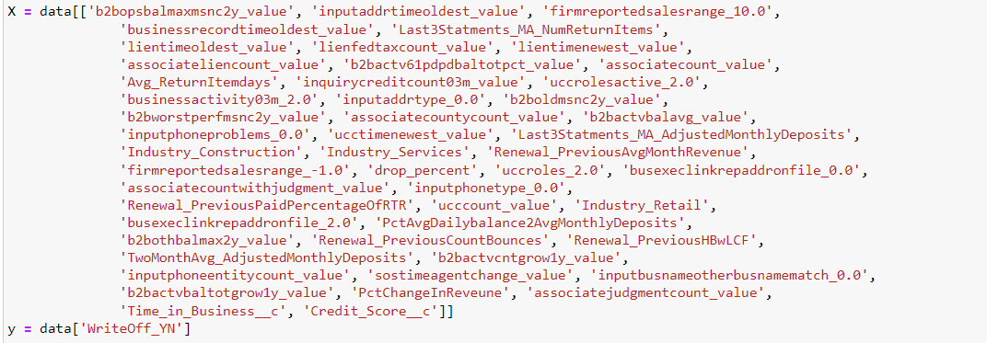

Hyperparameters:

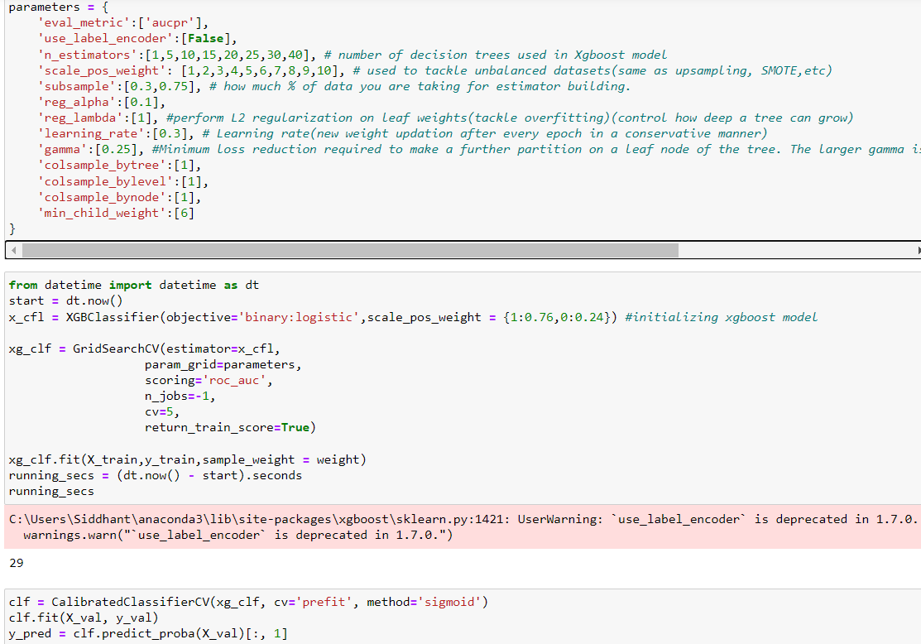

Deciles:-

Before Calibration Train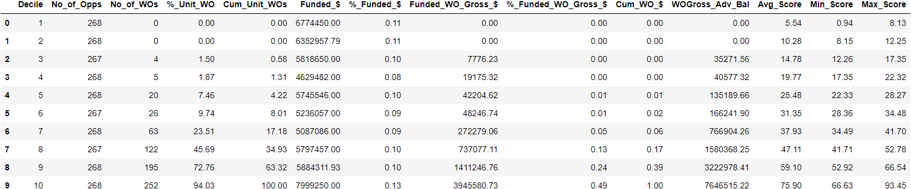

After calibration Train

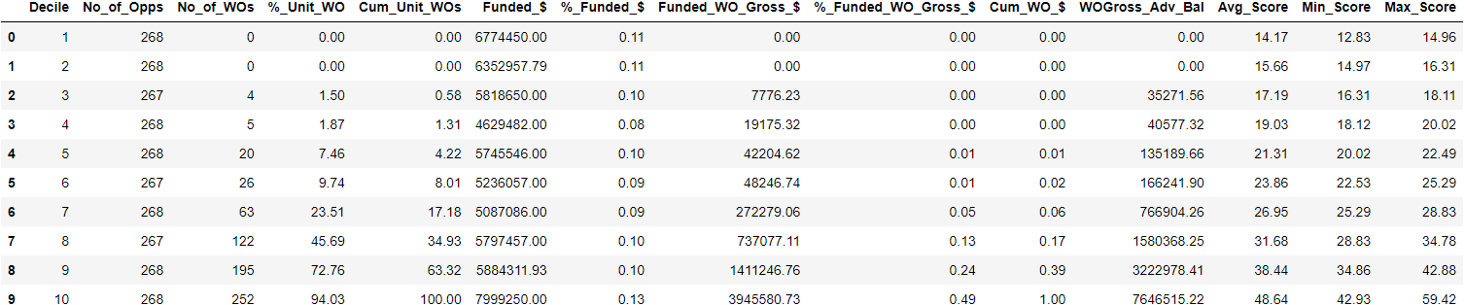

Before Calibration Test (split)

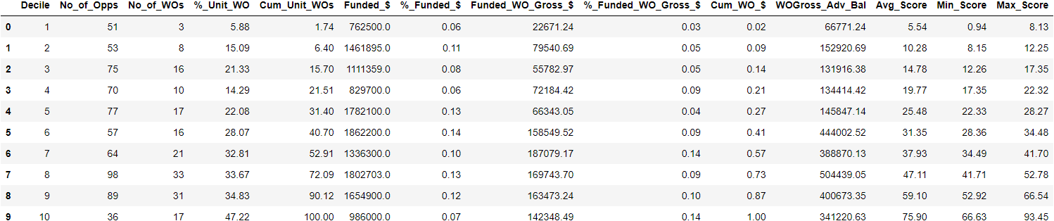

After calibration Test (split)

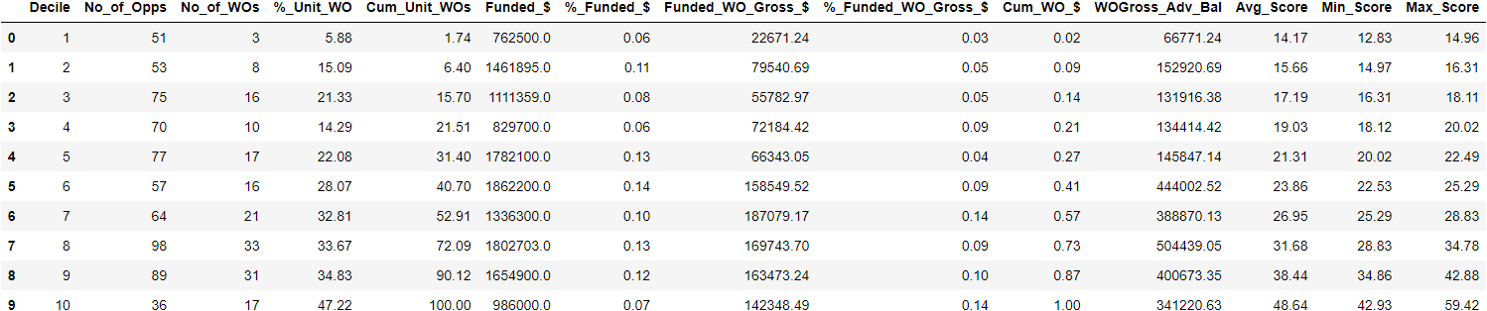

Deciles Figures

Train: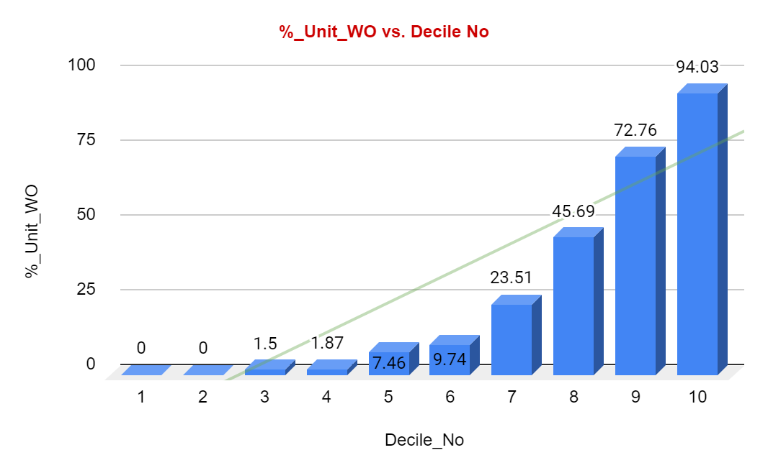

Test set: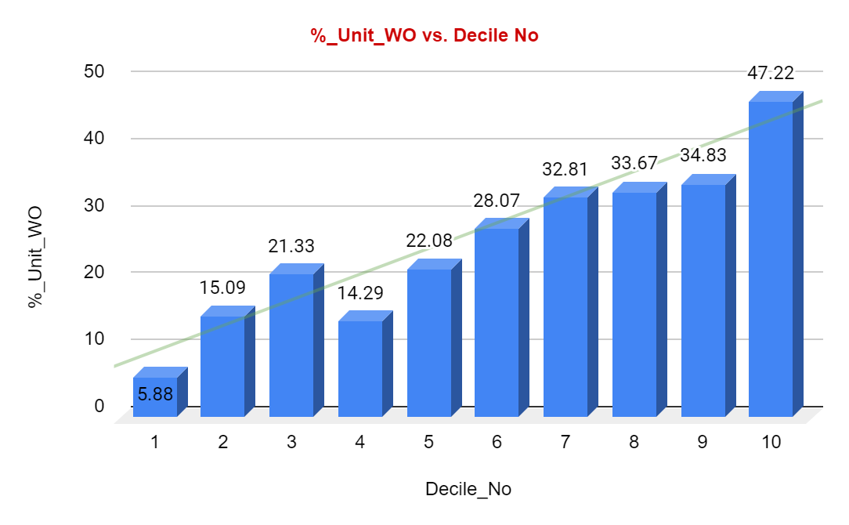

Pentiles:-

Before calibration train

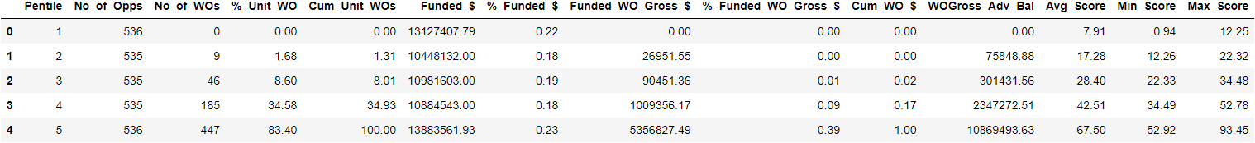

After calibration train

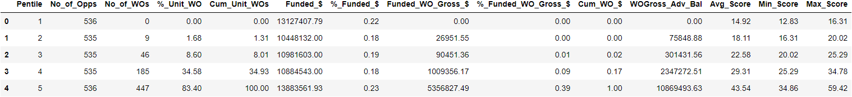

Before calibration test (split)

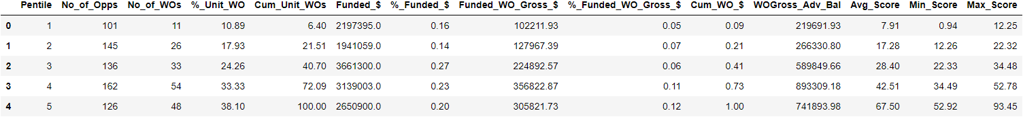

After calibration test (split)

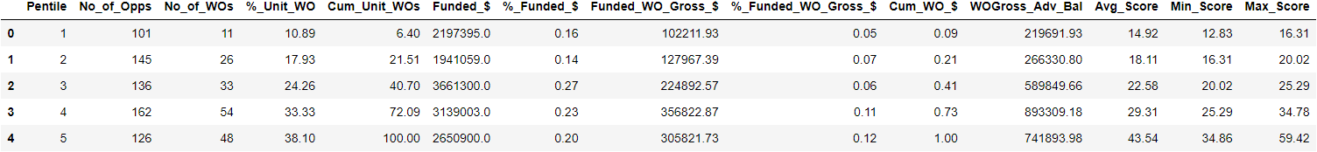

Pentile Figures -

Train set:

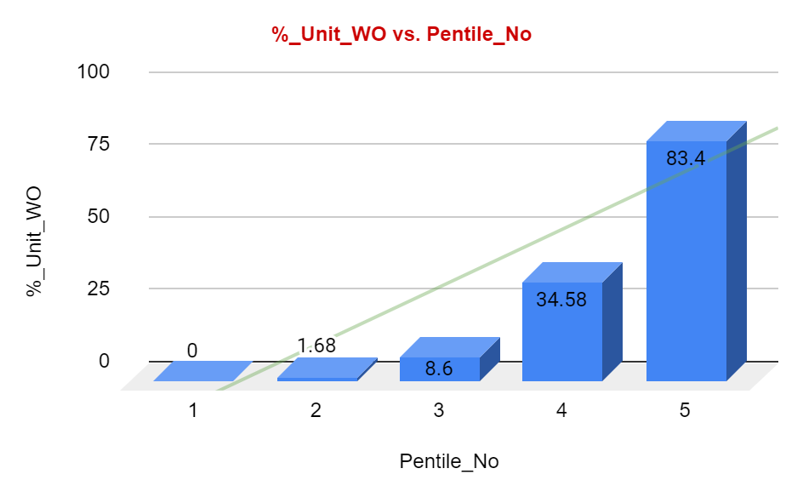

Test set:

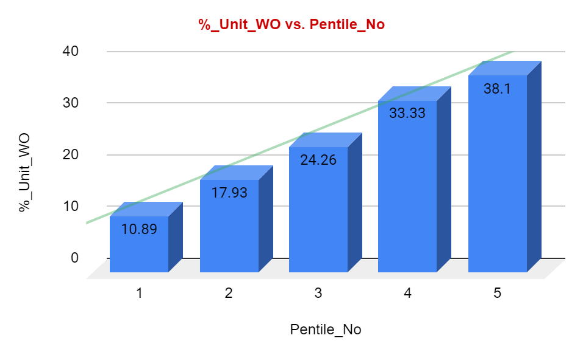

**Same model on new data:**

Distribution:

Training Data {2546, 50} {April 2019 - February 2022}

Test Set {637, 50} {April 2019 - February 2022}

Validation Set (458, 50) {March 2022 - May 2022}

Deciles:

Train set before calibrated_cv:

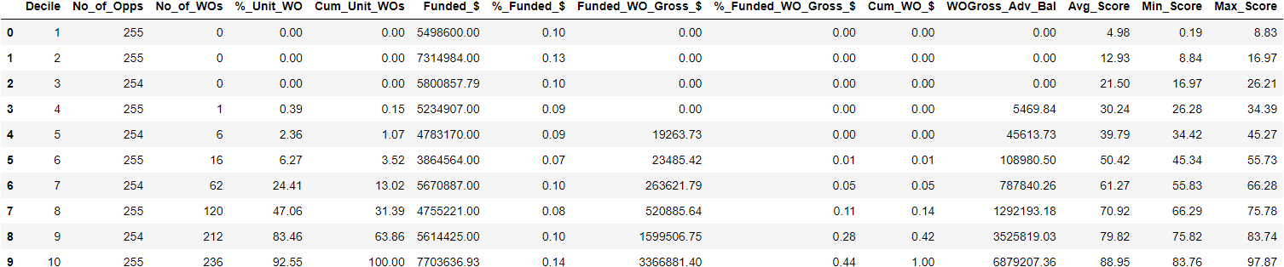

Train set after calibration: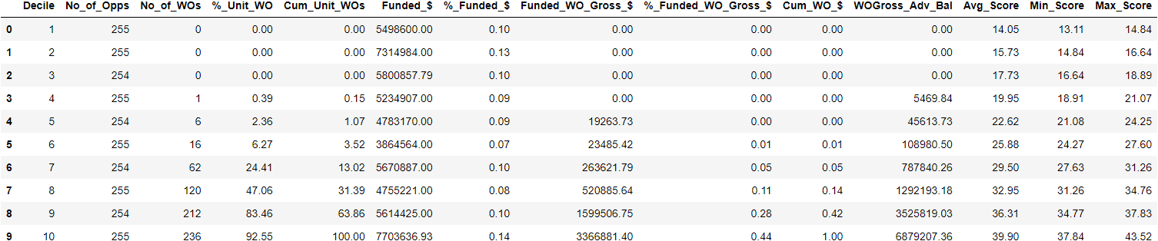

Before calibration Val set:

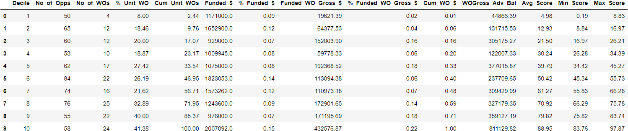

After calibration Val set: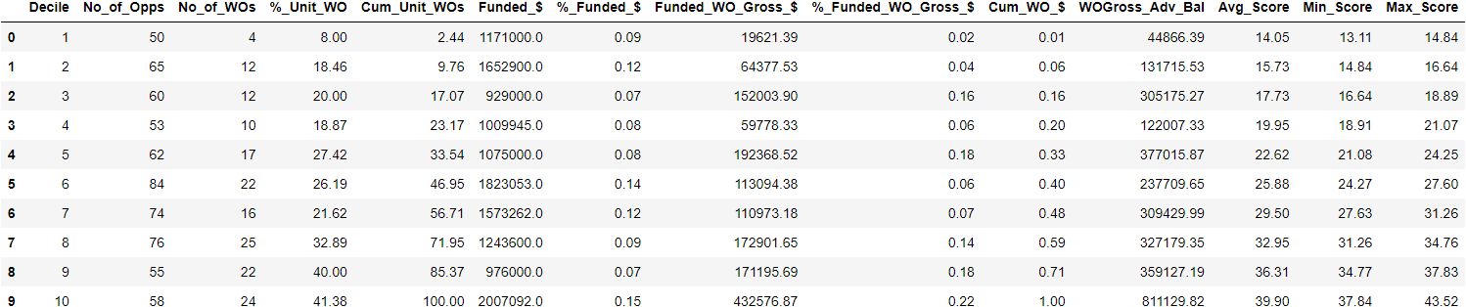

Before calibration Test Set:

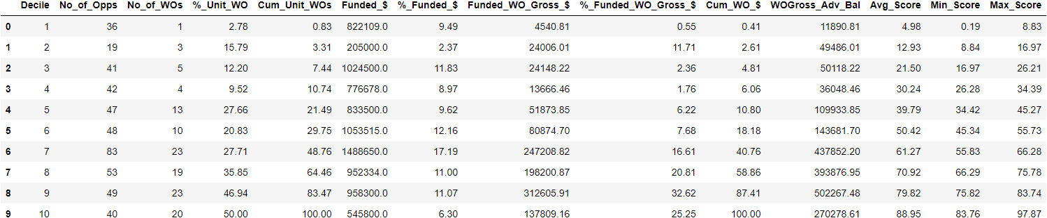

After calibration Test Set: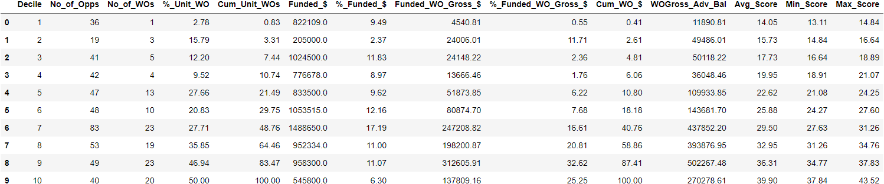

Decile Figures:

Train: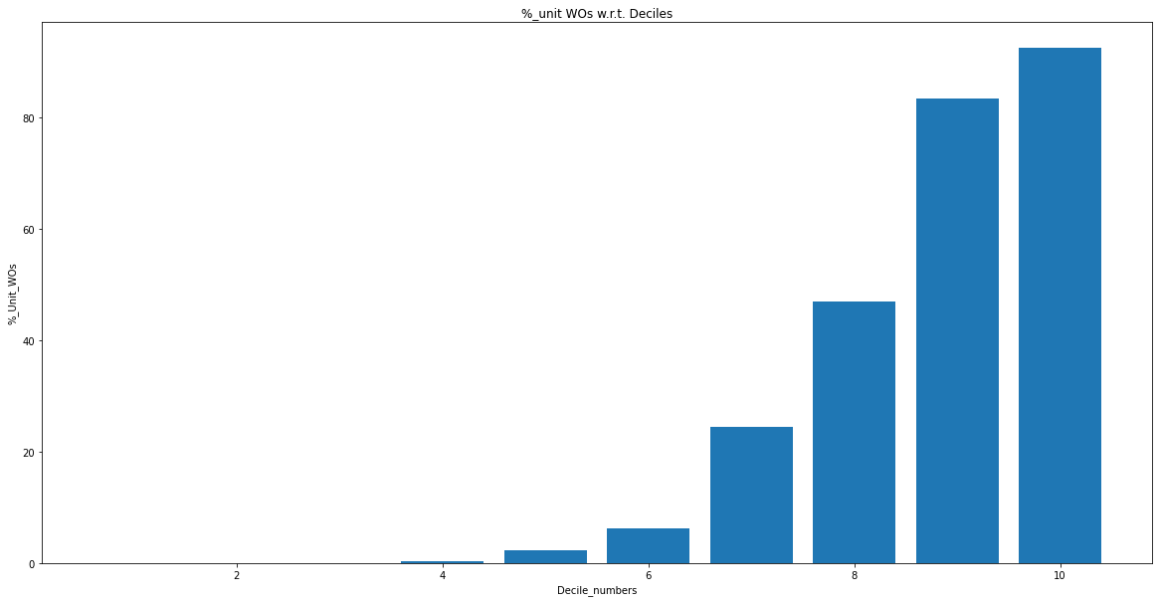

Val: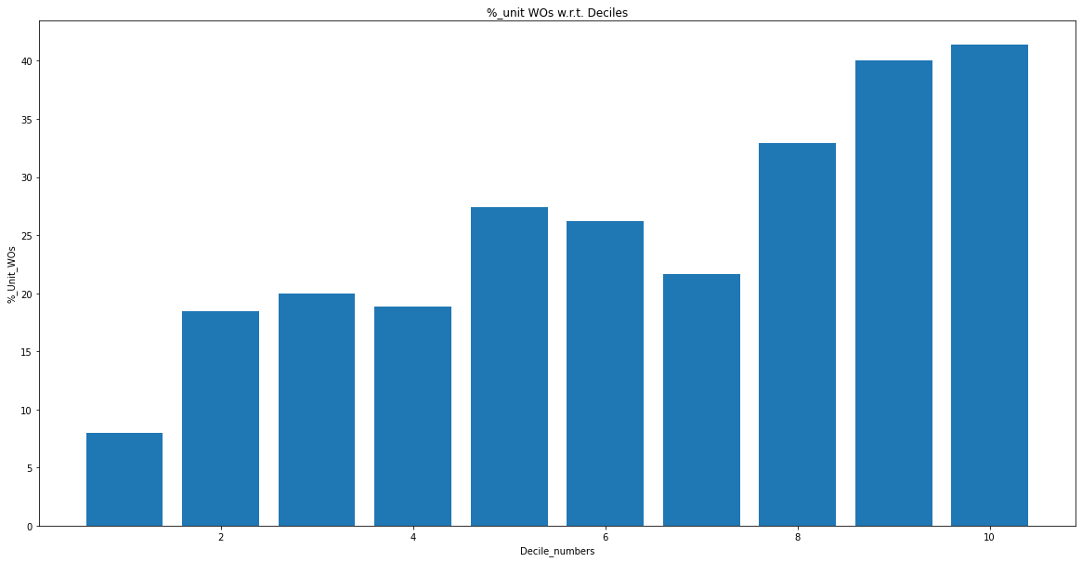

Test: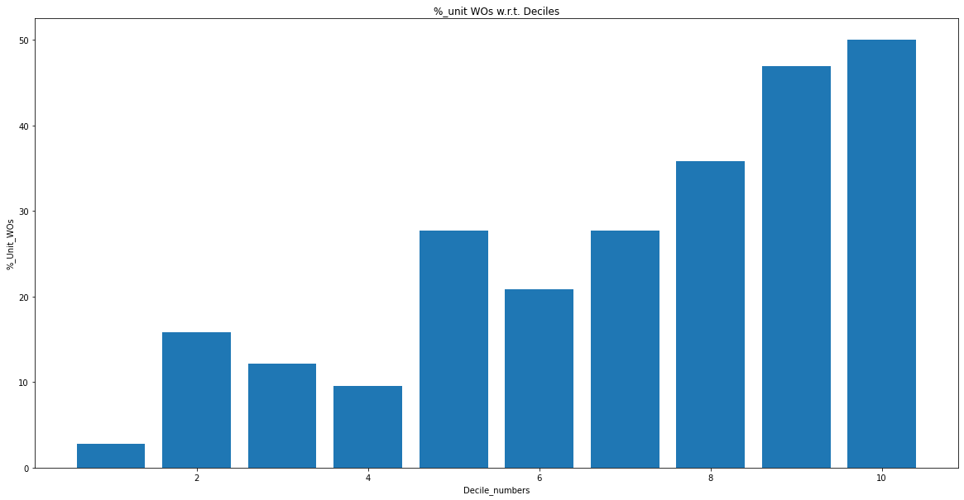

Pentiles:

Before calibration Train set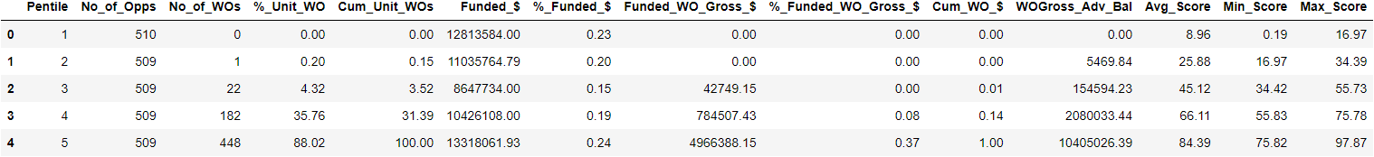

After calibration Train set:

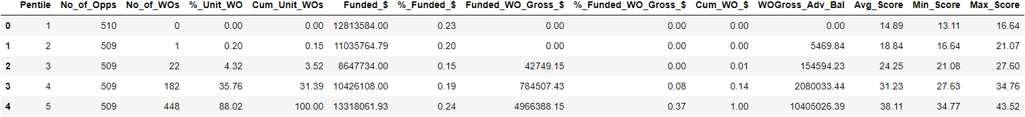

Before calibration test set (split):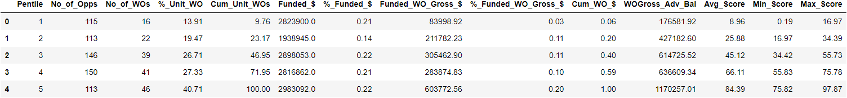

After calibration test set (split):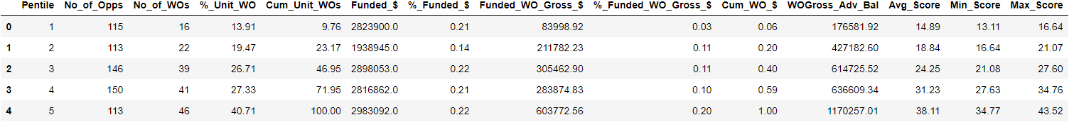

Before calibration Val set (unseen):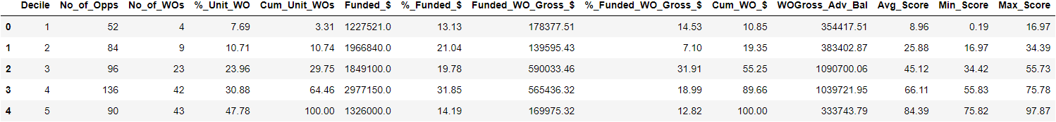

After calibration val set (unseen):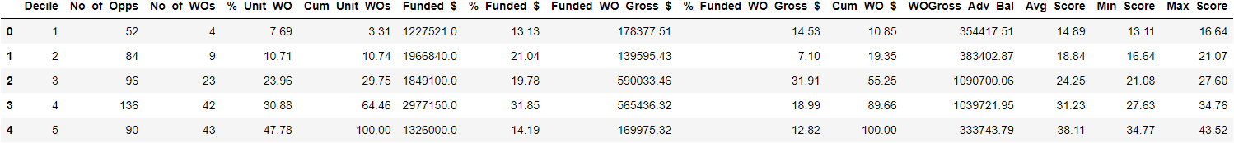

Pentile Figures:

Train:

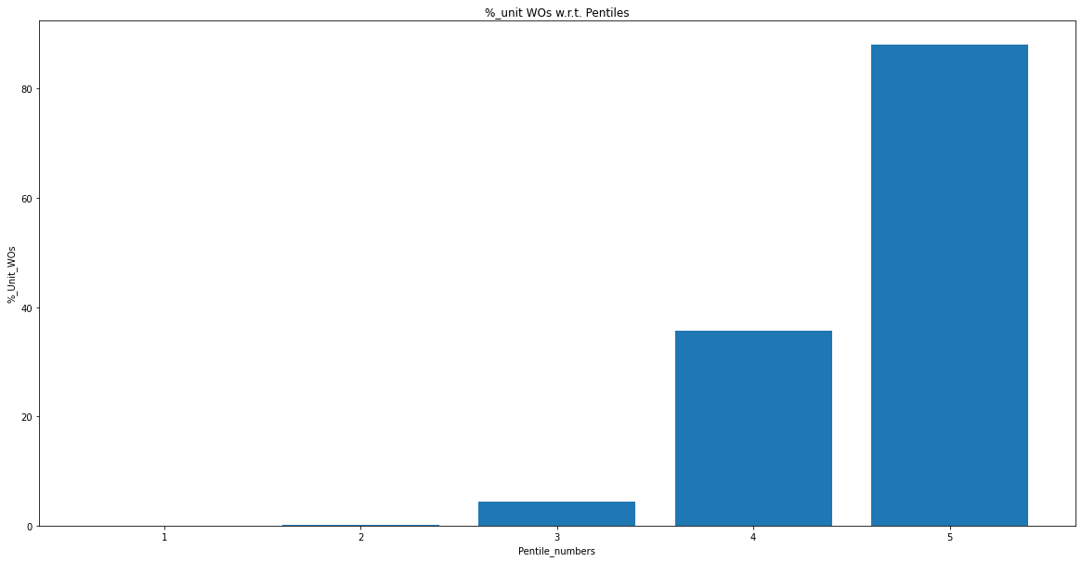

Val:

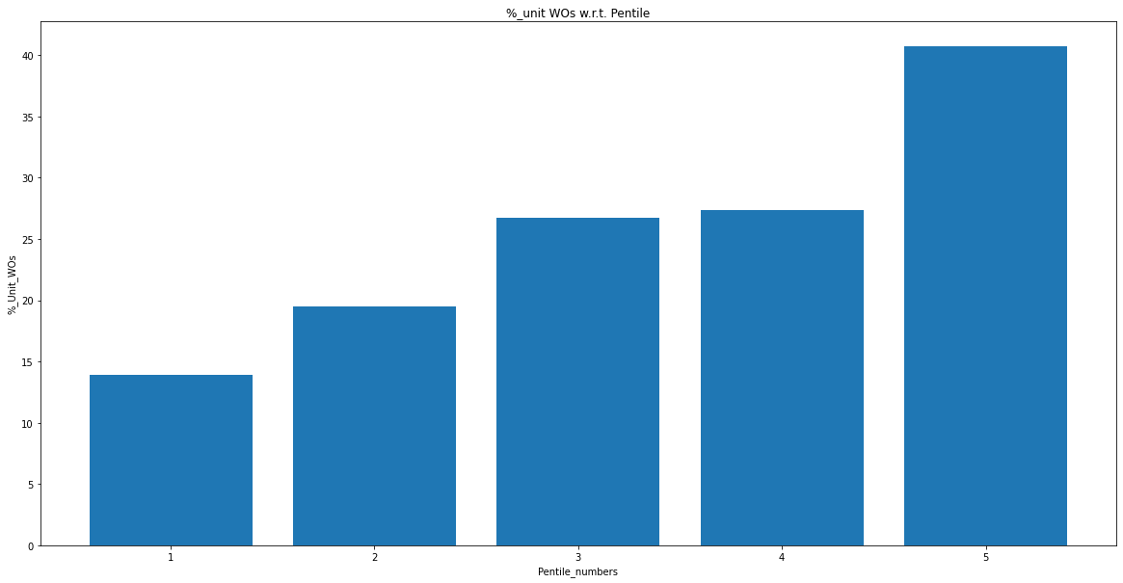

Test: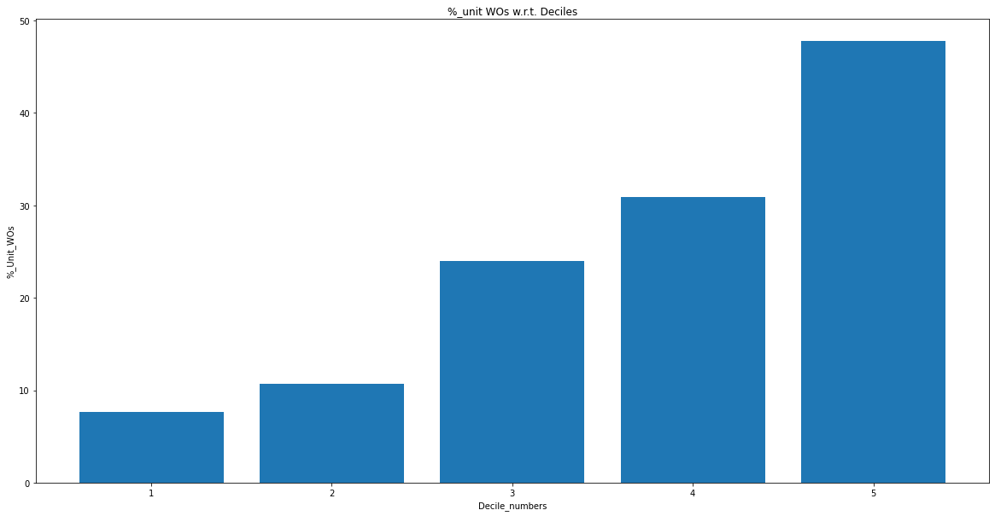

New model (after calibration) - Increasing n_estimators (Date - 02/12/2022)

Best 50 features - Same as above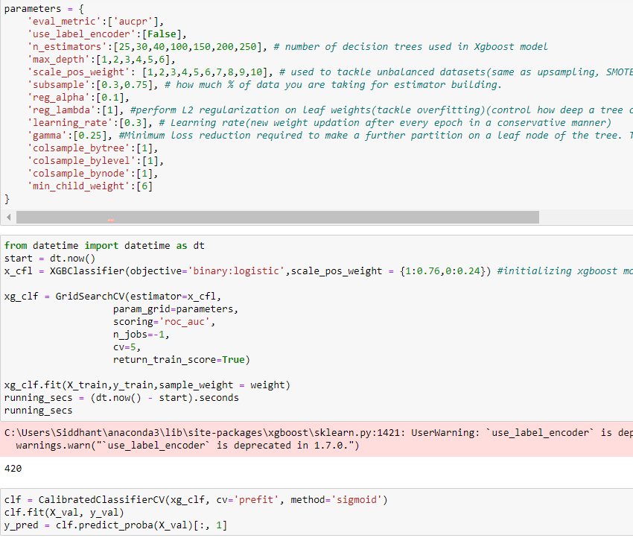

Deciles:

Train set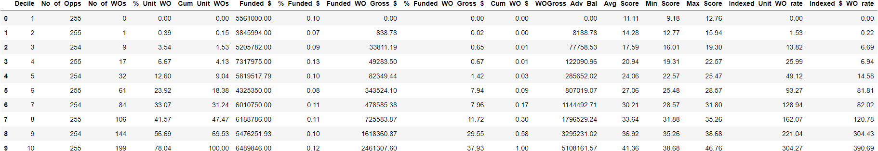

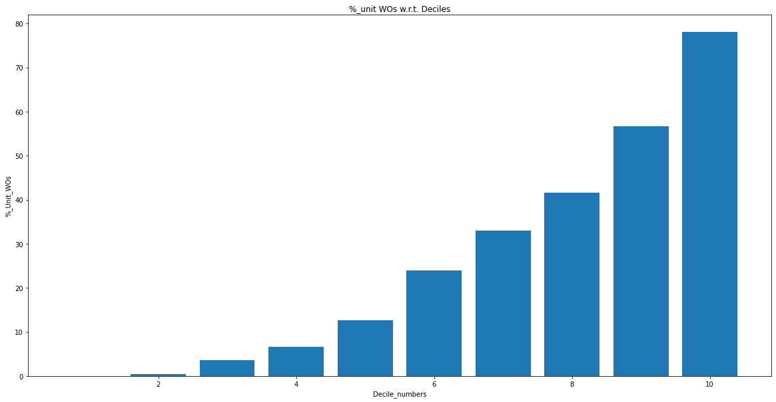

Test set (split)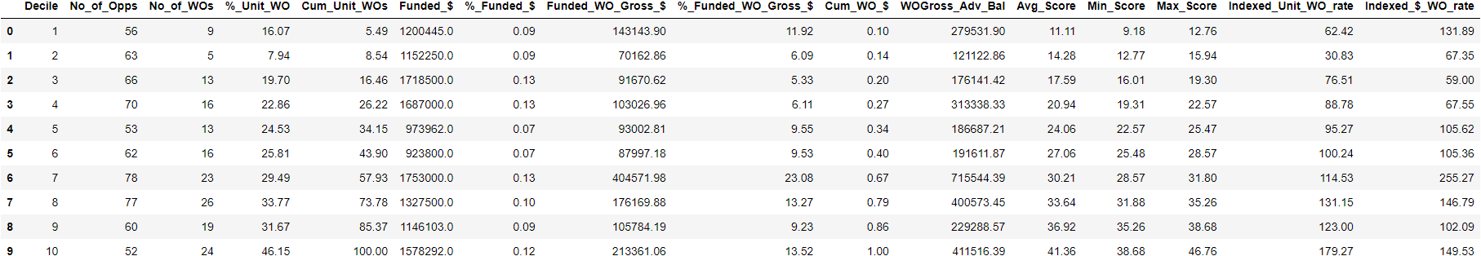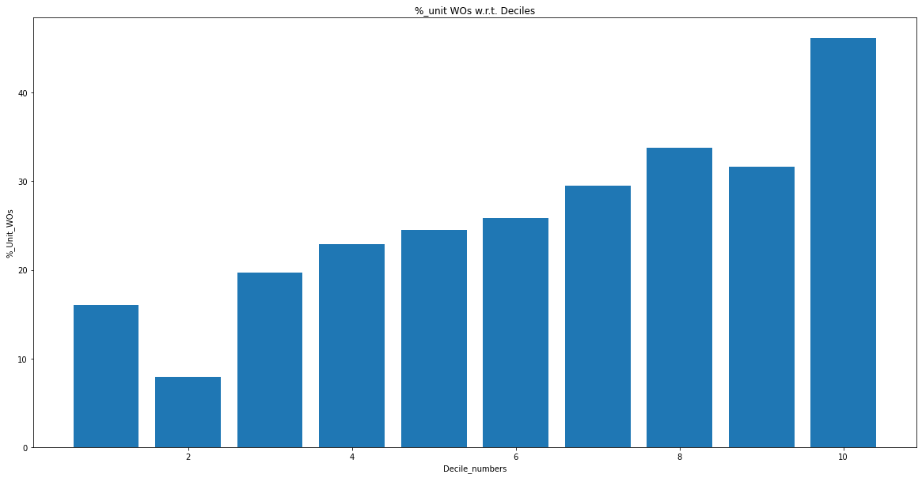

Val set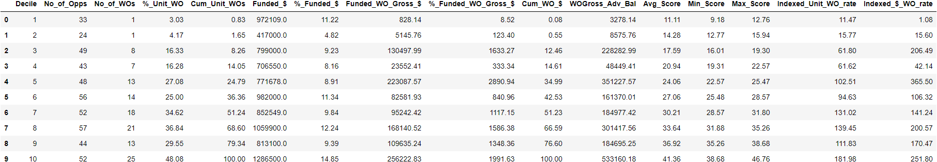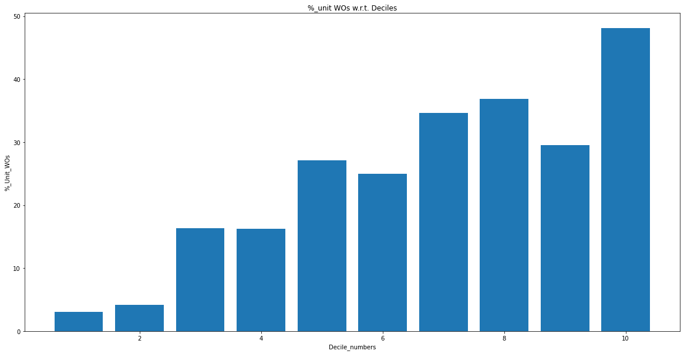

Pentiles:

Train set

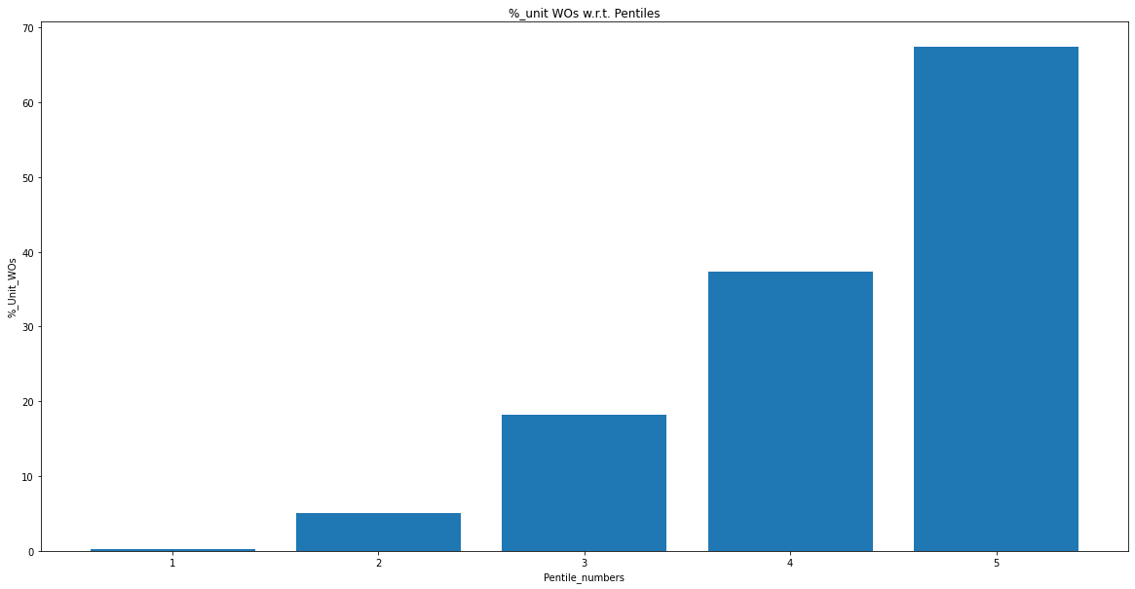

Test set(split):

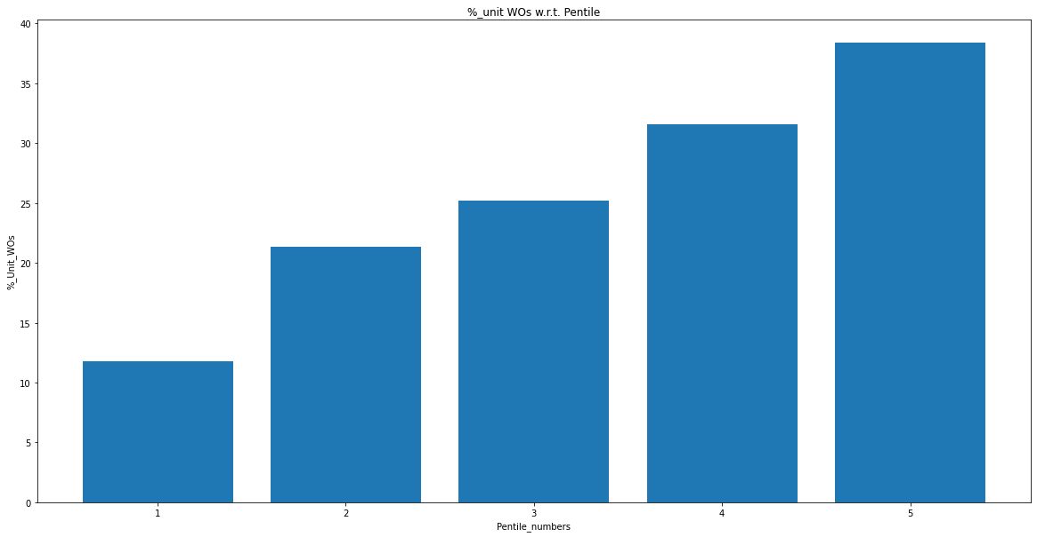

Val set:

