**Hyperparameter Tuning for Renewal+CBC**

| **Params** | **A_Tr** | **P_Tr** | **R_Tr** | **f1_Tr** | **A_Val** | **P_Val** | **R_Val** | **f1_Val** | **Min_Max** |
| --- | --- | --- | --- | --- | --- | --- | --- | --- | --- |
| L1 - 0.1  L2 - 1  lr - 0.3  (68 attributes - all) | 0.96 | 0.85 | 0.99 | 0.92 | 0.65 | 0.28 | 0.32 | 0.30 | 0.32-98.69 |
| L1 - 0  L2 - 1  lr - 0.3  (all attributes) | 0.89 | 0.70 | 0.94 | 0.80 | 0.64 | 0.29 | 0.38 | 0.33 | 0.95-95.91 |
| L1 - 0.2  L2 - 1  lr - 0.3  (all attributes) | 0.98 | 0.96 | 0.95 | 0.96 | 0.69 | 0.28 | 0.19 | 0.23 | 0.13-98.94 |
| L1 - 0.2  L2 - 0  lr - 0.3  (all attributes) | 0.97 | 0.95 | 0.95 | 0.95 | 0.69 | 0.28 | 0.20 | 0.24 | 0.09-98.13 |
| L1 - 0.2  L2 - 0  lr - 0.3  (50 attributes) | 0.90 | 0.71 | 0.92 | 0.82 | 0.61 | 0.27 | 0.42 | 0.33 | 0.38-98.15 |
| L1 - 0.1  L2 - 0  lr - 0.3  (50 attributes) | 0.96 | 0.86 | 0.99 | 0.92 | 0.65 | 0.27 | 0.29 | 0.28 | 0.25 - 98.80 |
| L1 - 0.1  L2 - 1  lr - 0.3  (50 attributes) | 0.94 | 0.79 | 0.99 | 0.88 | 0.62 | 0.27 | 0.37 | 0.31 | 0.16-99.27 |
| L1 - 0.2  L2 - 1  lr - 0.3  (50 attributes) | 0.93 | 0.78 | 0.98 | 0.87 | 0.65 | 0.28 | 0.30 | 0.29 | 0.25-98.14 |
| L1 - 0.2  L2 - 1  lr - 0.3  (20 attributes) | 0.60 | 0.37 | 0.99 | 0.53 | 0.46 | 0.25 | 0.65 | 0.36 | 0.52-95.62 |
| L1 - 0.1  L2 - 1  lr - 0.3  (20 attributes) | 0.72 | 0.45 | 0.99 | 0.63 | 0.52 | 0.26 | 0.57 | 0.36 | 0.89-97.81 |
| L1 - 0.1  L2 - 0  lr - 0.3  (20 attributes) | 0.90 | 0.82 | 0.75 | 0.78 | 0.73 | 0.39 | 0.28 | 0.33 | 1.09-95.38 |
| L1 - 0.2  L2 - 0  lr - 0.3  (20 attributes) | 0.84 | 0.60 | 0.88 | 0.72 | 0.63 | 0.30 | 0.42 | 0.35 | 0.61-95.59 |

**l1 = 0.1, l2 = 1, lr = 0.3(all attributes)**

**Training decile**

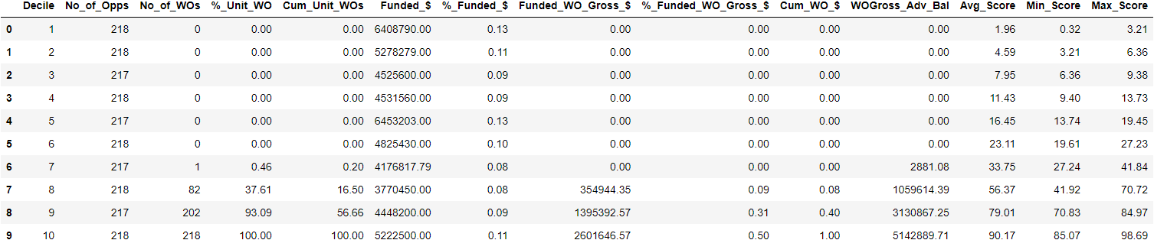

**Validation decile**

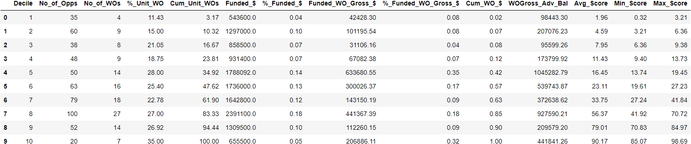

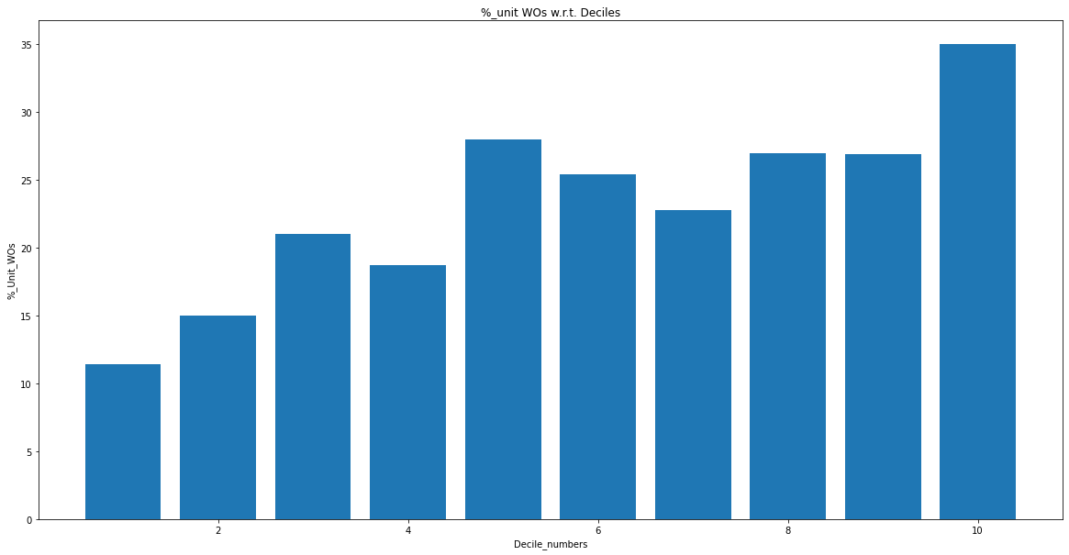

**L1 = 0, l2 = 1, lr = 0.3(all attributes)**

**Train set**

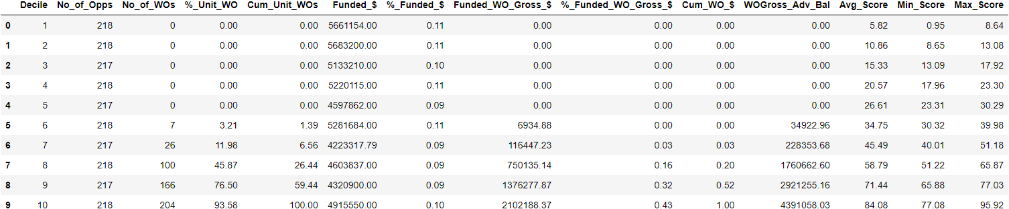

**Val set**

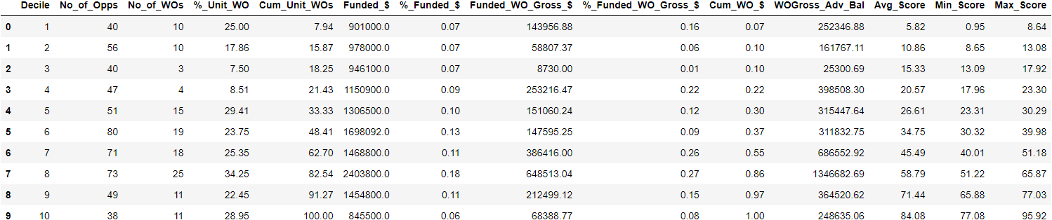

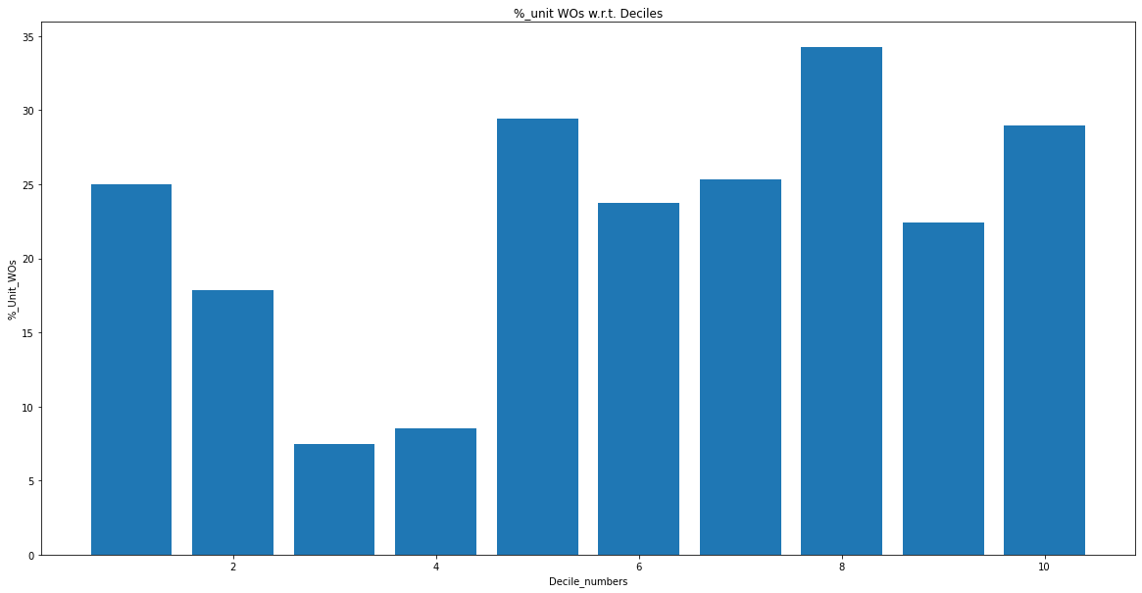

**L1 = 0.2, l2 = 1, lr = 0.3(all attributes)**

**Train set**

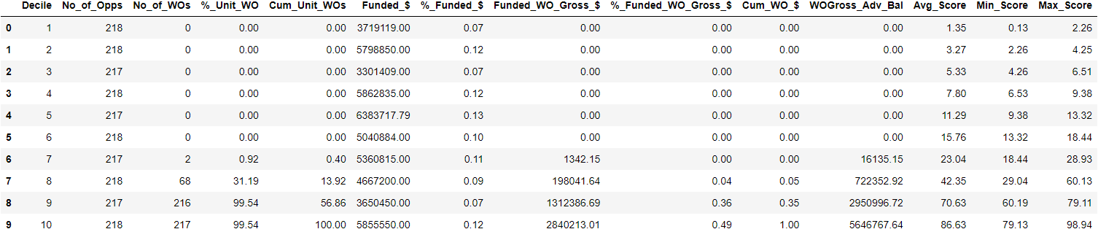

**Val set**

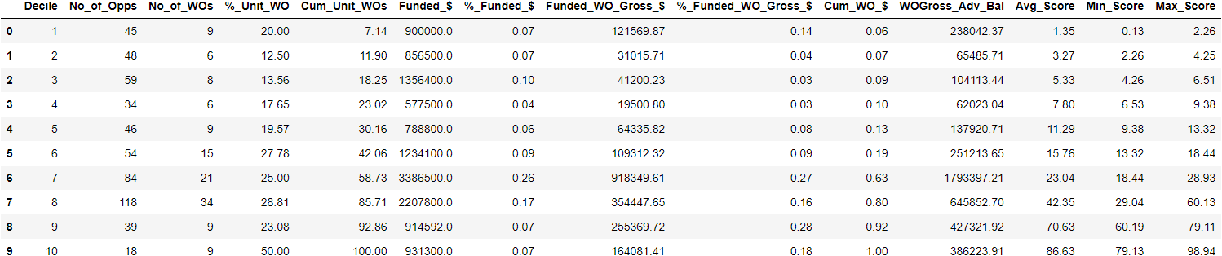

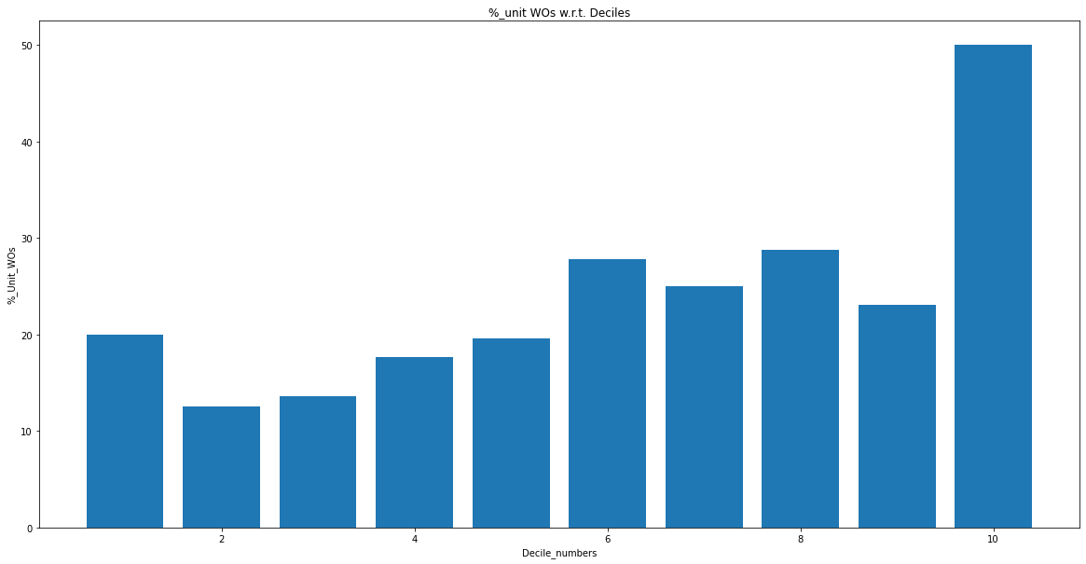

**L1 = 0.2, l2 = 0, lr = 0.3(all attributes)**

**Train set**

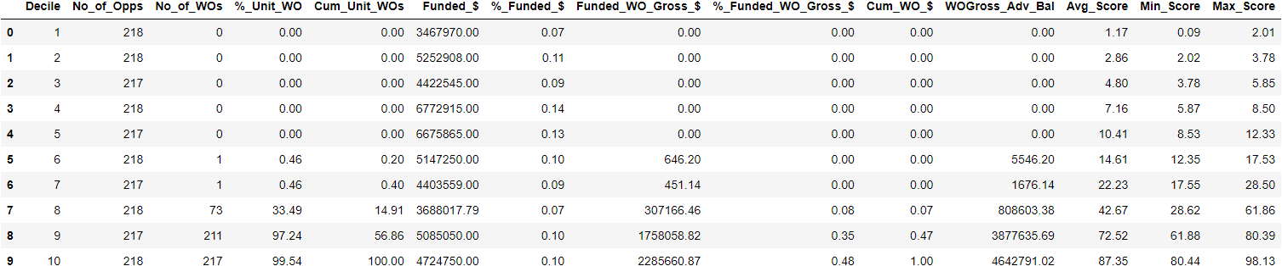

**Val set**

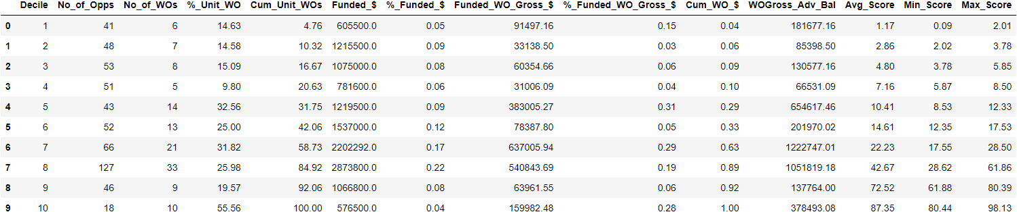

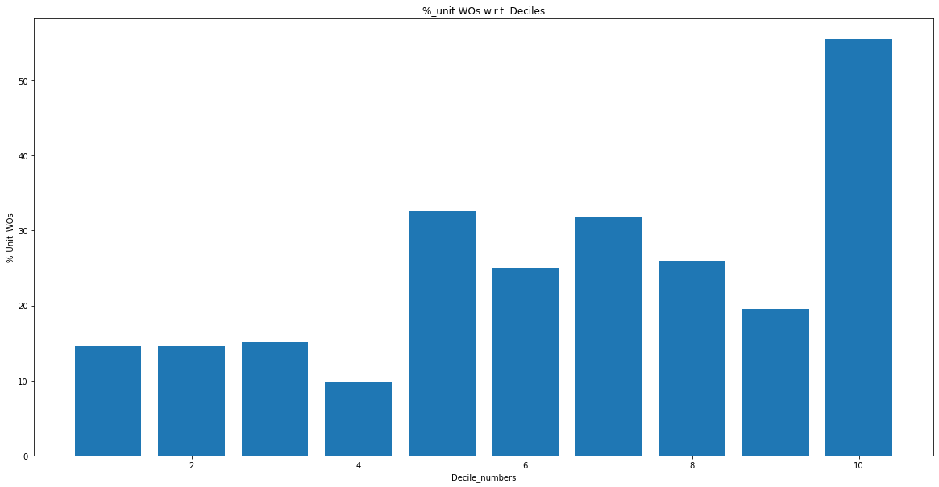

**L1 = 0.2, l2 = 0, lr = 0.3 (50 best features)**

**Train set**

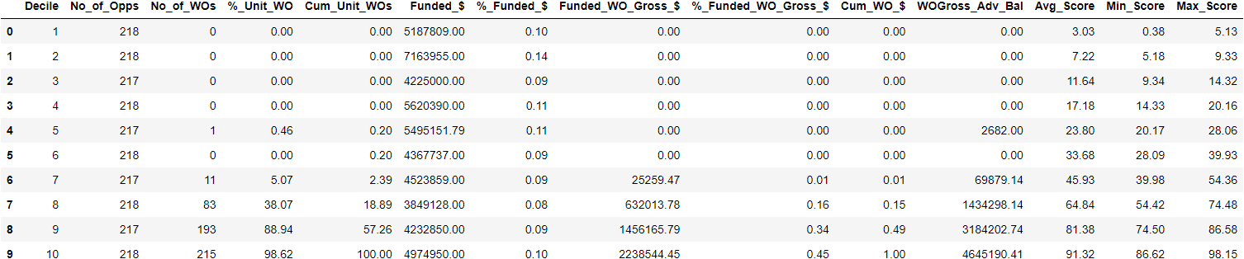

**Val set**

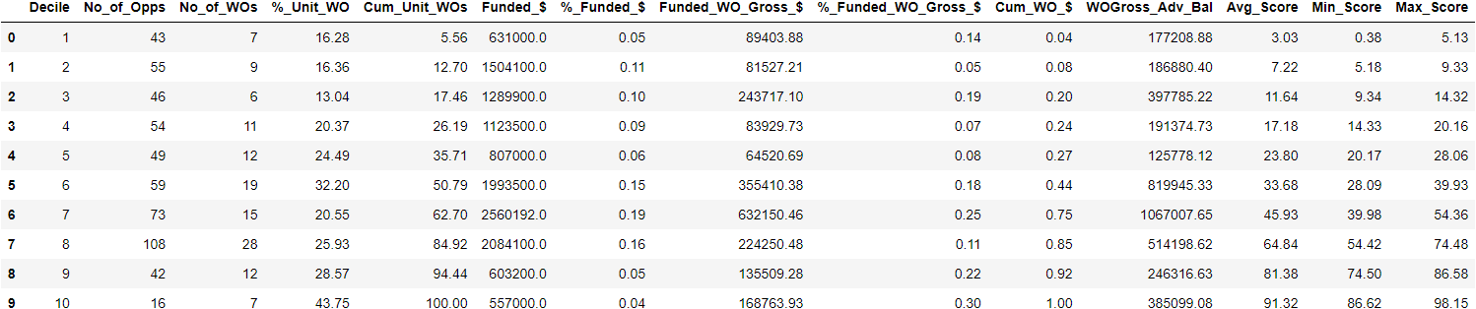

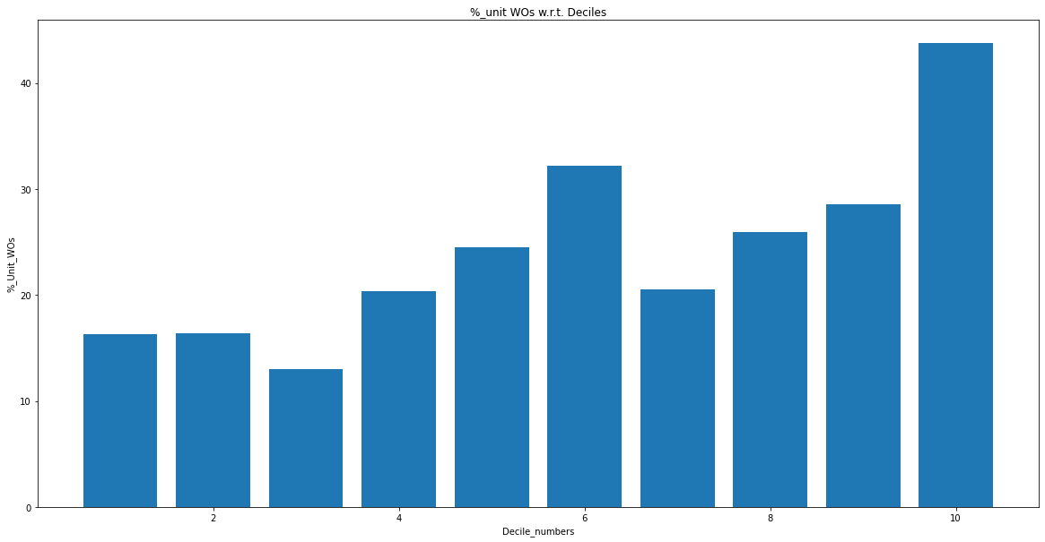

**L1 = 0.1, l2 = 0, lr - 0.3 (50 features)**

**Train set**

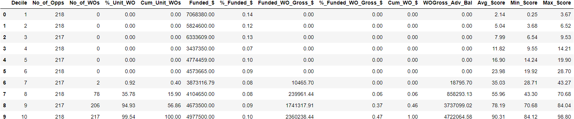

**Val set**

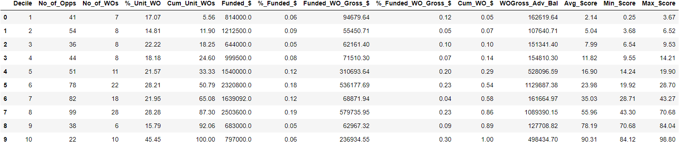

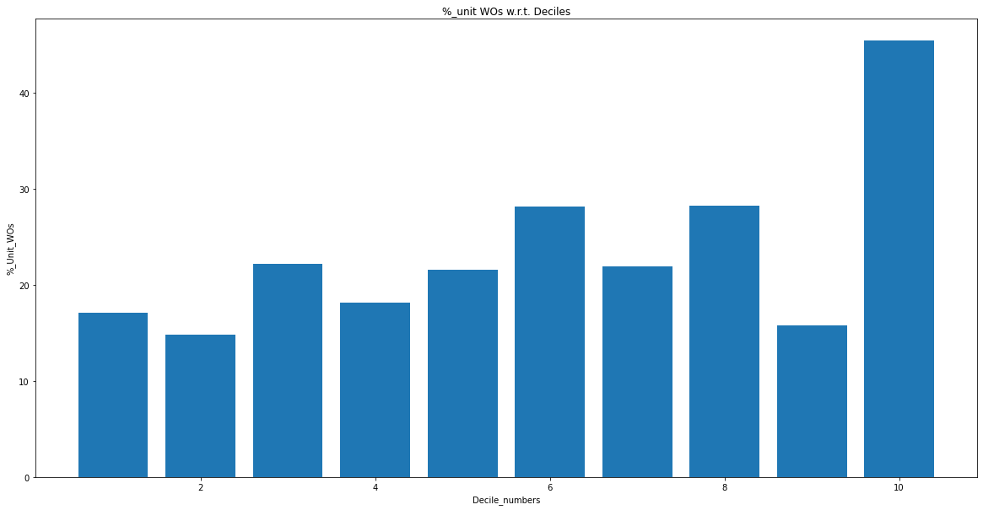

**L1 = 0.1 , l2 = 1, lr = 0.3 (50 features)**

**Train set**

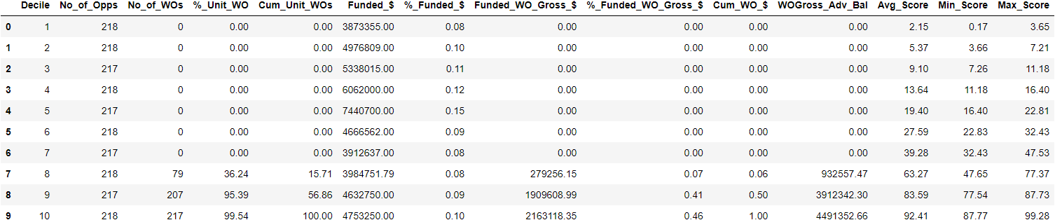

**Val set**

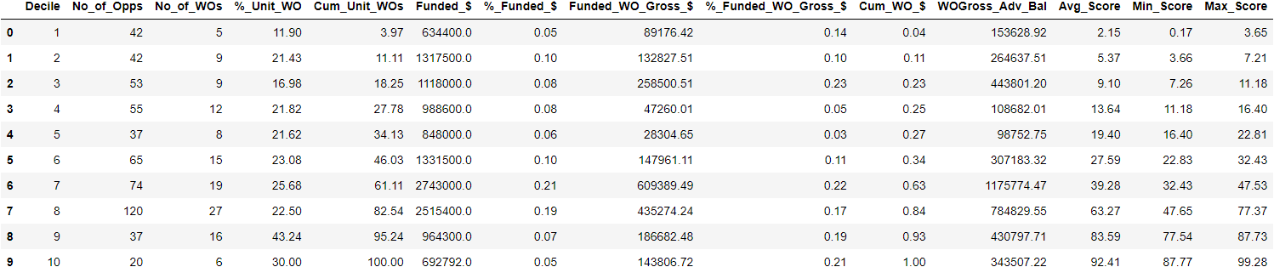

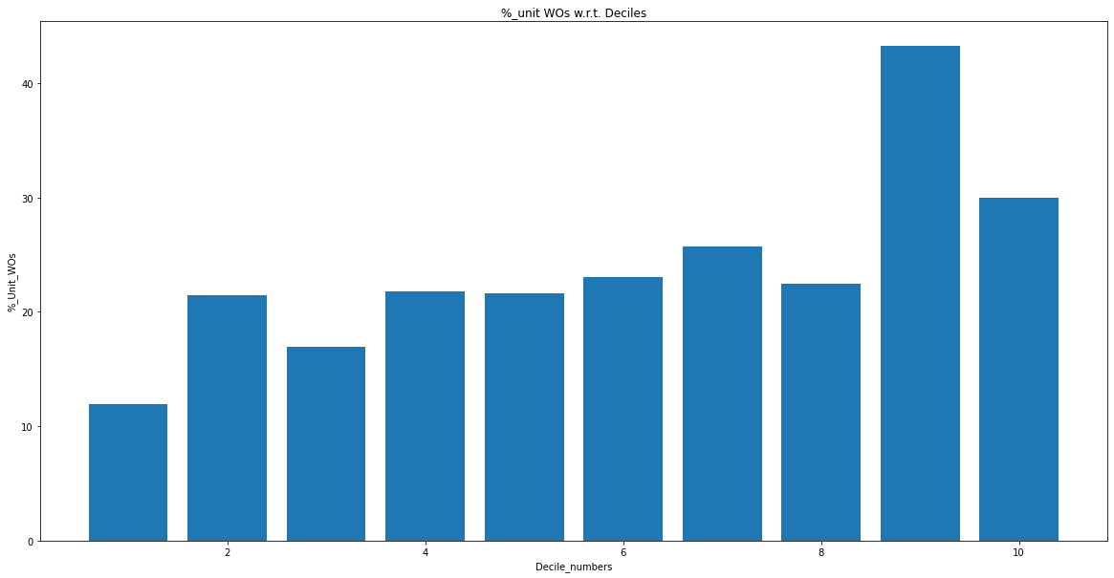

**L1 = 0.2 , l2 = 1, lr = 0.3(50 features)**

**Train set**

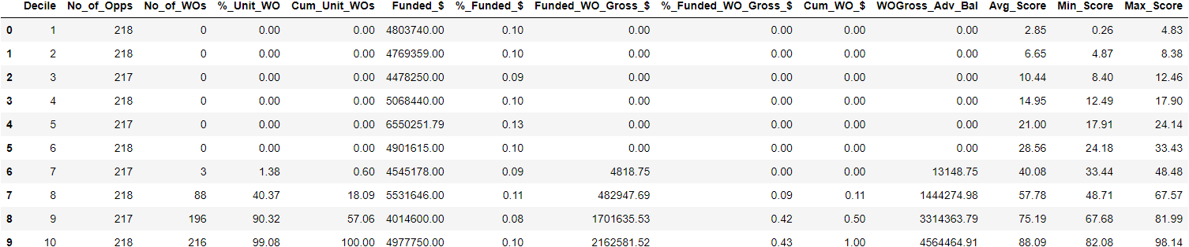

**Val set**

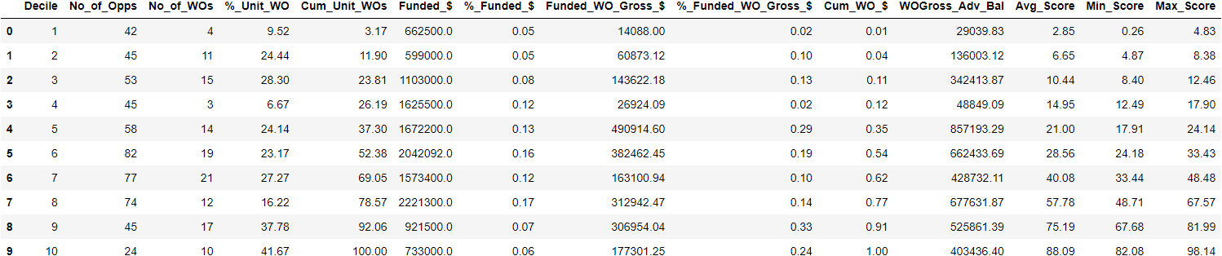

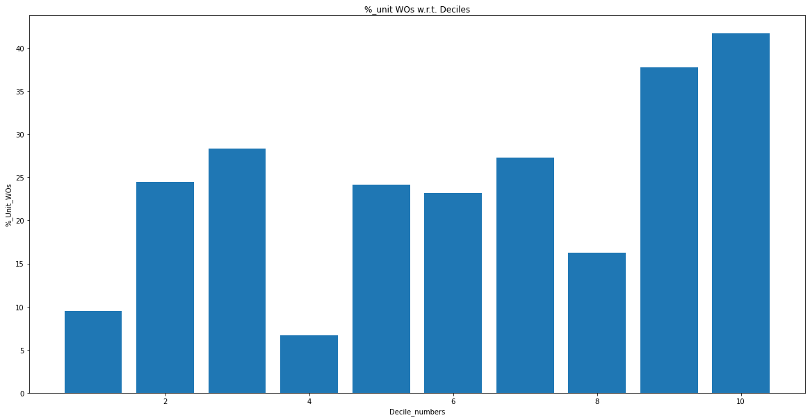

**L1 = 0.2 , l2 = 1, lr = 0.3(20 features)**

**Train set**

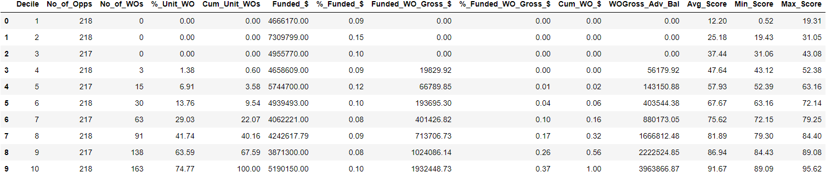

**Val set**

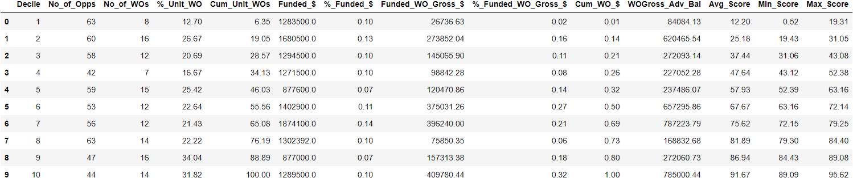

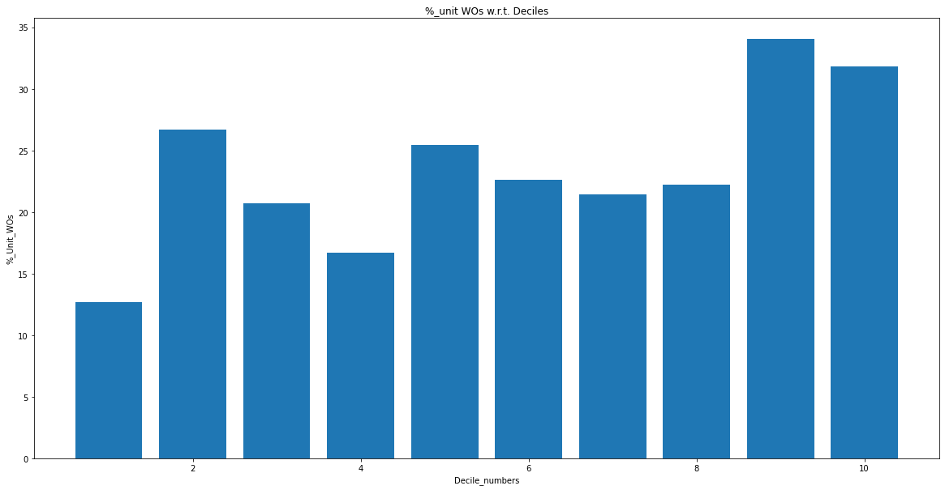

**L1 = 0.1, l2 =1 , lr = 0.3 (20 features)**

**Train set**

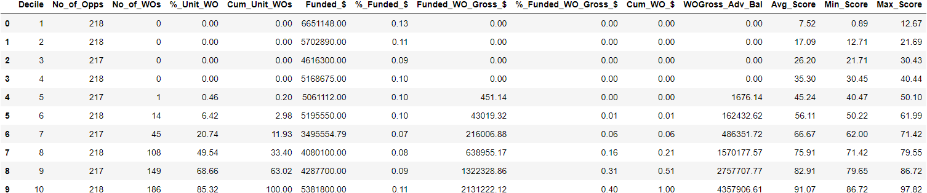

**Val set**

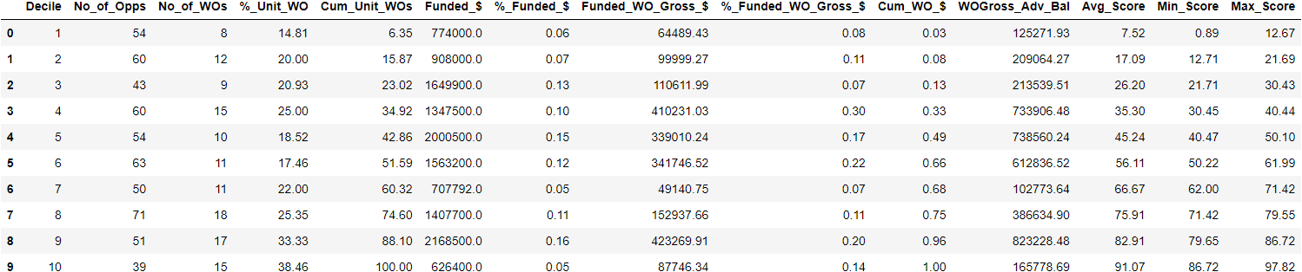

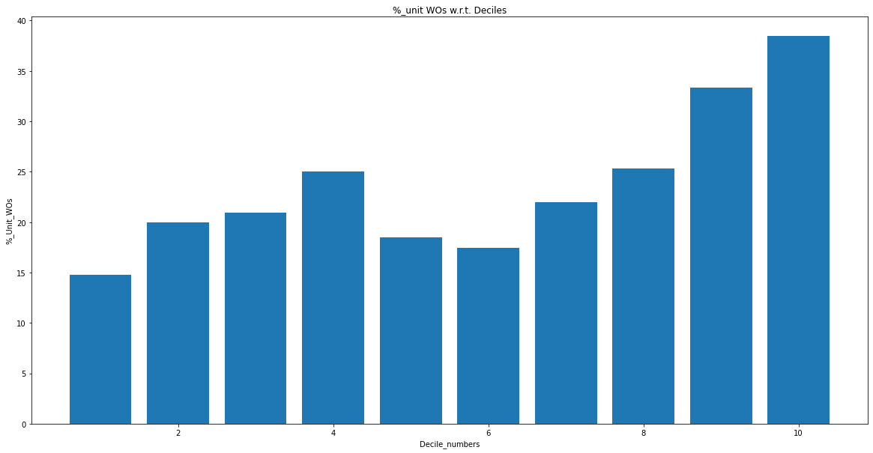

**L1 = 0.1, l2 = 0, lr = 0.3(20 features)**

**Train set**

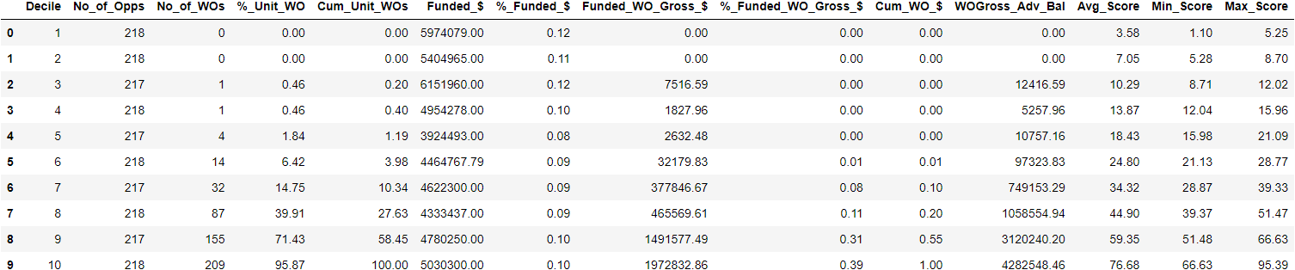

**Val set**

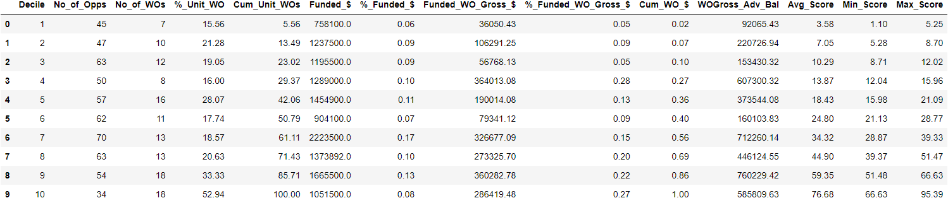

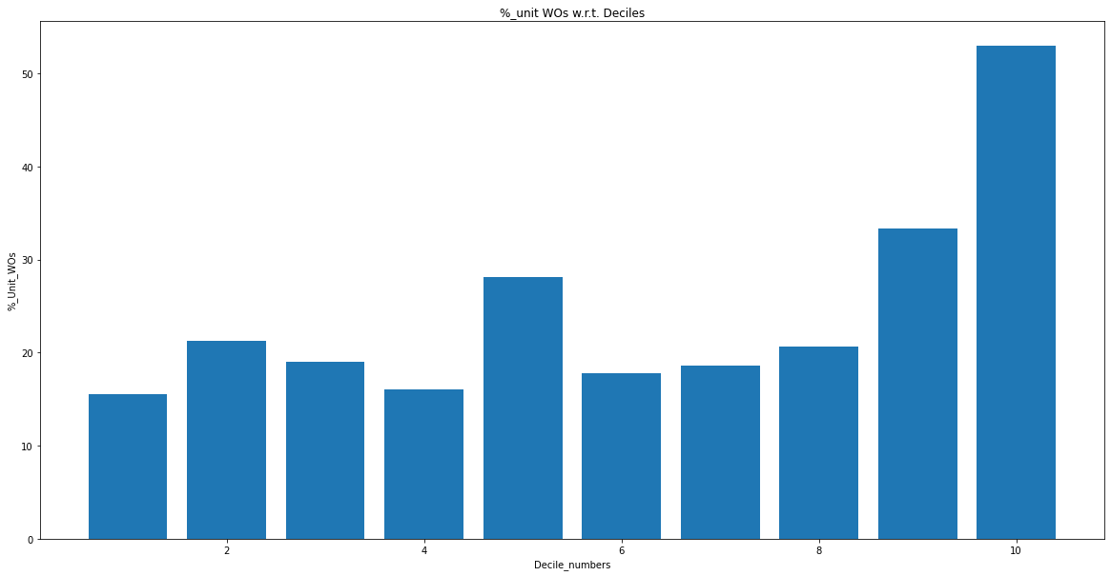

**L1 = 0.2, l2 = 0, lr = 0.3 (20 features)**

**Train set**

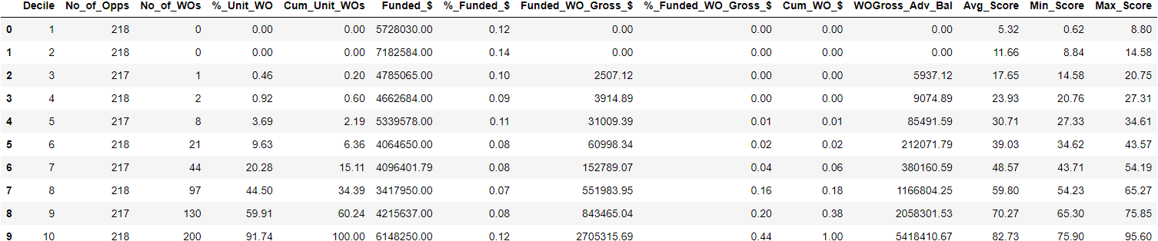

**Val set**

