**Hyperparameter Tuning for Renewal + LexisNexis+CBC**

| **Params** | **A_Tr** | **P_Tr** | **R_Tr** | **f1_Tr** | **A_Val** | **P_Val** | **R_Val** | **f1_Val** | **Min_Max** |
| --- | --- | --- | --- | --- | --- | --- | --- | --- | --- |
| L1 - 0  L2 - 1  lr - 0.3  (666 attributes - all) | 0.85 | 0.59 | 1.00 | 0.74 | 0.59 | 0.28 | 0.55 | 0.37 | 0.01-98.9 |
| L1 - 0.1  L2 - 1  lr - 0.3  (all attributes) | 0.80 | 0.53 | 0.99 | 0.69 | 0.56 | 0.28 | 0.61 | 0.38 | 0.4-98.67 |
| L1 - 0.2  L2 - 1  lr - 0.3  (all attributes) | 0.95 | 0.83 | 1 | 0.91 | 0.69 | 0.34 | 0.37 | 0.36 | 0.1-99.03 |
| L1 - 0.5  L2 - 1  lr - 0.3  (all attributes) | 0.95 | 0.84 | 1 | 0.91 | 0.65 | 0.27 | 0.33 | 0.30 | 0.09-99.16 |
| L1 - 0.1  L2 - 2  lr - 0.3  (all attributes) | 0.97 | 0.91 | 1 | 0.95 | 0.69 | 0.34 | 0.40 | 0.37 | 0.06-99.02 |
| L1 - 0.1  L2 - 1  lr - 0.3  (50 best features) | 0.80 | 0.53 | 0.99 | 0.69 | 0.58 | 0.28 | 0.56 | 0.37 | 0.61-97.49 |
| L1 - 0.2  L2 - 1  lr - 0.3  (50 best features)  (decent model) | 0.96 | 0.88 | 1 | 0.93 | 0.72 | 0.39 | 0.45 | 0.42 | 0.1 - 99.04 |
| L1 - 0  L2 - 1  lr - 0.3  (50 features) | 0.84 | 0.58 | 1 | 0.73 | 0.61 | 0.31 | 0.61 | 0.41 | 0.14-99.34 |
| L1 - 1  L2 - 1  lr - 0.3  (50 features) | 0.80 | 0.52 | 1 | 0.69 | 0.61 | 0.32 | 0.64 | 0.42 | 0.21-98.92 |
| L1 - 2  L2 - 1  lr - 0.3  (50 features) | 0.94 | 0.79 | 1 | 0.88 | 0.66 | 0.31 | 0.42 | 0.36 | 0.03-99.41 |
| L1 - 5  L2 - 1  lr - 0.3  (50 features) | 0.88 | 0.67 | 0.94 | 0.78 | 0.66 | 0.30 | 0.39 | 0.34 | 3.02-94.25 |
| L1 - 10  L2 - 1  lr - 0.3  (50 features) | 0.74 | 0.46 | 0.98 | 0.63 | 0.59 | 0.30 | 0.65 | 0.41 | 0 - 94.8 |
| L1 - 20  L2 - 1  lr - 0.3  (50 features) | 0.55 | 0.33 | 0.99 | 0.49 | 0.43 | 0.26 | 0.84 | 0.40 | 3.16-95.79 |
| L1 - 50  L2 - 1  lr - 0.3  (50 features) | 0.67 | 0.39 | 0.91 | 0.55 | 0.58 | 0.31 | 0.72 | 0.44 | 9.90 - 90.80 |
| L1 = 100  L2 = 1  Lr = 0.3  (50 features) | 0.28 | 0.23 | 1 | 0.38 | 0.26 | 0.22 | 0.97 | 0.37 | 27.61-95.20 |
| L1 = 0.2  L2 = 0  Lr = 0.3  (50 features)  (monotonic) | 0.87 | 0.63 | 0.99 | 0.77 | 0.64 | 0.31 | 0.51 | 0.39 | 0.39-98.03 |
| L1 = 0.2  L2 = 0.5  Lr = 0.3  (50 features)  (good scores) | 0.88 | 0.80 | 0.63 | 0.71 | 0.73 | 0.37 | 0.30 | 0.34 | 3.54-89.82 |
| L1 = 0.2  L2 = 2  Lr = 0.3  (50 features) | 0.76 | 0.48 | 1 | 0.65 | 0.56 | 0.28 | 0.62 | 0.39 | 0.63-97.80 |
| L1 =0.5  L2 = 2  Lr = 0.3  (50 features) | 0.85 | 0.59 | 1 | 0.74 | 0.61 | 0.30 | 0.56 | 0.39 | 0.11-98.92 |
| L1 = 0.2  L2 = 3  Lr = 0.3  (50 features)  (decent decile scores) | 0.93 | 0.77 | 1 | 0.87 | 0.68 | 0.35 | 0.51 | 0.41 | 0.14-99.32 |
| L1 = 0.2  L2 = 4  Lr = 0.3  (50 features) | 0.89 | 0.70 | 0.93 | 0.80 | 0.67 | 0.33 | 0.43 | 0.37 | 2.05-95.21 |
| L1 = 0.2  L2 = 5  Lr = 0.3  (50 features)  (early deciles in range) | 0.90 | 0.83 | 0.69 | 0.76 | 0.73 | 0.37 | 0.26 | 0.31 | 2.68-89.39 |
| L1 = 0.2  L2 = 6  Lr = 0.3  (50 features) | 0.74 | 0.46 | 0.99 | 0.63 | 0.58 | 0.30 | 0.66 | 0.41 | 1.75-97.02 |
| L1 = 0.2  L2 = 8  Lr = 0.3  (50 features) | 0.79 | 0.52 | 0.96 | 0.68 | 0.63 | 0.33 | 0.64 | 0.43 | 0.10-99.59 |
| L1 = 0.2  L2 = 10  Lr = 0.3  (50 features) | 0.70 | 0.42 | 1 | 0.60 | 0.53 | 0.28 | 0.74 | 0.41 | 0.95-98.14 |
| L1 = 0.2  L2 = 20  Lr = 0.3  (50 features) | 0.88 | 0.65 | 1 | 0.79 | 0.65 | 0.34 | 0.63 | 0.44 | 0.59-98.47 |
| L1 = 0.2  L2 = 30  Lr = 0.3  (50 features) | 0.72 | 0.43 | 0.70 | 0.53 | 0.63 | 0.32 | 0.60 | 0.42 | 10.96-82.27 |
| L1 = 0.2  L2 = 40  Lr = 0.3  (50 features) | 0.81 | 0.55 | 0.80 | 0.65 | 0.66 | 0.32 | 0.48 | 0.39 | 1.91-93.22 |
| L1 = 0.2  L2 = 50  Lr = 0.3  (50 features) | 0.79 | 0.52 | 0.78 | 0.63 | 0.67 | 0.33 | 0.48 | 0.4 | 3.91-92.29 |
| L1 = 0.2  L2 = 100  Lr = 0.3  (50 features) | 0.56 | 0.33 | 1 | 0.50 | 0.46 | 0.27 | 0.83 | 0.41 | 6.77-95.90 |
| L1 = 0.2  L2 = 0.5  Lr = 0.1  (50 features) | 0.89 | 0.86 | 0.63 | 0.73 | 0.76 | 0.44 | 0.22 | 0.30 | 5.46-80.72 |
| L1 = 0.2  L2 = 0.5  Lr = 0.05  (50 features) | 0.84 | 0.61 | 0.73 | 0.67 | 0.71 | 0.37 | 0.43 | 0.40 | 10.67-80.01 |
| L1 = 0.2  L2 = 0.5  Lr = 0.5  (50 features) | 0.90 | 0.69 | 1 | 0.82 | 0.64 | 0.32 | 0.54 | 0.40 | 0.01-99.83 |
| L1 = 0.2  L2 = 0.5  Lr = 1  (50 features) | 0.74 | 0.46 | 0.97 | 0.62 | 0.60 | 0.31 | 0.63 | 0.41 | 0.00-99.97 |
| L1 = 0.2  L2 = 0.5  Lr = 2  (50 features) | 0.59 | 0.33 | 0.88 | 0.49 | 0.48 | 0.26 | 0.73 | 0.38 | 1.94-97.55 |
| L1 = 0.2  L2 = 0.5  Lr = 3  (50 features) | 0.59 | 0.33 | 0.88 | 0.49 | 0.48 | 0.26 | 0.78 | 0.39 | 0.27-99.60 |
| L1 = 0.2  L2 = 0.5  Lr = 1.5  (50 features) | 0.91 | 0.78 | 0.84 | 0.81 | 0.69 | 0.31 | 0.29 | 0.30 | 0.00 - 100 |
| L1 = 0.2  L2 = 0.5  Lr = 1.2  (50 features) | 0.96 | 0.87 | 0.99 | 0.93 | 0.68 | 0.32 | 0.38 | 0.35 | 0.00 - 100 |
| L1 = 0.2  L2 = 0.5  Lr = 0.8  (50 features) | 0.87 | 0.63 | 0.99 | 0.77 | 0.61 | 0.28 | 0.48 | 0.35 | 0.01 - 99.96 |
| L1 = 0.2  L2 = 0.5  Lr = 0.2  (50 features) | 0.77 | 0.49 | 0.95 | 0.64 | 0.60 | 0.60 | 0.59 | 0.39 | 0.01 - 99.67 |
| L1 = 0.2  L2 = 0  Lr = 0.3  (Top 100 correlated features w.r.t WO) | 0.88 | 0.67 | 0.92 | 0.77 | 0.62 | 0.27 | 0.40 | 0.32 | 0.94-96.22 |
| L1 = 0.2  L2 = 1  Lr = 0.3  (Top 100 correlated features w.r.t WO) | 0.66 | 0.39 | 0.92 | 0.55 | 0.51 | 0.26 | 0.66 | 0.37 | 0.27 - 99.46 |
| L1 = 0.2  L2 = 5  Lr = 0.3  (Top 100 correlated features w.r.t WO) | 0.82 | 0.56 | 0.86 | 0.68 | 0.65 | 0.32 | 0.48 | 0.39 | 4.38-89.86 |
| L1 = 0.2  L2 = 10  Lr = 0.3  (Top 100 correlated features w.r.t WO) | 0.86 | 0.62 | 1 | 0.77 | 0.59 | 0.28 | 0.52 | 0.36 | 0.14-98.76 |
| L1 = 0  L2 = 1  Lr = 0.3  (Top 100 correlated features w.r.t WO) | 0.83 | 0.57 | 0.97 | 0.72 | 0.61 | 0.29 | 0.54 | 0.38 | 1.20 - 96.77 |
| L1 = 0  L2 = 0  Lr = 0.3  (Top 100 correlated features w.r.t WO) | 0.86 | 0.61 | 0.99 | 0.76 | 0.65 | 0.32 | 0.51 | 0.39 | 0.19-98.71 |
| L1 = 0.1  L2 = 0  Lr = 0.3  (top 100 correlated features w.r.t WO)  (monotonic except 4th) | 0.90 | 0.69 | 1 | 0.82 | 0.63 | 0.29 | 0.46 | 0.36 | 0.10-99.23 |
| L1 = 0.1  L2 = 1  Lr = 0.3  (Top 100 correlated features w.r.t WO) | 0.73 | 0.45 | 0.99 | 0.62 | 0.52 | 0.26 | 0.66 | 0.38 | 0.81-97.52 |
| L1 = 0.1  L2 = 0  Lr = 0.3  (Top 100 correlated features w.r.t WO) | 0.65 | 0.38 | 0.92 | 0.54 | 0.49 | 0.25 | 0.67 | 0.37 | 0.87-98.60 |
| L1 = 0.1  L2 = 0  Lr = 0.3  (dropping mutually correlated features) | 0.72 | 0.44 | 1 | 0.61 | 0.52 | 0.27 | 0.71 | 0.40 | 0.27-97.45 |
| L1 = 0  L2 = 1  Lr = 0.3  (dropping mutually correlated features) | 0.80 | 0.53 | 0.96 | 0.68 | 0.60 | 0.29 | 0.55 | 0.38 | 0.04-99.50 |
| L1 = 0.1  L2 = 1  Lr = 0.3  (dropping mutually correlated features) | 0.83 | 0.58 | 0.97 | 0.73 | 0.64 | 0.33 | 0.62 | 0.43 | 1.72-94.47 |
| L1 = 0.2  L2 = 1  Lr = 0.3  (dropping mutually correlated features)  (1st decile good) | 0.85 | 0.62 | 0.81 | 0.71 | 0.65 | 0.30 | 0.42 | 0.35 | 0.28-98.60 |
| L1 = 0.3  L2 = 1  Lr = 0.3  (dropping mutually correlated features) | 0.65 | 0.37 | 0.86 | 0.52 | 0.54 | 0.26 | 0.59 | 0.36 | 0.96-97.46 |
| L1 = 0.5  L2 = 1  Lr = 0.3  (dropping mutually correlated features) | 0.80 | 0.52 | 1 | 0.69 | 0.57 | 0.28 | 0.61 | 0.39 | 0.42-98.66 |
| L1 = 1  L2 = 1  Lr = 0.3  (dropping mutually correlated features)  (Decent deciles) | 0.86 | 0.62 | 0.99 | 0.76 | 0.65 | 0.32 | 0.53 | 0.40 | 0.78-95.14 |
| L1 = 0.8  L2 = 1  Lr = 0.3  (dropping mutually correlated features) | 0.75 | 0.47 | 0.92 | 0.62 | 0.59 | 0.30 | 0.65 | 0.41 | 0.16-99.70 |
| L1 = 1.2  L2 = 1  Lr = 0.3  (dropping mutually correlated features) | 0.91 | 0.71 | 0.98 | 0.83 | 0.67 | 0.33 | 0.47 | 0.38 | 0.53-96.34 |
| L1 = 1.5  L2 = 1  Lr = 0.3  (dropping mutually correlated features) | 0.63 | 0.36 | 0.87 | 0.51 | 0.49 | 0.25 | 0.68 | 0.38 | 1.57-97.13 |
| L1 = 1  L2 = 0  Lr = 0.3  (dropping mutually correlated features) | 0.72 | 0.43 | 0.79 | 0.56 | 0.55 | 0.24 | 0.48 | 0.32 | 1.87-97.11 |
| L1 = 1  L2 = 2  Lr = 0.3  (dropping mutually correlated features) | 0.74 | 0.46 | 1 | 0.63 | 0.55 | 0.29 | 0.69 | 0.41 | 0.78-97.52 |
| L1 = 1  L2 = 3  Lr = 0.3  (dropping mutually correlated features) | 0.75 | 0.47 | 0.95 | 0.63 | 0.56 | 0.29 | 0.67 | 0.41 | 0.38-99.46 |
| L1 = 1  L2 = 5  Lr = 0.3  (dropping mutually correlated features) | 0.73 | 0.45 | 0.97 | 0.62 | 0.59 | 0.31 | 0.67 | 0.42 | 3.03-91.81 |
| L1 = 1  L2 = 10  Lr = 0.3  (dropping mutually correlated features) | 0.84 | 0.68 | 0.54 | 0.60 | 0.73 | 0.36 | 0.26 | 0.30 | 1.03-94.89 |

**l1 = 0.1, l2 = 1, lr = 0.3**

**Training decile**

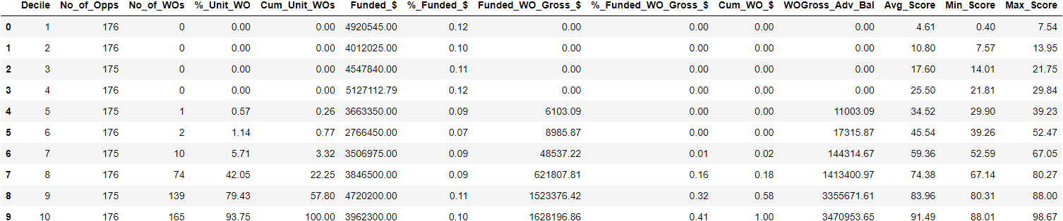

**Validation decile**

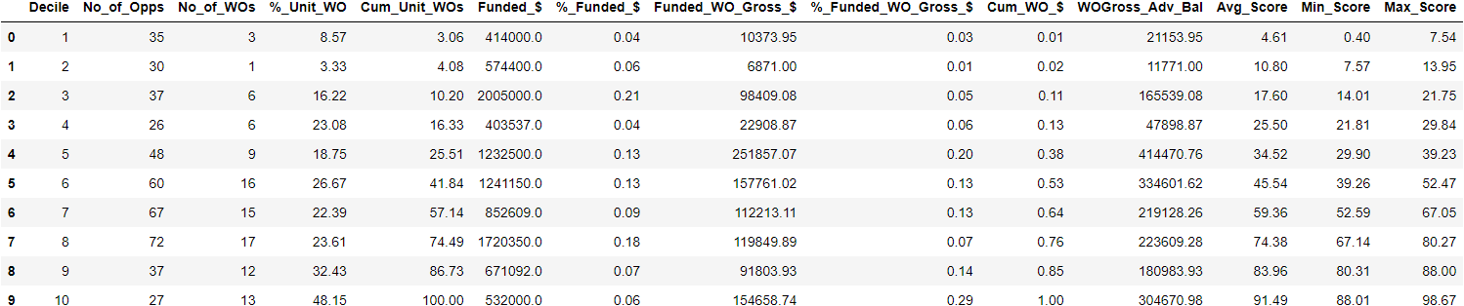

**L1 = 0.2, l2 = 1, lr = 0.3**

**Train set**

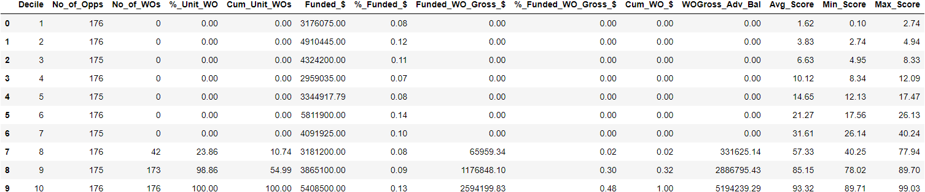

**Val set**

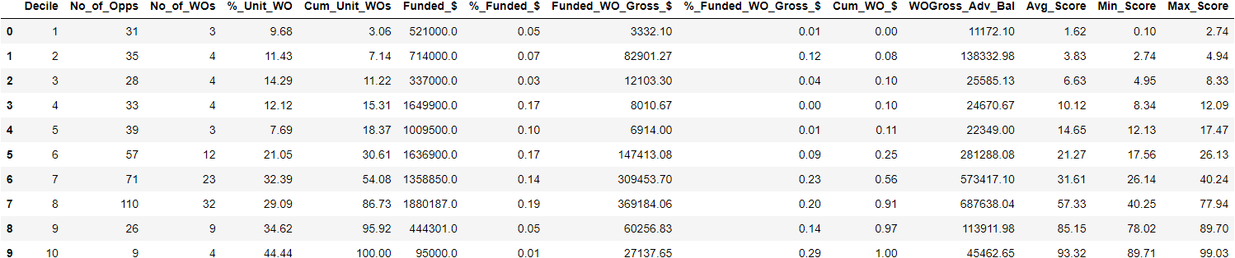

**L1 = 0.5, l2 = 1, lr = 0.3**

**Train set**

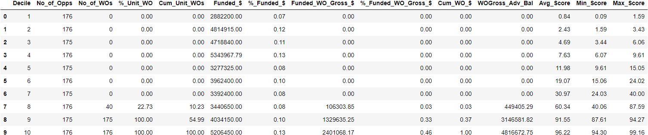

**Val set**

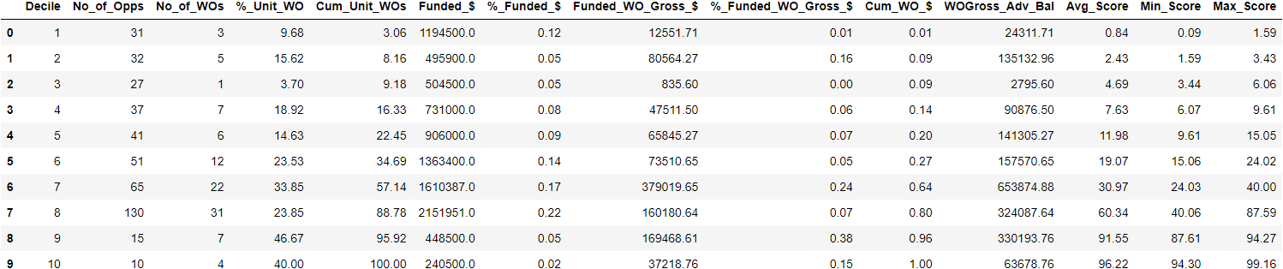

**L1 = 0.1, l2 = 2, lr = 0.3**

**Train set**

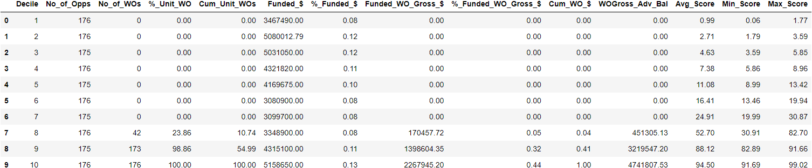

**Val set**

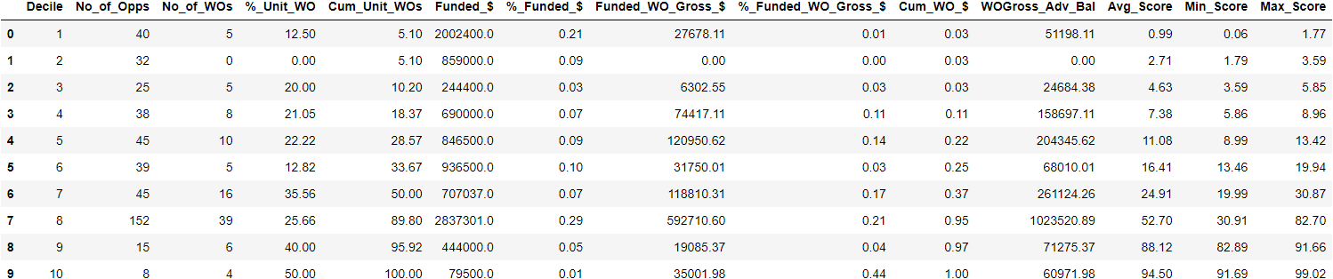

**L1 = 0.1, l2 = 1, lr = 0.3 (50 best features)**

**Train set**

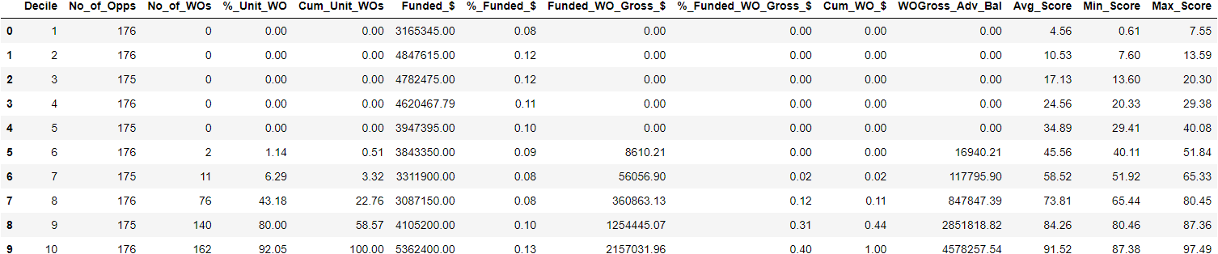

**Val set**

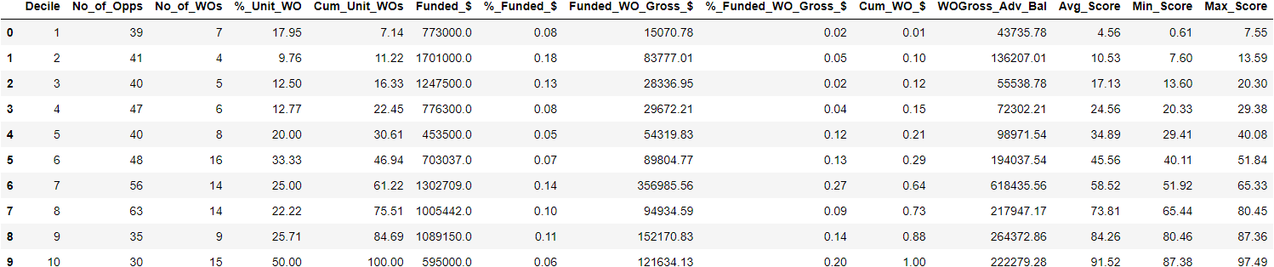

**L1 = 0.2 , l2 = 1, lr = 0.3 (50 best features)**

**Train set**

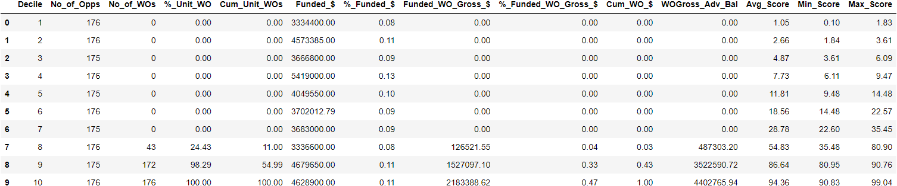

**Val set**

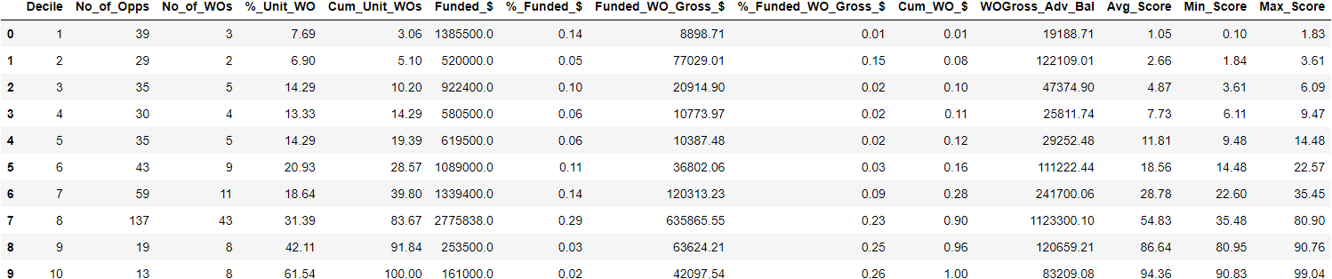

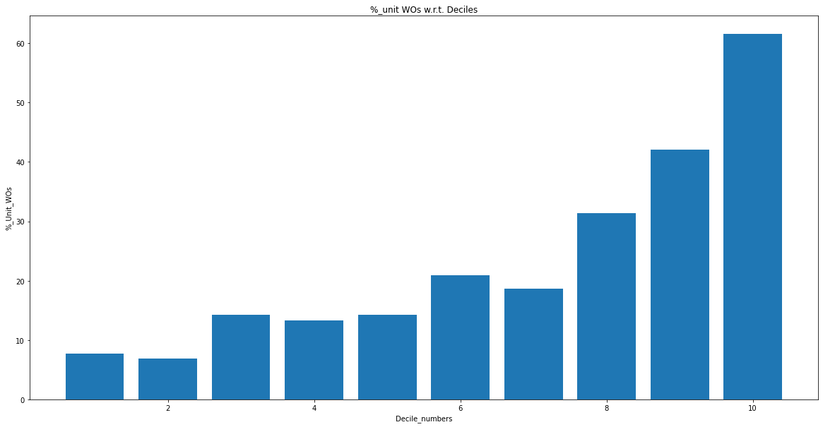

**L1 = 0, l2 = 1, lr = 0.3 (50 best features)**

**Train set**

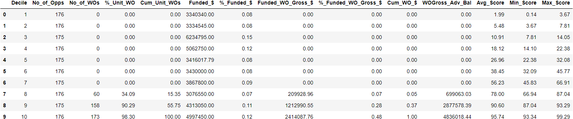

**Val set**

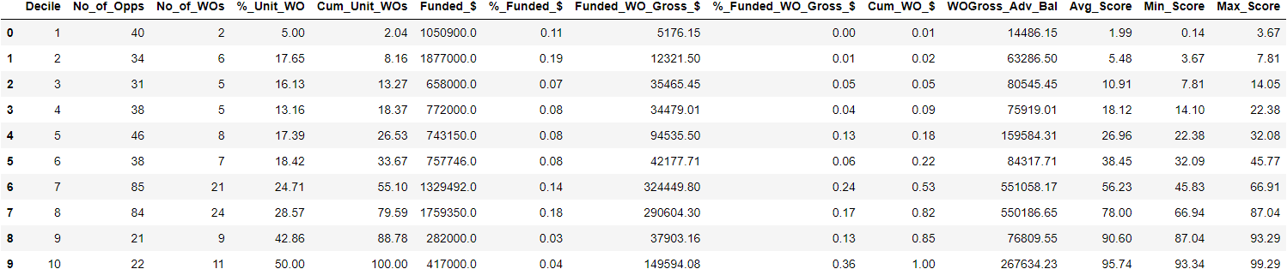

**Observations:**

* In validation set average scores are in decent ranges but % unit WOs are exceeding their boundaries
* The model is showing monotonic nature from the 4th decile onwards
* We cannot change the weights of false negatives in the first 6-7 deciles as the model is overfitting on the training set (Almost all correct predictions)

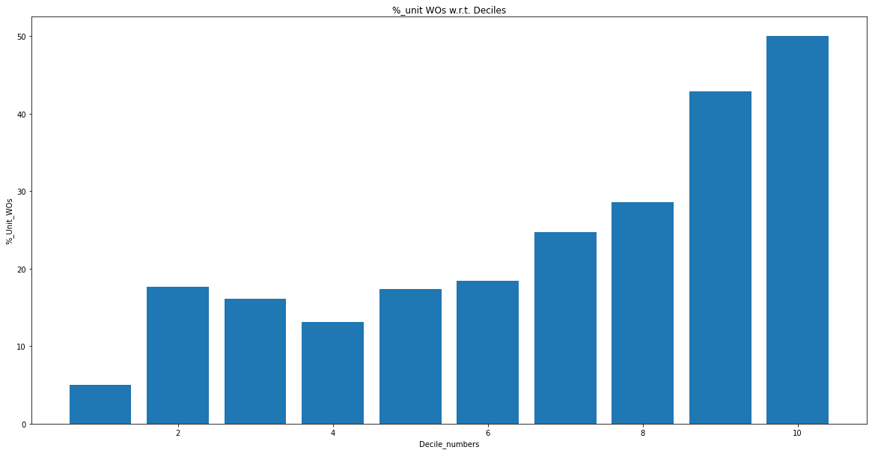

**L1 = 1, l2 = 1, lr = 0.3 (50 best features)**

**Train set**

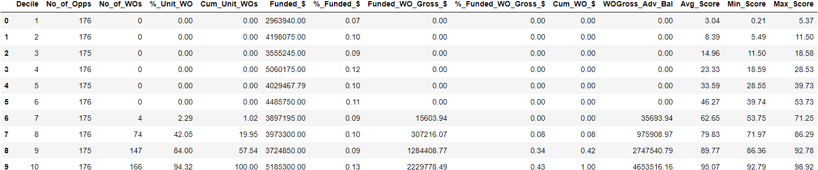

**Val set**

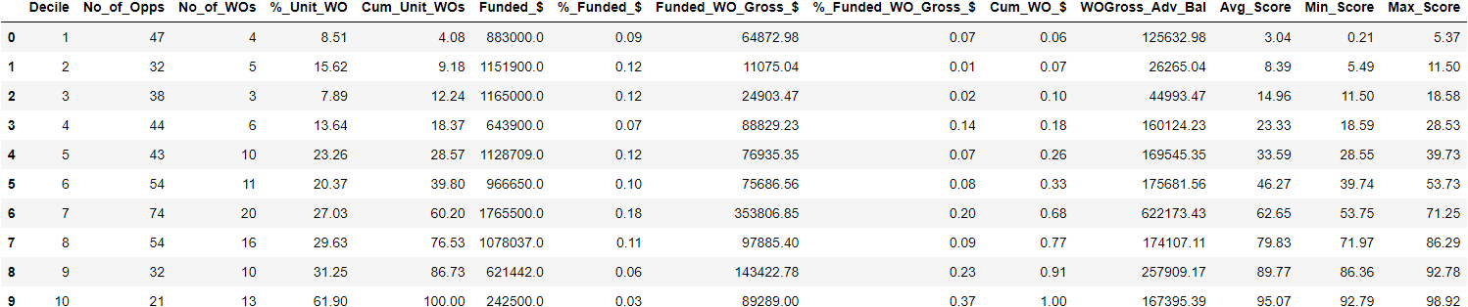

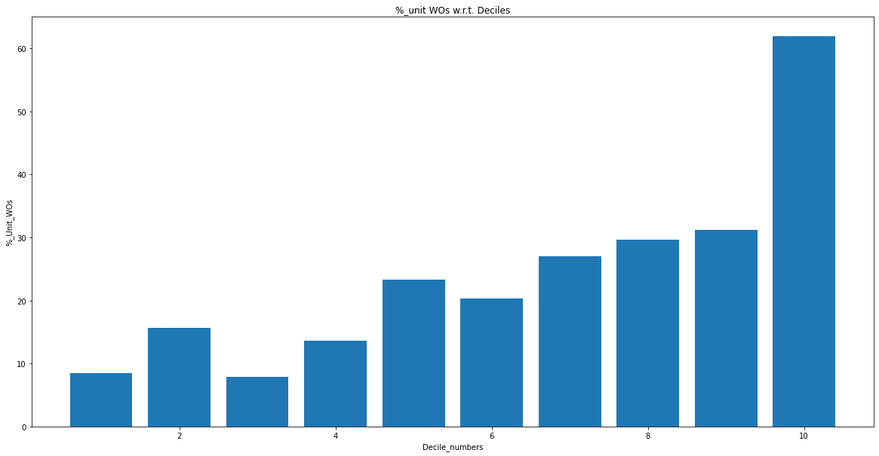

**L1 = 2, l2 =1 , l3 = 0.3 (best 50 features)**

**Train set**

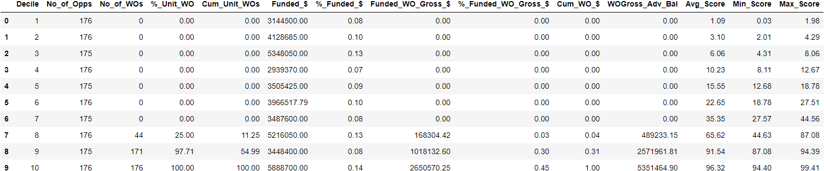

**Val set**

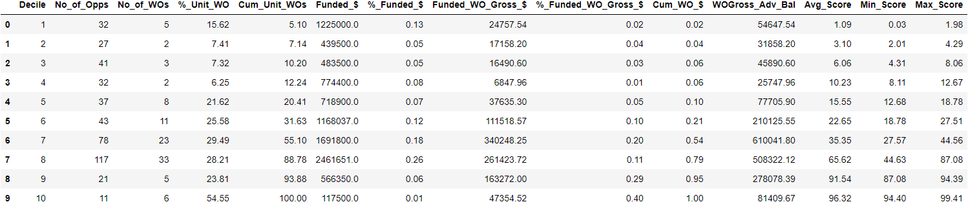

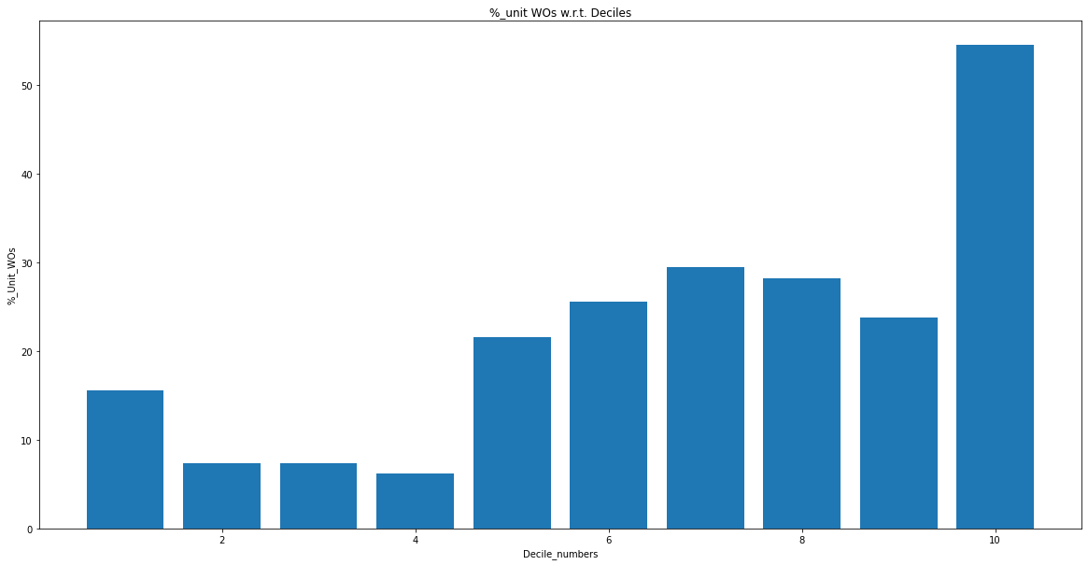

**L1 = 5, l2 = 0.1, lr = 0.3(50 best features)**

**Train set**

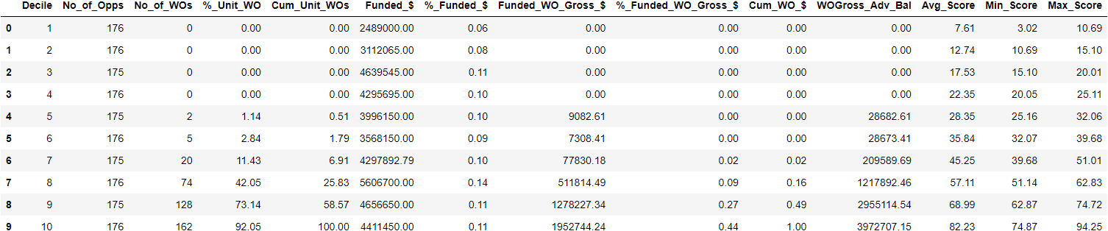

**Val set**

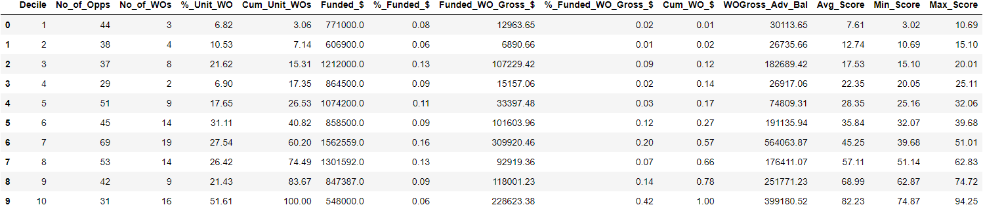

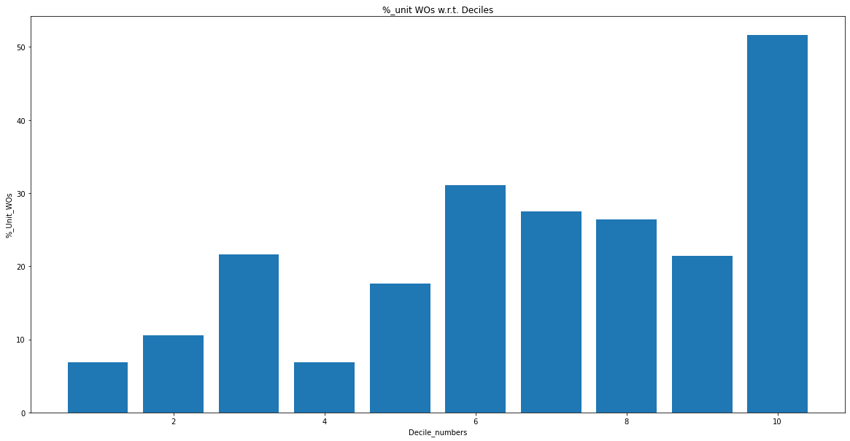

**L1 = 10, l2 =1 ,lr = 0.3 (50 best features)**

**Train set**

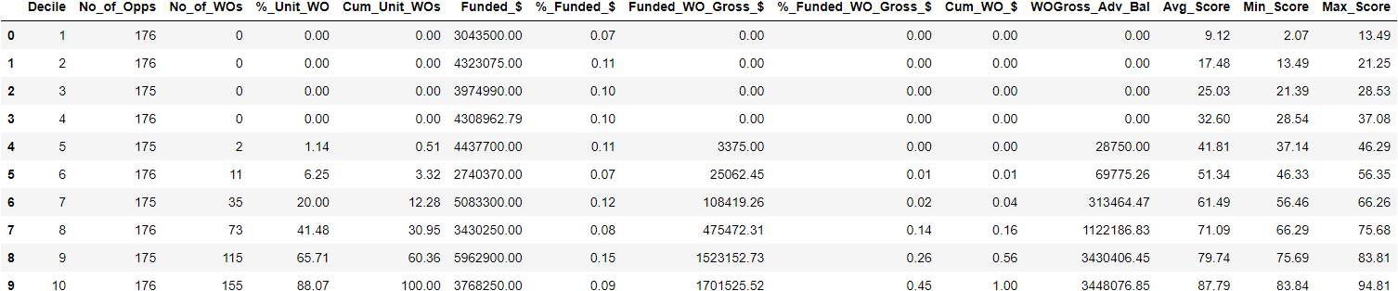

**Val set**

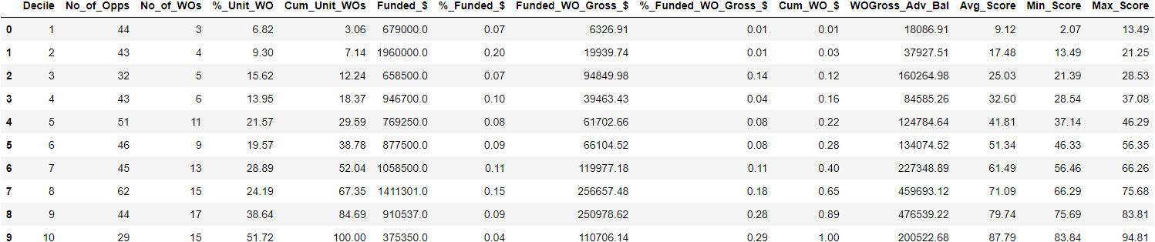

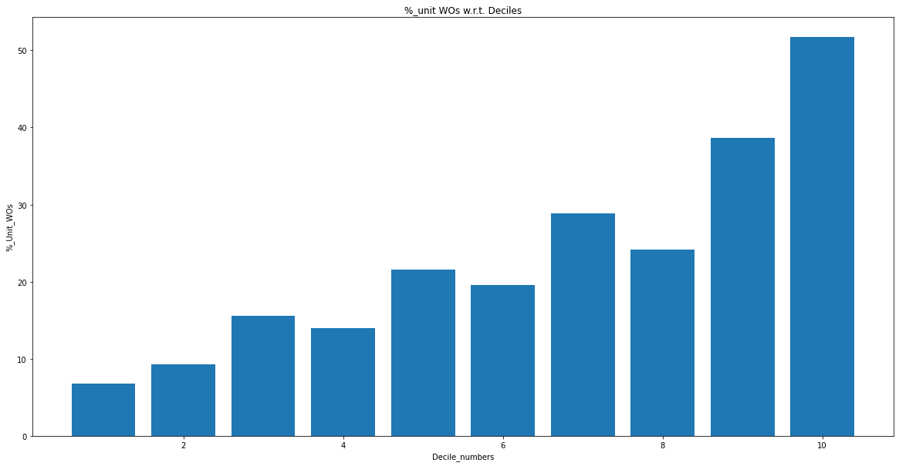

**L1 = 20, l2 =1 , lr = 0.3 (50 best features)**

**Train set**

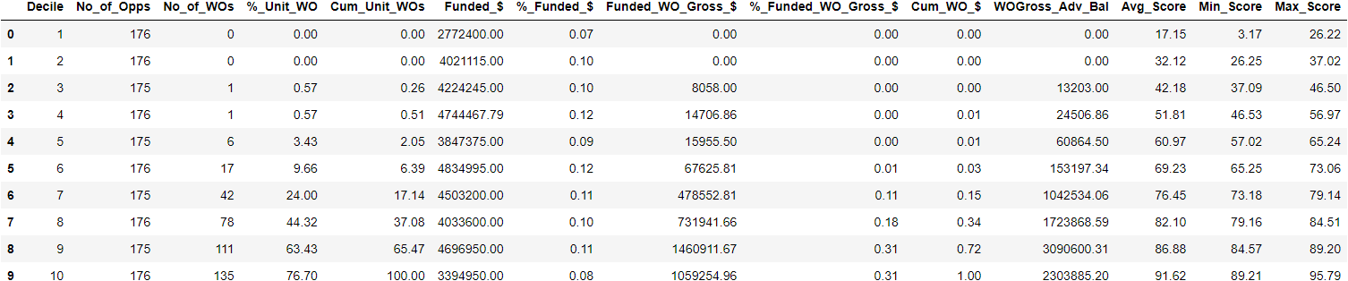

**Val set**

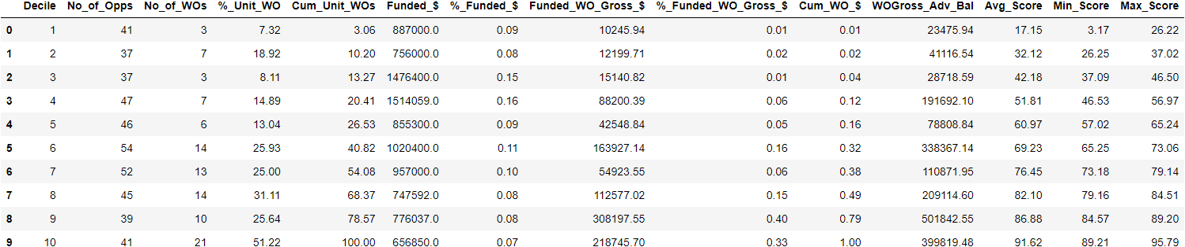

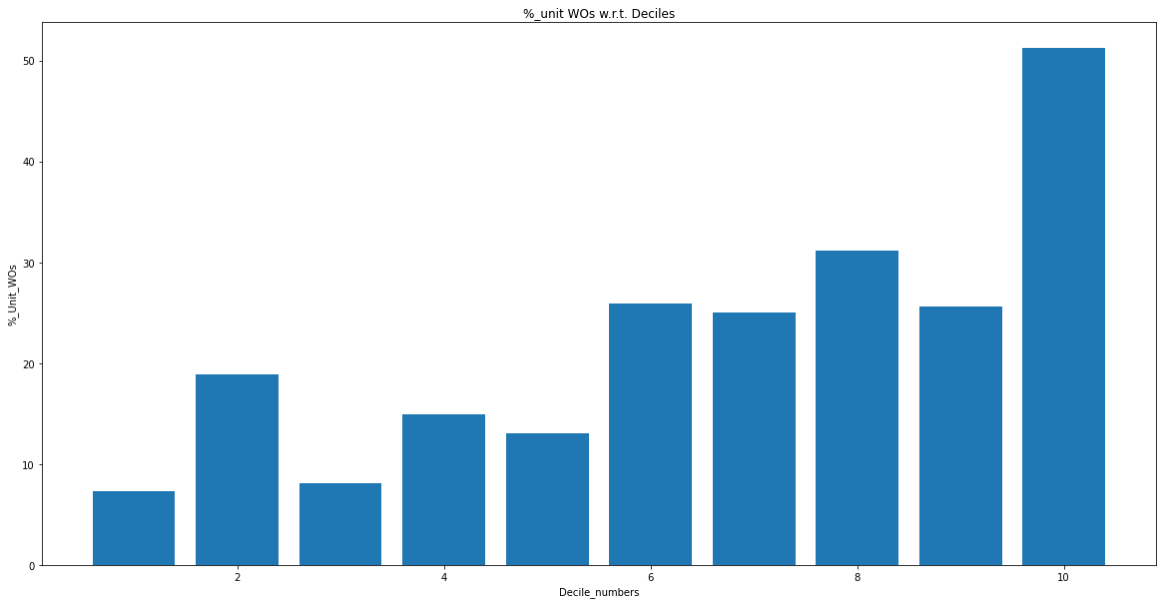

**L1 = 50 , l2 = 1, lr = 0.3(50 features)**

**Train set**

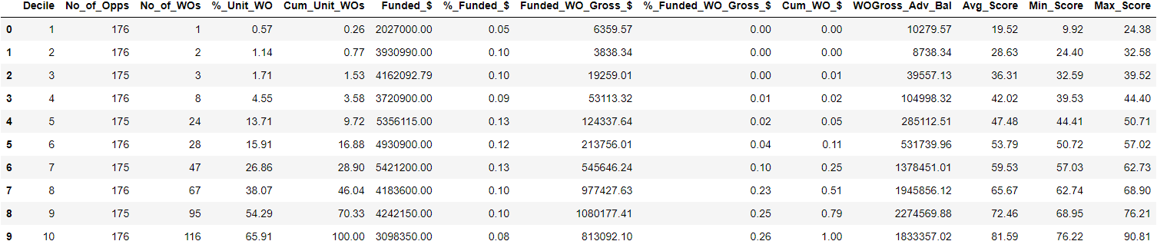

**Val set**

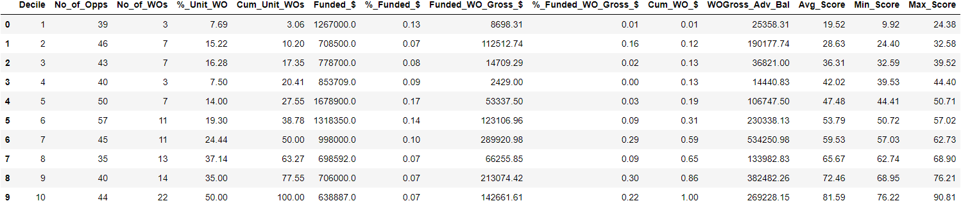

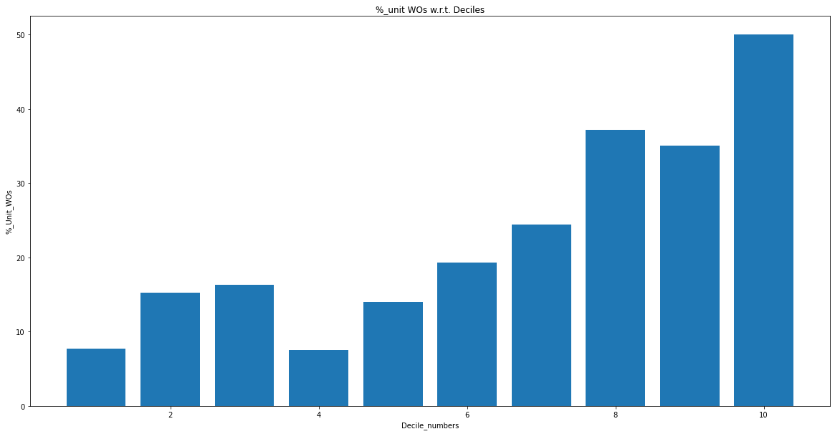

**L1 = 100, l2 = 1 , lr = 0.3 (50 features)**

**Train set**

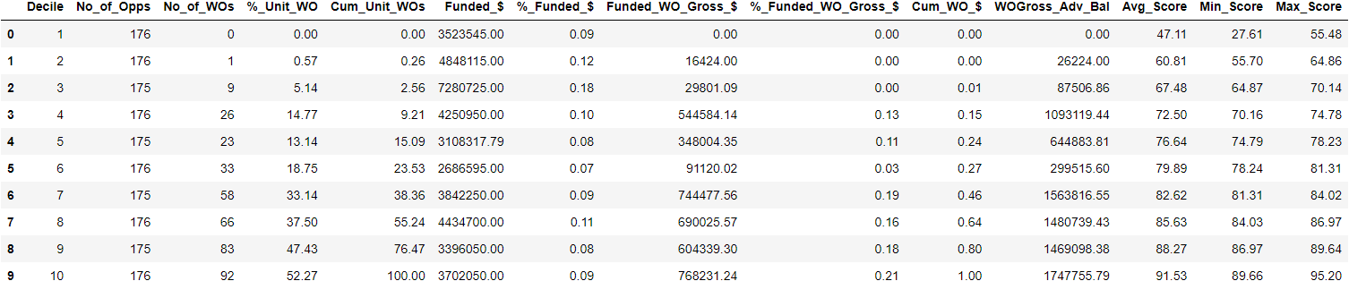

**Val set**

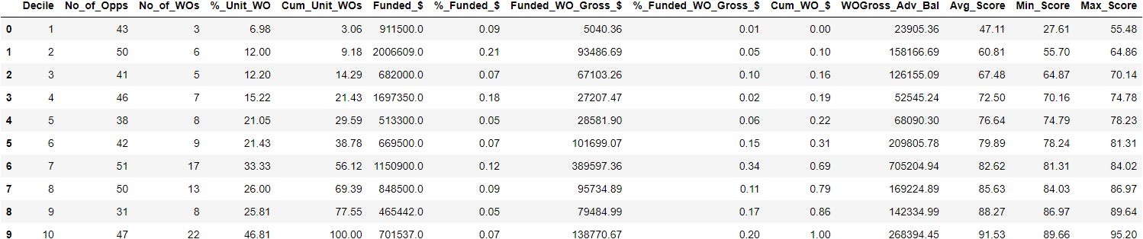

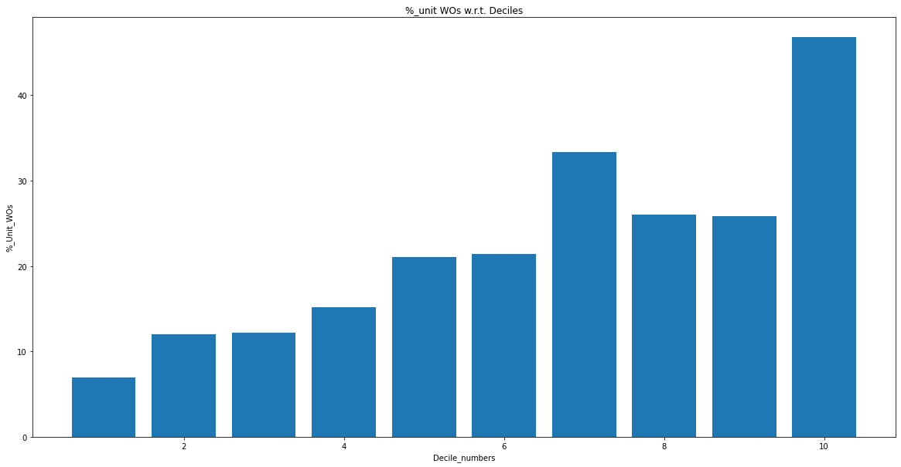

**L1 = 0.2 , l2 = 0 , lr = 0.3 (50 best features)**

**Train set**

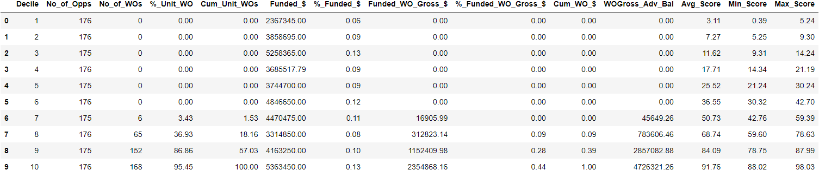

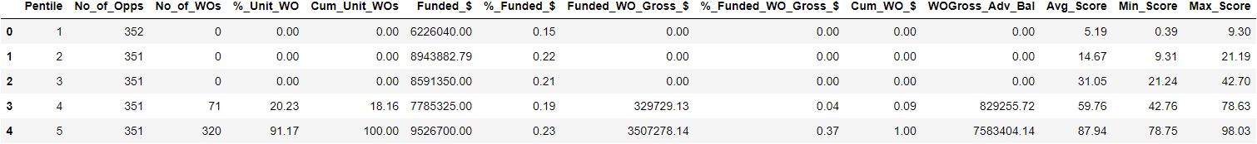

**Val set**

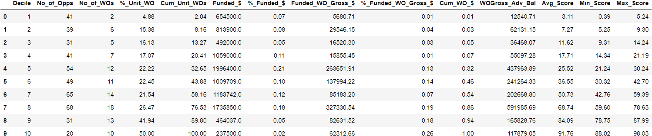

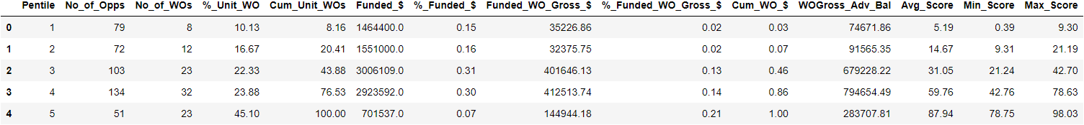

**Observations:**

* The model showing monotonic nature on validation set (a slight deviation from monotonic nature is observed in the 7th decile).
* The probability ranges are as expected.
* We cannot change the weights of false negatives in the first 6-7 deciles as the model is overfitting on the training set (Almost all correct predictions)
* In Pentiles (Val set)
  + 1st Pentile and 2nd pentile are exceeding average scores
  + However 2nd Pentile lies within probability boundary ranges
  + Pentile shows monotonicity

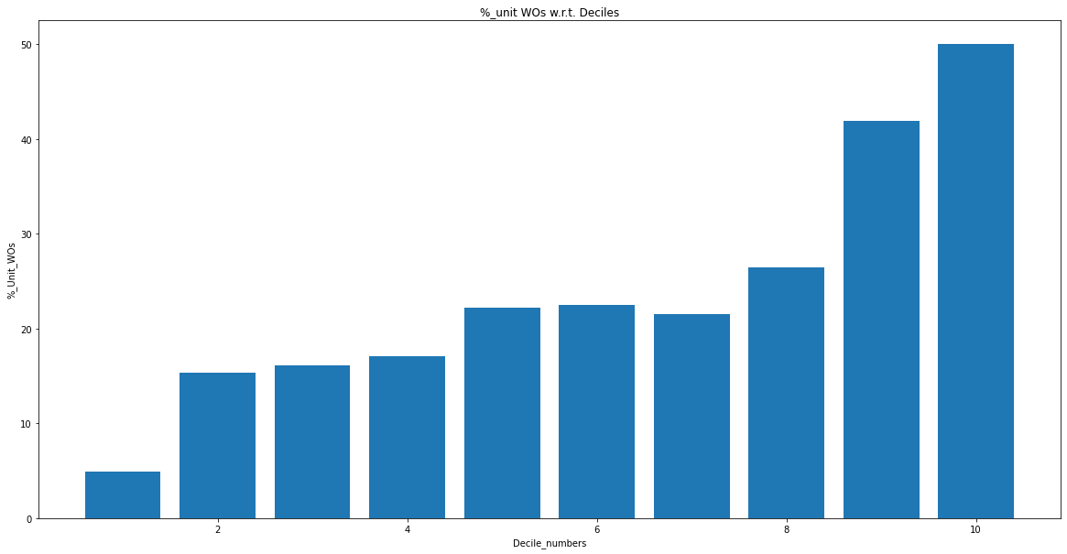

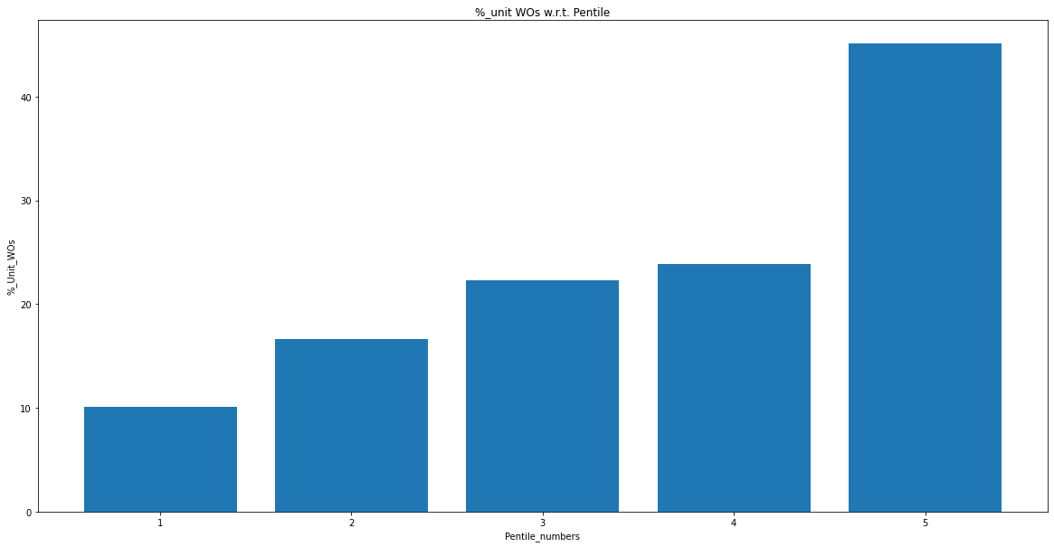

**L1 = 0.2 , l2 = 0.5, lr = 0.3 (50 features)**

**Train set**

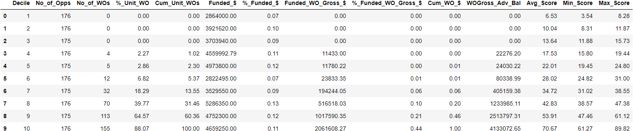

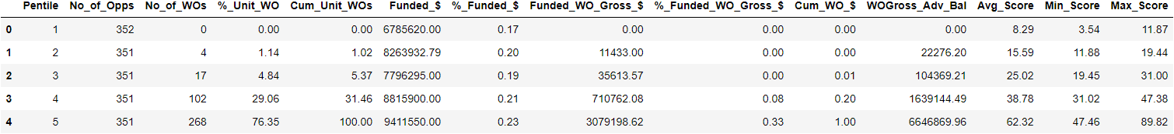

**Val set**

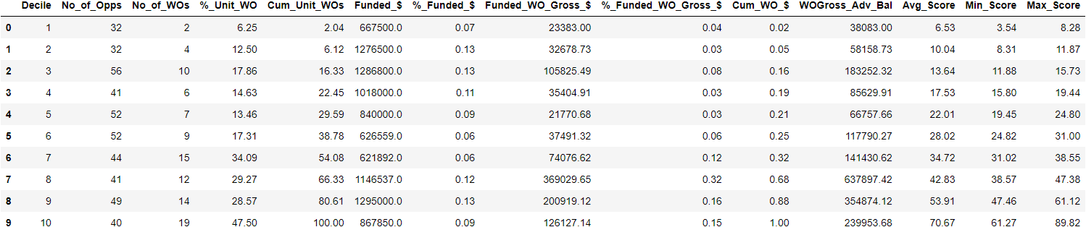

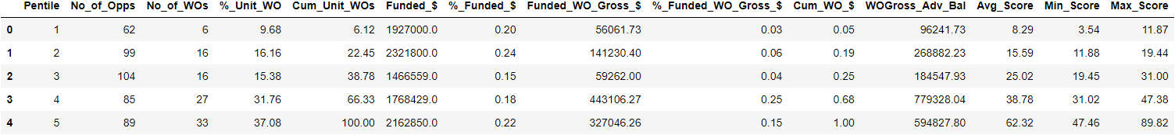

**Observations:**

* When we slightly changed l2 = 0 to l2 = 0.5, the overfitting on the training set has been slightly reduced.
* However the monotonicity is disturbed on the validation set.
* Additionally, the value of % Unit WOs are a lot closer to the average scores (probability boundaries).
* In Pentile (Validation Set)
  + 1st and 2nd pentile %Unit_Wos are exceeding average_scores
  + Slight monotonicity breaks at 2nd and 3rd pentiles

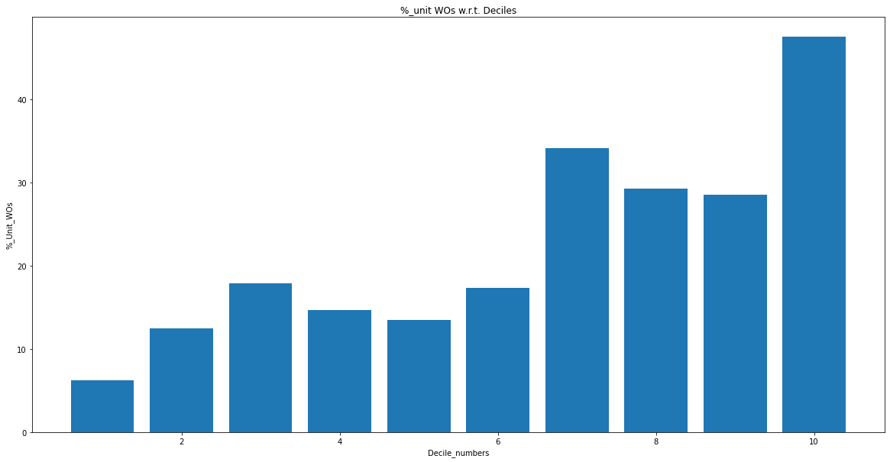

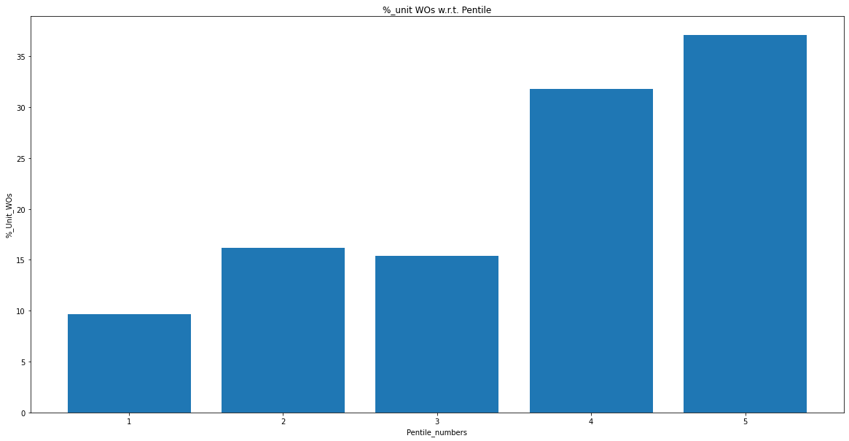

**L1 = 0.2 , l2 = 2, lr = 0.3 (50 features)**

**Train set**

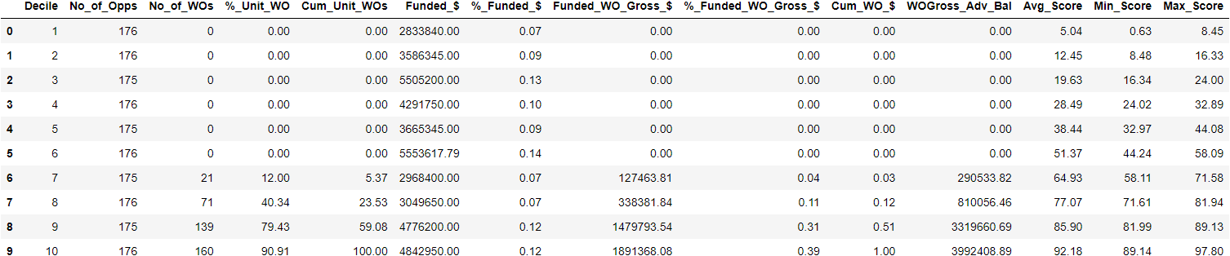

**Val set**

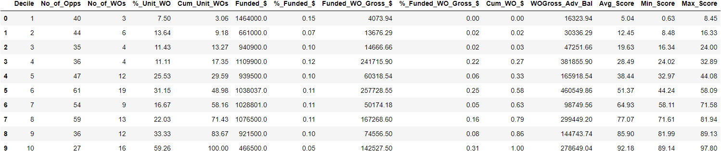

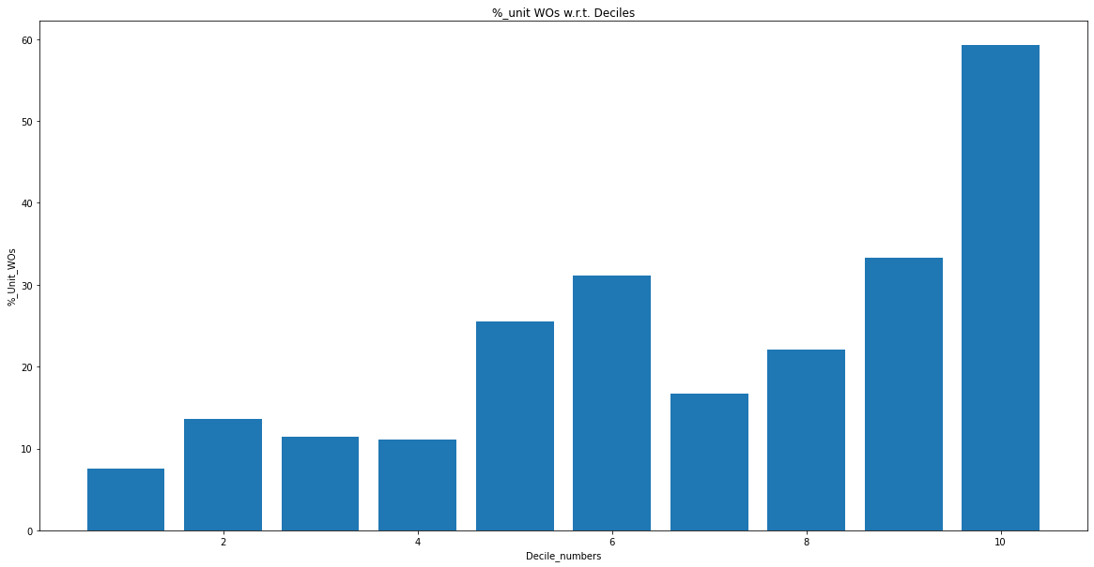

**L1 = 0.5 , l2 =2, lr = 0.3 (50 features)**

**Train set**

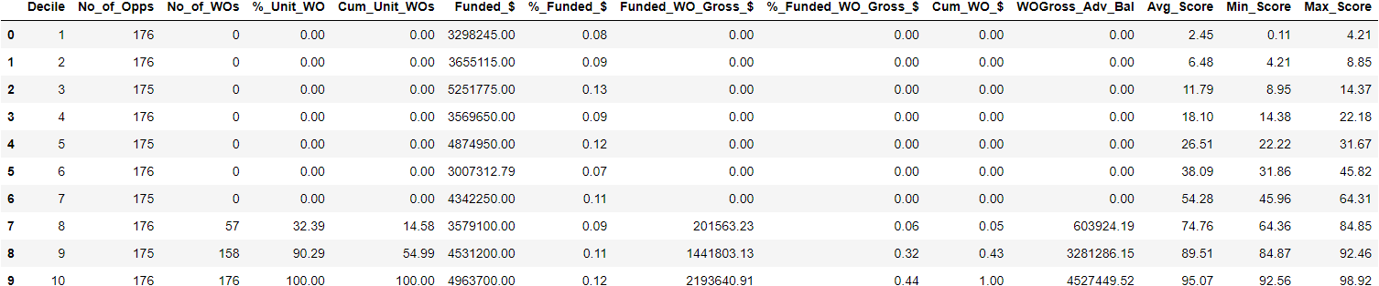

**Val set**

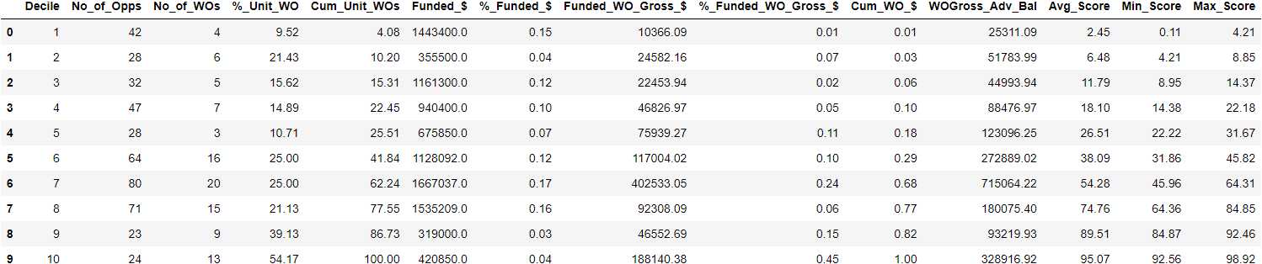

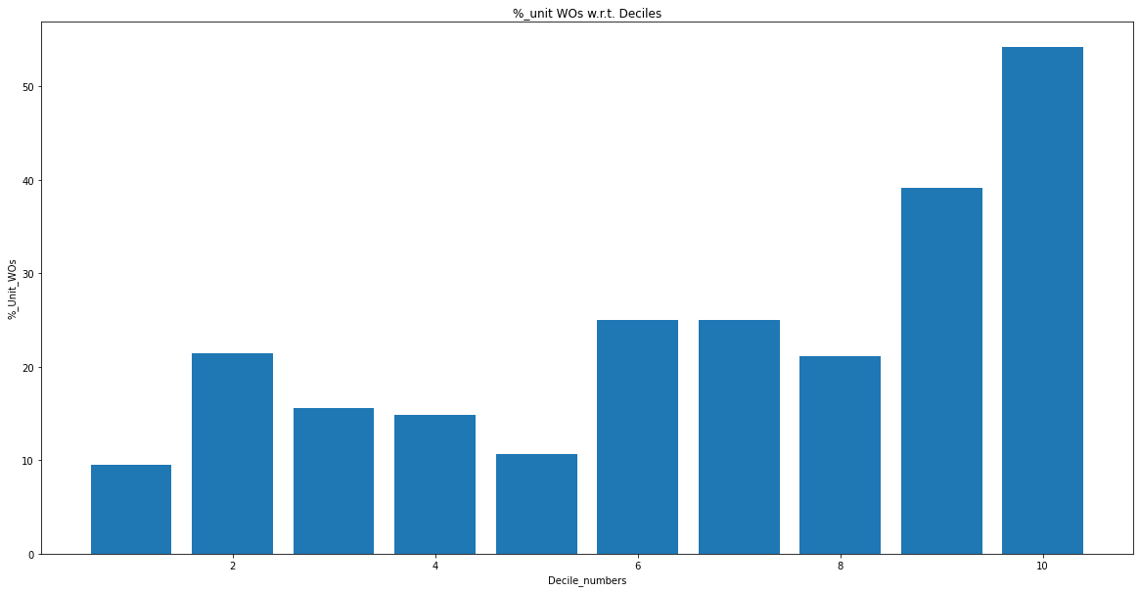

**L1 = 0.2, l2 = 3, lr = 0.3 (50 features)**

**Train set**

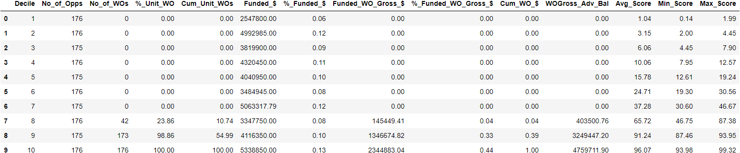

**Val set**

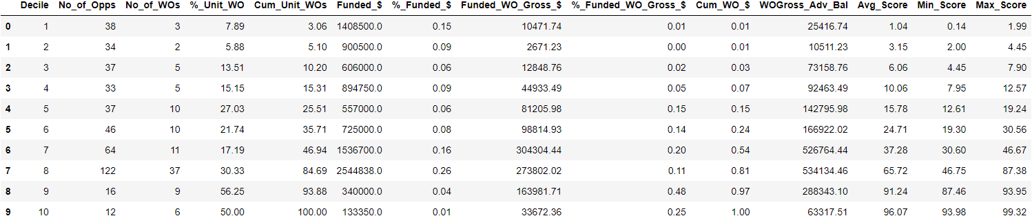

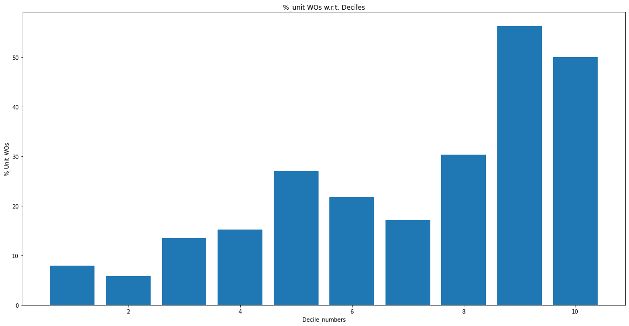

**L1 = 0.2, l2 = 4, lr = 0.3 (50 features)**

**Train set**

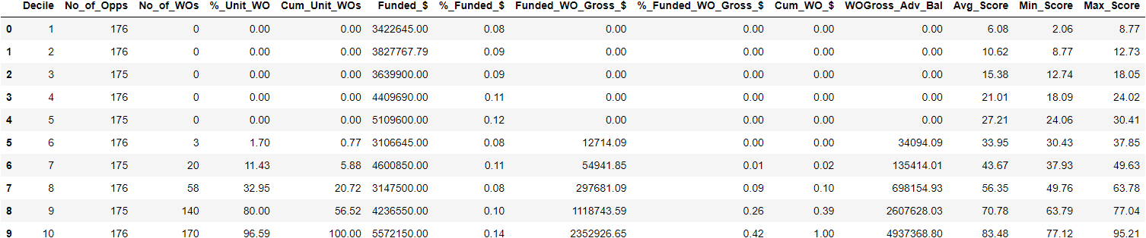

**Val set**

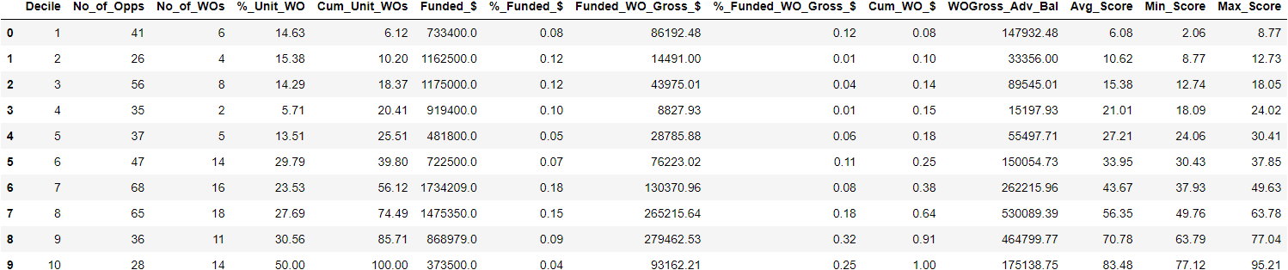

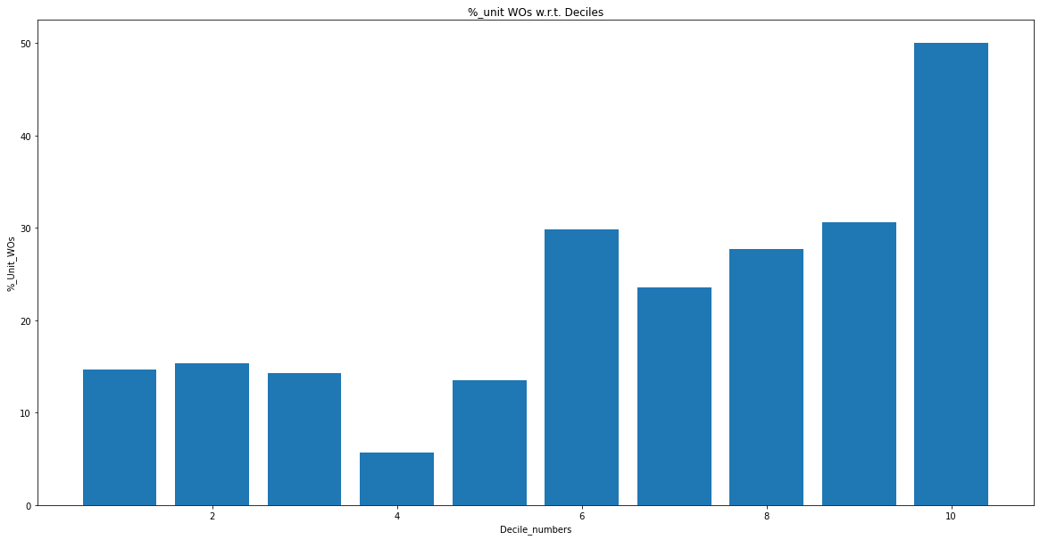

**L1 = 0.2 , l2 = 5, lr = 0.3(50 features)(early deciles in range)**

**Train set**

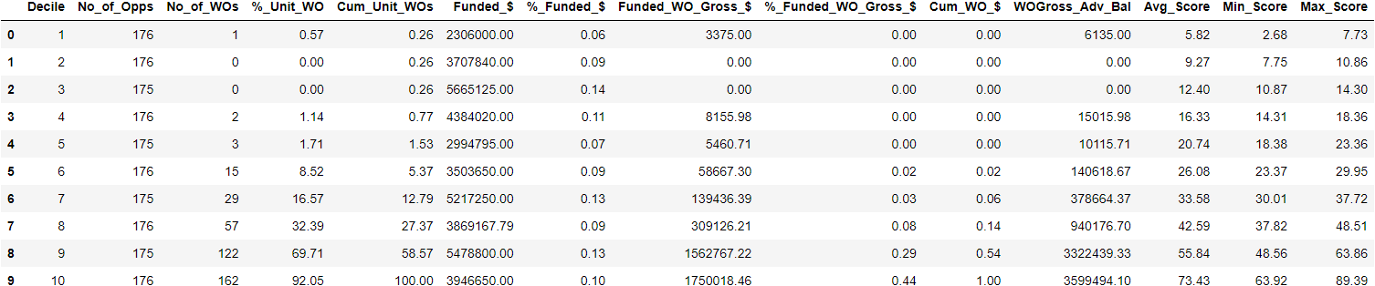

**Val set**

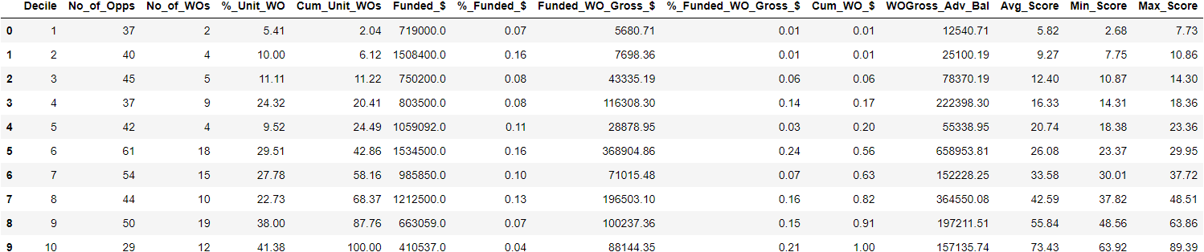

**Observations:**

* This model can be used to predict the reliable merchants(In the first 3 deciles, the %_Unit_WOs are within range and the average scores are also within prescribed range).

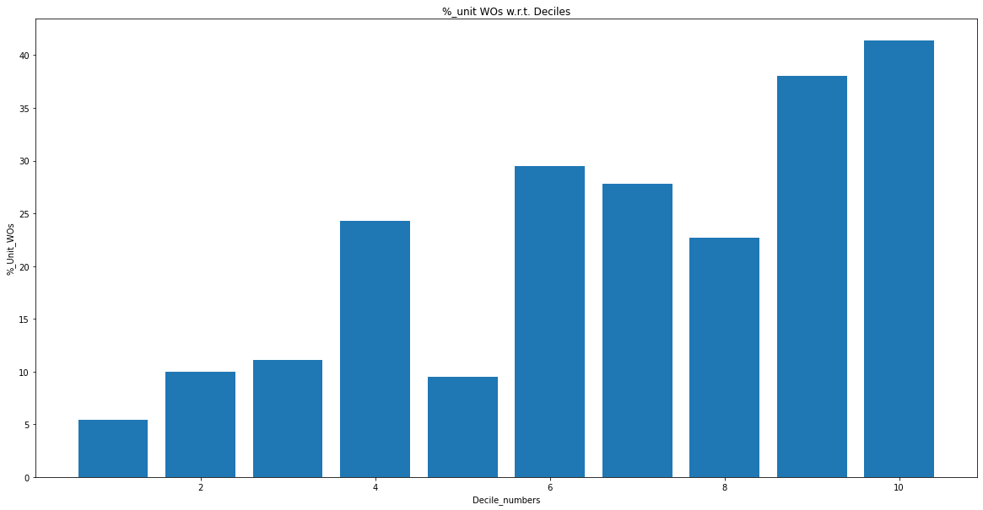

**L1 = 0.2, l2 = 6, lr = 0.3 (50 features)**

**Train set**

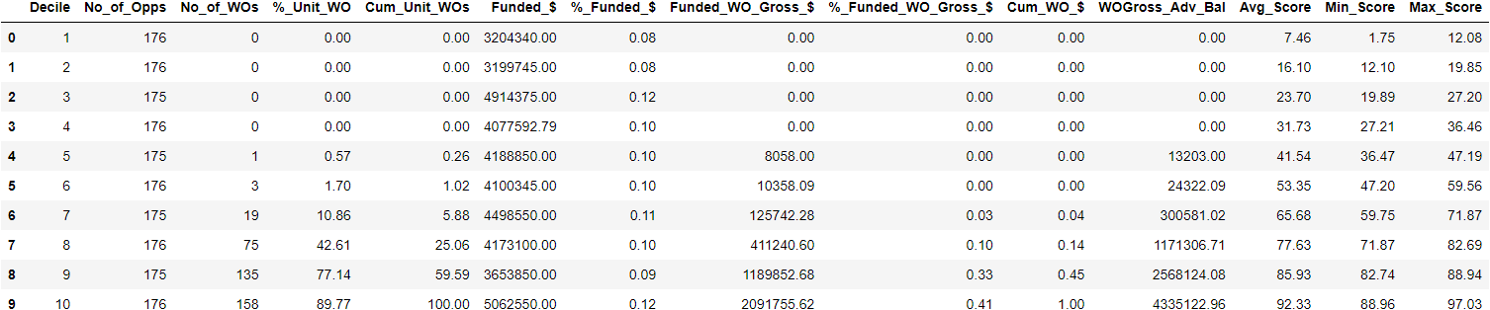

**Val set**

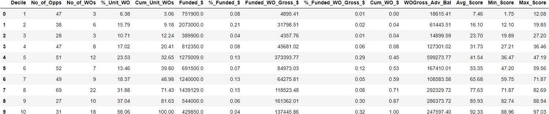

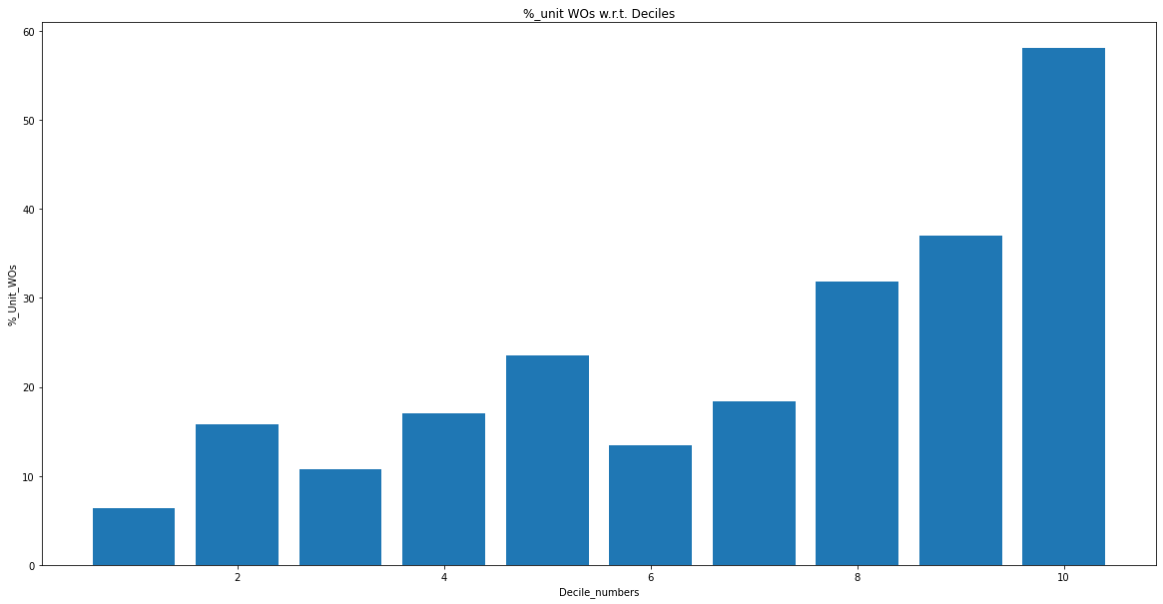

**L1 = 0.2, l2 = 8 ,lr = 0.3 (50 features)**

**Train set**

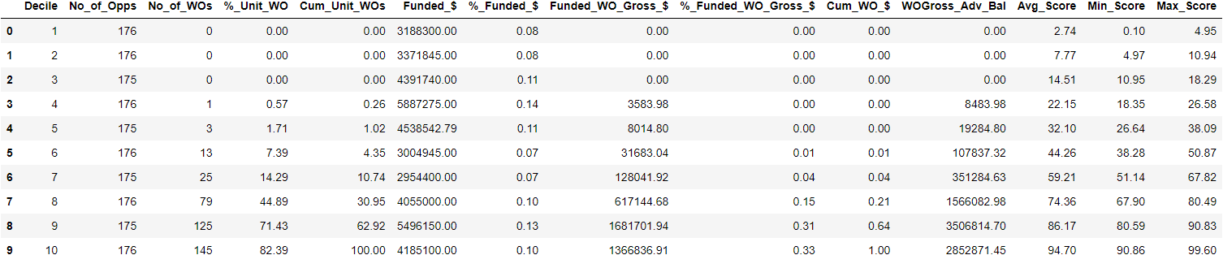

**Val set**

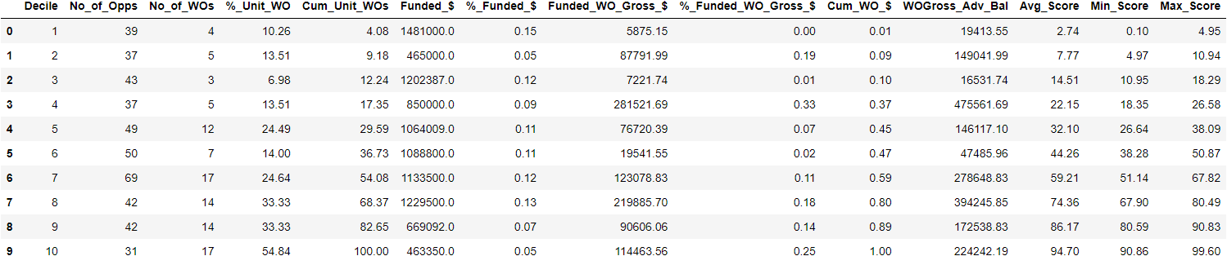

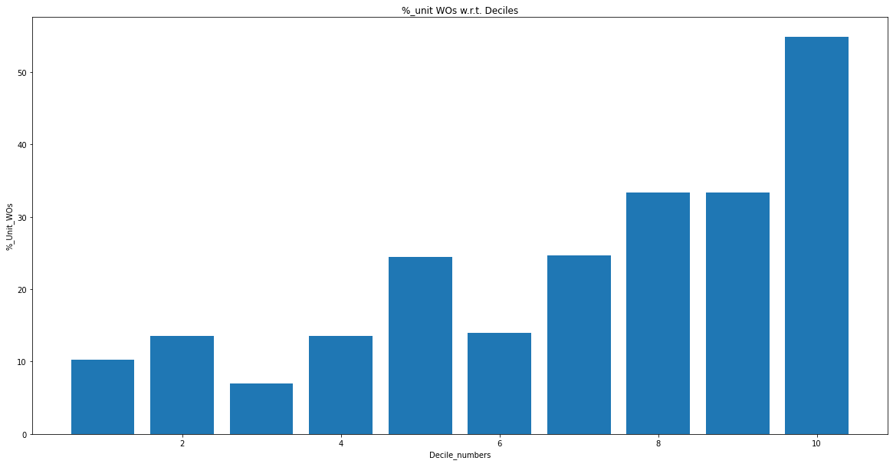

**L1 = 0.2, l2 = 10, lr = 0.3 (50 features)**

**Train set**

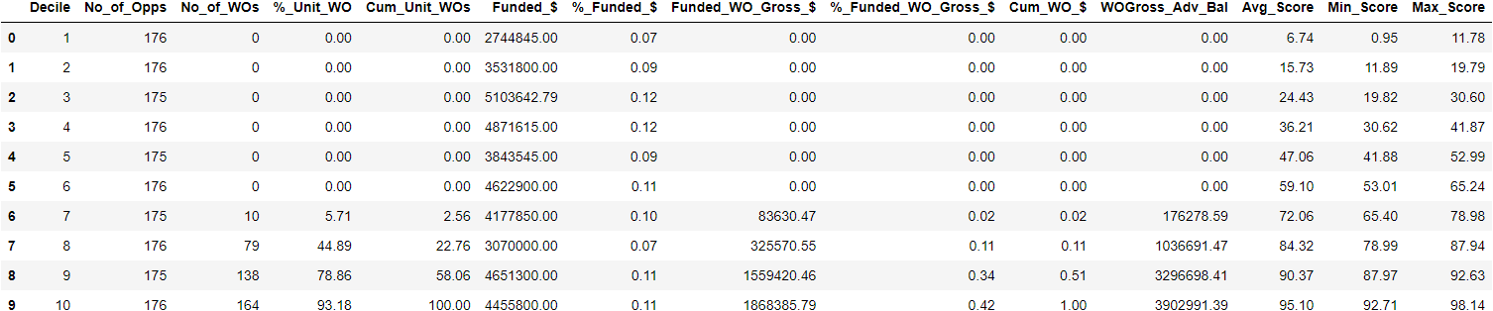

**Val set**

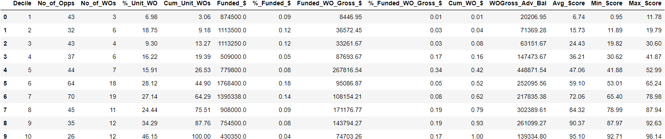

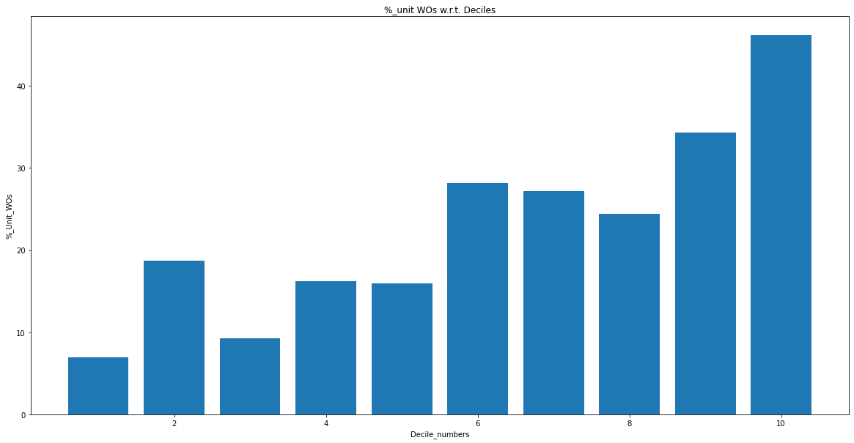

**L1 = 0.2 , l2 = 20, lr = 0.3 (50 features)**

**Train set**

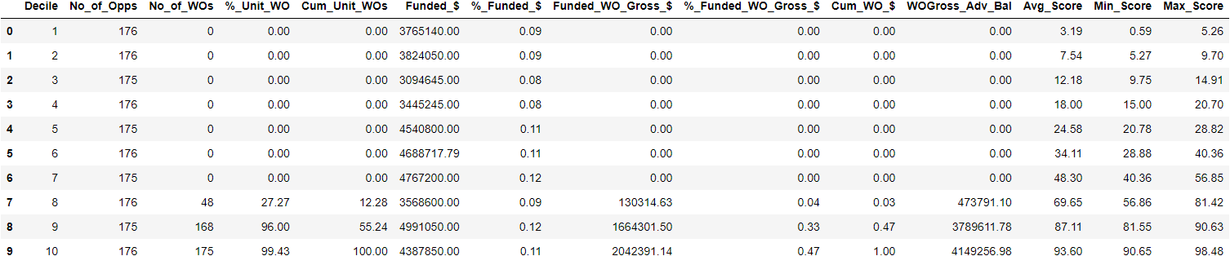

**Val set**

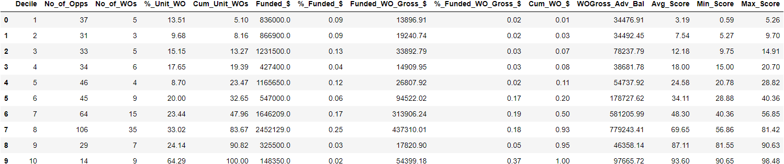

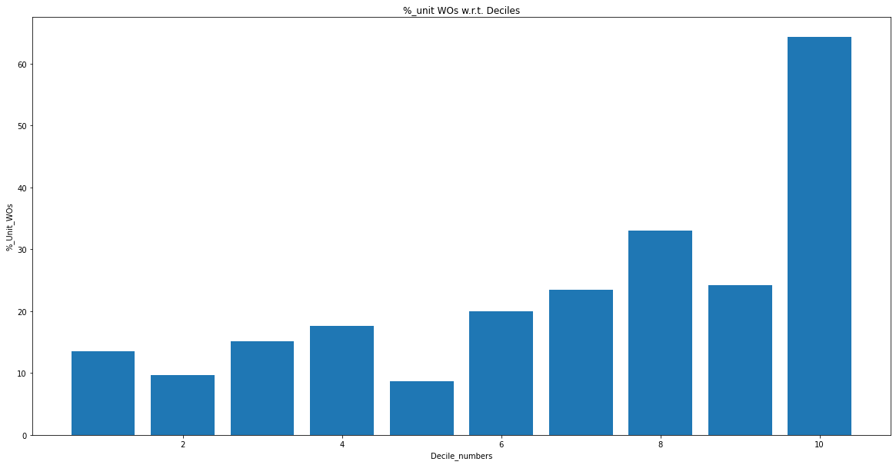

**L1 = 0.2, l2 = 30, lr = 0.3 (50 features)**

**Train set**

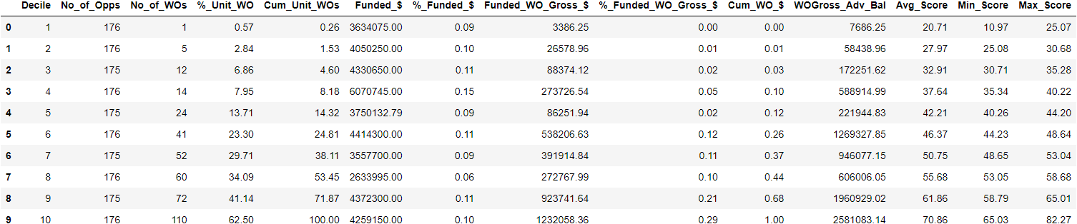

**Val set**

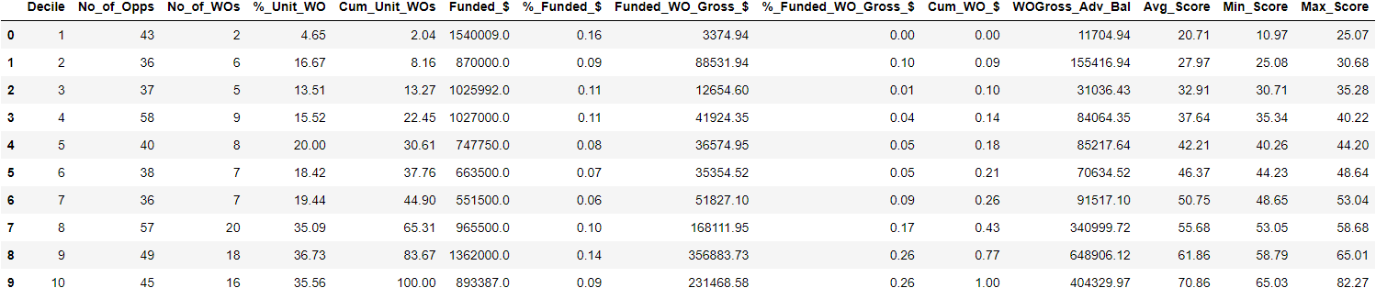

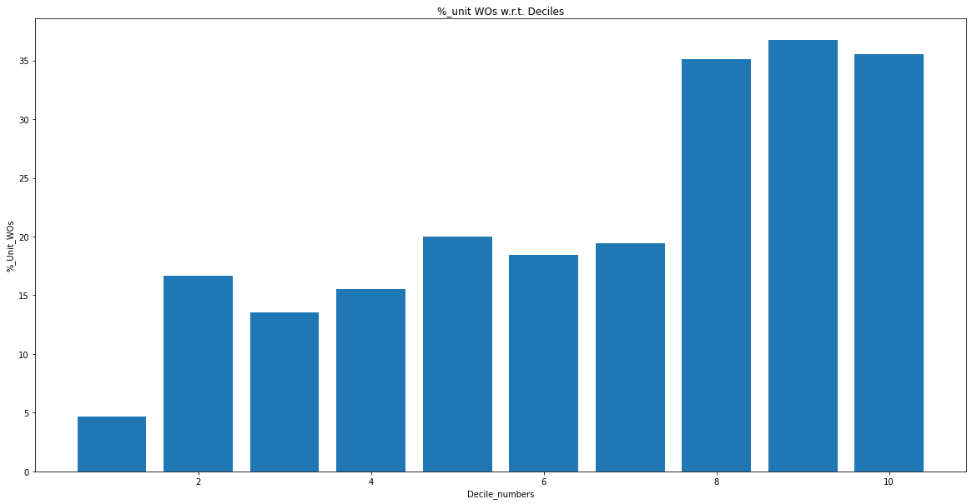

**L1 = 0.2, l2 = 40, lr = 0.3(50 features)**

**Train set**

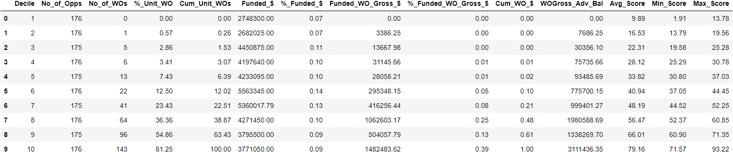

**Val set**

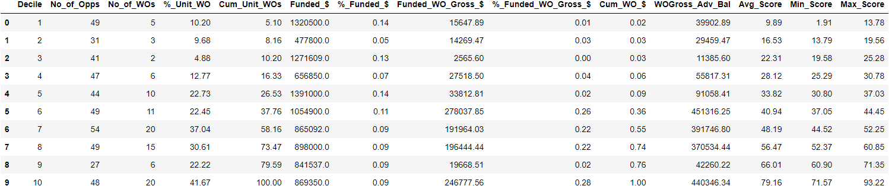

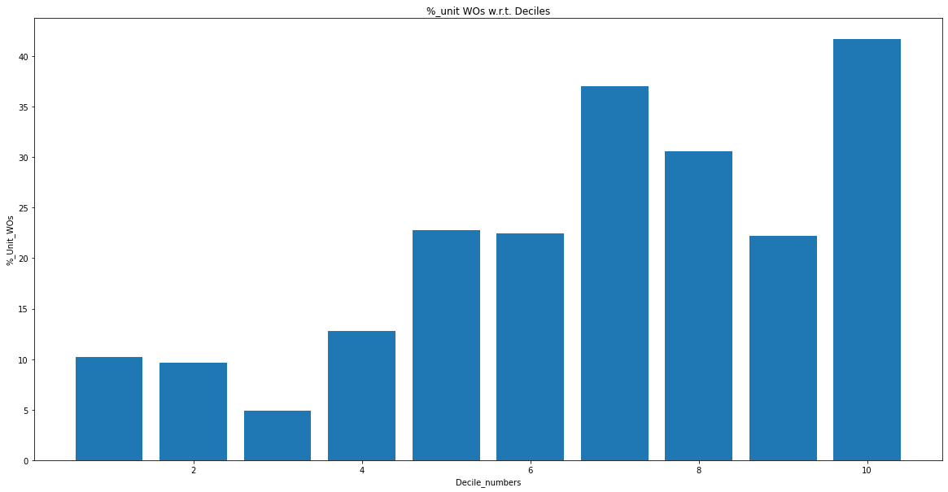

**L1 = 0.2, l2 = 50, lr = 0.3 (50 features)**

**Train set**

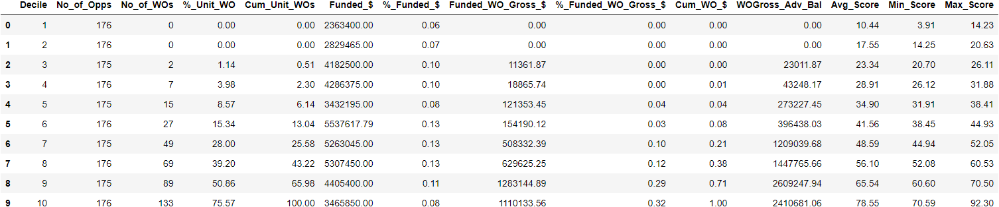

**Val set**

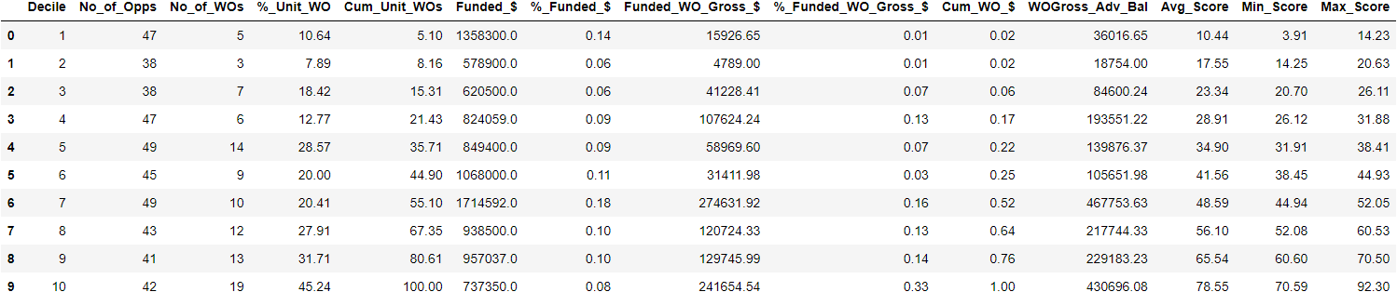

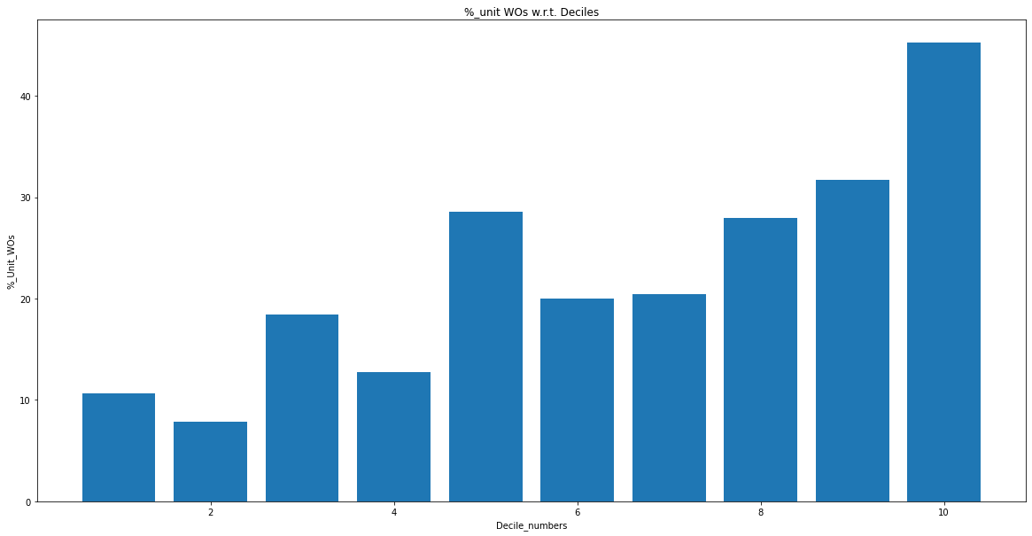

**L1 = 0.2, l2 = 100, lr = 0.3(50 features)**

**Train set**

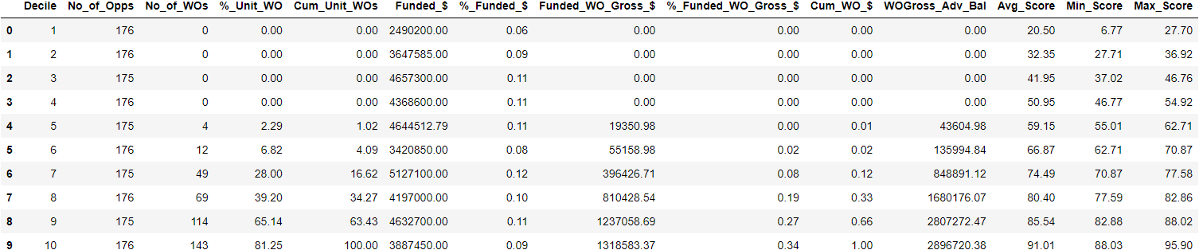

**Val set**

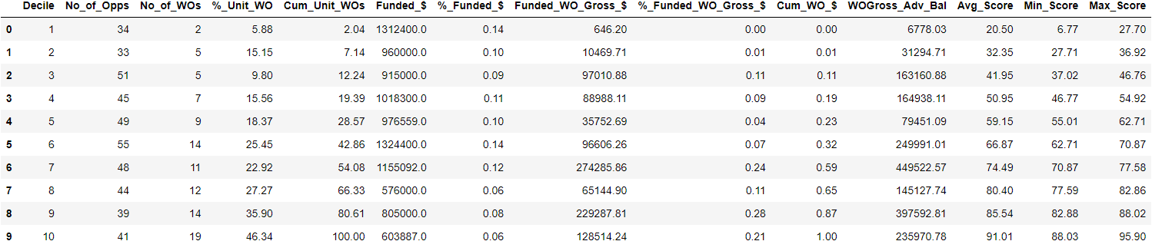

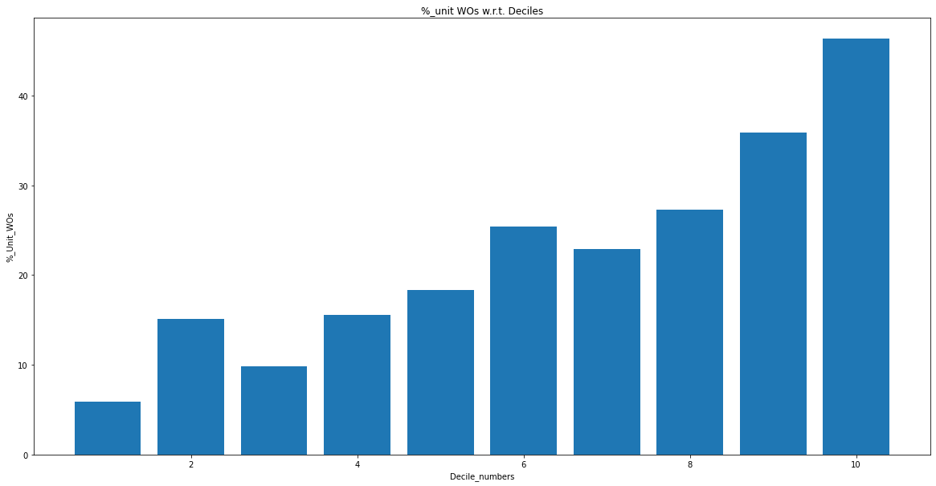

**L1 = 0.2, l2 = 0.5 , lr = 0.1 (50 features)**

**Trains set  
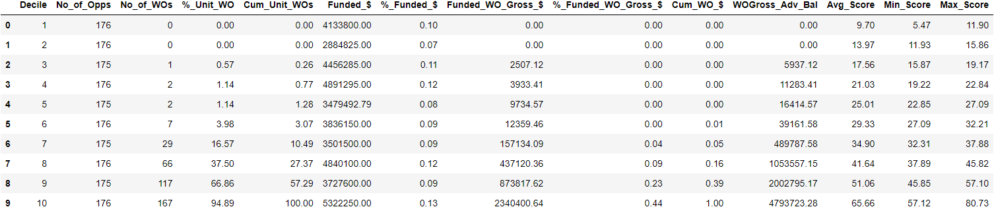**

**Val set**

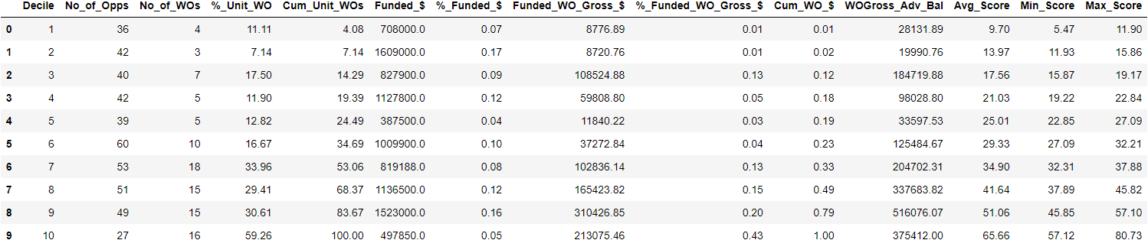

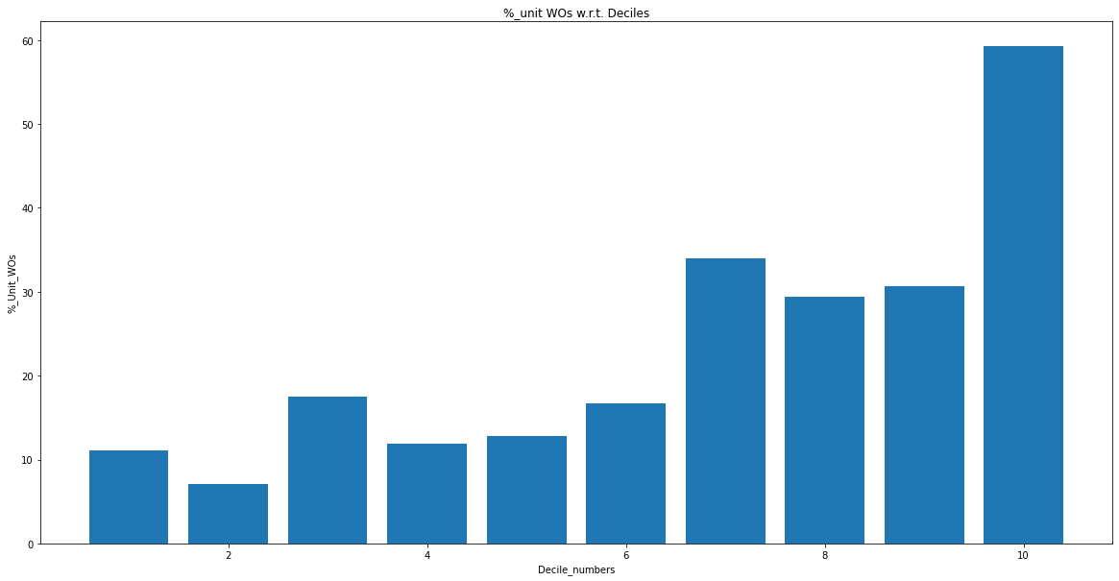

**L1 = 0.2, l2 = 0.5, lr = 0.05 (50 features)**

**Train set**

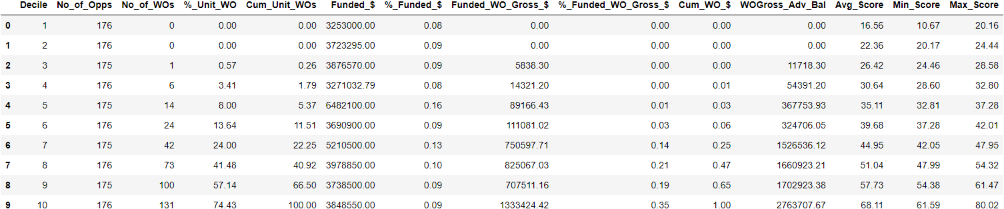

**Val set**

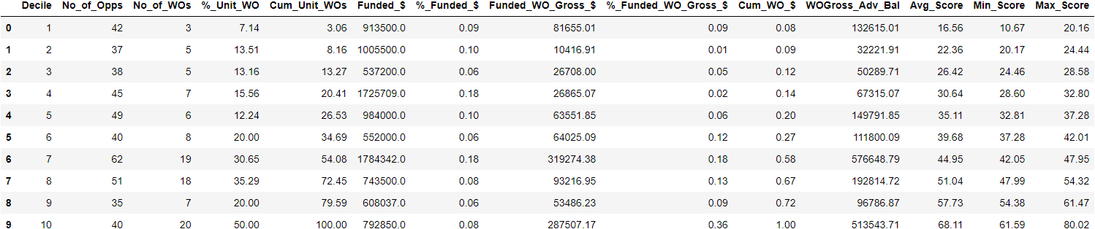

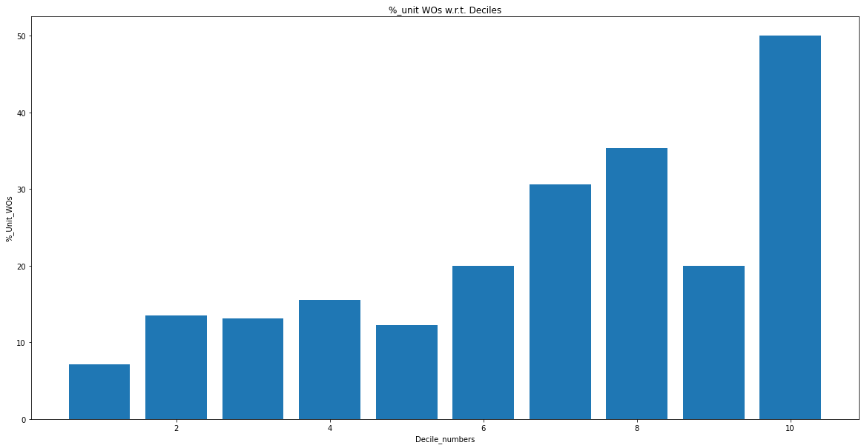

**L1 = 0.2, l2 = 0.5, lr = 0.5 (50 features)**

**Train set**

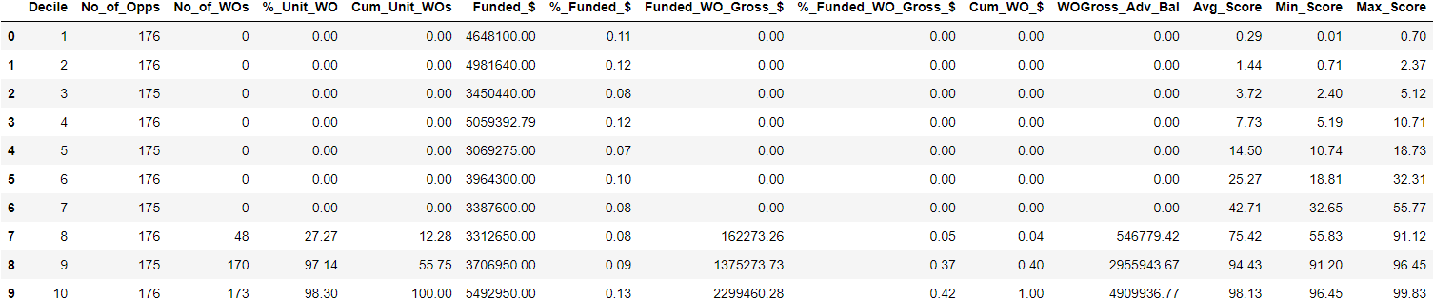

**Val set**

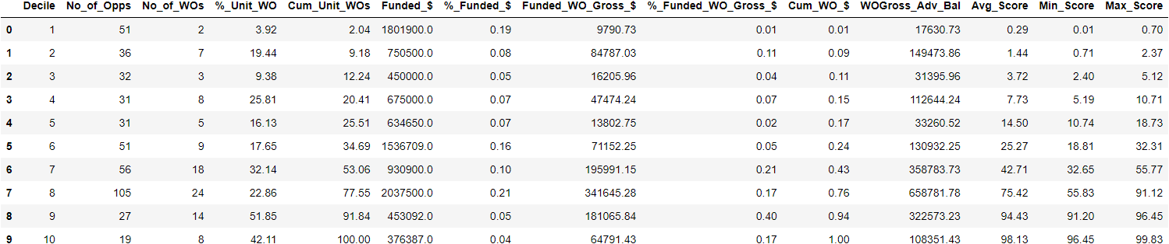

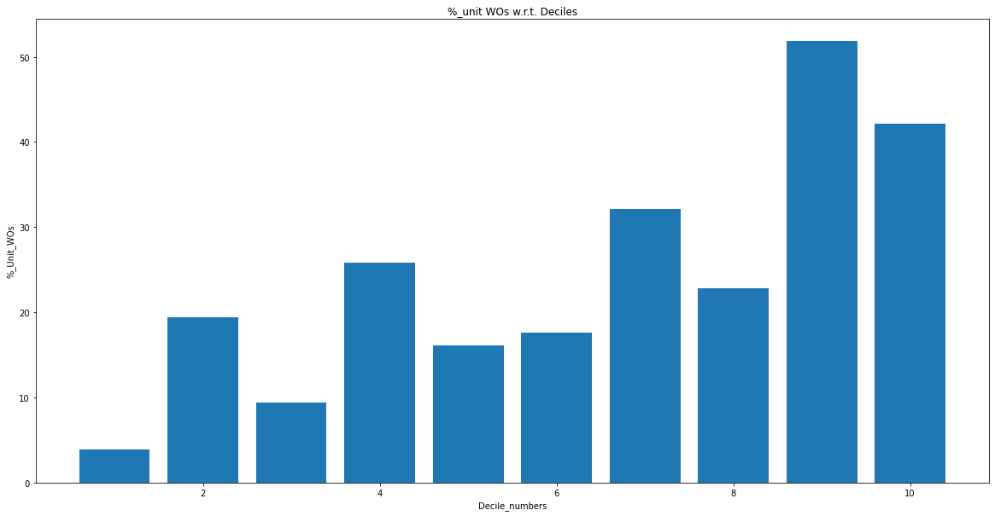

**L1 = 0.2, l2 = 0.5 , lr = 1 (50 features)**

**Train set**

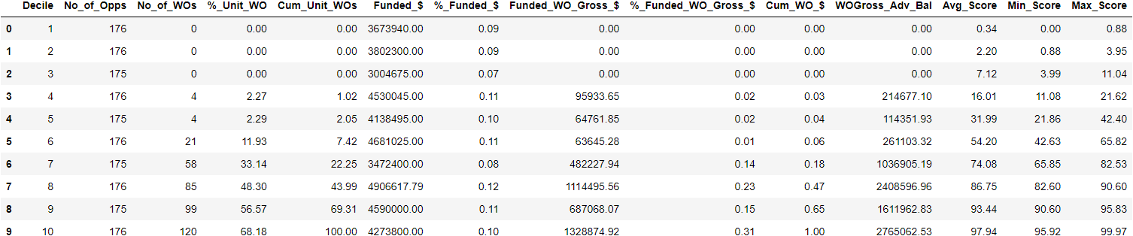

**Val set**

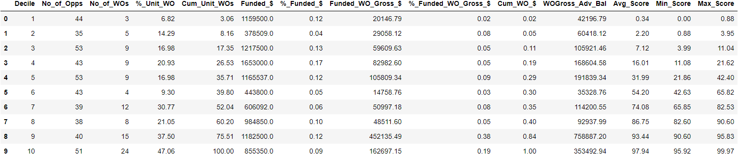

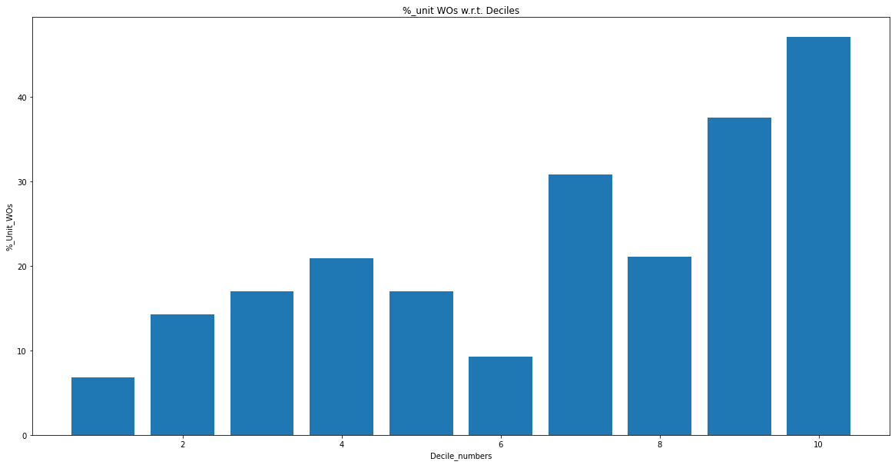

**L1 = 0.2, l2 = 0.5, lr = 2 (50 features)**

**Train set**

**Deciles can’t be formed **

**9th decile not present due to exactly same probability scores**

**L1 = 0.2, l2 = 0.5, lr = 3 (50 features)**

**Train set**

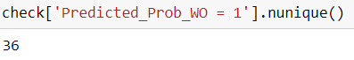

**Only 36 distinct probability scores**

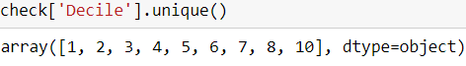

**9th decile again not formed due to exactly same probability scores**

**L1 = 0.2 , l2 = 0.5 , lr = 1.5 (50 features)**

**Train set**

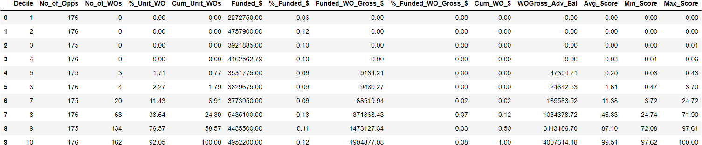

**Val set**

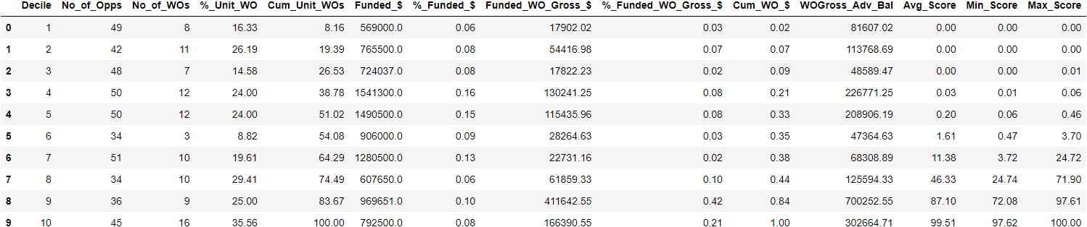

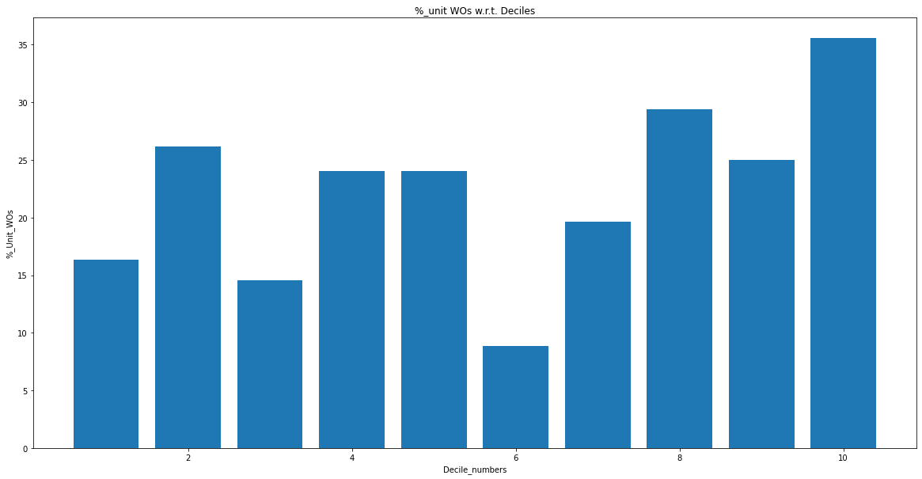

**L1 = 0.2, l2 = 0.5, lr = 1.2 (50 features)**

**Train set**

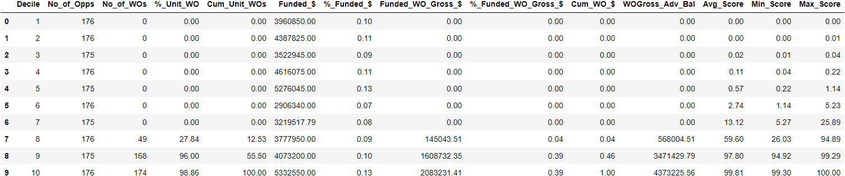

**Val set**

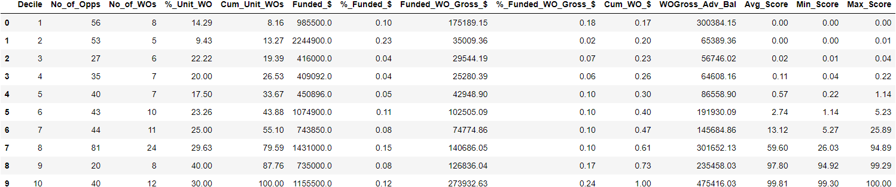

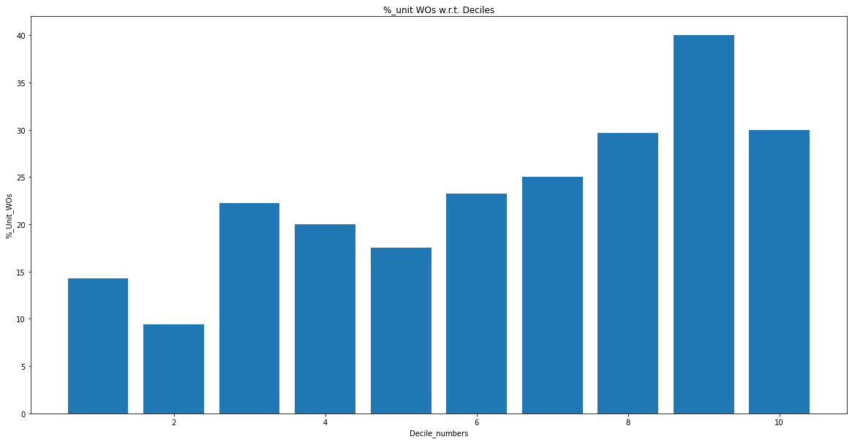

**L1 = 0.2, l2 = 0.5, lr = 0.8 (50 features)**

**Train set**

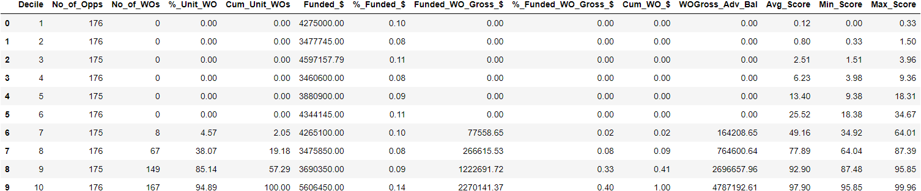

**Val set**

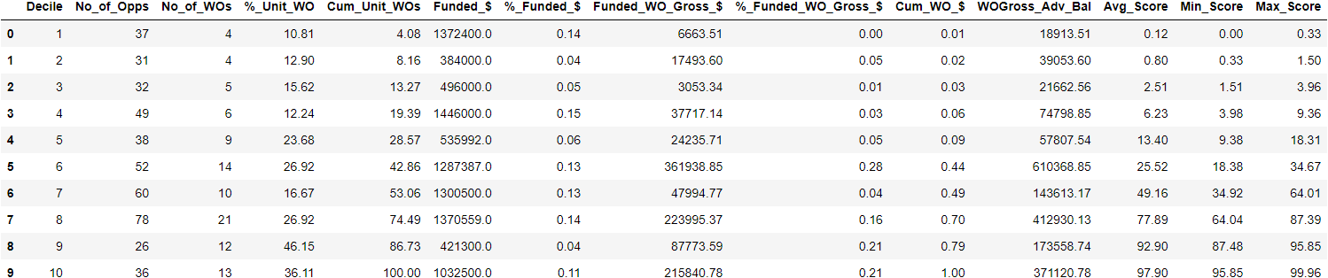

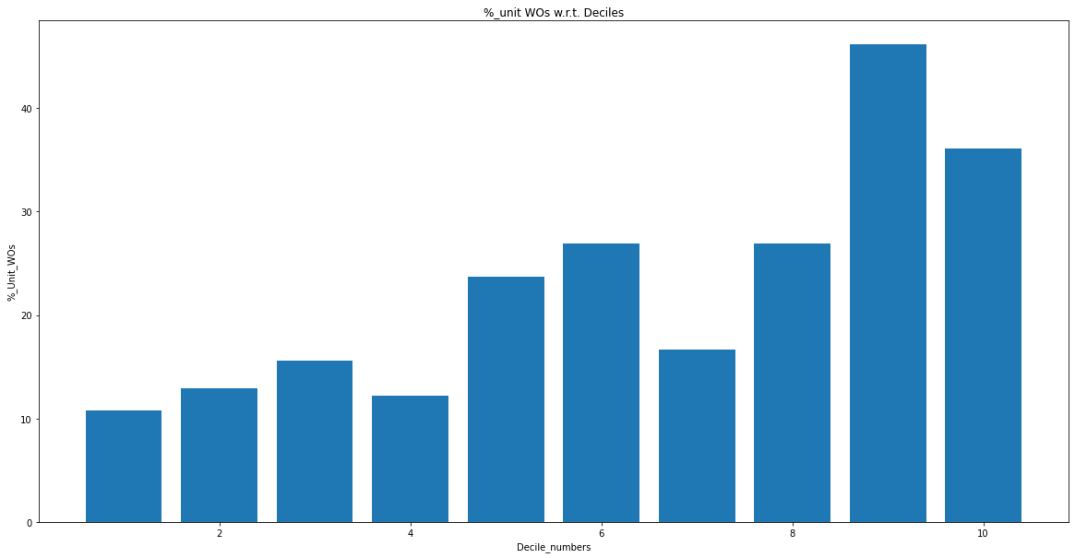

**L1 = 0.2 , l2 = 0.5 , lr = 0.2 (50 features)**

**Train set**

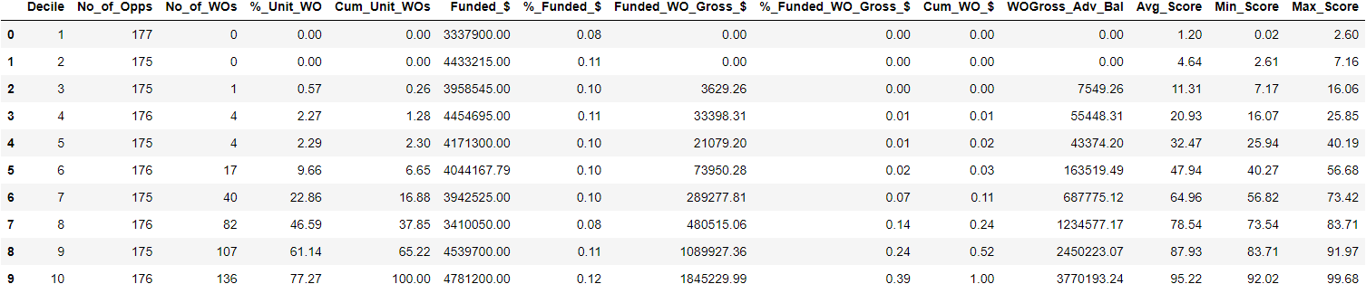

**Val set**

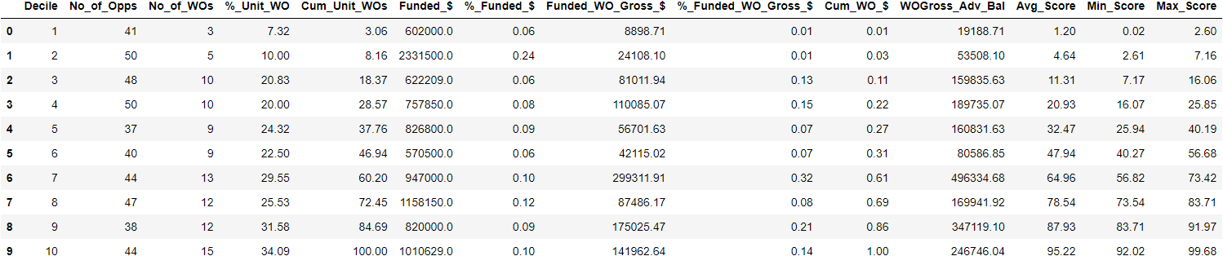

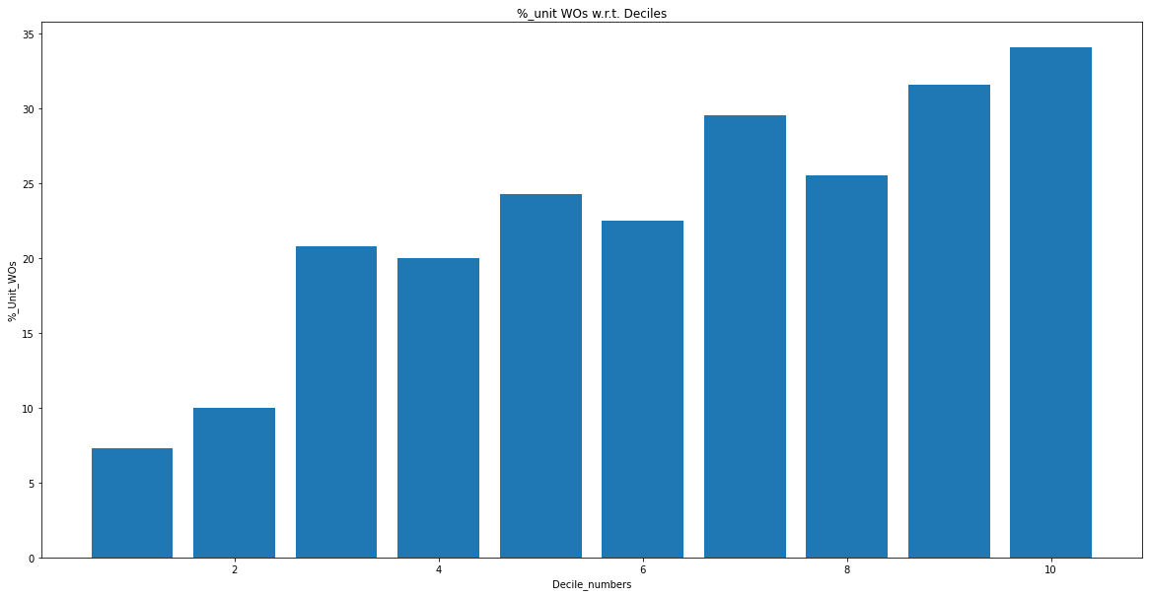

**L1 = 0.2 , l2 = 0, lr = 0.3 (correlated features)**

**Train set**

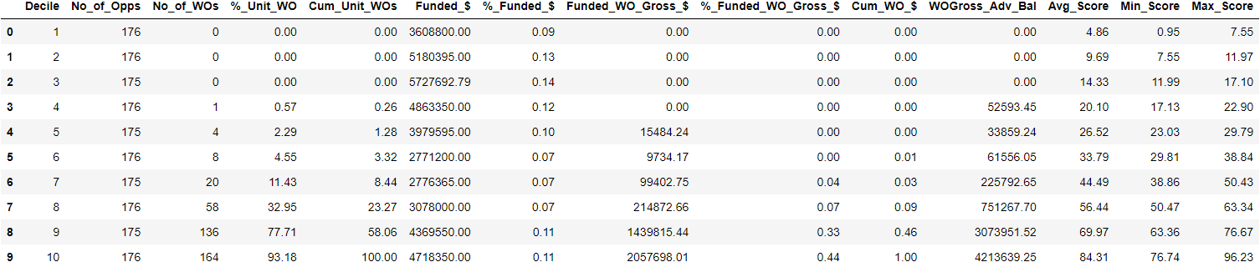

**Val set**

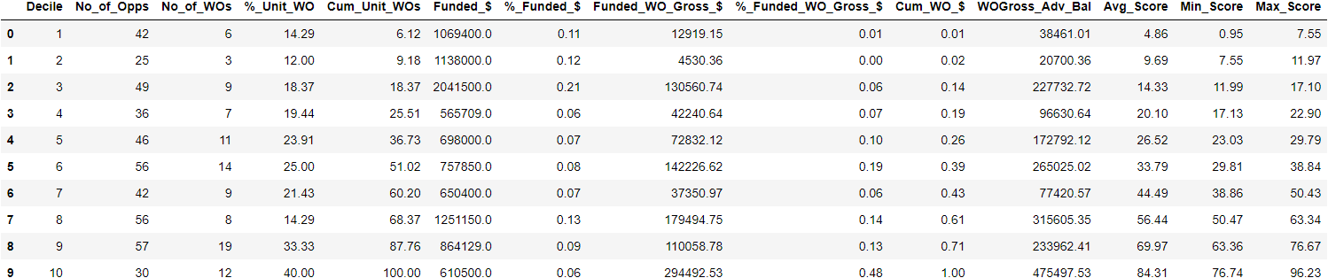

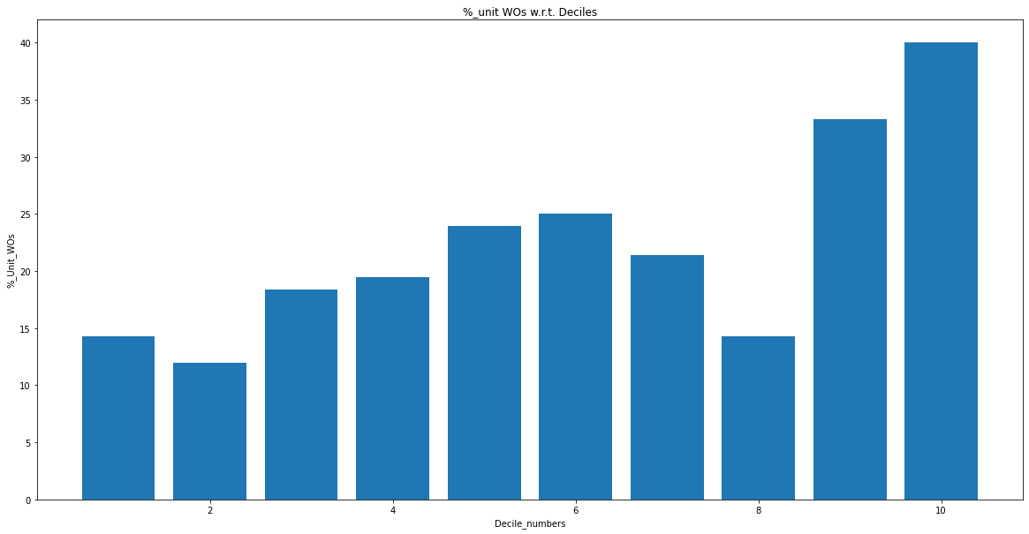

**L1 = 0.2 , l2 = 1, lr = 0.3 (highest correlated features)**

**Train set**

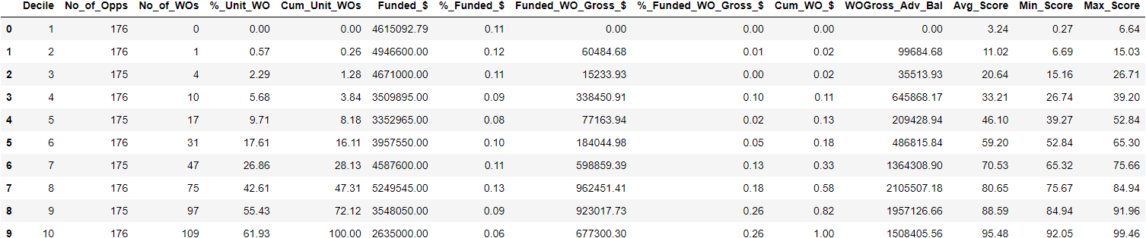

**Val set**

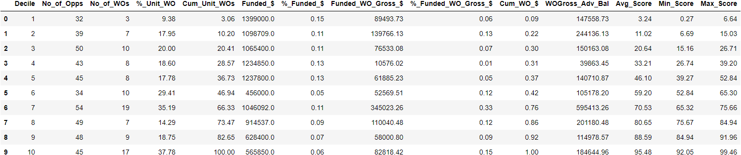

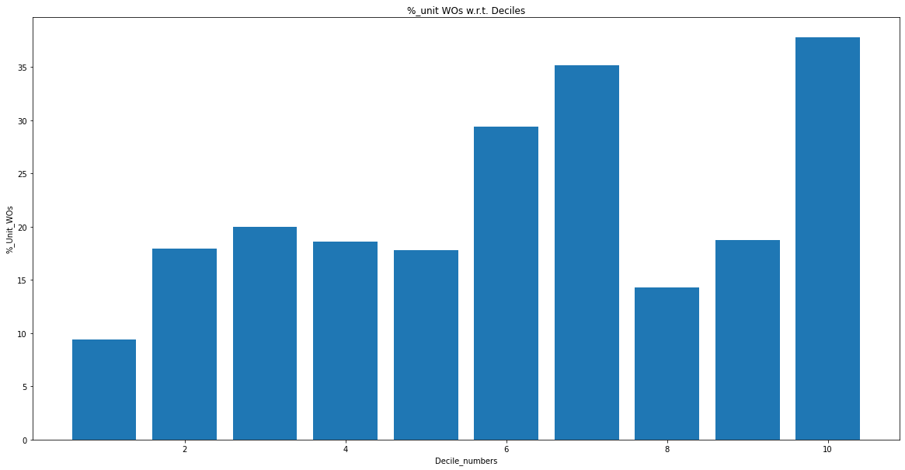

**L1 = 0.2, l2 = 5 , lr = 0.3 (highest correlated features)**

**Train set**

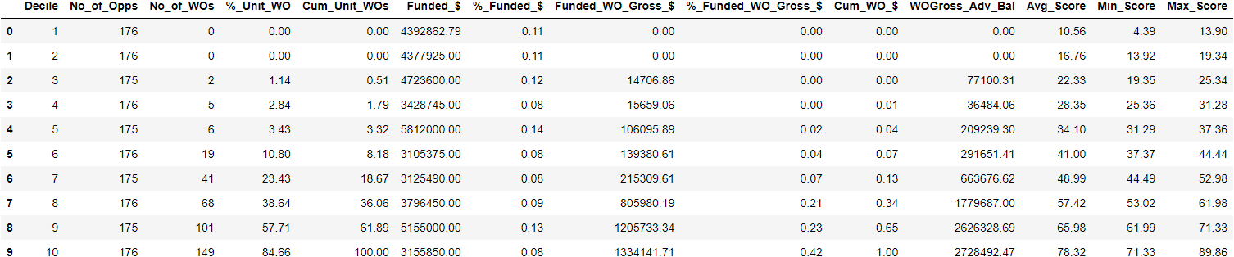

**Val set**

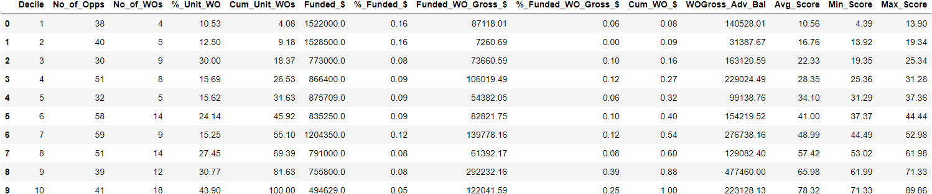

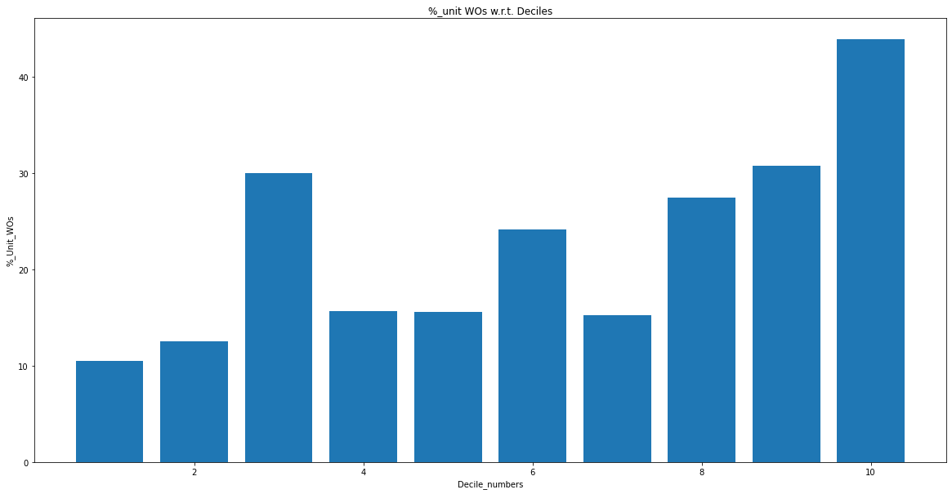

**L1 = 0.2, l2 = 10, lr = 0.3 (highest correlated features)**

**Train set**

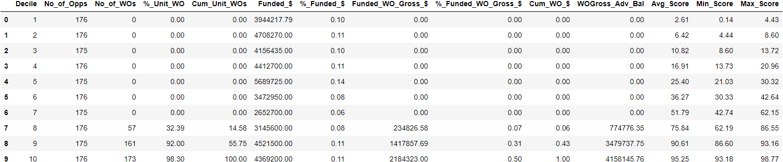

**Val set**

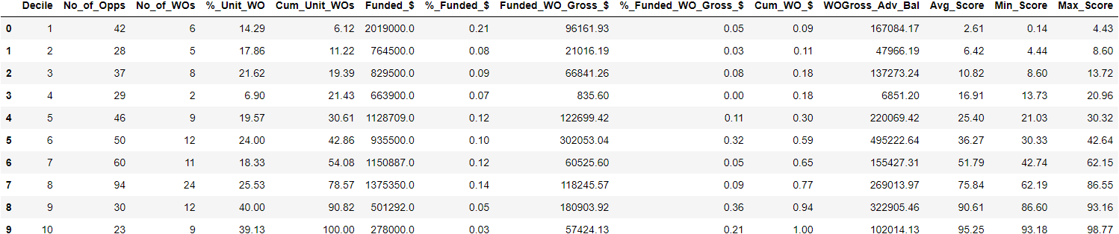

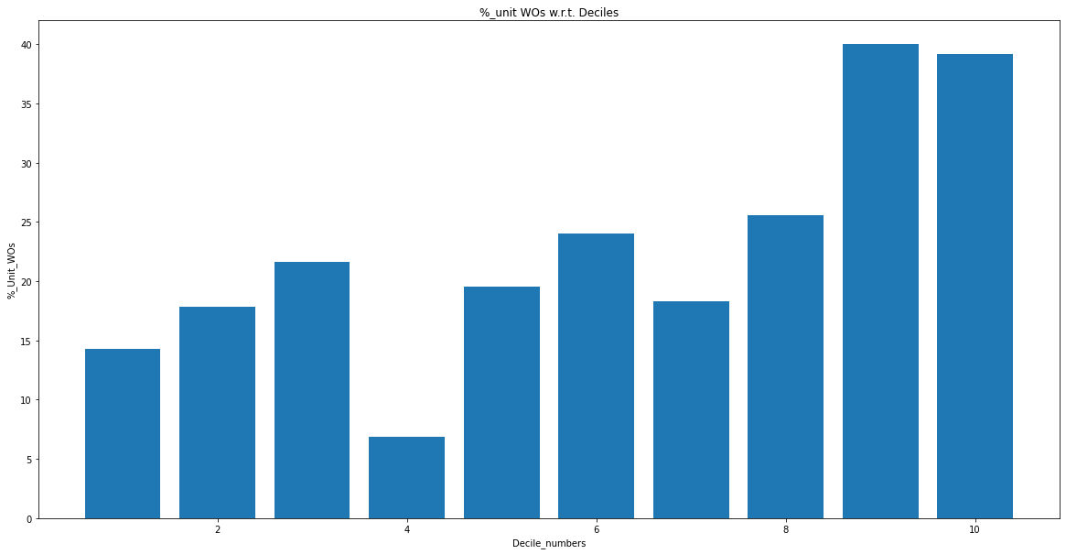

**L1 = 0, l2 = 1, lr = 0.3 (highest correlated features)**

**Train set**

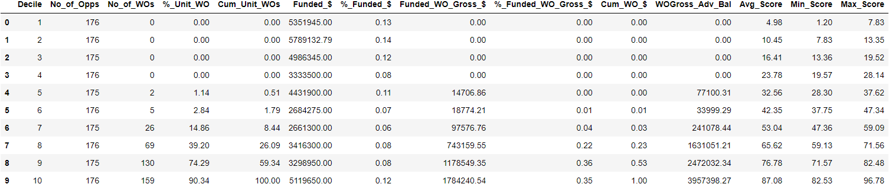

**Val set**

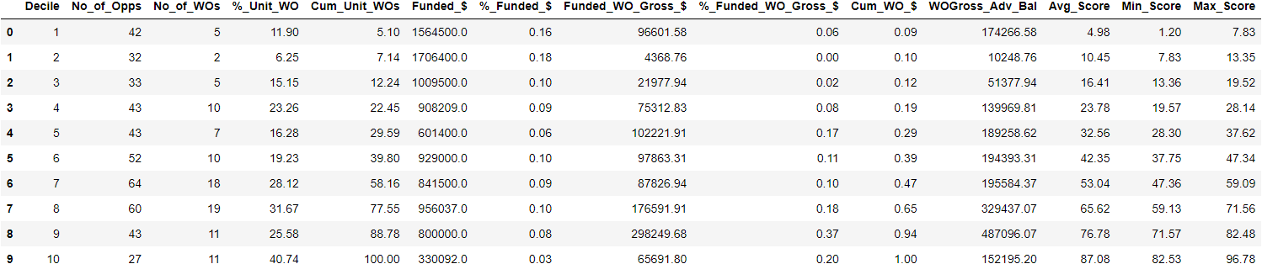

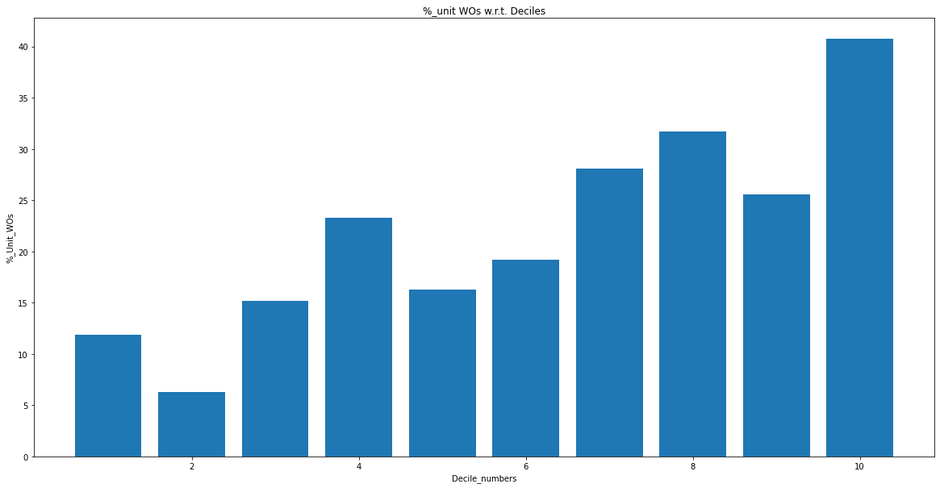

**L1 = 0, l2 = 0, lr = 0.3 (highest correlated features)**

**Train set**

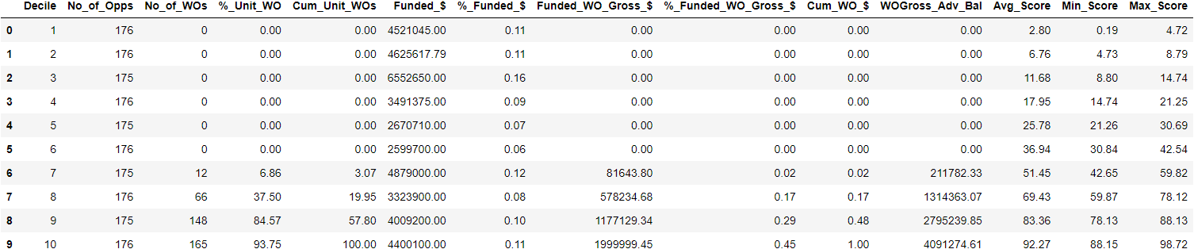

**Val set**

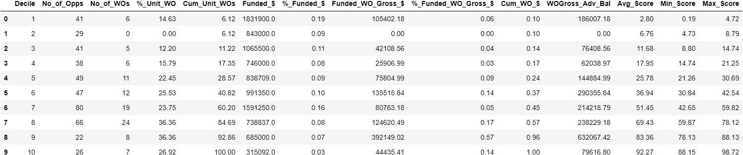

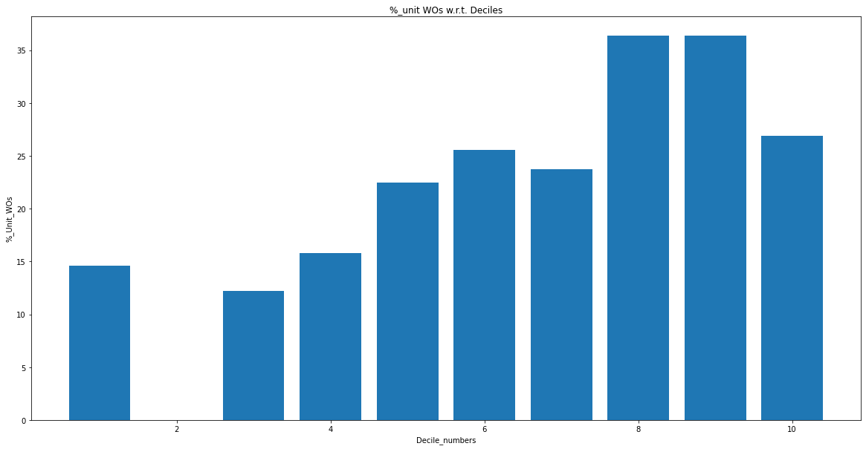

**L1 = 0.1, l2 = 0, lr = 0.3 (highest correlated features)(monotonic except 4th decile).**

**Train set**

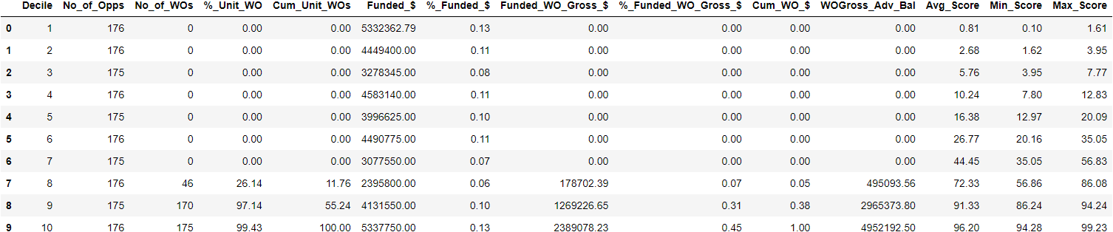

**Val set**

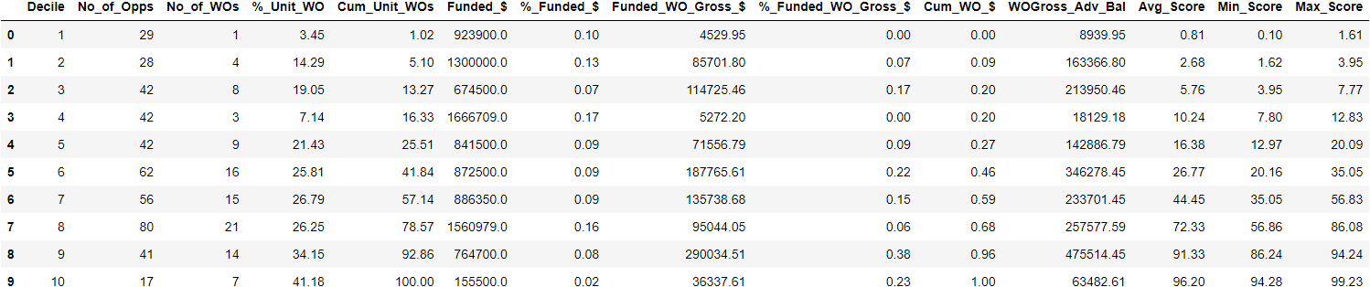

**Observations** (Overall not a good model)

1. Average Scores are very less compared to other model deciles. However %Unit_WOs are higher than average scores
2. In val set, model shows monotonic behaviour except in 4th decile
3. Till 4th deciles, cumulative_unit_wos is 16 %

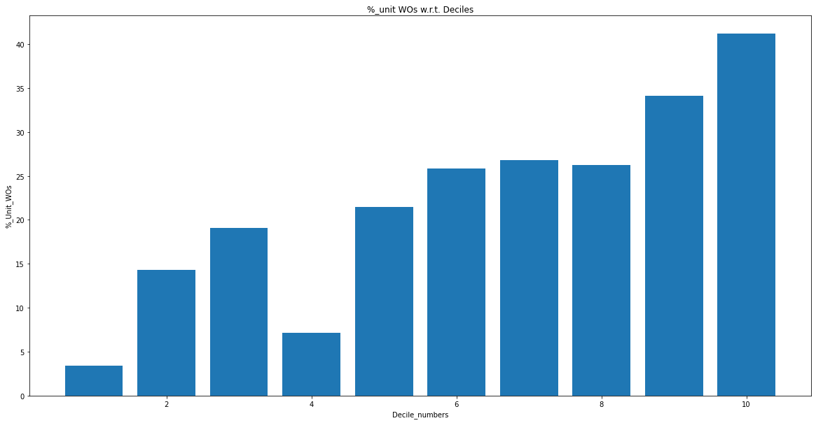

**L1 = 0.1, l2 = 1, lr = 0.3 (highest correlated features)(slight monotonicity)**

**Train set**

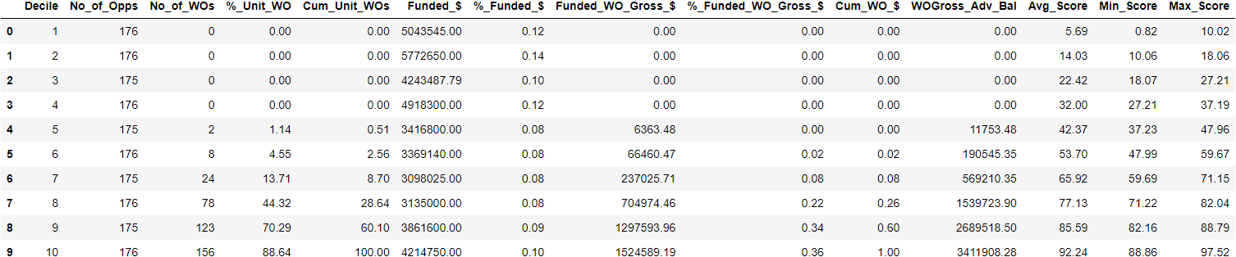

**Val set**

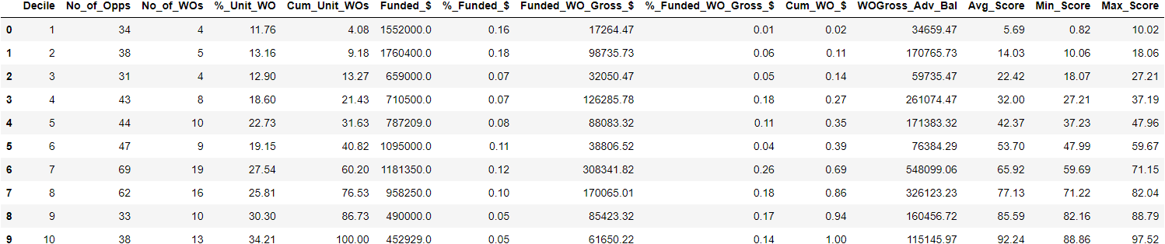

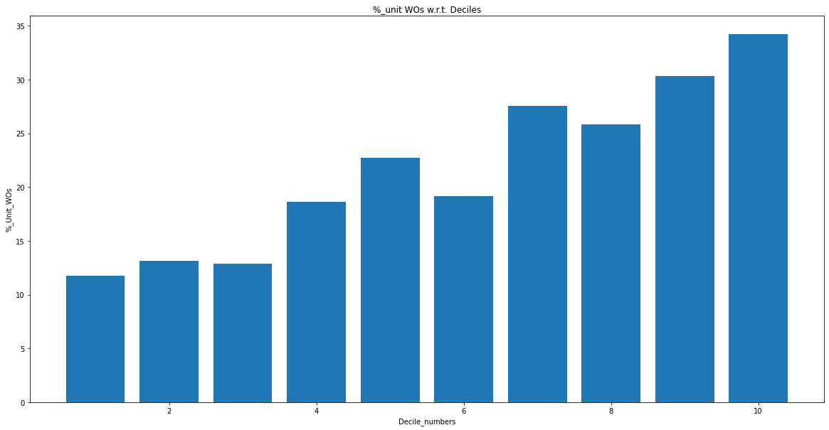

**L1 = 0.1, l2 = 2 , lr = 0.3(highest correlated features)**

**Train set**

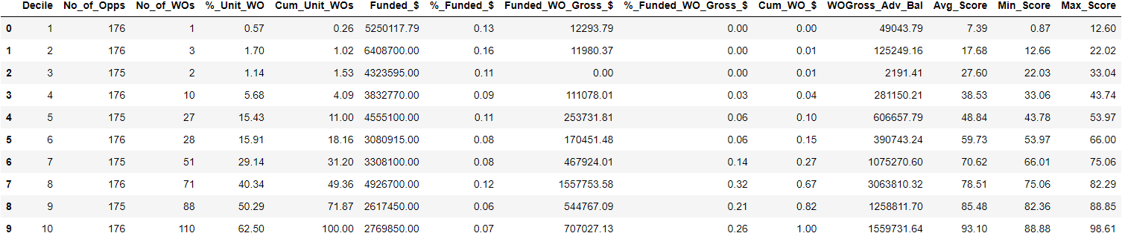

**Val set**

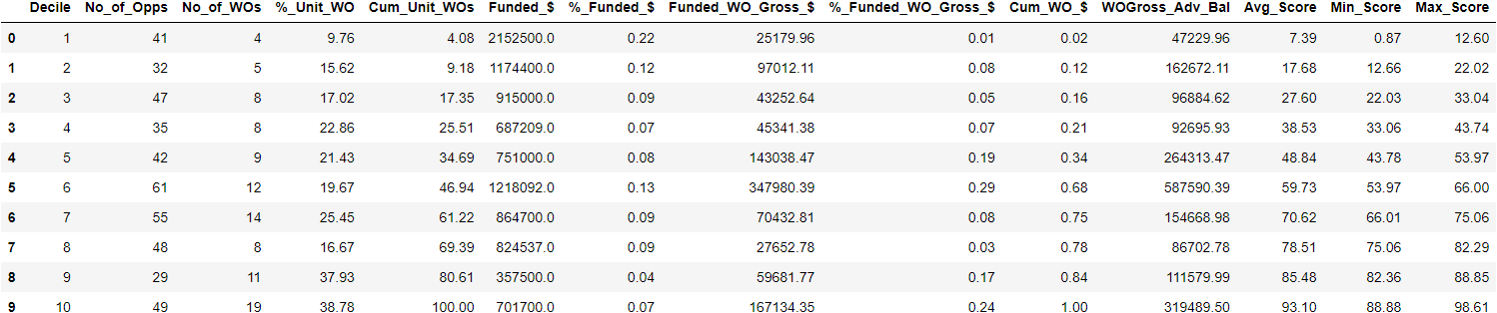

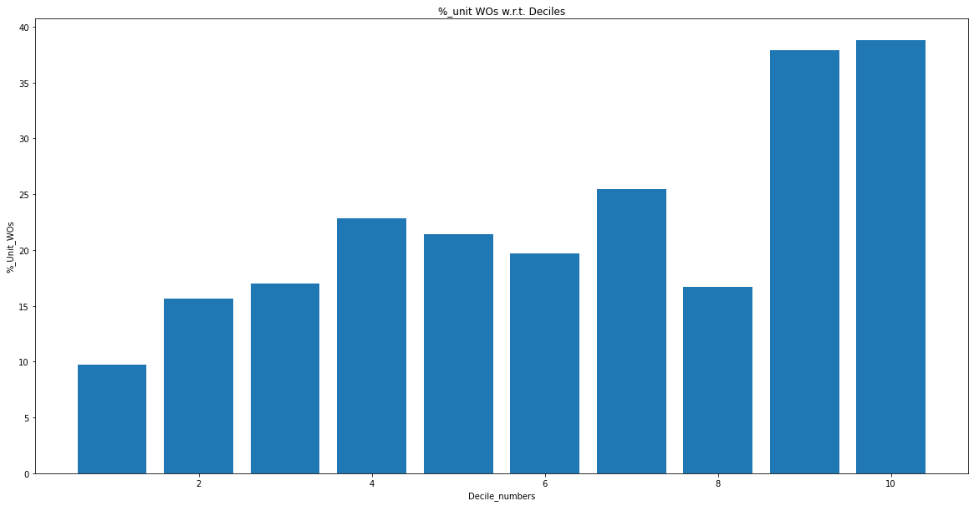

**L1 = 0.1, l2 = 0 ,lr = 0.3 (dropping correlated features)**

**Train set**

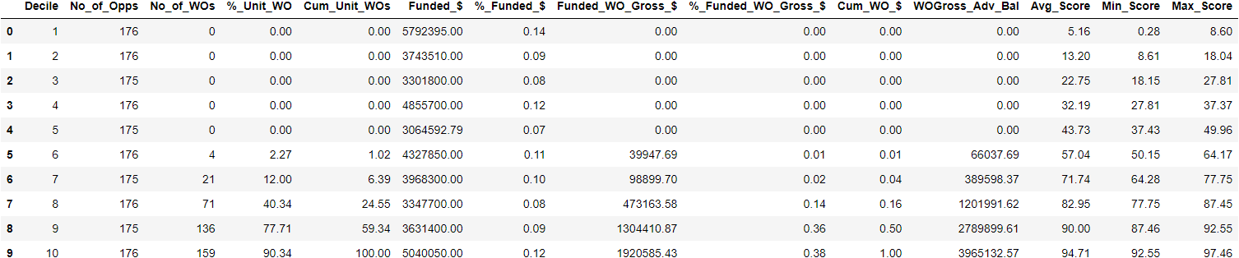

**Val set**

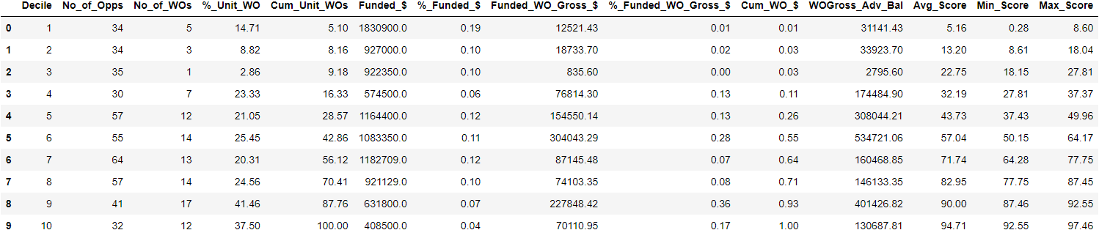

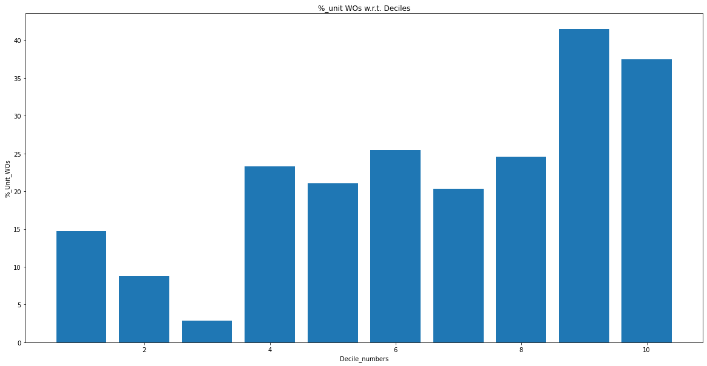

**L1 = 0 , l2 = 1 , lr = 0.3 (dropping correlated features)**

**Train set**

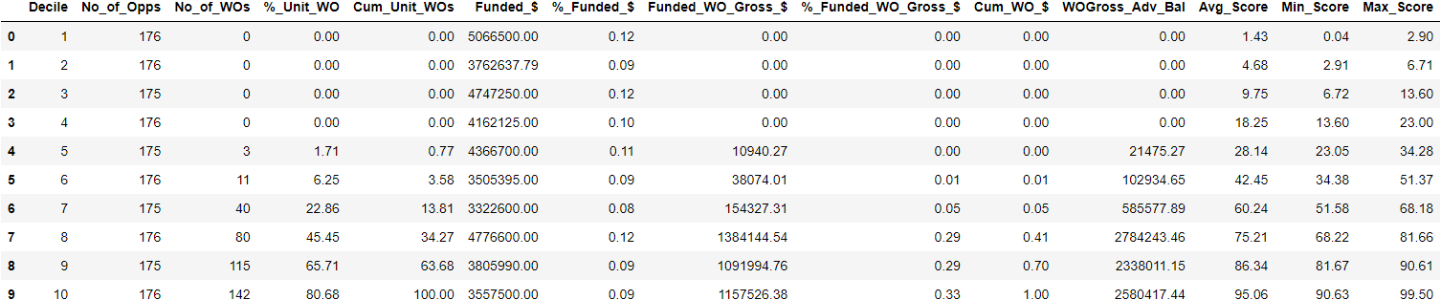

**Val set**

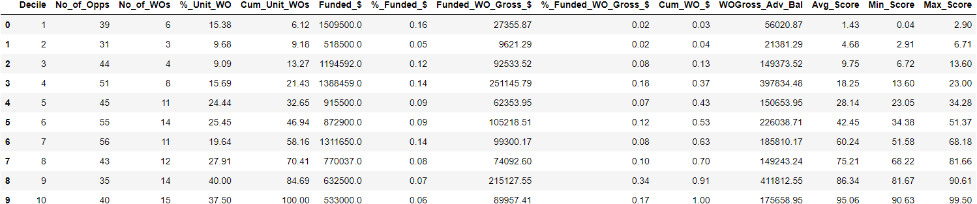

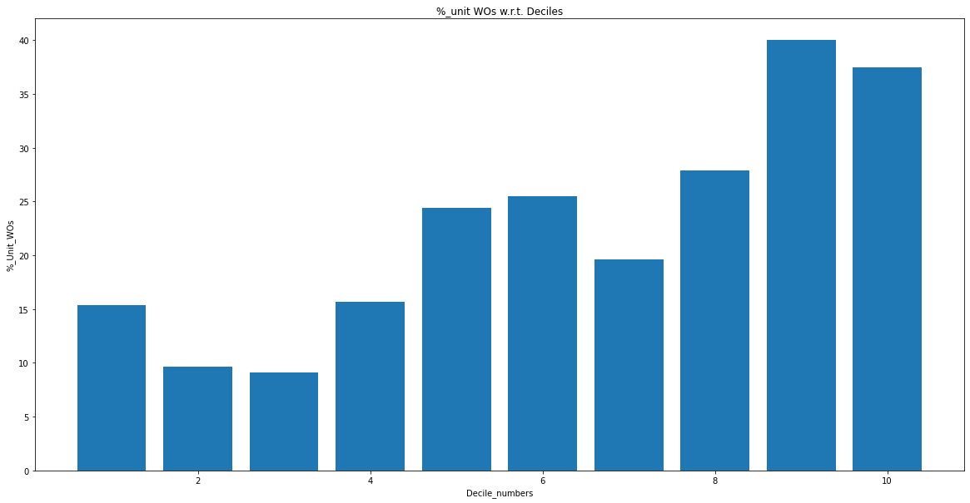

**L1 = 0.1 , l2 = 1, lr = 0.3 (dropping correlated features)**

**Train set**

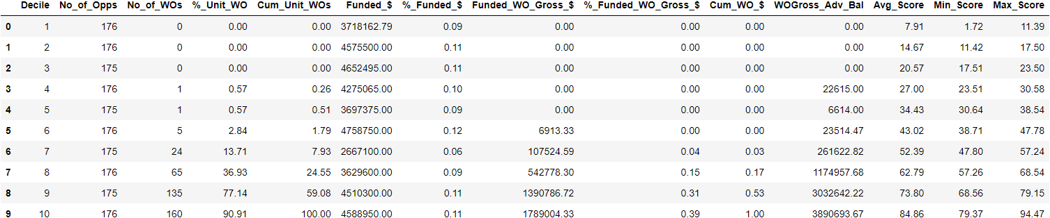

**Val set**

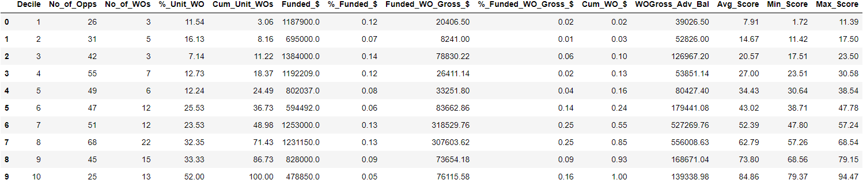

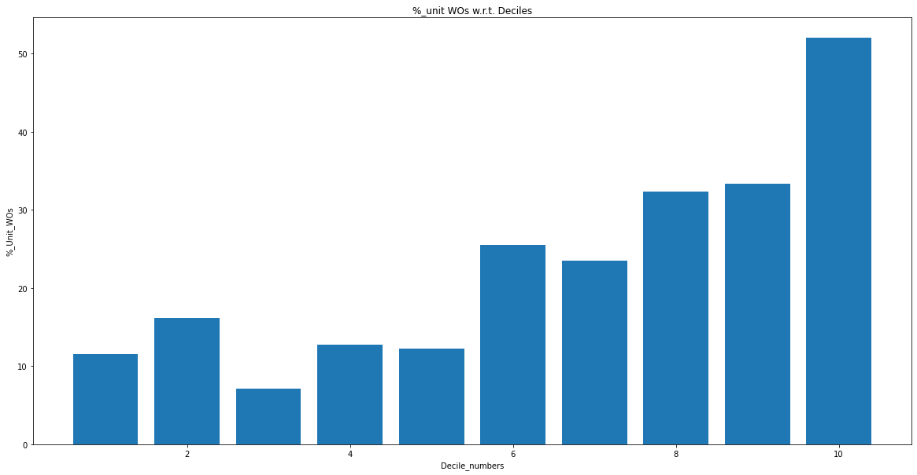

**L1 = 0.2 , l2 = 1, lr = 0.3 (dropping correlated features)(1st decile excellent)**

**Train set**

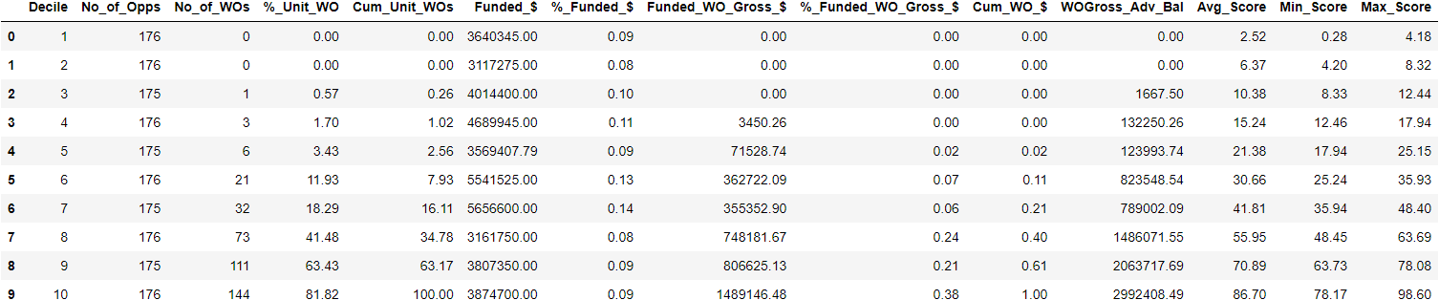

**Val set**

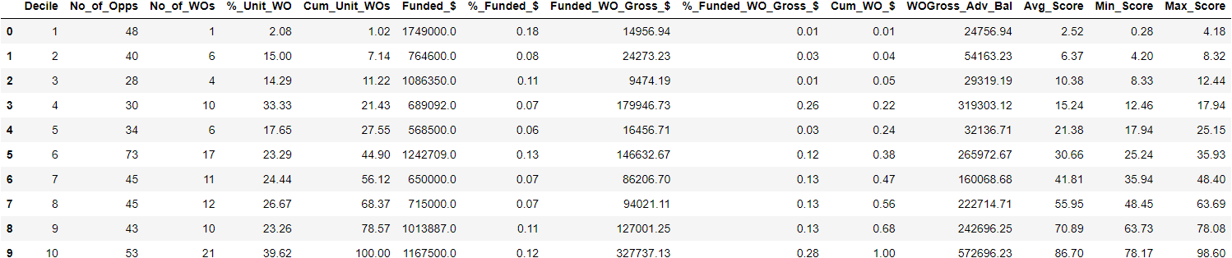

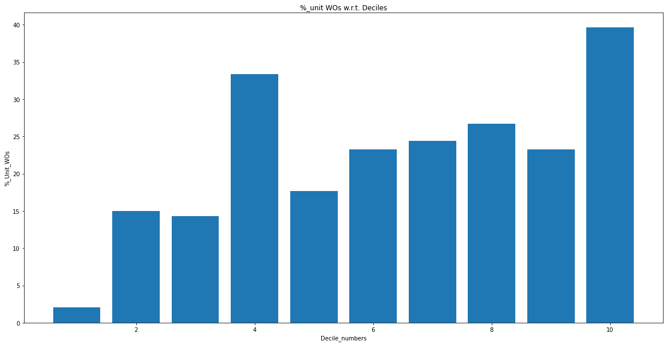

**L1 = 0.3 , l2 = 1, lr = 0.3 (dropping correlated features)**

**Train set**

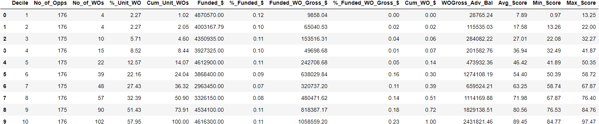

**Val set**

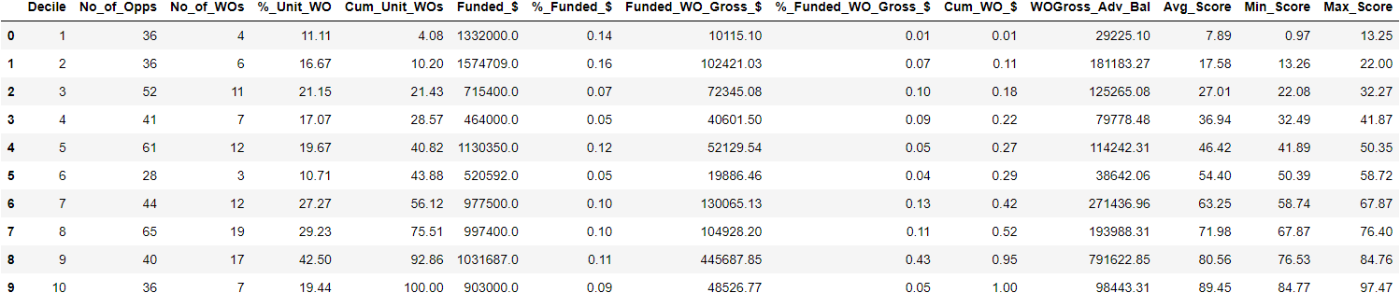

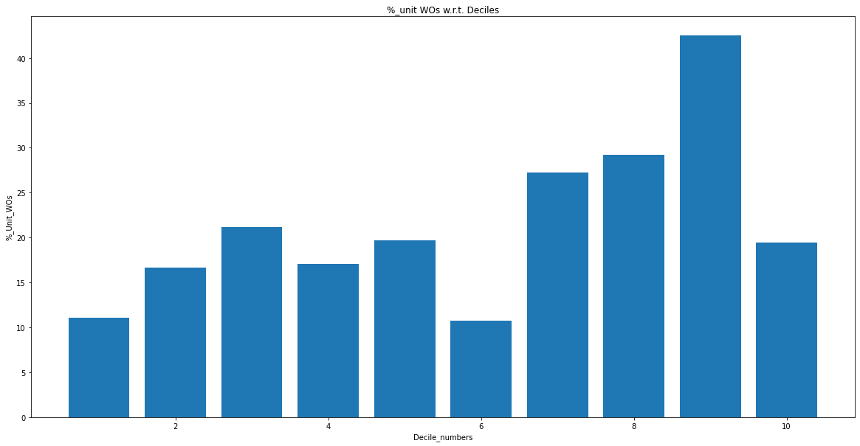

**L1 = 0.5, l2 = 1, lr = 0.3 (dropping correlated features)**

**Train set**

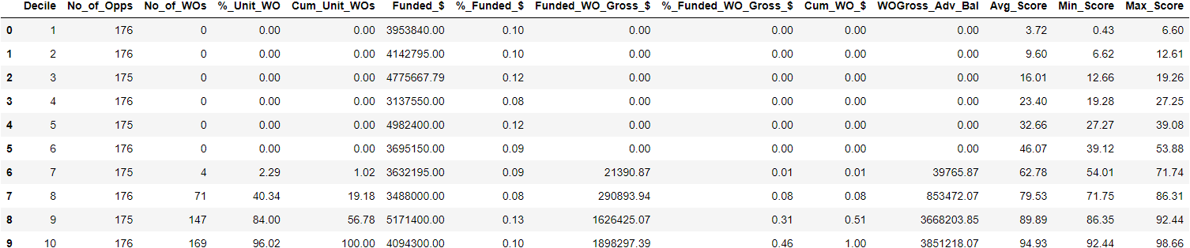

**Val set**

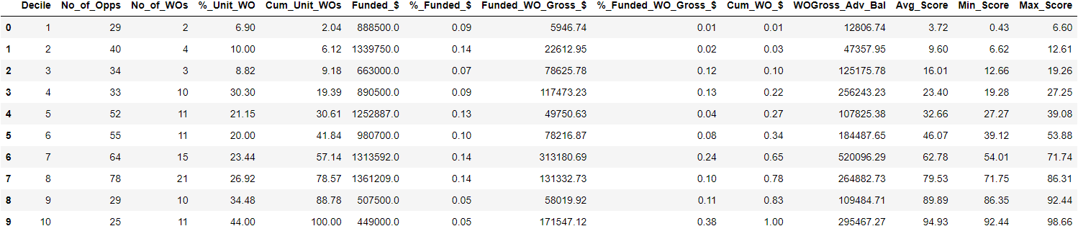

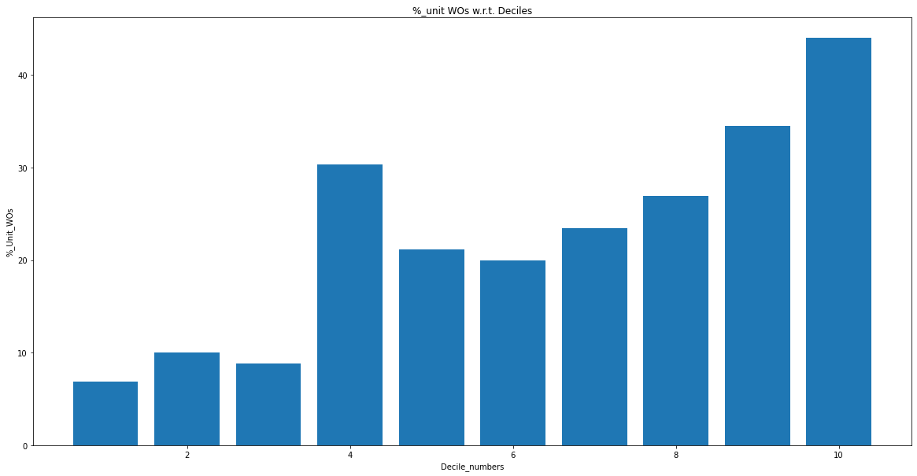

**L1 = 1, l2 = 1, lr = 0.3 (dropping correlated features)(decent val set)**

**Train set**

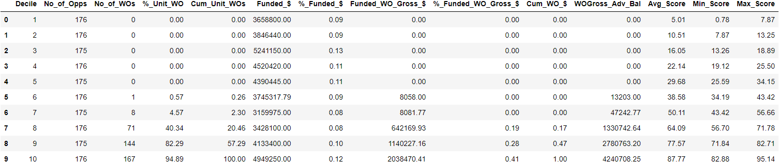

**Val set**

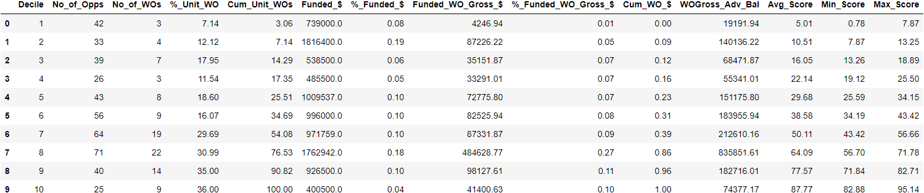

**Observations:**

1. Monotonicity breaks at 2 deciles (4th and 6th deciles)
2. In Upper Deciles %Unit_Wos are slightly higher than the average scores. However they are in the range of probability values (min and max)

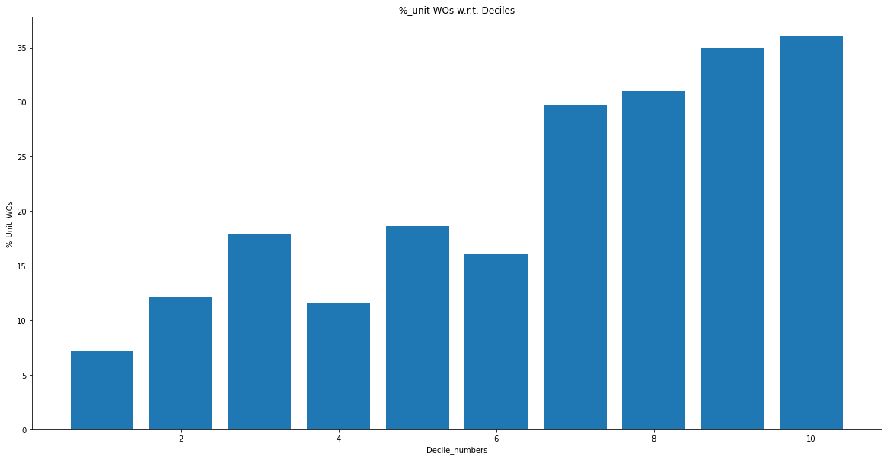

**L1 = 0.8 , l2 = 1, lr = 0.3 (dropping correlated features)**

**Train set**

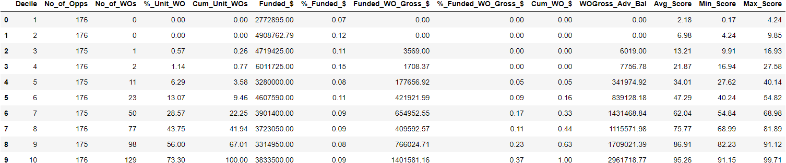

**Val set**

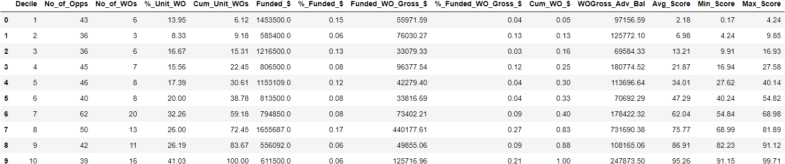

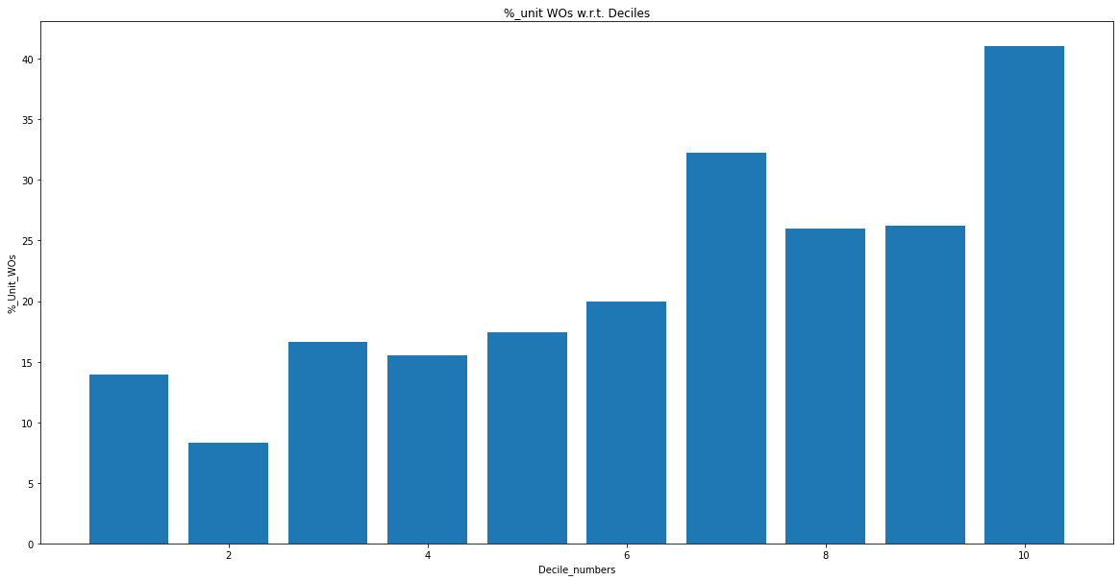

**L1 = 1.2, l2 = 1, lr = 0.3 (Dropping correlated features)(decent val set)**

**Train set**

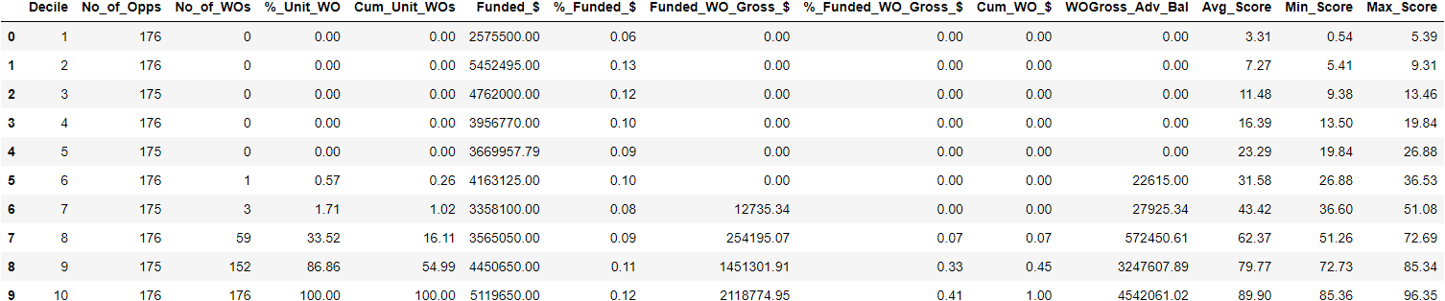

**Val set**

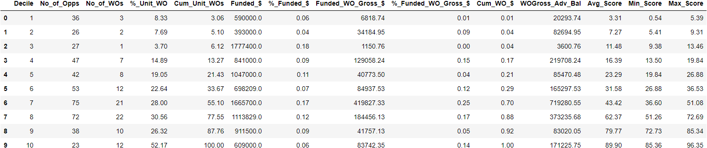

**Observations:**

1. Apart from 1st decile - all deciles %Unit_Wo are below average score
2. Cumulative Unit_WO of the first 4 deciles is small compare to other models (13%)

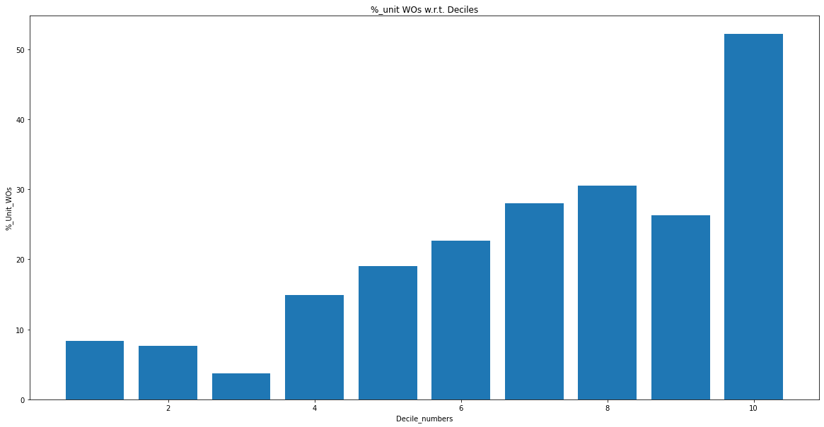

**L1 = 1.5, l2 = 1, lr = 0.3 (dropping correlated features)**

**Train set**

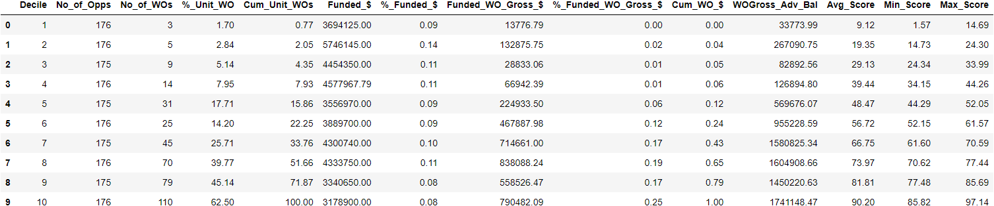

**Val set**

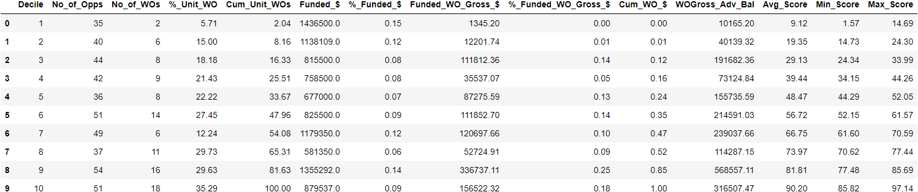

**Observations:**

1. Deciles are monotonic accept for the 7th decile, 9th decile %Unit_Wo ~ 8th decile %Unit_WO
2. %Unit_WO are less than the average scores. However average scores values are bit high

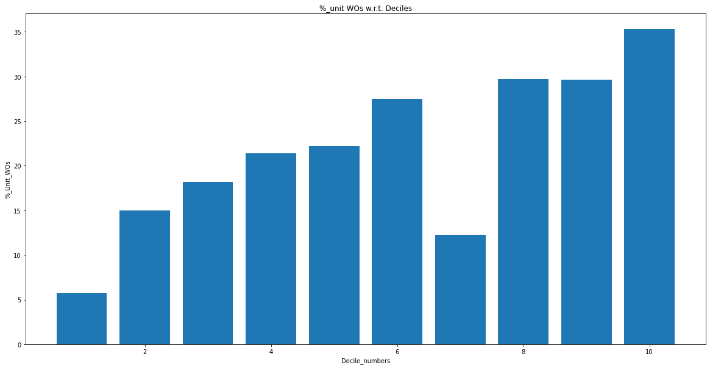

**L1 = 1, l2 = 0, lr = 0.3 (dropping correlated features)**

**Train set**

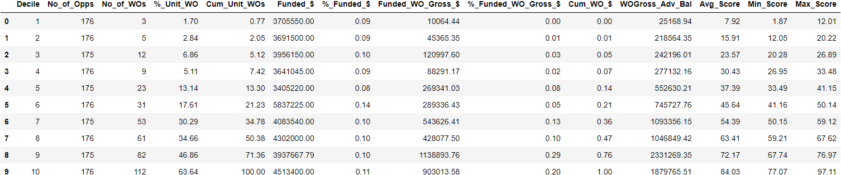

**Val set**

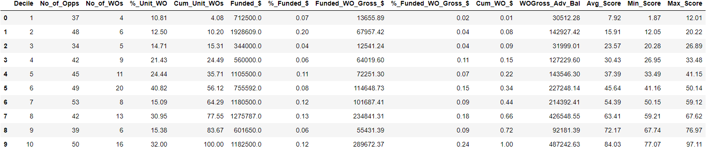

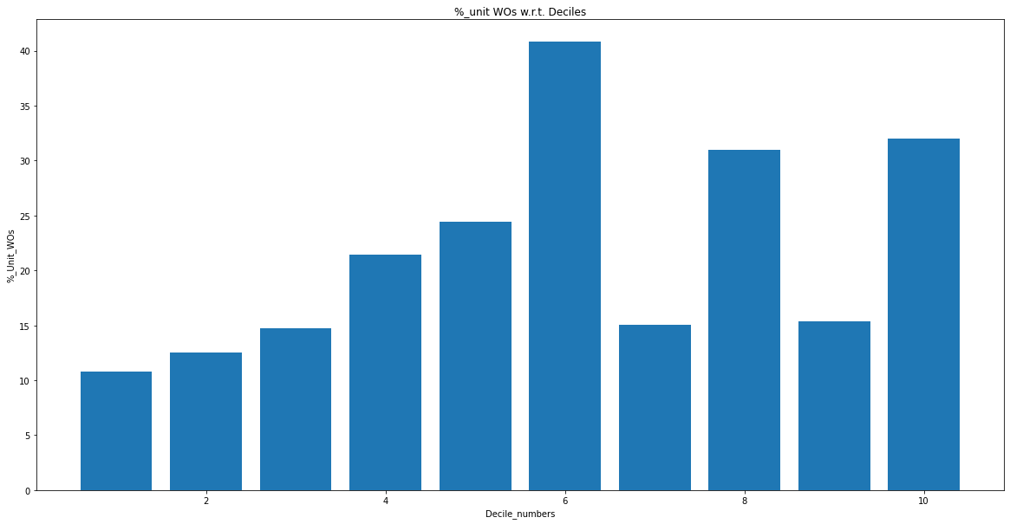

**L1 = 1, l2 = 2, lr = 0.3 (dropping correlated features)**

**Train set**

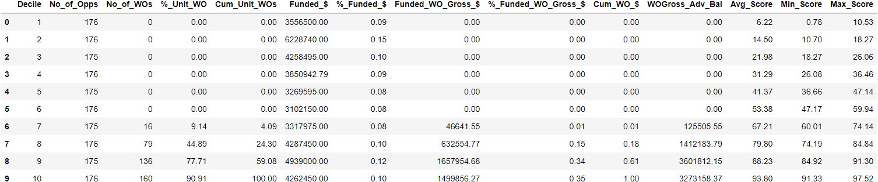

**Val set**

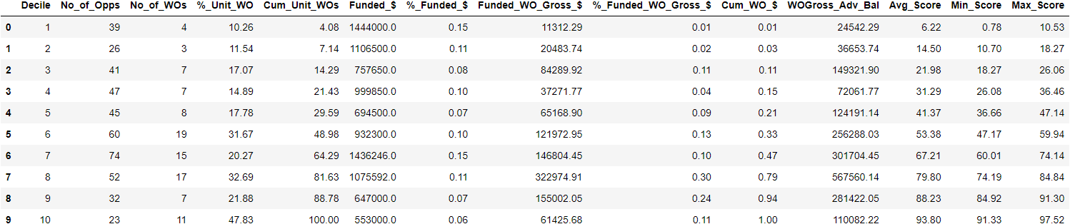

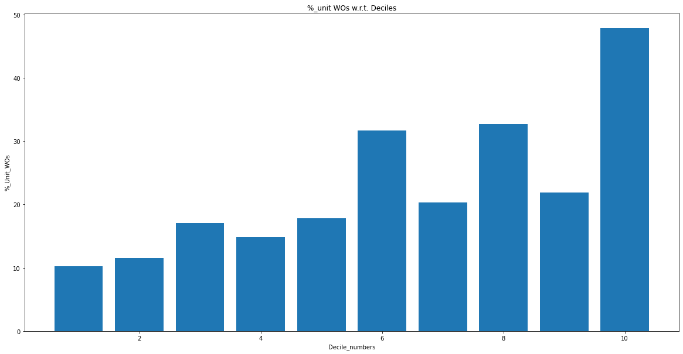

**L1 = 1, l2 = 3, lr = 0.3 (dropping correlated features)**

**Train set**

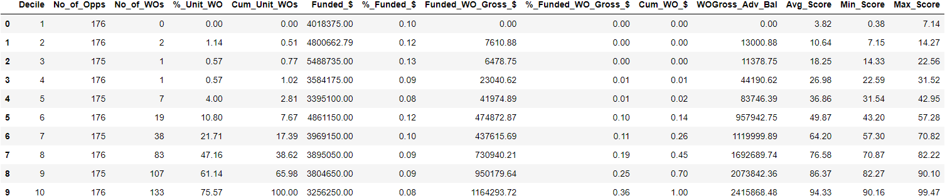

**Val set**

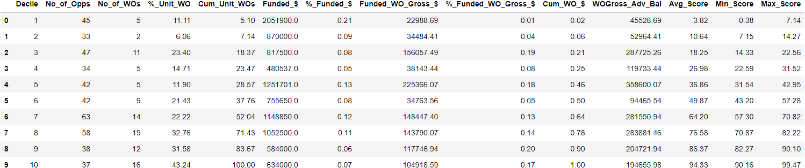

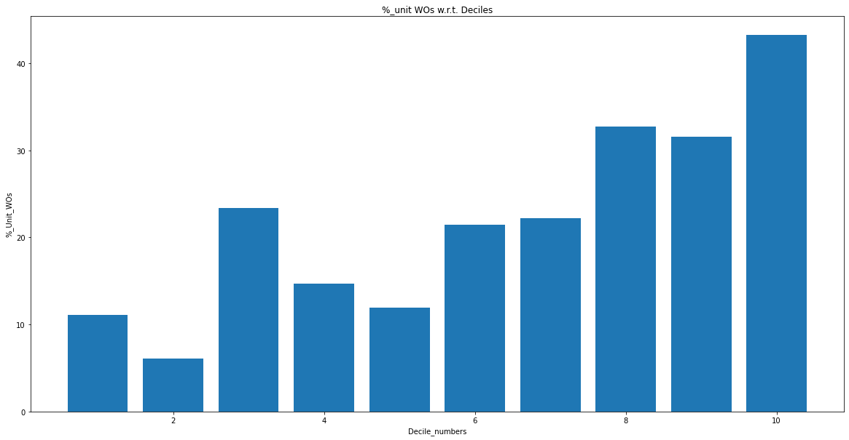

**L1 = 1, l2 = 5 , lr = 0.3 (dropping correlated features)**

**Train set**

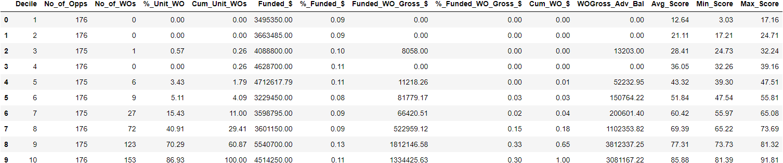

**Val set**

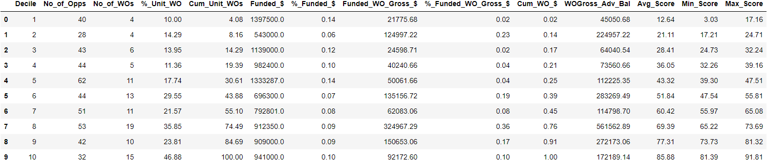

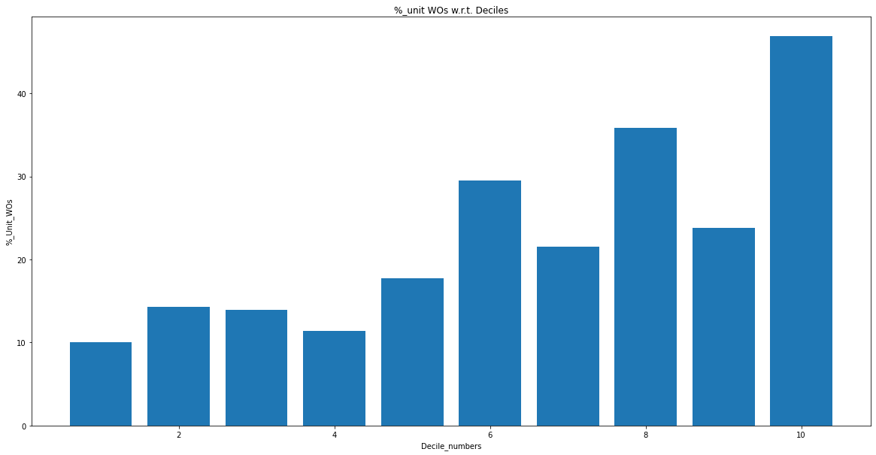

**L1 =1, l2 =10, lr =0.3 (dropping correlated features)**

**Train set**

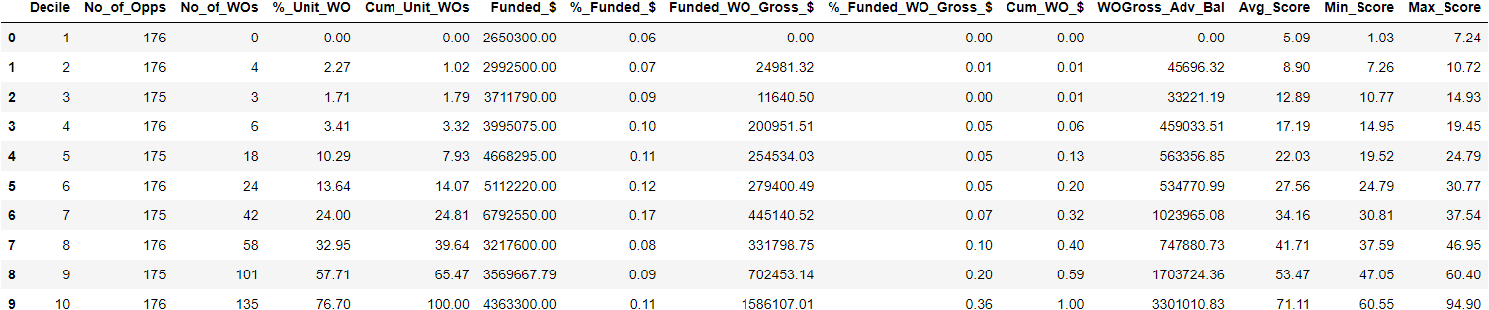

**Val set**

