A PROJECT REPORT ON
“ICC COMPANION: A WEB-BASED STUDENT PORTAL AND MANAGEMENT SYSTEM”
A Project Report in partial fulfilment of the requirement for the degree of
Bachelor of Computer Application
Under GAUHATI UNIVERSITY



Name of the Guide: Manas Chakraborty, Asst. Prof
Department: Bachelor of Computer Application
ICON Commerce College, Guwahati-781003
Submitted By:
Abhishek Sharma
Roll No: UT-231-049-0004
Registration No: 23084898
BCA 6th Semester (FYUGP)
ICON Commerce College
CERTIFICATE
This is to certify that the project entitled “ICC COMPANION: A WEB-BASED STUDENT PORTAL AND MANAGEMENT SYSTEM” has been submitted by Abhishek Sharma (Roll No: UT-231-049-0003, Registration No: 23084898) in partial fulfilment of the requirements for the degree of Bachelor of Computer Applications (BCA), 6th Semester, at Icon Commerce College, Gauhati University, during the Academic Session 2025–26.
This is an authentic work carried out by the candidate under my supervision and guidance. The project has not been submitted to any other university or institution for the award of any degree or diploma.
Date: ____________________

Name of the Guide: Manas Chakraborty
Designation: Assistant Professor
Department: Bachelor of Computer Application
Institution: Icon Commerce College
Guwahati – 781003
Signature of the Guide: ____________________
DECLARATION
I hereby declare that the project report “ICC Companion: A Web-Based Student Portal and Management System”, submitted in partial fulfilment of the requirement for the degree of Bachelor of Computer Application (BCA) in Icon Commerce College, under Gauhati University, is my original work and has not been submitted for the award of any other degree, diploma, fellowship, or other similar titles elsewhere.
Date: ____________________ Signature: ________________
Place: Guwahati

Name: Abhishek Sharma
Roll No: Ut-231-049-0003
Registration No: 23084898
Department: BCA 6th Semester
Icon Commerce College

ACKNOWLEDGEMENT
First of all, I would like to express my sincere gratitude to my project guide and mentor, Manas Chakraborty, Assistant Professor, Department of Computer Application, for instilling confidence in me, providing invaluable guidance, offering critical feedback, and sparing his valuable time throughout the duration of this project work.
It is my distinct honor to thank Dr. Mandira Saha, Principal of Icon Commerce College, and Tridib Kr. Handique, Co-Ordinator of the B.C.A Department, for providing excellent academic infrastructure, encouragement, and the necessary permissions to undertake this project work successfully.
I would also like to express my thanks to the entire faculty of the Computer Application department for their collective help and support during my study. My heartfelt gratitude goes to my classmates and friends who agreed to test the application, provide insights, and offer practical suggestions during its development stage.
Finally, I owe a deep debt of gratitude to my parents for their unconditional emotional and financial support, patience, and encouragement, which enabled me to finalize this project report within the limited timeframe.

Place: Guwahati
Date: ____________________

Name: Abhishek Sharma
Roll No: UT-231-049-0003
Registration No: 23084898
BCA 6th Semester (FYUGP),
Icon Commerce College
TABLE OF CONTENTS
SECTION / CHAPTER | PAGE NO.
Certificate | ii
Declaration | iii
Acknowledgement | iv
Chapter 1: Introduction | 1
1.1 Background | 1
1.2 Problem Statement | 1
1.3 Proposed Solution | 2
Chapter 2: Requirement Specification | 3
2.1 System Requirements | 3
2.2 Technologies Used | 3
Chapter 3: Objectives of the Project | 6
Chapter 4: Scope of the Project | 7
4.1 Functional Scope (In Scope) | 7
4.2 Out of Scope Limitations | 7
Chapter 5: System Analysis | 9
5.1 Existing System and Limitations | 9
5.2 Proposed System | 9
5.3 Feasibility Study | 10
Chapter 6: System Design | 12
6.1 System Architecture | 12
6.2 Data Flow Diagram (DFD) | 12
6.3 Use Case Diagram | 13
6.4 Entity-Relationship (ER) Diagram | 14
Chapter 7: Database Design | 15
Chapter 8: Implementation / Working | 19
Chapter 9: Sample Screenshots | 23
Chapter 10: Advantages & Limitations | 27
Chapter 11: Future Enhancements | 29
Chapter 12: Conclusion | 31
Reference | 33

CHAPTER 1: INTRODUCTION
1.1 Background
In modern higher education institutions, communication and information accessibility play a critical role in shaping the academic experience of students. Icon Commerce College, a premier educational center, serves hundreds of students across various streams. Currently, student services such as distributing academic notices, sharing day-to-day class timetables, allocating course resources, and managing feedback are managed through fragmented networks—physical notice boards, standalone emails, and third-party social messaging groups. This dispersion often results in missing critical academic updates, misplacing lecture resources, and creating a information gap between the student body and the administration.
With the rapid adoption of digital infrastructure in educational operations, establishing a centralized digital touchpoint is crucial. The 'ICC Companion' project is conceived as an integrated, secure, web-based student companion portal tailored specifically for the internal stakeholders of Icon Commerce College. By providing a structured database environment coupled with a responsive user interface, it ensures that students can access critical academic tools from any device seamlessly, thereby introducing high traceability, efficiency, and organizational transparency to day-to-day academic life.
1.2 Problem Statement
The absence of an integrated, dedicated student academic companion portal at the institutional level leads to several structural and administrative challenges:
- Physical notice boards require students to be present on campus and often lead to critical information being overlooked or delayed.
- Course handouts, lecture notes, and syllabus copies shared via external chat applications get buried in casual conversations, making search and archival extremely cumbersome for students.
- Class timetables and schedule modifications are communicated textually, resulting in room scheduling confusion, scheduling conflicts, or missed announcements.
- There is no private, formal, and structured digital mechanism for students to submit academic queries or feedback directly to administrative coordinators, leaving concerns unresolved or poorly documented.
- Administrators lack a unified data dashboard to broadcast updates, handle student records, upload academic schedules, and analyze feedback metrics effectively.
1.3 Proposed Solution
The 'ICC Companion' is an advanced, web-based platform built on a classic three-tier architecture using PHP, MySQL, HTML5, CSS3, and JavaScript. It serves as a single, unified digital portal that bridges the communication gap between students and college administration. The application organizes college life into separate, session-authenticated environments: a Student Portal and an Admin Portal.
Students are provided with personal profiles where they can track active institutional notices, view daily structured timetables, download learning resources organized by department and semester, and submit feedback or queries directly to coordinators with clear status tracking. On the backend, administrators access a powerful management control dashboard showing student enrollment metrics, active notice broadcast controls, structured timetable configuration tables, resource upload managers, and a feedback redressal handler. This system transforms college communication into an audit-ready, organized, and reliable digital ecosystem.

CHAPTER 2: REQUIREMENT SPECIFICATION
2.1 System Requirements
To ensure proper deployment and smooth performance during execution, the application requires standard infrastructure configurations on both the host server side and the end-user client side.
Hardware Requirements
Hardware Component | Minimum Server Specification | Minimum Client Specification
Processor | Intel Core i3 or equivalent (2.4 GHz) | Intel Celeron / Dual Core or equivalent
RAM | 4 GB or higher | 2 GB available system memory
Storage Space | 20 GB available SSD/HDD storage | 500 MB available local disk space
Network interface | Standard LAN / High-speed Internet line | Standard internet access / Intranet connectivity

Software Requirements
Software Component | Development & Server Host Environment | Client End-User Environment
Operating System | Windows 10 / 11 or Linux (Ubuntu 20.04+) | Windows, macOS, Linux, Android, or iOS
Web Server | Apache 2.4+ (via XAMPP or WAMP local bundle) | Not applicable (Server-side execution only)
Scripting Language | PHP 7.4+ (Server-side runtime interpreter) | Not applicable
Database Management | MySQL 5.7+ / MariaDB 10.4+ | Not applicable
Client Web Browser | Google Chrome (for testing administrative layouts) | Chrome, Firefox, Safari, Edge, or Opera

2.2 Technologies Used
The ICC Companion system is built purely using open-source web development technologies to ensure stability, ease of deployment, and high operational performance without licensing costs:
- PHP (Hypertext Preprocessor): Used as the primary server-side scripting runtime. It handles form data validation, session state persistence, file upload verification, and procedural queries to the database layer.
- MySQL Database Server: Acts as the secure relational data store, organizing data structures across six distinct normalization-compliant tables linked with relational foreign key integrity.
- mysqli Extension: Utilized for executing native database connections, employing parameter binding and prepared statements to defend against web injection exploits.
- HTML5: Sets up the structural semantics across all application layouts, forms, tables, and dash views.
- CSS3: Controls custom layout styling via an optimized, custom sheet (style.css), utilizing fluid grids, typographic hierarchies, and interactive component transitions.
- Vanilla JavaScript: Used extensively for form client-side pre-validation, dynamic tabular search filters, profile interaction widgets, character count safety, and modal overlay animations.
- Font Awesome Icons: Embedded via a secure CDN to provide intuitive vector iconography across menus, sidebar items, status indicators, and utility actions.

CHAPTER 3: OBJECTIVES OF THE PROJECT
The primary objectives guiding the conceptualization, development, and delivery of the ICC Companion system are:
- Centralize Student Information: Create a secure, centralized digital repository where students can view their academic profile, schedules, and college materials in one place.
- Automate Notice Broadcasting: Enable the administration to publish time-sensitive notices digitally, ensuring immediate visibility and removing the reliance on physical notice boards.
- Organize Class Timetables: Implement a structured database system to store and render class timetables by department and semester, preventing scheduling overlaps and confusion.
- Facilitate Resource Access: Provide an easy-to-use repository where teachers or admins can upload learning materials, syallbi, and reference files for instant download by students.
- Streamline Feedback Redressal: Establish a secure communication channel where students can raise academic questions, allowing administrators to review, track, and respond to them professionally.
- Ensure Robust Security: Protect user data through bcrypt password encryption, prevent cross-site execution via character escaping, and eliminate SQL injection with prepared queries.
- Optimize User Experience: Deliver a clean, highly intuitive interface requiring zero prior technical training for both students and non-technical staff.

CHAPTER 4: SCOPE OF THE PROJECT
4.1 Functional Scope (In Scope)
The system bounds are carefully tailored to address the internal student-coordination needs of a single-campus institution like Icon Commerce College. Features in active operational scope include:
- User Authentication: Secure multi-portal registration and authentication for students and administrators, using persistent session handling.
- Notice Management Module: Full administrative controls to write, update, and manage official college notices with optional file attachments.
- Academic Schedule Board: Administrative tools to input, modify, and display day-specific timetables, including faculty names, room allocations, and timings.
- Resource Vault: Upload engine for learning materials categorized strictly by target department and semester, with automated storage file sanitization.
- Feedback Tracker: Two-way communication terminal allowing students to draft feedback, trace status updates, and view inline administrative replies.
- Administrative Statistics Engine: Dashboard metrics rendering live analytical counts of registered student profiles, total notice logs, and pending student queries.
4.2 Out of Scope Limitations
To maintain project feasibility within the final-semester timeframe, the following boundaries are established as out of scope:
- No External SMS Gateway: The system does not integrate real-time cellular SMS text lines due to premium carrier API requirements.
- Single-Institution Architecture: The application cannot host multi-campus entities or separate standalone branches inside a shared database schema.
- No Mobile Native Build: The app is purely web-browser responsive and does not feature compilations for Android APK or iOS packages.
- No Automated Online Fee Gateway: Financial collection modules, payment processing, and ledger checkouts are completely excluded.

CHAPTER 5: SYSTEM ANALYSIS
5.1 Existing System and Its Limitations
Currently, operations at Icon Commerce College rely on scattered manual methods and generic communication tools. Notices are physically pinned to administrative bulletin boards or forwarded via unofficial chat channels. Learning resources are distributed via individual emails, or third-party file sharing links. Timetables are shared as image documents or printed flyers.
Limitations of the Existing Setup:
- Information is easily lost or overshadowed in crowded chat groups.
- Students missing physical classes often lose visibility of campus notice boards.
- Searching historic notices or old lecture notes requires manual scrolling and is highly inefficient.
- Students lack a formal, private channel to raise academic concerns, leading to unresolved student issues.
- Administrators cannot easily track total engagement, analyze feedback, or update details systematically.
5.2 Proposed System and Its Advantages
The proposed system, ICC Companion, replaces these scattered mechanisms with an organized database platform. It provides a secure portal where data is structured, indexed, and available 24/7.
Key Tactical Advantages:
- Instant Accessibility: Students can fetch notices, timetables, and notes anytime, anywhere via a web browser.
- High Structural Organization: Information is categorized cleanly by department and semester, removing clutter.
- Traceable Feedback Loop: Every inquiry has a clear tracking lifecycle, improving administrative accountability.
- Robust Security Architecture: Employs parameter binding, data sanitation, and encryption to safeguard data.
- Aggregated Administration View: Provides real-time dashboard summaries for faster decision-making.
5.3 Feasibility Study
A comprehensive three-pronged feasibility assessment was conducted to confirm the viability of the project:
Technical Feasibility: The system relies on well-established core web technologies (PHP, MySQL, HTML5, CSS3, JS). Since these technologies run seamlessly on standard local servers (like XAMPP/WAMP) and any modern web browser, the project is fully feasible without specialized hardware.
Economic Feasibility: All development tools, database servers, and runtime interpreters used are open-source and free. This keeps development and operational costs minimal, making it highly cost-effective for implementation.
Operational Feasibility: The application features clean layouts and simple navigation, tailored for users with basic digital literacy. Administrative workflows are straightforward, meaning non-technical college staff can manage data with zero specialized training.

CHAPTER 6: SYSTEM DESIGN
6.1 System Architecture
The system is designed using a clean three-tier software architecture. The Presentation Layer handles user views in the web browser. The Application Layer executes logical operations using server-side PHP on Apache. The Data Layer manages secure transactions via a structured MySQL database.
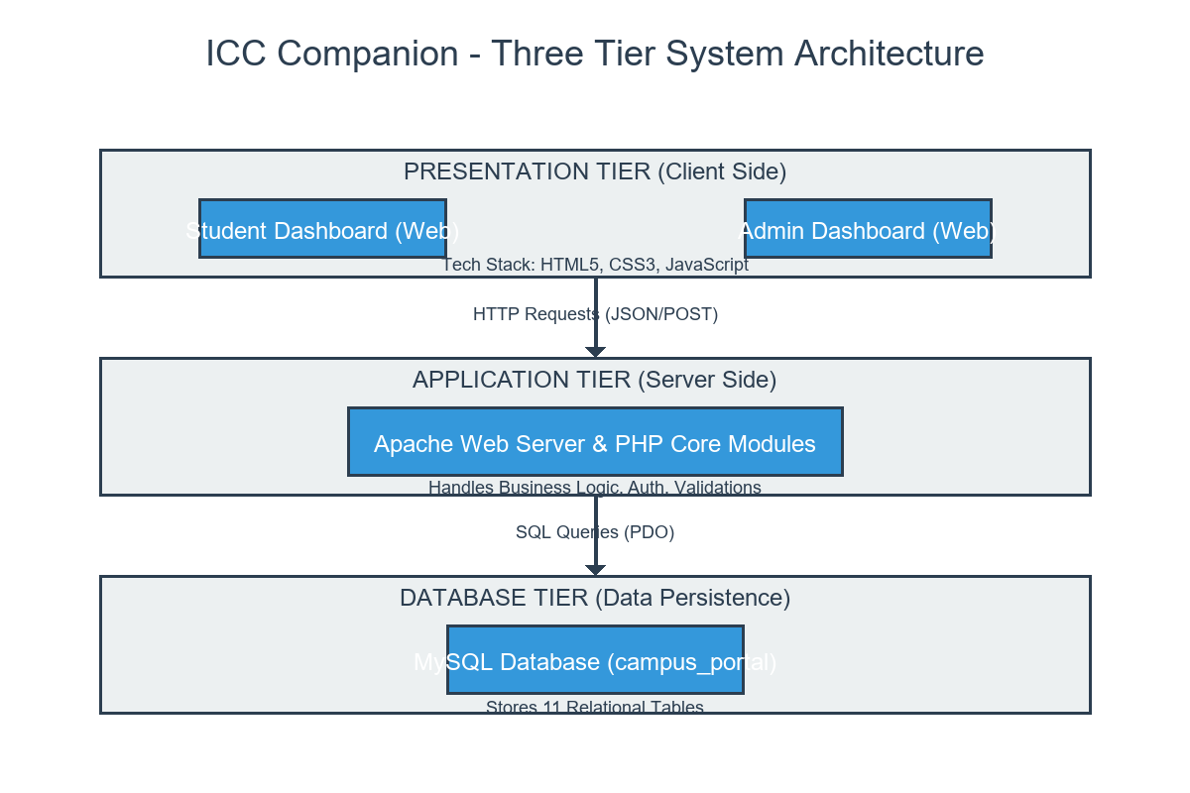

6.2 Data Flow Diagram (DFD)
The DFD details how information moves through the application, starting from external inputs down to database writes:
Level 0 Context Diagram: Focuses on high-level boundary flows, showing Student and Admin entities exchanging credentials, notifications, and feedback with the core application system process.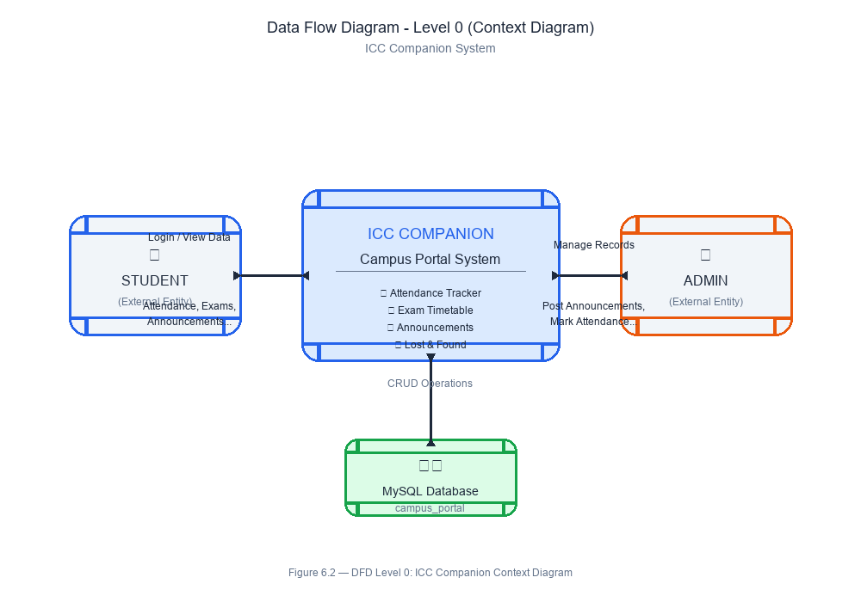

Level 1 Process Breakdown DFD: Maps data movements across specific sub-processes, including login validation, notice distribution, schedule filtering, file archiving, and feedback updating.
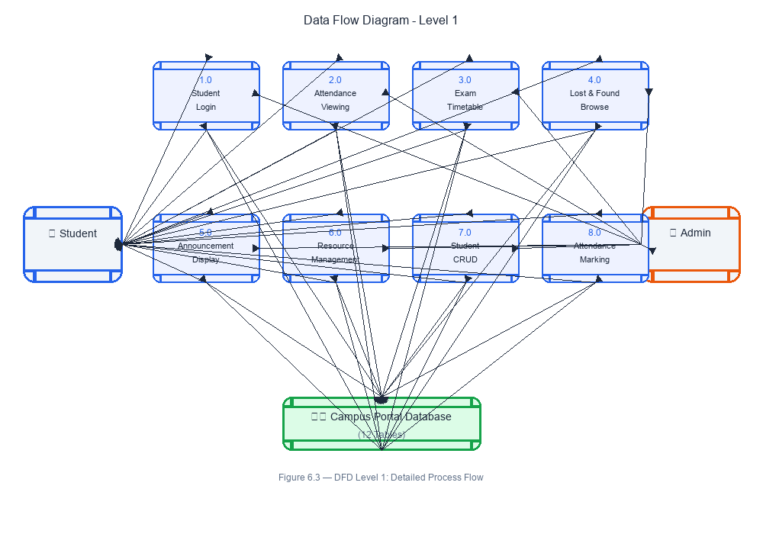

6.3 Use Case Diagram
The Use Case Diagram defines user roles and system boundaries, mapping user activities to specific application functions:
- Student Use Cases: Register account, authenticate sessions, check notices, look up schedules, download resources, and track submitted feedback.
- Admin Use Cases: Access dashboard, broadcast notices, configure timetables, manage files, review student entries, and update feedback responses.
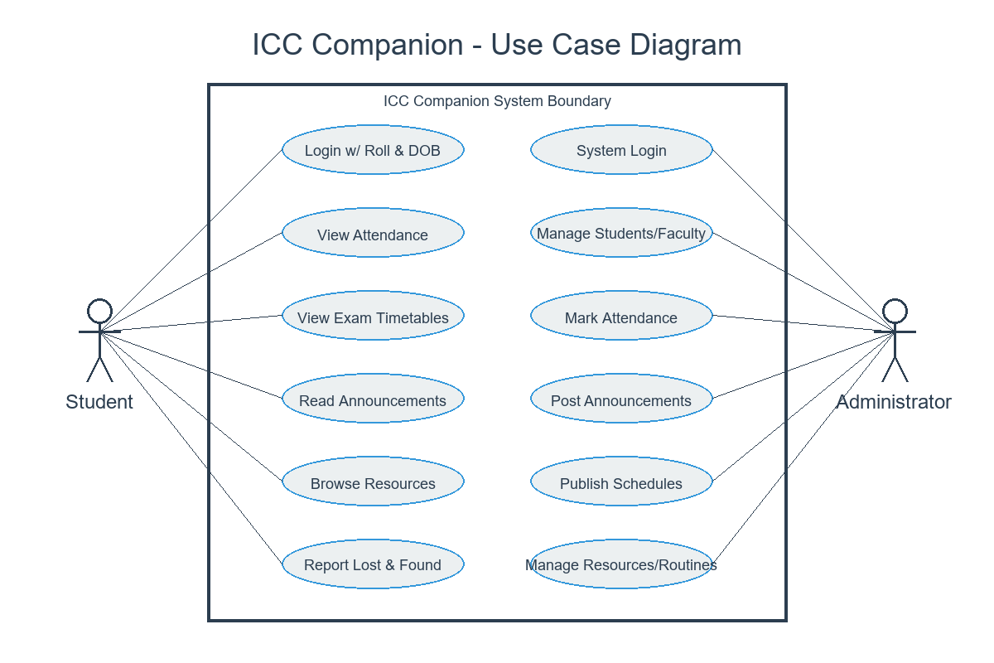

6.4 Entity-Relationship (ER) Diagram
The ER Diagram models the relational database structure, detailing the entities, their distinct attributes, and relational cardinalities:
- Entities: USERS, ADMINS, NOTICES, TIMETABLES, RESOURCES, FEEDBACK.
- Cardinality: One-to-many relationships link users to feedback records and tracking histories cleanly.
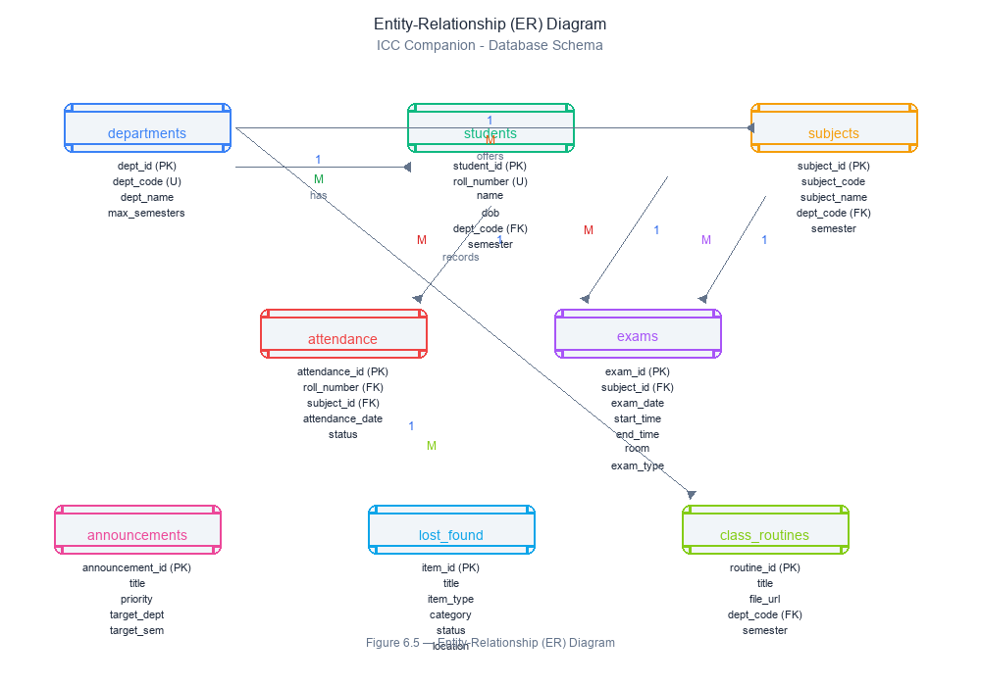

CHAPTER 7: DATABASE DESIGN
The application database, named 'icc_companion', is built on a relational structure using MySQL. It contains six tables designed to enforce data integrity, prevent redundancy, and optimize query speeds.
Table 1: users (Student Registration Data)
Field Name | Data Type | Constraint | Description
id | INT | PRIMARY KEY, AUTO_INCREMENT | Unique structural record ID for student
student_id | VARCHAR(50) | UNIQUE, NOT NULL | Official college roll/enrollment number
name | VARCHAR(100) | NOT NULL | Full legal name of the student
email | VARCHAR(100) | UNIQUE, NOT NULL | Email address used as login identity
phone | VARCHAR(20) | NULL | Contact telephone number
department | VARCHAR(100) | NOT NULL | Target academic stream (e.g., BCA)
semester | VARCHAR(20) | NOT NULL | Current active semester of study
password | VARCHAR(255) | NOT NULL | Secure bcrypt-hashed password string
created_at | TIMESTAMP | DEFAULT CURRENT_TIMESTAMP | Timestamp of initial registration

Table 2: admins (Administrative System Credentials)
Field Name | Data Type | Constraint | Description
id | INT | PRIMARY KEY, AUTO_INCREMENT | Unique record identifier for admin account
username | VARCHAR(50) | UNIQUE, NOT NULL | Alphanumeric login username string
name | VARCHAR(100) | NOT NULL | Full name of the administrative user
email | VARCHAR(100) | UNIQUE, NOT NULL | Official staff communication email
password | VARCHAR(255) | NOT NULL | Secure bcrypt-hashed administrative password
role | VARCHAR(50) | DEFAULT 'admin' | Role permission flag for access verification
created_at | TIMESTAMP | DEFAULT CURRENT_TIMESTAMP | Timestamp of profile instantiation

Table 3: notices (Broadcast Institutional Bulletins)
Field Name | Data Type | Constraint | Description
id | INT | PRIMARY KEY, AUTO_INCREMENT | Unique identifier for notice entry
title | VARCHAR(255) | NOT NULL | Heading or summary of the published notice
content | TEXT | NOT NULL | Detailed descriptive text body of the notice
attachment | VARCHAR(255) | NULL | Sanitized file path string for linked PDFs
expiry_date | DATE | NULL | Optional calendar expiration limit for visibility
created_at | TIMESTAMP | DEFAULT CURRENT_TIMESTAMP | Timestamp of initial publication

Table 4: timetables (Weekly Lecture Scheduling)
Field Name | Data Type | Constraint | Description
id | INT | PRIMARY KEY, AUTO_INCREMENT | Unique identifier for schedule cell row
department | VARCHAR(100) | NOT NULL | Department filter link string
semester | VARCHAR(20) | NOT NULL | Target semester level value
day_of_week | VARCHAR(20) | NOT NULL | Target weekday text name (Monday-Saturday)
time_slot | VARCHAR(50) | NOT NULL | Timing window duration string (e.g., 10:00 AM)
subject_name | VARCHAR(100) | NOT NULL | Name of the scheduled paper or course module
room_number | VARCHAR(50) | NOT NULL | Target physical classroom label string
faculty_name | VARCHAR(100) | NOT NULL | Full name of the assigned lecturer

Table 5: resources (Learning Materials Registry)
Field Name | Data Type | Constraint | Description
id | INT | PRIMARY KEY, AUTO_INCREMENT | Unique identifier for file index row
title | VARCHAR(255) | NOT NULL | Descriptive title for learning material
department | VARCHAR(100) | NOT NULL | Target department filter label
semester | VARCHAR(20) | NOT NULL | Target semester assignment filter
subject_name | VARCHAR(100) | NOT NULL | Course subject name string link
file_path | VARCHAR(255) | NOT NULL | Sanitized target file disk reference link
uploaded_by | INT | FOREIGN KEY -> admins(id) | Reference to admin uploading file
created_at | TIMESTAMP | DEFAULT CURRENT_TIMESTAMP | Timestamp of file upload execution

Table 6: feedback (Academic Communication Terminal)
Field Name | Data Type | Constraint | Description
id | INT | PRIMARY KEY, AUTO_INCREMENT | Unique structural record identifier
user_id | INT | FOREIGN KEY -> users(id) | Reference linking student submitter
subject | VARCHAR(255) | NOT NULL | Brief heading summarizing inquiry context
message | TEXT | NOT NULL | Detailed communication message body text
status | ENUM | Default 'Pending' | State tracking tag (Pending / Replied)
admin_response | TEXT | NULL | Text area field housing administrator's response
created_at | TIMESTAMP | DEFAULT CURRENT_TIMESTAMP | Timestamp of inquiry submission
updated_at | TIMESTAMP | ON UPDATE CURRENT_TIMESTAMP | Timestamp of last status modification

CHAPTER 8: IMPLEMENTATION / WORKING
The practical operation of the ICC Companion application follows a structured, step-by-step logic across both portals to ensure clear workflow coordination:
8.1 Public Entry & Registration (register.php & index.php)
When users open the root home directory, they see a clean public landing view presenting the system features. New students must register via register.php by inputting their full name, official college student ID, email address, contact phone, department, and active semester. The system executes server-side validation checks—ensuring the email format is valid and that neither the email nor the student ID already exists in the users database table. On validation success, the plain-text password is encrypted via PHP's native password_hash() using the bcrypt algorithm before being securely saved. Users are then redirected to log in.
8.2 Secure Login Routing Engine
Authentication is split into separate workflows for students and administrators. Students log in via index.php using their email and password, while admins use a dedicated portal with a username field. The application uses prepared statements with parameter binding to retrieve rows matching the user identity securely. It then runs password_verify() to validate the password against the stored bcrypt hash. On verification success, a secure, independent PHP session initializes, storing the user's primary database key, full name, and role permissions, before routing them to the correct dashboard view.
8.3 Student Dashboard Portal Operational Flows
Once logged in, students land on a responsive workspace dashboard providing clear utility options:
- Notice Center: Fetches and displays all active institutional bulletins sorted by date. If an optional file link is present, a download button allows users to open or save the attachment.
- Dynamic Timetable Lookup: Students can filter schedules by selecting their department and semester. The system queries the timetables table to render a clear weekly schedule showing courses, times, rooms, and lecturers.
- Resource Vault: Renders a repository of uploaded academic files, filtered by the student's department and semester. Clicking download safely opens the file from the server uploads folder.
- Feedback Desk: Allows students to type a subject header and a descriptive inquiry body. On submission, the record is inserted with a default 'Pending' status badge, appearing chronologically on their tracking list.
8.4 Administrative Workspace Control Flows
Administrators log into a comprehensive system control dashboard that tracks college data live:
- Broadcasting Notices: Features a text editor page where admins write notice titles and body text, with a file upload field that checks extensions before saving documents.
- Timetable Scheduler Grid: Provides structural input rows to add, update, or remove lecture time slots, assign rooms, and link faculty names to specific weekdays.
- Resource Upload Center: Allows administrators to select files (such as PDFs, DOCX, or PPTX), assign target department and semester visibility flags, and upload them to the repository.
- Feedback Review & Reply: Displays a list of all incoming student inquiries with filters for 'Pending' rows. Admins open an entry, review the student details, type a reply, and click submit—which updates the status to 'Replied' and updates the student's view instantly.

CHAPTER 9: SAMPLE SCREENSHOTS
This section maps the exact interface layouts, workflows, and visual screens of the ICC Companion application. Please place the corresponding system image grabs at the indicated positions below:
9.1 Public Views and Authentication Screens
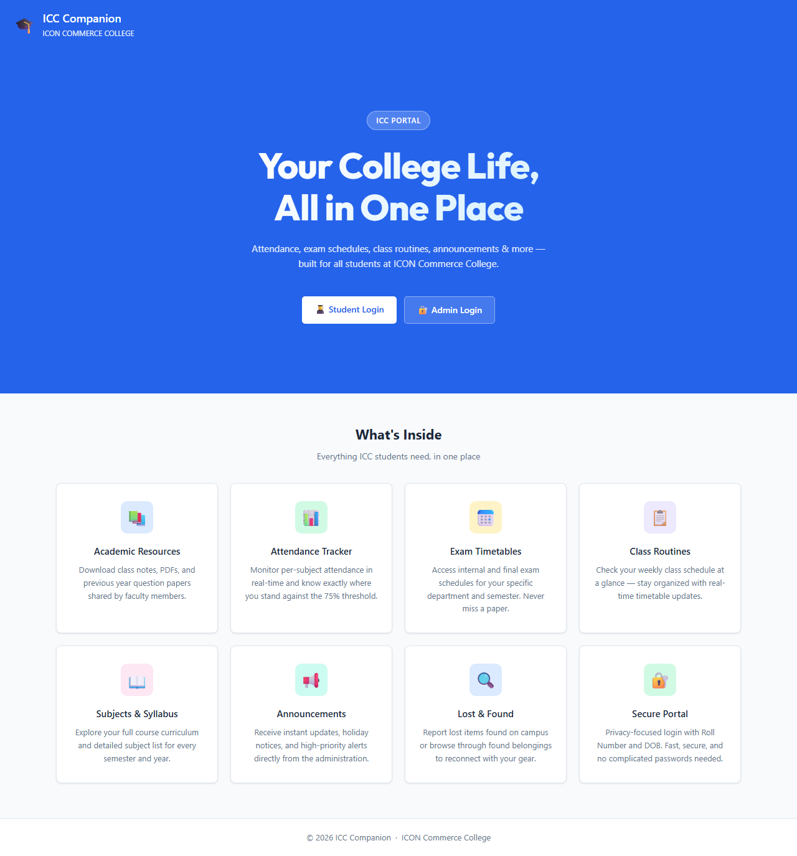
Description of view: The public landing page featuring an institutional navigation layout, an application overview banner, a feature summary grid, and direct buttons leading to the student and admin login terminals.

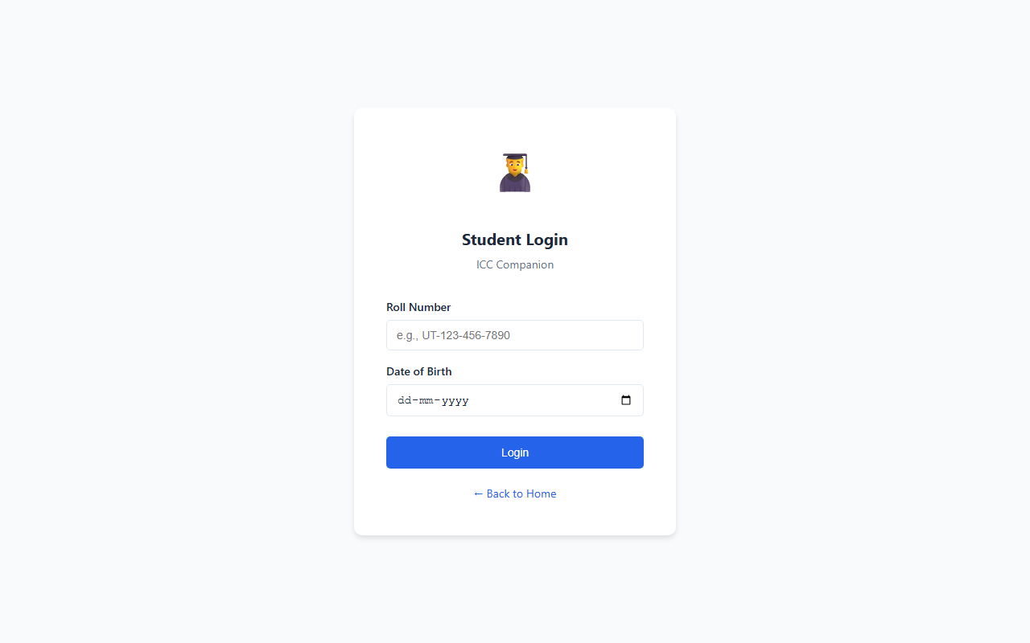
Description of view: A clean, centered card interface presenting email and password input fields, frontend validation alerts, and a redirect hyperlink for new student registration.
9.2 Student Workspace Views
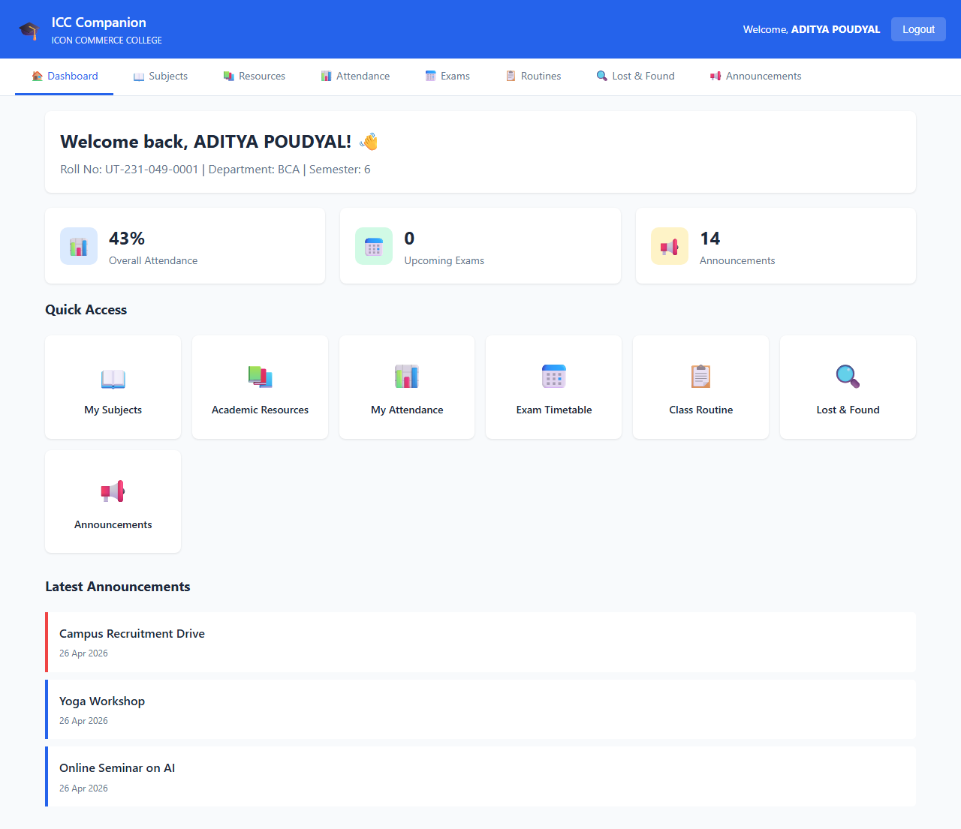

Description of view: The student's primary workspace, rendering user welcome headers, recent notice feeds, summary statistic tiles, and primary workspace navigation links in a clean sidebar layout.
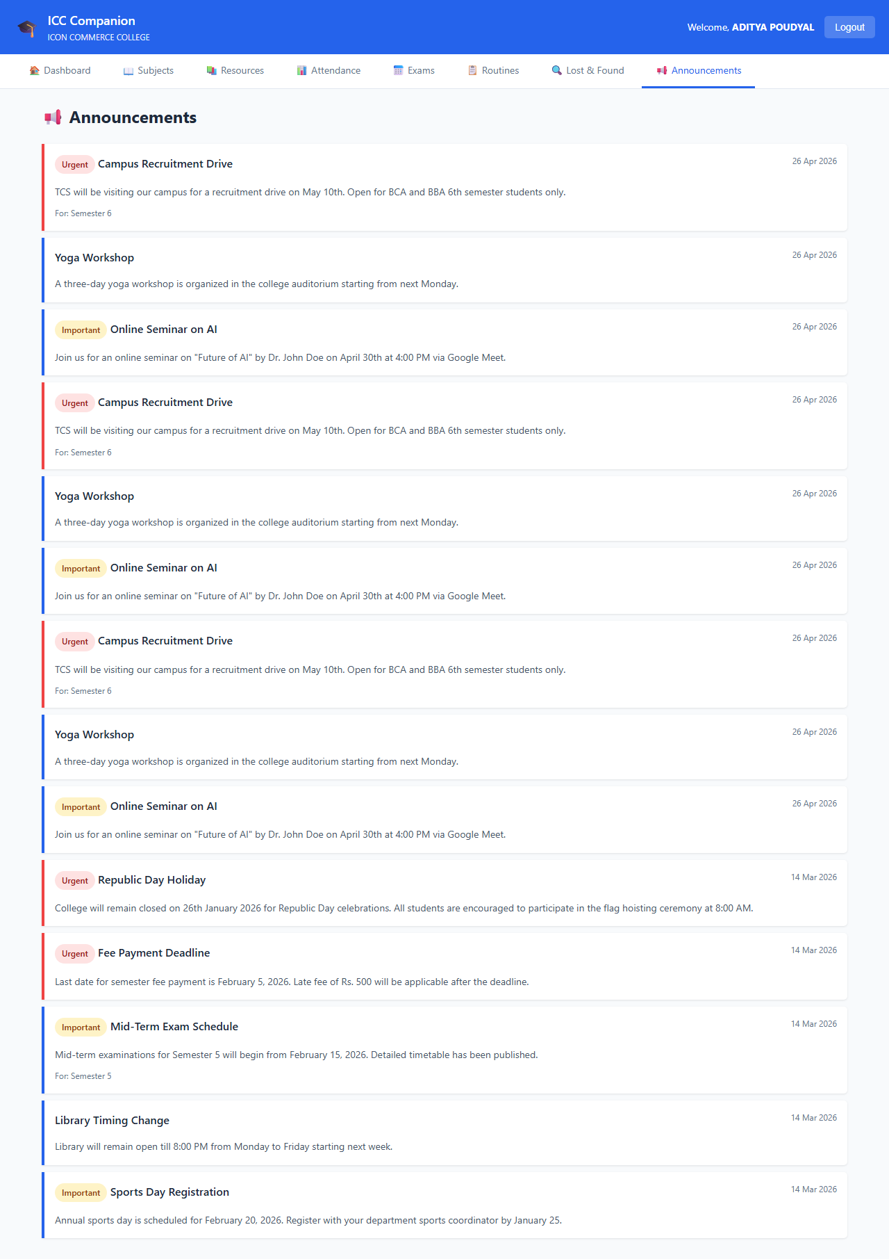
Description of view: A chronological listing view rendering broadcast college bulletins, detailing publish dates, content text boxes, and action links for downloading linked PDF files.

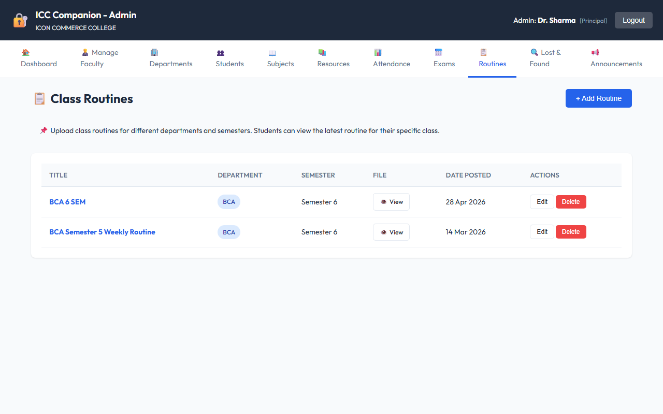

Description of view: A clean tabular grid showing filtered weekly lecture rows structured by day name, class timing slots, course labels, and physical lecture room indicators.
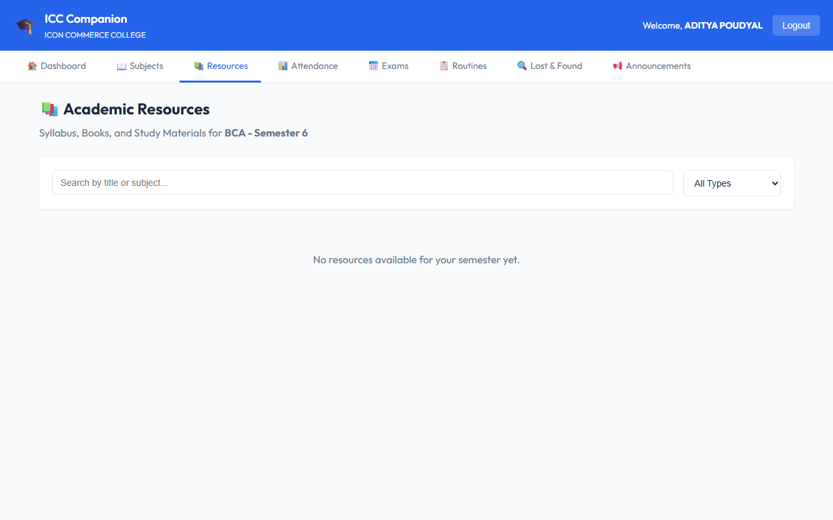

Description of view: An indexed digital shelf of learning files displaying reference material names, file type icons, source subject associations, and direct server download triggers.
9.3 Administrative Workspace Control Views
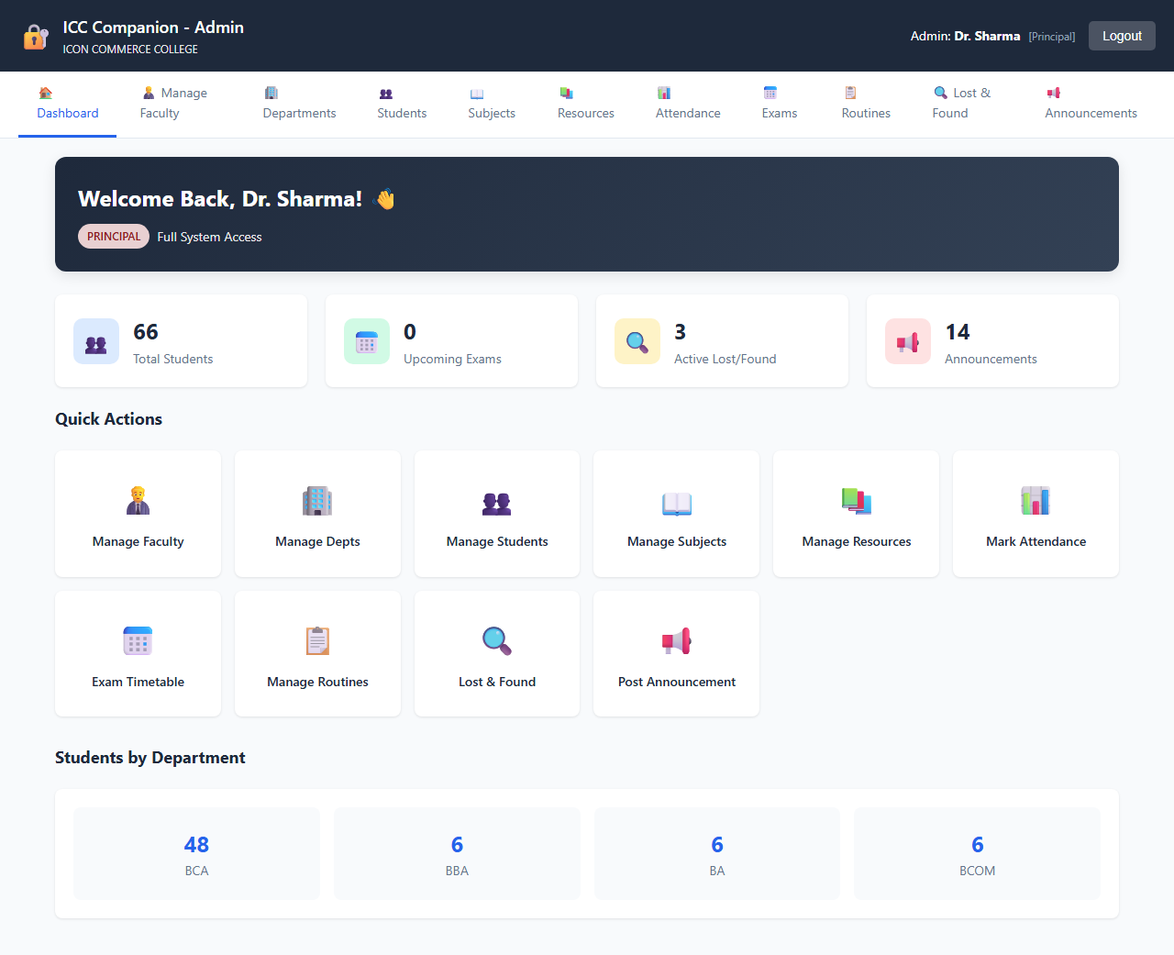

Description of view: The command interface displaying live system statistics counters (total student enrollment, active notices, file logs, pending queries) and system management menus.
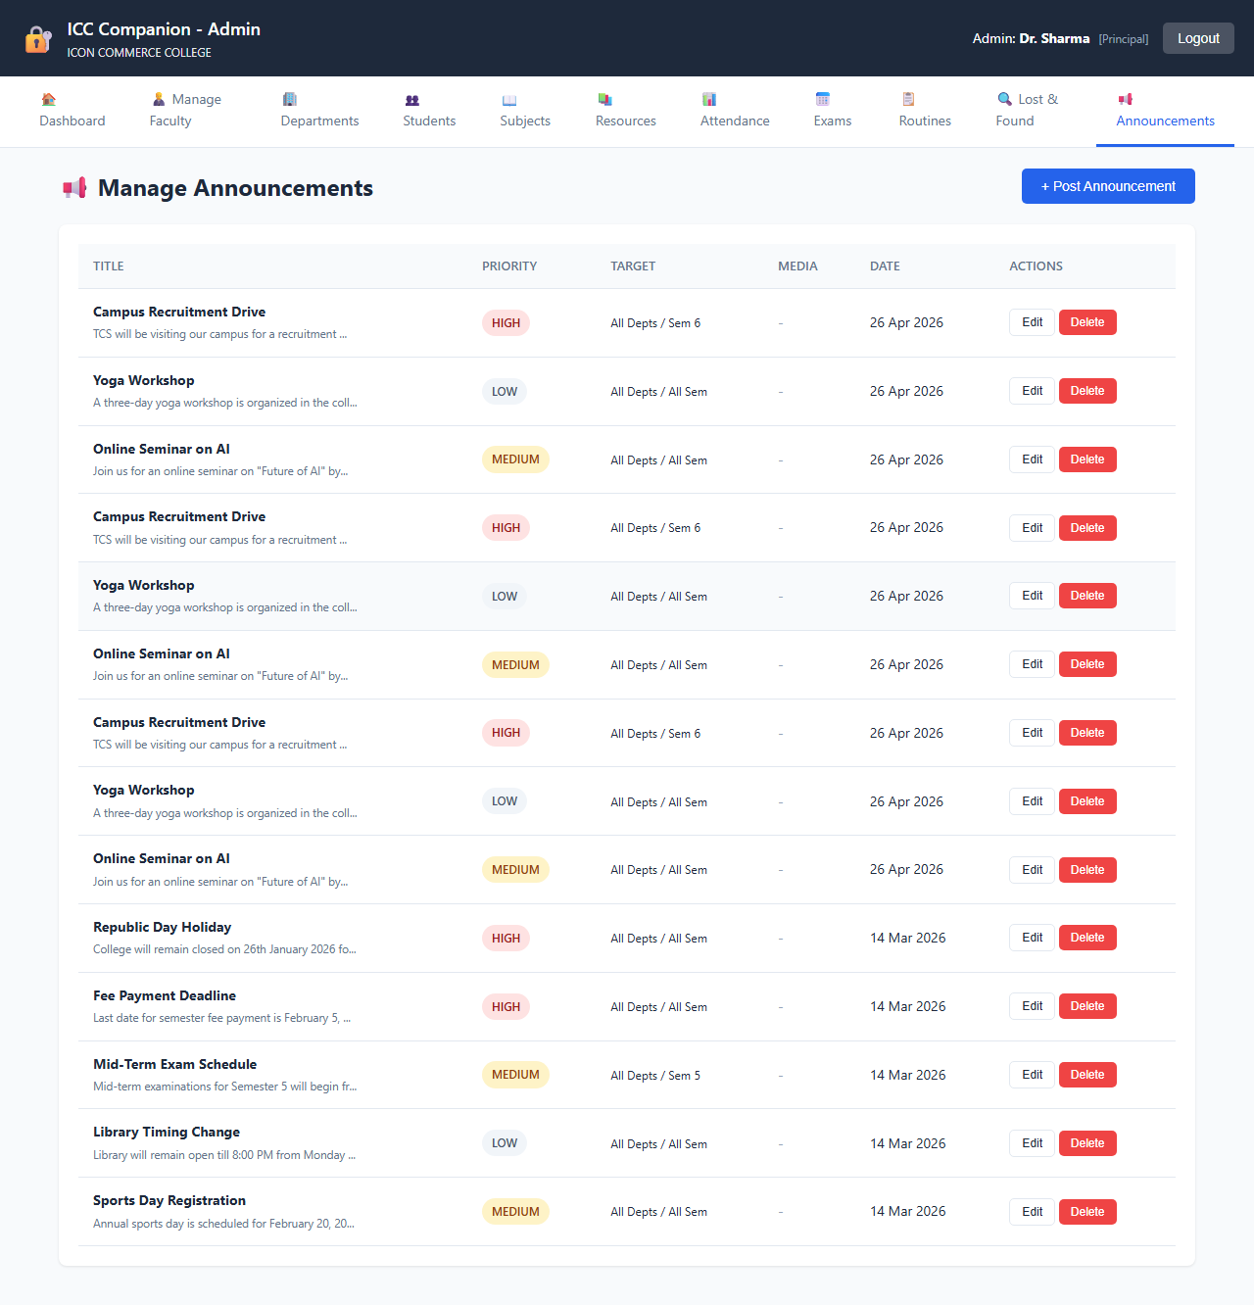

Description of view: A form page featuring heading input lines, an expansive text notice editor block, date pickers, and multi-format file attachment upload selectors.


Description of view: A management console displaying active timetable row matrices, featuring action icons to edit, delete, or append new lecture cells.
CHAPTER 10: ADVANTAGES & LIMITATIONS
10.1 Advantages
The implementation of the ICC Companion system delivers several operational benefits to the Icon Commerce College academic community:
- Centralized Academic Hub: Unifies notices, class timetables, learning files, and inquiries into a single system, replacing messy manual methods.
- 24/7 Availability and Reach: Students can access critical materials anytime, anywhere via web browser, removing the need to be physically on campus.
- High Material Security: Employs standard bcrypt encryption, query pre-compilation, and parameter binding to protect data records from typical web exploits.
- Structured Data Sorting: Enables targeted material sorting by department and semester, helping students find files and timetables instantly without clutter.
- Accountable Inquiry Tracking: Replaces informal notes with a clear, audited feedback loop, ensuring student issues are seen and handled by coordinators.
- Zero Operational Training: Simple interfaces allow non-technical administrative staff to update information easily with minimal guidance.
10.2 Limitations
While highly functional, the current version has a few technical and operational limits due to development scope boundaries:
- Manual Refresh Requirement: The user view doesn't use WebSocket connections. Users must refresh their browser manually to see new updates.
- No Live External Alerts: Lacks native integrations for cellular SMS lines or automated email alerts; users must log into the portal to check notifications.
- Flat System Roles: The admin portal uses a flat access structure. It lacks deep multi-tier hierarchies or automated sub-routing to individual department heads.
- No Offline Cache Capabilities: The application requires an active web connection and cannot store details or files locally for offline viewing.

CHAPTER 11: FUTURE ENHANCEMENTS
To expand the platform's capabilities beyond this foundational release, the following modular enhancements are planned for future updates:
- Real-Time Notification Engine: Integrate automated mailing libraries (like PHPMailer) and external SMS gateways (such as Twilio) to send instant alerts to students whenever a notice is posted or a query is replied to.
- Advanced Mobile App Build: Compile dedicated lightweight Android and iOS apps using frameworks like Flutter, using the existing PHP backend as an API endpoint layer.
- Role-Based Admin Hierarchy: Update the admin tables to support role hierarchies, automatically routing feedback and notice controls directly to respective department heads.
- Interactive Interactive Charts: Add an analytics suite to the admin dashboard using Chart.js to render visual pie charts and engagement trends for student queries and downloads.
- Automated Timetable Conflict Checker: Add backend validation rules that check space and lecturer schedules automatically to prevent double-booking rooms during timetable setup.
- Offline Cache via Service Workers: Build standard progressive web app (PWA) components to cache text bulletins and timetables on client devices for offline use.

CHAPTER 12: CONCLUSION
The ICC Companion system was developed to solve a real, practical challenge: the lack of a centralized, secure digital portal for student communication and resource sharing at Icon Commerce College. The platform successfully replaces scattered manual communication methods with a reliable, structured web application.
Built on a robust PHP-MySQL foundation, the system implements separate portals for students and administrators, custom data filters, and an audited feedback terminal. Security is integrated throughout using parameter binding, input sanitation, and secure password encryption, making the codebase production-ready for the campus intranet.
By meeting all core objectives, this project provides a scalable digital foundation that can grow with future features like automated email alerts and native mobile apps. Ultimately, developing this application applies core software engineering and database concepts learned in the BCA curriculum to a practical tool that improves academic administration.

REFERENCE

1. Official PHP Documentation Manual. Available online at: https://www.php.net/manual/en/
2. MySQL 5.7 Relational Database Management Reference Manual. Available online at: https://dev.mysql.com/doc/refman/5.7/en/
3. W3Schools Web Development Tutorials Suite (HTML5, CSS3, Vanilla JavaScript). Available online at: https://www.w3schools.com/
4. Mozilla Developer Network (MDN) Web Docs Core JavaScript Language Guide. Available online at: https://developer.mozilla.org/en-US/docs/Web/JavaScript
5. Font Awesome 6 Framework Typography Icon Documentation. Available online at: https://fontawesome.com/docs
6. Open Web Application Security Project (OWASP) Top 10 Security Defenses Standards Guide. Available online at: https://owasp.org/
7. PHP: The Right Way - Web Engineering Core Best Practices. Available online at: https://phptherightway.com/
8. Silberschatz, A., Korth, H. F., & Sudarshan, S. (2019). Database System Concepts (7th Edition). McGraw-Hill Education.

