A PROJECT REPORT ON

“ONLINE COMPLAINT MANAGEMENT SYSTEM”

A Project Report in partial fulfilment of the requirement for the degree of
Bachelor of Computer Application

Under GAUHATI UNIVERSITY




Name of the Guide:  Manisha Das, Asst. Prof  Department:  Bachelor of Computer Application  ICON Commerce College  Guwahati-781003 | Submitted By:  Sajib Biswas  Roll No: UT-231-049-0010  Registration No: 23084959  BCA 6TH Semester (FYUGP)  ICON Commerce College

CERTIFICATE

This is to certify that the project entitled "COLLEGE COMPLAINT MANAGEMENT SYSTEM" has been submitted by Sajib Biswas (Roll No: UT-231-049-0010, Registration No: 23084959) in partial fulfilment of the requirements for the degree of Bachelor of Computer Applications (BCA), 6th Semester, at Icon Commerce College, Gauhati University, during the Academic Session 2025–26.

This is an authentic work carried out by his under my supervision and guidance. The project has not been submitted to any other university or institution for the award of any degree or diploma.

Date: ____________________

Name of the Guide: Manisha Das
Designation: Assistant Professor
Department: Bachelor of Computer Application
Institution: Icon Commerce College
Guwahati – 781021

Signature of the Guide: ____________________

DECLARATION

I hereby declare that the project report “Online Complaint Management System”, submitted in partial fulfilment of the requirement for the degree of Bachelor of Computer Application (BCA) in Icon Commerce College, under Gauhati University, is my original work and has not been submitted for the award of any other degree, diploma, fellowship or any other similar titles.

Date: ____________________ Signature: ________________

Place: Guwahati NAME: SAJIB BISWAS
ROLL NO: UT-231-049-0010
REGISTRATION NO: 23084959
DEPARTMENT: BCA 6TH SEMESTER
ICON COMMERCE COLLEGE

ACKNOWLEDGEMENT

First of all, I would like to express my special thanks of gratitude to my project guide and mentor Manisha Das for instilling confidence in me and providing me with invaluable comments and criticism on many issues and constant rendering of timely advice and sparing valuable time throughout my project work.

It is my honour to thank Dr. Mandira Saha, Principal of Icon Commerce College and Tridib Kr. Handique, Co-Ordinator of B.C.A of Icon Commerce College for providing all the facilities me permission to undertake this project work. I would also like to thank the whole B.C.A department without whose help success could not have been attained.

My heartfelt gratitude goes to all those who agreed to participate in this project, for their time expended and for sharing insights and suggestions.

Finally, I would like to thank my parents and friends who helped a lot in finalizing this project within limited time frame.

Place: Guwahati Name: Sajib Biswas
Date: ____________________ Roll No: UT-231-049-0012
Registration No: 23084898
BCA 6TH Semester, Icon Commerce College

ABSTRACT

The College Complaint Management System is a web-based application developed using PHP, MySQL, HTML5, CSS3, and JavaScript to digitize the student grievance redressal process within a college. It replaces the traditional paper-based complaint handling method with a structured, transparent, and traceable digital platform.

The system provides two separate portals — a Student Portal and an Admin Portal — with independent session-based authentication. Students can register, log in, and submit complaints by selecting from ten predefined categories, assigning a priority level (Low, Medium, High, or Critical), and optionally attaching supporting files. Each complaint is automatically assigned a unique complaint number. Students can track the status of their complaints and view administrator responses at any time.
Administrators have access to a dashboard showing live complaint statistics, tools to update complaint status through a five-stage lifecycle (Pending, In Progress, Resolved, Closed, Rejected), and a reports section with category-wise, priority-wise, and monthly analytics.

Security is ensured through bcrypt password hashing, PHP session management, and SQL injection prevention via MySQLi prepared statements. The system is deployable on any standard Apache server environment such as XAMPP or WAMP.

CONTENTS

SECTION | PAGE NO.
Chapter 1: Introduction | 1-3
1.1 Background | 2
1.2 Problem Statement | 2
1.3 Proposed Solution | 3
Chapter 2: REQUIREMENT SPECIFICATION | 4-7
2.1 System Requirements | 5
2.2 Technologies Used | 5-7
Chapter 3: Object of the Project | 8-9
Chapter 4: Scope of the Project | 10-12
Chapter 5: System Analysis | 13-15
5.1 Existing System | 14
5.2 Proposed System | 14
5.3 Feasibility Study | 15
Chapter 6: System Design | 16-21
6.1 System Architecture | 17
6.2 Data Flow Diagram (Level 0) | 18
6.3 Data Flow Diagram (Level 1) | 19
6.4 Use Case Diagram | 20
6.5 ER Diagram | 21
Chapter 7: Database Design | 22-25
Chapter 8: Implementation / Working | 26-30
Chapter 9: Sample Screenshot | 31-39
Chapter 10: Advantages & Limitations | 40-42
Chapter 11: Future Enhancements | 43-45
Chapter 12: Conclusion | 46-48

Chapter 1
INTRODUCTION

Background

In an educational institution, students frequently face various issues — related to academics, infrastructure, hostel facilities, library resources, transportation, canteen services, and administrative procedures. Traditionally, such concerns are communicated informally, either through verbal discussion with teachers or by submitting handwritten complaint letters. This manual process is inefficient, untraceable, and often results in complaints being lost or unresolved.

With the widespread adoption of web-based technologies, it has become practical to digitize this process. A web-based complaint management system provides a centralized, transparent, and traceable platform where students can formally register their grievances and administrators can track, respond to, and resolve them systematically.

Problem Statement

The absence of a structured complaint mechanism in colleges leads to several issues:

- Complaints submitted verbally or on paper are easily misplaced and forgotten.
- Students have no way to track what happened to their complaint after submission.
- Administrators have no consolidated view of pending or recurring issues.
- There is no priority-based handling of urgent complaints.
- There is no permanent audit record of complaints and their resolutions.

Proposed Solution

The College Complaint Management System is a web-based application developed using PHP and MySQL. It provides a structured portal where students can register, log in, and submit complaints with a subject, description, category, and priority level. Each complaint is assigned a unique identifier. Administrators log into a separate panel, where they can view all complaints, respond to them, update their status, and view statistics through a dashboard. The system ensures transparency, traceability, and efficiency in the college grievance redressal process.

Chapter 2
REQUIREMENT SPECIFICATION

2.1 System Requirements

Hardware Requirements
Component | Minimum Specification
Processor | Intel Core i3 or equivalent
RAM | 4 GB or higher
Storage | 20 GB available disk space
Network | Internet connection for hosting / local network for LAN

2.2 Technologies Used
The following technologies were identified directly from the project source files. No external framework or technology beyond these was used.

Technology | Version / Detail | Role in Project
PHP | 7.4+ | Server-side scripting — handles all form processing, session management, database interaction, file uploads, and authentication logic.
MySQL | 5.7+ | Relational database — stores all data: users, admins, categories, complaints, and responses.
mysqli (PHP Extension) | — | Used for database connectivity, prepared statements, and parameterized queries to prevent SQL injection.
HTML5 | — | Provides the structure of all web pages — login, registration, complaint forms, dashboards.
CSS3 | — | Provides all visual styling via style.css — responsive layout, sidebar, cards, badges, forms.
JavaScript (Vanilla) | — | Client-side logic in main.js — form validation, modal control, file preview, table search/filter, CSV export, sidebar toggle, character counter, tooltip system.
Font Awesome | 6.4.0 (CDN) | Icon library used throughout the interface — navigation icons, stat card icons, button icons.
Apache Web Server | XAMPP/WAMP | Local server environment for running PHP and serving the web application.
Session Management | PHP Sessions | Used to maintain authenticated state for both students and administrators across pages.

1. PHP (Hypertext Preprocessor) PHP is an open-source, server-side scripting language designed specifically for web development. It runs on the server and generates dynamic HTML content before sending it to the browser. PHP supports database connectivity, file handling, session management, and form processing, making it one of the most widely used languages for building web applications.

2. MySQL MySQL is an open-source relational database management system (RDBMS) that stores and manages data in structured tables using rows and columns. It uses Structured Query Language (SQL) to perform operations like inserting, retrieving, updating, and deleting data. MySQL is widely used in web applications due to its reliability, speed, and ease of integration with PHP.

3. HTML5 (HyperText Markup Language) HTML is the standard markup language used to create the structure and layout of web pages. It defines elements such as headings, paragraphs, forms, tables, links, and buttons using tags. HTML5 is the latest version, introducing new semantic elements, improved form controls, and native support for multimedia content.

4. CSS3 (Cascading Style Sheets) CSS is a stylesheet language used to control the visual presentation of HTML elements. It defines properties such as colors, fonts, spacing, alignment, and layout. CSS3 is the latest version and introduces features like flexbox, grid layout, transitions, and media queries for responsive design across different screen sizes.

5. JavaScript JavaScript is a lightweight, interpreted, client-side scripting language that runs directly in the web browser. It is used to add interactivity and dynamic behavior to web pages — such as form validation, content updates without page reload, event handling, and DOM manipulation. In this project, plain (Vanilla) JavaScript is used without any external framework.

6. Font Awesome Font Awesome is a popular icon library and toolkit that provides a large collection of scalable vector icons. These icons are loaded via a CDN (Content Delivery Network) and displayed using simple HTML tags. Font Awesome icons automatically adapt to the surrounding text size and color, making them easy to use for buttons, navigation menus, and UI elements.

7. Apache Web Server (XAMPP / WAMP) Apache is a free, open-source web server software that handles incoming HTTP requests and serves web pages to the browser. XAMPP and WAMP are local development environments that bundle Apache, MySQL, and PHP together, allowing developers to run and test web applications on their own computer without needing a live internet server.

8. PHP Sessions A PHP Session is a server-side mechanism that stores user-specific information across multiple pages of a web application. When a user logs in, a unique session ID is created and stored on the server. This session data persists as the user navigates between pages, allowing the system to remember who is logged in and control access to protected pages.

9. mysqli (MySQL Improved Extension) mysqli is a PHP extension that provides an interface for connecting to and interacting with a MySQL database. It supports both procedural and object-oriented programming styles. The "improved" version over the older mysql extension adds support for prepared statements, which allow SQL queries to be pre-compiled with placeholders, preventing SQL injection attacks and improving security.

Chapter 3
OBJECT OF THE PROJECT

The primary objectives of the College Complaint Management System are:

- To provide students with a dedicated online portal to register and track complaints without needing to visit the administration office in person.
- To enable college administrators to view, manage, respond to, and resolve all student complaints through a centralized dashboard.
- To categorize complaints across 10 predefined areas — Academic, Infrastructure, Library, Hostel, Transport, Canteen, Administration, IT Services, Harassment, and Other — for organized handling.
- To implement a four-level priority classification (Low, Medium, High, Critical) that helps administrators identify and address urgent issues first.
- To track complaints through a well-defined five-stage lifecycle: Pending → In Progress → Resolved → Closed / Rejected.
- To allow students to attach supporting documents or images (JPG, PNG, PDF, DOC, DOCX) to their complaints.
- To auto-generate a unique complaint number for each submission, enabling easy reference and tracking.
- To provide statistical reports to administrators, including category-wise, priority-wise, and monthly complaint trends.
- To ensure system security through password hashing, session-based authentication, and SQL injection prevention via prepared statements.
- To allow students to update their profile information and change their password within the portal.

Chapter 4
SCOPE OF THE PROJECT

The College Complaint Management System is scoped to serve the internal grievance management needs of a single college institution. The system serves two types of users — students and administrators — through separate, secure portals.

4.1 What is In Scope:

- Student registration and login with secure password hashing.
- Submission of complaints across 10 defined categories with subject, description, priority, and optional file attachment.
- Unique complaint number generation upon each submission.
- Student ability to view all their submitted complaints and their current status.
- Student ability to view admin responses against their complaints.
- Student profile management — update personal details and change password.
- Admin login with session-based authentication.
- Admin dashboard with real-time statistics (total, pending, in progress, resolved complaints; total registered students).
- Admin ability to view all complaints, update status, and add responses.
- Admin management of student records and complaint categories.
- Admin reports section with category-wise, priority-wise, and monthly statistics.
- Print report functionality on the admin reports page.

4.2 What is Out of Scope:

- The system does not currently send automated email or SMS notifications (the function exists as a placeholder in the codebase but is not active).
- The system does not support multiple college institutions or departments as separate administrative units.
- No mobile application exists — the system is browser-based only.
- No role-based admin hierarchy — all admins have the same level of access.
- No real-time chat feature is implemented.

Chapter 5
SYSTEM ANALYSIS

5.1 Existing System
In most colleges, student complaints are currently handled through one or more of the following informal methods:

- Students verbally report issues to teachers, HODs, or office staff.
- Students submit handwritten complaint letters which are manually handled.
- Complaints via email are sent without any standardized format or tracking mechanism.
These approaches have clear shortcomings — complaints can easily be forgotten, there is no transparency for the student, there is no formal record maintained, and recurring issues cannot be identified from aggregate data.

5.2 Proposed System
The proposed College Complaint Management System replaces the informal process with a structured web-based platform. Key improvements over the existing approach include:
- All complaints are stored digitally in a MySQL database with a permanent audit trail.
- Students can submit and track complaints 24/7 from any device with a browser.
- Every complaint is given a unique auto-generated complaint number.
- Priority classification ensures critical issues are visible and handled first.
- Admins can respond to complaints in-system, and the response is visible to the student.
- A reports section gives administrators aggregate data to identify problem areas.

5.3 Feasibility Study

Technical Feasibility
The system is built using well-established and freely available technologies — PHP, MySQL, HTML5, CSS3, and JavaScript — that can be hosted on any standard Apache/XAMPP/WAMP server. No proprietary software or special hardware is required, making it technically feasible for any college with a basic server setup.

Economic Feasibility
All technologies used (PHP, MySQL, Apache) are open-source and free of cost. The system requires only a standard shared or local server, resulting in minimal operational cost. This makes the system highly economically feasible for educational institutions.

Operational Feasibility
The system is designed with a clean, intuitive interface for both students and administrators. Students with basic computer literacy can easily register, log in, and submit complaints. Administrators can manage complaints without any specialized technical training, making the system fully operationally feasible.

Chapter 6
SYSTEM DESIGN

6.1 System Architecture
The system follows a three-tier client-server architecture: a Presentation Layer (HTML/CSS/JavaScript in the browser), an Application Layer (PHP running on Apache), and a Data Layer (MySQL database). The student and admin portals share the same database but use independent authentication mechanisms.

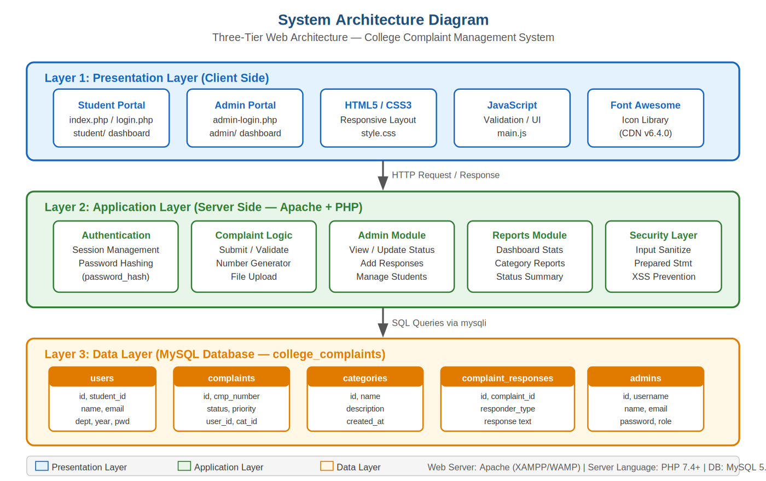
Figure 6.1 — System Architecture Diagram

6.2 Data Flow Diagram — Level 0 (Context Diagram)
The Level 0 DFD represents the system as a single process with two external entities — the Student and the Administrator — showing the high-level flow of data in and out of the system.

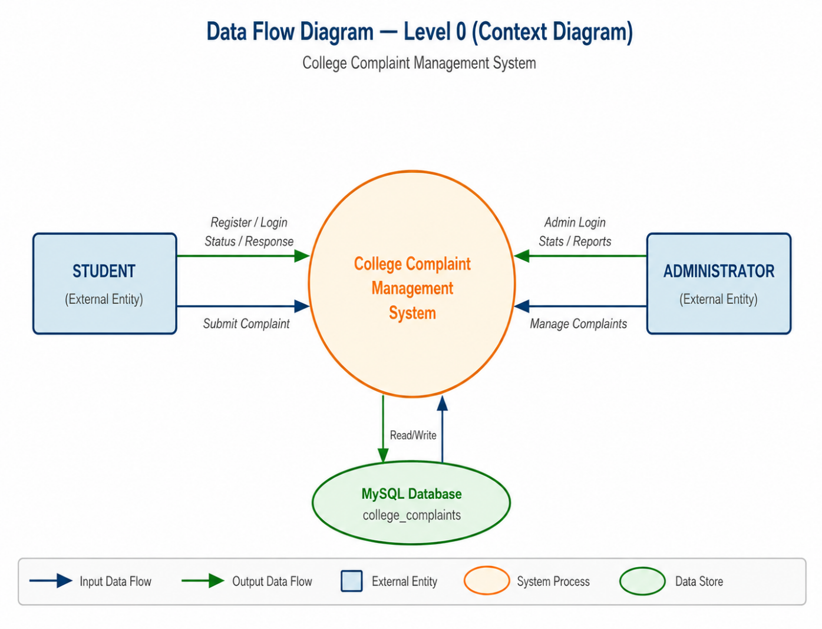
Figure 6.2 — DFD Level 0: Context Diagram

6.3 Data Flow Diagram — Level 1 (Detailed)
The Level 1 DFD breaks the system into six major processes: Student Registration/Login, Complaint Submission, Complaint Tracking, Admin Dashboard, Complaint Management, and Report Generation — each connected to the relevant data stores.

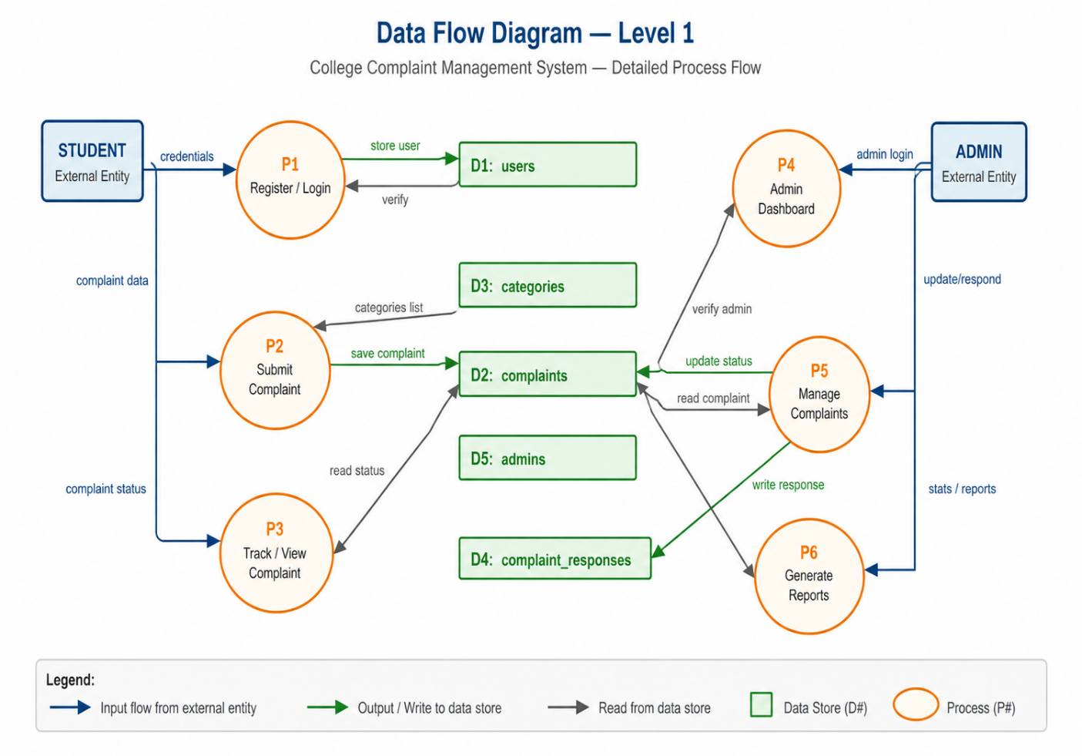
Figure 6.3 — DFD Level 1: Detailed Process Flow

6.4 Use Case Diagram
The Use Case Diagram shows all the actions available to each actor (Student and Administrator) and the boundary of the system.

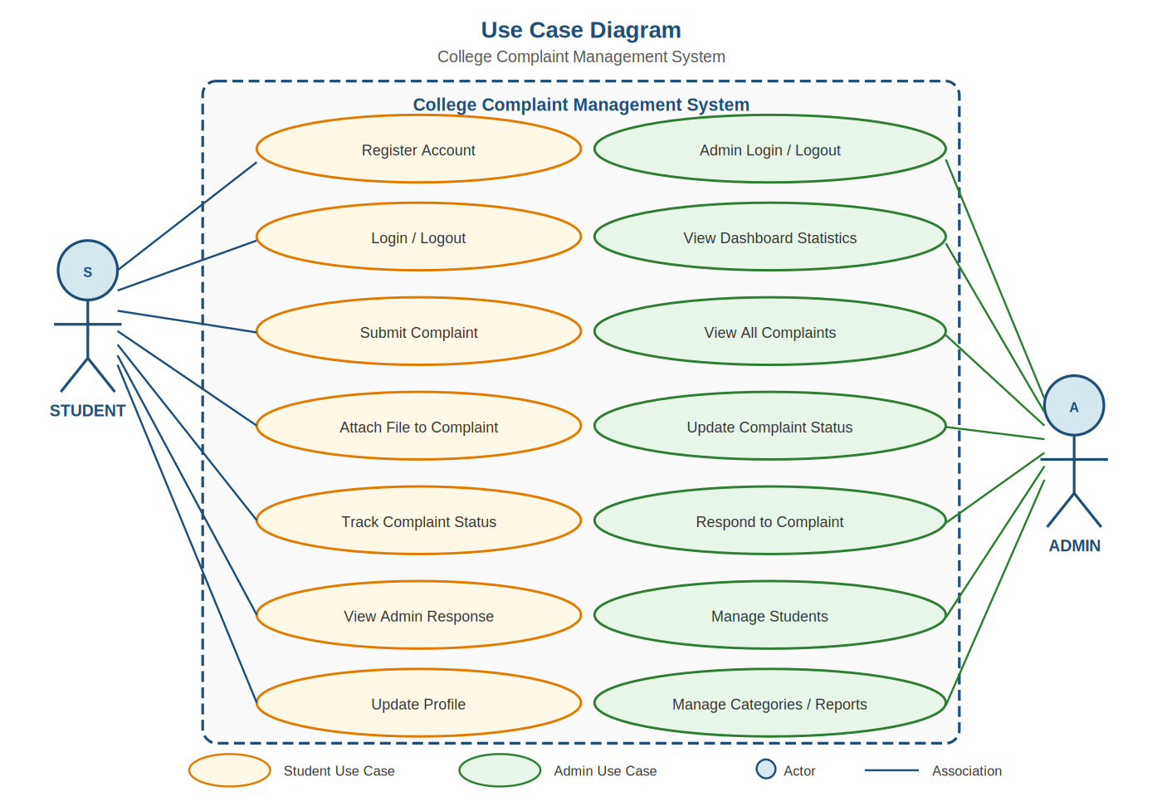
Figure 6.4 — Use Case Diagram

5.5 Entity-Relationship (ER) Diagram
The ER Diagram shows the five database entities and their relationships. COMPLAINTS is the central entity, linked to USERS and CATEGORIES through foreign keys, and to COMPLAINT_RESPONSES through a one-to-many relationship.

Figure 6.5 — Entity-Relationship (ER) Diagram
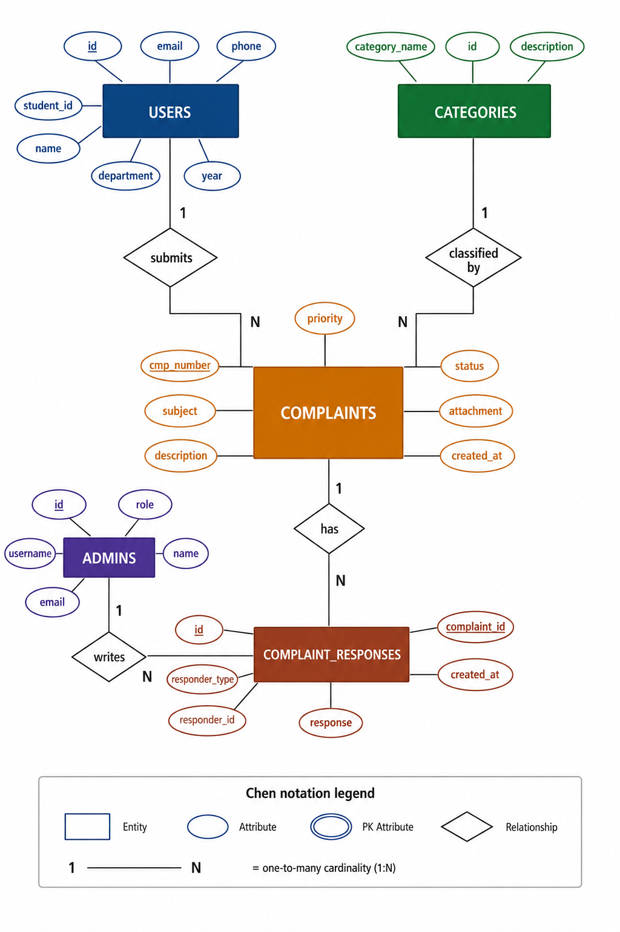

Chapter 7
DATABASE DESIGN

DATABASE DESIGN
The database is named college_complaints and consists of five tables. All tables are in MySQL with proper data types, primary keys, and foreign key relationships.

Table 1: users
Field Name | Data Type | Constraint | Description
id | INT | PK, AUTO_INCREMENT | Unique student record ID
student_id | VARCHAR(50) | UNIQUE, NOT NULL | College-assigned student ID
name | VARCHAR(100) | NOT NULL | Full name of the student
email | VARCHAR(100) | UNIQUE, NOT NULL | Email address (used for login)
phone | VARCHAR(20) | NULL | Contact phone number
department | VARCHAR(100) | NULL | Student's department
year | VARCHAR(20) | NULL | Year of study
password | VARCHAR(255) | NOT NULL | Bcrypt-hashed password
created_at | TIMESTAMP | DEFAULT NOW() | Registration timestamp

Table 2: admins
Field Name | Data Type | Constraint | Description
id | INT | PK, AUTO_INCREMENT | Unique admin record ID
username | VARCHAR(50) | UNIQUE, NOT NULL | Admin username for login
name | VARCHAR(100) | NOT NULL | Full name of administrator
email | VARCHAR(100) | UNIQUE, NOT NULL | Admin email address
password | VARCHAR(255) | NOT NULL | Bcrypt-hashed password
role | VARCHAR(50) | DEFAULT 'admin' | Admin role identifier
created_at | TIMESTAMP | DEFAULT NOW() | Account creation timestamp

Table 3: categories
Field Name | Data Type | Constraint | Description
id | INT | PK, AUTO_INCREMENT | Unique category ID
category_name | VARCHAR(100) | NOT NULL | Name of the complaint category
description | TEXT | NULL | Description of the category
created_at | TIMESTAMP | DEFAULT NOW() | Creation timestamp

Default categories pre-loaded: Academic, Infrastructure, Library, Hostel, Transport, Canteen, Administration, IT Services, Harassment, Other.

Table 4: complaints
Field Name | Data Type | Constraint | Description
id | INT | PK, AUTO_INCREMENT | Unique complaint ID
complaint_number | VARCHAR(50) | UNIQUE, NOT NULL | Auto-generated (CMP+date+rand)
user_id | INT | FK → users(id) | Student who submitted the complaint
category_id | INT | FK → categories(id) | Complaint category
subject | VARCHAR(255) | NOT NULL | Brief subject of the complaint
description | TEXT | NOT NULL | Detailed description
priority | ENUM | Default 'Medium' | Low / Medium / High / Critical
status | ENUM | Default 'Pending' | Pending/In Progress/Resolved/Closed/Rejected
attachment | VARCHAR(255) | NULL | Filename of uploaded attachment
created_at | TIMESTAMP | DEFAULT NOW() | Submission timestamp
updated_at | TIMESTAMP | ON UPDATE NOW() | Last modification timestamp
resolved_at | TIMESTAMP | NULL | Timestamp when resolved

Table 5: complaint_responses
Field Name | Data Type | Constraint | Description
id | INT | PK, AUTO_INCREMENT | Unique response ID
complaint_id | INT | FK → complaints(id) | The complaint being responded to
responder_type | ENUM | NOT NULL | 'admin' or 'student'
responder_id | INT | NOT NULL | ID of the admin or student responding
response | TEXT | NOT NULL | The response message text
created_at | TIMESTAMP | DEFAULT NOW() | Response timestamp

Chapter 8
IMPLEMENTATION/WORKING

IMPLEMENTATION / WORKING
This chapter explains the step-by-step working of the system as it operates in practice. The system is divided into a Student Portal and an Admin Portal.

8.1 Home Page (home.php)
The home page serves as a public landing page. It contains a navigation bar with links to the Student Login and Registration pages. It also displays a hero section describing the system, a features overview, and a how-it-works section. This page does not require authentication.

8.2 Student Registration (register.php)
A new student fills in a registration form with their Student ID, full name, email address, phone number, department, year of study, password, and confirm password. The system validates that all required fields are present, the passwords match, the password is at least 6 characters long, and the Student ID and email are not already registered. On success, the password is hashed using PHP's password_hash() and stored in the users table.

8.3 Student Login (index.php)
A registered student logs in using their email and password. The system uses a prepared statement to retrieve the user record by email, then verifies the submitted password against the stored hash using password_verify(). On success, a PHP session is created with user_id, user_name, user_email, and student_id. The student is then redirected to the Student Dashboard.

8.4 Student Dashboard (student/dashboard.php)
The student dashboard displays four statistics cards: Total Complaints, Pending, In Progress, and Resolved — all queried live from the complaints table filtered by the logged-in student's user_id. Below the stats, a table shows the 10 most recent complaints with their category, subject, priority, status, and date. Each complaint has a View button leading to its detail page.

8.5 Submit Complaint (student/new-complaint.php)
The student selects a complaint category from a dropdown (populated from the categories table), fills in a subject and description, selects a priority level (Low/Medium/High/Critical), and optionally uploads a file. Allowed file types are JPG, JPEG, PNG, PDF, DOC, and DOCX. The system uses the uploadFile() helper function (from functions.php) to validate and store the file in the /uploads/ directory using uniqid() as the filename. A unique complaint number is generated via generateComplaintNumber() in the format CMP + YYYYMMDD + 4 random digits. The complaint is then inserted into the complaints table via a prepared statement.

8.6 My Complaints (student/my-complaints.php)
This page lists all complaints submitted by the logged-in student, joined with the categories table to show the category name. Students can see the complaint number, category, subject, priority, status, and submission date, and can click any complaint to view its full detail and admin response.

8.7 View Complaint (student/view-complaint.php)
This page shows the full details of a specific complaint — including description, attachment (with a download link if present), current status, and all admin responses loaded from the complaint_responses table. Students can also add their own response from this page.

8.8 Student Profile (student/profile.php)
Students can view and update their profile details (name, phone, department, year). The email and student ID fields are read-only. Students can also change their password from this page — the current password is verified using password_verify() before the new password is hashed and saved.

8.9 Admin Login (admin-login.php)
Admins log in with a username and password. The system queries the admins table using a prepared statement and verifies the password with password_verify(). On success, an admin session is created and the admin is redirected to the Admin Dashboard.

8.10 Admin Dashboard (admin/dashboard.php)
The admin dashboard displays five statistics: Total Complaints, Pending, In Progress, Resolved (all from the complaints table), and Total Students (from the users table). A recent complaints table shows the last 10 complaints across all students, joined with users and categories tables.

8.11 All Complaints (admin/all-complaints.php)
This page lists all complaints from all students with search and status-filter functionality implemented in JavaScript (searchTable() and filterByStatus() functions from main.js). Each row has a View/Manage button.

8.12 View / Manage Complaint (admin/view-complaint.php)
The admin sees full complaint details including the student's name, email, student ID, and phone. The admin can update the complaint status from a dropdown (Pending, In Progress, Resolved, Closed, Rejected) via an UPDATE prepared statement. The admin can also add a response, which is inserted into the complaint_responses table with responder_type = 'admin'.

8.13 Manage Students (admin/manage-students.php)
This page displays a list of all registered students retrieved from the users table, showing student ID, name, email, department, year, and registration date.

8.14 Categories (admin/categories.php)
Admins can view the list of all complaint categories from the categories table. The page also allows adding new categories with a name and description.

8.15 Reports (admin/reports.php)
The reports page queries and displays: overall statistics (total, pending, resolved, in progress, closed, rejected), category-wise complaint counts (using a LEFT JOIN between categories and complaints, grouped by category), priority-wise counts (grouped by priority field), and monthly complaint counts for the last 6 months. A Print Report button uses window.print() via JavaScript.

8.16 Security Implementation
Security is implemented at multiple levels: password hashing using PHP's password_hash() with PASSWORD_DEFAULT (bcrypt), password verification using password_verify(), SQL injection prevention through MySQLi prepared statements with bind_param() across all database queries, input sanitization using the sanitize() function (trim, stripslashes, htmlspecialchars, mysqli_real_escape_string), and session-based access control using requireLogin() and requireAdminLogin() functions at the top of every protected page.

Chapter 9
SAMPLE SCREENSHOTS

The following screenshots illustrate the key pages and functionalities of the College Complaint Management System. Please insert the actual screenshots at the indicated positions before final submission.

10.1 Public Pages
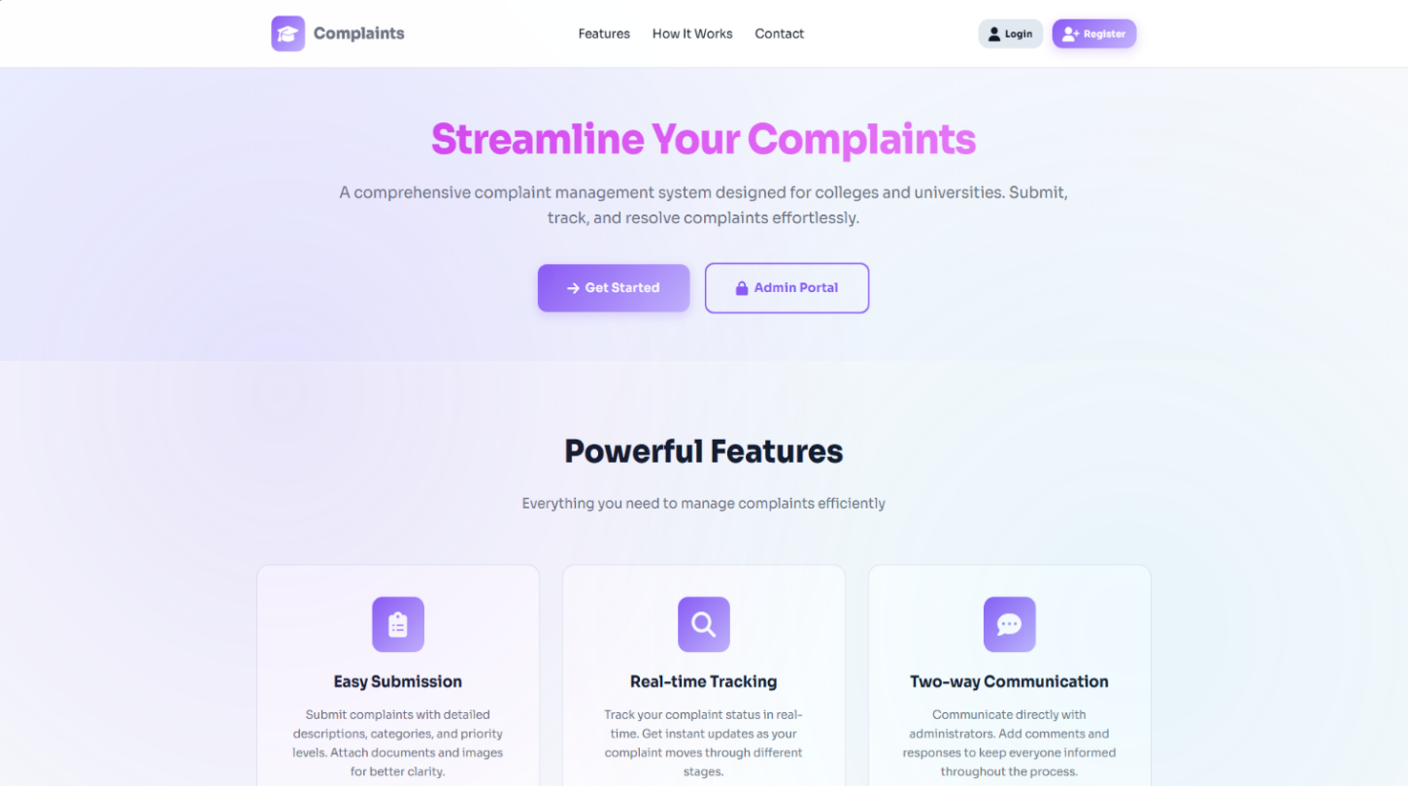
HOME-PAGE

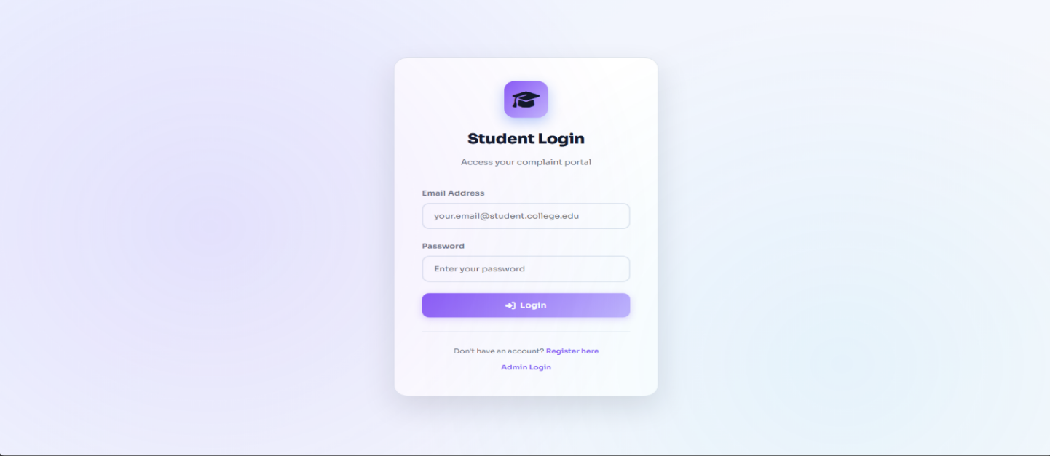
STUDENT LOGIN-PAGE
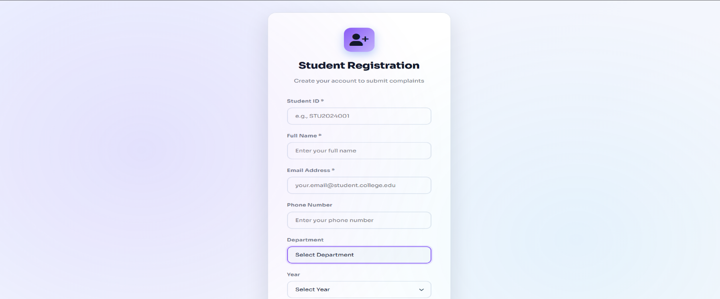
STUDENT REGISTRATION-PAGE

10.2 STUDENT PORTAL
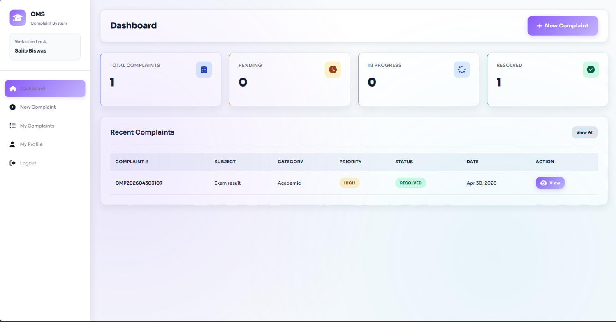
STUDENT DASHBOARD

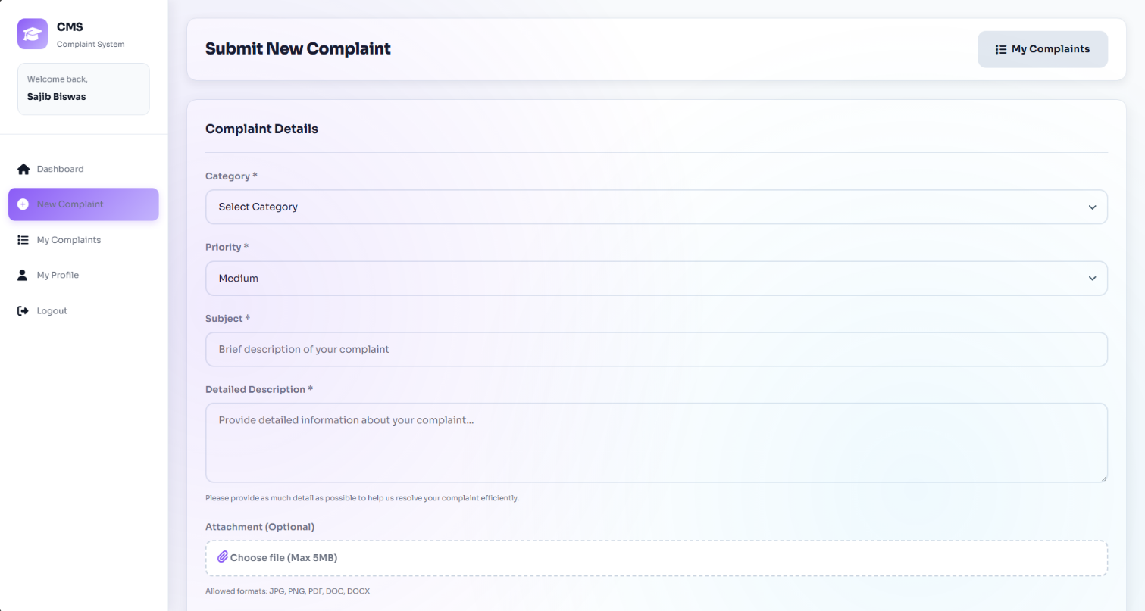
SUBMIT NEW COMPLAINT

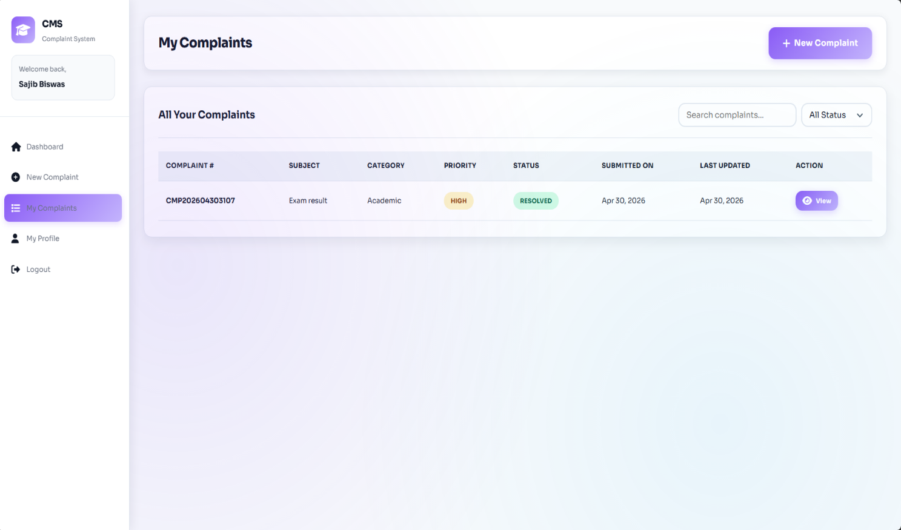
MY COMPLAINT LIST
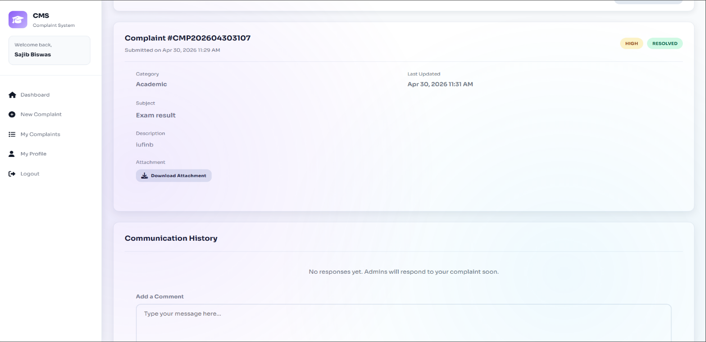
VIEW COMPLAINT

STUDENT PROFILE-PAGE

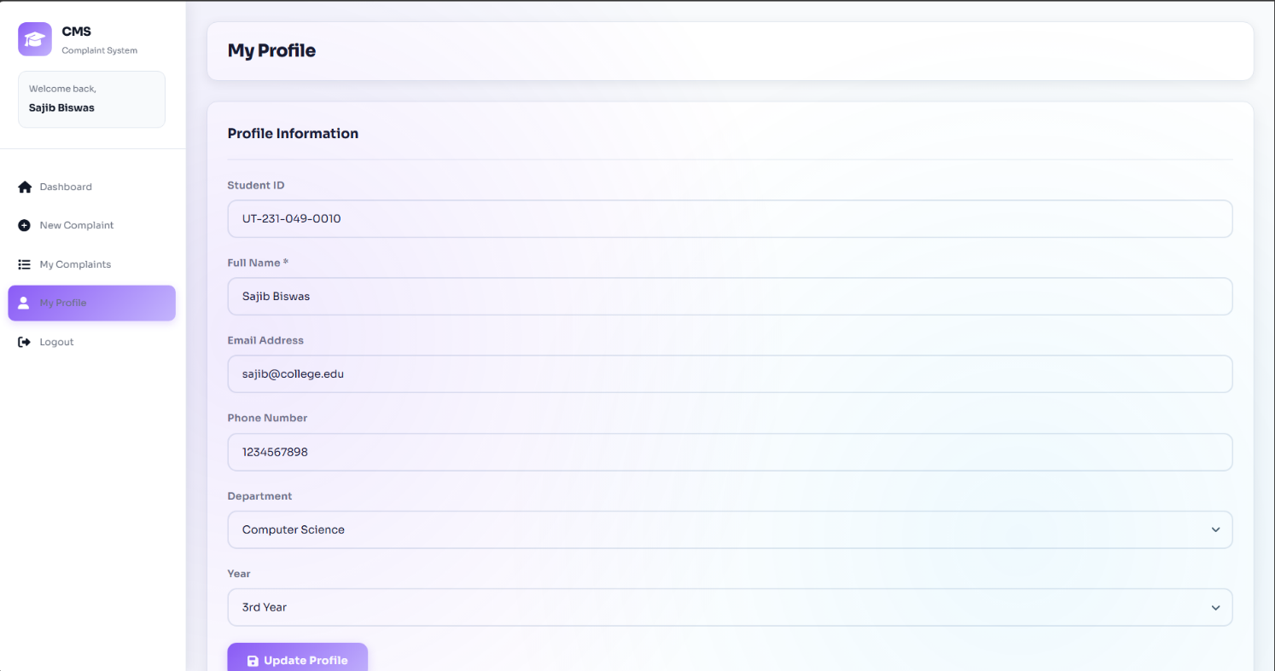
10.3 ADMIN PORTAL
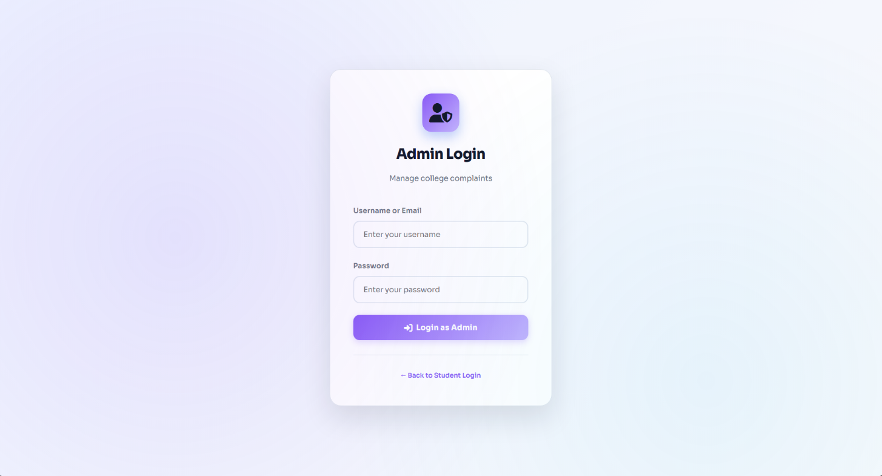
ADMIN LOGIN-PAGE

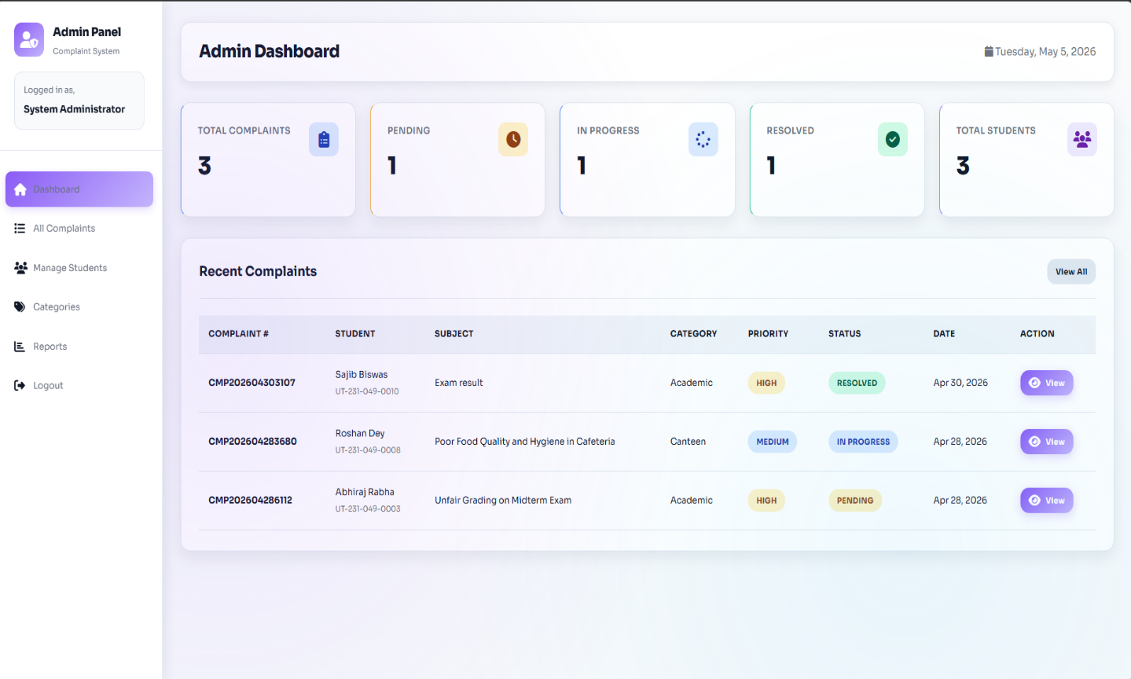
ADMIN DASHBOARD
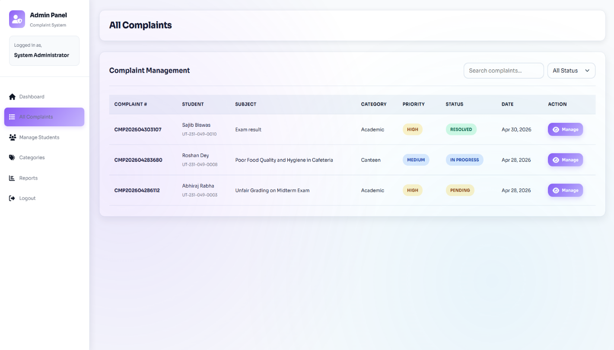
ALL COMPLAINT PAGE

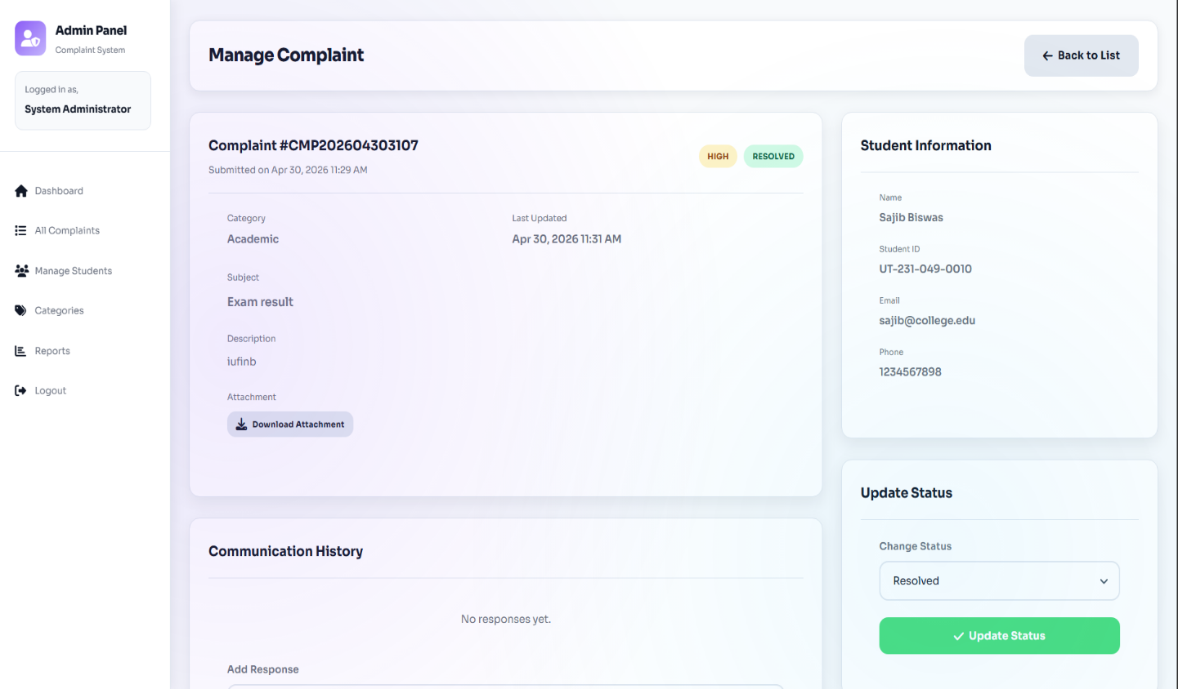
MANAGE COMPLAINT PAGE
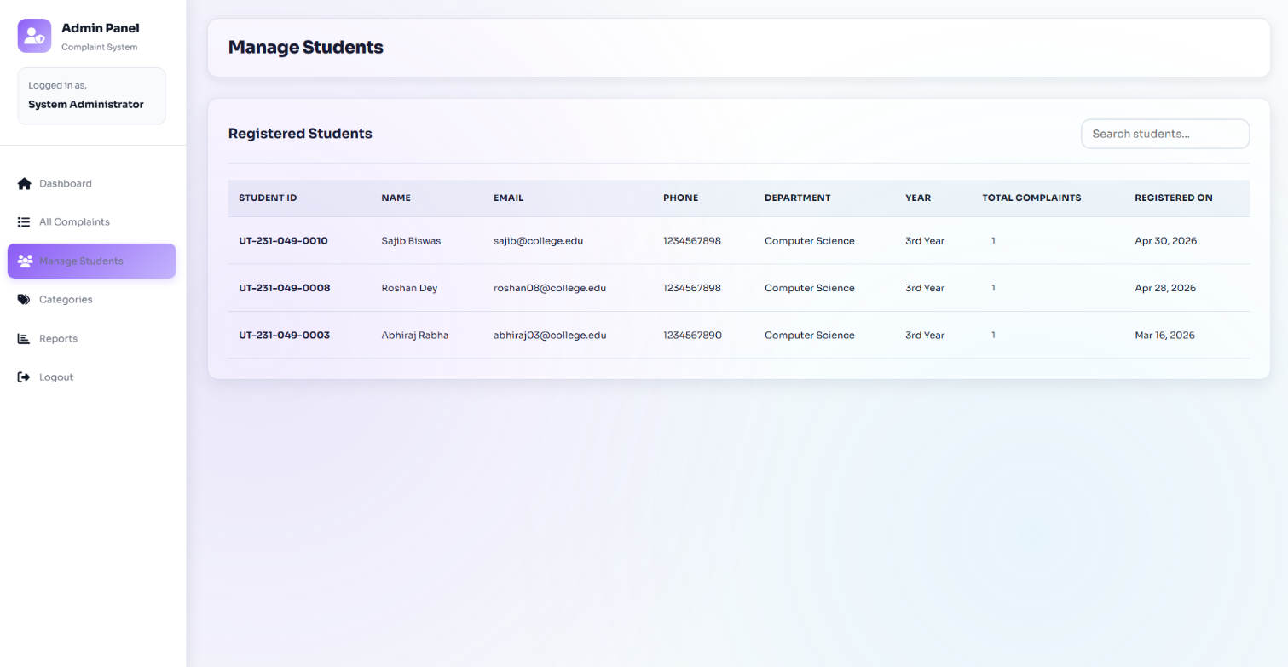
MANAGE STUDENT PAGE

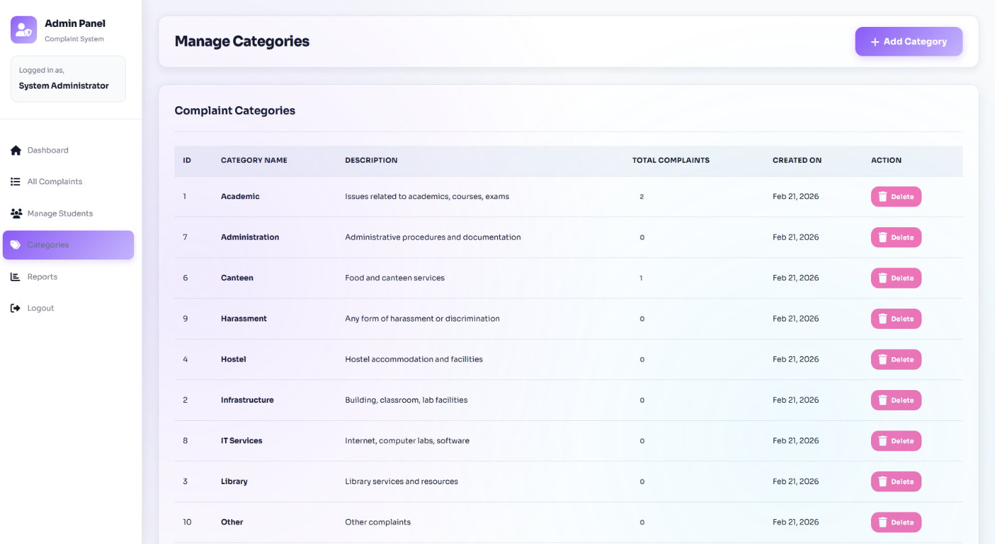
CATEGORIES PAGE

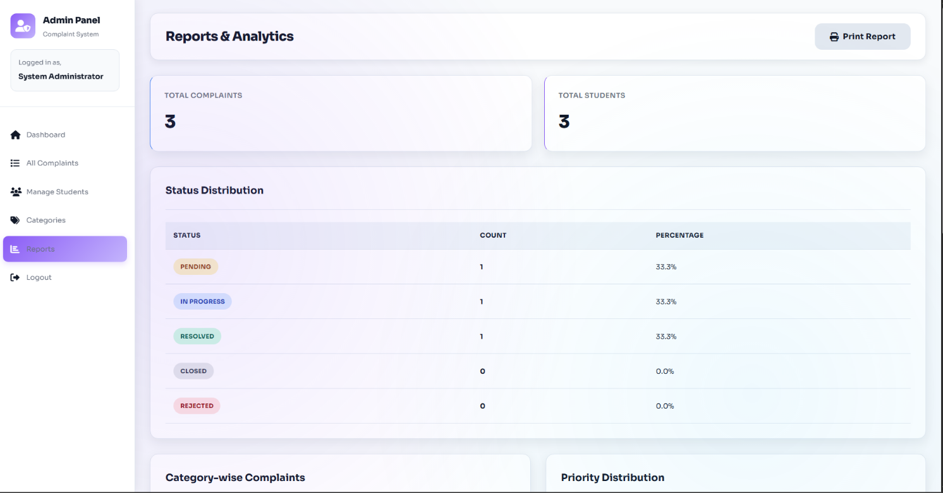
REPORTS PAGE

Chapter 10
ADVANTAGE AND LIMITATION

10.1 Advantages

- Centralized Record-Keeping: All complaints are stored in a MySQL database with timestamps, providing a permanent and searchable record.
- Transparency: Students can log in at any time to check the current status of their complaint and read administrator responses, eliminating uncertainty.
- Unique Complaint Tracking: Every complaint receives an auto-generated unique number (e.g., CMP202601150482), enabling easy reference in follow-up communication.
- Priority-Based Handling: The four-level priority system (Low, Medium, High, Critical) ensures administrators can identify and act on the most urgent complaints first.
- File Attachment Support: Students can attach photos or documents (JPG, PNG, PDF, DOC, DOCX) as evidence, making complaints more informative and verifiable.
- Administrative Reports: The reports module gives administrators aggregated data by status, category, priority, and month, enabling data-driven decisions.
- Secure System: Password hashing (bcrypt), prepared statements, and input sanitization make the system resistant to common web vulnerabilities.
- User-Friendly Interface: The system has a clean, consistent, and responsive interface that does not require specialized technical training to use.
- Admin Response Mechanism: Administrators can directly respond to complaints within the system, creating a documented two-way communication thread.

10.2 Limitations

- No Automated Email Notifications: The sendEmailNotification() function is present in the code but is implemented as a placeholder (returns true without sending). Students are not notified by email when their complaint status changes.
- Browser-Based Only: The system has no companion mobile application. Students and admins must use a web browser to access the portal.
- No Real-Time Updates: The complaint status does not update in real time — the student must manually refresh or revisit the page to see changes.
- Flat Admin Role: All administrators have identical access. There is no department-wise routing or multi-level admin hierarchy.
- Single Institution: The system is designed for a single college. It does not support multi-branch or multi-campus configurations.
- 5 MB File Limit: The uploadFile() function does not enforce a file size limit in the code, but practical server configuration typically limits uploads to 5 MB.
- No CSV Export in All Sections: CSV export (exportToCSV function in main.js) is implemented in JavaScript but may not be wired to all complaint listing tables.

Chapter 11
FUTURE ENHANCEMENTS

The following enhancements are realistic and directly tied to the current state of the project codebase:

- Activate Email Notifications: The sendEmailNotification() function already exists in functions.php but is commented out. Integrating PHPMailer or SMTP configuration would enable automated email alerts to students whenever their complaint status changes or when the admin posts a response.
- SMS Alerts: Integrate an SMS gateway (such as Twilio or Fast2SMS) to send text message updates to students' registered phone numbers, which are already stored in the users table.
- Department-Wise Admin Routing: Introduce an additional role field or department assignment for admins so that complaints are automatically routed to the relevant department's administrator based on the complaint category.
- Real-Time Complaint Status: Implement AJAX-based polling or WebSocket communication so that complaint status updates appear for the student without requiring a full page refresh.
- Graphical Analytics Dashboard: Add a visual statistics dashboard using Chart.js or similar library to display bar charts and pie charts of complaint data by category, priority, and month — in addition to the existing tabular reports.
- Mobile Application: Develop a companion Android or iOS application allowing students to submit and track complaints from their smartphones.
- Complaint Escalation System: Introduce an automatic escalation mechanism — if a complaint remains in 'Pending' status beyond a defined number of days, it is automatically flagged or escalated to a senior admin.
- Student Feedback and Rating: After a complaint is marked as Resolved, allow students to rate the resolution quality and submit feedback, helping measure admin performance.
- Full CSV/PDF Export: Extend the existing exportToCSV() JavaScript function (already in main.js) to all complaint tables, and add a server-side PDF export option for the reports page using a library like FPDF or TCPDF.

Chapter 12
CONCLUSION

The College Complaint Management System was developed to address a real and common challenge faced by educational institutions — the lack of a structured, transparent, and traceable mechanism for managing student grievances. The system successfully replaces the informal, paper-based complaint process with a fully functional web-based platform.

The project has been implemented using PHP, MySQL, HTML5, CSS3, and JavaScript — all freely available and widely supported technologies. The dual-portal architecture (separate portals for students and administrators), five-table relational database design, priority-based complaint classification, unique complaint number generation, file attachment support, admin response system, and a reports and analytics module collectively make this a complete and practical solution.

From a security perspective, the system implements bcrypt password hashing, session-based authentication, SQL injection prevention through prepared statements, and input sanitization — ensuring that the application is secure for production use.

The project fulfils all stated objectives and provides a solid foundation that can be extended with future enhancements such as email notifications, real-time updates, and department-wise routing. It demonstrates the practical application of web development concepts learned during the BCA program and represents a meaningful contribution to improving academic administration.

REFERENCE

The following resources were referenced during the development and documentation of this project:

- PHP Manual — Official PHP Documentation. Available at: https://www.php.net/manual/en/
- MySQL Reference Manual — MySQL 5.7 Documentation. Available at: https://dev.mysql.com/doc/refman/5.7/en/
- W3Schools — HTML, CSS, JavaScript Reference and Tutorials. Available at: https://www.w3schools.com/
- MDN Web Docs — JavaScript Reference. Mozilla Developer Network. Available at: https://developer.mozilla.org/en-US/docs/Web/JavaScript
- Font Awesome — Icon Library Documentation. Available at: https://fontawesome.com/docs
- OWASP Foundation — Web Application Security Guide. Available at: https://owasp.org/
- PHP: The Right Way — Best Practices for PHP Development. Available at: https://phptherightway.com/
- Silberschatz, A., Korth, H. F., & Sudarshan, S. — Database System Concepts, 7th Edition. McGraw-Hill Education.

