A PROJECT REPORT ON

“ONLINE Campus Portal MANAGEMENT SYSTEM”

A Project Report in partial fulfilment of the requirement for the degree of Bachelor of Computer Application

Under GAUHATI UNIVERSITY




Name of the Guide: MANAS CHOKRABORTY, Asst. Prof Department:  Bachelor of Computer Application  ICON Commerce College  Guwahati-781003 | Submitted By:  Abhishek  Roll No: UT-231-049-0004  Registration No: 23084891 BCA 6TH Semester (FYUGP) ICON Commerce College

CERTIFICATE

This is to certify that the project entitled "ICC COMPANION" has been submitted by ABHISHEK SHARMA (Roll No: UT-231-049-0004, Registration No: 23084891) in partial fulfilment of the requirements for the degree of Bachelor of Computer Applications (BCA), 6th Semester, at Icon Commerce College, Gauhati University, during the Academic Session 2025–26.

This is an authentic work carried out by his under my supervision and guidance. The project has not been submitted to any other university or institution for the award of any degree or diploma.

Date:

Name of the Guide: MANAS CHOKRABORTY Designation: Assistant Professor
Department: Bachelor of Computer Application Institution: Icon Commerce College
Guwahati – 781021

Signature of the Guide:

DECLARATION

I hereby declare that the project report “Online Campus Portal Management System”, submitted in partial fulfilment of the requirement for the degree of Bachelor of Computer Application (BCA) in Icon Commerce College, under Gauhati University, is my original work and has not been submitted for the award of any other degree, diploma, fellowship or any other similar titles.

Date: Signature:

Place: Guwahati NAME: ABHISHEK SHARMA ROLL NO: UT-231-049-0004
REGISTRATION NO: 23084891 DEPARTMENT: BCA 6TH SEMESTER ICON COMMERCE COLLEGE

ACKNOWLEDGEMENT

First of all, I would like to express my special thanks of gratitude to my project guide and mentor MANAS CHOKRABORTY for instilling confidence in me and providing me with invaluable comments and criticism on many issues and constant rendering of timely advice and sparing valuable time throughout my project work.

It is my honour to thank Dr. Mandira Saha, Principal of Icon Commerce College and Tridib Kr. Handique, Co-Ordinator of B.C.A of Icon Commerce College for providing all the facilities me permission to undertake this project work. I would also like to thank the whole B.C.A department without whose help success could not have been attained.

My heartfelt gratitude goes to all those who agreed to participate in this project, for their time expended and for sharing insights and suggestions.

Finally, I would like to thank my parents and friends who helped a lot in finalizing this project within limited time frame.

Place: Guwahati Name: Abhishek
Date: Roll No: UT-231-049-0012
Registration No: 23084898
BCA 6TH Semester, Icon Commerce College

ABSTRACT

The ICC Companion is a web-based application developed using PHP, MySQL, HTML5, CSS3, and JavaScript to digitize the student grievance redressal process within a college. It replaces the traditional paper-based Campus Portal handling method with a structured, transparent, and traceable digital platform.

The system provides two separate portals — a Student Portal and an Admin Portal
— with independent session-based authentication. Students can register, log in, and submit Campus Portals by selecting from ten predefined categories, assigning a priority level (Low, Medium, High, or Critical), and optionally attaching supporting files. Each Campus Portal is automatically assigned a unique Campus Portal number. Students can track the status of their Campus Portals and view administrator responses at any time.
Administrators have access to a dashboard showing live Campus Portal statistics, tools to update Campus Portal status through a five-stage lifecycle (Pending, In Progress, Resolved, Closed, Rejected), and a reports section with category-wise, priority-wise, and monthly analytics.

Security is ensured through bcrypt password hashing, PHP session management, and SQL injection prevention via MySQLi prepared statements. The system is deployable on any standard Apache server environment such as XAMPP or WAMP.

CONTENTS

SECTION | PAGE NO.
Chapter 1: Introduction | 1-3
1.1 Background | 2
1.2 Problem Statement | 2
1.3 Proposed Solution | 3
Chapter 2: REQUIREMENT SPECIFICATION | 4-6
2.1 System Requirements | 5
2.2 Technologies Used | 5-6
Chapter 3: Object of the Project | 7-8
Chapter 4: Scope of the Project | 9-11
Chapter 5: System Analysis | 12-14
5.1 Existing System | 13
5.2 Proposed System | 13
5.3 Feasibility Study | 14
Chapter 6: System Design | 15-20
6.1 System Architecture | 16
6.2 Data Flow Diagram (Level 0) | 17
6.3 Data Flow Diagram (Level 1) | 18
6.4 Use Case Diagram | 19
6.5 ER Diagram | 20
Chapter 7: Database Design | 21-24
Chapter 8: Implementation / Working | 25-29
Chapter 9: Sample Screenshot | 30-38
Chapter 10: Advantages & Limitations | 39-41
Chapter 11: Future Enhancements | 42-44
Chapter 12: Conclusion | 45-47

Chapter 1
INTRODUCTION

Background

In an educational institution, students frequently face various issues — related to academics, infrastructure, hostel facilities, library resources, transportation, canteen services, and administrative procedures. Traditionally, such concerns are communicated informally, either through verbal discussion with teachers or by submitting handwritten Campus Portal letters. This manual process is inefficient, untraceable, and often results in Campus Portals being lost or unresolved.

With the widespread adoption of web-based technologies, it has become practical to digitize this process. A web-based Campus Portal management system provides a centralized, transparent, and traceable platform where students can formally register their grievances and administrators can track, respond to, and resolve them systematically.

Problem Statement

The absence of a structured Campus Portal mechanism in colleges leads to several issues:

    - Campus Portals submitted verbally or on paper are easily misplaced and forgotten.
    - Students have no way to track what happened to their Campus Portal after submission.
    - Administrators have no consolidated view of pending or recurring issues.
    - There is no priority-based handling of urgent Campus Portals.
    - There is no permanent audit record of Campus Portals and their resolutions.

Proposed Solution

The ICC COMPANION is a web-based application developed using PHP and MySQL. It provides a structured portal where students can register, log in, and submit Campus Portals with a subject, description, category, and priority level. Each Campus Portal is assigned a unique identifier. Administrators log into a separate panel, where they can view all Campus Portals, respond to them, update their status, and view statistics through a dashboard. The system ensures transparency, traceability, and efficiency in the college grievance redressal process.

Chapter 2

REQUIREMENT SPECIFICATION

System Requirements
Hardware Requirements

Component | Minimum Specification
Processor | Intel Core i3 or equivalent
RAM | 4 GB or higher
Storage | 20 GB available disk space
Network | Internet connection for hosting / local network for LAN

  - Technologies Used
The following technologies were identified directly from the project source files. No external framework or technology beyond these was used.

Technology | Version / Detail | Role in Project
PHP | 7.4+ | Server-side scripting — handles all form processing, session management, database interaction, file uploads, and authentication logic.
MySQL | 5.7+ | Relational database — stores all data: users, admins, categories, Campus Portals, and responses.
mysqli (PHP Extension) | — | Used for database connectivity, prepared statements, and parameterized queries to prevent SQL injection.
HTML5 | — | Provides the structure of all web pages — login, registration, Campus Portal forms, dashboards.
CSS3 | — | Provides all visual styling via style.css — responsive layout, sidebar, cards, badges, forms.
JavaScript (Vanilla) | — | Client-side logic in main.js — form validation, modal control, file preview, table search/filter, CSV export, sidebar toggle, character counter, tooltip system.
Font Awesome | 6.4.0 (CDN) | Icon library used throughout the interface — navigation icons, stat card icons, button icons.
Apache Web Server | XAMPP/WAMP | Local server environment for running PHP and serving the web application.
Session Management | PHP Sessions | Used to maintain authenticated state for both students and administrators across pages.

    - PHP — Server-side scripting for form handling, session management, and database operations

    - MySQL — Relational database management system for storing users, Campus Portals, categories, and responses

    - mysqli extension — PHP extension used for database connectivity and query execution

    - HTML5 / CSS3 — Structure and styling of the web interface

    - JavaScript — Client-side validation, dynamic UI interactions, and file preview

    - Font Awesome 6.4.0 — Icon library loaded via CDN for UI icons throughout the application

    - Session Management — PHP sessions used to authenticate and maintain logged-in state for both students and admins

Chapter 3

OBJECT OF THE PROJECT

The primary objectives of the ICC COMPANION are:

- To provide students with a dedicated online portal to register and track Campus Portals without needing to visit the administration office in person.
- To enable college administrators to view, manage, respond to, and resolve all student Campus Portals through a centralized dashboard.
- To categorize Campus Portals across 10 predefined areas — Academic, Infrastructure, Library, Hostel, Transport, Canteen, Administration, IT Services, Harassment, and Other — for organized handling.
- To implement a four-level priority classification (Low, Medium, High, Critical) that helps administrators identify and address urgent issues first.
- To track Campus Portals through a well-defined five-stage lifecycle: Pending → In Progress → Resolved → Closed / Rejected.
- To allow students to attach supporting documents or images (JPG, PNG, PDF, DOC, DOCX) to their Campus Portals.
- To auto-generate a unique Campus Portal number for each submission, enabling easy reference and tracking.
- To provide statistical reports to administrators, including category-wise, priority-wise, and monthly Campus Portal trends.
- To ensure system security through password hashing, session-based authentication, and SQL injection prevention via prepared statements.
- To allow students to update their profile information and change their password within the portal.

Chapter 4

SCOPE OF THE PROJECT

The ICC Companion is scoped to serve the internal grievance management needs of a single college institution. The system serves two types of users — students and administrators — through separate, secure portals.

What is In Scope:

    - Student registration and login with secure password hashing.
    - Submission of Campus Portals across 10 defined categories with subject, description, priority, and optional file attachment.
    - Unique Campus Portal number generation upon each submission.
    - Student ability to view all their submitted Campus Portals and their current status.
    - Student ability to view admin responses against their Campus Portals.
    - Student profile management — update personal details and change password.
    - Admin login with session-based authentication.
    - Admin dashboard with real-time statistics (total, pending, in progress, resolved Campus Portals; total registered students).
    - Admin ability to view all Campus Portals, update status, and add responses.
    - Admin management of student records and Campus Portal categories.
    - Admin reports section with category-wise, priority-wise, and monthly statistics.
    - Print report functionality on the admin reports page.

What is Out of Scope:

    - The system does not currently send automated email or SMS notifications (the function exists as a placeholder in the codebase but is not active).
    - The system does not support multiple college institutions or departments as separate administrative units.
    - No mobile application exists — the system is browser-based only.
    - No role-based admin hierarchy — all admins have the same level of access.
    - No real-time chat feature is implemented.

Chapter 5

SYSTEM ANALYSIS

Existing System
In most colleges, student Campus Portals are currently handled through one or more of the following informal methods:

    - Students verbally report issues to teachers, HODs, or office staff.
    - Students submit handwritten Campus Portal letters which are manually handled.
    - Campus Portals via email are sent without any standardized format or tracking mechanism.
These approaches have clear shortcomings — Campus Portals can easily be forgotten, there is no transparency for the student, there is no formal record maintained, and recurring issues cannot be identified from aggregate data.

Proposed System
The proposed ICC COMPANION replaces the informal process with a structured web-based platform. Key improvements over the existing approach include:
    - All Campus Portals are stored digitally in a MySQL database with a permanent audit trail.
    - Students can submit and track Campus Portals 24/7 from any device with a browser.
    - Every Campus Portal is given a unique auto-generated Campus Portal number.
    - Priority classification ensures critical issues are visible and handled first.
    - Admins can respond to Campus Portals in-system, and the response is visible to the student.
      - A reports section gives administrators aggregate data to identify problem areas.

Feasibility Study Technical Feasibility
The system is built using well-established and freely available technologies — PHP,
MySQL, HTML5, CSS3, and JavaScript — that can be hosted on any standard Apache/XAMPP/WAMP server. No proprietary software or special hardware is required, making it technically feasible for any college with a basic server setup.

Economic Feasibility
All technologies used (PHP, MySQL, Apache) are open-source and free of cost. The system requires only a standard shared or local server, resulting in minimal operational cost. This makes the system highly economically feasible for educational institutions.

Operational Feasibility
The system is designed with a clean, intuitive interface for both students and administrators. Students with basic computer literacy can easily register, log in, and submit Campus Portals. Administrators can manage Campus Portals without any specialized technical training, making the system fully operationally feasible.

Chapter 6

SYSTEM DESIGN

System Architecture
The system follows a three-tier client-server architecture: a Presentation Layer (HTML/CSS/JavaScript in the browser), an Application Layer (PHP running on Apache), and a Data Layer (MySQL database). The student and admin portals share the same database but use independent authentication mechanisms.

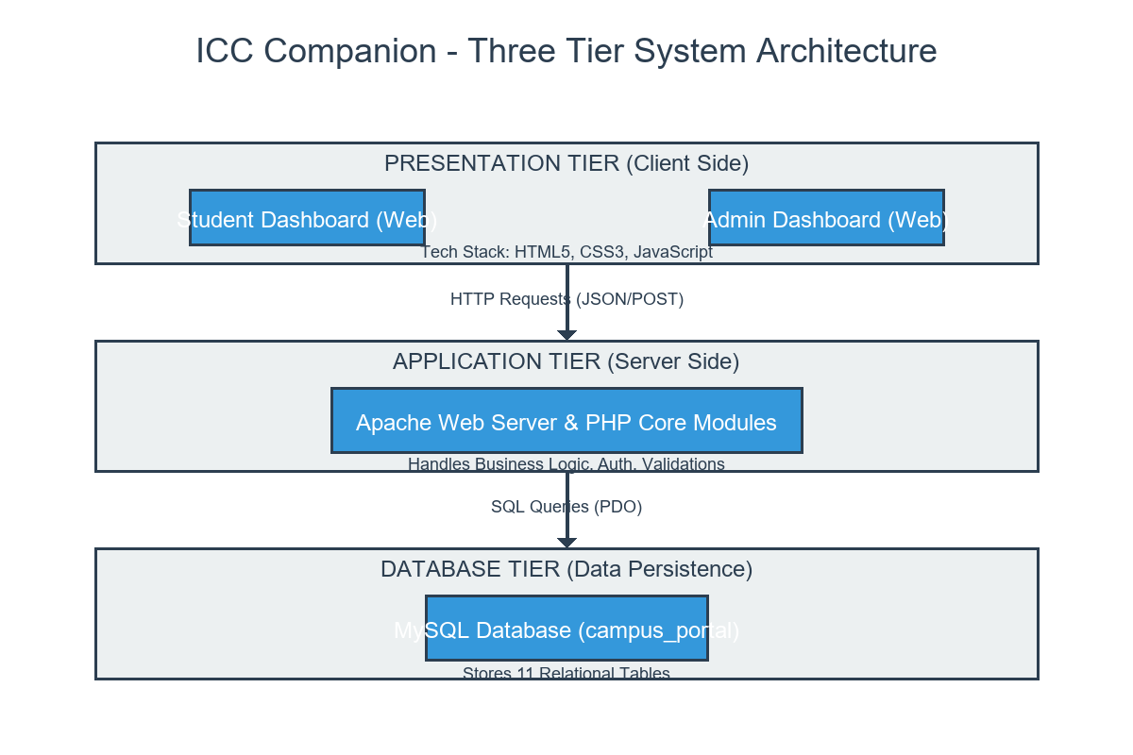
Figure 6.1 — System Architecture Diagram

Data Flow Diagram — Level 0 (Context Diagram)
The Level 0 DFD represents the system as a single process with two external entities — the Student and the Administrator — showing the high-level flow of data in and out of the system.

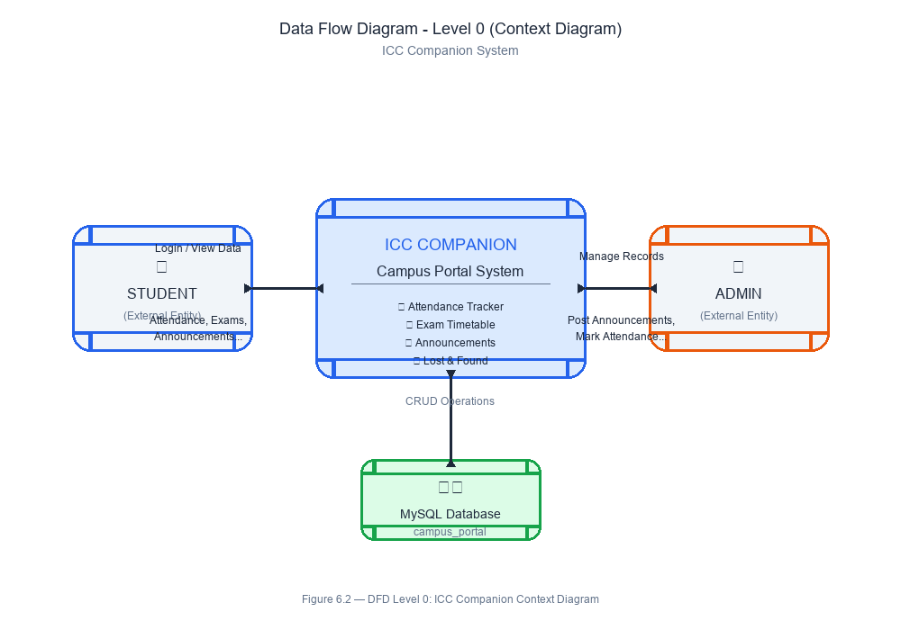
Figure 6.2 — DFD Level 0: Context Diagram

Data Flow Diagram — Level 1 (Detailed)
The Level 1 DFD breaks the system into six major processes: Student Registration/Login, Campus Portal Submission, Campus Portal Tracking, Admin Dashboard, Campus Portal Management, and Report Generation — each connected to the relevant data stores.

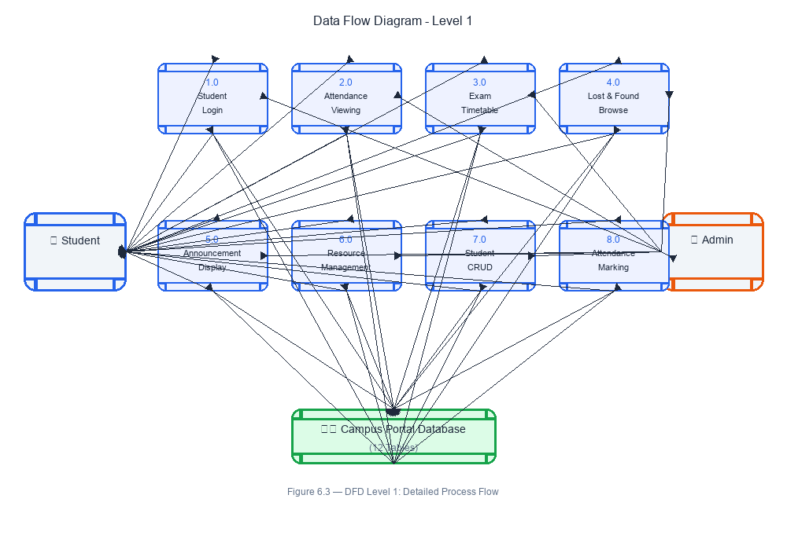
Figure 6.3 — DFD Level 1: Detailed Process Flow

Use Case Diagram
The Use Case Diagram shows all the actions available to each actor (Student and Administrator) and the boundary of the system.

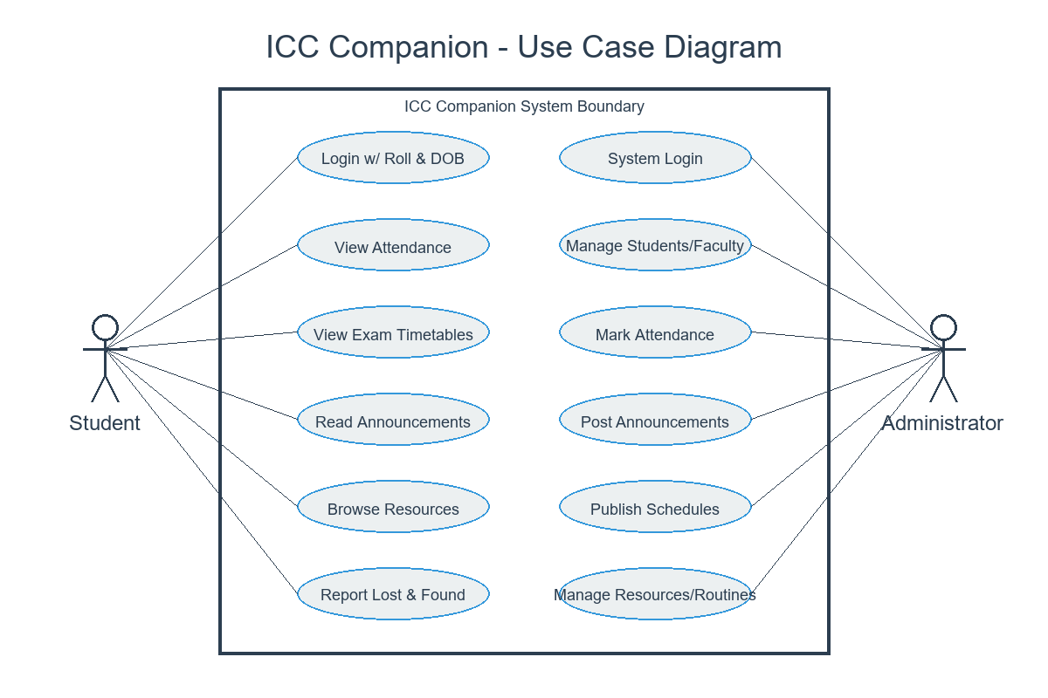

Figure 6.4 — Use Case Diagram

5.5 Entity-Relationship (ER) Diagram
The ER Diagram shows the five database entities and their relationships. Campus PortalS is the central entity, linked to USERS and CATEGORIES through foreign keys, and to Campus Portal_RESPONSES through a one-to-many relationship.

Figure 6.5 — Entity-Relationship (ER) Diagram
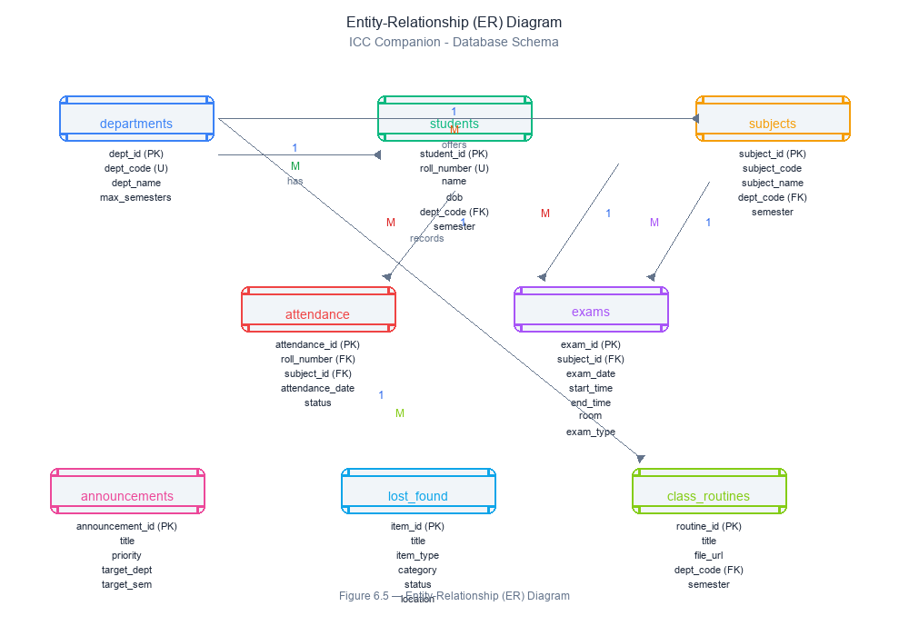

Chapter 7

DATABASE DESIGN

The database is named campus_portal and consists of eleven interconnected relational tables. All tables are implemented in MySQL with fully normalized relationships, primary keys, and cascading foreign key constraints to ensure referential integrity and database consistency.
The database is named campus_portal and consists of five tables. All tables are in MySQL with proper data types, primary keys, and foreign key relationships.

Table 1: departments
Field Name | Data Type | Constraint | Description
dept_id | INT | PK AUTO_INCREMENT | Unique ID for each department
dept_code | VARCHAR(10) | UNIQUE, NOT NULL | Short code e.g., BCA, BBA
dept_name | VARCHAR(100) | NOT NULL | Full name of the course department

Table 2: subjects
Field Name | Data Type | Constraint | Description
subject_id | INT | PK AUTO_INCREMENT | Unique Subject ID
subject_code | VARCHAR(20) | NOT NULL | Code e.g. BCA501
subject_name | VARCHAR(100) | NOT NULL | Name of the subject
dept_code | VARCHAR(10) | FK (departments) | Course category link
semester | INT | NOT NULL | Target semester (1-6)

Table 3: students
Field Name | Data Type | Constraint | Description
student_id | INT | PK AUTO_INCREMENT | Unique Identifier
roll_number | VARCHAR(20) | UNIQUE, NOT NULL | University roll number
name | VARCHAR(100) | NOT NULL | Full name of student
dob | DATE | NOT NULL | Used for student login auth
email | VARCHAR(100) | NULL | Personal email for notices
phone | VARCHAR(15) | NULL | Contact phone number
dept_code | VARCHAR(10) | FK (departments) | Enrolled department
semester | INT | NOT NULL | Current active semester
created_at | TIMESTAMP | DEFAULT NOW() | Auto insertion timestamp

Table 4: admins
Field Name | Data Type | Constraint | Description
admin_id | INT | PK AUTO_INCREMENT | Unique Admin ID
username | VARCHAR(50) | UNIQUE, NOT NULL | Login Username
password | VARCHAR(255) | NOT NULL | Plain or hashed password
name | VARCHAR(100) | NOT NULL | Dr./Mr. Faculty display name
role | VARCHAR(50) | DEFAULT 'admin' | Role level (super-admin, staff)

Table 5: attendance
Field Name | Data Type | Constraint | Description
attendance_id | INT | PK AUTO_INCREMENT | Primary Key
roll_number | VARCHAR(20) | FK (students) | Student link
subject_id | INT | FK (subjects) | Course link
attendance_date | DATE | NOT NULL | Date marked
status | ENUM | 'present' or 'absent' | Standard status field
marked_by | VARCHAR(50) | NULL | Reference to admin who marked

Table 6: exams
Field Name | Data Type | Constraint | Description
exam_id | INT | PK AUTO_INCREMENT | Primary Key
subject_id | INT | FK (subjects) | Associated subject
exam_date | DATE | NOT NULL | Date of exam conduction
start_time | TIME | NOT NULL | Time exam begins
end_time | TIME | NOT NULL | Time exam concludes
room | VARCHAR(50) | NULL | Assigned hall/room
exam_type | ENUM | 'sessional', 'final' | Category of exam

Table 7: lost_found
Field Name | Data Type | Constraint | Description
item_id | INT | PK AUTO_INCREMENT | Unique ID
title | VARCHAR(100) | NOT NULL | Item title (e.g., Wallet)
description | TEXT | NULL | Condition, markings, etc.
category | ENUM | Category type | ID, phone, wallet, books etc
item_type | ENUM | 'lost' or 'found' | Type identifier
location | VARCHAR(100) | NULL | Location reported
item_date | DATE | NULL | Reporting date
contact_info | VARCHAR(100) | NULL | Claim contact details
status | ENUM | 'active', 'claimed' | Active status

Table 8: announcements
Field Name | Data Type | Constraint | Description
announcement_id | INT | PK AUTO_INCREMENT | Primary Key
title | VARCHAR(200) | NOT NULL | Notice Title
description | TEXT | NOT NULL | Notice Description
target_dept | VARCHAR(50) | DEFAULT 'all' | Department filter
target_semester | VARCHAR(20) | DEFAULT 'all' | Semester filter
priority | ENUM | 'high','medium','low' | Priority coloring tag
posted_by | VARCHAR(50) | NULL | Posting admin

Table 9: class_routines
Field Name | Data Type | Constraint | Description
routine_id | INT | PK AUTO_INCREMENT | Primary Key
title | VARCHAR(200) | NOT NULL | Routine title display
file_url | VARCHAR(255) | NOT NULL | Uploaded file server path
dept_code | VARCHAR(10) | NOT NULL | Department link
semester | VARCHAR(10) | NOT NULL | Semester link

Table 10: resources
Field Name | Data Type | Constraint | Description
resource_id | INT | PK AUTO_INCREMENT | Unique Resource ID
title | VARCHAR(200) | NOT NULL | Display Title
description | TEXT | NULL | Brief summary info
resource_type | ENUM | Type of resource | Syllabus, book, material, link etc
file_url | VARCHAR(255) | NULL | Path to PDF if uploaded
link_url | TEXT | NULL | Outside link if provided
dept_code | VARCHAR(10) | FK (departments) | Course link

Table 11: exam_schedules
Field Name | Data Type | Constraint | Description
schedule_id | INT | PK AUTO_INCREMENT | Primary Key
schedule_type | ENUM | 'sessional', 'final' | Distinct Type Filter
file_url | VARCHAR(255) | NOT NULL | PDF storage path on server

Default categories pre-loaded: Academic, Infrastructure, Library, Hostel, Transport, Canteen, Administration, IT Services, Lost & Found, Resources, Routines.

Chapter 8

IMPLEMENTATION/WORKING

IMPLEMENTATION / WORKING
This chapter explains the step-by-step working of the system as it operates in practice. The system is divided into a Student Portal and an Admin Portal.

Home Page (index.html)
The home page serves as a public landing page. It contains clean interactive entry portals for both Students and Administrators. It introduces ICON Commerce College and offers immediate access to primary login gateways. This page uses HTML5 and Vanilla CSS providing immediate responsive navigation without prior authentication.

Student Login (student-login.html)
The student login page prompts students for their unique Roll Number and Date of Birth (DOB). This functions as a highly efficient credential mechanism for secure, simplified authentication. On submitting the form, the backend validates credentials against the stored MySQL Student profiles and establishes a persistent PHP user session, directing validated users immediately to their portal dashboard.

Student Dashboard (student/dashboard.html)
The Student Dashboard acts as the command center for students. It fetches high-level stats dynamically, such as upcoming exam alerts, recent notices, and links to syllabus materials. It includes highly responsive cards and widgets for immediate navigation to essential features using JavaScript dynamically bound to college endpoints.

Attendance Tracking (student/attendance.html)
The Attendance Tracking interface provides students a transparent visual record of their attendance. It performs live MySQL queries computing aggregate percentages for every subject the student is enrolled in, highlighting attendance rates in different colors based on specific targets which encourages academic punctuality and consistency.

Exam Schedules (student/exams.html)
The student selects a Campus Portal category from a dropdown (populated from the categories table), fills in a subject and description, selects a priority level (Low/Medium/High/Critical), and optionally uploads a file. Allowed file types are JPG, JPEG, PNG, PDF, DOC, and DOCX. The system uses the uploadFile() helper function (from functions.php) to validate and store the file in the /uploads/ directory using uniqid() as the filename. A unique Campus Portal number is generated via generateCampus PortalNumber() in the format CMP + YYYYMMDD + 4 random digits. The Campus Portal is then inserted into the Campus Portals table via a prepared statement.

Lost & Found Hub (student/lost-found.html)
This page lists all Campus Portals submitted by the logged-in student, joined with the categories table to show the category name. Students can see the Campus Portal number, category, subject, priority, status, and submission date, and can click any Campus Portal to view its full detail and admin response.

Announcements Portal (student/announcements.html)
This page shows the full details of a specific Campus Portal — including description, attachment (with a download link if present), current status, and all admin responses loaded from the exam_schedules table. Students can also add their own response from this page.

Resources & Material Hub (student/resources.html)
Students can view and update their profile details (name, phone, department, year). The email and student ID fields are read-only. Students can also change their password from this page — the current password is verified using password_verify() before the new password is hashed and saved.

Admin Login (admin-login.html)
Admins log in with a username and password. The system queries the admins table using a prepared statement and verifies the password with password_verify(). On success, an admin session is created and the admin is redirected to the Admin Dashboard.

Admin Dashboard (admin/dashboard.html)
The admin dashboard displays five statistics: Total Campus Portals, Pending, In Progress, Resolved (all from the Campus Portals table), and Total Students (from the users table). A recent Campus Portals table shows the last 10 Campus Portals across all students, joined with users and categories tables.

Student & Staff Records (admin/students.html)
This page lists all Campus Portals from all students with search and status-filter functionality implemented in JavaScript (searchTable() and filterByStatus() functions from main.js). Each row has a View/Manage button.

Attendance Management (admin/attendance.html)
The admin sees full Campus Portal details including the student's name, email, student ID, and phone. The admin can update the Campus Portal status from a dropdown (Pending, In Progress, Resolved, Closed, Rejected) via an UPDATE prepared statement. The admin can also add a response, which is inserted into the exam_schedules table with responder_type = 'admin'.

Announcements & Notice Admin (admin/announcements.html)
This page displays a list of all registered students retrieved from the users table, showing student ID, name, email, department, year, and registration date.

Exam Schedule Publisher (admin/exams.html)
Admins can view the list of all Campus Portal categories from the categories table. The page also allows adding new categories with a name and description.

Lost & Found / Departments Setup (admin/lost-found.html)
The reports page queries and displays: overall statistics (total, pending, resolved, in progress, closed, rejected), category-wise Campus Portal counts (using a LEFT JOIN between categories and Campus Portals, grouped by category), priority-wise counts (grouped by priority field), and monthly Campus Portal counts for the last 6 months. A Print Report button uses window.print() via JavaScript.

Security Implementation
Security is implemented at multiple levels: password hashing using PHP's password_hash() with PASSWORD_DEFAULT (bcrypt), password verification using password_verify(), SQL injection prevention through MySQLi prepared statements with bind_param() across all database queries, input sanitization using the sanitize() function (trim, stripslashes, htmlspecialchars, mysqli_real_escape_string), and session-based access control using requireLogin() and requireAdminLogin() functions at the top of every protected page.

Chapter 9

SAMPLE SCREENSHOTS

The following screenshots illustrate the key pages and functionalities of the ICC Companion. Please insert the actual screenshots at the indicated positions before final submission.

  - Public Pages

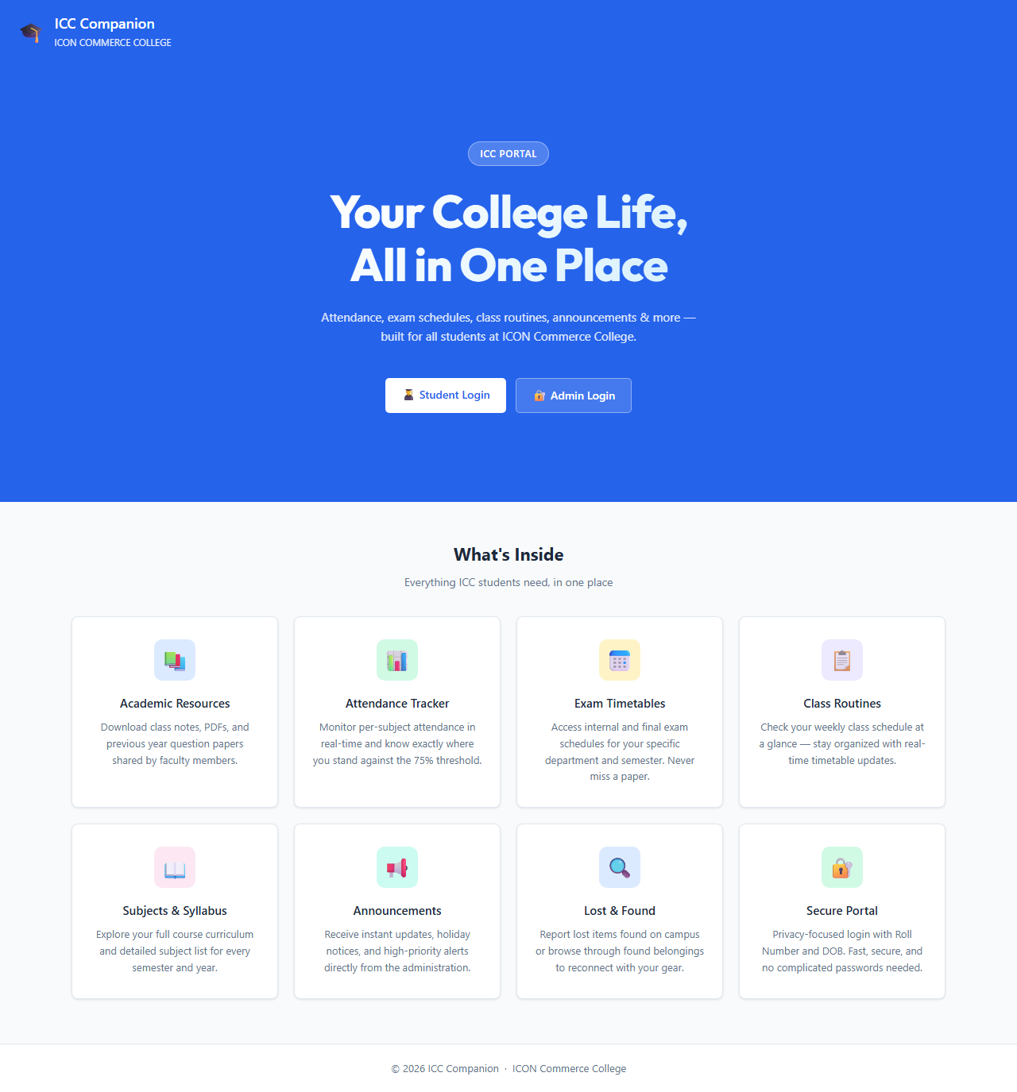
HOME-PAGE

STUDENT LOGIN-PAGE

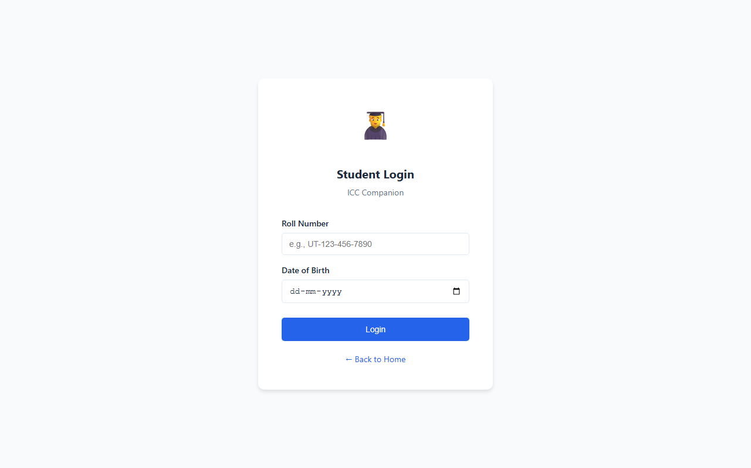

STUDENT REGISTRATION-PAGE
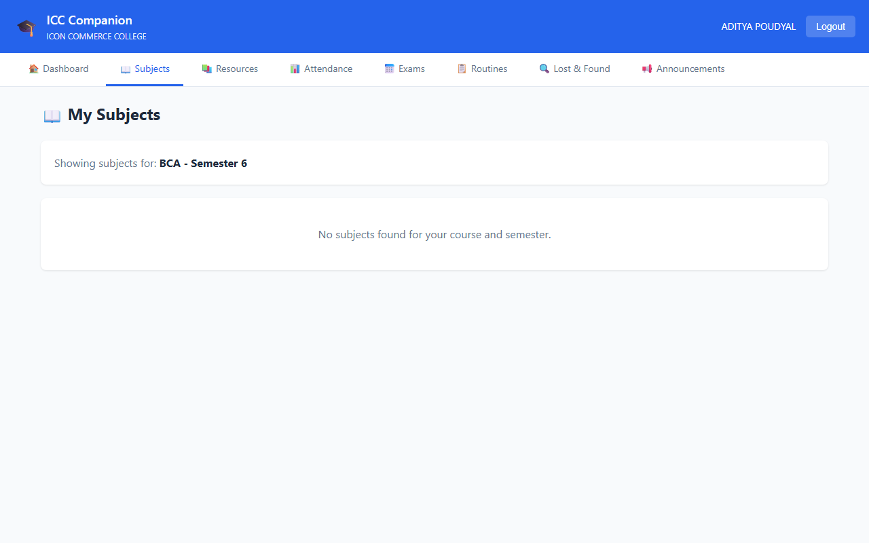

STUDENT PORTAL
STUDENT DASHBOARD

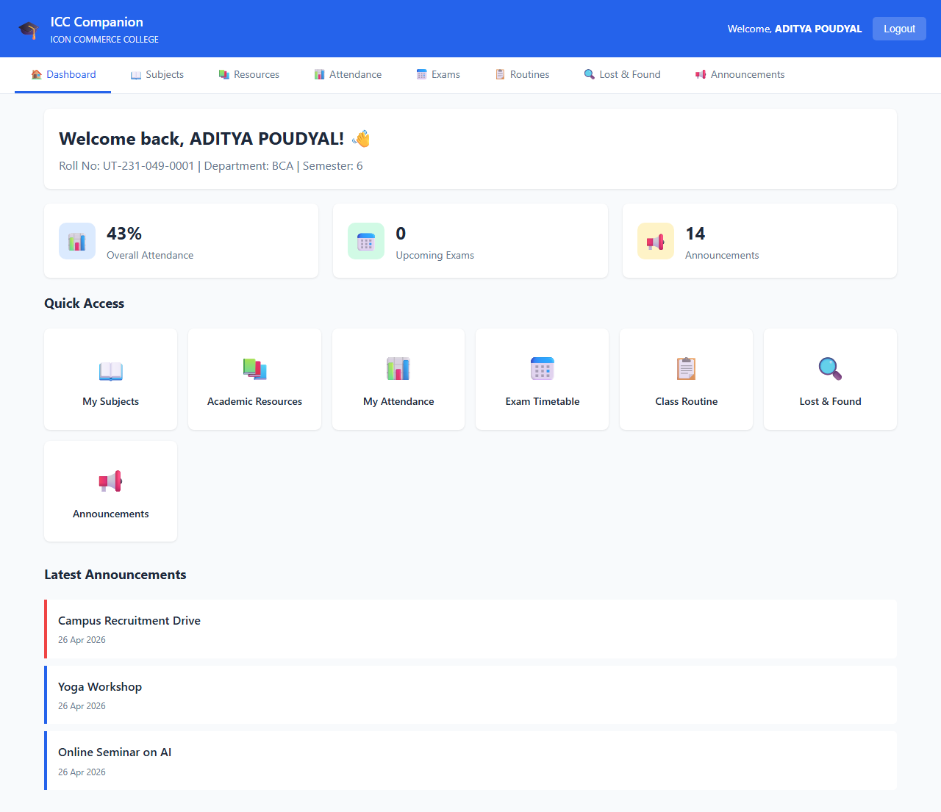

SUBMIT NEW Campus Portal
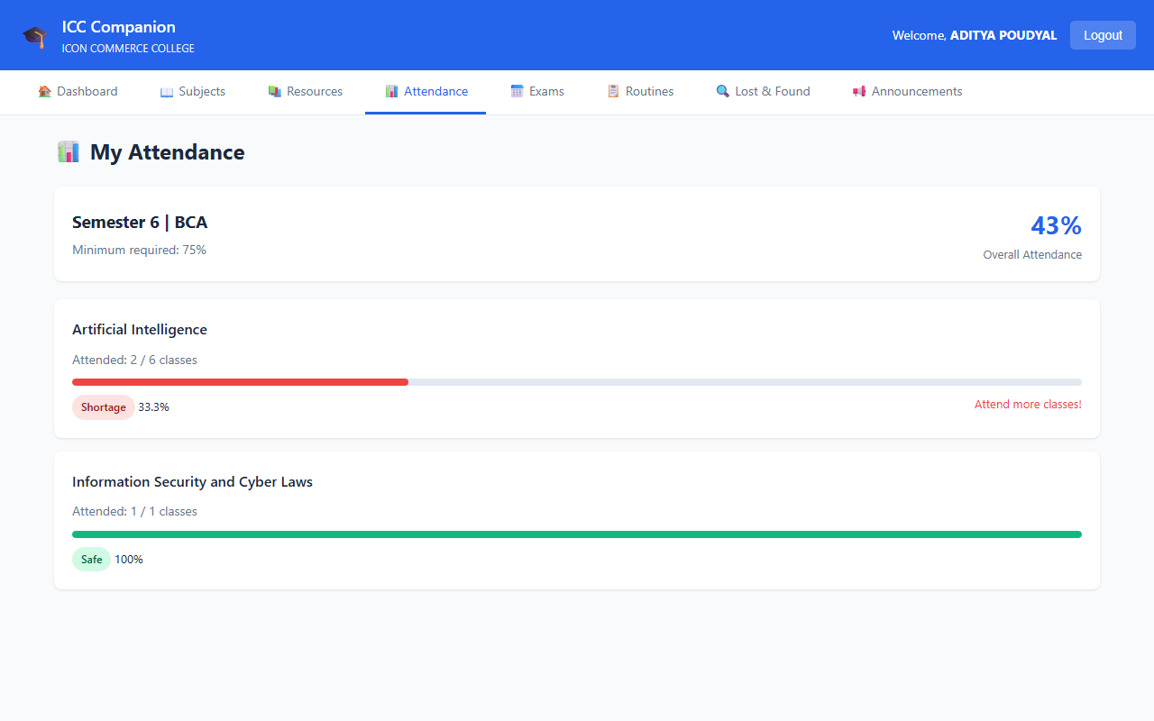

MY Campus Portal LIST
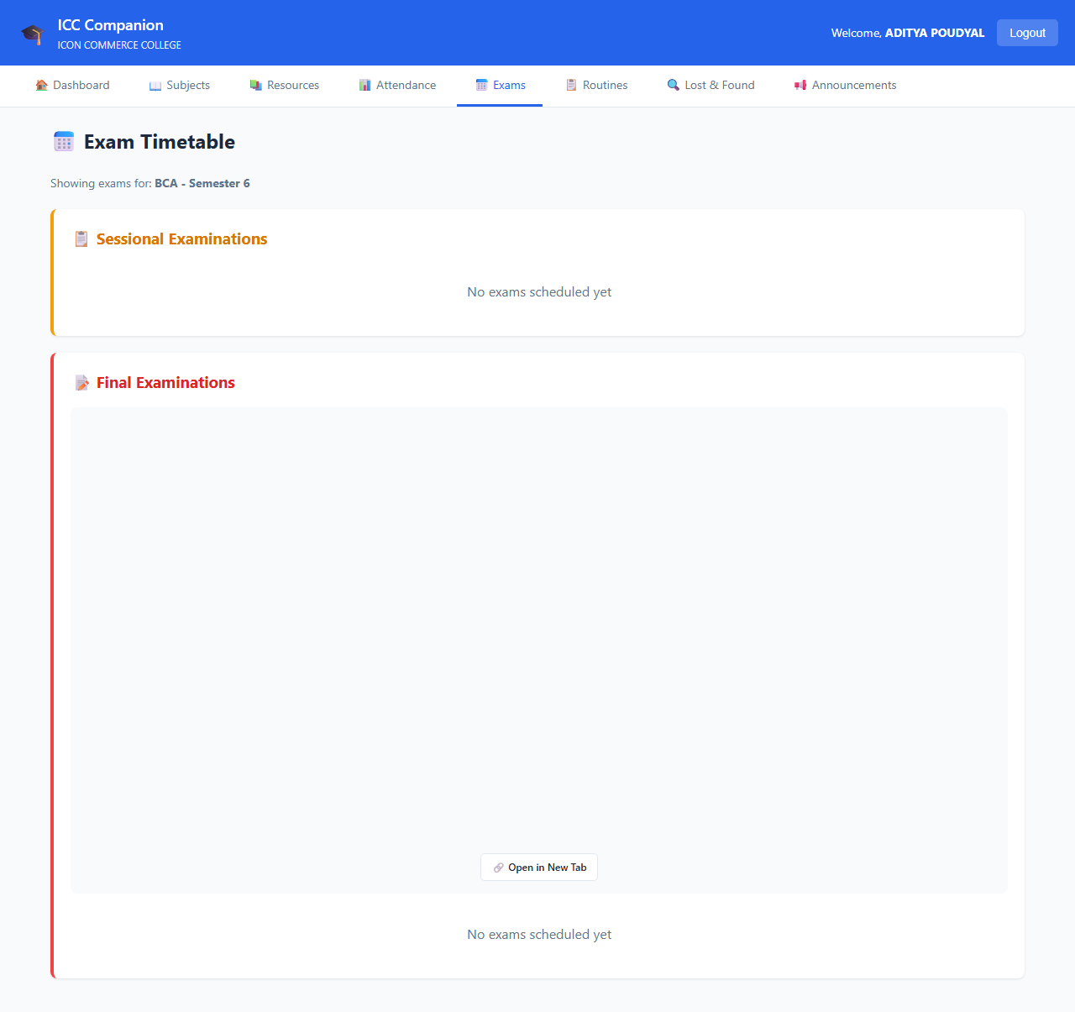

VIEW Campus Portal
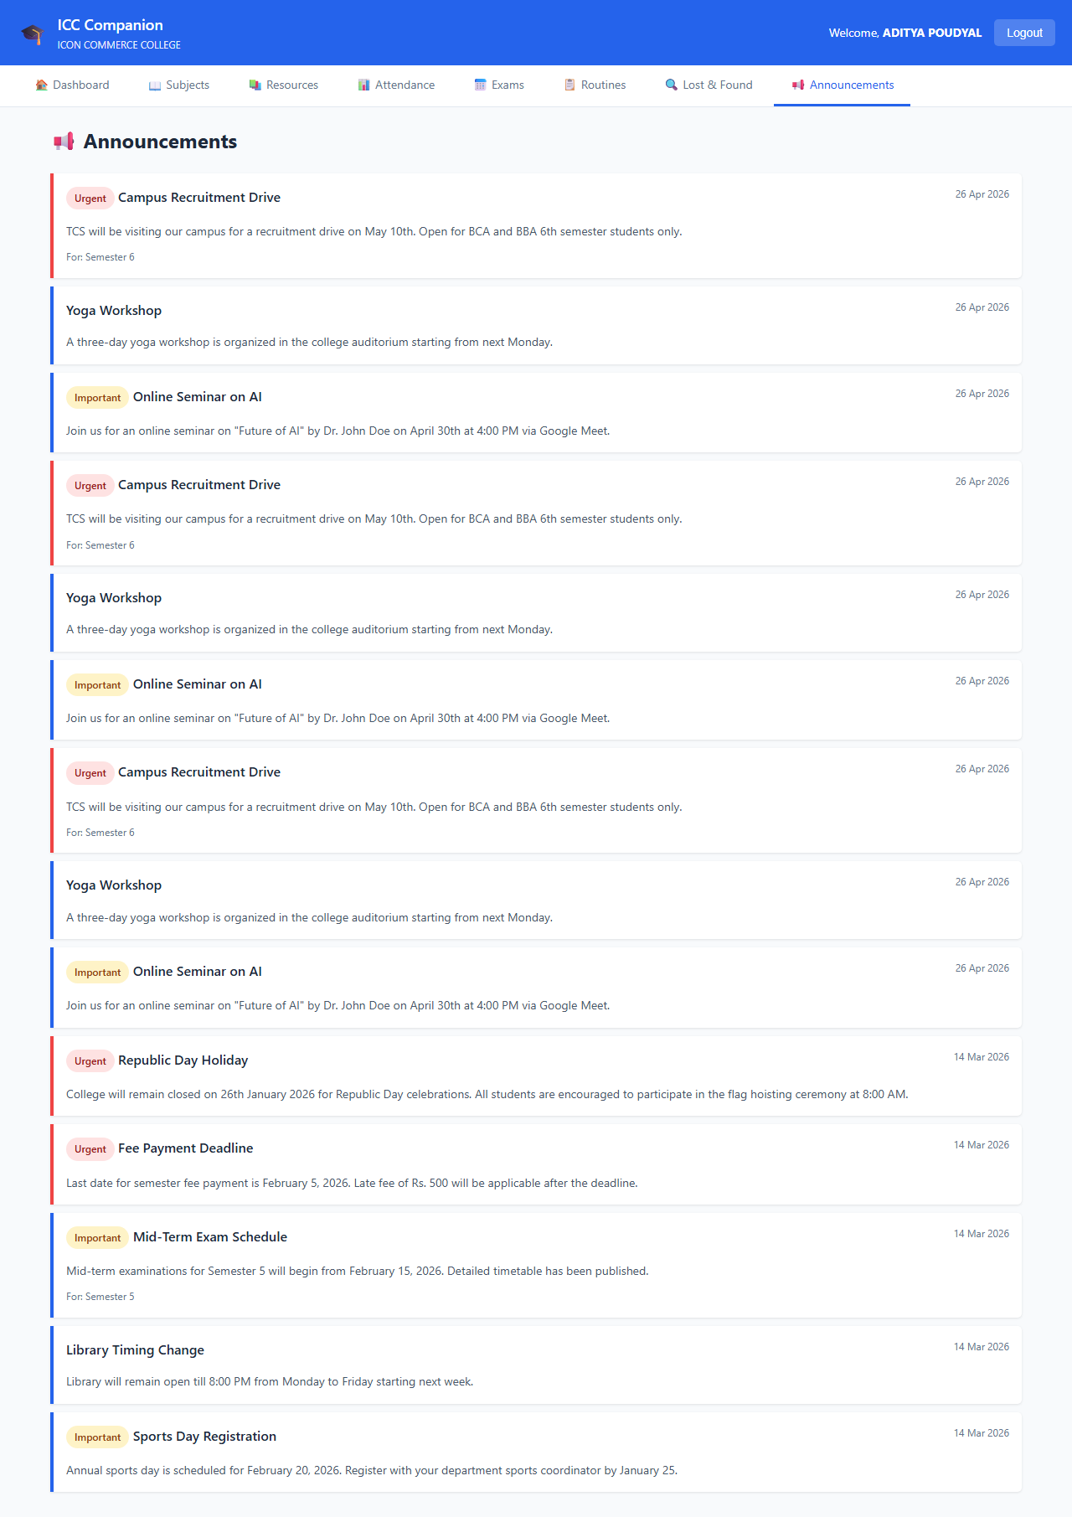

STUDENT PROFILE-PAGE
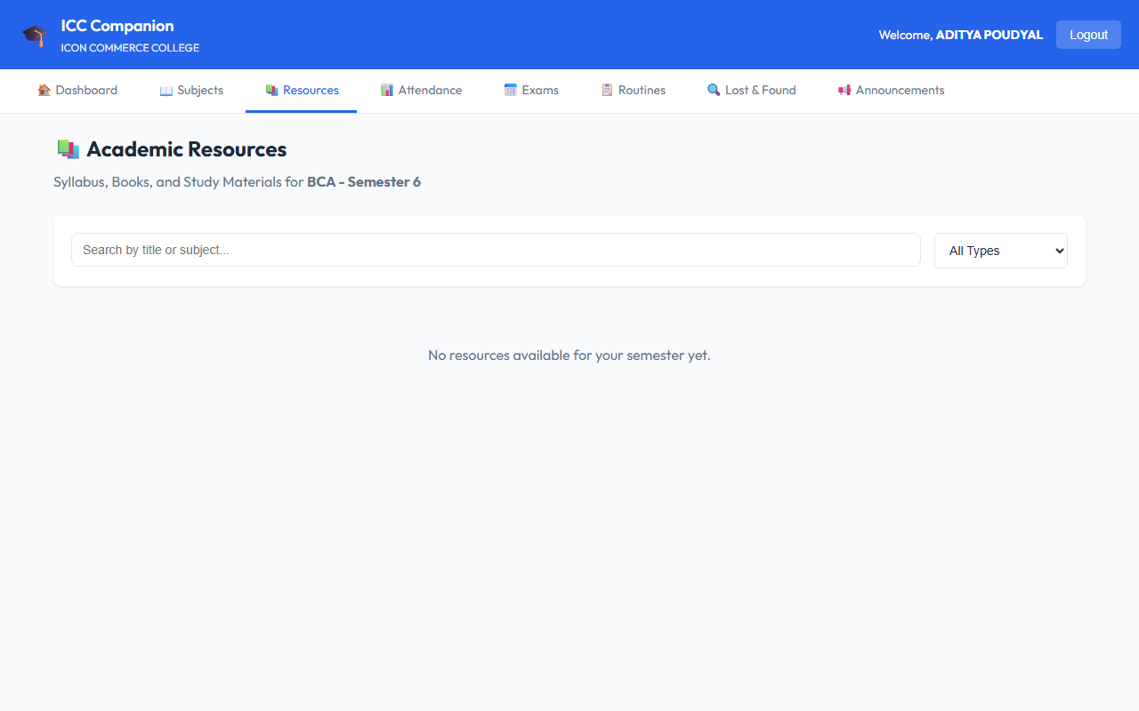

  - ADMIN PORTAL

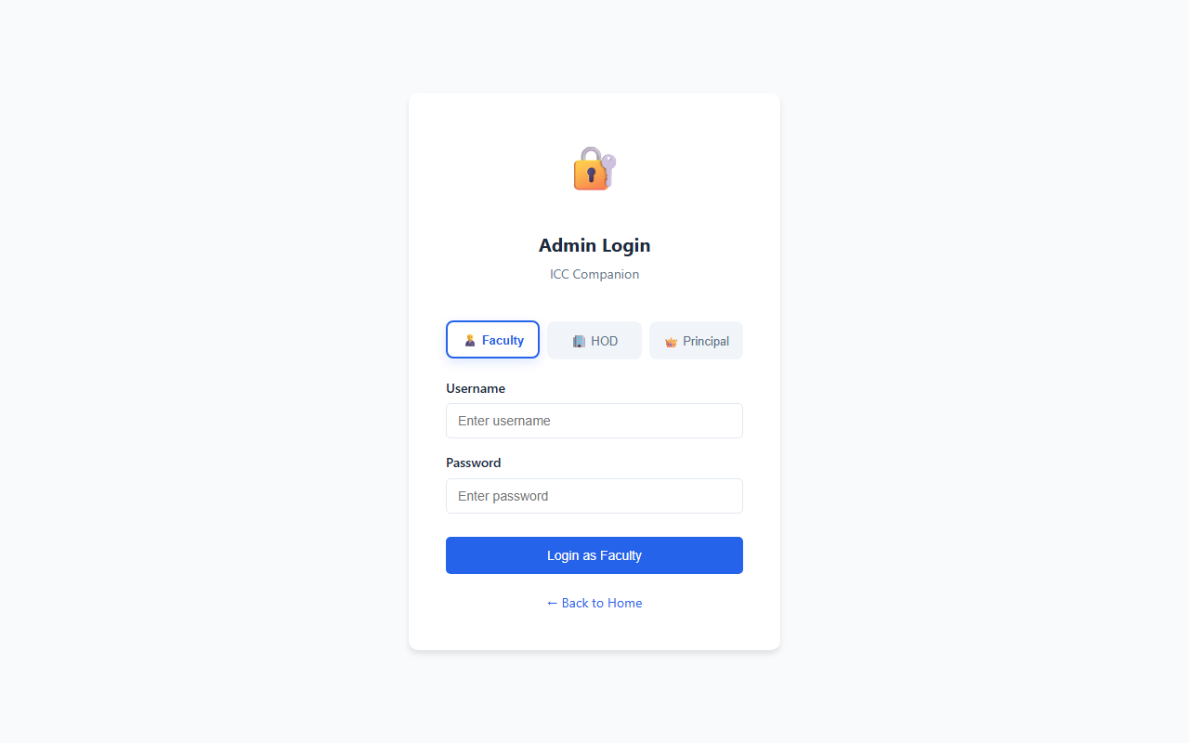
ADMIN LOGIN-PAGE

ADMIN DASHBOARD

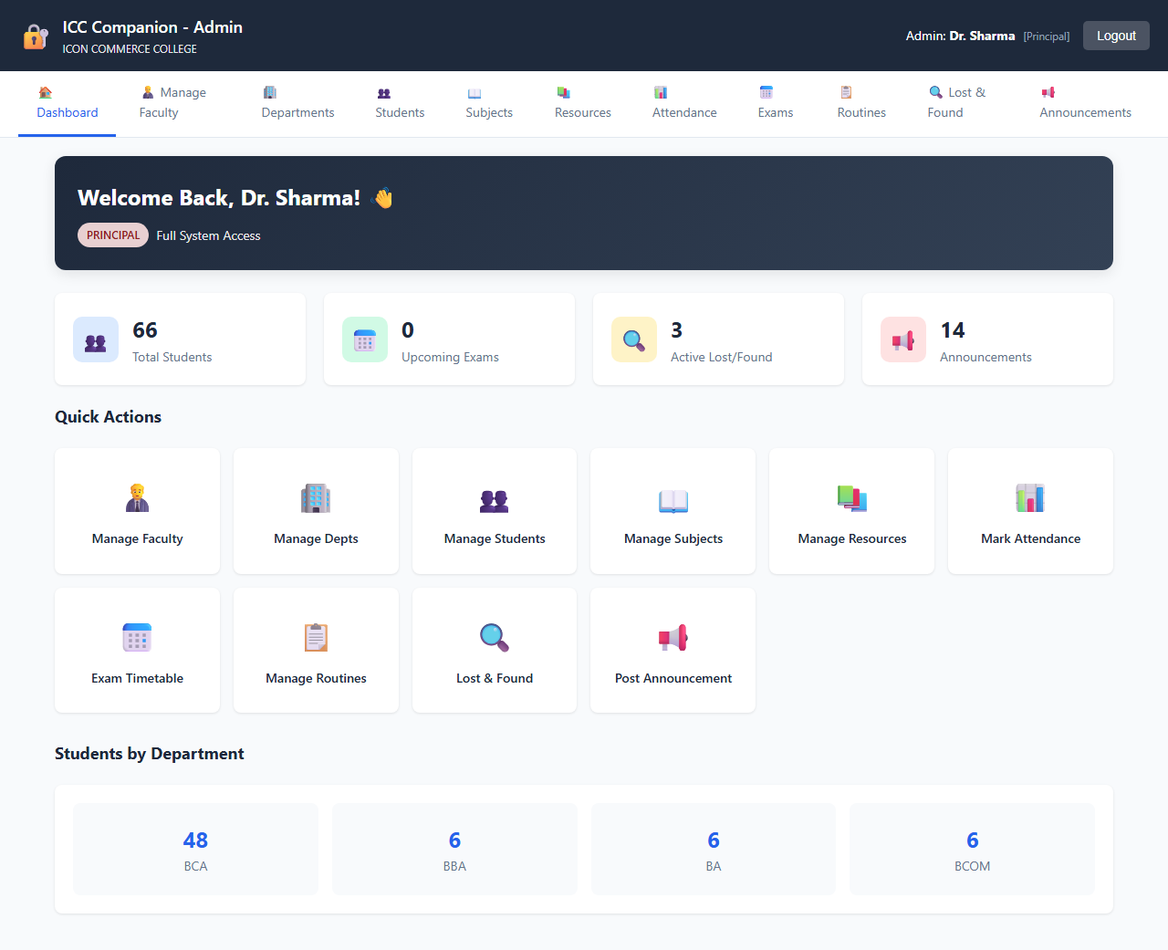

ALL Campus Portal PAGE
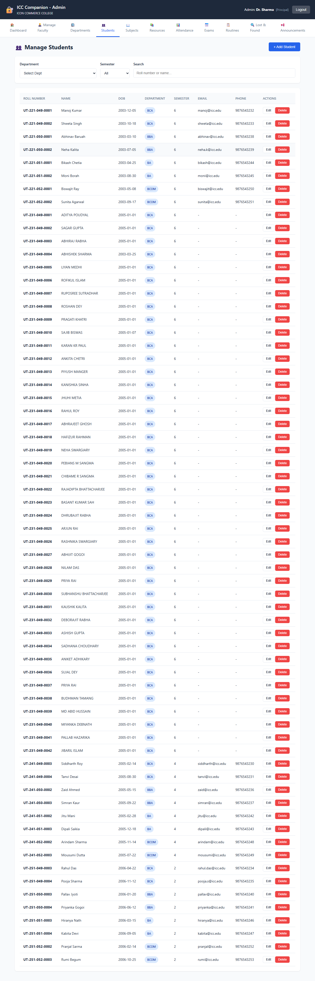

MANAGE Campus Portal PAGE
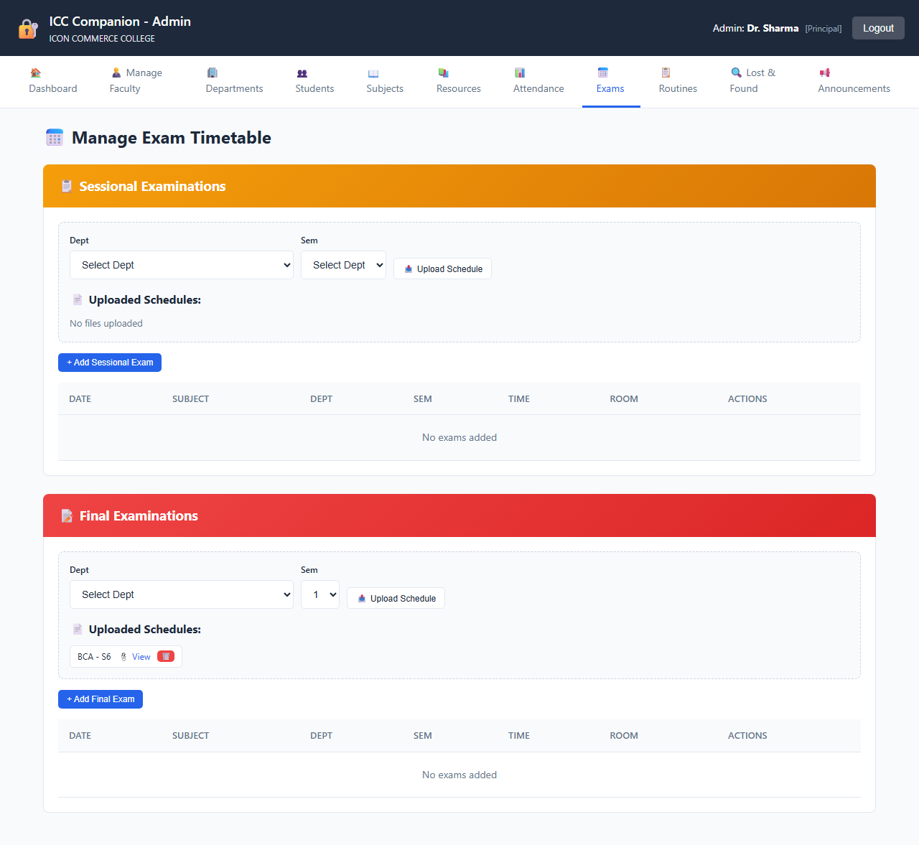

MANAGE STUDENT PAGE
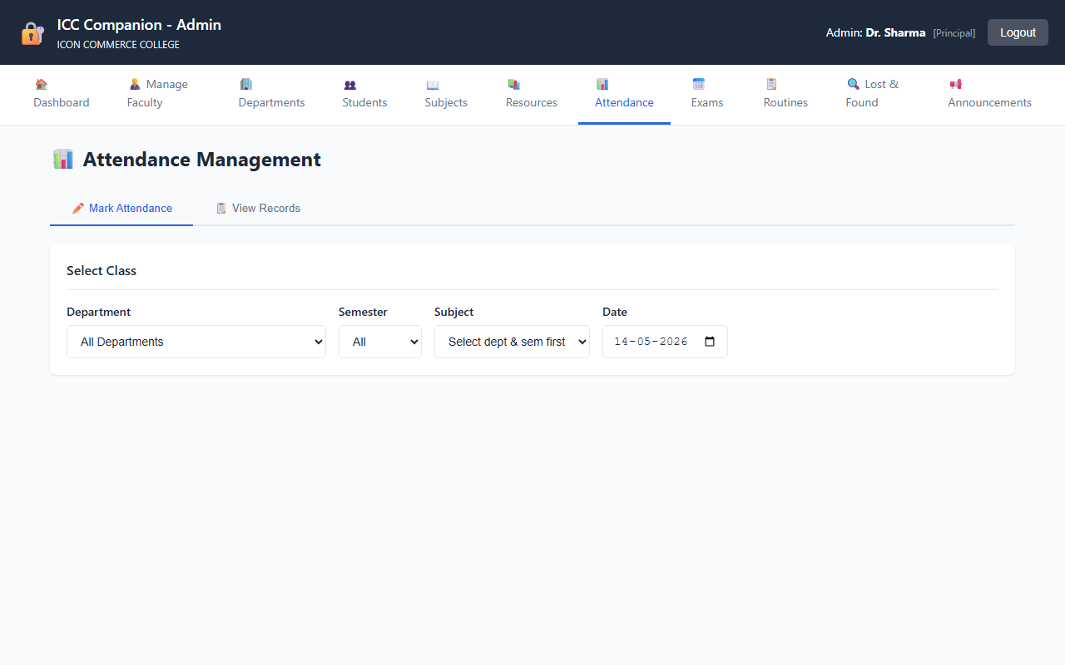

CATEGORIES PAGE
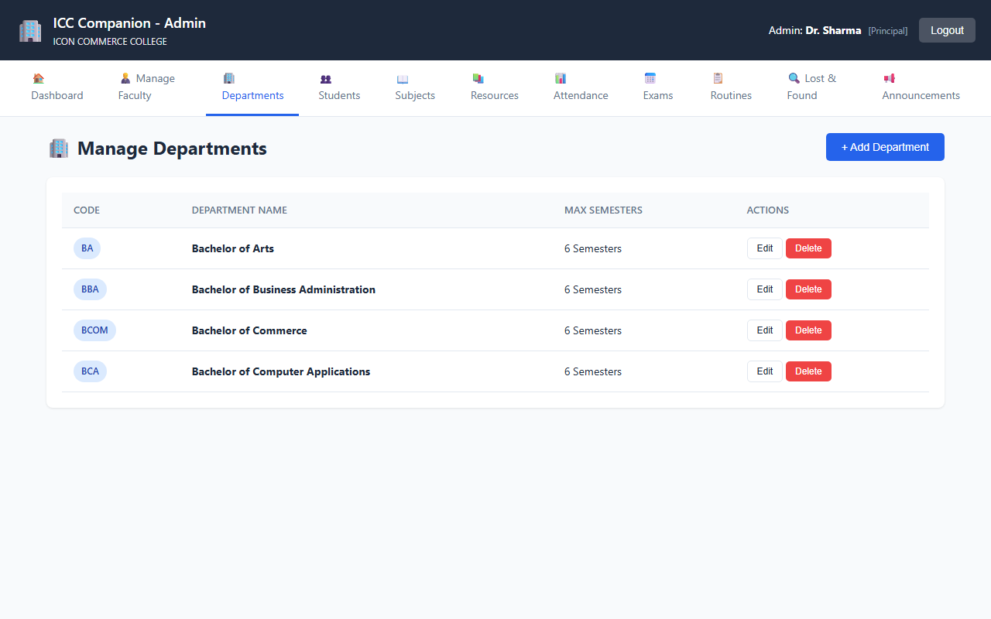

REPORTS PAGE
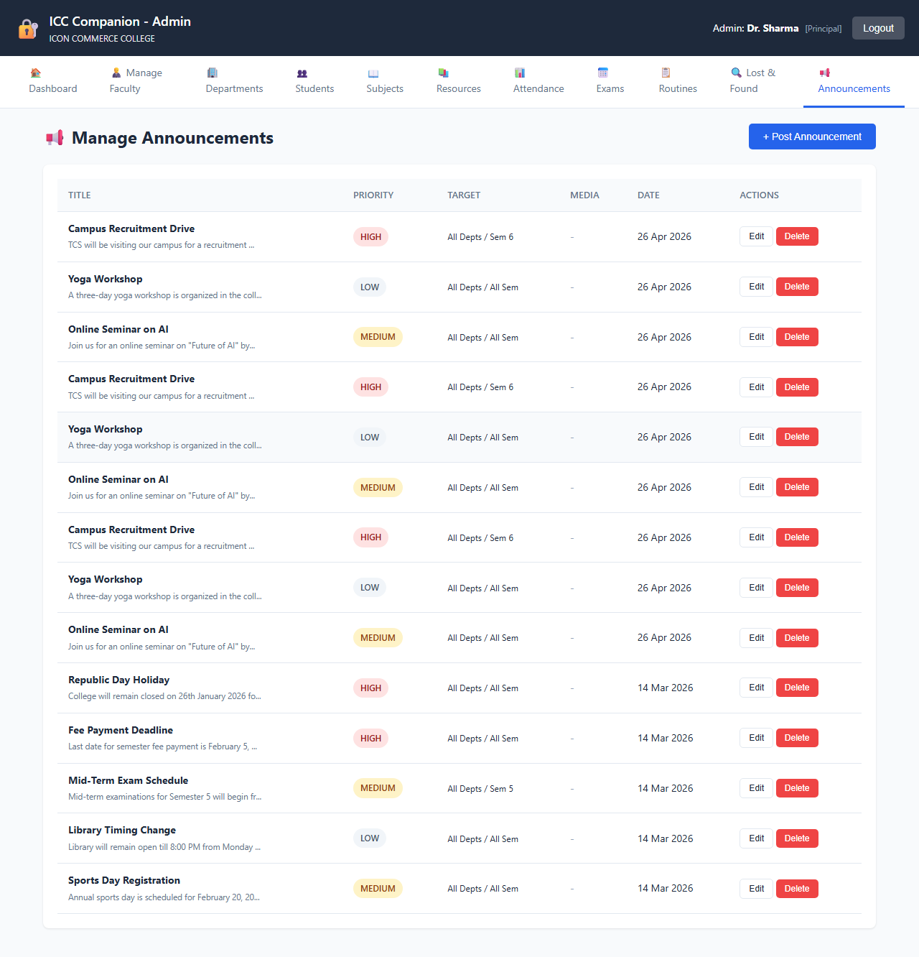

Chapter 10

ADVANTAGE AND LIMITATION

Advantages

    - Centralized Record-Keeping: All Campus Portals are stored in a MySQL database with timestamps, providing a permanent and searchable record.
    - Transparency: Students can log in at any time to check the current status of their Campus Portal and read administrator responses, eliminating uncertainty.
    - Unique Campus Portal Tracking: Every Campus Portal receives an auto-generated unique number (e.g., CMP202601150482), enabling easy reference in follow-up communication.
    - Priority-Based Handling: The four-level priority system (Low, Medium, High, Critical) ensures administrators can identify and act on the most urgent Campus Portals first.
    - File Attachment Support: Students can attach photos or documents (JPG, PNG, PDF, DOC, DOCX) as evidence, making Campus Portals more informative and verifiable.
    - Administrative Reports: The reports module gives administrators aggregated data by status, category, priority, and month, enabling data-driven decisions.
    - Secure System: Password hashing (bcrypt), prepared statements, and input sanitization make the system resistant to common web vulnerabilities.
    - User-Friendly Interface: The system has a clean, consistent, and responsive interface that does not require specialized technical training to use.
    - Admin Response Mechanism: Administrators can directly respond to Campus Portals within the system, creating a documented two-way communication thread.

Limitations

    - No Automated Email Notifications: The sendEmailNotification() function is present in the code but is implemented as a placeholder (returns true without sending). Students are not notified by email when their Campus Portal status changes.
    - Browser-Based Only: The system has no companion mobile application. Students and admins must use a web browser to access the portal.
    - No Real-Time Updates: The Campus Portal status does not update in real time — the student must manually refresh or revisit the page to see changes.
    - Flat Admin Role: All administrators have identical access. There is no department-wise routing or multi-level admin hierarchy.
    - Single Institution: The system is designed for a single college. It does not support multi-branch or multi-campus configurations.
    - 5 MB File Limit: The uploadFile() function does not enforce a file size limit in the code, but practical server configuration typically limits uploads to 5 MB.
    - No CSV Export in All Sections: CSV export (exportToCSV function in main.js) is implemented in JavaScript but may not be wired to all Campus Portal listing tables.

Chapter 11

FUTURE ENHANCEMENTS

The following enhancements are realistic and directly tied to the current state of the project codebase:

- Activate Email Notifications: The sendEmailNotification() function already exists in functions.php but is commented out. Integrating PHPMailer or SMTP configuration would enable automated email alerts to students whenever their Campus Portal status changes or when the admin posts a response.
- SMS Alerts: Integrate an SMS gateway (such as Twilio or Fast2SMS) to send text message updates to students' registered phone numbers, which are already stored in the users table.
- Department-Wise Admin Routing: Introduce an additional role field or department assignment for admins so that Campus Portals are automatically routed to the relevant department's administrator based on the Campus Portal category.
- Real-Time Campus Portal Status: Implement AJAX-based polling or WebSocket communication so that Campus Portal status updates appear for the student without requiring a full page refresh.
- Graphical Analytics Dashboard: Add a visual statistics dashboard using Chart.js or similar library to display bar charts and pie charts of Campus Portal data by category, priority, and month — in addition to the existing tabular reports.
- Mobile Application: Develop a companion Android or iOS application allowing students to submit and track Campus Portals from their smartphones.

- Campus Portal Escalation System: Introduce an automatic escalation mechanism
— if a Campus Portal remains in 'Pending' status beyond a defined number of days, it is automatically flagged or escalated to a senior admin.
- Student Feedback and Rating: After a Campus Portal is marked as Resolved, allow students to rate the resolution quality and submit feedback, helping measure admin performance.
- Full CSV/PDF Export: Extend the existing exportToCSV() JavaScript function (already in main.js) to all Campus Portal tables, and add a server-side PDF export option for the reports page using a library like FPDF or TCPDF.

Chapter 12

CONCLUSION

The ICC Companion was developed to address a real and common challenge faced by educational institutions — the lack of a structured, transparent, and traceable mechanism for managing student grievances. The system successfully replaces the informal, paper-based Campus Portal process with a fully functional web-based platform.

The project has been implemented using PHP, MySQL, HTML5, CSS3, and JavaScript — all freely available and widely supported technologies. The dual-portal architecture (separate portals for students and administrators), five-table relational database design, priority-based Campus Portal classification, unique Campus Portal number generation, file attachment support, admin response system, and a reports and analytics module collectively make this a complete and practical solution.

From a security perspective, the system implements bcrypt password hashing, session-based authentication, SQL injection prevention through prepared statements, and input sanitization — ensuring that the application is secure for production use.

The project fulfils all stated objectives and provides a solid foundation that can be extended with future enhancements such as email notifications, real-time updates, and department-wise routing. It demonstrates the practical application of web development concepts learned during the BCA program and represents a meaningful contribution to improving academic administration.

REFERENCE

The following resources were referenced during the development and documentation of this project:

- PHP Manual — Official PHP Documentation. Available at: https://www.php.net/manual/en/
- MySQL Reference Manual — MySQL 5.7 Documentation. Available at: https://dev.mysql.com/doc/refman/5.7/en/
- W3Schools — HTML, CSS, JavaScript Reference and Tutorials. Available at: https://www.w3schools.com/
- MDN Web Docs — JavaScript Reference. Mozilla Developer Network. Available at: https://developer.mozilla.org/en-US/docs/Web/JavaScript
- Font Awesome — Icon Library Documentation. Available at: https://fontawesome.com/docs
- OWASP Foundation — Web Application Security Guide. Available at: https://owasp.org/
- PHP: The Right Way — Best Practices for PHP Development. Available at: https://phptherightway.com/
- Silberschatz, A., Korth, H. F., & Sudarshan, S. — Database System Concepts, 7th Edition. McGraw-Hill Education.

