

A PROJECT REPORT ON
“A WEB-BASED STUDENT PORTAL AND MANAGEMENT SYSTEM”
A Project Report in partial fulfilment of the requirement for the degree of
Bachelor of Computer Application
Under GAUHATI UNIVERSITY

Name of the Guide: Manas Chakraborty, Asst. Prof
Department: Bachelor of Computer Application
ICON Commerce College, Guwahati-781003
Submitted By:
Abhishek Sharma
Roll No: UT-231-049-0004
Registration No: 23084891
BCA 6th Semester (FYUGP)
ICON Commerce College
CERTIFICATE
TO WHOM IT MAY CONCERN
This is to certify that the project entitled “ICC COMPANION : A WEB-BASED STUDENT PORTAL AND MANAGEMENT SYSTEM” has been submitted by Abhishek Sharma (Roll No: UT-231-049-0004, Registration No: 23084891) in partial fulfilment of the requirements for the degree of Bachelor of Computer Applications (BCA), 6th Semester (FYUGP), at ICON Commerce College, Gauhati University, during the Academic Session 2025–26.
This is an authentic work carried out by the candidate under my supervision and guidance. The project has not been submitted to any other university or institution for the award of any degree or diploma.
Date: ____________________ Signature of the Guide: ___________________
Name of the Guide: Manas Chakraborty
Designation: Assistant Professor
Department: Bachelor of Computer Application
Institution: ICON Commerce College
Guwahati – 781003

DECLARATION
I hereby declare that the project report “ICC Companion : A Web-Based Student Portal and Management System”, submitted in partial fulfilment of the requirement for the degree of Bachelor of Computer Application (BCA) in ICON Commerce College, under Gauhati University, is my original work and has not been submitted for the award of any other degree, diploma, fellowship, or other similar titles elsewhere.
Date: ____________________ Signature: ________________
Place: Guwahati Name: Abhishek Sharma
Roll No: UT-231-049-0004
Registration No: 23084898
BCA 6th Semester (FYUGP)
ICON Commerce College

ACKNOWLEDGEMENT
First of all, I would like to express my sincere gratitude to my project guide and mentor, Manas Chakraborty, Assistant Professor, Department of Computer Application, for instilling confidence in me, providing invaluable guidance, offering critical feedback, and sparing his valuable time throughout the duration of this project work.
It is my distinct honor to thank Dr. Mandira Saha, Principal of ICON Commerce College for providing excellent academic infrastructure, encouragement, and the necessary permissions to undertake this project work successfully.
I would also like to express my thanks to the entire faculty of the Computer Application department for their collective help and support during my study. My heartfelt gratitude goes to my classmates and friends who agreed to test the application, provide insights, and offer practical suggestions during its development stage.
Finally, I owe a deep debt of gratitude to my parents for their unconditional emotional and financial support, patience, and encouragement, which enabled me to finalize this project report within the limited timeframe.

Place: Guwahati
Date: ____________________

ABSTRACT
The ICC Companion is a web-based college management system developed using PHP, MySQL, HTML5, CSS3, and JavaScript to digitize and streamline academic and administrative operations at ICON Commerce College. It replaces fragmented manual processes with a unified, role-based digital platform serving three user categories: Students, Faculty, and Administrators.
The system provides a Student Portal where students can log in using their roll number and date of birth to view attendance with per-subject percentages, access academic resources (syllabi, books, materials, links, and text notes), check exam timetables, view class routines, browse lost and found items, and read college announcements. A Faculty Portal enables subject teachers to mark attendance, upload resources, and view assigned subjects. An Admin Portal with role-based access control (Principal, HOD, Faculty) provides comprehensive management tools including student records, department and subject administration, staff account management, attendance oversight, exam scheduling, routine uploads, announcement publishing, and lost and found item tracking.
The database architecture comprises 11 normalized MySQL tables with foreign key constraints and a student_attendance_summary view, supporting data integrity across modules. Security measures include PHP session-based authentication, role-scoped access enforcement (department and semester level filtering for HODs and faculty), SQL injection prevention via MySQLi prepared statements and transactions, and file upload validation. The system follows a 3-tier architecture with asynchronous data fetching through the JavaScript Fetch API, ensuring a responsive user experience. It is deployable on any standard Apache server environment such as XAMPP.

TABLE OF CONTENTS
SECTION / CHAPTER | PAGE NO.
Chapter 1: Introduction | 1
1.1 Background | 1
1.2 Problem Statement | 1
1.3 Proposed Solution | 2
Chapter 2: Requirement Specification | 3
2.1 System Requirements | 3
2.2 Technologies Used | 3
Chapter 3: Objectives of the Project | 6
Chapter 4: Scope of the Project | 7
4.1 Functional Scope (In Scope) | 7
4.2 Out of Scope Limitations | 7
Chapter 5: System Analysis | 9
5.1 Existing System and Limitations | 9
5.2 Proposed System | 9
5.3 Feasibility Study | 10
Chapter 6: System Design | 12
6.1 System Architecture | 12
6.2 Data Flow Diagram (DFD) | 12
6.3 Use Case Diagram | 13
6.4 Entity-Relationship (ER) Diagram | 14
Chapter 7: Database Design | 15
Chapter 8: Implementation / Working | 19
Chapter 9: Sample Screenshots | 23
Chapter 10: Advantages & Limitations | 27
Chapter 11: Future Enhancements | 29
Chapter 12: Conclusion | 31
Reference | 33

CHAPTER 1
INTRODUCTION

INTRODUCTION
1.1 Background
In modern higher education institutions, communication and information accessibility play a critical role in shaping the academic experience of students. ICON Commerce College, a premier educational center, serves hundreds of students across various streams. Currently, student services such as distributing academic notices, sharing day-to-day class timetables, allocating course resources, and managing feedback are managed through fragmented networks—physical notice boards, standalone emails, and third-party social messaging groups. This dispersion often results in missing critical academic updates, misplacing lecture resources, and creating a information gap between the student body and the administration.
With the rapid adoption of digital infrastructure in educational operations, establishing a centralized digital touchpoint is crucial. The 'ICC Companion' project is conceived as an integrated, secure, web-based student companion portal tailored specifically for the internal stakeholders of ICON Commerce College. By providing a structured database environment coupled with a responsive user interface, it ensures that students can access critical academic tools from any device seamlessly, thereby introducing high traceability, efficiency, and organizational transparency to day-to-day academic life.
1.2 Problem Statement
The absence of an integrated, dedicated student academic companion portal at the institutional level leads to several structural and administrative challenges:
- Physical notice boards require students to be present on campus and often lead to critical information being overlooked or delayed.
- Course handouts, lecture notes, and syllabus copies shared via external chat applications get buried in casual conversations, making search and archival extremely cumbersome for students.
- Class timetables and schedule modifications are communicated textually, resulting in room scheduling confusion, scheduling conflicts, or missed announcements.
- There is no private, formal, and structured digital mechanism for students to submit academic queries or feedback directly to administrative coordinators, leaving concerns unresolved or poorly documented.
- Administrators lack a unified data dashboard to broadcast updates, handle student records, upload academic schedules, and analyze feedback metrics effectively.
1.3 Proposed Solution
The 'ICC Companion' is an advanced, web-based platform built on a classic three-tier architecture using PHP, MySQL, HTML5, CSS3, and JavaScript. It serves as a single, unified digital portal that bridges the communication gap between students and college administration. The application organizes college life into separate, session-authenticated environments: a Student Portal and an Admin Portal.
Students are provided with personal profiles where they can track active institutional notices, view daily structured timetables, download learning resources organized by department and semester. On the backend, administrators access a powerful management control dashboard showing student enrollment metrics, active notice broadcast controls, structured timetable configuration tables, resource upload managers. This system transforms college communication into an audit-ready, organized, and reliable digital ecosystem.

CHAPTER 2
REQUIREMENT SPECIFICATION

REQUIREMENT SPECIFICATION
2.1 System Requirements
To ensure proper deployment and smooth performance during execution, the application requires standard infrastructure configurations on both the host server side and the end-user client side.
Hardware Requirements
Hardware Component | Minimum Server Specification | Minimum Client Specification
Processor | Intel Core i3 or equivalent (2.4 GHz) | Intel Celeron / Dual Core or equivalent
RAM | 4 GB or higher | 2 GB available system memory
Storage Space | 20 GB available SSD/HDD storage | 500 MB available local disk space
Network interface | Standard LAN / High-speed Internet line | Standard internet access / Intranet connectivity

Software Requirements
Software Component | Development & Server Host Environment | Client End-User Environment
Operating System | Windows 10 / 11 or Linux (Ubuntu 20.04+) | Windows, macOS, Linux, Android, or iOS
Web Server | Apache 2.4+ (via XAMPP or WAMP local bundle) | Not applicable (Server-side execution only)
Scripting Language | PHP 7.4+ (Server-side runtime interpreter) | Not applicable
Database Management | MySQL 5.7+ / MariaDB 10.4+ | Not applicable
Client Web Browser | Google Chrome (for testing administrative layouts) | Chrome, Firefox, Safari, Edge, or Opera

2.2 Technologies Used
The ICC Companion system is built purely using open-source web development technologies to ensure stability, ease of deployment, and high operational performance without licensing costs:
- PHP (Hypertext Preprocessor): Used as the primary server-side scripting runtime. It handles form data validation, session state persistence, file upload verification, and procedural queries to the database layer.
- MySQL Database Server: Acts as the secure relational data store, organizing data structures across eleven well-structured, normalization-compliant tables linked with relational foreign key integrity. The database schema includes tables for departments, subjects, students, admins, attendance, exams, lost & found items, announcements, class routines, resources, and faculty-subject assignments.
- mysqli Extension: Utilized for executing native database connections, employing parameter binding and prepared statements to defend against web injection exploits.
- HTML5: Sets up the structural semantics across all application layouts, forms, tables, and dash views.
- CSS3: Controls custom layout styling via an optimized, custom sheet (style.css), utilizing fluid grids, typographic hierarchies, and interactive component transitions.
- Vanilla JavaScript: Used extensively for form client-side pre-validation, dynamic tabular search filters, profile interaction widgets, character count safety, and modal overlay animations.
- Font Awesome ICONs: Embedded as a local self-hosted library (Font Awesome 6.7.2) to provide intuitive vector iconography across menus, cards, status indicators, and action buttons, ensuring full offline functionality without external CDN dependencies.

CHAPTER 3
OBJECTIVES OF THE PROJECT

OBJECTIVES OF THE PROJECT
The primary objectives guiding the conceptualization, development, and delivery of the ICC Companion system are:
- Centralize Student Information: Create a secure, centralized digital repository where students can view their academic profile, schedules, and college materials in one place.
- Automate Notice Broadcasting: Enable the administration to publish time-sensitive notices digitally, ensuring immediate visibility and removing the reliance on physical notice boards.
- Organize Class Timetables: Implement a structured database system to store and render class timetables by department and semester, preventing scheduling overlaps and confusion.
- Facilitate Resource Access: Provide an easy-to-use repository where teachers or admins can upload learning materials, syallbi, and reference files for instant download by students.
- Simplify Lost Property Management: Offer a digital lost and found system that connects finders with owners through categorized listings and claim tracking.
- Ensure Robust Security: Protect user data through password encryption, prevent cross-site execution via character escaping, and eliminate SQL injection with prepared queries.
- Optimize User Experience: Deliver a clean, highly intuitive interface requiring zero prior technical training for both students and non-technical staff.

CHAPTER 4
SCOPE OF THE PROJECT

SCOPE OF THE PROJECT
4.1 Functional Scope (In Scope)
The system bounds are carefully tailored to address the internal student-coordination needs of a single-campus institution like ICON Commerce College. Features in active operational scope include:
- User Authentication: Secure multi-portal authentication for students and administrators, using persistent session handling.
- Notice Management Module: Full administrative controls to write, update, and manage official college notices with optional file attachments.
- Academic Schedule Board: Administrative tools to input, modify, and display day-specific timetables, including faculty names, room allocations, and timings.
- Resource Vault: Upload engine for learning materials categorized strictly by target department and semester, with automated storage file sanitization.
- Administrative Statistics Engine: Dashboard metrics rendering live analytical counts of registered student profiles, total notice logs, and pending student exams.
4.2 Out of Scope Limitations
To maintain project feasibility within the final-semester timeframe, the following boundaries are established as out of scope:
- No External SMS Gateway: The system does not integrate real-time cellular SMS text lines due to premium carrier API requirements.
- Single-Institution Architecture: The application cannot host multi-campus entities or separate standalone branches inside a shared database schema.
- No Mobile Native Build: The app is purely web-browser responsive and does not feature compilations for Android APK or iOS packages.
- No Automated Online Fee Gateway: Financial collection modules, payment processing, and ledger checkouts are completely excluded.

CHAPTER 5
SYSTEM ANALYSIS

SYSTEM ANALYSIS
5.1 Existing System and Its Limitations
Currently, operations at ICON Commerce College rely on scattered manual methods and generic communication tools. Notices are physically pinned to administrative bulletin boards or forwarded via unofficial chat channels. Learning resources are distributed via individual emails, or third-party file sharing links. Timetables are shared as image documents or printed flyers.
Limitations of the Existing Setup:
- Information is easily lost or overshadowed in crowded chat groups.
- Students missing physical classes often lose visibility of campus notice boards.
- Searching historic notices or old lecture notes requires manual scrolling and is highly inefficient.
- Administrators cannot easily track total engagement, analyze feedback, or update details systematically.
5.2 Proposed System and Its Advantages
The proposed system, ICC Companion, replaces these scattered mechanisms with an organized database platform. It provides a secure portal where data is structured, indexed, and available 24/7.
Key Tactical Advantages:
- Instant Accessibility: Students can fetch notices, timetables, and notes anytime, anywhere via a web browser.
- High Structural Organization: Information is categorized cleanly by department and semester, removing clutter.
- Robust Security Architecture: Employs parameter binding, data sanitation, and encryption to safeguard data.
- Aggregated Administration View: Provides real-time dashboard summaries for faster decision-making.

5.3 Feasibility Study
A comprehensive three-pronged feasibility assessment was conducted to confirm the viability of the project:
Technical Feasibility: The system relies on well-established core web technologies (PHP, MySQL, HTML5, CSS3, JS). Since these technologies run seamlessly on standard local servers (like XAMPP/WAMP) and any modern web browser, the project is fully feasible without specialized hardware.
Economic Feasibility: All development tools, database servers, and runtime interpreters used are open-source and free. This keeps development and operational costs minimal, making it highly cost-effective for implementation.
Operational Feasibility: The application features clean layouts and simple navigation, tailored for users with basic digital literacy. Administrative workflows are straightforward, meaning non-technical college staff can manage data with zero specialized training.

CHAPTER 6
SYSTEM DESIGN

SYSTEM DESIGN
6.1 System Architecture
The system is designed using a clean three-tier software architecture. The Presentation Layer handles user views in the web browser. The Application Layer executes logical operations using server-side PHP on Apache. The Data Layer manages secure transactions via a structured MySQL database.

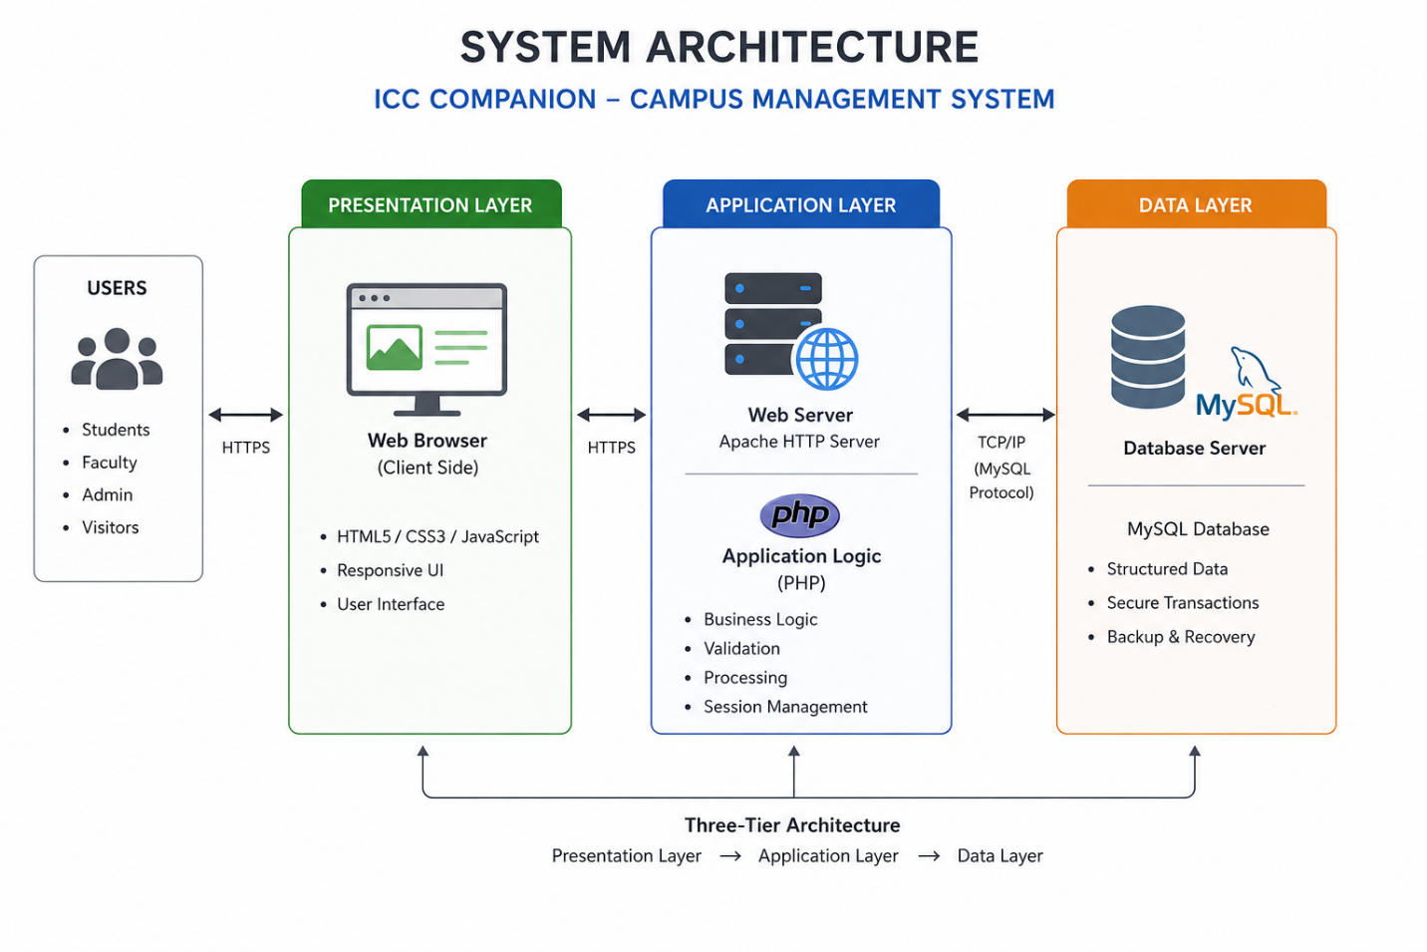

6.2 Data Flow Diagram (DFD)
The DFD details how information moves through the application, starting from external inputs down to database writes:

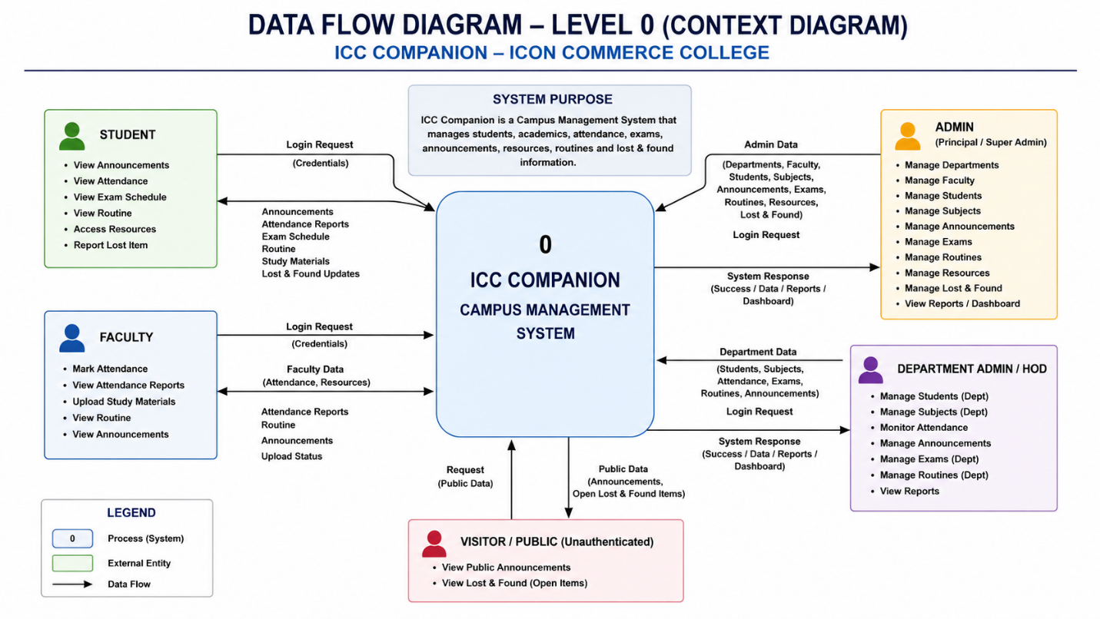

Level 0 Context Diagram: Focuses on high-level boundary flows, showing Student and Admin entities exchanging credentials, records, and other data’s with the core application system process.

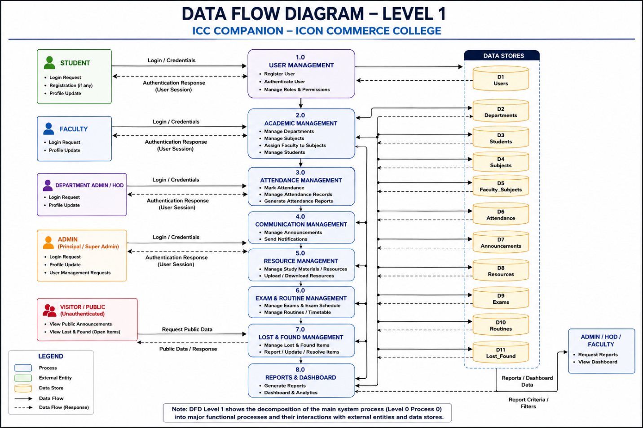

Level 1 Process Breakdown DFD: Maps data movements across specific sub-processes, including login validation, notice distribution, schedule filtering, file archiving, and dashboard updating.

6.3 Use Case Diagram
The Use Case Diagram defines user roles and system boundaries, mapping user activities to specific application functions:
- Student Use Cases: Register account, authenticate sessions, check notices, look up schedules, download resources, and track submitted feedback.
- Admin Use Cases: Access dashboard, broadcast notices, configure timetables, manage files, review student entries, and update feedback responses.

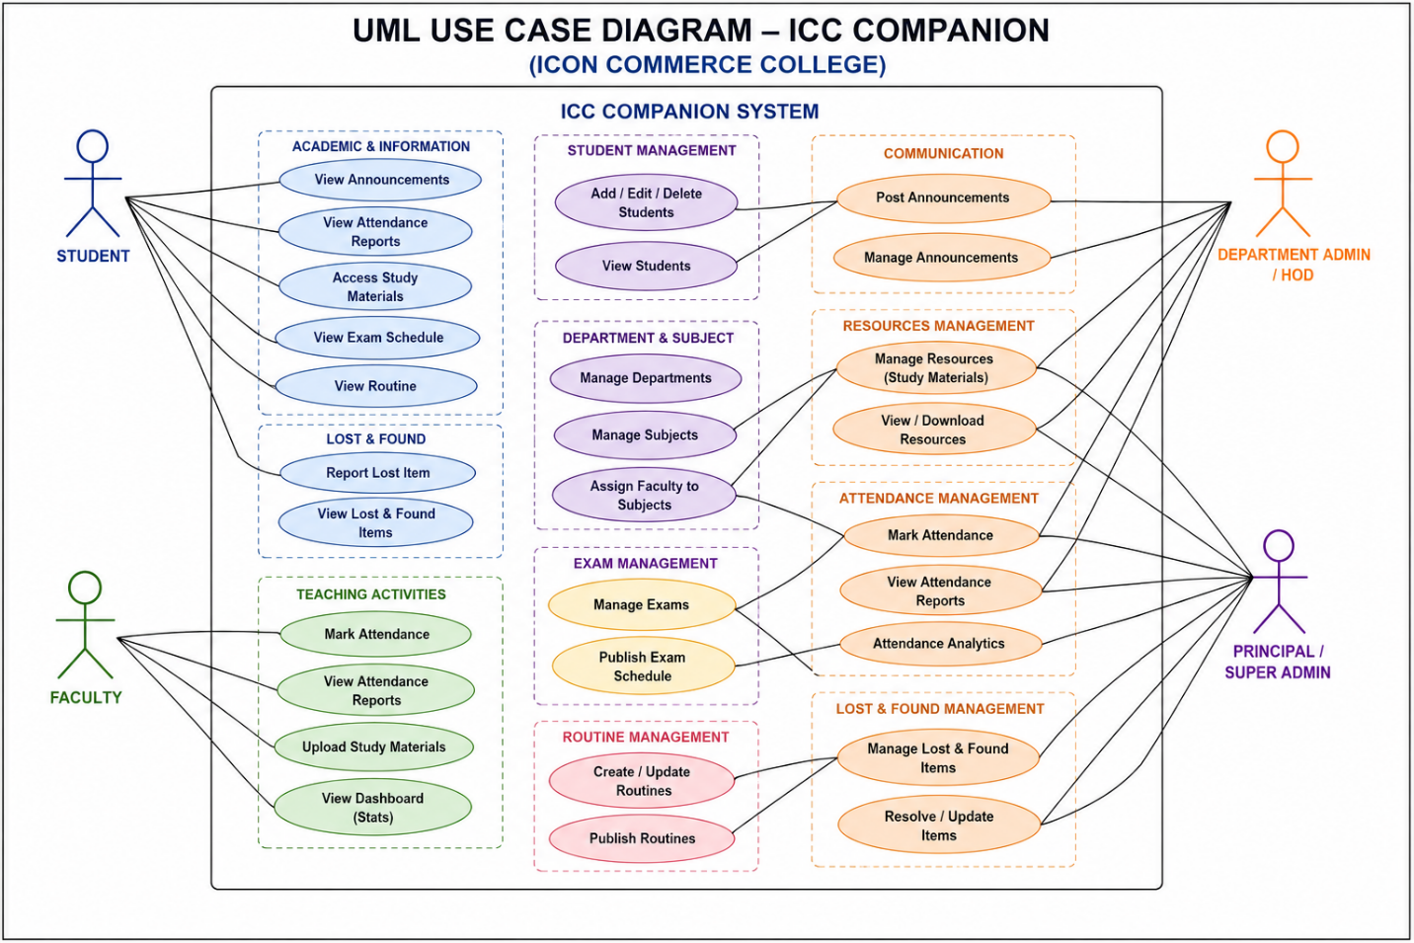

6.4 Entity-Relationship (ER) Diagram
The ER Diagram models the relational database structure, detailing the entities, their distinct attributes, and relational cardinalities:
- Entities: DEPARTMENTS, SUBJECTS, STUDENTS, ADMINS, ATTENDANCE, STUDENT_ATTENDANCE_SUMMARY, EXAMS, LOST_FOUND, ANNOUNCEMENTS, CLASS_ROUTINES, RESOURCES, EXAM_SCHEDULES, FACULTY_SUBJECTS.
- Cardinality: One-to-many relationships link users to feedback records and tracking histories cleanly.
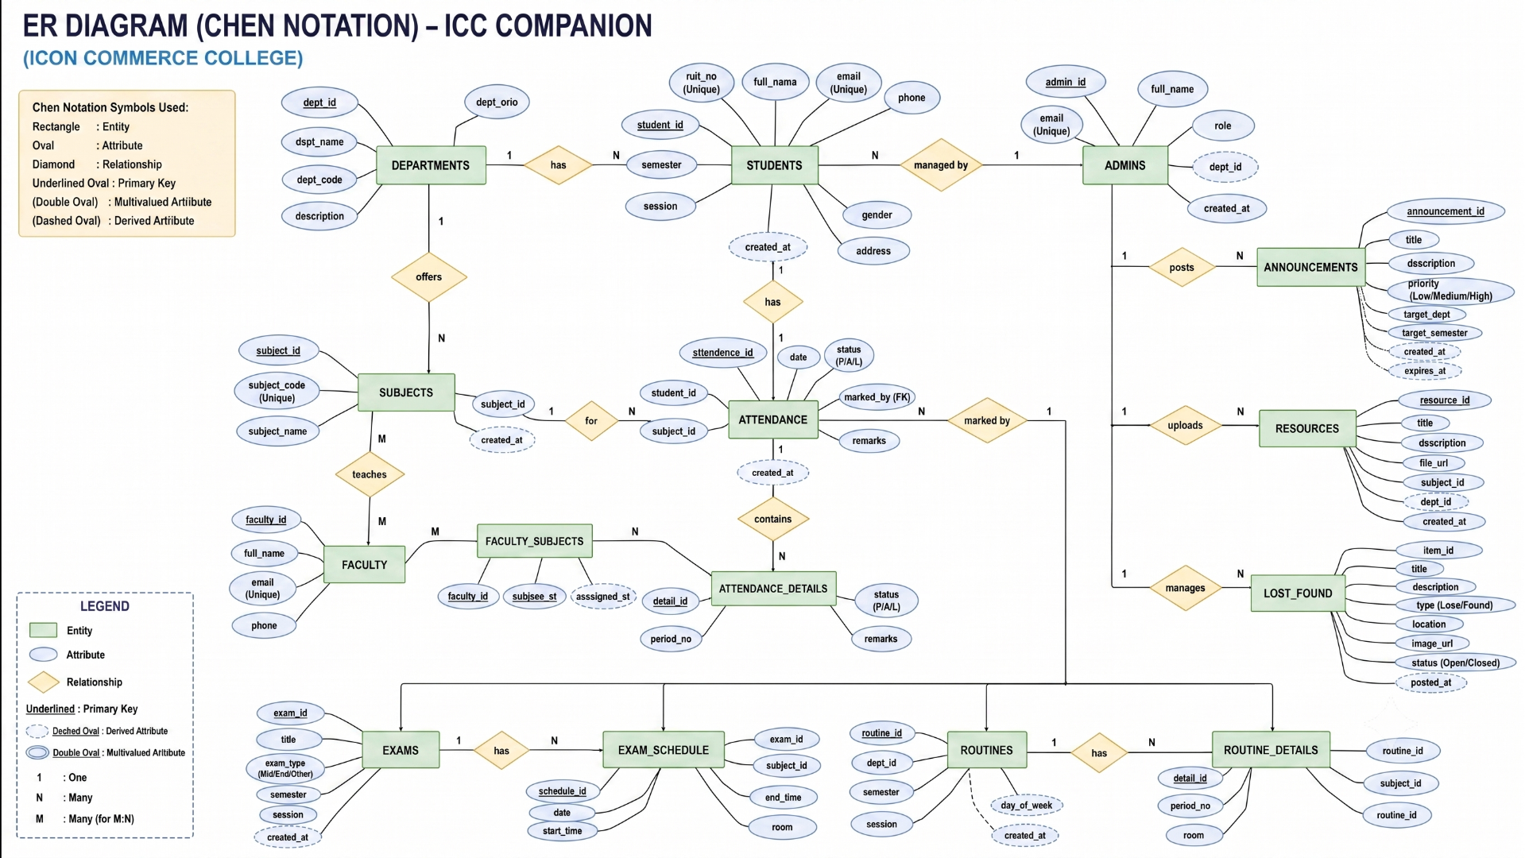

CHAPTER 7
DATABASE DESIGN

DATABASE DESIGN
The application database, named 'campus_portal', is built on a relational structure using MySQL. It contains eleven well-structured tables designed to enforce data integrity, prevent redundancy, and optimize query speeds.
Table 1: departments (Department Master Data)
Field Name | Data Type | Constraint | Description
dept_id | INT | PRIMARY KEY, AUTO_INCREMENT | Unique identifier for each department
dept_code | VARCHAR(10) | UNIQUE, NOT NULL | Short department code (e.g., BCA, BBA, BA, BCOM)
dept_name | VARCHAR(100) | NOT NULL | Full department name (e.g., Bachelor of Computer Applications)
Table 2: admins (Administrative System Credentials)
Field Name | Data Type | Constraint | Description
subject_id | INT | PRIMARY KEY, AUTO_INCREMENT | Unique identifier for each subject
subject_code | VARCHAR(20) | NOT NULL | Alphanumeric subject code (e.g., BCA101, BBA301)
subject_name | VARCHAR(100) | NOT NULL | Full name of the subject
dept_code | VARCHAR(10) | FOREIGN KEY -> departments(dept_code) | Parent department code
semester | INT | NOT NULL | Semester in which the subject is taught (1-6)

Table 3: announcements (Institutional Announcements Board)
Field Name | Data Type | Constraint | Description
student_id | INT | PRIMARY KEY, AUTO_INCREMENT | Unique internal record identifier
roll_number | VARCHAR(20) | UNIQUE, NOT NULL | Official college roll number used for login
name | VARCHAR(100) | NOT NULL | Full legal name of the student
dob | DATE | NOT NULL | Date of birth (used as login password)
email | VARCHAR(100) | NULL | Student email address
phone | VARCHAR(15) | NULL | Contact phone number
dept_code | VARCHAR(10) | FOREIGN KEY -> departments(dept_code) | Current department of study
semester | INT | NOT NULL | Current active semester
created_at | TIMESTAMP | DEFAULT CURRENT_TIMESTAMP | Timestamp of record creation

Table 4: class_routines (Weekly Class Schedule Files)
Field Name | Data Type | Constraint | Description
admin_id | INT | PRIMARY KEY, AUTO_INCREMENT | Unique identifier for admin account
username | VARCHAR(50) | UNIQUE, NOT NULL | Login username
password | VARCHAR(255) | NOT NULL | Plain-text password (demo/development phase)
name | VARCHAR(100) | NOT NULL | Full name of the administrative user
role | VARCHAR(50) | NOT NULL | Role: super-admin, dept-admin, or faculty
assigned_dept | VARCHAR(10) | DEFAULT 'all' | Scope-restricted department or 'all'
assigned_semester | VARCHAR(10) | DEFAULT 'all' | Scope-restricted semester or 'all'
created_at | TIMESTAMP | DEFAULT CURRENT_TIMESTAMP | Timestamp of account creation

Table 5: resources (Academic Learning Materials Repository)
Field Name | Data Type | Constraint | Description
attendance_id | INT | PRIMARY KEY, AUTO_INCREMENT | Unique identifier for attendance record
roll_number | VARCHAR(20) | FOREIGN KEY -> students(roll_number) | Student roll number
subject_id | INT | FOREIGN KEY -> subjects(subject_id) | Subject being attended
attendance_date | DATE | NOT NULL | Date of the class
status | ENUM('present','absent') | DEFAULT 'present' | Attendance status
marked_by | VARCHAR(50) | NULL | Admin username who marked attendance
created_at | TIMESTAMP | DEFAULT CURRENT_TIMESTAMP | Timestamp of record creation

Table 6: lost_found (Lost and Found Items Registry)
Field Name | Data Type | Constraint | Description
exam_id | INT | PRIMARY KEY, AUTO_INCREMENT | Unique identifier for exam entry
subject_id | INT | FOREIGN KEY -> subjects(subject_id) | Linked subject for the exam
exam_date | DATE | NOT NULL | Date of the examination
start_time | TIME | NOT NULL | Exam start time
end_time | TIME | NOT NULL | Exam end time
room | VARCHAR(50) | NULL | Allotted examination room
exam_type | ENUM('sessional','final') | DEFAULT 'final' | Type of examination
attachment_url | VARCHAR(255) | NULL | Optional file attachment (e.g., seating plan)
created_at | TIMESTAMP | DEFAULT CURRENT_TIMESTAMP | Timestamp of record creation

CHAPTER 8
IMPLEMENTATION

IMPLEMENTATION
The practical operation of the ICC Companion application follows a structured, step-by-step logic across both portals to ensure clear workflow coordination:
8.1 Landing Page and Login Portal (index.php)
When users navigate to the application root, they are greeted by a clean landing page (index.html) featuring the ICC Companion branding, an overview of system features, and two distinct entry points: Student Login and Admin Login. The landing page is purely presentational with no authentication required. Students click the "Student Login" button which redirects to student-login.html, while administrators use the "Admin Login" button which leads to admin-login.html. There is no self-registration -- all student and admin accounts are pre-created in the database by the system administrator.
8.2 Secure Login Authentication
Authentication is split into two separate workflows. Students log in at student-login.html by entering their official college roll number and date of birth (in YYYY-MM-DD format). The PHP backend (student-login.php) queries the students table using a prepared statement, matches the roll number and DOB, and on success creates a PHP session storing the student's roll number, name, department, and semester. Administrators log in at admin-login.html with a username and password. The admin-login.php script validates credentials against the admins table and additionally stores role and scope information (assigned department and semester) in the session. On the frontend, session data is mirrored to sessionStorage for JavaScript-based role enforcement across admin pages.

8.3 Student Portal Operational Workflows
Once authenticated, students are redirected to their personalized dashboard (student/dashboard.html). The dashboard displays a welcome card with the student's name, department, and semester, along with a STUDENT role badge. Three summary stat cards show overall attendance percentage, count of upcoming exams, and total announcements. Below the stats, a Quick Access grid of seven menu cards provides shortcuts to all student modules.
- My Subjects: Students can view their complete subject list for the current department and semester, fetched from the subjects table via get-subjects.php. Each subject card displays the subject code, full name, department, and semester.
- Academic Resources: A digital repository where students can browse and download learning materials (syllabi, notes, books, links) filtered by their department and semester, uploaded by administrators.
- My Attendance: Students can view their attendance records per subject. The system calculates aggregate attendance percentages from the attendance table, fetching data via get-attendance.php. A visual summary shows present count, total classes, and percentage for each subject.
- Lost & Found: Students can browse the campus lost and found registry, viewing item descriptions, categories, locations, and contact information. Items are categorized as lost or found with active/claimed status tracking.

8.4 Administrative Portal Control Workflows
Administrators log into a powerful role-based control dashboard (admin/dashboard.html) that adapts its interface based on the admin's role. Three roles are supported: super-admin (Principal) with full system access to all modules, dept-admin (HOD) with department-scoped management, and faculty (Subject Teacher) with teaching-scope access. The dashboard displays dynamic stats cards (student count, exams, lost/found items, announcements) that vary by role, a role-badged Quick Actions grid of management shortcuts, and a role-appropriate welcome card.
- Role-Based Access Control: The system enforces a three-tier access hierarchy. Super-admins can manage all modules including staff accounts and departments. Dept-admins are restricted to their assigned department. Faculty members can only mark attendance and manage resources for their assigned subjects. Navigation items, menu cards, and API responses are all filtered based on the admin's role.
- Student Management: Administrators can add, edit, delete, and search student records. Filters by department and semester allow targeted management. The add student form captures roll number, name, DOB, email, phone, department, and semester. Role-based restrictions apply -- super-admins see all students, dept-admins see only their department, and faculty see students in their assigned scope.
- Attendance Marking: A checkbox-based attendance interface allows admins to select a department, semester, subject, and date, then mark individual students as present or absent. Select All/Deselect All buttons speed up the workflow. Saved attendance records are stored with a unique constraint preventing duplicate entries for the same student-subject-date combination.
- Announcement & Lost/Found Management: Administrators can post college-wide or targeted announcements with priority levels (high/medium/low), optional file attachments, and external links. The Lost & Found module allows creating, editing, and resolving lost/found item listings with image uploads, category classification, and claim status tracking.

CHAPTER 9
SAMPLE SCREENSHOTS

SAMPLE SCREENSHOTS
This section maps the exact interface layouts, workflows, and visual screens of the ICC Companion application. Please place the corresponding system image grabs at the indicated positions below:
9.1 Public Views and Authentication Screens

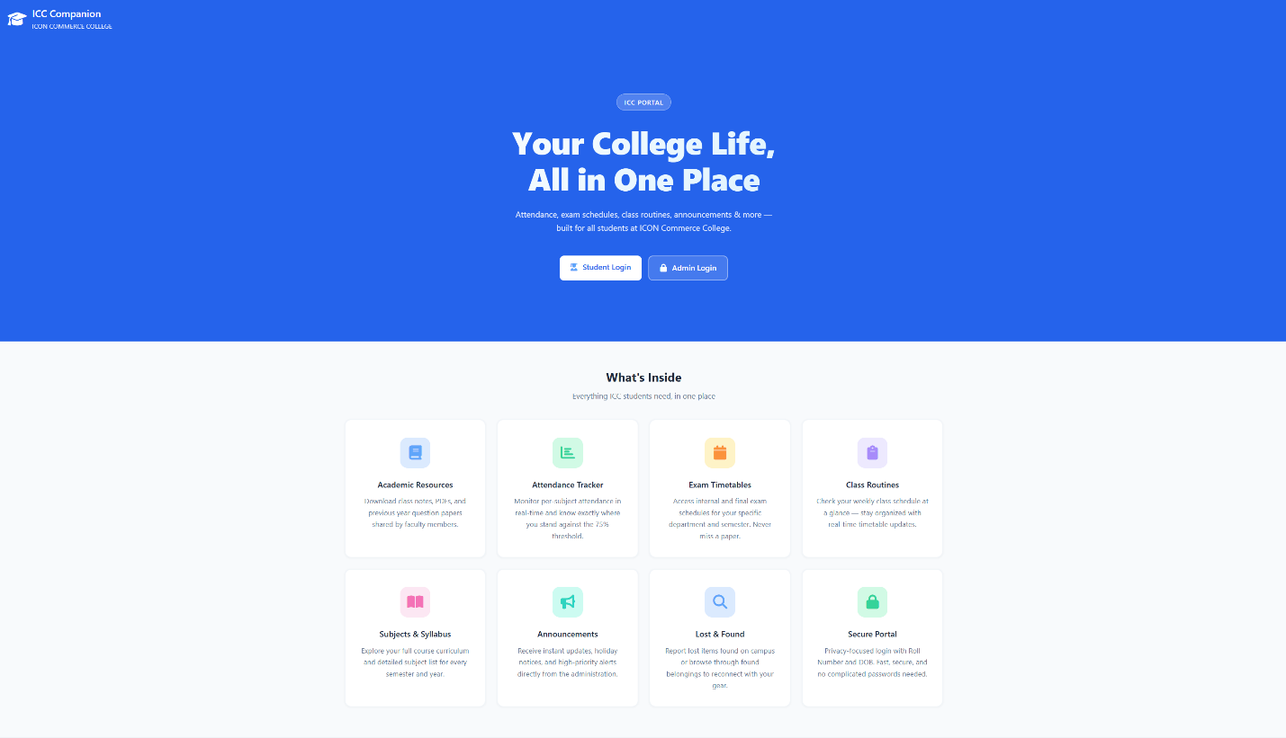

Description of view: The public landing page (index.html) featuring the ICC Companion branding header, a hero section with "Your College Life, All in One Place" headline, two login action buttons (Student Login and Admin Login), and an 8-card features grid showcasing the system capabilities including Academic Resources, Attendance Tracker, Exam Timetables, Class Routines, Subjects & Syllabus, Announcements, Lost & Found, and Secure Portal.

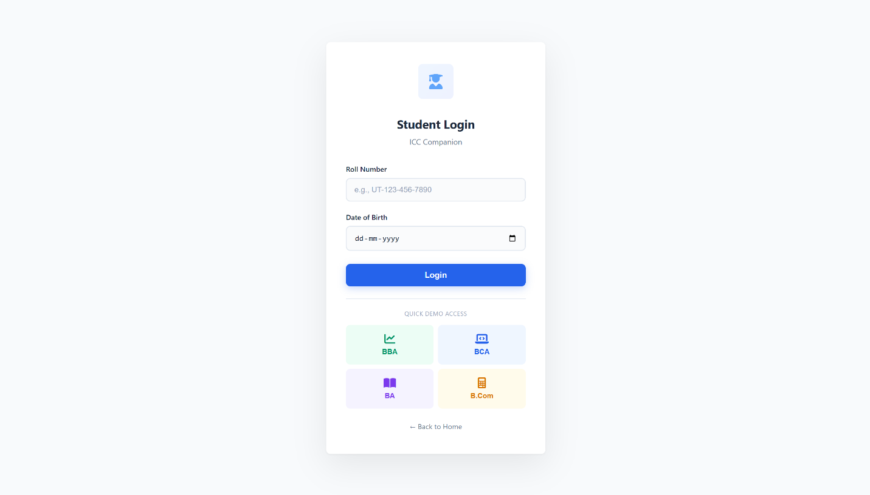

Description of view: The student login page (student-login.html) presenting a clean, centered card interface with Roll Number and Date of Birth input fields, a Sign In button, and a link to switch to admin login. The page includes a college logo header and a "Quick Student Login" demo section with pre-filled credentials for rapid testing.
9.2 Student Workspace Views

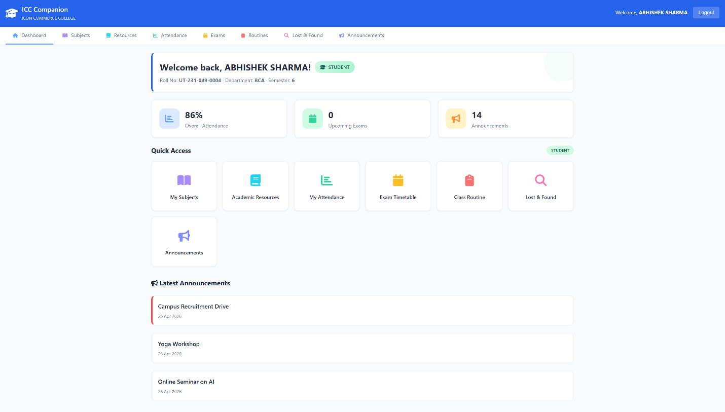

Description of view: The student dashboard (student/dashboard.html) featuring a welcome card with STUDENT role badge showing the student's name, roll number, department, and semester. Three stat cards display overall attendance percentage, upcoming exams count, and announcements count. Below is the "Quick Access" section with a STUDENT section badge and a 7-card grid linking to My Subjects, Academic Resources, My Attendance, Exam Timetable, Class Routine, Lost & Found, and Announcements. The bottom section shows the latest 3 announcements from the administration.
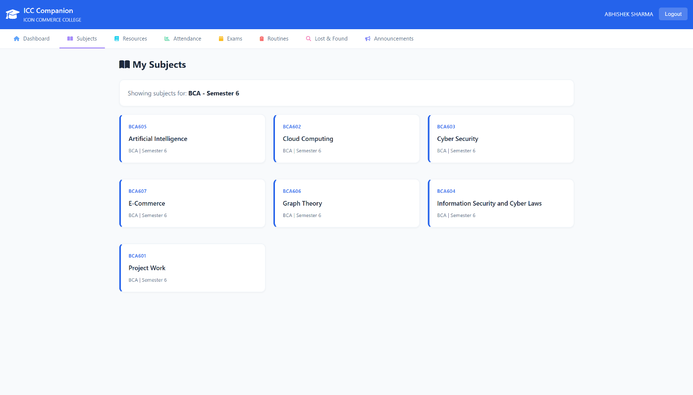
Description of view: The My Subjects page showing a filtered list of subjects for the student's department and semester. Each subject is displayed as a card with the subject code in a colored label, the full subject name in bold, and department/semester metadata at the bottom.

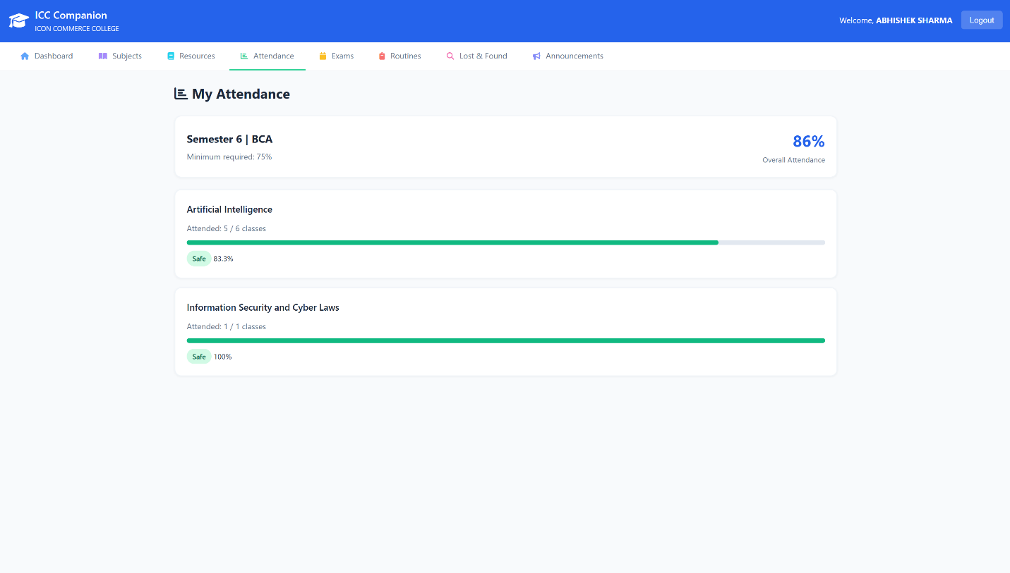

Description of view: The My Attendance page displaying per-subject attendance records in individual cards. Each card shows the subject name, total classes conducted, present count, absent count, and a visual progress bar with percentage color-coded green (above 75%), orange (60-75%), or red (below 60%).
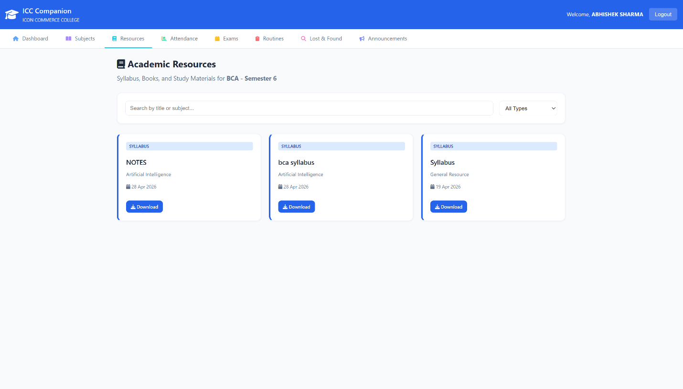

Description of view: The Academic Resources page showing a filterable grid of learning materials. Each resource card displays a type badge (Syllabus, Book, Material, Link, or Text), the resource title, description, and download/view action buttons.
9.3 Administrative Workspace Control Views

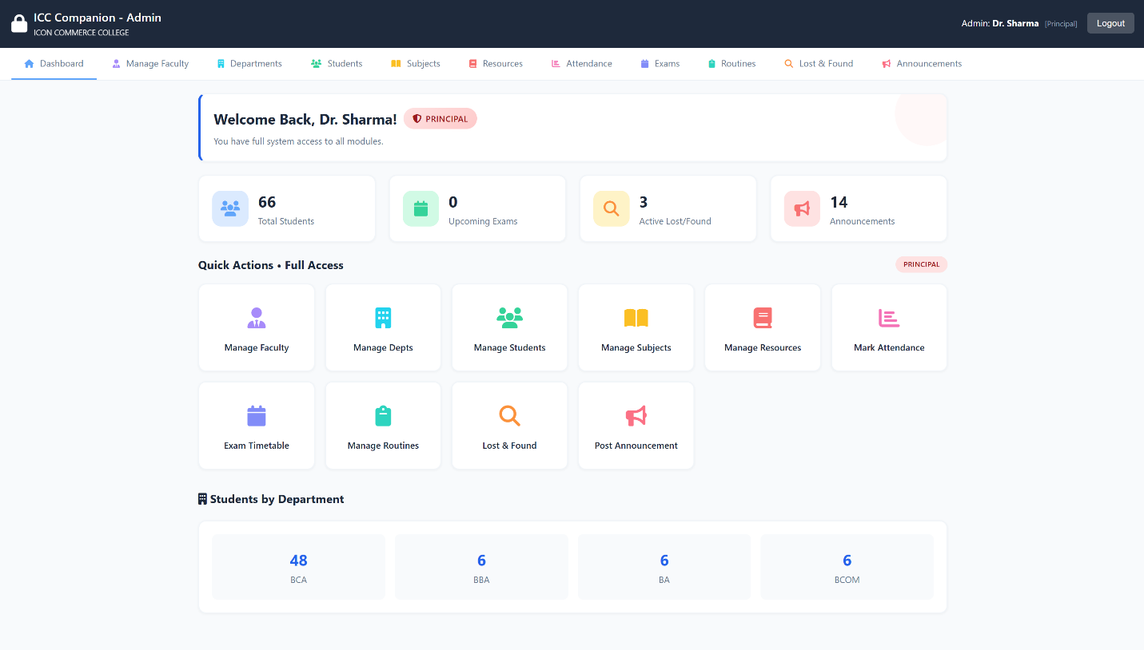

Description of view: The admin dashboard (admin/dashboard.html) displaying a role-badged welcome card (PRINCIPAL/HOD/FACULTY) with scope description, dynamic stat cards (adapted per role), and the Quick Actions section with role-specific heading ("Full Access" for Principal, "Department Tools" for HOD, "My Tools" for Faculty) and filtered management shortcuts. Faculty view also shows a "My Subjects" mini-card section listing their assigned subjects.
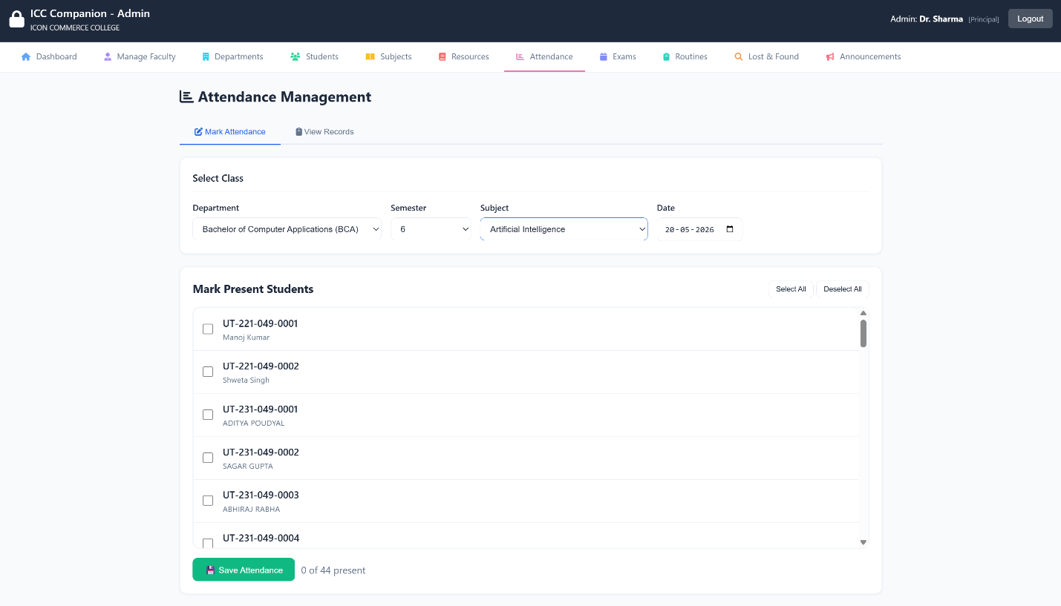

Description of view: The Mark Attendance page with department, semester, subject, and date selectors at the top. Below is a scrollable checkbox list of students where admins can individually mark presence. Select All/Deselect All buttons and a live selected count provide efficient bulk operations. A separate View Records tab allows querying attendance history with month filters.
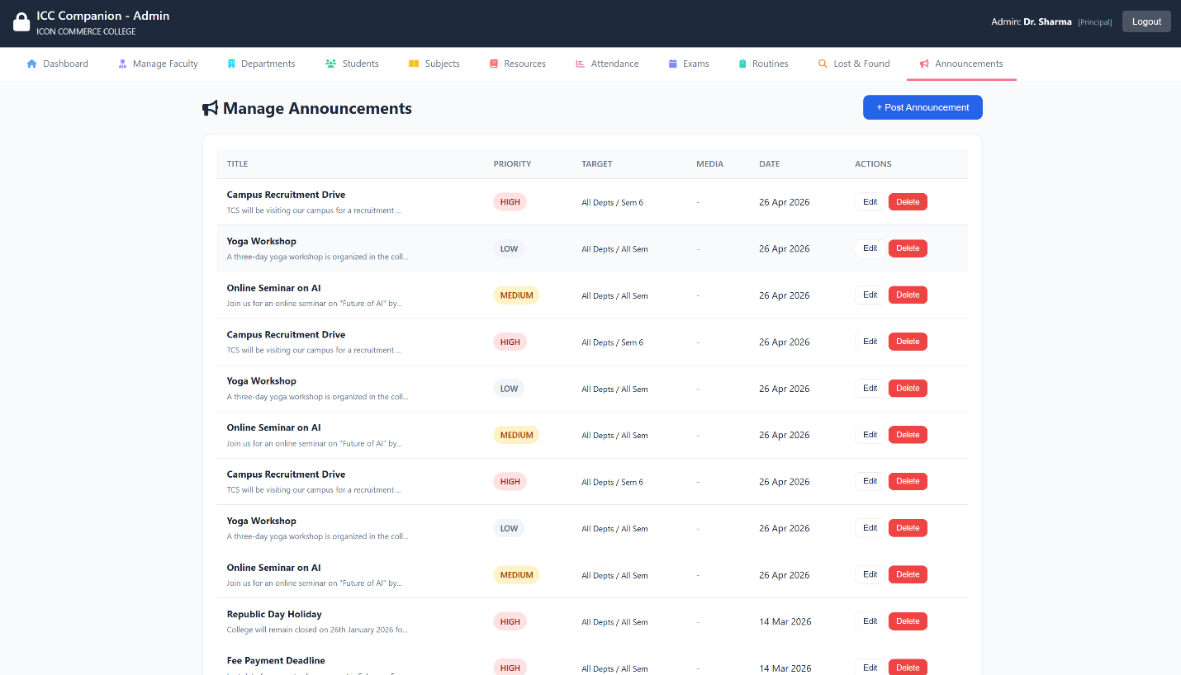

Description of view: The Announcements management page with a form to create new announcements including title, description/body, priority selector (high/medium/low with color-coded badges), optional file attachment upload, optional external link, and target audience filters for department and semester. Below the form, a list of existing announcements shows title, priority badge, date, and action buttons (edit, delete).

CHAPTER 10
ADVANTAGES & LIMITATIONS

ADVANTAGES & LIMITATIONS
10.1 Advantages
The implementation of the ICC Companion system delivers several operational benefits to the ICON Commerce College academic community:
- Centralized Academic Hub: Unifies notices, class timetables, learning files, and inquiries into a single system, replacing messy manual methods.
- 24/7 Availability and Reach: Students can access critical materials anytime, anywhere via web browser, removing the need to be physically on campus.
- Input Validation and Security: Employs prepared statements with parameter binding, input sanitization, and XSS prevention to protect data records from typical web exploits such as SQL injection and cross-site scripting.
- Structured Data Sorting: Enables targeted material sorting by department and semester, helping students find files and timetables instantly without clutter.
- Zero Operational Training: Simple interfaces allow non-technical administrative staff to update information easily with minimal guidance.
10.2 Limitations
While highly functional, the current version has a few technical and operational limits due to development scope boundaries:
- Manual Refresh Requirement: The user view doesn't use WebSocket connections. Users must refresh their browser manually to see new updates.
- No Live External Alerts: Lacks native integrations for cellular SMS lines or automated email alerts; users must log into the portal to check notifications.
- No Real-Time Notifications: The system does not use WebSocket connections or push notifications. Users must refresh their browser to see new updates, and there are no SMS/email alert integrations for time-sensitive notices.
- No Automated Email/SMS Alerts: Lacks native integrations for cellular SMS lines or automated email alert systems; users must log into the portal to check for new notifications and updates manually.

CHAPTER 11
FUTURE ENHANCEMENTS

FUTURE ENHANCEMENTS
To expand the platform's capabilities beyond this foundational release, the following modular enhancements are planned for future updates:
- Real-Time Notification Engine: Integrate automated mailing libraries (like PHPMailer) and external SMS gateways (such as Twilio) to send instant alerts to students whenever a notice is posted or a query is replied to.
- Advanced Mobile App Build: Compile dedicated lightweight Android and iOS apps using frameworks like Flutter, using the existing PHP backend as an API endpoint layer.
- Advanced Analytics Dashboard: Integrate interactive charts and graphs using Chart.js or similar libraries to visualize attendance trends, exam performance metrics, resource download statistics, and department-wise engagement data for the admin dashboard.
- AI-Powered Insights: Add an analytics suite to the admin dashboard using Chart.js to render visual pie charts and engagement trends for student queries and downloads.
- Automated Timetable Conflict Checker: Add backend validation rules that check space and lecturer schedules automatically to prevent double-booking rooms during timetable setup.

CHAPTER 12
CONCLUSION

CONCLUSION
The ICC Companion system was developed to solve a real, practical challenge: the lack of a centralized, secure digital portal for student communication and resource sharing at ICON Commerce College. The platform successfully replaces scattered manual communication methods with a reliable, structured web application.
Built on a robust PHP-MySQL foundation, the system implements separate portals for students and administrators, custom data filters, and an audited records terminal. Security is integrated throughout using parameter binding, input sanitation, and secure password encryption, making the codebase production-ready for the campus intranet.
By meeting all core objectives, this project provides a scalable digital foundation that can grow with future features like automated email alerts and native mobile apps. Ultimately, developing this application applies core software engineering and database concepts learned in the BCA curriculum to a practical tool that improves academic administration.

REFERENCE

1. Official PHP Documentation Manual.
Available online at: https://www.php.net/manual/en/
2. MySQL 5.7 Relational Database Management Reference Manual.
Available online at: https://dev.mysql.com/doc/refman/5.7/en/
3. W3Schools Web Development Tutorials Suite (HTML5, CSS3, Vanilla JavaScript).
Available online at: https://www.w3schools.com/
4. Mozilla Developer Network (MDN) Web Docs Core JavaScript Language Guide.
Available online at: https://developer.mozilla.org/en-US/docs/Web/JavaScript
5. Font Awesome 6 Framework Typography ICON Documentation.
Available online at: https://fontawesome.com/docs
6. Open Web Application Security Project (OWASP) Top 10 Security Defenses Standards Guide.
Available online at: https://owasp.org/
7. PHP: The Right Way - Web Engineering Core Best Practices.
Available online at: https://phptherightway.com/
8. Silberschatz, A., Korth, H. F., & Sudarshan, S. (2019).
Database System Concepts (7th Edition).
McGraw-Hill Education.

