Ajeenkya D.Y Patil Innovation University
School of Computer Engineering
2024-2025

A
PROJECT REPORT
ON
NUMBER GUSSING GAME

BY
ABHISHEK DARPHE
URN: 2024-M-11032003
VASUDHA SURYAWANSHI
URN: 2024-M-31052003A

IN PARTIAL FULFILLMENT OF
MCA

School of Engineering

Certificate

This is to certify that,________________________ student of MCA Semester I has successfully / partially completed Mini Project in partial fulfilment of MCA under Ajeenkya D.Y Patil University, for the academic year 2024-2025.

______________ _________________
Internal Guide Program Coordinator

Date: ___/___/______

External Examiners:

1. ____________________________ 2. ____________________________

ACKNOWLEDGEMENT

I would like to express my sincere gratitude to everyone who supported and guided me throughout the development of the Number Guessing Game project.
First, I would like to thank my mentor Miss Devyani for providing the necessary guidance, valuable feedback, and continuous support in enhancing my understanding of Java programming concepts. Their patience and encouragement were crucial in the successful completion of this project.
I also want to acknowledge the resources available on online programming communities, including Stack Overflow, Java documentation, and other educational websites, which proved to be immensely helpful when tackling challenges such as handling user input, exception handling, and random number generation.
Lastly, I would like to thank my friends and mentors for their encouragement and for offering constructive suggestions during the development process.
This project would not have been possible without their help, and I am deeply grateful for all the support I received

- Abhishek Darphe
- Vasudha Suryawanshi

DECLARATION

I hereby declare that the Number Guessing Game project has been developed by me and my partner as part of my academic requirements. The work presented in this project is original and has not been copied from any other source. All the concepts, code, and ideas used in this project have been implemented independently, except for those obtained from publicly available resources such as Java documentation and online programming forums, which are duly acknowledged.
I further declare that this project has not been submitted for any other course or evaluation, and I take full responsibility for the content and accuracy of the project.

INDEX

Sr. No. | Contents | Page No.
Chapter 1 | INTRODUCTION
 | 1.1 Existing System
 | 1.2 Problem Definition- Need of Computerization
Chapter 2 | PROPOSED SYSTEM
 | 2.1 Proposed System
 | 2.2 Objectives of System
 | 2.3 User Requirements
 | 2.4 Operating Environment – Hardware and Software
Chapter 3 | ANALYSIS AND DESIGN
 | 3.1 Flow Chart
 | 3.2 Screen Shots
Chapter 4 | CONCLUSION
 | 4.1 Limitations & Drawbacks
 | 4.2 Future Enhancement
 | 4.3 References & Bibliography

CHAPTER 1 :
1.1 EXISTING SYSTEM

In the domain of number guessing games, several existing systems and implementations exist, both in terms of physical games and software applications. These games are generally designed to provide users with a fun and interactive experience in which they try to guess a number based on feedback (too high, too low, or correct). However, most existing systems in this domain have the following general characteristics:

- Console-Based Games: Simple text-based games where the user guesses a number, and feedback is provided on whether the guess is too high or too low.
- Web-Based Games: Online versions with additional features like score tracking and difficulty levels, often using a graphical user interface (GUI).
- Mobile Apps: Apps for iOS and Android offering more advanced features like high score tracking, multiple difficulty levels, and engaging graphics.

1.2 PROBLEM DEFINATION:
The Number Guessing Game project addresses the need for an interactive and engaging way for users to test their guessing skills. The problem arises from the common limitation in many basic number guessing games, which are either too simplistic or lack features that enhance user experience. The specific issues are:
- Limited User Interaction: Existing number guessing games often fail to provide personalized experiences, such as customizable difficulty levels or tracking the number of attempts taken to guess the correct number.
- Poor Input Handling: Many implementations do not handle invalid inputs properly (e.g., non-numeric entries or out-of-range guesses), which can lead to crashes or an unresponsive game.
- Lack of Feedback and Error Handling: Many games do not offer detailed feedback for each guess beyond indicating if the guess was too high or too low. Some systems do not guide users on how to improve their guesses after several attempts.
- Single-Player Limitation: Most existing systems focus only on a single-player experience, offering no multiplayer or competitive features that would make the game more engaging.

CHAPTER 2:
2.1 PRAPOSE SYSTEM:
The Number Guessing Game is a simple, interactive console game where the system generates a random number within a defined range, and the player has to guess that number. The system will provide feedback to the player after each guess, telling them whether their guess is too high, too low, or correct. The game will track the number of attempts and end when the player guesses the correct number.
The proposed system for the Number Guessing Game will consist of the following components:
- User Interface: A simple interface where users can input their guesses and receive feedback.
- Game Logic: The core functionality that handles the random number generation, user input validation, and feedback mechanisms.
- Error Handling: Ensure that invalid user inputs (such as non-numeric input) are handled gracefully.
- Persistence: Optional tracking of scores, attempts, or game history, which can be stored locally or remotely (in case of an online version).

2.2 OBJECTIVE OF SYSTEM:
The Number Guessing Game system aims to:
- Engage Users: Provide an interactive and fun experience where players guess a randomly generated number.
- Facilitate Learning: Help beginners practice core programming concepts such as random number generation, loops, and input handling.
- Track Progress: Monitor and display the number of attempts made by the player to guess the correct number.
- Handle Errors: Ensure smooth gameplay with graceful error handling for invalid inputs.
- Customize Difficulty: Offer different difficulty levels to adjust the game's complexity.
- Encourage Replayability: Keep players coming back with random number generation for each new game.
- Provide Feedback: Offer immediate feedback to players, celebrating their success when they guess correctly.
- Promote Competition (optional): Track and display high scores to motivate improvement.

2.2 USER REQUIREMENTS:
1. FUNCTIONAL REQUIREMENTS:
These are the core features the system must include:
- Random Number Generation:
  - The system must generate a random number within a defined range (e.g., 1 to 100).
- User Input Handling:
  - The system should prompt the user to enter a guess.
  - The system must allow the user to input guesses multiple times until they guess the correct number.
- Feedback Mechanism:
  - The system should provide feedback on each guess, indicating if the guess is too high, too low, or correct.
- Attempts Tracking:
  - The system must keep track of the number of attempts the player makes until they guess the correct number.
- Error Handling:
  - The system should handle invalid inputs (non-numeric, out-of-range guesses) and prompt the user to try again.
  - The system must display an error message for invalid inputs and request a valid number.
6.End of Game:
  - The game should end when the player guesses the correct number, and it should display a congratulatory message with the number of attempts .

2. NON-FUNCTIONAL REQUIREMENTS
These are additional qualities and performance factors the system must meet:
- Usability:
  - The system must be user-friendly, providing clear instructions and intuitive gameplay.
- Performance:
  - The system should operate efficiently, with minimal delays in generating random numbers and processing guesses.
- Cross-platform Compatibility:
  - The system must be compatible with common platforms, such as Windows, macOS, and Linux for desktop applications, or web-based platforms if developed for the web.
- Error Handling:
  - The system must handle input errors gracefully and continue functioning without crashing or freezing.
- Accessibility:
  - The system should be accessible to all users, including those who might not be familiar with advanced technical concepts.
3. SYSTEM REQUIREMENTS:
These are the technical requirements needed for the system to function properly:
- Hardware Requirements:
  - A basic computer or device with minimal processing power to run a console or GUI-based application.
  - For web-based versions, an internet browser is required.
- Software Requirements:
  - Java Development Kit (JDK) for development (Java 8 or higher).
  - An IDE or text editor (e.g., IntelliJ IDEA, Eclipse, or Visual Studio Code) for writing and executing Java code.
  - JavaFX/Swing (optional, if developing a GUI).
  - For web-based versions: A browser and possibly a web server for hosting the game.

2.4 OPERATING ENVIRONMENT – HARDWARE AND SOFTWARE
HARDWARE REQUIREMENTS:
- Processor: 1.0 GHz or higher.
- RAM: 1 GB minimum (2 GB recommended).
- Storage: 50 MB free disk space.
- Display: 1024x768 resolution or higher.
- Input Devices: Keyboard (and mouse for GUI).
SOFTWARE REQUIREMENTS:
- Programming Language: Java (JDK 8 or higher).
- IDE: IntelliJ IDEA, Eclipse, or NetBeans.
- Libraries: Java Standard Library, JavaFX/Swing for GUI.
- Operating System: Windows 7 or higher, macOS Sierra or higher, Linux Ubuntu 16.04 or higher.
- JRE: Java 8 or higher.
- Web-based Version (optional): JavaScript, HTML5, CSS, and web browsers (Chrome, Firefox, etc.)

CHAPTER 3:
3.1 FLOW CHART
Start
│
├──> Generate Random Number (e.g., between 1 and 100)
│
├──> Display Instructions (e.g., "Guess the number between 1 and 100")
│
├──> Input User Guess
│
├──> Is Guess Correct?
│ ├──> Yes --> Display "Correct! You've won!"
│ │ └──> Display the number of attempts
│ │
│ └──> No
│ │
│ ├──> Is Guess Too High?
│ │ ├──> Yes --> Display "Too High! Try again."
│ │ └──> No
│ │
│ ├──> Is Guess Too Low?
│ │ ├──> Yes --> Display "Too Low! Try again."
│ │ └──> No (Shouldn't happen, because it's neither high nor low)
│ │
│ ├──> Increment Attempt Counter
│ │
│ └──> Go back to "Input User Guess"
│
├──> Play Again?
│ ├──> Yes --> Restart Game (Go back to "Generate Random Number")
│ └──> No --> Exit Game
│
End

3.2 SCREEN SHOTS:

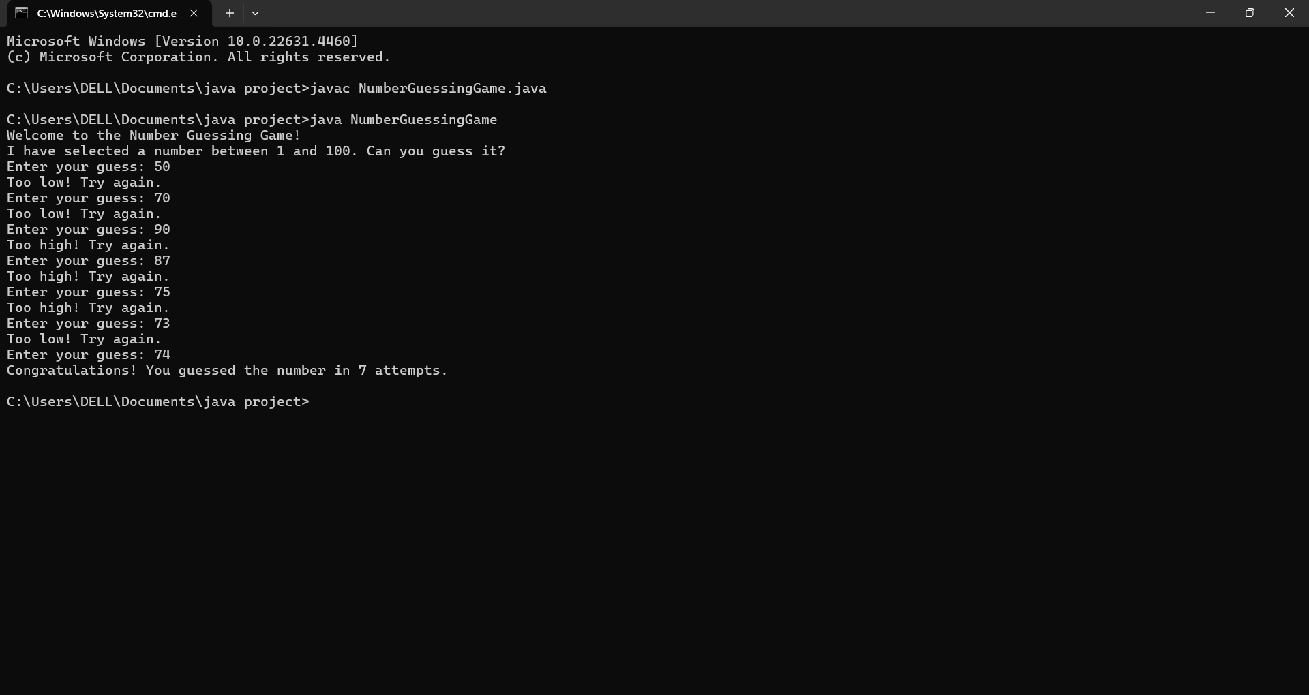

CHAPTER 4 :
4.1 LIMITATION AND DRAWBACK
- Limited Challenge: The game may become too easy for experienced players if the number range remains fixed.
- No Multiplayer: It's typically a single-player game, limiting social interaction and competition.
- No Difficulty Scaling: The game lacks adjustable difficulty levels, making it repetitive.
- Basic Feedback: Feedback is limited to "Too High," "Too Low," or "Correct," offering little depth or variety.
- No High Score Tracking: Players can't track progress or set goals without a high-score feature.
- Repetitiveness: The gameplay can feel monotonous, especially with the same guessing mechanics.
- Limited Input Options: The game relies solely on numeric input, which can feel tedious.
- Lack of Visuals/Sound: Basic console versions lack engaging visuals or sound effects.
- No Advanced Mechanics: The game is simple with no extra features or complexity.
- Limited Accessibility: The game may not be accessible to all users, especially those with disabilities

4.2 FUTURE ENHANCEMENT:

- Multiplayer Mode:
- Enable players to compete against each other in real-time. Players can take turns guessing the number, and the first to guess correctly wins.
- Benefit: Adds a competitive and social element to the game, increasing engagement.
- Difficulty Levels:
- Introduce multiple difficulty levels (e.g., Easy, Medium, Hard) by adjusting the number range or adding time limits.
- Benefit: Customizes the experience to different skill levels, keeping the game challenging for everyone.
- Leaderboard/High Score Tracking:
- Implement a system to track the highest scores and the number of attempts to guess correctly.
- Benefit: Encourages replayability and motivates players to improve their performance.
- Hints and Assistance:
- Offer optional hints, such as whether the correct number is even or odd, or provide a narrowed range if the player struggles.
- Benefit: Helps players who may be stuck, improving accessibility and user satisfaction.
- Time Limit Mode:
- Introduce a timer that challenges players to guess the correct number within a specific time limit.
- Benefit: Adds excitement and urgency to the game, making it more intense.
- Increasing Difficulty:
- After each round, the number range could increase, or the time allowed for guesses could decrease to make the game progressively harder.
- Benefit: Keeps the game fresh and challenging, even for experienced players.
- Educational Features:
- Add a learning mode where players can practice number recognition, estimation, or simple math skills.

4.3 REFERENCES & BIBLIOGRAPHY:

- Books:

- Schildt, Herbert. Java: The Complete Reference. 10th ed. McGraw-Hill, 2018.
- Horstmann, Cay S. Core Java Volume I–Fundamentals. 11th ed. Pearson, 2018.

- Websites:

- "Introduction to Java Programming." Oracle. URL: https://www.oracle.com/java/ (Accessed: November 2024).
- "Number Guessing Game in Java." GeeksforGeeks. URL: https://www.geeksforgeeks.org/number-guessing-game-in-java/ (Accessed: November 2024).

- Java Documentation:

- Oracle. The Java™ Tutorials. URL: https://docs.oracle.com/javase/tutorial/ (Accessed: November 2024).

