PRACTICAL : 19
Graph Coloring Problem Analysis

Aim
To assign colors to vertices of a graph such that no two adjacent vertices have the same color and to determine the chromatic number, i.e., the minimum number of colors required to color the graph properly.

Theory
Graph coloring is a classical problem in combinatorics, graph theory, and computer science. Given an undirected graph G = (V, E), the objective is to assign a color to every vertex such that no two adjacent vertices have the same color. This condition is called proper coloring.
The minimum number of colors required for a proper coloring of a graph is called the chromatic number and is denoted by chi(G). For example, an empty graph needs only one color, a bipartite graph needs two colors if it has at least one edge, a triangle needs three colors, and a complete graph with n vertices needs n colors.
Graph coloring has important real-world applications. In compiler design, register allocation can be modeled as graph coloring because variables that are live at the same time must be placed in different registers. In examination timetabling, exams with common students cannot be scheduled in the same time slot. Other applications include map coloring, frequency assignment in wireless networks, Sudoku solving, and resource allocation.
The decision version of the problem asks whether a graph can be colored using at most m colors. For general graphs, m-coloring is NP-complete when m >= 3. The optimization version asks for the chromatic number and is NP-hard. Therefore, backtracking is commonly used for small and medium-sized graphs because it explores possible assignments and prunes invalid branches early.
In this practical, the number of colors is not taken as test-case input. Instead, the algorithm starts with one color and checks whether the graph can be colored. If it fails, it tries two colors, then three colors, and so on. The first value of m for which a valid coloring exists is the chromatic number.

Algorithm
1. Read the graph as an adjacency matrix or adjacency list.
2. For m = 1 to number of vertices:
3. Initialize the color of every vertex as 0, meaning uncolored.
4. Use backtracking to try assigning colors from 1 to m to each vertex.
5. Before assigning a color to a vertex, check whether any adjacent vertex already has the same color.
6. If the color is safe, assign it and recursively color the next vertex.
7. If no color is safe for the current vertex, backtrack and try a different color for the previous vertex.
8. If all vertices are colored successfully, stop. The current m is the chromatic number.
9. Print the chromatic number and one valid color assignment.

Pseudocode
FIND-CHROMATIC-NUMBER(graph, n):
for m <- 1 to n do
color[0..n-1] <- 0
if GRAPH-COLOR(graph, color, vertex = 0, m, n) is true then
print m as chromatic number
print color assignment
return m
GRAPH-COLOR(graph, color, vertex, m, n):
if vertex = n then
return true
for c <- 1 to m do
if IS-SAFE(graph, color, vertex, c, n) then
color[vertex] <- c
if GRAPH-COLOR(graph, color, vertex + 1, m, n) then
return true
color[vertex] <- 0
return false
IS-SAFE(graph, color, vertex, c, n):
for each adjacent vertex i of vertex do
if color[i] = c then
return false
return true

C++ Code Implementation
#include <iostream>
#include <vector>
using namespace std;
string colorName(int c) {
vector<string> names = {"None", "Red", "Green", "Blue", "Yellow", "Orange"};
return c < (int)names.size() ? names[c] : "Color" + to_string(c);
}
bool isSafe(const vector<vector<int>>& graph, const vector<int>& color, int v, int c) {
for (int i = 0; i < (int)graph.size(); i++) {
if (graph[v][i] == 1 && color[i] == c) return false;
}
return true;
}
bool graphColoring(const vector<vector<int>>& graph, vector<int>& color, int v, int m) {
int n = graph.size();
if (v == n) return true;
for (int c = 1; c <= m; c++) {
if (isSafe(graph, color, v, c)) {
color[v] = c;
if (graphColoring(graph, color, v + 1, m)) return true;
color[v] = 0;
}
}
return false;
}
int findChromaticNumber(const vector<vector<int>>& graph, vector<int>& finalColor) {
int n = graph.size();
for (int m = 1; m <= n; m++) {
vector<int> color(n, 0);
if (graphColoring(graph, color, 0, m)) {
finalColor = color;
return m;
}
}
return n;
}

Test Cases

Test Case 1: Triangle Graph K3
Input: Graph only. The number of colors is not accepted as test-case input; the algorithm finds the minimum required colors automatically.
Vertices = { V0, V1, V2 }
Edges = { (V0,V1), (V1,V2), (V2,V0) }
Before Coloring:
Matplotlib graph representation before coloring:
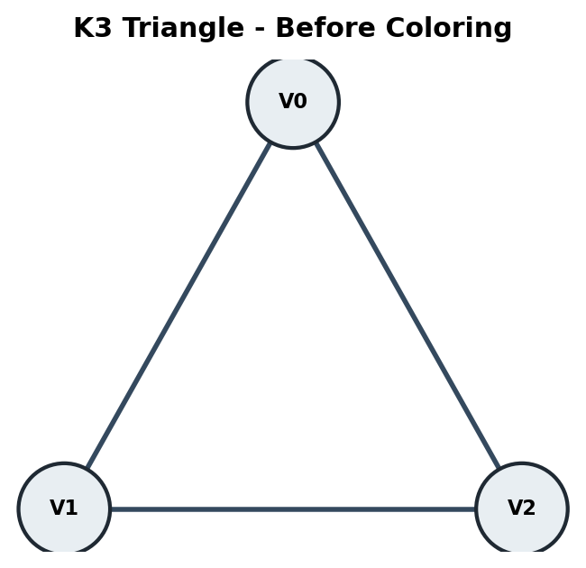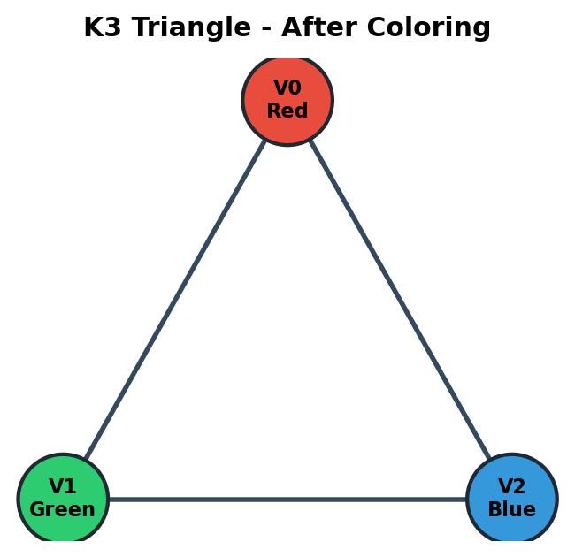
V0
/ \
/ \
V1------V2
Adjacency Matrix:
Vertex | V0 | V1 | V2
V0 | 0 | 1 | 1
V1 | 1 | 0 | 1
V2 | 1 | 1 | 0

Dry Run for Finding Chromatic Number:
Try m = 1: Assign Red to V0. V1 is adjacent to V0, so Red is not safe. Coloring fails.
Try m = 2: Assign V0 = Red and V1 = Green. V2 is adjacent to both V0 and V1, so Red and Green are both unsafe. Coloring fails.
Try m = 3: Assign V0 = Red, V1 = Green, and V2 = Blue. All adjacent vertices have different colors. Coloring succeeds.
Therefore, chromatic number chi(G) = 3.
After Coloring:
Matplotlib graph representation after coloring:

V0(Red)
/ \
/ \
V1(Green)--V2(Blue)
Vertex | Color Number | Color Name
V0 | 1 | Red
V1 | 2 | Green
V2 | 3 | Blue

Code Implementation Output:
Graph: K3 triangle
Trying with 1 color -> Not possible
Trying with 2 colors -> Not possible
Trying with 3 colors -> Possible
Chromatic Number = 3
Color Assignment:
V0 -> Red
V1 -> Green
V2 -> Blue

Test Case 2: Cycle Graph C4
Input: Graph only. The number of colors is not accepted as test-case input; the algorithm finds the minimum required colors automatically.
Vertices = { V0, V1, V2, V3 }
Edges = { (V0,V1), (V1,V2), (V2,V3), (V3,V0) }
Before Coloring:
Matplotlib graph representation before coloring:
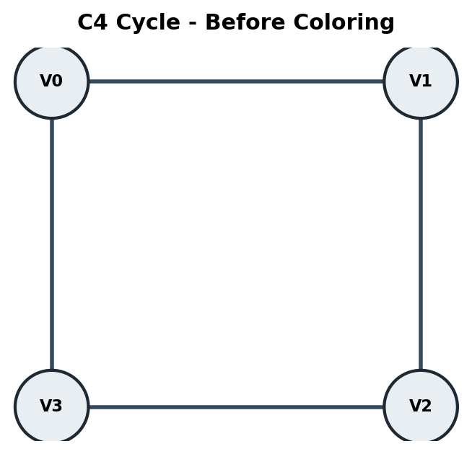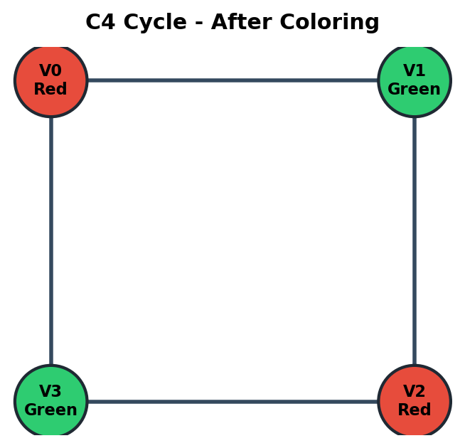
V0------V1
| |
| |
V3------V2
Adjacency Matrix:
Vertex | V0 | V1 | V2 | V3
V0 | 0 | 1 | 0 | 1
V1 | 1 | 0 | 1 | 0
V2 | 0 | 1 | 0 | 1
V3 | 1 | 0 | 1 | 0

Dry Run for Finding Chromatic Number:
Try m = 1: Assign Red to V0. V1 and V3 are adjacent to V0 and cannot use Red. Coloring fails.
Try m = 2: Assign V0 = Red, V1 = Green, V2 = Red, and V3 = Green.
Every edge connects one Red vertex and one Green vertex, so no conflict occurs.
Therefore, chromatic number chi(G) = 2.
After Coloring:
Matplotlib graph representation after coloring:

V0(Red)------V1(Green)
| |
| |
V3(Green)----V2(Red)
Vertex | Color Number | Color Name
V0 | 1 | Red
V1 | 2 | Green
V2 | 1 | Red
V3 | 2 | Green

Code Implementation Output:
Graph: C4 cycle
Trying with 1 color -> Not possible
Trying with 2 colors -> Possible
Chromatic Number = 2
Color Assignment:
V0 -> Red
V1 -> Green
V2 -> Red
V3 -> Green

Test Case 3: Complete Graph K4
Input: Graph only. The number of colors is not accepted as test-case input; the algorithm finds the minimum required colors automatically.
Vertices = { V0, V1, V2, V3 }
Edges = { (V0,V1), (V0,V2), (V0,V3), (V1,V2), (V1,V3), (V2,V3) }
Before Coloring:
Matplotlib graph representation before coloring:
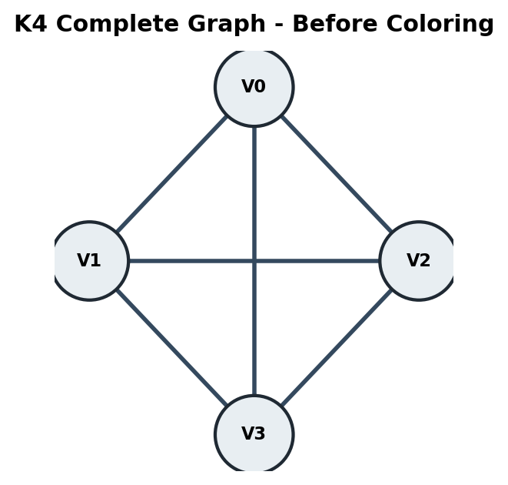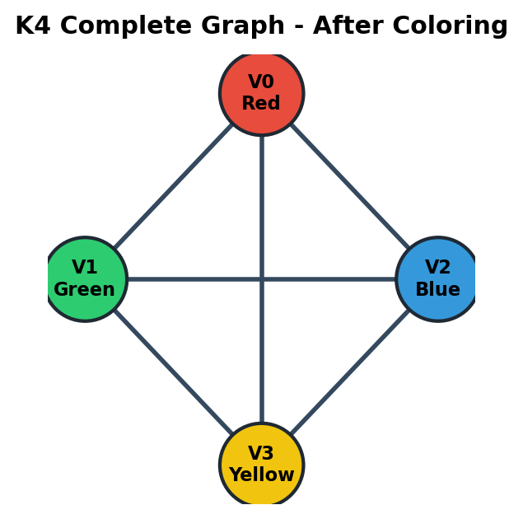
V0
/ | \
/ | \
V1---V2
\ | /
\ | /
V3
Adjacency Matrix:
Vertex | V0 | V1 | V2 | V3
V0 | 0 | 1 | 1 | 1
V1 | 1 | 0 | 1 | 1
V2 | 1 | 1 | 0 | 1
V3 | 1 | 1 | 1 | 0

Dry Run for Finding Chromatic Number:
Try m = 1: Only one color is available, but every pair of vertices is adjacent. Coloring fails.
Try m = 2: V0 and V1 can receive two different colors, but V2 is adjacent to both and cannot use either color. Coloring fails.
Try m = 3: V0, V1, and V2 can receive three different colors, but V3 is adjacent to all three and cannot use any of them. Coloring fails.
Try m = 4: Assign V0 = Red, V1 = Green, V2 = Blue, and V3 = Yellow. Coloring succeeds.
Therefore, chromatic number chi(G) = 4.
After Coloring:
Matplotlib graph representation after coloring:

V0(Red)
/ | \
/ | \
V1(Green)-V2(Blue)
\ | /
\ | /
V3(Yellow)
Vertex | Color Number | Color Name
V0 | 1 | Red
V1 | 2 | Green
V2 | 3 | Blue
V3 | 4 | Yellow

Code Implementation Output:
Graph: K4 complete graph
Trying with 1 color -> Not possible
Trying with 2 colors -> Not possible
Trying with 3 colors -> Not possible
Trying with 4 colors -> Possible
Chromatic Number = 4
Color Assignment:
V0 -> Red
V1 -> Green
V2 -> Blue
V3 -> Yellow

Test Case 4: Star Graph K1,4
Input: Graph only. The number of colors is not accepted as test-case input; the algorithm finds the minimum required colors automatically.
Vertices = { V0, V1, V2, V3, V4 }
Edges = { (V0,V1), (V0,V2), (V0,V3), (V0,V4) }
Before Coloring:
Matplotlib graph representation before coloring:
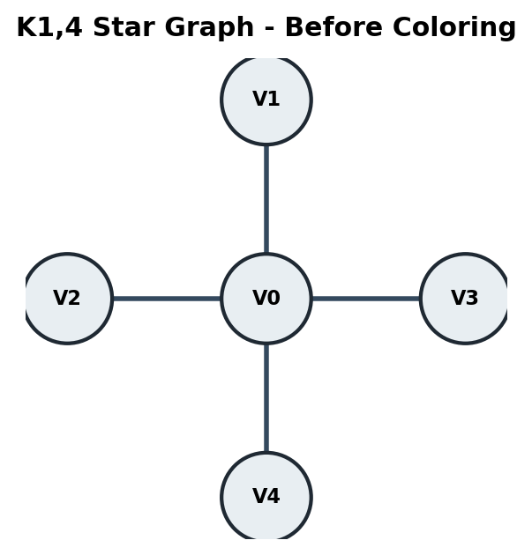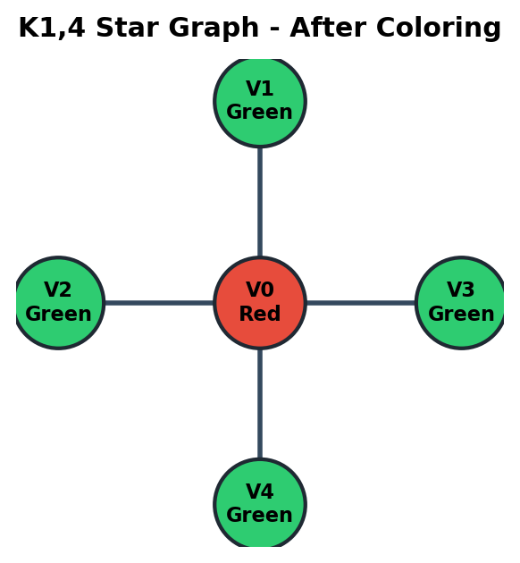
V1
|
V2------V0------V3
|
V4
Adjacency Matrix:
Vertex | V0 | V1 | V2 | V3 | V4
V0 | 0 | 1 | 1 | 1 | 1
V1 | 1 | 0 | 0 | 0 | 0
V2 | 1 | 0 | 0 | 0 | 0
V3 | 1 | 0 | 0 | 0 | 0
V4 | 1 | 0 | 0 | 0 | 0

Dry Run for Finding Chromatic Number:
Try m = 1: Assign Red to V0. Every other vertex is adjacent to V0, so none of them can use Red. Coloring fails.
Try m = 2: Assign V0 = Red. Vertices V1, V2, V3, and V4 are not adjacent to each other, so all can be assigned Green.
All edges connect the center vertex to a leaf vertex with a different color. Coloring succeeds.
Therefore, chromatic number chi(G) = 2.
After Coloring:
Matplotlib graph representation after coloring:

V1(Green)
|
V2(Green)-V0(Red)-V3(Green)
|
V4(Green)
Vertex | Color Number | Color Name
V0 | 1 | Red
V1 | 2 | Green
V2 | 2 | Green
V3 | 2 | Green
V4 | 2 | Green

Code Implementation Output:
Graph: K1,4 star graph
Trying with 1 color -> Not possible
Trying with 2 colors -> Possible
Chromatic Number = 2
Color Assignment:
V0 -> Red
V1 -> Green
V2 -> Green
V3 -> Green
V4 -> Green

Summary of Test Cases
Test Case | Graph Type | Edges | Chromatic Number
1 | Triangle K3 | 3 | 3
2 | Cycle C4 | 4 | 2
3 | Complete Graph K4 | 6 | 4
4 | Star Graph K1,4 | 4 | 2

Key Points
- Graph coloring is a constraint satisfaction problem.
- Adjacent vertices cannot share the same color.
- Backtracking assigns colors vertex by vertex.
- If a color causes conflict, the next color is tried.
- If no color works for a vertex, the algorithm backtracks.
- The chromatic number is the minimum number of colors needed.
- In this practical, test cases provide only the graph; the algorithm finds the minimum color count automatically.
- Worst-case time complexity is O(n * m^n) while searching m from 1 to n; for a fixed m-coloring check it is O(m^n).
- Space complexity is O(n) for the color array and recursion stack.

Result
All test cases were executed conceptually using the chromatic-number approach. The algorithm correctly found the minimum number of colors required for each graph and produced a valid coloring for every graph.

Conclusion
Graph coloring demonstrates how backtracking can solve constraint-based optimization problems by rejecting invalid choices early. By testing color counts from one upward, the algorithm determines the chromatic number instead of simply checking whether a user-given number of colors is enough. The test cases show that different graph structures require different minimum numbers of colors, making graph coloring useful in scheduling, register allocation, map coloring, and resource management problems.

