#### Learning Outcomes

* Using the CloudFormation CLI
* Observe the JSON structure used in CloudFormation
* Observe the process of stack creation in CloudFormation

How to do it.

* Download the file *CF1.json* and *CF2.json* provided along with this DIY
* Open the AWS Console and navigate to the VPC section
* Note down the ID of the default VPC already created
* Navigate to the subnet section by clicking on “Subnets” on the left side.
* Note down the subnet ID of the default subnet already created for the default VPC
* Click on “Create Subnet” at the top of the screen
* Fill in the form as shown below and click on Create

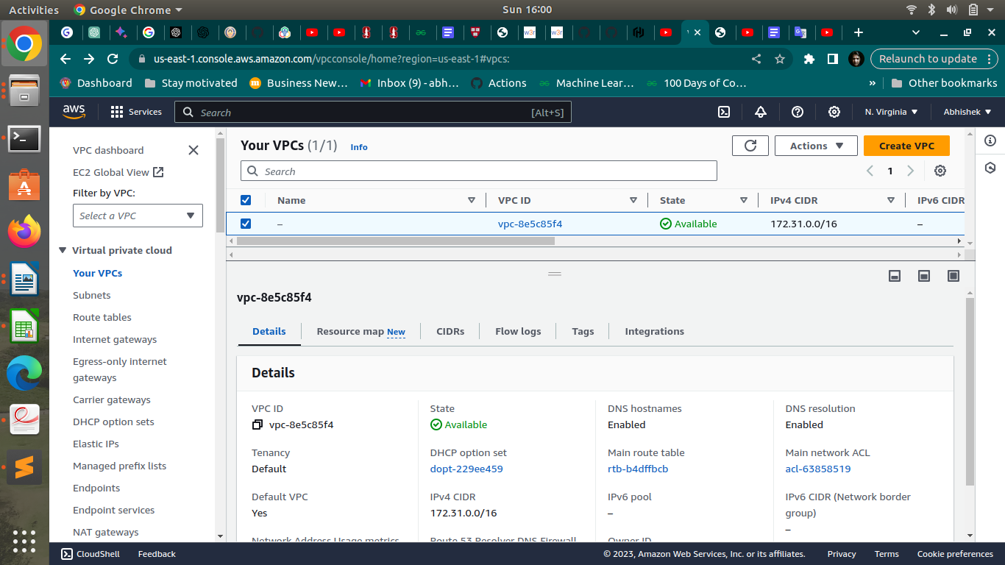

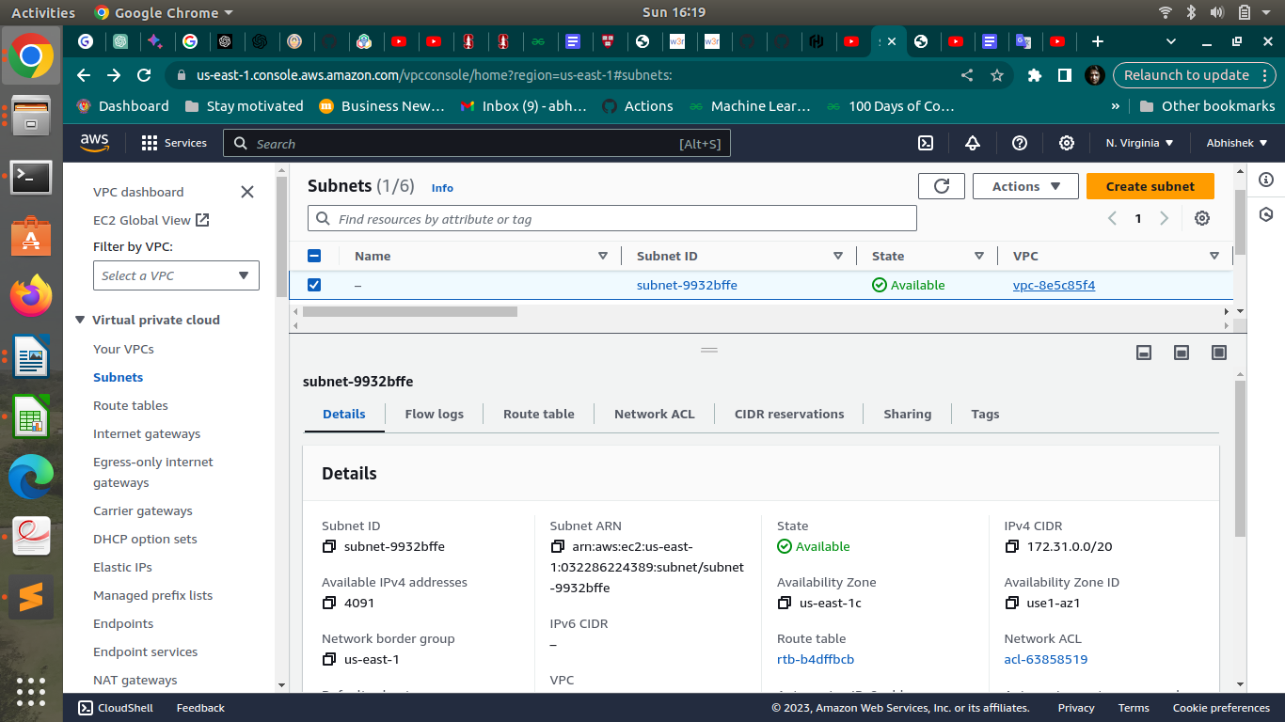

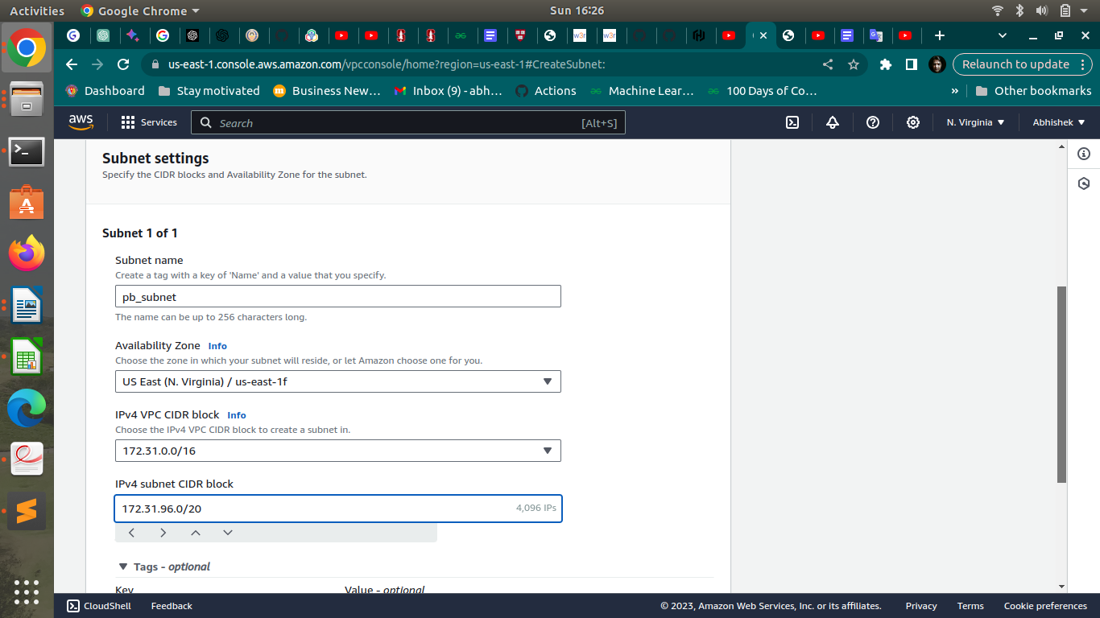

* Open the CF1.json file in your preferred text editor
* Change the values marked below in lines 18,23 and 28, with the values of the default VPC ID, default subnet ID and the ID of the created subnet respectively
* Repeat the above step for the file CF2.json as well i.e. open CF2.json and replace the appropriate values on lines 18,23, and 28.

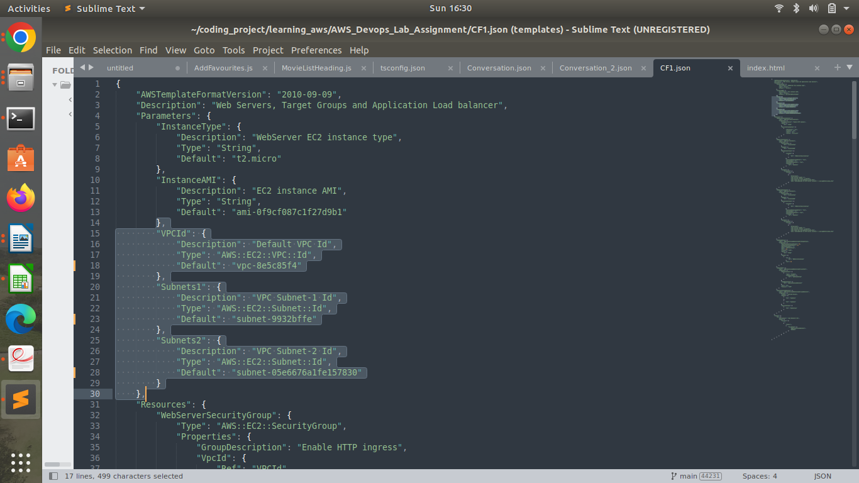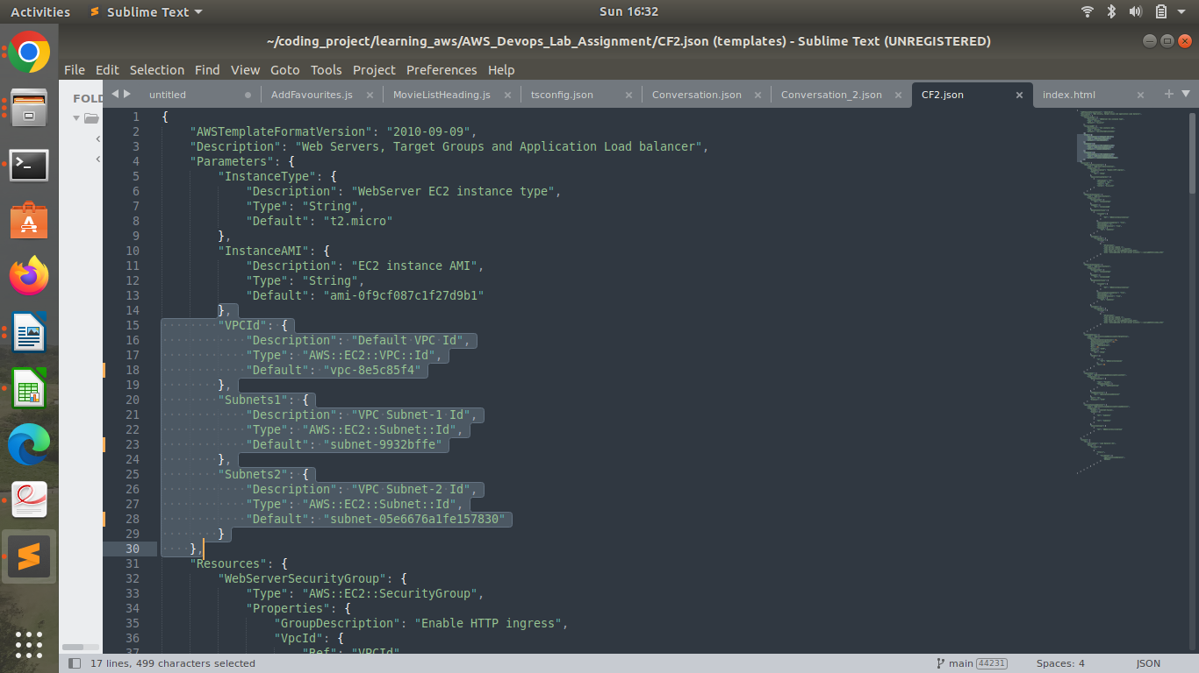

* Save and close the file
* Open your terminal (assuming AWS CLI is already installed and configured)
* Navigate to the folder where the JSONs file are stored
* Enter the following command and press Enter  
  *aws cloudformation create-stack --stack-name gltest-stack --template-body file://CF1.json*

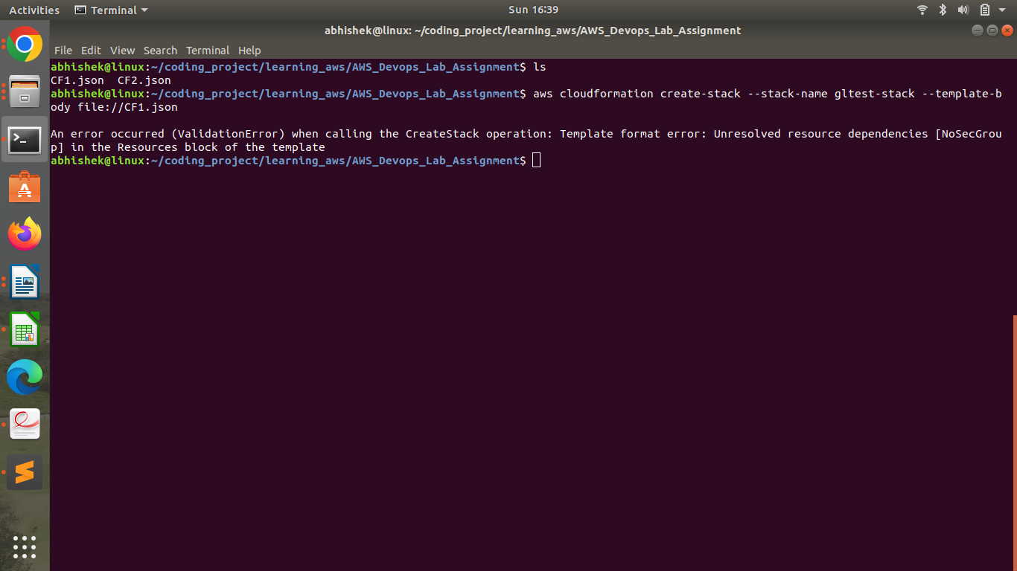

Go back to the terminal and type the command

aws cloudformation create-stack --stack-name gltest-stack --template-body file://CF2.json

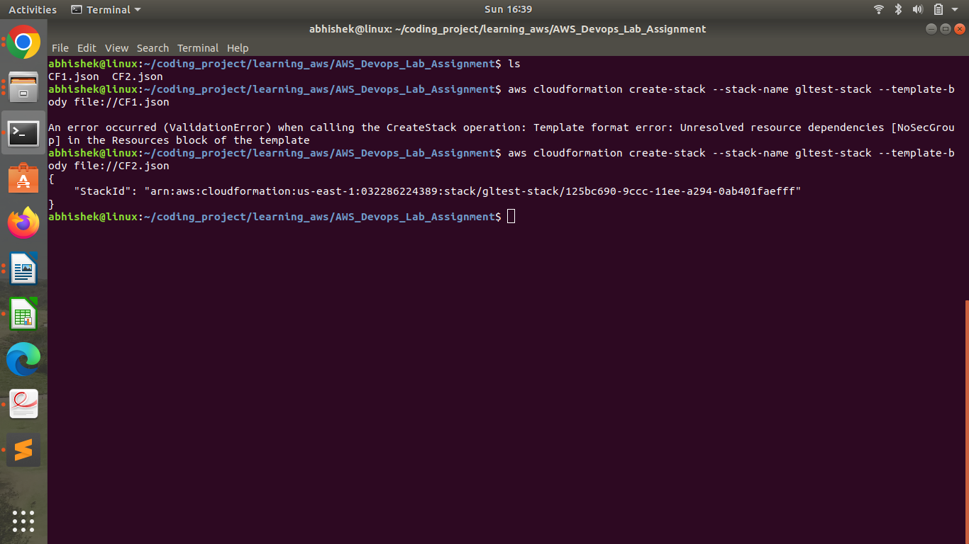

• Go back to the AWS console and navigate to CloudFormation

• Click on the stack and follow the steps of its creation. Wait for a few minutes for stack creation to finish.

• When stack creation is completed, navigate to the Outputs tab.

• Click on the URL value to confirm that Apache was installed and hence the load balancer was created successfully using the CloudFormation Template.

• Navigate back to the CloudFormation console, select the stack and click on Delete to delete the stack.

