SWIGGY FOOD ORDER
SALES & CUSTOMER ANALYTICS
Interactive Excel Dashboard Project Report
Prepared by
Rudraraju Vivek Varma
Tools: Microsoft Excel • Power Query • PivotTables • PivotCharts
Data Analysis | Visualization | Business Insights

Document Overview
Item | Details
Project Title | Swiggy Food Order Sales & Customer Analytics Dashboard
Project Type | Excel-based Data Analytics & Business Intelligence project
Primary Tool | Microsoft Excel
Data Preparation | Excel / Power Query
Analysis | PivotTables, formulas and calculated metrics
Visualization | PivotCharts, KPI cards, slicers and timeline
Output | Interactive sales and customer analytics dashboard
Dataset Size | 197,430 records; 15 source fields including one blank field
Report purpose: This document explains the problem, dataset, preparation, analytical approach, KPIs, dashboard design, key findings, limitations and how the project can be presented in an interview or academic review.

Table of Contents
1. Project Overview
2. Problem Statement
3. Objectives
4. Dataset Description
5. Data Preparation and Power Query Workflow
6. Analytical Methodology
7. KPI Development
8. Dashboard Design
9. Key Analysis and Findings
10. Business Interpretation
11. Data Limitations
12. Testing and Validation
13. Project Workflow
14. Interview / Viva Explanation
15. Future Enhancements
16. Conclusion

1. Project Overview
The Swiggy Food Order Sales & Customer Analytics Dashboard is an Excel-based data analytics project designed to convert raw food-order data into meaningful business information. The project focuses on sales performance, customer ratings, food-type contribution, geographic distribution, time-based trends and interactive filtering.
The project follows a practical analyst workflow: raw data is prepared, analytical measures are created, PivotTables and PivotCharts are used to explore patterns, and the resulting metrics are assembled into an interactive dashboard.

Core analytical questions
- How much total sales are generated in the dataset?
- How does sales performance change over time?
- Which food type contributes more to sales?
- Which states and cities contribute the most sales?
- Which days of the week show stronger sales activity?
- How does performance differ across quarters?
- How can the analysis be presented through an interactive dashboard?

2. Problem Statement
Food-ordering data can contain a large number of records covering locations, restaurants, dishes, categories, prices, ratings and dates. Looking at raw rows alone makes it difficult to understand overall performance and identify useful patterns.
The problem addressed by this project is to transform the raw Swiggy dataset into a structured analytical view that enables a user to quickly understand sales performance and customer-related patterns through KPIs, charts and interactive filters.

3. Objectives
- Prepare the source dataset for reliable analysis.
- Calculate key sales and customer-related KPIs.
- Analyze sales trends by month, day and quarter.
- Compare sales by food type.
- Identify high-performing states and cities.
- Create PivotTables and PivotCharts for analytical exploration.
- Build an interactive Excel dashboard using slicers and a timeline.
- Convert numerical results into concise business insights.
- Document data limitations so that metrics are interpreted correctly.

4. Dataset Description
The source dataset contains approximately 197,430 records and 15 fields. The fields support time, geographic, restaurant, food and customer-rating analysis.
Field | Analytical Use
State | State-level sales comparison
City | City-level sales and ranking
Order Date | Monthly, quarterly and time-series analysis
Day | Day-of-week sales analysis
Quarter | Quarterly performance
Week | Weekly trend analysis
Restaurant Name | Restaurant-level exploration
Location | Local-area analysis
Category | Food/category comparison
Dish Name | Dish-level exploration
Food Type | Veg vs Non-Veg comparison
Price (INR) | Sales/revenue metric
Rating | Average customer rating
Rating Count | Volume of recorded ratings
Column1 | Blank field; should be removed from final cleaned data

5. Data Preparation and Power Query Workflow
Power Query is used as the data-preparation layer. The objective is to keep the transformation process repeatable so that updated source data can be refreshed rather than manually rebuilt.

Preparation steps
- Connect Excel to the source dataset.
- Inspect the imported columns and data types.
- Ensure Order Date is treated as a date field.
- Ensure Price and Rating Count are numeric.
- Check categorical fields such as State, City, Food Type and Category for consistency.
- Remove the completely blank Column1 field from the final dataset.
- Use the first row as headers where necessary.
- Apply appropriate data types after splitting or transforming columns.
- Load the cleaned query result back to Excel.
- Refresh the query after source-data updates and verify that downstream PivotTables update correctly.
Refresh principle: If the CSV/source file changes, refresh the Power Query connection first. Then refresh PivotTables/PivotCharts so the dashboard reflects the updated data.

6. Analytical Methodology
The analysis combines calculated metrics, PivotTables, PivotCharts, slicers and a timeline. Each analytical view answers a different business question.
Analysis | Purpose
Total Sales | Measures overall sales generated by the available records
Average Rating | Measures the average recorded customer rating
Rating Count | Measures the total recorded rating-count values
Monthly Sales | Shows sales movement across available months
Daily Sales | Compares sales across days of the week
Quarterly Sales | Compares cumulative sales across quarters
Food Type Sales | Compares Veg and Non-Veg contribution
State Sales | Identifies high-performing states
Top 5 Cities | Identifies leading cities by sales
Weekly Trend | Supports short-term sales pattern analysis

7. KPI Development
The dashboard uses KPI cards to give the user an immediate high-level view.
KPI | Value | Interpretation
Total Sales | ₹5,30,12,505.77 | Total price value across the available records
Average Rating | 4.34 | Average of the recorded rating values
Rating Count | 5,591,574 | Sum of the available rating-count field
Records | 197,430 | Number of available data records
Average value per record | ₹268.51 | Total sales divided by available records
Important metric definition: Because the source data does not contain a unique Order ID, the ₹268.51 metric should be described as average value per available record unless the dataset documentation confirms that each row represents one complete order.

8. Dashboard Design
The dashboard is organized from high-level performance to detailed analysis. Interactive controls allow the user to filter the visualizations without rebuilding the analysis.

Interactive controls
- Region / geographic filtering where available in the workbook.
- Category filtering.
- Product or dish filtering.
- Date timeline for time-period selection.

Dashboard components
Component | Purpose
KPI Cards | Display total sales, total profit where available, profit margin and sales growth in the workbook version
Monthly Sales Trend | Shows movement of sales across months
Sales by Product | Compares product/dish-level sales
Sales by Region / State | Compares geographic performance
Sales by Category | Shows category contribution
Sales by Salesperson | Used in the separate sales-analysis workbook version
Slicers | Enable interactive filtering
Timeline | Filters date-based PivotTables/Charts
Note: The Swiggy project should keep its own metrics separate from the separate sales-analysis dashboard workbook that contains Profit, Profit Margin and Sales Growth cards. Those metrics belong to the other dataset/workbook unless corresponding profit fields are present in the Swiggy data.

9. Key Analysis and Findings

9.1 Monthly Sales
Month | Sales
Jan | ₹6,825,000
Feb | ₹6,269,000
Mar | ₹6,574,000
Apr | ₹6,595,000
May | ₹6,794,000
Jun | ₹6,514,000
Jul | ₹6,651,000
Aug | ₹6,791,000
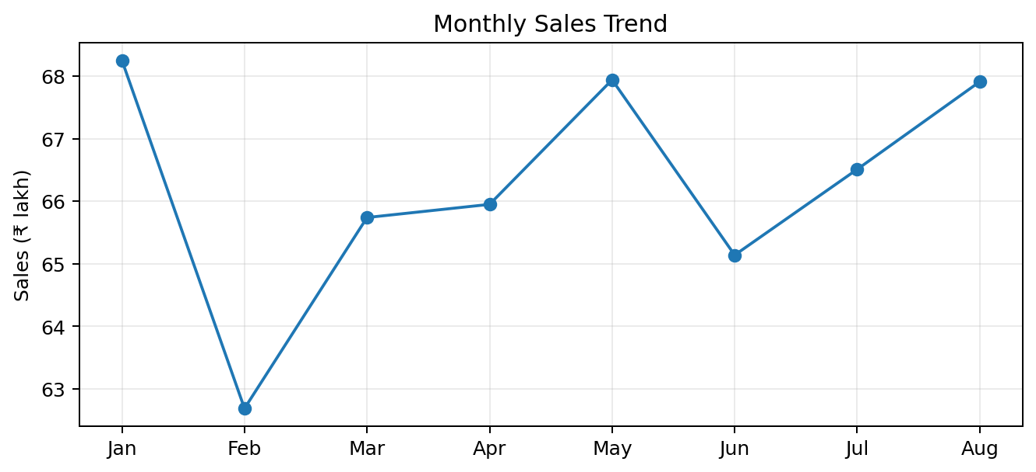
Finding: January is the highest-sales month in the available period at approximately ₹68.25 lakh, while February is the lowest at approximately ₹62.69 lakh. The overall monthly pattern is relatively stable.

9.2 Food Type Analysis
Food Type | Sales | Approx. Share
Veg | ₹4.56 Cr | ≈86%
Non-Veg | ₹0.74 Cr | ≈14%
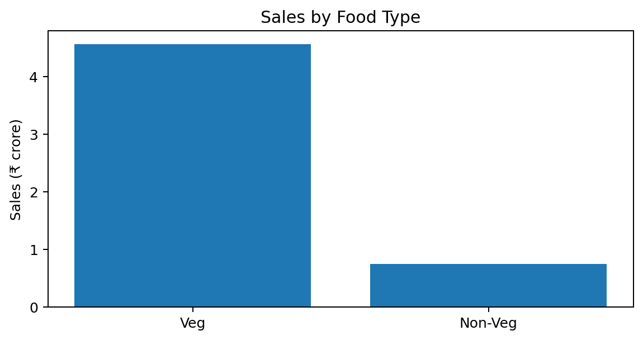
Finding: Vegetarian items contribute the majority of sales in the available dataset.

9.3 Day-of-Week Analysis
Day | Sales
Monday | ₹7,445,000
Tuesday | ₹7,359,000
Wednesday | ₹7,542,000
Thursday | ₹7,665,000
Friday | ₹7,580,000
Saturday | ₹7,783,000
Sunday | ₹7,638,000
Finding: Saturday records the highest sales among the available days, while Tuesday records the lowest.

9.4 State Analysis
State | Sales
Karnataka | ₹5,457,000
Uttar Pradesh | ₹3,117,000
Telangana | ₹3,022,000
Maharashtra | ₹3,016,000
Delhi | ₹2,829,000
Gujarat | ₹2,818,000
Finding: Karnataka is the leading state in the analyzed data, with approximately ₹54.57 lakh in sales.

9.5 Top City Analysis
Rank | City | Sales
1 | Bengaluru | ₹54.57L
2 | Lucknow | ₹31.17L
3 | Hyderabad | ₹30.22L
4 | Mumbai | ₹30.16L
5 | New Delhi | ₹28.29L
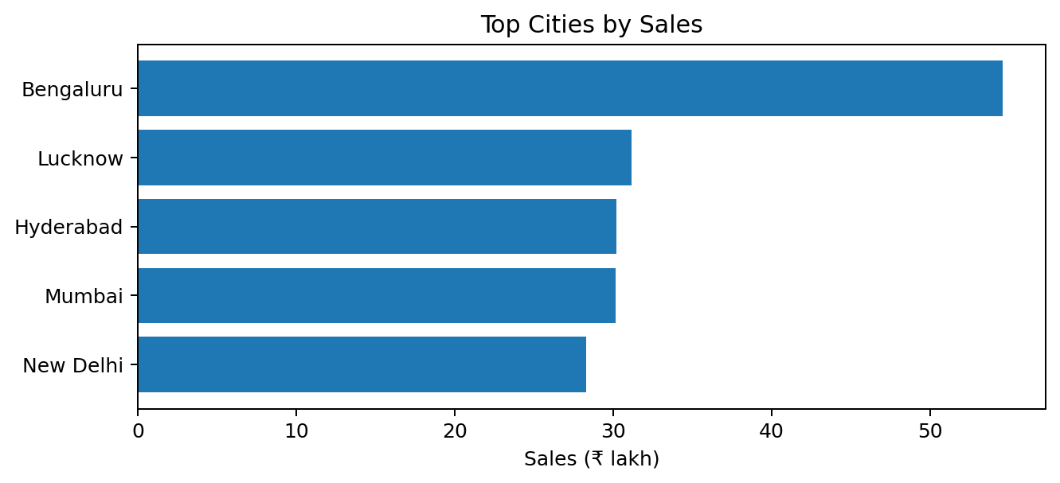
Finding: Bengaluru is the leading city in the available dataset, followed by Lucknow, Hyderabad, Mumbai and New Delhi.

9.6 Quarterly Analysis
Period | Sales
Q1 | ₹1.97 Cr
Q2 | ₹1.99 Cr
Q3 (partial) | ₹1.34 Cr
Quarterly caution: The available data does not cover a complete Q4 period, and Q3 is also partial. Therefore, quarterly comparisons should be interpreted using the actual covered dates rather than treated as complete-year performance.

10. Business Interpretation
The dashboard can support several business questions. The findings do not by themselves prove causal relationships; they describe patterns visible in the available dataset.
- Sales are distributed fairly consistently across the available months, suggesting no single month dominates the period.
- Vegetarian products represent the largest observed sales contribution.
- Weekend activity, particularly Saturday, shows stronger sales than several weekday periods.
- Karnataka and Bengaluru are prominent geographic contributors in the dataset.
- The dashboard's interactive filters allow a user to move from overall performance to a specific category, location or time period.
- Customer ratings provide a second dimension of performance alongside revenue, allowing sales and customer-experience metrics to be viewed together.

11. Data Limitations
- No explicit unique Order ID is present in the source fields, so distinct-order metrics cannot be guaranteed.
- Average value per record should not automatically be interpreted as true Average Order Value.
- The dataset's time coverage is incomplete for a full-year comparison; Q4 is not available in the analyzed period.
- Rating Count is treated as the supplied rating-count measure and should not automatically be interpreted as the number of unique reviews without source documentation.
- The analysis describes observed patterns and does not establish causation.
- The source dataset may contain duplicate or repeated business records; data-quality checks should be performed before production use.

12. Testing and Validation
Area | Validation
Data Types | Checked date, numeric and categorical fields
Blank Columns | Identified Column1 as empty and recommended removal
Totals | Compared KPI totals with PivotTable aggregations
Charts | Verified that PivotCharts use the intended PivotTable fields
Filters | Tested slicer/timeline interaction with dashboard visuals
Refresh | Verified Power Query refresh behavior after source-file changes
Metric Interpretation | Documented the absence of unique Order ID

13. Project Workflow
RAW SWIGGY DATA
↓
DATA PREPARATION / POWER QUERY
↓
PIVOTTABLES + FORMULAS
↓
ANALYTICAL CHARTS
↓
INTERACTIVE DASHBOARD
↓
BUSINESS INSIGHTS

End-to-end implementation
- Import the source data into Excel.
- Prepare and validate fields using Power Query.
- Create PivotTables for each business question.
- Create calculated KPI cells where required.
- Build PivotCharts from the analytical tables.
- Add slicers and timeline controls.
- Arrange KPI cards and charts into a single dashboard.
- Test filtering and refresh behavior.
- Interpret the resulting patterns and document insights.

14. Interview / Viva Explanation

30-second explanation
I developed an Excel-based Swiggy food-order analytics dashboard to analyze sales and customer-related patterns. I started with raw food-order data and prepared it using Excel and Power Query. Then I created PivotTables and analytical measures for total sales, average rating, food-type contribution, monthly and daily trends, quarterly performance, state-wise sales and top cities. Finally, I converted these analyses into an interactive dashboard using PivotCharts, slicers and a timeline. The dashboard helps users quickly understand sales performance and identify important geographic, product and time-based patterns.

If asked: What was your contribution?
I handled the data preparation, analytical calculations, PivotTable/PivotChart development, KPI creation, dashboard layout, interactive filtering and interpretation of the final business insights.

If asked: What was the most important insight?
One major observation is that Veg items contribute the majority of sales in the available dataset, while Bengaluru/Karnataka is a major geographic contributor. The monthly pattern is comparatively stable, with January being the highest month among the available months.

If asked: What is a limitation?
The source does not provide a unique Order ID, so I cannot guarantee that a record count represents unique orders. Therefore, I interpret the average-value metric at the available record level and explicitly document this limitation.

15. Future Enhancements
- Add a validated unique Order ID if available from the original source.
- Create true distinct-order metrics and true Average Order Value.
- Add restaurant-level performance and top-dish analysis.
- Create customer segmentation if customer identifiers become available.
- Add profitability metrics if cost or margin fields are available.
- Add year-over-year and month-over-month comparisons when multiple complete years are available.
- Add a geographic map for state/city performance.
- Automate the refresh pipeline from a stable source file.
- Rebuild the final dashboard in Power BI for more scalable interactive reporting.

16. Conclusion
This project demonstrates a complete practical Excel analytics workflow: raw data preparation, structured analysis, KPI development, interactive visualization and business interpretation. The dashboard converts a large food-order dataset into a concise decision-support view covering sales, time trends, food types, geography and customer ratings.
The project also demonstrates an important analyst skill: distinguishing what the data actually supports from what cannot be concluded. In particular, the absence of a unique Order ID and the incomplete time period are explicitly documented so that the resulting metrics are not overstated.
Final project statement: The project follows the complete analyst cycle — Data → Preparation → Analysis → Visualization → Insight — using Excel and Power Query.

Appendix A — Recommended Dashboard Structure
Dashboard Area | Recommended Content
Top row | Dashboard title + slicers/timeline
KPI row | Total Sales | Average Rating | Rating Count | Records
Trend section | Monthly Sales Trend
Composition section | Veg vs Non-Veg
Geographic section | State Sales + Top 5 Cities
Time section | Day-of-week + Quarterly Sales
Detail section | Category / Restaurant / Dish analysis

Appendix B — Project Files
- Raw / source data file
- Excel workbook containing analysis and dashboard
- Power Query transformations
- Analysis sheet
- Dashboard sheet
- Project report (this document)

