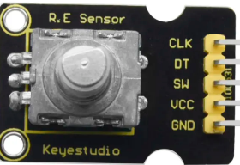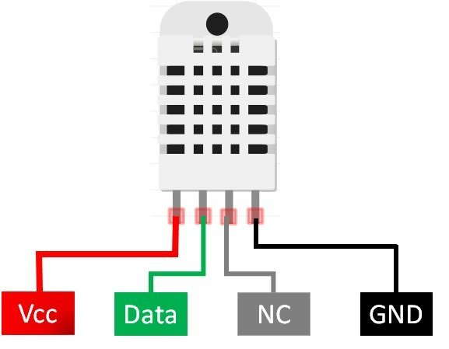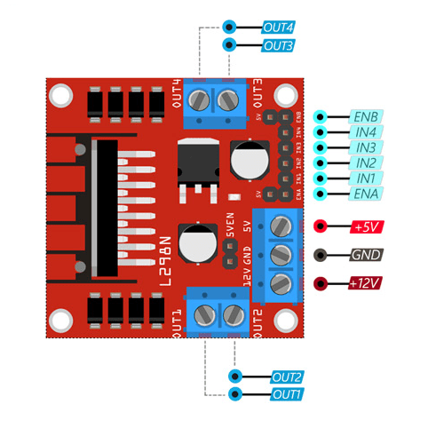­­­

Power Source

S

Power Source

S