SMART INDIA HACKATHON
Technical Project Report
AI / Machine Learning Based System for Identification, Classification and Prediction of Tropical Cyclone Patterns Using Multi-Source Satellite Data
An End-to-End, Self-Learning, Cloud-Native Forecasting & Early-Warning Platform
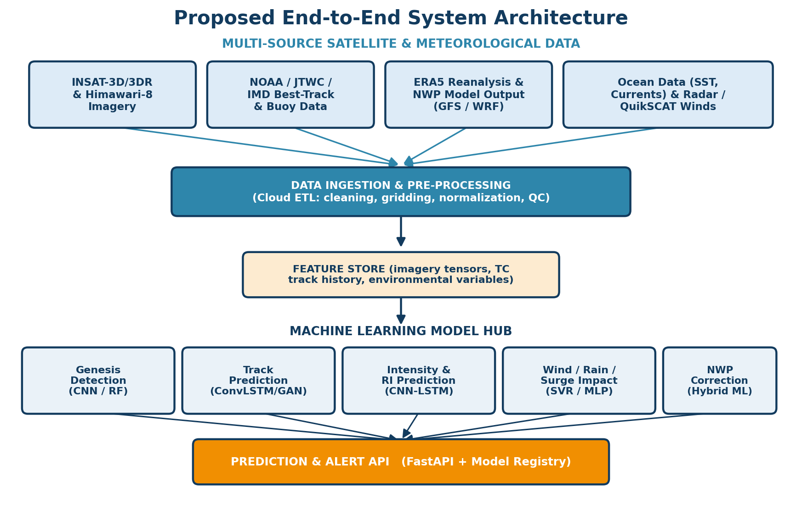

Domain: Disaster Management / Meteorology & Earth Sciences
Category: Software – Machine Learning / Artificial Intelligence
Team Name: [Insert Team Name] | Team ID: [Insert Team ID]
Prepared: September 2026

Table of Contents
1. Executive Summary
2. Problem Statement
3. Project Objectives
4. Literature Basis & Research Grounding
5. Proposed Solution — System Architecture
6. Machine Learning Approach
7. Real-Time Visualization Dashboard
8. Self-Learning AI: Continual Learning Pipeline
9. Technology Stack
10. Dataset Sources (Free & Publicly Available)
11. Expected Outcomes & Impact
12. Challenges & Future Scope
13. Conclusion
14. References

1. Executive Summary
Tropical cyclones (TCs) are among the most destructive natural hazards affecting India's eastern and western coastlines every year, causing loss of life, large-scale property damage, and disruption to agriculture, fisheries and infrastructure. Traditional forecasting relies on numerical weather prediction (NWP) models that are computationally expensive, suffer from inaccurate vortex initialisation, and remain weak at predicting cyclogenesis, rapid intensification (RI) and localised disaster impacts (Chen, Zhang & Wang, 2020).
This report presents a proposed AI/ML-based system that ingests multi-source satellite and meteorological data (INSAT-3D/3DR, Himawari-8, NOAA/JTWC best-track records, ERA5 reanalysis and ocean data) to identify, classify and predict tropical cyclone patterns across five dimensions: genesis, track, intensity, rapid intensification and disastrous-weather impact (wind, rainfall, storm surge). The system is designed to be reproducible on modest hardware by relying entirely on free cloud-based compute (Google Colab, Kaggle Notebooks) for model training, and lightweight web technologies for real-time visualisation.
Two features distinguish the proposed solution from a conventional forecast dashboard:
- Rich geo-visual outputs — genesis-probability and intensity heatmaps, and a real-time cyclone-tracking map with an animated forecast cone, so that both technical judges and non-technical disaster-management officials can interpret the output at a glance.
- A self-improving (continual learning) loop — the deployed model's predictions are automatically compared against newly-arriving IMD/JTWC best-track observations; the resulting error signal triggers incremental re-training so that forecast skill compounds over each cyclone season without manual intervention.
The remainder of this report details the problem statement, the system architecture, the specific machine-learning techniques used for each forecasting task (grounded in peer-reviewed literature), the technology stack, and publicly available datasets suitable for a hackathon prototype-to-MVP build.

2. Problem Statement
Official SIH problem statement: “To develop an Artificial Intelligence (AI) / Machine Learning (ML) based system for identification, classification, and prediction of different tropical cyclone patterns using multi-source satellite data.”
India's coastline is regularly struck by cyclones forming in the Bay of Bengal and the Arabian Sea. Current operational forecasting depends on numerical models that are expensive to run, slow to update, and known to underperform specifically on cyclogenesis, rapid intensification, unusual (recurving/stalling) tracks, and rainfall/storm-surge impact — precisely the events that cause the most damage. The problem statement calls for a data-driven, AI/ML layer that complements existing NWP systems by learning nonlinear relationships directly from historical and real-time multi-source satellite imagery and meteorological/oceanic parameters.

2.1 Key Sub-Problems to be Solved
- Identification: Detecting whether a developing weather disturbance (tropical low/depression) will evolve into a tropical cyclone.
- Classification: Categorising a system by basin-specific intensity scale (Depression, Deep Depression, Cyclonic Storm, Severe Cyclonic Storm, Very Severe Cyclonic Storm, Extremely Severe Cyclonic Storm, Super Cyclonic Storm) directly from satellite imagery.
- Prediction: Forecasting the future track (position), intensity (wind speed / central pressure) and associated hazards (wind field, rainfall, storm surge) at lead times from a few hours up to 5 days.
- Continuous Improvement: Ensuring the system keeps learning and correcting itself as new cyclones occur, rather than remaining static after initial training.

3. Project Objectives
- O1 — Multi-source data pipeline: Build an automated ingestion pipeline that fuses INSAT/Himawari satellite imagery, IBTrACS/IMD best-track records, ERA5 reanalysis fields and ocean parameters into a unified, model-ready feature store.
- O2 — Modular ML model suite: Develop / fine-tune separate but interoperable models for genesis detection, track prediction, intensity estimation and prediction, rapid-intensification classification, and wind/rainfall/storm-surge impact forecasting.
- O3 — Real-time geo-visual dashboard: Deliver a web dashboard with a live cyclone-tracking map, genesis/intensity heatmaps, an uncertainty cone, and category-wise colour coding understandable by disaster-management officials.
- O4 — Self-learning feedback loop: Implement an automated pipeline that scores each prediction against later-confirmed best-track data and incrementally retrains the underlying models — approximating an AI system that “learns from its own mistakes” in real time.
- O5 — Low-compute reproducibility: Ensure the entire system can be built, trained and demonstrated without a dedicated GPU workstation, using only free-tier cloud notebooks and lightweight inference formats (ONNX / TensorFlow-Lite).
- O6 — Alignment with operational agencies: Design outputs (alert format, categories, lead times) to be directly consumable by IMD, NDMA and state disaster-management authorities.

4. Literature Basis & Research Grounding
Rather than inventing techniques speculatively, the proposed system design is grounded in the peer-reviewed review article “Machine Learning in Tropical Cyclone Forecast Modeling: A Review” (Chen, R.; Zhang, W.; Wang, X. Atmosphere 2020, 11, 676), which surveys the state of the art in ML-based TC genesis, track, intensity and disaster-impact forecasting, as well as ML-assisted improvements to numerical models. The proposed architecture in Section 5 directly maps each of the paper's five application areas onto a corresponding module in the proposed system, and Section 6 cites the specific algorithms and reported accuracy figures that justify each design choice.
Key findings from the review that motivate this project:
- Machine learning is well suited to TC forecasting precisely because TC genesis and intensification are governed by complex, poorly-understood nonlinear physical processes that traditional statistical and dynamical models struggle to represent.
- Convolutional Neural Networks (CNNs) applied to satellite imagery already rival or exceed the accuracy of the manually-applied Dvorak technique for intensity estimation, with reported RMSE dropping from ~18 kt (early decision-tree methods) to ~8.3 kt (recent CNN methods).
- Spatio-temporal architectures (ConvLSTM, hybrid CNN-LSTM, GANs) outperform simple feed-forward networks for track and intensity prediction because cyclone evolution is both a spatial (imagery) and temporal (sequence) problem.
- A large amount of multi-source satellite, reanalysis and observational data remains under-exploited — precisely the opportunity this hackathon project targets.
- Explainability, short-lead-time bias and scarcity of in-situ observations remain open challenges that the proposed system's design (Section 13) explicitly accounts for.

5. Proposed Solution — System Architecture
The system is organised as five layers: (1) multi-source data acquisition, (2) cloud-based pre-processing and feature engineering, (3) a hub of task-specific ML models, (4) a prediction/alert API, and (5) a visualization and feedback layer that closes the loop back into model retraining. Each layer is described in the following sections.
Figure 5.1 — End-to-end system architecture: from multi-source data ingestion through the ML model hub to the prediction API.

5.1 Data Ingestion & Pre-processing
Raw satellite imagery (IR, water-vapour, visible channels), best-track archives and reanalysis grids are pulled on a schedule (every 30–60 minutes during an active cyclone) via a Python-based ETL pipeline. Pre-processing includes geographic re-gridding to a common lat/lon resolution, normalisation, cloud/no-data masking, and temporal alignment across sources so that a single training example combines an image tensor with the matching environmental variables at the same timestamp.

5.2 Feature Store
Processed tensors and tabular features (Coriolis parameter, vertical wind shear, mid-tropospheric relative humidity, sea-surface temperature, ocean heat content — the classical Gray (1998) genesis predictors) are cached in a feature store so that all downstream models draw from a single, versioned source of truth, avoiding train/serve skew.

5.3 Machine Learning Model Hub
Five task-specific model families operate on the shared feature store, detailed in Section 6. Each model is registered with a version, training-data snapshot and validation score in an MLflow model registry, allowing the continual-learning loop (Section 8) to compare candidate retrained models against the currently deployed one before promoting it.

5.4 Prediction & Alert API
A FastAPI service exposes REST and WebSocket endpoints that return genesis probabilities, predicted tracks with uncertainty cones, intensity trajectories and impact-risk layers, consumed by the dashboard and, in a production deployment, by IMD/NDMA systems.
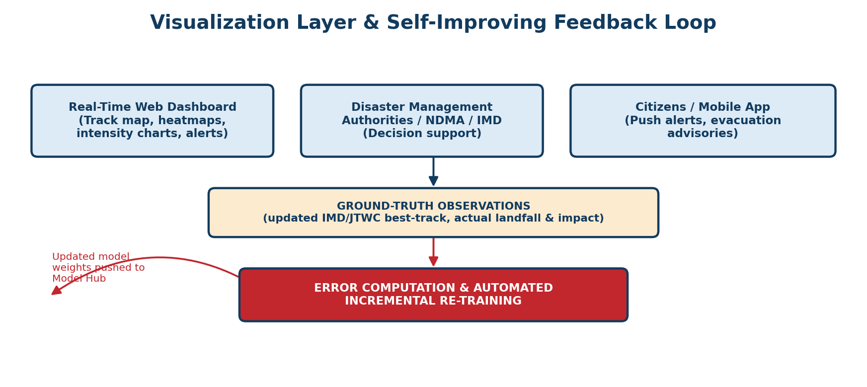
Figure 5.2 — Visualization layer and the self-improving feedback loop that routes newly-confirmed observations back into model retraining.

6. Machine Learning Approach
Consistent with the five application areas identified in the literature survey, the Model Hub is composed of five task-specific model families. Each is described below together with the specific algorithms recommended, the reasoning behind the choice, and representative accuracy figures reported in prior published work.

6.1 Cyclone Genesis Detection & Forecasting
Short-term genesis forecasting is framed as a binary classification problem (“will this disturbance become a TC within the next 24–72 hours?”) while seasonal genesis-frequency forecasting is framed as a regression problem. The proposed system uses a CNN on satellite imagery for short-term detection (recommended over classical DT/SVM baselines because it can learn spatial cloud-pattern features automatically) combined with a Random-Forest / gradient-boosted classifier on environmental predictors as an ensemble check.
Sub-task | Recommended Algorithm(s) | Reported Accuracy (literature)
Short-term genesis classification | CNN on satellite imagery; Decision Tree / Random Forest / AdaBoost on environmental predictors | Up to 97.2% F1-score (AdaBoost, 6h lead); 91.2% precursor detection at 2-day lead (CNN)
Long-term / seasonal genesis frequency | Support Vector Regression (SVR); MLP; SOM + feed-forward NN for Genesis Potential Index (GPI) | SVR + QBO predictor improved MAE by 31.2% and RMSE by 29.2% over multiple linear regression

6.2 Track (Path) Prediction
Cyclone tracks are inherently spatio-temporal — position depends on both the current steering environment (large-scale winds, pressure fields) and the cyclone's own recent trajectory. The proposed system therefore uses a ConvLSTM (Convolutional LSTM) as the primary track model, since it jointly captures spatial structure from gridded fields and temporal dependence from the historical track sequence, supplemented by a satellite-image-conditioned GAN for short-lead visual nowcasting.
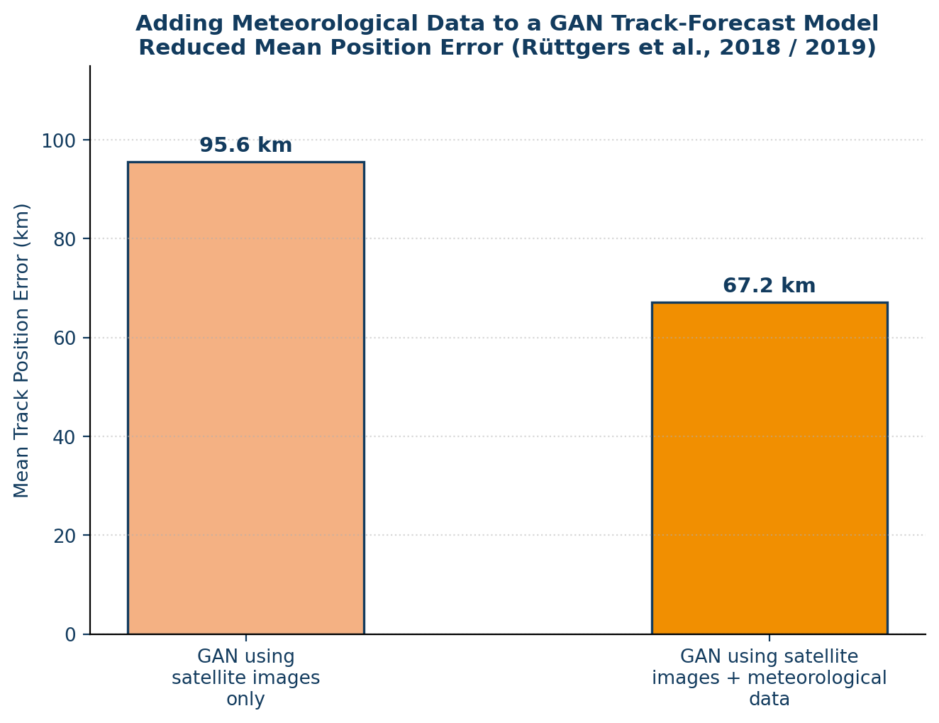
Figure 6.1 — Adding meteorological variables (SST, pressure, wind fields) to a satellite-image-only GAN track model reduced the mean track-position error from 95.6 km to 67.2 km (Rüttgers et al., 2018/2019).
Sub-task | Recommended Algorithm(s) | Reported Result (literature)
24–120h path prediction | ConvLSTM; RNN; Matrix Neural Network (MNN) | RNN track model gave a 120h lead-time forecast outperforming techniques then used at the U.S. National Hurricane Center
Image-conditioned nowcasting | GAN (satellite images + meteorological fields) | Mean track error reduced from 95.6 km (images only) to 67.2 km (images + met. data)
Predictor / rule mining | Decision Tree (C4.5 / CART) | Derived explainable rules for TC recurvature and landfall behaviour
Historical similarity search | Deep Belief Network (DBN) + clustering (K-means, FMM, SOM) | Improved similarity-based forecasts at 85% confidence, 54–66h lead

6.3 Intensity Estimation & Prediction
Two distinct problems are addressed: (a) estimating the current intensity from a satellite image (replacing the manual Dvorak technique), and (b) predicting future intensity, including rapid intensification (RI). CNNs are recommended for (a) given their consistently superior accuracy on satellite-imagery-based estimation reported across four independent studies; a hybrid CNN-LSTM (spatio-temporal) network is recommended for (b).
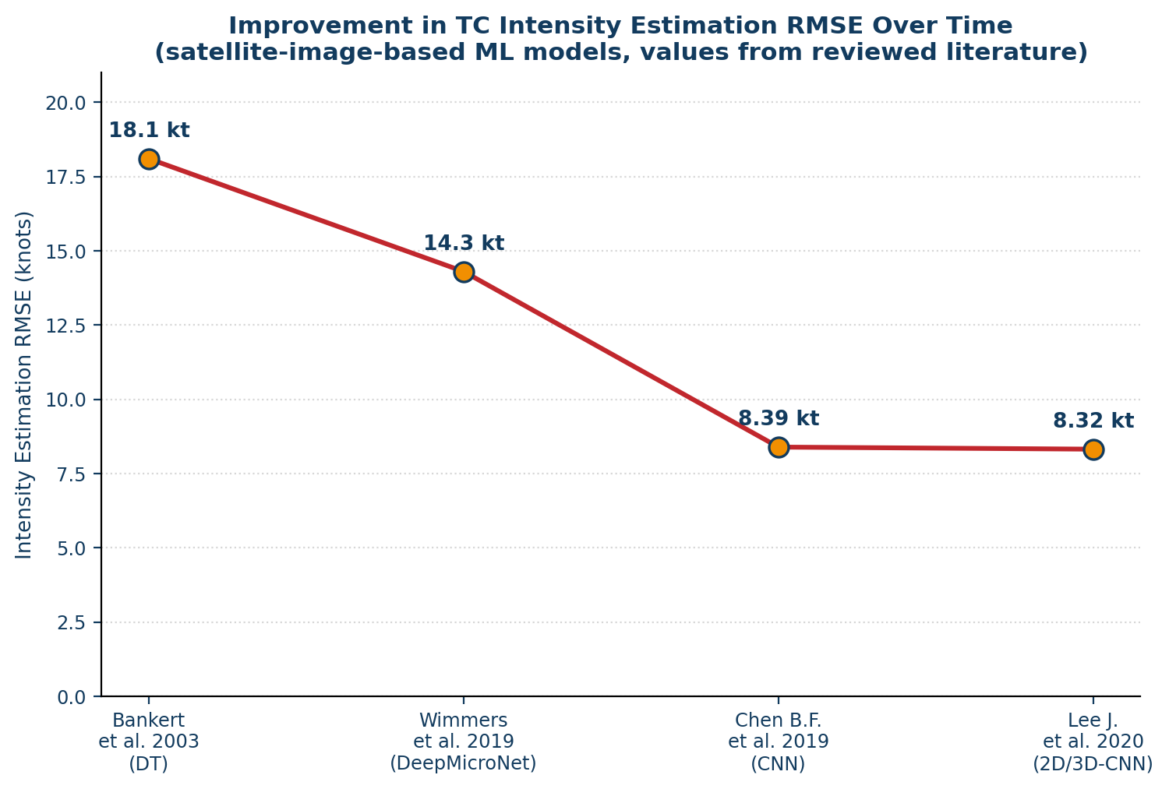
Figure 6.2 — Reported improvement in satellite-image-based TC intensity-estimation RMSE across four studies spanning 2003–2020.
Sub-task | Recommended Algorithm(s) | Reported Result (literature)
Current-intensity estimation from imagery | 2D/3D-CNN (Dvorak-technique replacement) | Best reported RMSE ≈ 8.3 kt vs. best-track (down from ≈ 18 kt for early Decision-Tree methods)
Future intensity prediction (24–48h) | Hybrid CNN-LSTM spatio-temporal model | Mean error 7.9 kt (West Pacific basin), outperforming compared numerical and statistical baselines
Rapid intensification (RI) classification | Decision Tree with ocean-coupling potential-intensity (OC_PI) predictor; SVM; ensemble (SVM+ANN+RF) | 83.5–89.6% cross-validation / independent-verification accuracy; ~30% skill improvement over climatology

6.4 Disastrous-Weather Impact Forecasting
Beyond track and intensity, the system forecasts the three hazards that cause most cyclone-related damage: destructive winds, heavy rainfall/flooding, and coastal storm surge.
Hazard | Recommended Algorithm(s) | Purpose
TC wind field | Support Vector Regression (SVR); MLP; Least-Squares SVM | Simulate/predict near-surface and boundary-layer wind speed for a given cyclone position and intensity
TC rainfall & flood forecasting | SVM; hybrid SOM + MLP; Fuzzy Neural Network | Hourly rainfall prediction (1–6h lead) and downstream flood / runoff estimation
Storm surge | MLP; SVR; ANN-based storm-surge forecast model (ANN-SFM); BPN-ANFIS hybrid | Predict coastal water-level rise from wind speed, pressure drop and astronomical tide

6.5 Using ML to Improve the Underlying Numerical Model
In addition to the pure data-driven models above, the system includes a complementary physics-informed track: ML is used to (a) pre-process satellite/assimilation data by flagging TC-affected regions (SVM classifier), (b) improve NWP parameterisation — e.g. quantifying typhoon-induced sea-surface-temperature cooling with an MLP/CNN to correct WRF-model intensity forecasts, and (c) post-process NWP output for TC detection and tracking (CNN / ConvLSTM applied to model fields). This hybrid approach is included as a stretch goal beyond the pure data-driven MVP.

7. Real-Time Visualization Dashboard
Because forecasters and disaster-management officials need to interpret model output in seconds, not minutes, the dashboard is built around two flagship geo-visualisations requested for this project — probability heatmaps and a real-time tracking map — plus supporting charts.

7.1 Genesis / Intensification Heatmap
A gridded heatmap overlays the basin (Bay of Bengal / Arabian Sea, extendable to any basin) with the model's genesis or intensification probability, updated on every ingestion cycle. Colour intensity (dark blue → red) lets an official spot an emerging risk area without reading raw numbers.
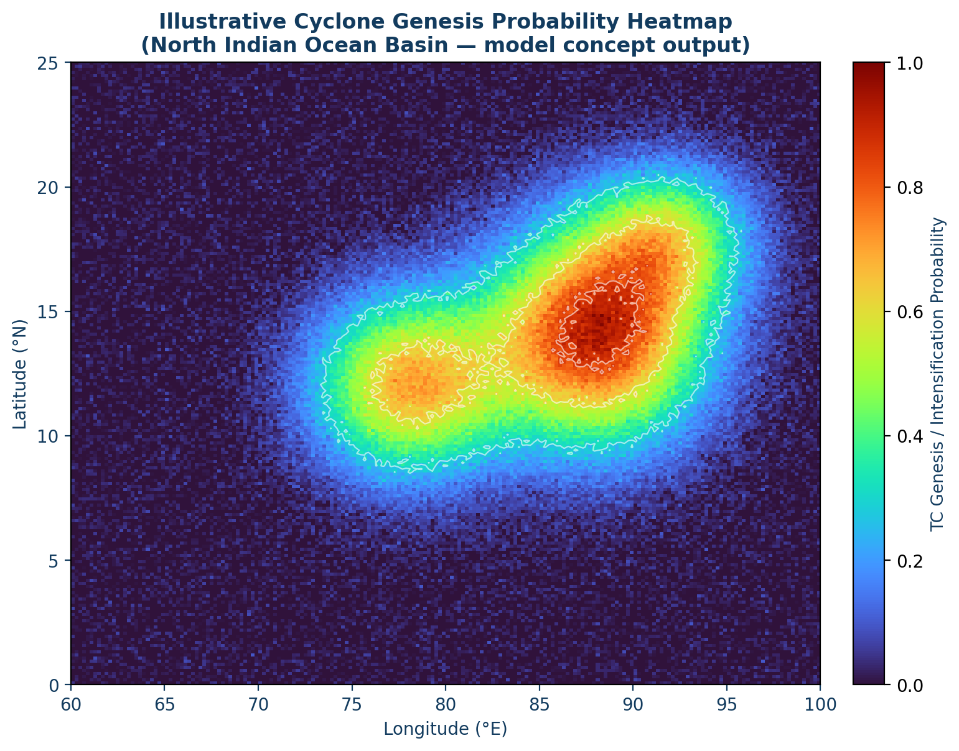
Figure 7.1 — Illustrative genesis/intensification probability heatmap (synthetic example; live version is generated from real model output).

7.2 Real-Time Cyclone Tracking Map
Once a system is classified as a tropical cyclone, the map switches to track mode: the observed best-track is plotted as solid points colour-coded by IMD/JTWC intensity category, and the ML-predicted track for the next 24–120 hours is overlaid as a dashed line inside a widening “cone of uncertainty” — the same visual language used operationally by IMD and NHC, so the output is immediately familiar to domain experts.
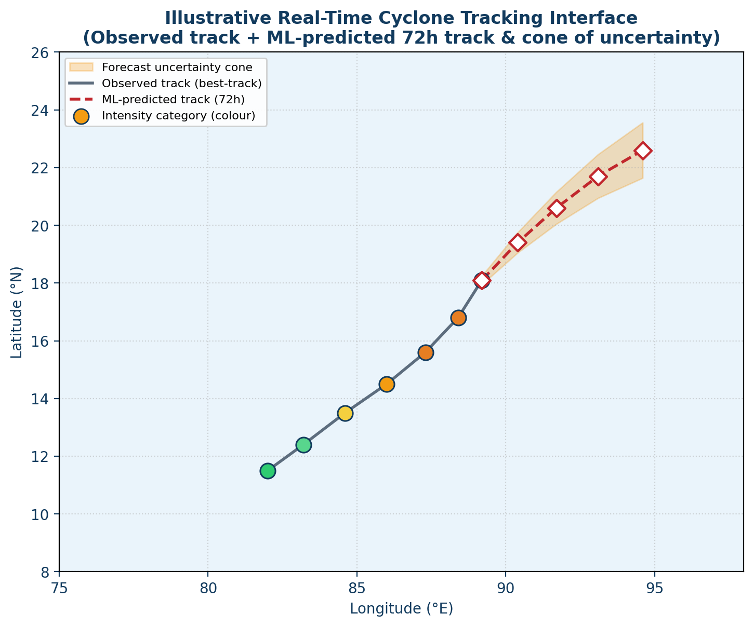
Figure 7.2 — Illustrative real-time tracking interface: observed track (solid, colour-coded by category) and ML-predicted track with uncertainty cone (dashed).

7.3 Additional Dashboard Views
- Intensity timeline: line chart of estimated vs. predicted maximum sustained wind speed / central pressure over time, with an RI-risk flag.
- Impact-risk layers: toggleable map layers for predicted wind-field extent, expected rainfall accumulation, and storm-surge inundation risk along the coast.
- Alert panel: auto-generated plain-language advisories (category, expected landfall window, districts at risk) exportable as a bulletin for NDMA / State Disaster Management Authorities.
- Model confidence indicator: shows current model version, validation score and last retraining timestamp, so users can see the system's live “health”.

8. Self-Learning AI: Continual Learning Pipeline
A key requirement of this project is that the AI should not remain static after its initial training — it should keep improving by learning from its own forecast errors as real cyclones occur. This is implemented as a closed-loop MLOps pipeline rather than a single training run.
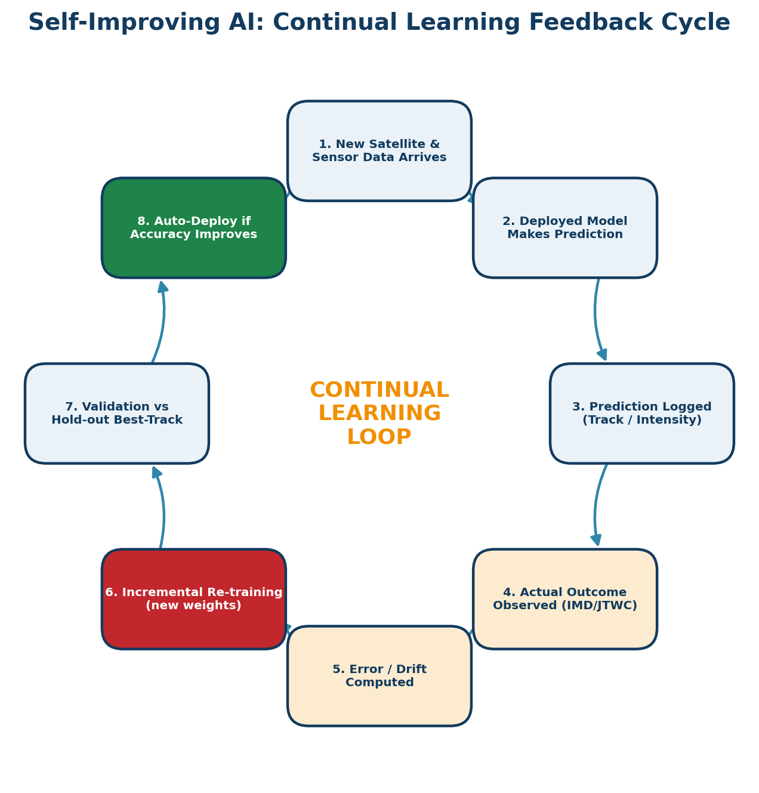
Figure 8.1 — The eight-step continual-learning cycle that lets the deployed model improve itself after every cyclone event.

8.1 How the Loop Works
- New satellite and sensor data arrives on schedule and is fed to the currently deployed model.
- The model produces a prediction (genesis probability, track, intensity) which is timestamped and logged.
- As the cyclone evolves, the actual outcome becomes known from updated IMD/JTWC best-track releases and post-event impact reports.
- The system automatically computes the prediction error (track-position error in km, intensity error in knots, classification accuracy) and checks for distributional drift between recent data and the training set.
- If error/drift exceeds a threshold, an incremental re-training job is triggered — the model is fine-tuned on the newly accumulated, corrected examples rather than trained from scratch, which keeps retraining fast and cheap enough to run on free-tier cloud GPUs.
- The retrained candidate model is validated against a held-out set of historical best-track cyclones to confirm it has not regressed on past cases.
- Only if the candidate model's validation score improves on the currently deployed model is it automatically promoted (canary / blue-green deployment) — this guards against a single noisy event degrading the system.
- The cycle repeats continuously, so forecast skill is expected to compound season over season, particularly for the basin(s) the system is actively deployed on.

8.2 Why This Matters for the Problem Statement
This directly answers the brief's requirement that “the AI will train by itself by getting the data and fixing its mistakes in real time”: rather than a one-off offline-trained model, the deployed system behaves like an operational forecasting service that is continuously re-calibrated against ground truth, in the same spirit as online/incremental learning and MLOps drift-monitoring practice.

9. Technology Stack
The stack is chosen specifically so that the team can build and demonstrate the full system without owning a powerful laptop or GPU — every training-heavy step is offloaded to a free cloud notebook, and the serving stack is lightweight enough to run on a free-tier web host for the hackathon demo.
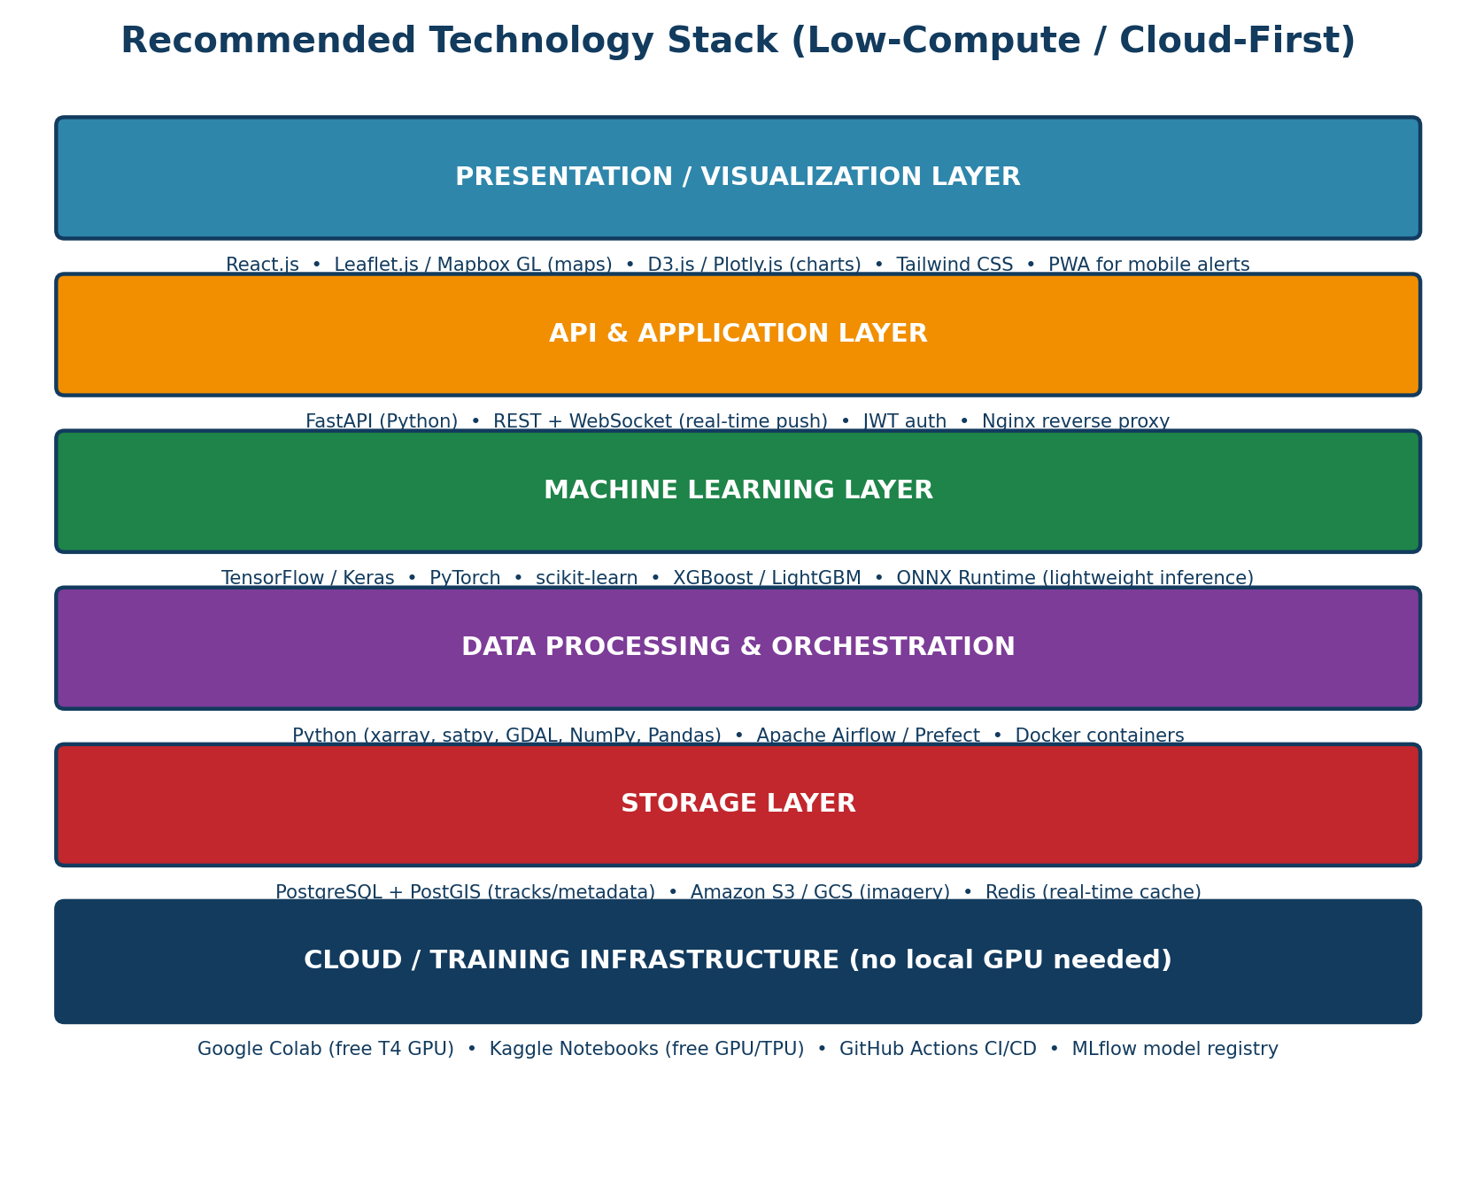
Figure 9.1 — Recommended layered technology stack, from cloud training infrastructure up to the visualization layer.
Layer | Technology Choices | Why
Visualization | React.js, Leaflet.js / Mapbox GL, D3.js / Plotly.js, Tailwind CSS | Free, well-documented, renders interactive maps and charts entirely in-browser
API & application | FastAPI (Python), WebSocket for live push, JWT auth, Nginx | Async-native, auto-generates OpenAPI docs, minimal boilerplate for a hackathon timeline
Machine learning | TensorFlow/Keras, PyTorch, scikit-learn, XGBoost/LightGBM, ONNX Runtime | Covers CNN/ConvLSTM/GAN deep-learning needs plus classical ensemble baselines; ONNX gives fast, low-resource inference
Data processing | Python (xarray, satpy, GDAL, NumPy, Pandas), Apache Airflow / Prefect, Docker | Standard geoscience-Python stack for satellite/NetCDF/GRIB data; Airflow schedules ingestion
Storage | PostgreSQL + PostGIS, Amazon S3 / Google Cloud Storage, Redis | PostGIS handles geospatial track queries; object storage holds bulky imagery cheaply
Training infrastructure | Google Colab (free T4 GPU), Kaggle Notebooks (free GPU/TPU, 30 hrs/week) | Removes the need for local GPU hardware entirely — see Section 9.1
MLOps | MLflow (experiment tracking + model registry), GitHub Actions (CI/CD) | Tracks every model version and automates the retraining/promotion pipeline from Section 8
Deployment (demo) | Render / Railway / HuggingFace Spaces (backend), Vercel / Netlify (frontend) | Free tiers sufficient for a judged hackathon demo; swappable for AWS/GCP/Azure in production

9.1 Why No Local GPU Is Required
- Google Colab: provides a free NVIDIA T4 GPU per session, sufficient to train the CNN/ConvLSTM models described in Section 6 on cropped/downsampled satellite tiles.
- Kaggle Notebooks: offers free GPU and TPU quota (≈30 hrs/week) and direct access to many public TC datasets already hosted on the platform.
- Transfer learning: starting from a pretrained CNN backbone (e.g. ResNet/EfficientNet pretrained on ImageNet) drastically cuts the compute and data needed to reach good accuracy on satellite-imagery tasks.
- ONNX / TensorFlow-Lite export: once trained, models are exported to a lightweight inference format so the demo/serving backend runs comfortably on a free-tier CPU-only cloud instance — no GPU needed at inference time.
- GitHub Codespaces / free student credits: GitHub Student Developer Pack, AWS Educate and Azure for Students provide additional free compute/hosting credits useful during the hackathon build phase.

10. Dataset Sources (Free & Publicly Available)
Since the team does not have access to a powerful workstation, every dataset below is chosen because it is (a) free and publicly downloadable, (b) small enough in a pre-processed subset to fit Colab/Kaggle session storage, and (c) already used in the published ML-for-TC literature reviewed in Section 4, which means baseline architectures and expected accuracy figures are known in advance.
Dataset | Provider | What it gives you | Access
IBTrACS (International Best Track Archive for Climate Stewardship) | NOAA / NCEI | Global best-track position, intensity and category for every recorded cyclone since 1841 (CSV / NetCDF) | ncei.noaa.gov/products/international-best-track-archive
RSMC New Delhi Cyclone e-Atlas / Best Track Data | India Meteorological Department (IMD) | Official best-track & intensity records for North Indian Ocean cyclones — ground truth for India-focused models | rsmcnewdelhi.imd.gov.in
MOSDAC — INSAT-3D/3DR Imagery | ISRO / Space Applications Centre | Indian geostationary satellite IR / water-vapour / visible imagery over the North Indian Ocean | mosdac.gov.in
NOAA GOES-16/17 (Open Data) | NOAA, hosted on AWS/Google Cloud Public Datasets | Free geostationary imagery over the Atlantic/Pacific basins, directly streamable — no download quota limits | registry.opendata.aws/noaa-goes
Himawari-8/9 P-Tree Data | Japan Meteorological Agency (JMA) | Geostationary imagery over the West/North Pacific basin | p-tree.nict.go.jp
ERA5 Reanalysis | Copernicus Climate Data Store (ECMWF) | Hourly global reanalysis: wind shear, humidity, SST, pressure — the classical genesis predictors | cds.climate.copernicus.eu
HURDAT2 | NOAA National Hurricane Center | Atlantic & East-Pacific best-track database, widely used as an ML benchmark | nhc.noaa.gov/data
Digital Typhoon | National Institute of Informatics, Japan | Large labelled archive of typhoon satellite imagery purpose-built for ML research | agora.ex.nii.ac.jp/digital-typhoon
NASA Tropical Cyclone Wind-Speed / IMPACT datasets | NASA / Radiant Earth MLHub | Curated, ML-ready satellite-imagery + wind-speed label sets for benchmarking intensity models | mlhub.earth
GPM (Global Precipitation Measurement) | NASA / JAXA | Satellite-based rainfall estimates for training the rainfall/flood-impact model | gpm.nasa.gov
Kaggle public TC datasets | Kaggle | Several community-curated, pre-cleaned cyclone imagery/track datasets, plus free GPU/TPU notebooks to train on them directly in-browser | kaggle.com/datasets

10.1 Suggested Starting Subset for a Hackathon Prototype
To keep the prototype's data footprint small enough for free-tier Colab/Kaggle storage, it is recommended to start with: IBTrACS for track/intensity ground truth (a few MB as CSV), a downsampled INSAT-3D or Himawari-8 IR image tile per 3-hourly timestep for the last 3–5 cyclone seasons in the North Indian Ocean basin, and ERA5 single-level variables (10m wind, SST, mean sea-level pressure) at a coarse ~0.5° resolution. This combination is sufficient to train and demonstrate all five model families in Section 6 within a single hackathon build cycle.

11. Expected Outcomes & Impact
- Earlier, more accurate warnings: CNN-based genesis detection and RI classification can flag dangerous systems earlier than purely dynamical models, giving coastal authorities more lead time.
- Reduced forecast error over time: the continual-learning loop is designed so that track and intensity error should trend downward season over season, rather than remaining fixed at the initial training-time accuracy.
- Actionable, interpretable output: heatmaps, tracking maps and plain-language alert bulletins reduce the interpretation gap between raw model output and the decisions disaster-management officials must make.
- Lower compute barrier to entry: because the entire pipeline runs on free cloud resources, the same architecture can be replicated by state-level disaster-management cells or research groups without dedicated ML infrastructure.
- Complementary, not competitive, with IMD/NHC: the system is explicitly designed as a fast, data-driven layer that augments — rather than replaces — expensive numerical weather prediction, consistent with the direction recommended in the reviewed literature.

12. Challenges & Future Scope
- Explainability: deep-learning predictions can be difficult for meteorologists to trust without justification; future work should add saliency-map / Grad-CAM visualisation so forecasters can see which image regions drove a prediction.
- Long-lead-time accuracy: like the literature surveyed, current ML methods are most reliable at short lead times (24–72h); extending reliable skill to 5-day forecasts remains an open research problem.
- Data scarcity for rare events: rapid intensification and extremely severe cyclones are rare in the historical record, making supervised learning harder; future versions could explore semi-supervised or synthetic-data augmentation approaches.
- Label ambiguity: there is no single international standard for defining rapid intensification or storm-surge severity, so model outputs should always be presented with the specific definition/threshold used.
- Future scope: extending the wind-field and storm-surge modules to street-level impact estimates, integrating population/exposure data for automated risk-scoring, and offering a public mobile app with push-based hyperlocal alerts.

13. Conclusion
This report has presented a complete, literature-grounded blueprint for an AI/ML-based tropical cyclone identification, classification and prediction system built entirely on free, cloud-accessible tools. By decomposing the problem into five well-studied ML sub-tasks — genesis detection, track prediction, intensity estimation/prediction, rapid-intensification classification and disaster-impact forecasting — and pairing each with the specific algorithm family best supported by prior published results, the design minimises technical risk for a hackathon build. The addition of a real-time, heatmap-and-track visualization dashboard and an automated continual-learning feedback loop directly answers the brief's requirements for an interpretable, self-improving system, while a cloud-first technology stack ensures the team can build and demonstrate the full pipeline without needing a dedicated GPU machine.

14. References
The following works are cited from, or via, the review article that forms the primary technical basis of this report: Chen, R.; Zhang, W.; Wang, X. Machine Learning in Tropical Cyclone Forecast Modeling: A Review. Atmosphere 2020, 11, 676. https://doi.org/10.3390/atmos11070676

1. Gray, W.M. The formation of tropical cyclones. Meteorol. Atmos. Phys. 1998, 67, 37–69.
2. Zhang, T.; Lin, W.; Lin, Y.; Zhang, M.; Yu, H.; Cao, K.; Xue, W. Prediction of Tropical Cyclone Genesis from Mesoscale Convective Systems Using Machine Learning. Weather Forecast. 2019, 34, 1035–1049.
3. Matsuoka, D.; Nakano, M.; Sugiyama, D.; Uchida, S. Deep learning approach for detecting tropical cyclones and their precursors in the simulation by a cloud-resolving global nonhydrostatic atmospheric model. Prog. Earth Planet. Sci. 2018, 5, 80.
4. Alemany, S.; Beltran, J.; Perez, A.; Ganzfried, S. Predicting hurricane trajectories using a recurrent neural network. Proc. 33rd AAAI Conf. Artif. Intell. 2019, 33, 468–475.
5. Rüttgers, M.; Lee, S.; Jeon, S.; You, D. Prediction of a typhoon track using a generative adversarial network and satellite images. Sci. Rep. 2019, 9, 1–15.
6. Kim, S.; Kim, H.; Lee, J.; Yoon, S.; Kahou, S.E.; Kashinath, K.; Prabhat, M. Deep-Hurricane-Tracker: Tracking and Forecasting Extreme Climate Events. IEEE WACV 2019, 1761–1769.
7. Wimmers, A.; Velden, C.; Cossuth, J.H. Using Deep Learning to Estimate Tropical Cyclone Intensity from Satellite Passive Microwave Imagery. Mon. Weather Rev. 2019, 147, 2261–2282.
8. Chen, B.F.; Chen, B.; Lin, H.T.; Elsberry, R.L. Estimating Tropical Cyclone Intensity by Satellite Imagery Utilizing Convolutional Neural Networks. Weather Forecast. 2019, 34, 447–465.
9. Lee, J.; Im, J.; Cha, D.H.; Park, H.; Sim, S. Tropical Cyclone Intensity Estimation Using Multi-Dimensional Convolutional Neural Networks from Geostationary Satellite Data. Remote Sens. 2020, 12, 108.
10. Chen, R.; Wang, X.; Zhang, W.; Zhu, X.; Li, A.; Yang, C. A hybrid CNN-LSTM model for typhoon formation forecasting. Geoinformatica 2019, 23, 375–396.
11. Gao, S.; Zhang, W.; Liu, J.; Lin, I.-I.; Chiu, L.S.; Cao, K. Improvement in typhoon intensity change classification by incorporating an ocean coupling potential intensity index into decision trees. Weather Forecast. 2016, 31, 95–106.
12. Mercer, A.; Grimes, A. Atlantic tropical cyclone rapid intensification probabilistic forecasts from an ensemble of machine learning methods. Procedia Comput. Sci. 2017, 114, 333–340.
13. Lin, G.F.; Jhong, B.C.; Chang, C.C. Development of an effective data-driven model for hourly typhoon rainfall forecasting. J. Hydrol. 2013, 495, 52–63.
14. Kim, S.; Pan, S.; Mase, H. Artificial neural network-based storm surge forecast model: Practical application to Sakai Minato, Japan. Appl. Ocean Res. 2019, 91, 101871.
15. Wei, J.; Jiang, G.Q.; Liu, X. Parameterization of typhoon-induced ocean cooling using temperature equation and machine learning algorithms: An example of typhoon Soulik (2013). Ocean Dyn. 2017, 67, 1179–1193.
16. Loridan, T.; Crompton, R.P.; Dubossarsky, E. A Machine Learning Approach to Modeling Tropical Cyclone Wind Field Uncertainty. Mon. Weather Rev. 2017, 145, 3203–3221.

Dataset & Tooling Sources
International Best Track Archive for Climate Stewardship (IBTrACS) — NOAA National Centers for Environmental Information, ncei.noaa.gov/products/international-best-track-archive
RSMC New Delhi Tropical Cyclone Best Track Data — India Meteorological Department, rsmcnewdelhi.imd.gov.in
MOSDAC (Meteorological & Oceanographic Satellite Data Archival Centre) — ISRO, mosdac.gov.in
NOAA GOES Open Data on AWS / Google Cloud Public Datasets — registry.opendata.aws/noaa-goes
Himawari-8/9 P-Tree System — Japan Meteorological Agency, p-tree.nict.go.jp
ERA5 Reanalysis — Copernicus Climate Data Store, ECMWF, cds.climate.copernicus.eu
HURDAT2 Best Track Data — NOAA National Hurricane Center, nhc.noaa.gov/data
Digital Typhoon Dataset — National Institute of Informatics, Japan, agora.ex.nii.ac.jp/digital-typhoon
Global Precipitation Measurement (GPM) — NASA/JAXA, gpm.nasa.gov
Google Colaboratory (free GPU notebooks) — colab.research.google.com
Kaggle Notebooks (free GPU/TPU) — kaggle.com

