***PROJECT***:-SMART DUSTBIN

***INTRODUCTION***

(Dustbin or garbage bins. Trash cans. Whatever you call them) are small (plastic or metal) containers that are used to store trash or waste on a temporary basis. They are often used in homes, offices , streets ,parks etc. to collect the waste.

In this project. We have designed a simple system called smart dustbin using ardino uno , ultrasonic senser and servo motor. Where the lid of dustbin will automatically open itself upon detecting the human hand.

***CONCEPT BEHIND SMART DUSTBIN USING ARDINO***

The main concept behind the Smart Dustbin using Arduino project is Object Detection. Where the Ultrasonic Sensor is placed on top of the dustbin’s lid and when the sensor detects any object like a human hand, it will trigger Arduino to open the lid.

**CIRCUIT DIAGRAM**

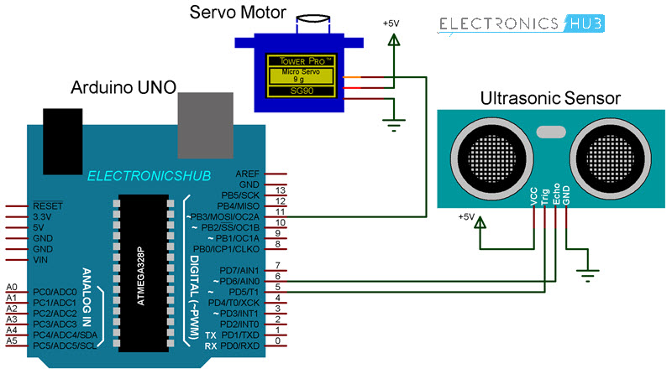

***Components Required***

* Arduino UNO  [[Buy Here](https://amzn.to/2MmTt0j?tag=eh04e-21" \t "_blank)]
* HC-SR04 Ultrasonic Sensor Module
* TowerPro SG90 Servo Motor
* Connecting Wires
* 5V Power Supply
* A small dustbin with hinged lid
* Miscellaneous (glue, plastic tube, etc.)

***CODE***

#include<servo.h>

Servo myservo;

Int pos=20;

Const int tribpin = 5;

Const int echopin = 6;

Const int led = 13;

Long duration;

Float distance;

Void setup()

{

Myservo.attach(11);

Pinmode(trigpin,output);

Pinmode(echopin, input);

Pinmode(led,output);

Myservo.write(pos);

}

Void loop()

{

Digitalwrite(trigpin, low);

Delaymicroseconds(2);

Digitalwrite(trigpin, high);

Delaymicroseconds(10);

Digitalwrite(trigpin,low);

Duration=pulsein(echopin, high);

Distance = 0.034\*(duration/2);

//serial.printin(distance);

{

Digitalwrite(led,high);

Myservo.write(pos+160);

Delay(1000);

}

Else

{

Digitalwrite(led,low);

Myservo.write(pos);

}

Delay(300);

}

***WORKING***

After setting up the Smart Dustbin and making all the necessary connections, upload the code to Arduino and provide 5V power supply to the circuit. Once the system is powered ON, Arduino keeps monitoring for any object near the Ultrasonic Sensor.

If the Ultrasonic Sensor detects any object like a hand for example, Arduino calculates its distance and if it less than a certain predefined value, Arduino will activate the Servo Motor and with the support of the extended arm, it will list the lid open.

After certain time, the lid is automatically closed.

***CONCLUTION***

A simple but useful project called Smart Dustbin using Arduino is designed and developed here. Using this project, the lid of the dustbin stays closed, so that waste is not exposed (to avoid flies and mosquitos) and when you want dispose any waste, it will automatically open the lid.