**BIRLA INSTITUTE OF TECHNOLOGY & SCIENCE, PILANI**

**WORK INTEGRATED LEARNING PROGRAMMES**

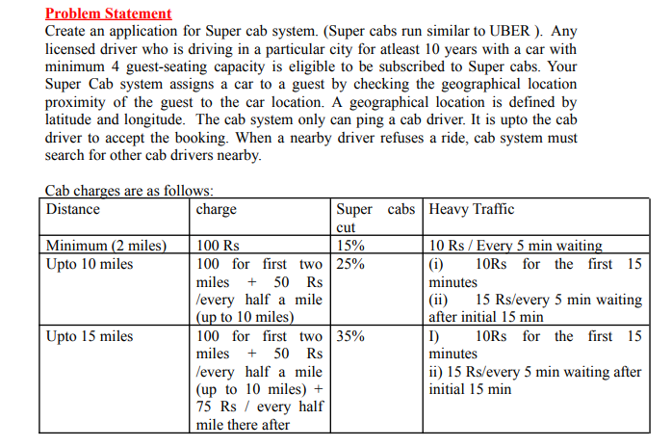

**Contribution table:**

|  |  |  |  |
| --- | --- | --- | --- |
| SI no. | Name | ID | contribution |
| 1 | TIWARI ABHISHEK OM PRAKASH RAJKUMARI | 2021mt70008 | yes |
| 2 | RAJDEEP MAJUMDER | 2021mt70085 | yes |
| 3 | KHUT TANUJ JAYESH MONA |  |  |
| 4 | MOTIWALE OMKESH RAJESH RENUKA | 2021mt70040 | yes |