Alpha Trader User Installation & Help Manual (Pi v1.0.0.6)
Before installing the latest version of Pi, ensure you uninstall the older version of Pi from the Control Panel.
Note: On Windows 8 / 10, if you get a message Windows protected your PC, click on More Info and then click on Run Anyway

Prerequisites:
- Microsoft .NET Framework 4(x86 and x64).
- Microsoft Visual C++ 2008 Runtime Libraries(x86)
- Microsoft Visual C++ 2010 Runtime Libraries(x86)
Once Pi.zip is downloaded from the link provided, unzip the folder and view the following files:
- Pi_setup.exe

Perform the following steps:

1. Run Pi_setup.exe

It will check for the above prerequisites and if needed will prompt for the installation of dependencies.
Click Install.
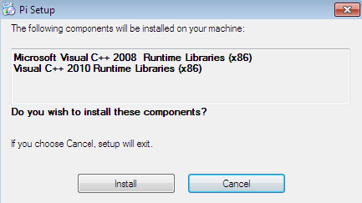

If unable to download/install automatically these prerequisites, use the following link to install manually.

2. Once all dependencies are checked/ installed automatically, the following window will be prompted:
Click Next
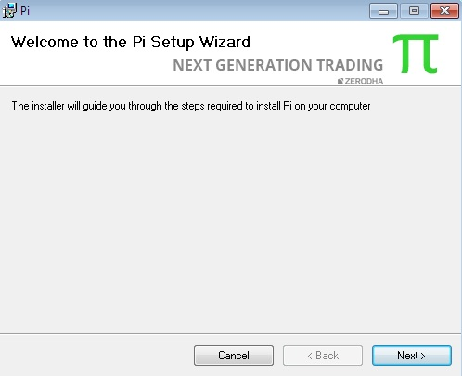
3. Click Next
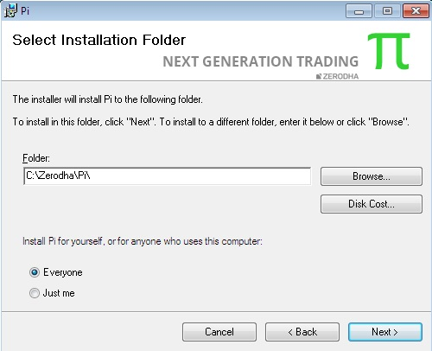

4. Click Next
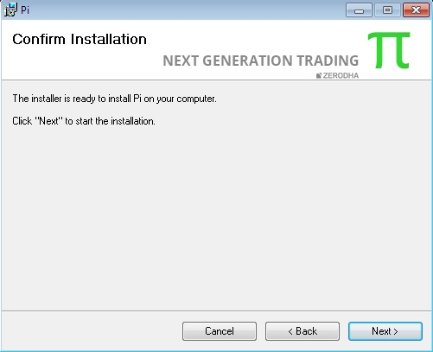
5.
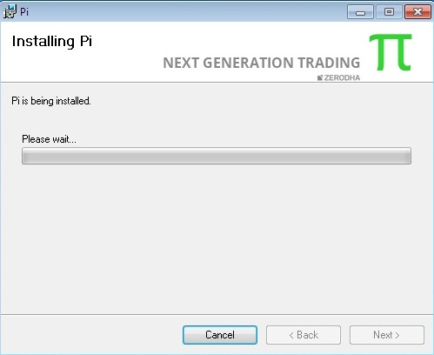

6. Click Close
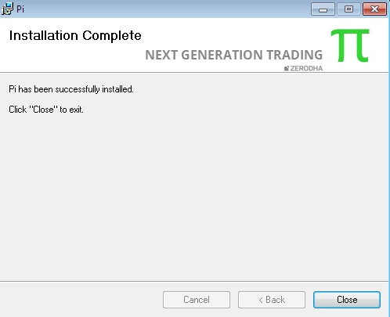

7. Once the installation is complete, the user can find the shortcut for Pi on his desktop.
8. To check for successful installation, login into Pi. Help->About Pi
You will be able to see the latest version and date.

Additional Note/Troubleshooting:
- Unable to install prerequisites, following are the direct links to do the same:
- Microsoft .NET Framework 4(x86 and x64) (Restart required):
Microsoft Link or Google Drive Link

.NET Framework 4 installer error (HRESULT: 0xc8000222) -Install the following patch:
Google Drive link

- Microsoft Visual C++ 2008 Runtime Libraries(x86):
Microsoft Link

- Microsoft Visual C++ 2010 Runtime Libraries(x86)
Microsoft Link
or
For 2 & 3
Google Drive Link

- Some Antivirus might give Pi_setup.exe as False positive eg: 360 Total Security, add it to trusted file.
- Softwares like Magic Macro, AutoHotKey, AutoIT, FastKeys etc. should be disabled while running Pi.
- If Pi Chart is not opening, go to C:\Zerodha\Pi right click on register_chart.bat, run as Administrator. Re-login in Pi.
- Link to Excel functionality won't work on Windows XP due to compatibility issue.
- F1 / F2 / F6 etc not opening Buy/Sell/SnapQuote. Pi installation has become corrupt. Navigate to C:/Zerodha/Pi ,and double click Uninstall.vbs .Reinstall Pi
Frequently Asked Questions:
- Minimum System Specification for running Pi smoothly:
- Intel Dual Core Processor or Higher.
- Windows 7/8/10.
- RAM required is 1 GB.
- Display Resolution greater than 1024 X 768
- HDD required is 1 GB free space in the installation directory.
- Internet Connection >=512Kbps and should be seamless.

- Windows XP issue:
For Windows XP users, before the Pi installation, please download and install Microsoft WIC (if not installed already) from the following link:
http://www.microsoft.com/en-in/download/confirmation.aspx?id=32 (32 bit OS)
http://www.microsoft.com/en-in/download/details.aspx?id=1385 (64 bit OS)

- For Best GUI experience for using Pi:
For Windows 8 /Windows 7:
Control Panel -> All Control Panel Items ->Display
Change the size of all items Smaller -100%
Shortcuts in Pi
S no. | Functionality | Shortcut Keys
1. | Change Password | Ctrl + Shift + F9
2. | Exit | Alt + F4
3. | Buy Order | F1 or Alt + F1
4. | Sell Order | F2 or Alt + F2
5. | Cover Order Buy | Shift + F1
6. | Cover Order Sell | Shift + F2
7. | After Market Order Buy | Ctrl + F1
8. | After Market Order Sell | Ctrl + F2
9. | Bracket Order Buy | Shift + F3
10. | Bracket Order Sell | Shift + F4
11. | Order Book | F3
12. | Modify Order | Shift + M
13. | Cancel Order | Shift + K
14. | Cancel All | Shift + A
15. | Exit Order | Shift + E
16. | Trade Book | F8
17. | Admin Position | F11
18. | Cash Position | Ctrl + Shift + V
19. | Stock Holding | Alt + F9
20. | User Settings | Ctrl + P
21. | View Market Index | Ctrl + M
22. | View Quick Order | Ctrl + Q
23. | Scrip Property | Shift + F7
24. | Snap Quote | F6
25. | Chart settings | Shift + C
26. | Add blank space in market watch | Space Bar
27.  27.1  27.2  27.3  27.4  27.5  27.6 | Chart Shortcuts  Zoom Out /In  Scroll Left /Right  Navigate to 1st 100 bars  Navigate to last 100 bars  Vertical Scale Up  Vertical Scale Down | Arrow Key Down/ Up  Arrow key Left/Right  Home  End  Page Up  Page Down
28. | Reconcile (Orders/Trades/Chart data) | Ctrl + R
29. | Switch between Pi Document Tabs | a)Ctrl + TAB  b)Ctrl + F6
30. | Lock Pi | Ctrl + Alt + L
31. | Delete (symbol from MW, or selected indicators/drawings from chart) | Delete
32. | Create Market Watch | Ctrl + W
33. | Find Symbol | Ctrl + F
34. | Show/Hide Connection Logs | Ctrl + Shift + W
35. | Link to excel | Ctrl + E
36. | Pop Out Active Window | Ctrl + Shift + A

