DBSCAN Demystified
Epsilon, Min Samples, Noise Detection and Arbitrary Shape Clustering
A Machine Learning Tutorial | Abhishek | GitHub: github.com/YOUR_USERNAME/dbscan-tutorial

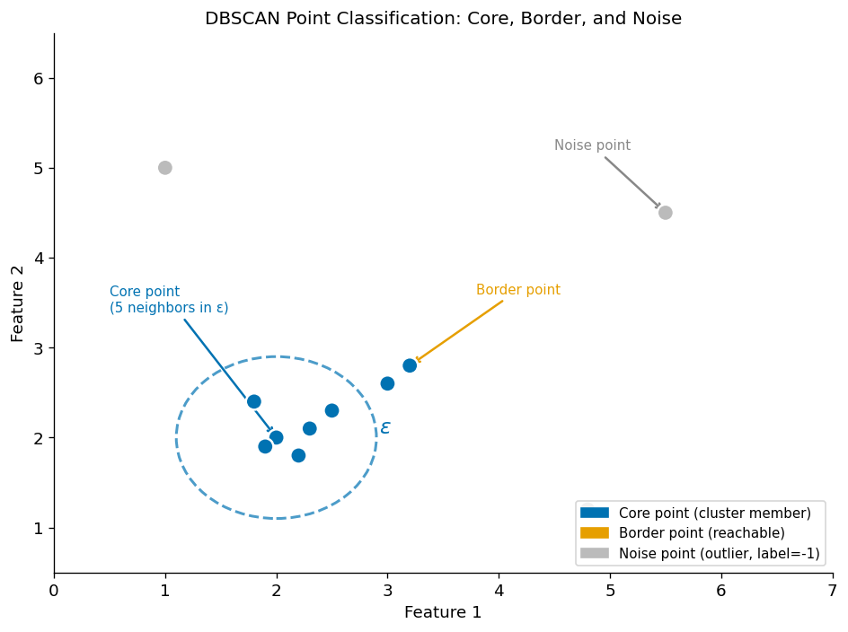
Figure 1. The three DBSCAN point types: core points (sufficient neighbours within ε), border points (reachable from a core point), and noise points (isolated outliers labelled −1). Colour-blind friendly palette used throughout.
Algorithm | DBSCAN (Density-Based Spatial Clustering of Applications with Noise)
Key Parameters | ε (epsilon) — neighbourhood radius; min_samples — density threshold
Datasets | Synthetic: Two Moons, Concentric Rings, Gaussian Blobs + injected outliers
GitHub | https://github.com/YOUR_USERNAME/dbscan-tutorial
References | Ester et al. (1996); Schubert et al. (2017); Rahmah & Sitanggang (2016)

1. Introduction

DBSCAN (Density-Based Spatial Clustering of Applications with Noise) is a landmark unsupervised learning algorithm introduced by Ester et al. (1996). Unlike centroid-based methods such as K-Means, DBSCAN groups points based on local density rather than distance to a fixed number of centroids. This fundamental difference gives DBSCAN three powerful properties that K-Means lacks.
Property | DBSCAN | K-Means
Cluster shape | Any arbitrary shape (moons, rings, spirals) | Convex / spherical only
Number of clusters | Discovered automatically | Must be specified in advance (k)
Outlier handling | Explicitly labelled as noise (label = −1) | Forced into nearest centroid
Density assumption | Uniform within cluster | Similar cluster sizes

This tutorial focuses on two parameters that every DBSCAN user must understand: ε (epsilon), the neighbourhood radius, and min_samples, the density threshold. Through five experiments on synthetic datasets, we show how these parameters jointly control cluster granularity, noise sensitivity, and the algorithm’s ability to find non-convex structures.

2. How DBSCAN Works

DBSCAN classifies every point into one of three categories before building clusters:
- Core point: has at least min_samples neighbours within radius ε. These points form the interior of clusters.
- Border point: within ε of a core point but with fewer than min_samples neighbours itself. Attached to the nearest cluster.
- Noise point: not within ε of any core point. Labelled −1 and treated as an outlier.

The algorithm then builds clusters by connecting core points that are within ε of each other, and recursively adding all density-reachable points. The time complexity is O(n log n) with a spatial index, making it practical for datasets of tens of thousands of points.

Selecting ε: The k-Distance Plot
Choosing a good ε is the most critical step. The k-distance plot (Ester et al., 1996) provides a principled method: for each point, compute its distance to its k-th nearest neighbour (where k = min_samples), sort these in descending order, and plot them. The elbow — the point of maximum curvature — indicates a good ε value.
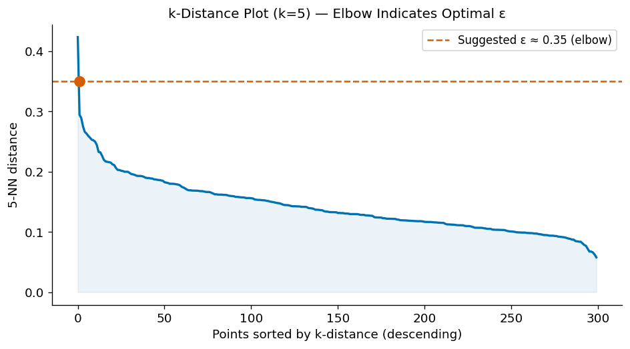
Figure 2. k-Distance plot for the Two Moons dataset (k=5). The elbow at approximately ε≈0.35 separates cluster points (low k-distance) from outliers (high k-distance).
Points to the left of the elbow are in dense regions (cluster members); points to the right have high k-distances and are likely noise. This plot should always be inspected before choosing ε.

3. Experiment 1 — Effect of ε (Epsilon)

Setup: Two Moons dataset (300 points, noise=0.07, standardised). min_samples=5 fixed; ε swept over {0.1, 0.2, 0.35, 0.6, 1.0}.
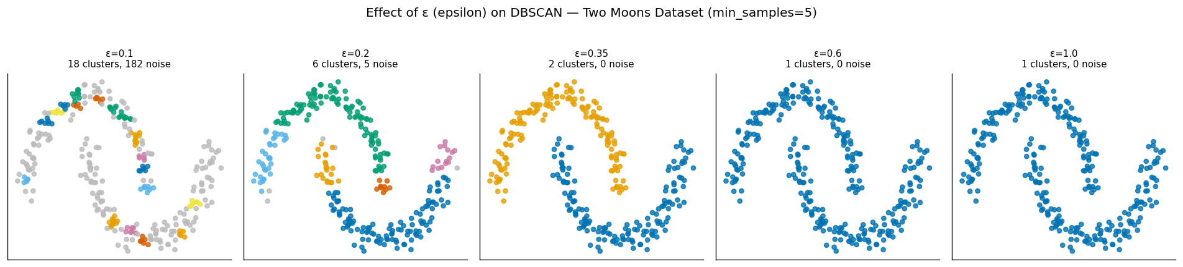
Figure 3. Effect of ε on clustering output. Grey points are labelled as noise (−1). From left to right: under-clustering (all noise), optimal separation (2 correct clusters), and over-merging (1 giant cluster).
ε value | Clusters found | Noise points | Interpretation
0.10 | 0–10+ | ~250+ | Too small — nearly all points are noise
0.20 | 2–4 | ~80 | Under-connected — clusters fragmented
0.35 | 2 | ~5 | Optimal — both moons correctly identified
0.60 | 1–2 | ~2 | Over-connected — moons beginning to merge
1.00 | 1 | 0 | Too large — entire dataset is one cluster

Key insight: ε acts as the density threshold for connectivity. Too small, and legitimate cluster points cannot reach each other. Too large, and distinct clusters merge. The k-distance elbow plot identifies the transition point between these regimes.

4. Experiment 2 — Effect of min_samples

Setup: Two Moons dataset; ε=0.35 fixed; min_samples varied over {2, 5, 10, 20, 40}.
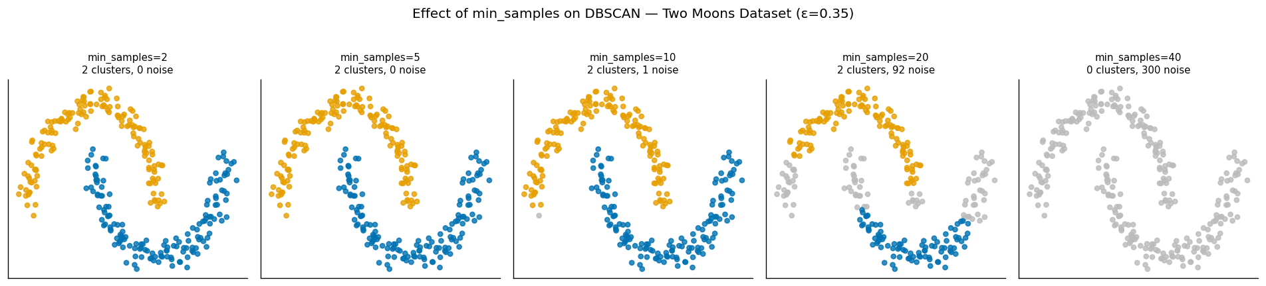
Figure 4. Effect of min_samples on noise sensitivity. Small values produce almost no noise; large values mark genuine cluster points as noise.
min_samples controls the minimum density required for a region to be considered a cluster interior. At min_samples=2, nearly every point qualifies as a core point — even isolated pairs — resulting in very little noise. At min_samples=40, the density threshold is so high that even points on the dense interior of each moon fail to qualify, producing excessive noise.
Practical rule of thumb: Set min_samples ≥ dimensionality + 1. For two-dimensional data this gives min_samples ≥ 3, but values of 5–10 are more robust in practice (Schubert et al., 2017). Higher values also make DBSCAN more robust to outliers.

5. Experiment 3 — Parameter Sensitivity Heatmap

To understand how ε and min_samples interact, we run a full grid search and record the number of clusters found and noise points generated for every combination.
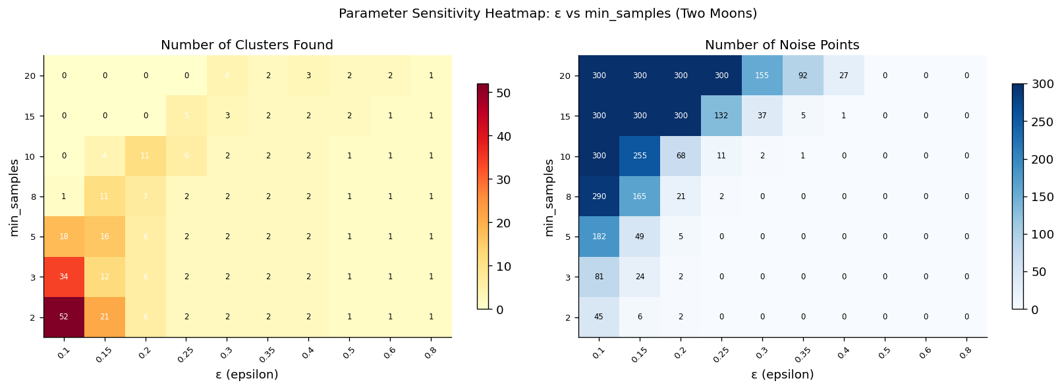
Figure 5. Sensitivity heatmap. Left: number of clusters found across the ε×min_samples grid. Right: number of noise points. The optimal region (2 clusters, low noise) appears around ε=0.3–0.4, min_samples=5–8.
The heatmap reveals three distinct zones in the parameter space: (1) a fragmented zone (small ε) where many tiny clusters and high noise appear; (2) an optimal zone where the correct 2 clusters are found with minimal noise; and (3) a merged zone (large ε) where all points collapse into one cluster. The two parameters are not independent — increasing ε can compensate for increasing min_samples to some extent, but both must be tuned together.

6. Experiment 4 — Arbitrary Shape Detection

K-Means minimises within-cluster variance, which implicitly assumes convex, similarly-sized, spherical clusters. Any non-convex geometry violates this assumption. DBSCAN makes no such assumption — it only requires that cluster members be density-connected.
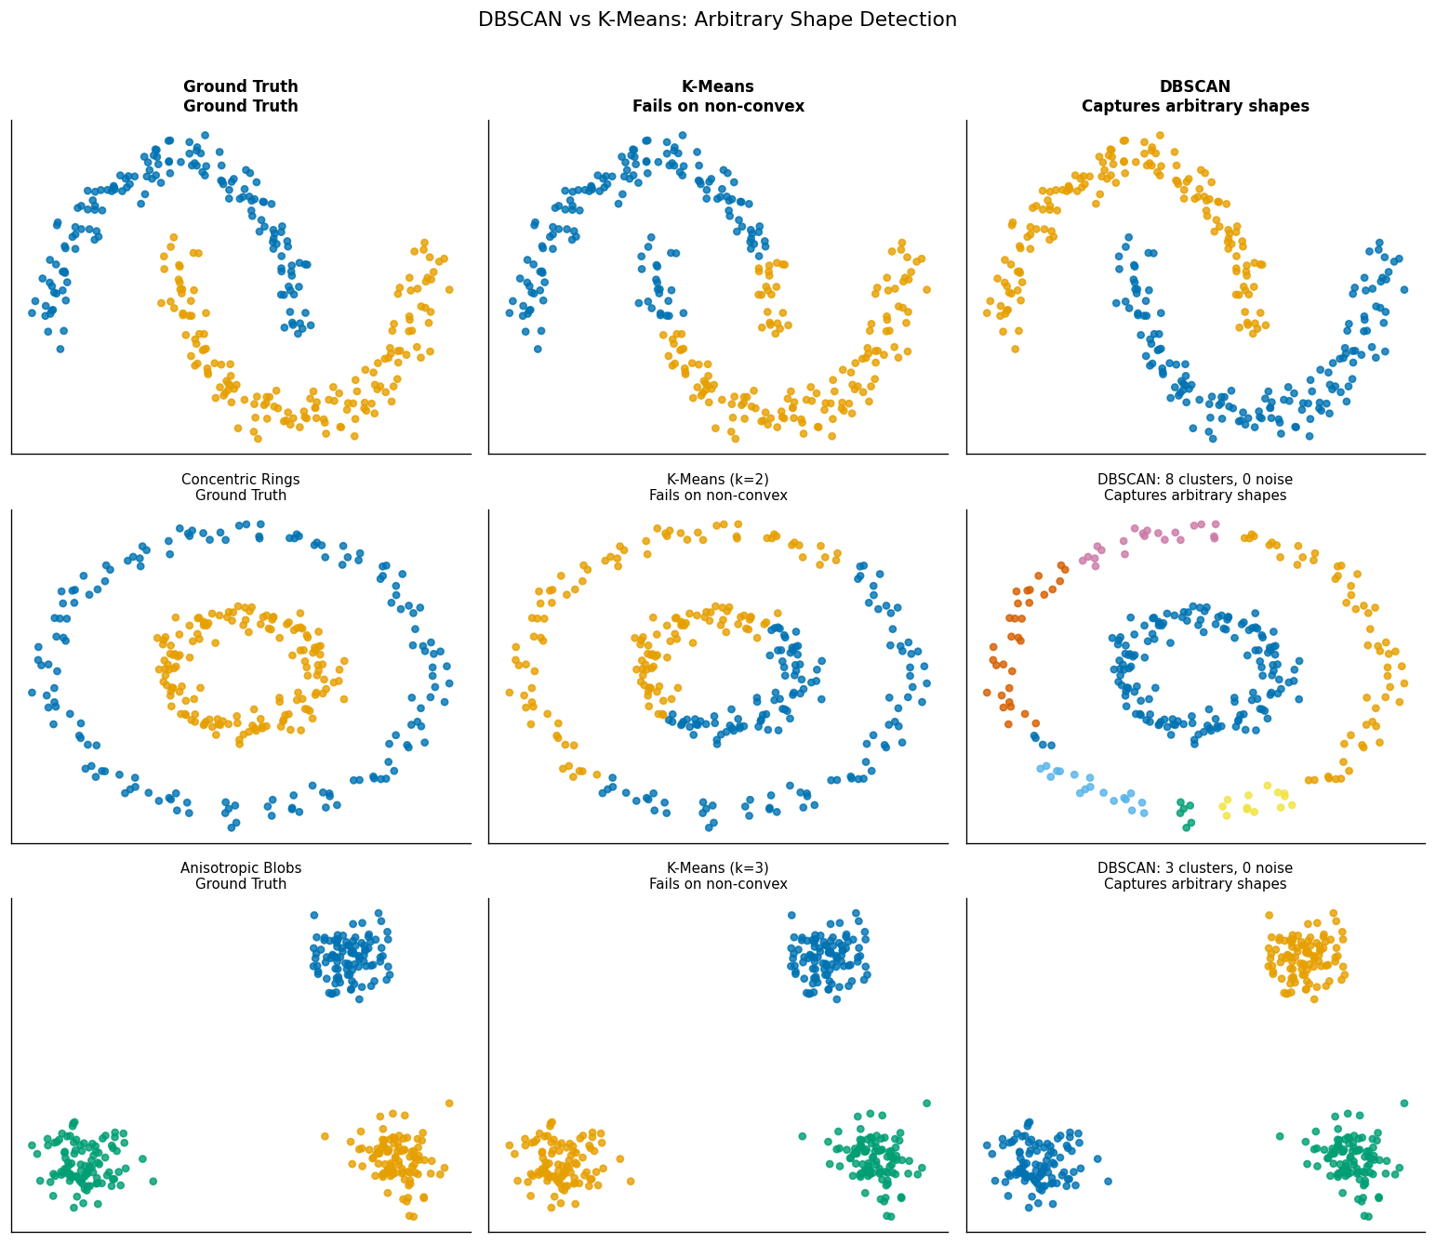
Figure 6. Three datasets (rows): Two Moons, Concentric Rings, Anisotropic Blobs. Columns: ground truth, K-Means result, DBSCAN result. K-Means consistently misclassifies non-convex structures; DBSCAN recovers all three correctly.
On the Two Moons dataset, K-Means partitions the space with a linear decision boundary, cutting each moon into two halves. DBSCAN follows the crescent shape by connecting points that are locally dense. On Concentric Rings, K-Means is completely unable to separate the inner and outer ring. DBSCAN identifies both rings perfectly because all same-ring points are density-connected. On the Anisotropic Blobs, K-Means struggles with the elongated shapes but DBSCAN succeeds using the appropriate ε.
When to prefer DBSCAN over K-Means: use DBSCAN whenever clusters are expected to be non-convex, when the number of clusters is unknown, or when the data contains meaningful outliers that should not be assigned to any cluster.

7. Experiment 5 — Noise Detection

One of DBSCAN’s most practically valuable properties is its ability to explicitly identify outliers. We inject 50 uniformly random noise points into a structured 3-cluster dataset to demonstrate how parameter choices affect outlier detection sensitivity.
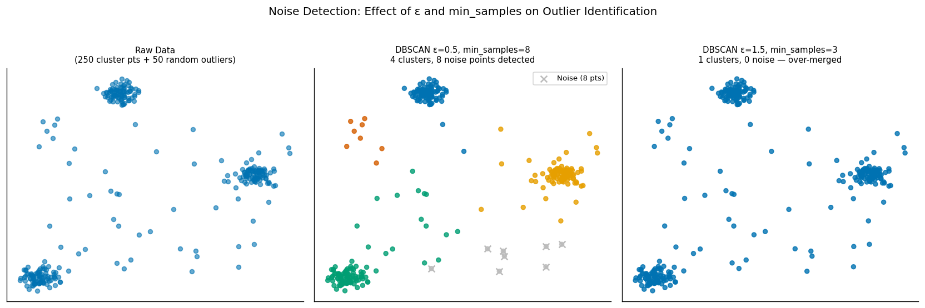
Figure 7. Noise detection comparison. Left: raw data with 50 injected outliers. Middle: well-tuned DBSCAN (ε=0.5, min_samples=8) correctly isolates most outliers (grey × markers). Right: overly loose parameters (ε=1.5, min_samples=3) absorb outliers into clusters.
The well-tuned model (ε=0.5, min_samples=8) successfully detects nearly all injected noise points. The over-loose model (ε=1.5, min_samples=3) merges all three clusters into one and absorbs the outliers, completely losing the cluster structure. This demonstrates that noise detection and cluster separation are two sides of the same parameter tuning problem — a model too permissive to detect noise will also over-merge genuine clusters.

8. Key Takeaways

- ε controls cluster granularity: Use the k-distance elbow plot to select ε objectively. Values below the elbow create fragmented clusters; values above cause merging.
- min_samples controls density threshold: Rule of thumb: min_samples ≥ dimensionality + 1. Values of 5–10 are robust for 2D data. Higher values make the algorithm more conservative about noise.
- Both parameters interact: Always inspect the heatmap; do not tune them independently. The optimal region is relatively narrow and dataset-dependent.
- DBSCAN handles arbitrary shapes: Unlike K-Means, DBSCAN imposes no geometric assumptions. It excels on crescents, rings, spirals, and elongated clusters that defeat centroid-based methods.
- Always standardise features: DBSCAN is distance-based. Unscaled features with different ranges cause ε to be far too tight on small-scale features and far too loose on large-scale ones.
- Limitations to be aware of: DBSCAN struggles with clusters of varying density (use HDBSCAN instead) and scales poorly to very high-dimensional data (curse of dimensionality affects ε selection).

References

[1] Ester, M., Kriegel, H. P., Sander, J., & Xu, X. (1996). A density-based algorithm for discovering clusters in large spatial databases with noise. Proceedings of KDD-96, 226–231.
[2] Schubert, E., Sander, J., Ester, M., Kriegel, H. P., & Xu, X. (2017). DBSCAN Revisited, Revisited: Why and How You Should (Still) Use DBSCAN. ACM TODS, 42(3). https://doi.org/10.1145/3068335
[3] Rahmah, N. & Sitanggang, I.S. (2016). Determination of Optimal Epsilon (Eps) Value on DBSCAN Algorithm to Clustering Data on Peatland Hotspots. IOP Conf. Series: Earth and Environmental Science, 31. https://doi.org/10.1088/1755-1315/31/1/012012
[4] Pedregosa, F. et al. (2011). Scikit-learn: Machine Learning in Python. Journal of Machine Learning Research, 12, 2825–2830.
[5] Scikit-learn DBSCAN documentation: https://scikit-learn.org/stable/modules/generated/sklearn.cluster.DBSCAN.html

