**Click-o-Mania**

Clickomania is a 1-player game consisting of a rectangular grid of square blocks, each colored in one of *k* colors. Adjacent blocks horizontally and vertically of the same color are considered to be a part of the same group. A move selects a group containing at least two blocks and removes those blocks, followed by two “falling” rules;

a. Any blocks remaining above the holes created, fall down through the same column.  
b. Any empty columns are removed by sliding the succeeding columns left.

**Sample illustration**

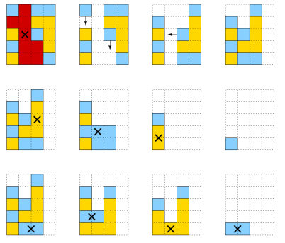

In this game, you have to code a bot such that it eliminates as many possible blocks from the grid. The top left of the grid is indexed (0,0) and the bottom right of the grid is indexed (rows-1,columns-1).

**Input Format**  
The first line of the input is 3 space separated integers, *x y k* where x and y are the number of rows and columns of the grid and k is the number of colors the grid has.

An empty cell in the grid will be denoted by ‘-‘.

**Output Format**   
Output 2 space separated integer co-ordinates of the block you choose to remove from the grid. You can output any one of the nodes of the group which you choose to remove.

**Constraints**  
1 ≤ k ≤ 7  
Each color can be any of ‘V’,’I’,’B’,’G’,’Y’,’O’,’R’ (VIBGYOR)

**Sample Input**

20 10 2

BBRBRBRBBB

RBRBRBBRRR

RRRBBRBRRR

RBRBRRRBBB

RBRBRRRRBB

RBBRBRRRRR

BBRBRRBRBR

BRBRBBRBBB

RBBRRRRRRB

BBRBRRBBRB

BBBRBRRRBB

BRBRRBRRBB

BRRBBBBBRB

RRBBRRBRRR

RRRBRRRBBB

RRRRRBBBRR

BRRRBRRRBB

BBBBRBRRRB

BRBBBBBRBB

RRRRRBBRRR

**Sample Output**  
0 1

**Explanation**  
In this output, the player chooses to remove all the adjacent blocks of the group (*0,0*), (*0,1*) and (*1,1*) which forms one group.

**Challenge**  
Complete the function *nextMove* which takes integers *x*,*y* - the row and column size of the grid, **color** the number of colors the grid has, and a 2D array of characters, *grid* which is the board.

**Play the game**  
You can play a sample game [here.](http://games.bugaco.com/games/clickomania/)

**Scoring**  
Your score depends on the number of blocks left (*count*), the size of the board and the number of colors (*k*).   
Score = (1 - count/20) x 5 x k

if count ≥ 20, a nominal score of 0.01 would be given.

The max scores for the testcases are 10, 15, 25, and 30. Totalling for a max score of 80.