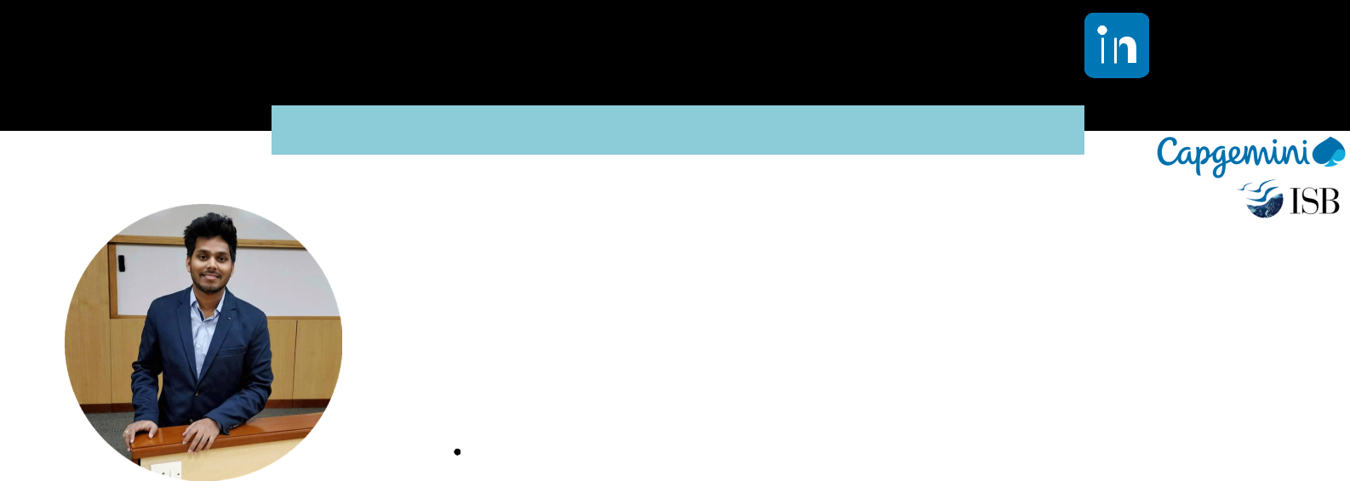SATWICK BODDUNA

satwick.bodduna@gmail.com | +91-8074030375

PROFILE



Data Science Consultant at **Capgemini India Pvt ltd** | Data science & BusinessAnalytics from **Indian School of Business** (CBA) 2018-2019



EXPERTISE



R Python SQL Azure



Data Analysis Data Modeling



Deep Learning Data Factory



AI Tableau Qlik Power BI



Cognitive Services Selenium PostgreSQL AWS



SKILL RATING



Data Science



Business Intellgence



Data Engineering



SQL



Data Analysis



Data Modeling



Req Understanding



Cloud Services



Advance Analytics Professional

PROFESSIONAL PROFILE

I am a **Advance Analytical Professional** who has over 7 years of experience in industry, research and academics. I have experience working in the field of Data Science, Business Intelligence and Data Warehousing with a strong work ethics. Looking to leverage acquired academic knowledge from **Indian School of Business** and work experience to effectively

SKILLS

Statistics / Mathematics : Data Quality Analysis, Data identification, Hypothesis testing, Univariate / Multivariate Analysis, Cluster Analysis, Classification/PCA, Factor Analysis, Linear Modeling, Affinity & Association, Time Series, Deep Learning, Computer Vision Add real -world experience and academic expertise from Indian School of Business Develop data science products and solution framework and architecture for clients as well as for our data science team



Able to Work in a multi-disciplinary environment with specialists in Data Science, data engineering and Business Intelligence



Ability to translate a business or marketing question into a well-defined analytical plan that includes data requirements



Easily analyzes, draws and synthesizes important insights from complex data.



Extremely curious and self-driven to understand business performance through data.

BODS



WORK EXPERIENCE

Data Science Consultant

**CAPGEMINI INDIA PVT LTD | HYDERABAD | MAY 2017 - PRESENT**

**Unilever - AI/ML Demand Forecasting Tool**

Creating a Forecasting solution which can be helpful for the forecasting Analyst to choose the best model for Products

**Activities performed:**

Supply Chain Analytics, Demand forecasting using MLP and LSTM, ARIMA, CROSTON, FB Prophet Techniques



Created Framework for Best Aggregation, Disaggregation based on product, channel and organizational Hierarchies.



Created Framework for Best model selection and Hyper-parameter Tuning;



Used ADF for data ingestion and PostgreSQL for hosting the data and involved in creating the warehouse data model



Created a front-end dashboard on PowerBI, SSIS, JAVA



**GAP (Product Assortment)**

market basket analysis to reveal regularities in the purchase behavior of customers

**Activities performed:**

Identified identical stores for test and control sets using K-means algorithm and correlation Metrics



Identified products that go together using Association rule mining(Frequent Pattern Matching algorithm



Used K-nearest neighbor and TF-idf vectorizer to match new products with old products based on product description so that new products can have rules



REACH ME AT



+91-807-403-0375



satwick.bodduna@gmail.com



Flat No:102, Tirumala Residency, Road no 6, Balaji Hills, Boduppal, Uppal, Hyderabad- 500039

**Capgemini CDP (Cognitive Document Processing)**

Capgemini’s Cognitive Document Processing(CDP) for clients is an end-to-end solution that automates the ingestion, organization, and evaluation of documents rapidly, securely and at a reduced cost, enabling digitizing documents

**Activities performed:**

Developed Advanced classification AI & ML algorithms like OCR for machine printed and ICR for hand printed documents



Used CNN for Facial Recognition, matching signatures and ML models for address verification



Semantic Data extraction from documents using Deep Learning (BERT) model Language Translation using API



Involved in ETL Pipeline architecture for solution



**Predictive maintenance for BD**

Creating a predictive maintenance model to predict the future failure point of a machine component, so that the component can be replaced, based on a plan, just before it fails. Thus, equipment downtime is minimized, and the component lifetime is maximized. It increased 25%-30% of reduction in maintenance costs and to Avoid or minimize the downtimes

**Activities performed:**

Analyzed the data using data mining techniques, including data reduction, data enhancement, feature engineering and data transformations.



Imputation of missing values using advanced techniques



Predictive Modelling for predicting probability of failing the machine before the maintenance.



Algorithms Used: XgBoost, Random forest.



**Analytics & Strategic Insights for BD**

Business Insights executive dashboard for Becton Dickinson in Qliksense / Qlikview for visually tracks, analyzes and displays key performance indicators (KPI), metrics and key data points

**Activities performed:**

Participate in prototype development for business use cases and created architecture for the data flow



Data Management and modeling – understanding data sources, objects and model framework within a DataMart Involved in data integration through extracting, transforming and loading (ETL) data from various sources. Derived KPI's and Delivered visualizing/presenting in format of dashboard for production



Associate Data Scientist

**ROCKLINE SOLUTIONS PVT LTD | HYDERABAD | JULY 2015 - DEC 2016**

**Article Recommendation for Whitecoats Application**

Objective of the project is to build content-based Recommendation engine for article recommendations in application which is widely used by healthcare professionals.

**Activities performed:**

Performed various preprocessing steps (NLP) on the text data (Description of article, Title)



Generated weighted embedding’s using TFIDF scores and PubMed embeddings.



Measured the similarity between article being read by the user and t article which is to be recommended using cosine similarity. **Operational Insights in Qlik**



Defining metric for Operating and monitor business processes that frequently change and to track current performance of key metrics and KPIs

**Activities performed:**

Involved in the requirement gathering from the business and part of end-to-end implementation of Business Intelligence (BI) projects, especially in creating scorecards, KPIs, reports



Created tables and views in the SQL Server data warehouse and also created ETL Pipelines for data flow, loaded the data into the Qliksense an created Data Modeling



Sourcing data from disparate systems for the Data Models and ETL procedures



Design operational dashboard which has to have a fairly detailed view and deployed in production and supported them in Hypercare



Indian School Business - Capstone

**QUANTUM TECHNICAL LTD| HYDERABAD | SEP 2019 - DEC 2019**

**Anomaly Detection using Deep Learning**

AI based anomaly detection engine for preventive health and safety compliance in workshop environment

**Activities performed:**

Worked on current solutions in the market and made the product wireframe and solutions which to be integrated in product. Collecting data from different sources like videos and images and collaborated with other team for annotations on object level Involved in Data Prep, Data Preprocessing and Data Augmentation Used a CNN Deep Learning Model with Transfer Learning



EDUCATIONAL HISTORY

**Indian School of Business -** Graduated Jan 2020

**Jawaharlal Nehuru Institute of Technology -** Graduated May 2015

DECLARATION

|  |  |  |
| --- | --- | --- |
| I hereby declare that all the particulars stated above are true to the best of my knowledge and belief | **Regards,** |  |
| SciPy, NLTK, Machine Learning, Python, Keras, PyTorch, Scikit-Learn, Data Science, Data Scientist, |  |  |
| Statistical, Statistics, R, Microsoft Azure, Amazon Web Services (AWS), Artificial Intelligence (AI), |  |  |
| Pattern Recognition, SQL Server Integration Services (SSIS), Optimization, Notebooks, OpenCV, Tableau, | Satwick Bodduna |  |
| Data Analysis, Problem Solving, Unstructured Data, TensorFlow, Computer Vision, Presentation Skills, |  |
| Algorithms, Neural Networks, Git, PySpark, Databricks, Cloud Infrastructure, Pre-Sales, Applied Mathematics, |  |  |
| Big Data, Data Mining, Modeling, AWS Sagemaker, Troubleshooting, Natural Language Processing (NLP), |  |  |
| Recommender Systems, Deep Learning, Anomaly Detection, SVM, Convolutional Neural Networks (CNN), |  |  |
| Gradient Boosting, REST APIs, Research , Statistical Modeling, Predictive Modeling, Linux, Anaconda, pycharm |  |  |

