**TASK FOR OZIVA INTERNSHIP**

I have done the question number one using three different tools HTML5, CSS3 and JavaScript.

How I built it:

1. Firstly I have added a heading using h1 tags

2. Then I have added a input tag to add the list in a sequential order, according to the user's requirements.

3. Then I have given a button using button tag which will automatically add the list when got clicked upon.

Screenshots:

1. This is the home page with empty to do list.

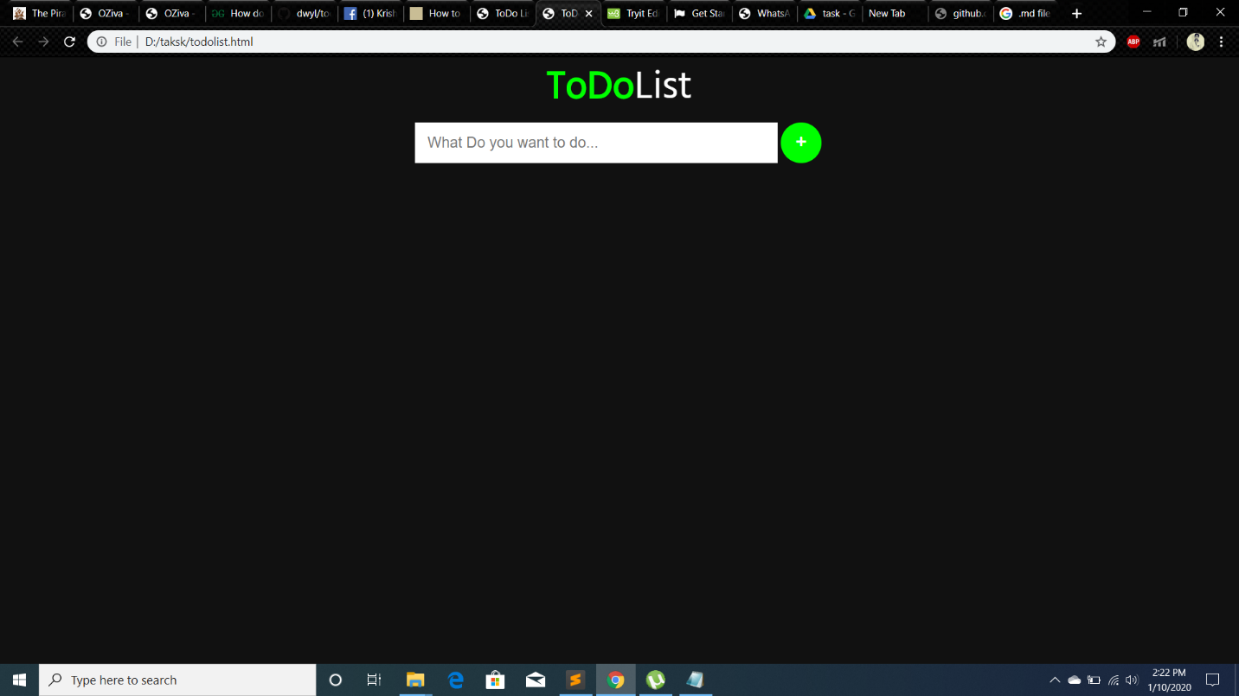

1. This is how the to-do list looks when tasks are added.

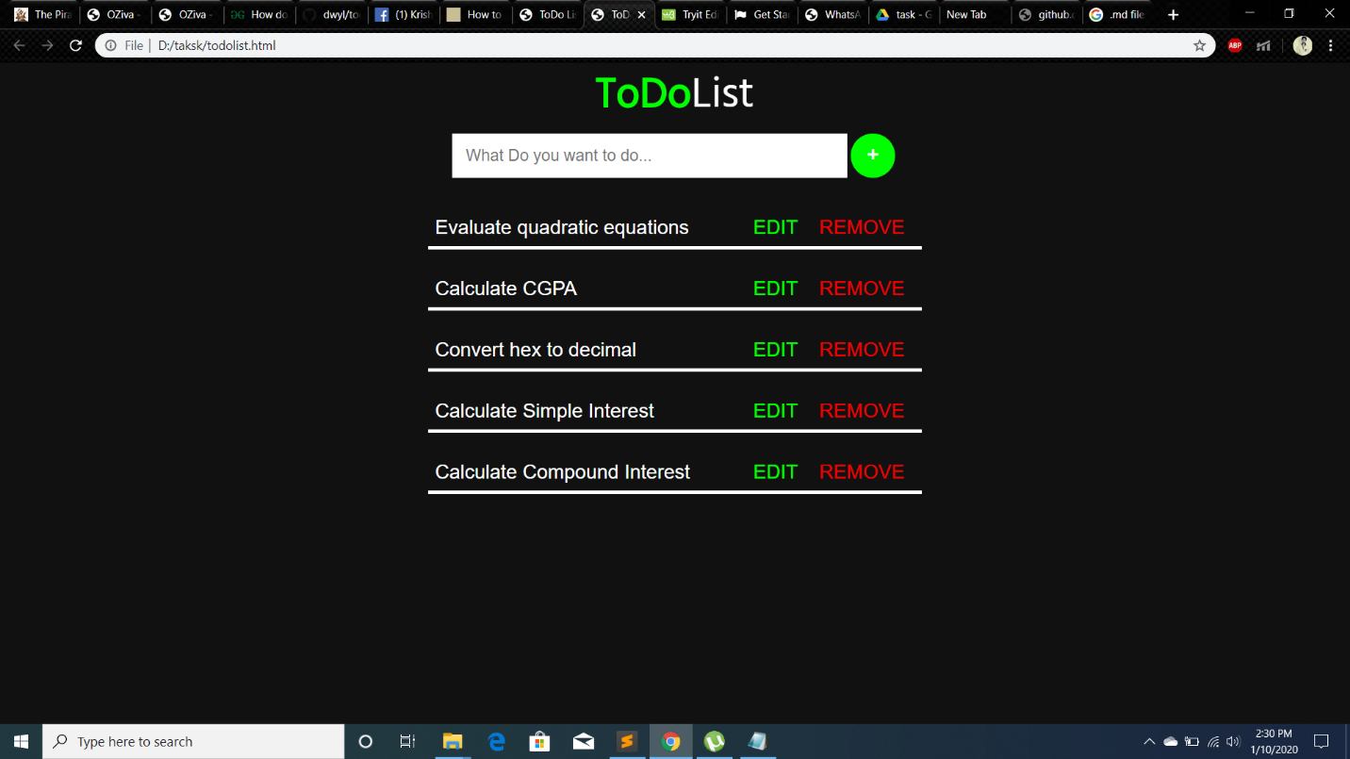

1. This is how the to-do list looks when some tasks are removed.

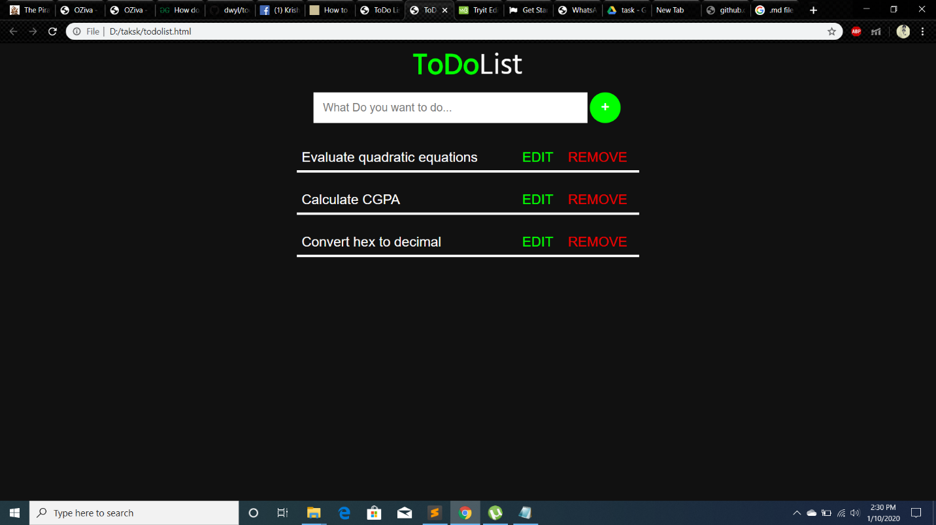

Thank you