Software Requirements Specification (SRS) Document
AR Integration of Board and Card Games
Team No:21
Vani Sancheti, Samhita, Ishita Vohra, Abhishek Mathur

Brief problem statement :

To help students understand harder concepts well and remember them easily there are many educational games. AR integration on these Educational games(Board and Card) make the game more interesting which increases the child’s curiosity towards learning.

Games for AR Integration:
1.Nutrition
2.Integer Maze

System requirements:
FUNCTIONAL REQUIREMENTS:
Req1:

→AR integration:
-Once the screen is pointed to the objects of the physical game the augmented reality is viewed on the screen.

Req2:

→Detection of objects:
-When the object is viewed Should be able to detect which kind is it (ex: cards, board, dice) and perform the actions accordingly.
Req3:
→Different Modes:
-Should have Comparitve mode, Informative mode.
-The specifications of the modes are different for different games.
Req4:
→Load and Display information about the object chosen:
-When a particular object is chosen. It is detected, should load the information from database and display according to game mode (In particular to some games).
Req:
→ Interactive character.
-The character should be used for interaction in the game.
Req7:
→Help.
-Should have a help option to detail about the game.
Req8:
→Player Score record.
-Should display the scores and the statistics of the player after the game.
Req3.1-
Input: Single-player mode
Output: Normal game mode
Req3.2-
Input: Informative mode
Output: Load and Display information about object chosen.
NON-FUNCTIONAL REQUIREMENTS:
→Portability.
→More interesting.
→Easy handling.
→Detect general objects other than objects of respective game.
TOOLS REQUIRED:
→Unity 3D
→Vuforia
→Database of objects.
→Blender
→Ink Scape
→ C#
→ CSV file of object information

Users profile:
Children:
-In player mode, they require a very basic software for easy usage.
-They choose their specifications like mode, object, interactive character etc.

Feature requirements (described using use cases):

No. | User Case Name | Description | Release
- 11111 | Select mode | User can select mode according modes available to the respective games (Comparative mode, Informative mode). | R1
- 22222 | Selection of object | Choose a card or the block of the board. | R1
- 33333 | Detection of objects | Get the information about the object detected. | R1
- 44444 | Object Details | Loads the information about the object from the database. | R1
- 55555 | Object Information | Display information loaded about the object from database.
- 66666 | Select category | Category selection on which the comparison is made between two objects. | R2
- 77777 | Comparison of Objects | The comparison between two objects is made. | R2
- 99999 | Selection character for interaction | The choice of Interactive cartoon character from database. | R4
- 11110 | Help | Display detailed information about the game and instructions. | R2
- 11111 | Score | Display score after the game is over. | R1
- 12112 | Watch statistics | Displaying the stats of player from previous score records. | R2
- 13113 | Exit | User can surrender the game anytime he/she wants to. | R1

Use case diagram
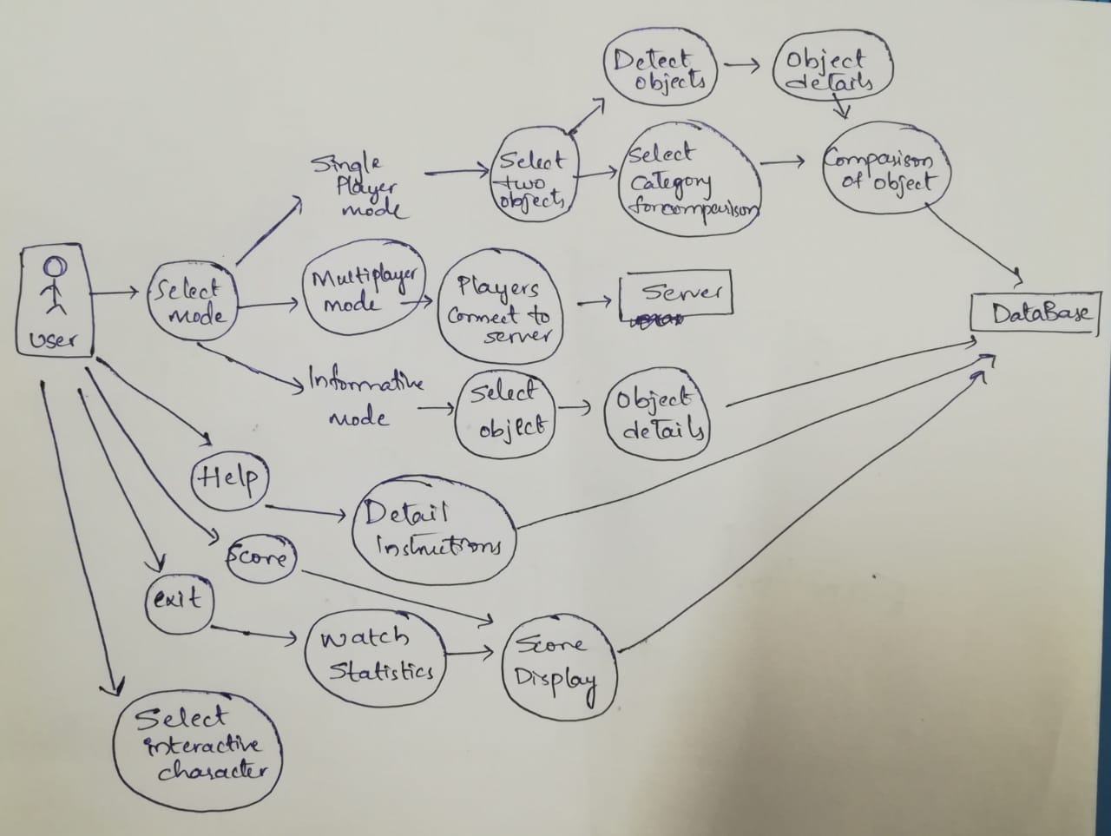

Use case description:
Use Case Number: | UC-01
Use Case Name: | Select Mode
Overview: | User can select mode according modes available to the respective games (Comparative mode, Informative mode).
Actors: | Children, Database of the game.
Precondition: | Screen loaded with AR game.
Flow: | Main (success) Flow: Screen loaded with AR.
 | Alternate Flows: NIL
Post Condition: | The specification for the chosen mode is loaded.

Use Case Number: | UC-02
Use Case Name: | Selection of object
Overview: | Choose a card or the block of the board.
Actors: | Children, Database of the game.
Precondition: | After selection mode is finished.
Flow: | Main (success) Flow: Choosing the mode.
 | Alternate Flows: NIL
Post Condition: | The information about the object is loaded.

Use Case Number: | UC-03
Use Case Name: | Detection of objects
Overview: | Get the information about the object detected.
Actors: | AR interface, Database of the game.
Pre condition: | Selection of object
Flow: | Main (success) Flow: Get the state of the object, When the Informative mode or single mode is selected.
 | Alternate Flows: NIL
Post Condition: | The specification for the chosen mode is loaded.

Use Case Number: | UC-04
Use Case Name: | Object Details
Overview: | Loads the information about the object from the database.
Actors: | Database of the game.
Pre condition: | Selection of object by the player.
Flow: | Main (success) Flow: Loads information from Database.
 | Alternate Flows: NIL
Post Condition: | Displays the Information according to the mode requirements.

Use Case Number: | UC-05
Use Case Name: | Object Information
Overview: | Display information loaded about the object from database.
Actors: | Children, Database of the game.
Pre condition: | Selection of mode and object.
Flow: | Main (success) Flow: Display the information or compare two objects according to the mode chosen.
 | Alternate Flows: NIL
Post Condition: | Allows the game flow.

Use Case Number: | UC-06
Use Case Name: | Select Category
Overview: | Category selection on which the comparison is made between two objects.
Actors: | Children, Database of the game.
Pre condition: | Select the Informative mode of the game and select two objects.
Flow: | Main (success) Flow: The particular category of the two objects is compared.
 | Alternate Flows: NIL
Post Condition: | Compare the two objects selected based on the specified category.

Use Case Number: | UC-07
Use Case Name: | Comparison of objects.
Overview: | The comparison between two objects is made.
Actors: | Children, Database of the game.
Pre condition: | Select objects to be compared and the category based on which the comparison is done.
Flow: | Main (success) Flow: Compares the objects according to the category from the information provided in the database.
 | Alternate Flows: NIL
Post Condition: | The object which has more value for the chose category is shown.
Use Case Number: | UC-09
Use Case Name: | Selection of character for interaction.
Overview: | The choice of Interactive cartoon character from database.
Actors: | Children, Database of the game.
Pre condition: | Have a AR game setup on the screen.
Flow: | Main (success) Flow: Screen loaded with AR.
 | Alternate Flows: NIL
Post Condition: | The selected character is used for interaction through the whole(In particular to some games).

Use Case Number: | UC-10
Use Case Name: | Help option
Overview: | Display detailed information about the game and instructions.
Actors: | Children, Database of the game.
Pre condition: | Screen with Menu page.
Flow: | Main (success) Flow: The details of the particular game are accessed from the database.
 | Alternate Flows: NIL
Post Condition: | The Detailed information and instructions of the particular game are loaded.

Use Case Number: | UC-11
Use Case Name: | View Score
Overview: | Display score after the game is over.
Actors: | Player, Database of the game.
Pre condition: | Game exited
Flow: | Main (success) Flow: Score is displayed.
 | Alternate Flows: NIL
Post Condition:

Use Case Number: | UC-13
Use Case Name: | Exit
Overview: | User can surrender the game anytime he/she wants to.
Actors: | Player, Database of the game.
Pre condition: | Should be previously loaded with the game.
Flow: | Main (success) Flow: Game is exited.
 | Alternate Flows: NIL
Post Condition: | The game is exited.

