Q-Design an automatic night lighting system (with 4 connected led’s) such the system is only activated when the master control switch is pressed. a) Below 50% value of full brightness all LED’s constantly ON. b) Above 50% value of full brightness only first LED is ON.

**Circuit Diagram:**

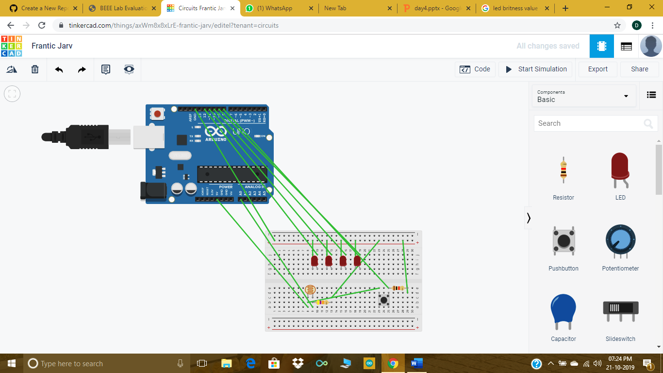

**Theory:**

Concept Used: In this experiment we have done coding to flash LED (Light Emitting Diode) with the help of Arduino uno. Led light setup is done on breadboard.

Learning and Observations : The coding is done on computer from which the instructions are given to the Arduino Uno board .Coding done on Arduino software is C++ .software used in Arduino is COMP5. Arduino is a single-board microcontroller meant to make the application more accessible which are interactive objects and its surroundings .This micro controller gives the valid instruction to the elements fitted on the breadboard according to coding done on software.THE ARDUINO Uno is an open-source microcontroller board based on the Microchip ATmega328p.

**LDR (LIGHT DEPENDENT RESISTOR):**

The resistance of a LDR decreases with increasing incident light intensity.

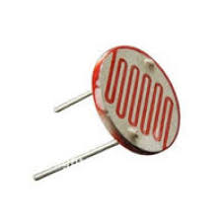

**ADC (ANALOG TO DIGITAL CONVERTER):**

=>An analog-to-digital converter is a system that converts an

analog signal, such as a sound picked up by a microphone or

light entering a digital camera, into a digital signal.

=>The voltage resolution of an ADC is equal to its overall voltage

measurement range divided by the number of intervals:

=>where M is the ADC's resolution in bits and EFSR is the full scale

voltage range (also called 'span').

**Precautions:**

1-The coding done on the software should be correct in every manner. All the errors should be avoided i.e. syntax,logical errors ,semantic etc..

2-All the wires and elements should be connected tightly and according to the coding done on the system.

3-Postive and Negative terminals should be put in correct order.

4-arduino cable should be fitted or connected tightly.

**Problems and Trouble shooting:**

1-The incorrect coding might cause problems in the working of hardware. This can be corrected by learning C++ and practicing it on the software.

2-Hardware should be correctly fitted on the Breadboard or they might get fuse or get permanently damaged .

3-Arduino wire must be checked if they are loose or not. And the ports should be properly cleaned before using ,they might cause problem in future.

**Learning Outcome:**

From this experiment we have learn how to code in the arduino software . we have learn how to flash an led with the help of Arduino. Learn various components eg-pins(output or input) about Arduino or we have also learn LED chasher used to turn on and off groups of LED either sequentially or according to a programmed pattern done on Arduino.

**CODING:**

1. int sensorValue=0;
2. void setup()
3. {
4. Serial.begin(9600);
5. pinMode(8, INPUT);
6. pinMode(9, OUTPUT);
7. pinMode(10, OUTPUT);
8. pinMode(11, OUTPUT);
9. pinMode(12, OUTPUT);
10. }
11. void loop()
12. {
13. sensorValue= analogRead(A0);
14. Serial.println(sensorValue);
15. int reading= digitalRead(8);
16. delay(100);
17. if(reading==HIGH && sensorValue<=480)
18. {
19. digitalWrite(9,HIGH);
20. digitalWrite(10,HIGH);
21. digitalWrite(11,HIGH);
22. digitalWrite(12,HIGH);
23. }
24. else if(reading==HIGH && sensorValue>480)
25. {digitalWrite(12,HIGH);}
26. else
27. {digitalWrite(9,LOW);
28. digitalWrite(10,LOW);
29. digitalWrite(11,LOW);
30. digitalWrite(12,LOW);
31. }
32. }