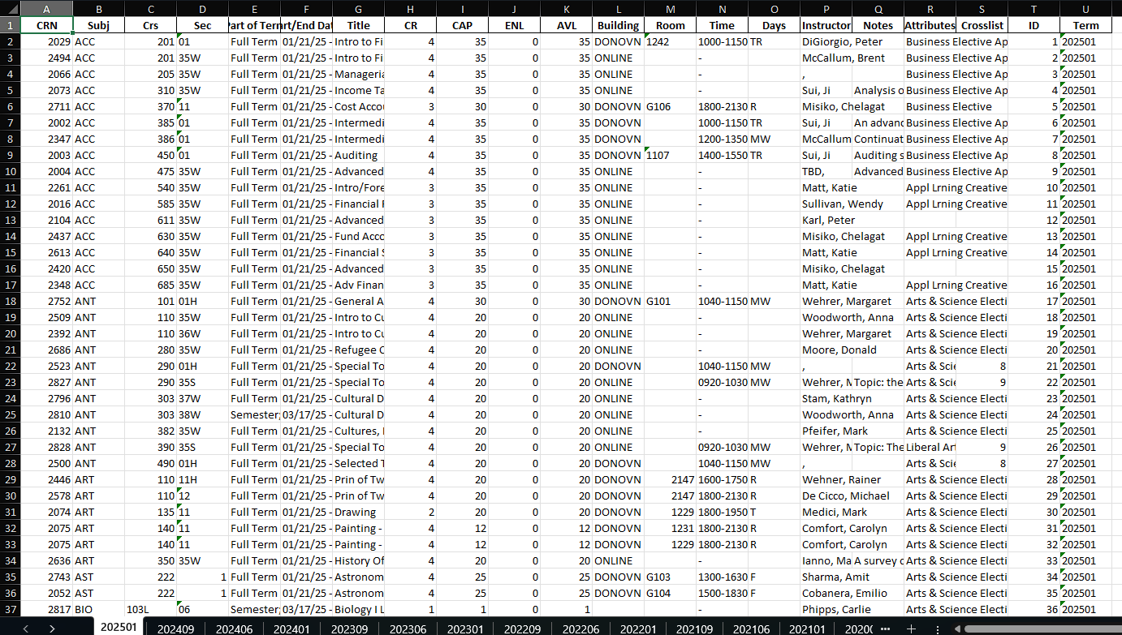

1. I started by trying to scrape course schedules from a university website and ran into problems when the Excel file I was saving the data to turned up empty.

2. We figured out there were issues with how I was scraping the data and the format of URLs. After fixing those, we also adjusted the way we handled data with Python to make sure everything was captured correctly.

3. We dealt with several errors like URLs not formatting right and tables not reading into pandas correctly, which meant tweaking the script quite a bit.

4. We updated the script to loop through academic terms and subjects, putting the data into different sheets in an Excel file. We made sure each sheet had unique IDs for rows and included the term information. 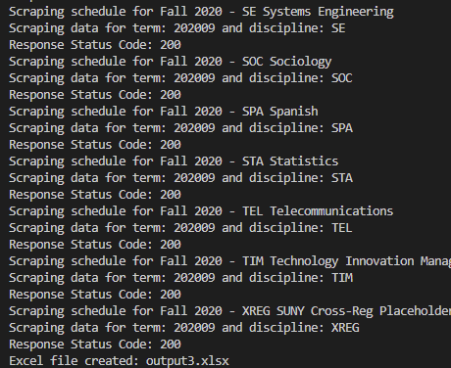

Abhishek Saketh priya