CSS: cascading style sheet

**Inline:**

        <h2 style="color:red" >hello ABB</h2>

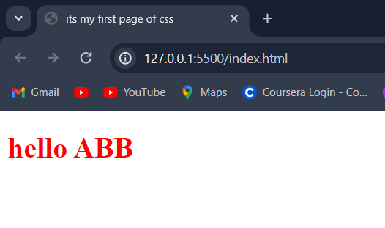

<!DOCTYPE html>

<html>

    <head>

        <title>

            its my first page of css

        </title>

        <link  rel="stylesheet" href="style.css">

       <!--- <style>

            <p> hey what are dpoing </p>

            <h1 style="color:red" >hello ABB</h1>

        </style>-->

    </head>

    <boy>

        <h1 style="color:red" >hello ABB</h1>

    </body>

</html>

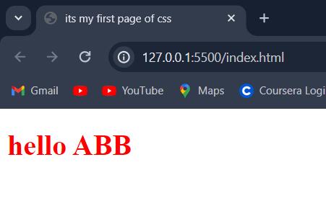

<!DOCTYPE html>

<html>

    <head>

        <title>

            its my first page of css

        </title>

        <link  rel="stylesheet" href="style.css">

    </head>

    <boy>

        <!--<h1 style="color:red" >hello ABB</h1>-->

       <style>

            <p> hey what are dpoing </p>

        </style>

    </body>

</html>

<!DOCTYPE html>

<html>

    <head>

        <title>

            its my first page of css

        </title>

        <link  rel="stylesheet" href="style.css">

    </head>

    <boy>

        <!--<h1 style="color:red" >hello ABB</h1>-->

       <style>

           h1{

            color:"red";

           }

        </style>

    </body>

</html>

**External:**

<!DOCTYPE html>

<html>

<head>

    <title>My First CSS Page</title>

    <link rel="stylesheet" href="style.css">

</head>

<body>

    <h1>Hello ABB</h1>

</body>

</html>

/* style.css */

h1 {

    color: red;

    font-family: Arial, sans-serif;

}

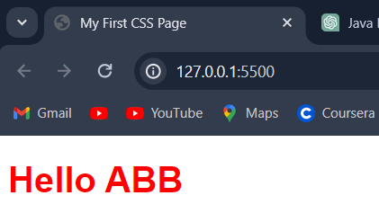

**Priority:**

<!DOCTYPE html>

<html>

    <head>

        <title>

            its my first page of css

        </title>

        <link  rel="stylesheet" href="style.css">

    </head>

    <boy>

        <h1 style="color:red" >hello ABB</h1>

    </body>

</html>

h1{

    color:aqua;

}

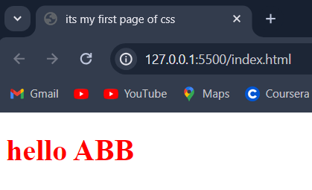

**Inline has priority**

**color property:**

**foreground:**

<!DOCTYPE html>

<html>

<head>

    <title>My First CSS Page</title>

    <link rel="stylesheet" href="style.css">

</head>

<body>

    <h1>Hello ABB</h1>

    <button>click me</button>

</body>

</html>

/* style.css */

h1 {

    color: red;

    font-family: Arial, sans-serif;

}

button{

    color:"blue";

}

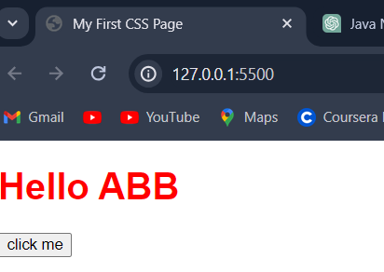

**Background color property:**

<!DOCTYPE html>

<html>

<head>

    <title>My First CSS Page</title>

    <link rel="stylesheet" href="style.css">

</head>

<body>

    <h1>Hello ABB</h1>

    <button>click me</button>

</body>

</html>

/* style.css */

h1 {

    color: red;

    font-family: Arial, sans-serif;

}

button{

    background-color:"yellow";

}

body{

    background-color:blue;

}

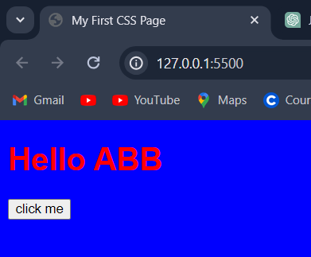

**Color System:**

**RGB**

**HEXADECIMAL**

**1.RGB=red green blue;**

<!DOCTYPE html>

<html>

<head>

    <title>My First CSS Page</title>

    <link rel="stylesheet" href="style.css">

</head>

<body>

    <h1>Hello ABB</h1>

    <button>click me</button>

</body>

</html>

/* style.css */

h1 {

    color: rgb(0,0,255);

    font-family: Arial, sans-serif;

}

button{

    background-color:rgb(255,0,0);

}

body{

    background-color:rgb(0,255,0);

}

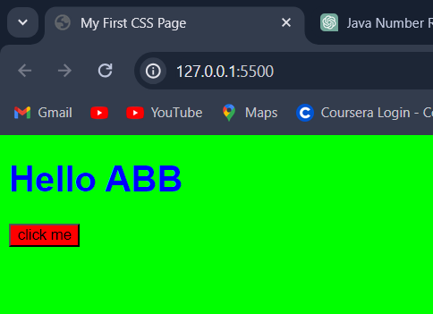

**2.HEXADECIMAL:  
color:#ff0000;**

<!DOCTYPE html>

<html>

<head>

    <title>My First CSS Page</title>

    <link rel="stylesheet" href="style.css">

</head>

<body>

    <h1>Hello ABB</h1>

    <button>click me</button>

</body>

</html>

/* style.css */

h1 {

    color:#00ff00;

    font-family: Arial, sans-serif;

}

button{

    background-color:#ff0000;

}

body{

    background-color:#0000ff;

}

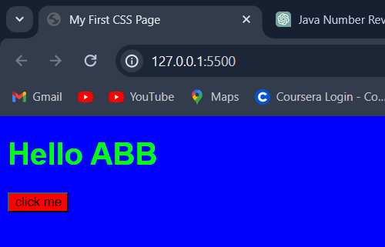

**Selectors:**

**Universal *{}:**

<!DOCTYPE html>

<html>

<head>

    <title>My First CSS Page</title>

    <link rel="stylesheet" href="style.css">

</head>

<body>

    <h1>Hello ABB</h1>

    <button>click me</button>

</body>

</html>

/* style.css */

*{

    color:aquamarine;

}

h1 {

    color:#00ff00;

    font-family: Arial, sans-serif;

}

button{

    background-color:#ff0000;

}

body{

    background-color:#0000ff;

}

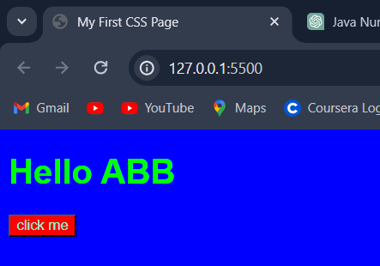

**Element selector:**

**h{**

**color:green**

**}**

<!DOCTYPE html>

<html>

<head>

    <title>My First CSS Page</title>

    <link rel="stylesheet" href="style.css">

</head>

<body>

    <h1>Hello ABB</h1>

    <button>click me</button>

</body>

</html>

/* style.css */

*{

    color:aquamarine;

}

h1 {

    color:#00ff00;

    font-family: Arial, sans-serif;

}

button{

    background-color:#ff0000;

}

body{

    background-color:#0000ff;

}

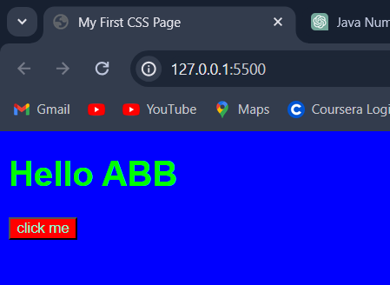

**Id selector**

  <h3 id="h31">hey buddy</h3>

#h31{

    color:yellow;

}

<!DOCTYPE html>

<html>

<head>

    <title>My First CSS Page</title>

    <link rel="stylesheet" href="style.css">

</head>

<body>

    <h1>Hello ABB</h1>

    <button>click me</button>

    <h3 id="h31">hey buddy</h3>

</body>

</html>

}

/* style.css */

*{

    color:aquamarine;

}

h1 {

    color:#00ff00;

    font-family: Arial, sans-serif;

}

button{

    background-color:#ff0000;

}

body{

    background-color:#0000ff;

}

#h31{

    color:yellow;

}

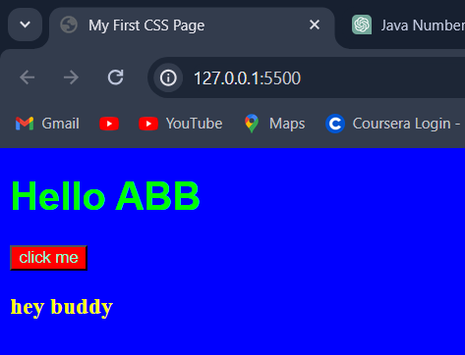

**Class selector:**

.class{

    color:pink;

}

<!DOCTYPE html>

<html>

<head>

    <title>My First CSS Page</title>

    <link rel="stylesheet" href="style.css">

</head>

<body>

    <h1>Hello ABB</h1>

    <button>click me</button>

    <h3 id="h31">hey buddy</h3>

    <div>

        <h1 class="myclass">so heelo word</h1>

        <p class="myclass"> hey word</p>

    </div>

</body>

</html>

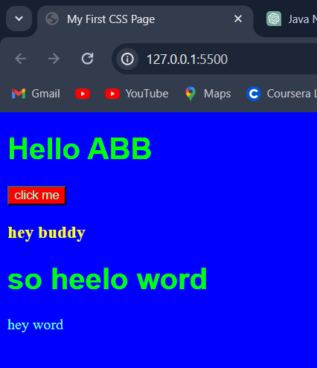

**TEXT PROPERTIES:  
1.text-align:**

p{

    text-align:right;

}

<!DOCTYPE html>

<html>

<head>

    <title>My First CSS Page</title>

    <link rel="stylesheet" href="style.css">

</head>

<body>

    <h1>Hello ABB</h1>

    <button>click me</button>

    <h3 id="h31">hey buddy</h3>

    <div>

        <h1 class="myclass">so heelo word</h1>

        <p class="myclass"> hey word</p>

        <br>

        <p>"Hi, my name is Sarah. I'm currently working as a software engineer at XYZ Tech Solutions, where I specialize in front-end development using React. With over 3 years of experience in the tech industry, I've had the opportunity to work on several high-impact projects that have improved user experience and increased engagement. I'm passionate about leveraging technology to solve complex problems and am always eager to learn about the latest advancements in the field. I'm excited to be here today and look forward to connecting with like-minded professionals."

        </p>

    </div>

</body>

</html>

/* style.css */

*{

    color:aquamarine;

}

h1 {

    color:#00ff00;

    font-family: Arial, sans-serif;

}

button{

    background-color:#ff0000;

}

body{

    background-color:#0000ff;

}

#h31{

    color:yellow;

}

.class{

    color:pink;

}

p{

    text-align:right;

}

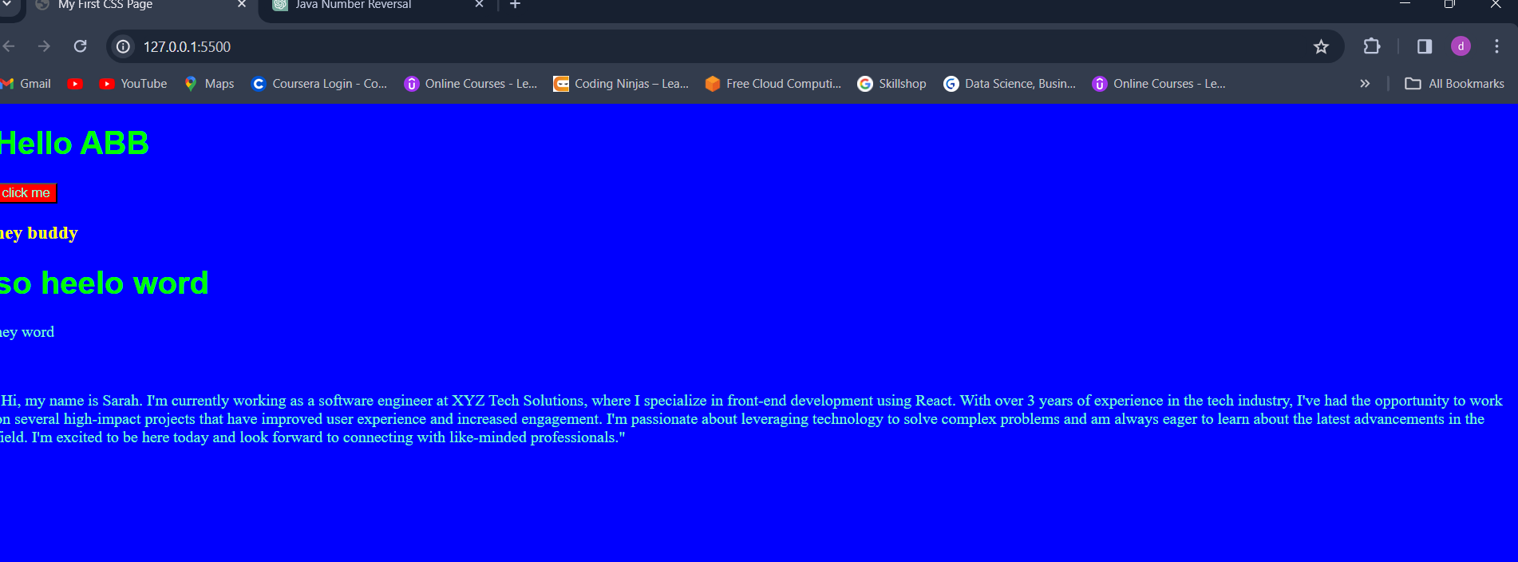

**Text-align left:**

p{

    text-align:left;

}

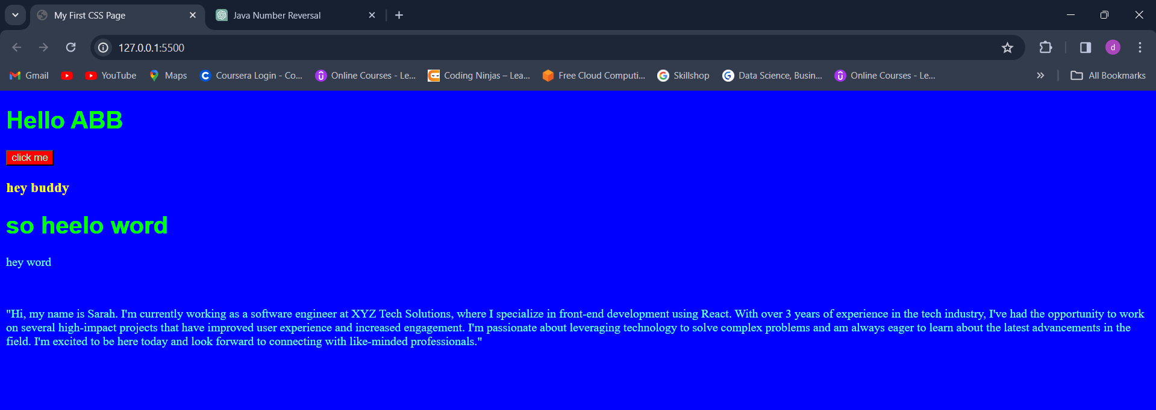

**Text-align:**

p{

    text-align:center;

}

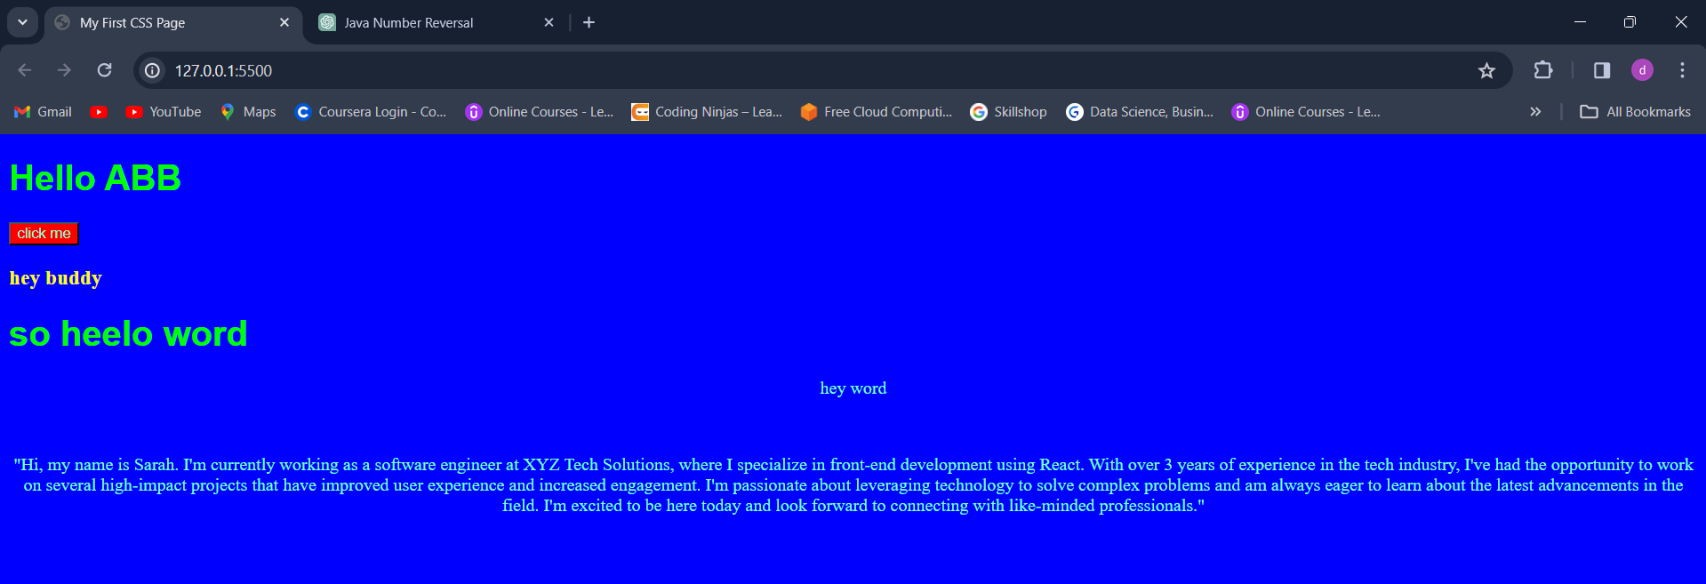

**2.TEXT DECORATION:**

<!DOCTYPE html>

<html>

<head>

    <title>My First CSS Page</title>

    <link rel="stylesheet" href="style.css">

</head>

<body>

    <h1>Hello ABB</h1>

    <button>click me</button>

    <h3 id="h31">hey buddy</h3>

    <div>

        <h1 class="myclass">so heelo word</h1>

        <p class="myclass"> hey word</p>

        <br>

        <p>"Hi, my name is Sarah. I'm currently working as a software engineer at XYZ Tech Solutions, where I specialize in front-end development using React. With over 3 years of experience in the tech industry, I've had the opportunity to work on several high-impact projects that have improved user experience and increased engagement. I'm passionate about leveraging technology to solve complex problems and am always eager to learn about the latest advancements in the field. I'm excited to be here today and look forward to connecting with like-minded professionals."

        </p>

    </div>

</body>

</html>

/* style.css */

*{

    color:aquamarine;

}

h1 {

    color:#00ff00;

    font-family: Arial, sans-serif;

}

button{

    background-color:#ff0000;

}

body{

    background-color:#0000ff;

}

#h31{

    color:yellow;

}

.class{

    color:pink;

}

p{

    text-align:center;

    text-decoration:underline;

}

**Underline:**

p{

    text-align:center;

    text-decoration:underline;

}

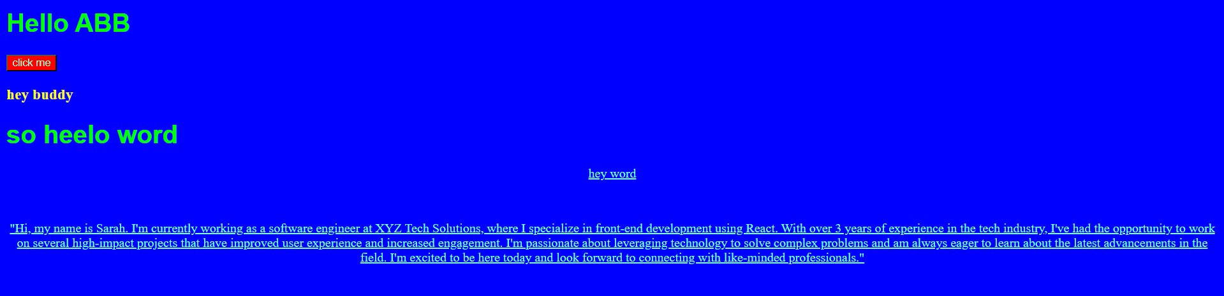

**Overline:**p{

    text-align:center;

    text-decoration:overline;

}

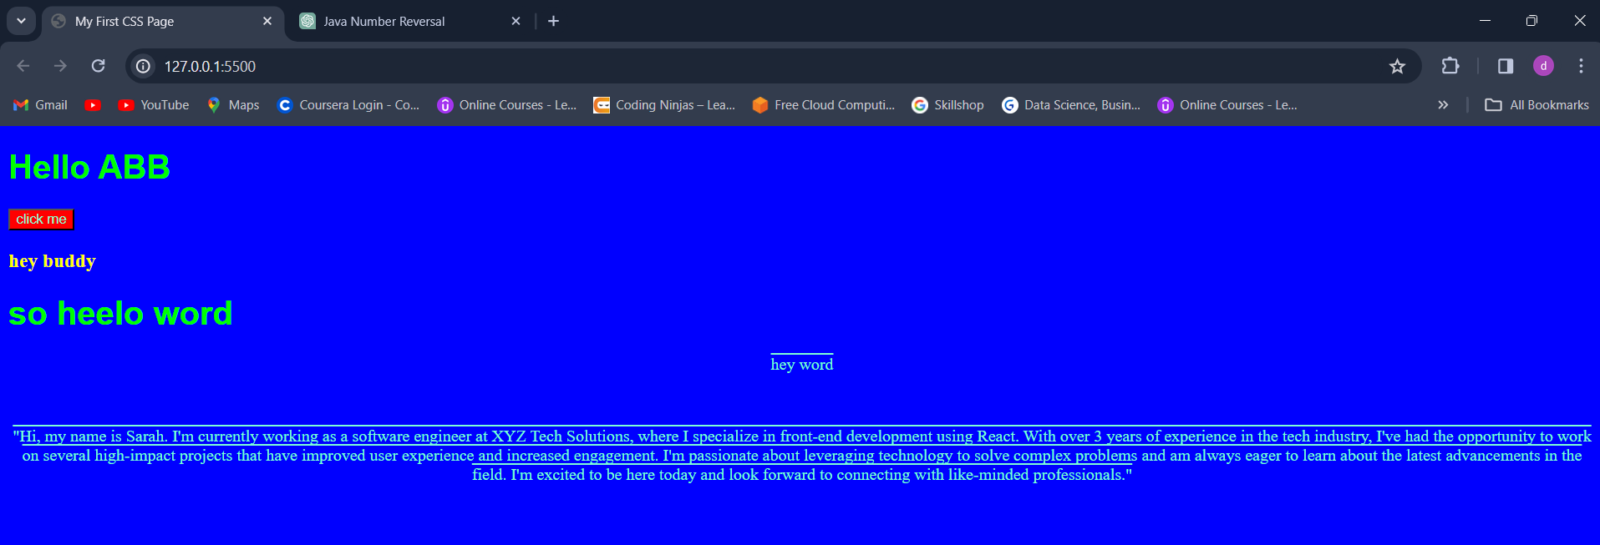

**Line-through**

p{

    text-align:center;

    text-decoration:line-through;

}

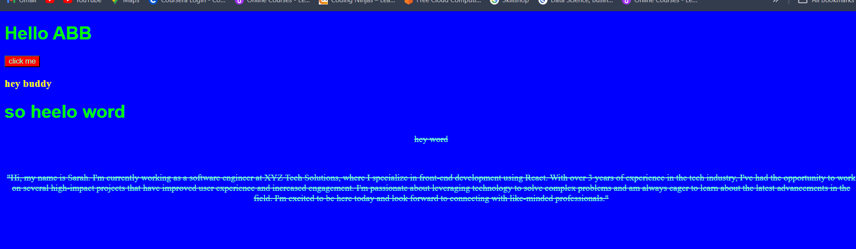

**None;**

a{

    text-decoration:none;

}



**3.FONT WEIGHT:  
100,900**

**Bold,bolder**

p{

    text-align:center;

    text-decoration:black wawe underline;

    font-weight:bold;

}



p{

    text-align:center;

    text-decoration:black wawe underline;

    font-weight:900;

}



**4.font-family:**

font-family:arial;

p{

    text-align:center;

    text-decoration:black wawe underline;

    font-weight:900;

    font-family:arial;

}

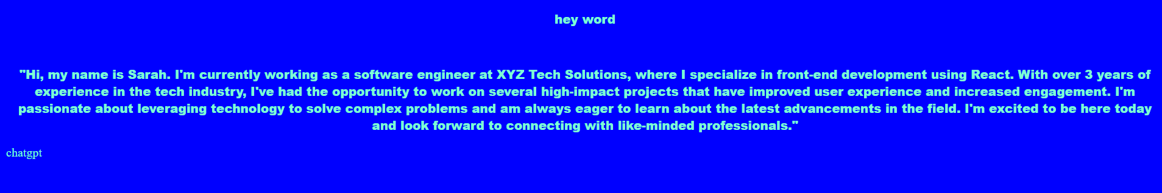

**5.units in css:**

**a.absolute unit:**

font-size :30px;

p{

    text-align:center;

    text-decoration:black wawe underline;

    font-weight:900;

    font-family:arial;

    font-size :30px;

}



**6.line height:**

   line-height: 40px;

p{

    text-align:center;

    text-decoration:black wawe underline;

    font-weight:900;

    font-family:arial;

    font-size :20px;

    line-height: 40px;

}



**7.text transform:**

**Uppercase,lowercase,capitalize;**

  text-transform: uppercase;

p{

    text-align:center;

    text-decoration:black wawe underline;

    font-weight:900;

    font-family:arial;

    font-size :20px;

    line-height: 40px;

    text-transform: uppercase;

}

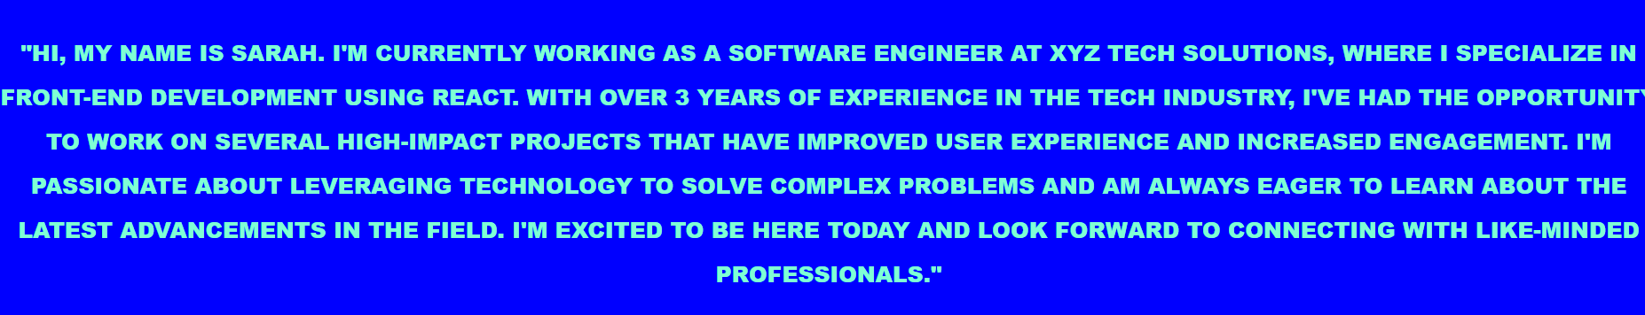

**Lowercase:**

 text-transform: lowercase;

p{

    text-align:center;

    text-decoration:black wawe underline;

    font-weight:900;

    font-family:arial;

    font-size :20px;

    line-height: 40px;

    text-transform: lowercase;

}

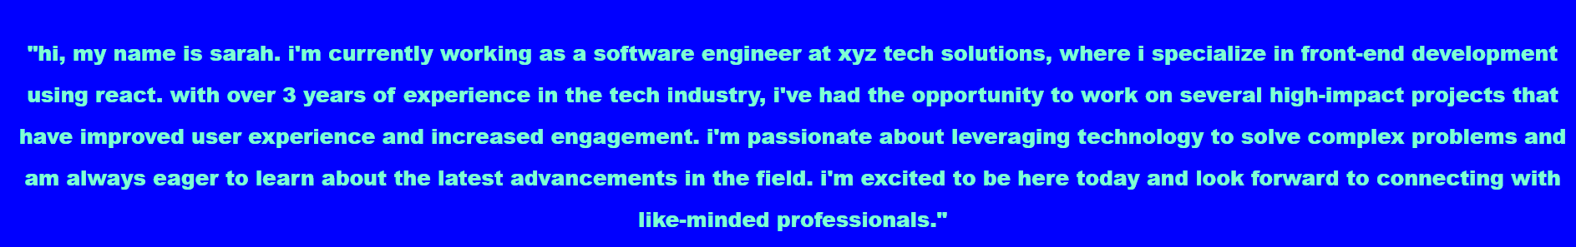

**Capitalize:**

 text-transform: capitalize;

p{

    text-align:center;

    text-decoration:black wawe underline;

    font-weight:900;

    font-family:arial;

    font-size :20px;

    line-height: 40px;

    text-transform: capitalize;

}

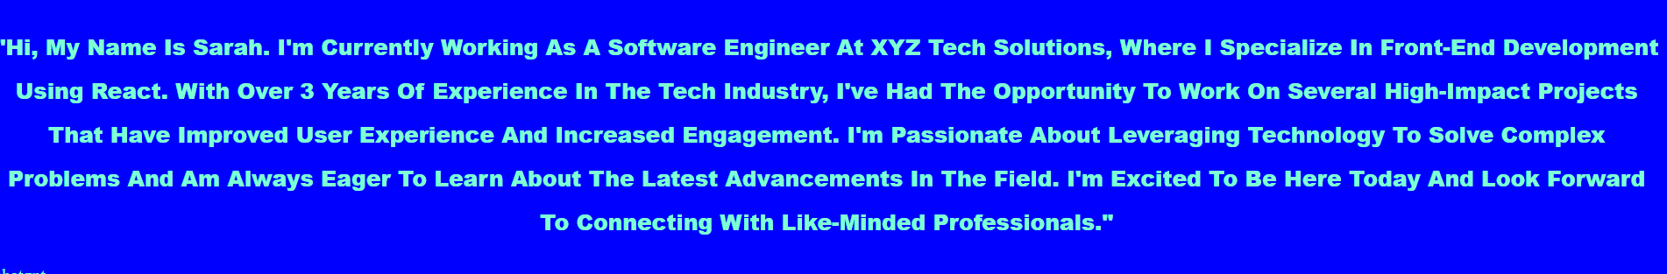

**\*BOX MODELS:**

**Height:**

div{

    height:50px;

}

**Width:**

   width:50px;

div{

    height:50px;

    width:50px;

}

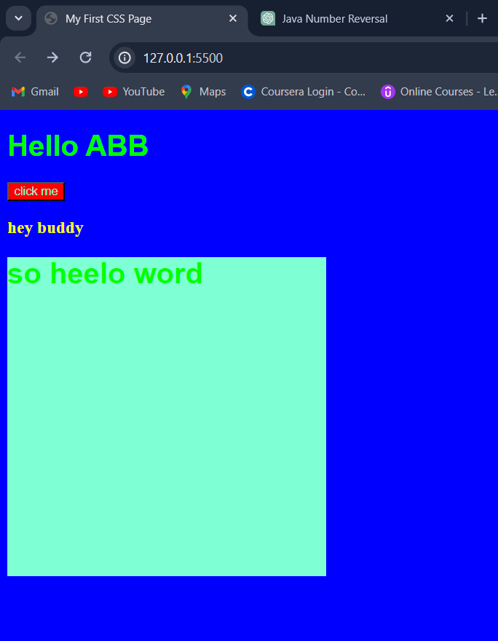

**BORDER:**

**Border style:solid,dotted,dashe,double**

 border-style:solid;

div{

    height:350px;

    width:350px;

    background-color: aquamarine;

    border-style:solid;

}

**Border-color;**

 border-color:brown;

div{

    height:350px;

    width:350px;

    background-color: aquamarine;

    border-style:solid;

    border-color:brown;

}

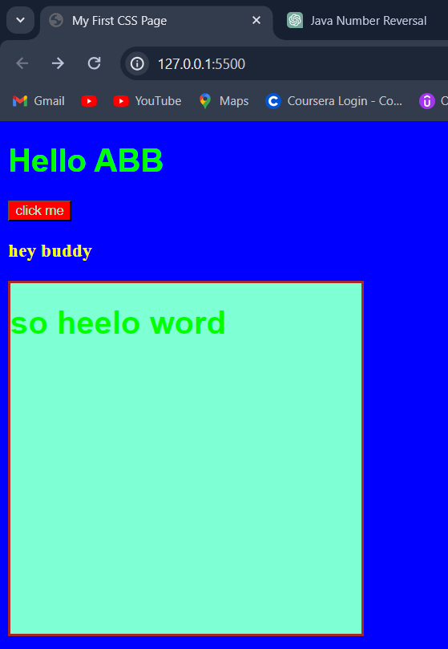

**Border-width:**

div{

    height:350px;

    width:350px;

    background-color: aquamarine;

    border-style:solid;

    border-color:brown;

    border-width: 5px;

}

border-width: 5px;

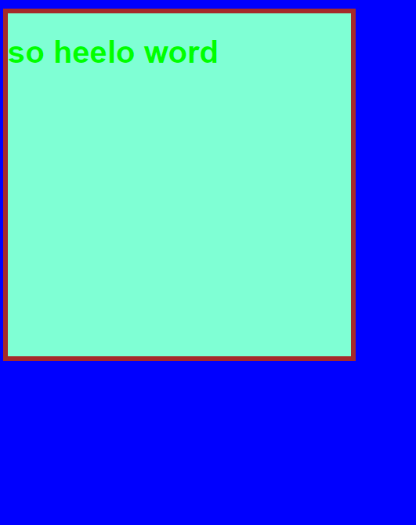

**Shorthand:**

div{

    border:5px solid brown;

}

**RADIUS:**

**Border-radius:100px;**

 border-radius: 10px;

div{

    height:350px;

    width:350px;

    background-color: aquamarine;

    border-style:solid;

    border-color:brown;

    border-width: 5px;

    border-radius: 10px;

}

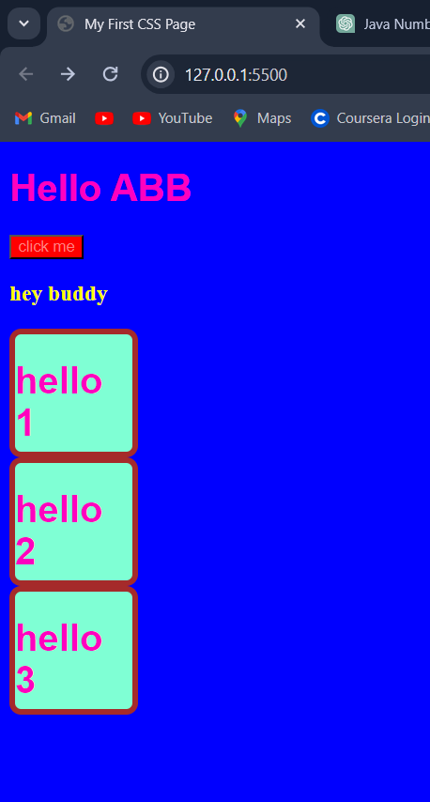

 border-radius: 50px;

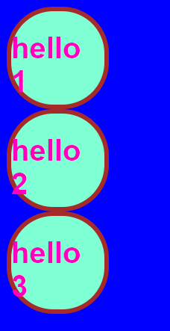

**PADDING:  
left,right,top,bottom;**

padding-left: 20px;

div{

    height:100px;

    width:100px;

    background-color: aquamarine;

    border-style:solid;

    border-color:brown;

    border-width: 5px;

    border-radius: 20px;

    padding-left: 40px;

}

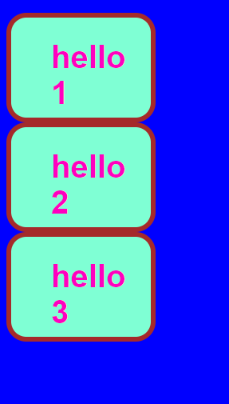

**Padding right**

 padding-right: 40px;

div{

    height:100px;

    width:100px;

    background-color: aquamarine;

    border-style:solid;

    border-color:brown;

    border-width: 5px;

    border-radius: 20px;

    padding-right: 40px;

}

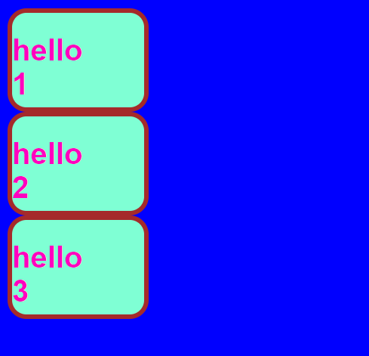

**Padding top**

 padding-top: 20px;

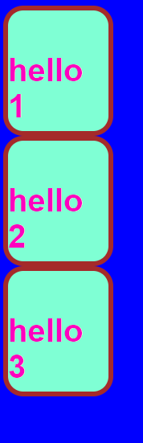

div{

    height:100px;

    width:100px;

    background-color: aquamarine;

    border-style:solid;

    border-color:brown;

    border-width: 5px;

    border-radius: 20px;

    padding-top: 10px;

    padding-bottom: 10px;

    padding-left: 10px;

    padding-right: 10px;

}

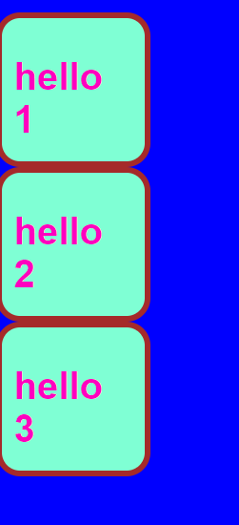

**Shorthand:**

  padding:10px 10px 10px 10px;

div{

    height:100px;

    width:100px;

    background-color: aquamarine;

    border-style:solid;

    border-color:brown;

    border-width: 5px;

    border-radius: 20px;

    padding:10px 10px 10px 10px;

}

   padding:50px;

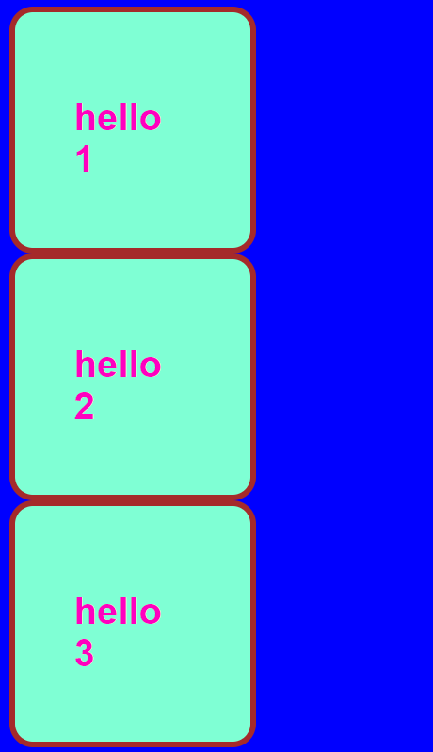

**Margin:**

**Right,left,top,bottom:**

 margin-top:50%;

  margin:50px;

div{

    height:100px;

    width:100px;

    background-color: aquamarine;

    border-style:solid;

    border-color:brown;

    border-width: 5px;

    border-radius: 20px;

    padding:50px;

    margin-top:30px;

}

    margin-top:30px;

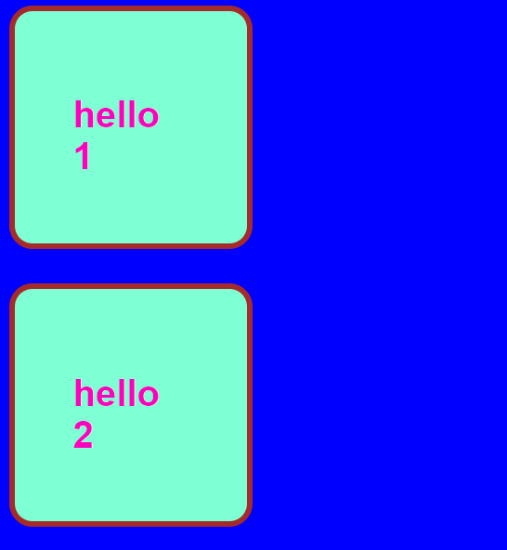

  margin:50px 50px 50px 50px ;

**DISPLAY PROPERTY:  
block,inline,inline-block,none;**

<!DOCTYPE html>

<html>

<head>

    <title>My First CSS Page</title>

    <link rel="stylesheet" href="style.css">

</head>

<body>

    <div> hello</div>

    <button>click</click>

</body>

</html>

/* style.css */

*{

    color:rgb(255, 127, 127);

}

h1 {

    color:#ff00bf;

    font-family: Arial, sans-serif;

}

button{

    background-color:#ff0000;

}

body{

    background-color:#0000ff;

}

#h31{

    color:yellow;

}

.class{

    color:pink;

}p{

    text-align:center;

    text-decoration:black wawe underline;

    font-weight:900;

    font-family:arial;

    font-size :20px;

    line-height: 40px;

    text-transform: capitalize;

}

a{

    text-decoration:none;

}

div{

    height:100px;

    width:100px;

    background-color: aquamarine;

    border-style:solid;

    border-color:brown;

    border-width: 5px;

    border-radius: 20px;

    padding:50px;

    margin:50px 50px 50px 50px ;

}

div{

    border:5px solid brown;

}

div{

    display: inline;

    background-color: pink;

}

div{

    display: inline;

    background-color: pink;

}

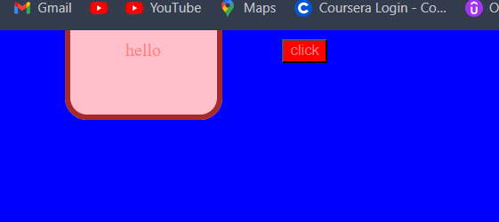

div{

    display: block;

    background-color: pink;

}

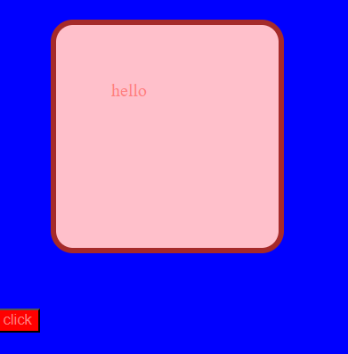

**Visibility:**

 visibility:hidden;

**OPACITY:  
0-1**

**color:rgba(255,0,0,0.5);**

 background-color:rgba(255,0,0,0.30);

div{

    height:100px;

    width:100px;

    background-color:rgba(255,0,0,0.30);

    border-style:solid;

    border-color:brown;

    border-width: 5px;

    border-radius: 20px;

    padding:50px;

    margin-top: 60px ;

}

**UNITS:**

**%,em,rem;**

<!DOCTYPE html>

<html>

<head>

    <title>My First CSS Page</title>

    <link rel="stylesheet" href="style.css">

</head>

<body>

    <div id="box1"> box1

        <div id="box2">box2

        </div>

    </div>

</body>

</html>

#box1{

    height:100px;

    width:100px;

    background-color: #ff00bf;

}

#box2{

    height:30px;

    width:30px;

    background-color: darkorange;

}

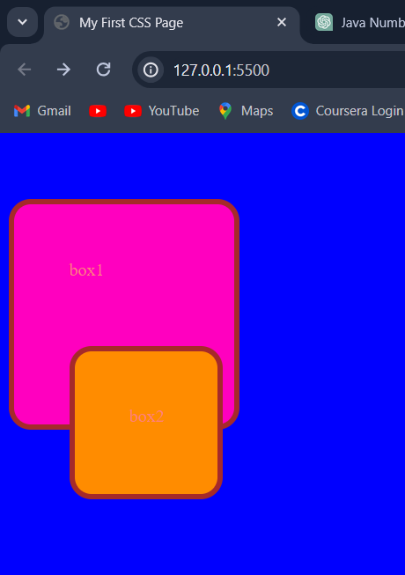

<!DOCTYPE html>

<html>

<head>

    <title>My First CSS Page</title>

    <link rel="stylesheet" href="style.css">

</head>

<body>

    <div id="box1"> box1

        <div id="box2">box2

        </div>

    </div>

</body>

</html>

#box1{

    height:100px;

    width:100px;

    background-color: #ff00bf;

    font-size: 30px;

}

#box2{

    height:30px;

    width:30px;

    background-color: darkorange;

    font-size: 2em;

}

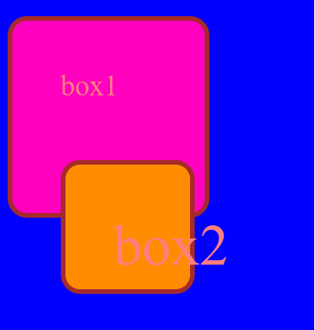

**Rem:parent element;**

**POSITION:  
static,relative,absolute,fixed**

**Static::**

<!DOCTYPE html>

<html>

<head>

    <title>My First CSS Page</title>

    <link rel="stylesheet" href="style.css">

</head>

<body>

    <h1>position</h1>

    <div id="box1">box1</div>

    <div id="box2">box 2</div>

    <div id="box3">box 3</div>

</body>

</html>

/* style.css */

*{

    color:rgb(29, 2, 2);

}

h1 {

    color:#ff00bf;

    font-family: Arial, sans-serif;

}

button{

    background-color:#ff0000;

}

body{

    background-color:#0000ff;

}

#h31{

    color:yellow;

}

.class{

    color:pink;

}p{

    text-align:center;

    text-decoration:black wawe underline;

    font-weight:900;

    font-family:arial;

    font-size :20px;

    line-height: 40px;

    text-transform: capitalize;

}

a{

    text-decoration:none;

}

div{

    height:100px;

    width:100px;

    background-color:rgba(255,0,0,0.30);

    border-style:solid;

    border-color:brown;

    border-width: 5px;

    border-radius: 20px;

    padding:50px;

    margin-top: 60px ;

}

div{

    border:5px solid brown;

}

div{

    height: 100px;

    width:100px;

    display: inline-block;

    background-color: pink;

    border: 2px solid black;

}

#box1{

    background-color: #ff00bf;

    font-size: 30px;

    position:static;

}

div{

    height: 100px;

    width:100px;

    display: inline-block;

    background-color: pink;

    border: 2px solid black;

}

#box1{

    background-color: #ff00bf;

    font-size: 30px;

    position:static;

}

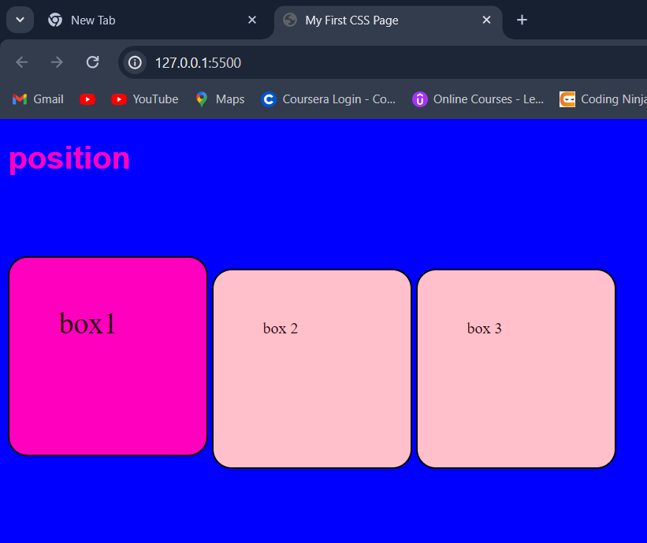

**Relative:top,right,bottom,left**

#box2{

    position:relative;

    top:20px;

    left:10px;

}

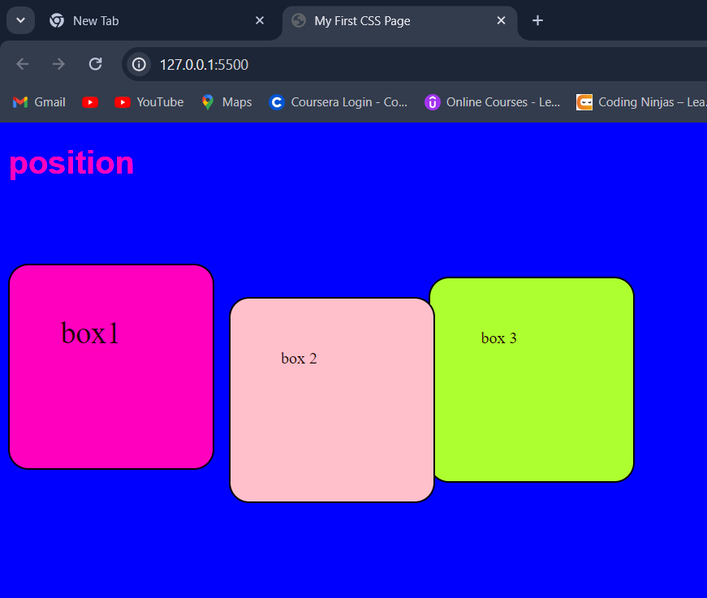

#box2{

    position:relative;

    bottom:30px;

}

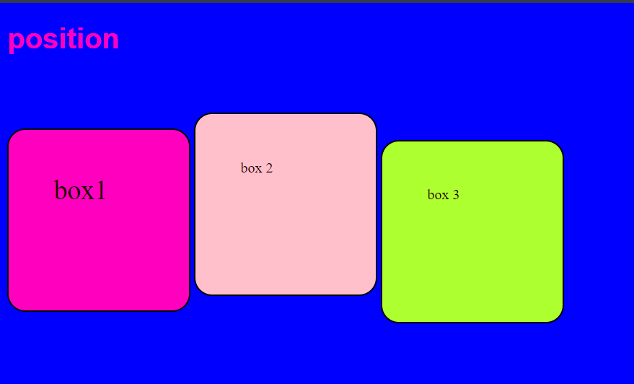

**Absolute:**

#box3{

    background-color: greenyellow;

    position:30px;

}

**Fixed-position relative to browser;**

#box3{

  position:fixed;

  right:10px;

}

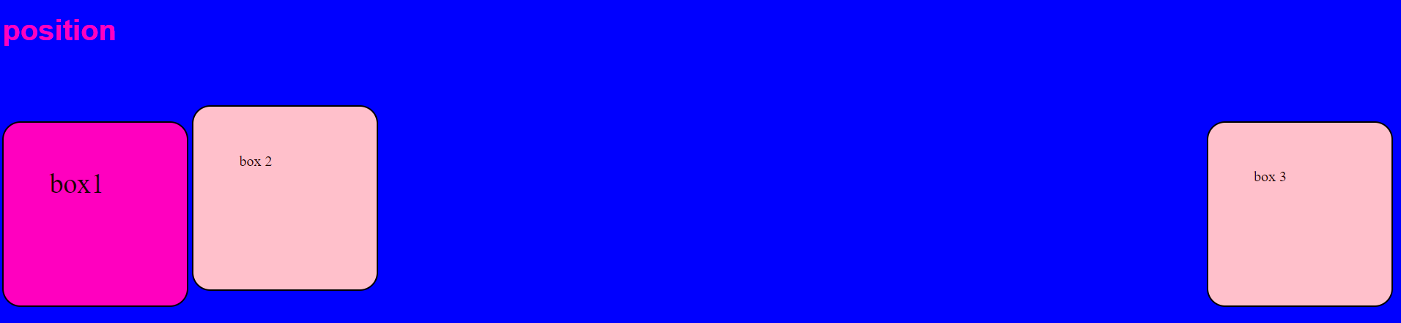

**Sticky position:**

#box3{

  position:sticky;

  right:500px;

left:20px;

}

**Stay at one place**

#box2{

    position:relative;

    top:20px;

    left:10px;

    z-index:1;

}

#box3{

  position:fixed;

top:20px;

z-index:-3;

}

**BACKGROUND IMAGE:**

 background-image: url("spider.jpeg");

#box3{

    background-color: #ff00bf;

    font-size: 30px;

    position:static;

    background-image: url("spider.jpeg");

}

**Background-size:**

**Cover,contain,auto:**

**Cover:**

#box3{

    background-color: #ff00bf;

    font-size: 30px;

    position:static;

    background-image: url("spider.jpeg");

    background-size: cover;

}

**Contain:**

  background-size: contain;

    background-repeat:no-repeat ;

#box3{

    background-color: #ff00bf;

    font-size: 30px;

    position:static;

    background-image: url("spider.jpeg");

    background-size: contain;

    background-repeat:no-repeat ;

}

**Auto:**

#box3{

    background-color: #ff00bf;

    font-size: 30px;

    position:static;

    background-image: url("spider.jpeg");

    background-size: auto;

}

**FLEXBOX:  
flexible layout:**

**Flex-direction:**

**1.Flex-direction:row;**

**2.Flex-direction:row-reverse;**

**3.Flex-direction:column;**

**4.Flex-direction:column-reverse;**

<!DOCTYPE html>

<html>

<head>

    <title>My First CSS Page</title>

    <link rel="stylesheet" href="style.css">

</head>

<body>

    <h1>flexbox</h1>

    <div id="container">

    <div id="box1">box1</div>

    <div id="box2">box 2</div>

    <div id="box3">box 3</div>

    <div id="box4">box 4</div>

    </div>

</body>

</html>

body{

    text-align:center;

}

div{

    height:100px;

    width:500px;

    display:inline-block;

    border:2px solid block;

}

#container{

    width:800px;

    height:300px;

    display:flex;

    flex-direction:row;

}

#box1{

    background-color: aquamarine;

}

#box2{

    background-color:red;

}

#box1{

    background-color:green;

}

**Row reverse:**

#container{

    width:800px;

    height:300px;

    display:flex;

    flex-direction:row-reverse;

}

**Column:**

#container{

    width:800px;

    height:300px;

    display:flex;

    flex-direction:column;

}

**Column reverse**

#container{

    width:800px;

    height:300px;

    display:flex;

    flex-direction:column-reverse;

}

**Flex properties:**

**1.justify-content**

**2.flex-wrap**

**3.align-itmes**

**4.align-content;**

**Justify-content:flext-start,flex-end,center,space-evenly**

#container{

    width:800px;

    height:300px;

    display:flex;

    flex-direction:row;

    justify-content: flex-start;

}

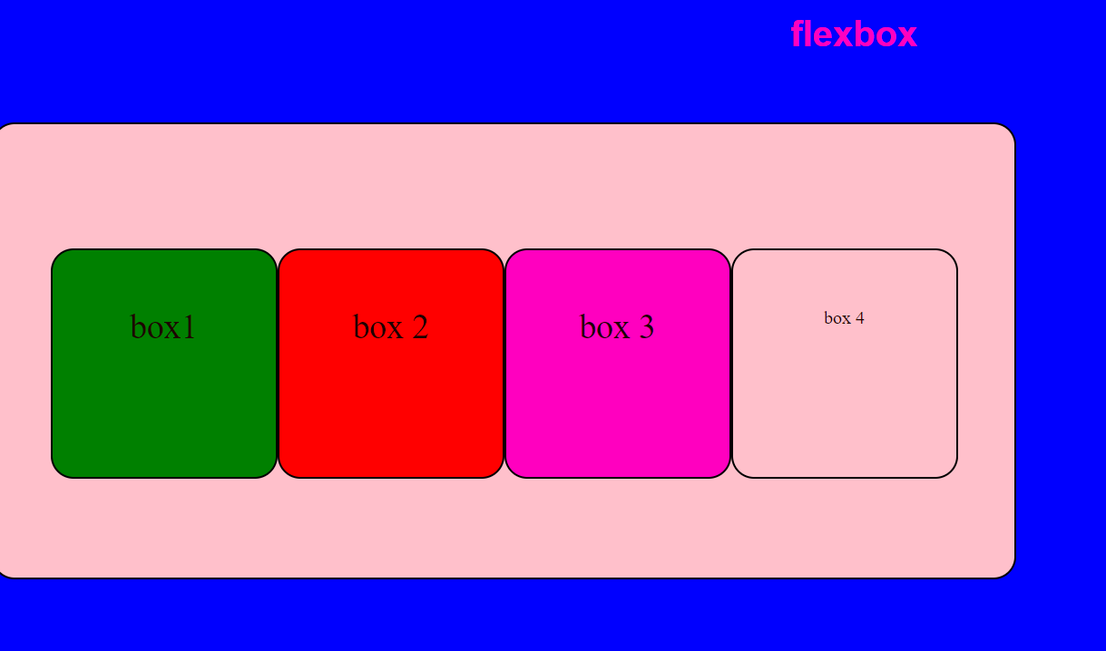

#container{

    width:800px;

    height:300px;

    display:flex;

    flex-direction:row;

    justify-content: flex-end;

}

#box1{

    background-color: aquamarine;

}

#box2{

    background-color:red;

}

#box1{

    background-color:green;

}

#container{

    width:800px;

    height:300px;

    display:flex;

    flex-direction:row;

    justify-content: center;

}

#container{

    width:800px;

    height:300px;

    display:flex;

    flex-direction:row;

    justify-content: space-around;

}

#container{

    width:800px;

    height:300px;

    display:flex;

    flex-direction:row;

    justify-content: space-between;

}

#container{

    width:800px;

    height:300px;

    display:flex;

    flex-direction:row;

    justify-content: space-evenly;

}

**Column;**

#container{

    width:800px;

    height:300px;

    display:flex;

    flex-direction:column;

    justify-content: flex-start;

}

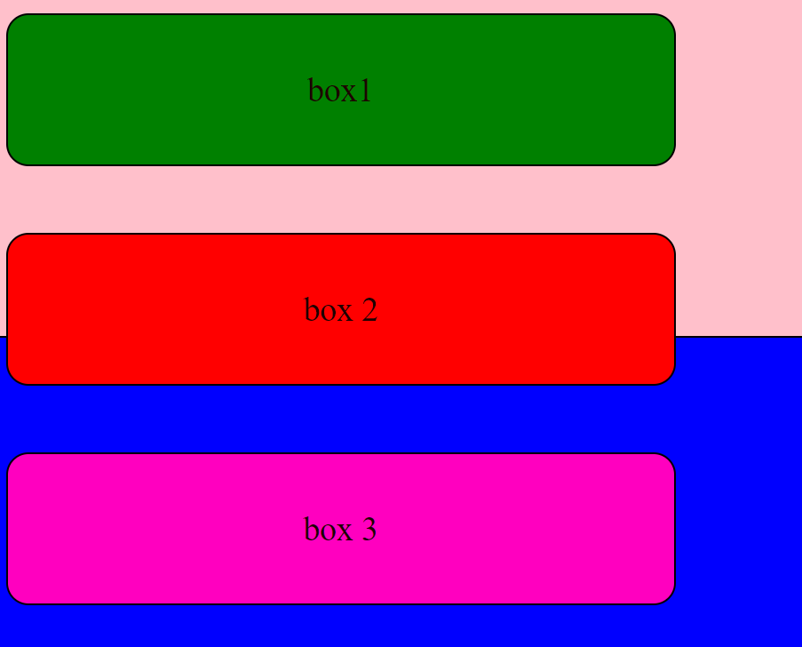

#container{

    width:800px;

    height:300px;

    display:flex;

    flex-direction:column;

    justify-content: flex-end;

}

#container{

    width:800px;

    height:300px;

    display:flex;

    flex-direction:column;

    justify-content:center;

}

**Align content;**

  align-items: center;

    align-content: center;

#container{

    width:800px;

    height:300px;

    display:flex;

    flex-direction:row;

    justify-content:center;

    align-items: center;

    align-content: center;

}

#container{

    width:800px;

    height:300px;

    display:flex;

    flex-direction:row ;

    flex-wrap: wrap;

    justify-content:flex-start;

    align-items: center;

    align-content: flex-start;

}

#container{

    width:800px;

    height:300px;

    display:flex;

    flex-direction:row ;

    flex-wrap: wrap;

    justify-content:flex-start;

    align-items: center;

    align-content: flex-end;

}

**Flex item;**

**Align-self:**

**flexe-grow:**

**flex-shrink:**

**align-self:**

#box1{

    background-color: aquamarine;

    align-self:flex-end;

}

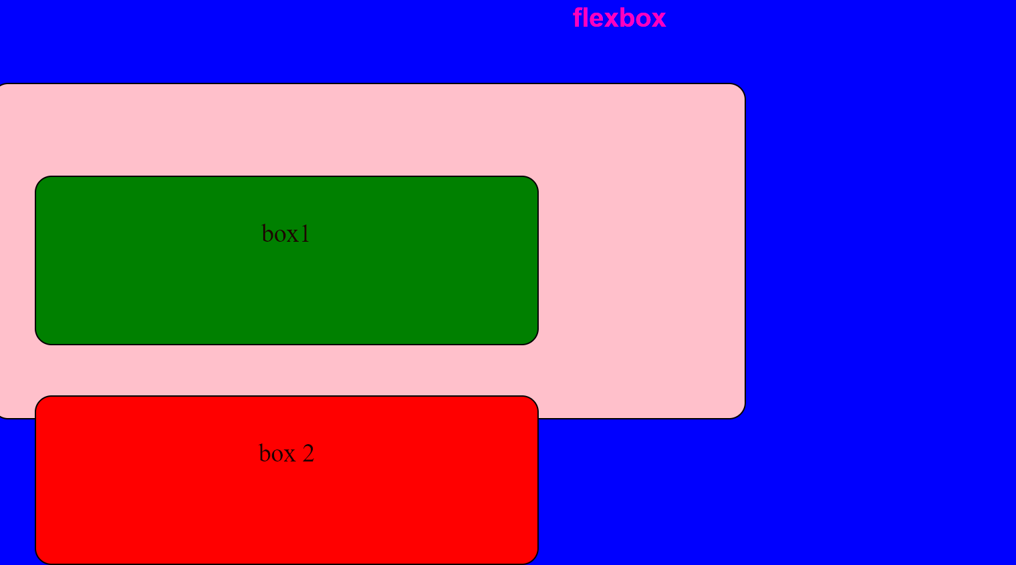

**Flex-grow:**

#box1{

    background-color: aquamarine;

    align-self:flex-end;

}

#box2{

    background-color:red;

    flex-shrink:0.5;

}

**Media queries:**

}

@media(width:600px){

    div{background-color: maroon;}

}

@media(width:600px){

    div{background-color: maroon;}

}

@media(min-width:600px){

    div{

        background-color: darkslategray;

    }

}

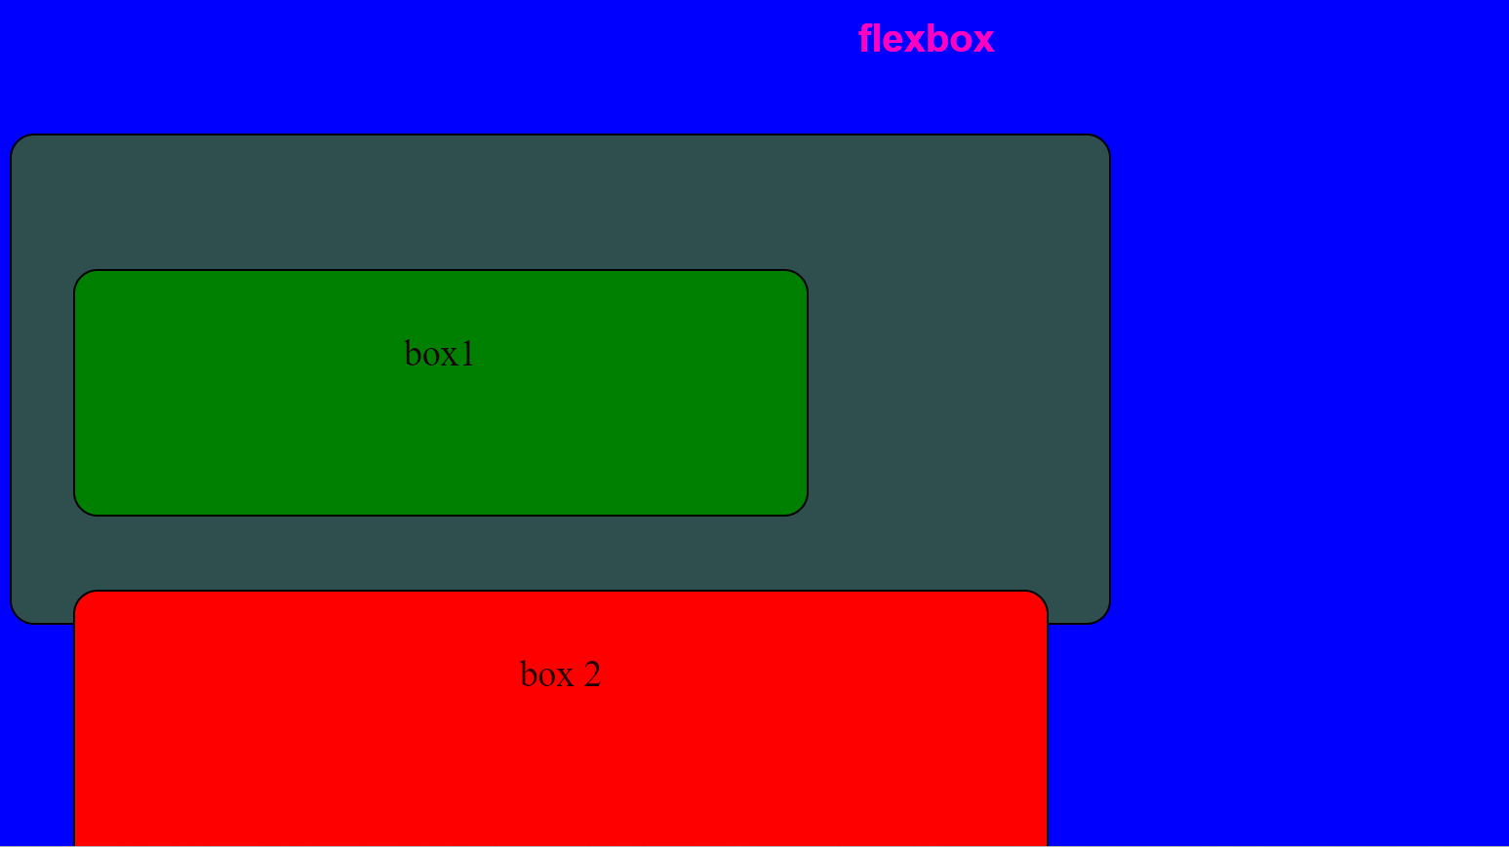

**Transition:**

**Transition-property:**

<!DOCTYPE html>

<html>

<head>

    <title>My First CSS Page</title>

    <link rel="stylesheet" href="style.css">

</head>

<body>

   <div>hello</div>

</body>

</html>

div{

    height:100px;

    width:100px;

    background-color:aquamarine;

    border:2px solid black;

}

div:hover

{

background-color: red;

color:white;

}

**div:active:**

div:active{

    background-color:#ff00bf;

}

**Transition -propery:all**

**Transition:duration:2s;**

div{

    transition-property:all;

    transition-duration: 2s;

}

**Font-size:**

div:hover

{

background-color: red;

color:white;

font-size:20px;

}

**Transition-timing-function:steps(3);**

div{

    transition-property:all;

    transition-duration: 2s;

    transition-timing-function: steps(3) ;

}

**Shorthand:**

div{

    transition:all 2s ease-in 1s;

}

**Transform:**

**Transform:rotate(45deg);**

div{

    transform:rotate(360deg);

}

**Scale:**

**Transform scale(2);**

div:hover{

    transform:scale(2);

}

**Translate:**

**Element move right side**

 transform:translate(250px);

div:hover{

    transform:scale(2);

    transform:translate(250px);

}

**Element move left side**

div:hover{

    transform:scale(2);

    transform:translate(-250px);

}

**Skew:**

 transform:skew(30deg);

div:hover{

    transform:scale(2);

    transform:translate(-250px);

    transform:skew(30deg);

}

**ANIMATION:**div{

    animation-name:colorAnimate;

    animation-duration: 3s;

    animation-timing-function: ease-in;

    animation-delay: 1s;

    animation-iteration-count: 5;

    animation-direction: alternate;

}

animation-direction:normal;

animation-direction:reverse;

animation-direction:alternate;

animation-direction:alternate-reverse;

div{

    animation-name:colorAnimate;

    animation-duration: 3s;

    animation-timing-function: ease-in;

    animation-delay: 1s;

    animation-iteration-count: 5;

    animation-direction: alternate;

}

@keyframes  colorAnimate{

    from{

        left:0px;

    }to{

        left:200px;

    }

}

**Shorthand:**

div{

    animation:colorAnimate 2s ease-in 3s infinite normal;

}

**% in Animation:**

@keyframes colorAnimate{

    0%{font-size:20px;}

    5%{font-size:30px;}

    100%{font-size:40px;

    }

}