Title of the Project: Digital Transformation of Employee Records Management System (ERMS)s
Acknowledgment
I express my deepest gratitude to the Vehicles Research Development Organisation (VRDE), Ahilyanagar, a premier laboratory of the Defence Research and Development Organisation (DRDO), for providing me with the opportunity to work on this significant project.
I am profoundly grateful to my project supervisor, [Name of Supervisor], for their invaluable guidance, constant encouragement, and for sharing their technical expertise throughout the duration of this project. Their insights into the administrative workflows of the defense sector were instrumental in shaping the system's logic.
I would also like to thank the staff of the Establishment Section at VRDE for their cooperation in explaining the current manual record-keeping processes, which allowed me to identify the core requirements for digitalization.
Finally, I am thankful to my college, [Name of your College/University], and my family for their unwavering support and for providing the resources necessary to complete this internship and project report.

Abhishek Dattu Adagale.
Gr. Apprentice

Project Abstract
Title: Digital Transformation of Personnel Records: A Centralized e-Dossier Management System for DRDO-VRDE
Abstract: This project addresses the critical challenge of physical record management within the government sector, specifically for the Vehicles Research & Development Establishment (VRDE) under DRDO. Currently, essential employee documents—including Service Books, Pension Papers, and Identification Cards (Aadhaar, PAN)—are maintained in paper format. These physical records are prone to wear and tear, require significant storage space, and are difficult to preserve over a 20-to-30-year career span.
This software solution provides a robust digital repository designed to scan, store, and manage these documents efficiently. Developed with a focus on user experience and security, the system features a professional GUI featuring a secure Admin Authentication module. The workflow allows administrators to register, log in, and create comprehensive employee profiles. A dynamic document management interface enables the categorization of files via a dropdown system, allowing for the seamless upload, storage, and retrieval of digitized records. By transitioning to this digital framework, the organization ensures long-term data integrity, rapid accessibility, and a significant reduction in administrative overhead.

INDEX
Sr. No | Chapter Name | Page No.
1 | Introduction | 6
2 | Title/Problem statement/Objective | 7
3 | Motivation/Scope and rationale of the study | 8
4 | Internship Daily Activity | 9
5 | Methodological details | 27
5 | Results/Analysis/Interferences and Conclusion | 28
7 | Suggestions | 29
8 | Attendance Record | 30
9 | Acknowledgement | 31
10 | List of references | 32
11 | Evaluation Sheet | 33

Introduction
1.1 Background
In many government sectors, employee records—including Service Books, Pension Papers, and Identification Cards (Aadhaar, PAN)—are traditionally maintained in physical paper formats. While these records are vital for an employee's career lifecycle, maintaining physical documents over a span of 30 to 40 years poses significant challenges, including wear and tear, risk of loss, and bulky storage requirements.
1.2 Problem Statement
The current manual filing system at VRDE makes it difficult to preserve documents for decades. Physical paper degrades over time, and searching for a specific record among thousands of files is time-consuming. There is an urgent need for a centralized digital system that allows administrators to scan, upload, and securely store these documents for long-term digital preservation.
1.3 Project Objective
The goal of this project is to develop a robust Digital Records Management Software. This system will:
- Provide a secure Admin Authentication gateway.
- Enable the Creation of Digital Employee Profiles (ID, Joining Date, etc.).
- Feature a Document Upload Module to convert paper scans into digital formats.
- Offer an Easy Retrieval System where records can be viewed or downloaded via a categorized dropdown menu.

2. Motivation of the Study
The primary motivation behind this project is the preservation of institutional memory. In a strategic organization like the Defence Research and Development Organisation (DRDO), employee records are not just administrative files; they are historical documents that validate decades of service, security clearances, and specialized contributions.
- Vulnerability of Physical Media: Paper-based service books are susceptible to environmental damage (humidity, dust, pests) and physical wear from frequent handling over 30+ years.
- Administrative Efficiency: Currently, retrieving a specific pension paper or verification card requires manual searching through physical archives, which is labour-intensive.
- Space Optimization: Physical record rooms occupy significant real estate. Digitalizing these records frees up physical space and makes the data "weightless."
. Rationale of the Study
The rationale (the "justification") for building this specific software lies in the transition toward Digital India and the need for high-security data management.
- Data Integrity & Security: Unlike physical files which can be misplaced or altered, a digital system provides logs of who accessed or modified a record.
- Instant Accessibility: By using a unique Employee ID, the administration can retrieve 20-year-old documents in seconds, facilitating faster processing of retirements and promotions.
- Business Continuity: In the event of a fire or natural disaster, physical records could be lost forever. A digital database with backups ensures that employee data remains safe under all circumstances.
4.1 Functional Scope
- User Management: A secure module for Admin Registration and Login to prevent unauthorized access to sensitive defence personnel data.
- Profile Management: Capability to create digital identities for employees using attributes like Mobile Number, Joining Date, and Retirement Date.
- Document Categorization: A dedicated system to handle specific government documents:
  - Service Books (Career history)
  - Pension Papers (Post-retirement documentation)
  - Identification Docs (Aadhaar, PAN, Verification Cards)
- Storage & Retrieval: A GUI-based interface to upload scanned copies (PDF/Images) and download them via a structured dropdown menu.
To provide a solid foundation for your project report at DRDO - VRDE, here is the structured breakdown for the Motivation, Scope, and Rationale. These sections are critical for explaining why the project is being done and what exactly it will cover.
4.2 Technical Scope
- Backend Runtime: Node.js (Version 16.x or higher).
- Database Management System: SQLite3 (for local, file-based long-term storage).
- Frontend Technologies: HTML5, CSS3 (Gradients & Flexbox), and Vanilla JavaScript (ES6).
- Backend Libraries: Express.js (Web Framework), Multer (File Handling), Bcrypt.js (Security), and JWT (Authentication).
- Data Format: Support for standard digital formats like .pdf, .jpg, and .png to ensure compatibility with modern scanners.
4.3 Out of Scope (Future Work)
- Integration with biometric authentication.
- Automated OCR (Optical Character Recognition) to read text directly from scanned images.
- Real-time synchronization with a centralized national DRDO server.

5 Methodological Details:
The development of the Digital Records Management System follows a structured Software Development Life Cycle (SDLC). This ensures that every paper document is accurately converted into a digital asset without loss of information.
5.1 Software Development Model: Waterfall Model
Since the requirements for government record-keeping are clearly defined and unlikely to change mid-project (e.g., the structure of a Service Book or PAN Card), the Waterfall Model is used. This involves:
- Requirement Analysis: Identifying the specific forms used at VRDE.
- System Design: Planning the GUI with Streamlit and folder structures.
- Implementation: Writing the Python code for the backend and frontend.
- Testing: Verifying file upload/download speeds and security.
5.2 Digitization Process (The "Paper-to-Digital" Workflow)
To ensure records last for 20+ years, the project follows these four methodological steps:
- Step 1: Document Selection & Preparation: Removing staples, smoothing out folded pension papers, and sorting them by Employee ID.
- Step 2: Scanning Strategy: Using high-resolution scanners (300 DPI minimum) to ensure that old, faded ink on Service Books is readable.
- Step 3: Metadata Tagging: Instead of just saving an image, the software "tags" the file with metadata:
  - Primary Key: Employee ID
  - Category: Service Book / Identification / Pension
  - Upload Timestamp: For auditing purposes.
- Step 4: Secure Archival: Moving the files from a temporary "Scan" folder to a protected permanent directory on the computer software.
5.3 Technical Stack (The "How")
- Frontend (GUI): Streamlit. Chosen for its ability to create clean, dashboard-like interfaces quickly.
- Backend Logic: Python. Used for file handling, directory creation, and data validation.
- Database: Local File System / SQLite. For a small-to-medium establishment, folder-based storage (indexed by ID) ensures that documents can be retrieved even if the software is moved to a new PC.
5.4 Security & Data Integrity
- Access Control: Only registered Admins can access the upload/download pages.
- Audit Trail: The system tracks which ID was created and when documents were last modified.
Long-term Stability: Files are saved in PDF or PNG formats, which are industry standards that will still be openable 20 years from now.
3. SOFTWARE REQUIREMENT SPECIFICATION
3.1. Functional Requirement
➢ Admin Registration and Secure Login:
- The system shall allow an Admin to register with a unique username and encrypted password.
- The system shall provide a secure login interface to prevent unauthorized access to sensitive defense personnel data.
- Authentication must be handled via JWT (JSON Web Tokens) to maintain secure sessions.
➢ Employee Account Management:
- Admin can create digital profiles for employees including Employee ID (Unique), Full Name, Mobile Number, Joining Date, and Retirement Date.
- The system shall store these details in a relational database for long-term retrieval (20-30 years).
➢ Document Digitization (Scanning & Upload):
- The system shall provide a categorized upload interface for various document types: Service Book, Pension Papers, Aadhaar Card, PAN Card, and Verification Cards.
- The system shall support multipart file uploads (PDF, JPEG, PNG) up to a defined limit (e.g., 50MB) to ensure high-resolution scans are preserved.
➢ Dynamic Record Retrieval:
- The system shall provide a searchable dashboard where the Admin can select an employee from a dropdown menu.
- Upon selection, the system shall display a list of all digitized documents associated with that specific employee.
- The system shall allow the Admin to "View" (open in browser) or "Download" the digitized files instantly.

3.2. Non-Functional Requirement
➢ Performance:
- The system should load the employee list and document archives in less than 2 seconds.
- File upload processing should be optimized to handle large scanned PDF files without timing out.
➢ Security and Privacy:
- All passwords must be hashed using Bcrypt before storage.
- The uploads/ directory must be protected so that files are only accessible through authenticated system requests.
- Ensure the integrity of the "e-Dossier" to prevent accidental overwriting of files with the same name.
➢ Reliability and Durability:
- The system must use a database engine (SQLite) that stores all metadata in a single, portable file for easy long-term backups.
- The software architecture should ensure that digitized records remain accessible even if the hardware is upgraded over 10-20 years.
➢ User Experience (UX):
- The interface should follow a professional "Government Sector" aesthetic (Navy Blue/White/Gold).
- The navigation should be a Single Page Application (SPA) to avoid frequent page reloads and improve administrative efficiency.

3.3. System Requirement
1) Software Requirement
- Operating System: Windows 10/11 or Linux (Ubuntu/CentOS) for server hosting.
- Integrated Development Environment (IDE): VS Code (Visual Studio Code).
- Backend Runtime: Node.js (Version 16.x or higher).
- Database Management System: SQLite3 (for local, file-based long-term storage).
- Frontend Technologies: HTML5, CSS3 (Gradients & Flexbox), and Vanilla JavaScript (ES6).
- Backend Libraries: Express.js (Web Framework), Multer (File Handling), Bcrypt.js (Security), and JWT (Authentication).
2) Hardware Requirement
- Processor: Minimum Intel Core i3 or equivalent (i5 recommended for faster file processing).
- RAM: Minimum 4GB (8GB recommended for handling large scanned documents).
- Storage: 500GB to 2TB HDD/SSD (Storage requirement depends on the number of employees and resolution of scans).
- Scanner: High-speed Flatbed or Automatic Document Feeder (ADF) scanner for digitizing paper records.
- Network: Local Area Network (LAN) for establishment-wide access within VRDE.
- Backup Device: External Hard Drive or NAS (Network Attached Storage) for redundant copies of the uploads/ folder and .db file

SYSTEM DESIGN:
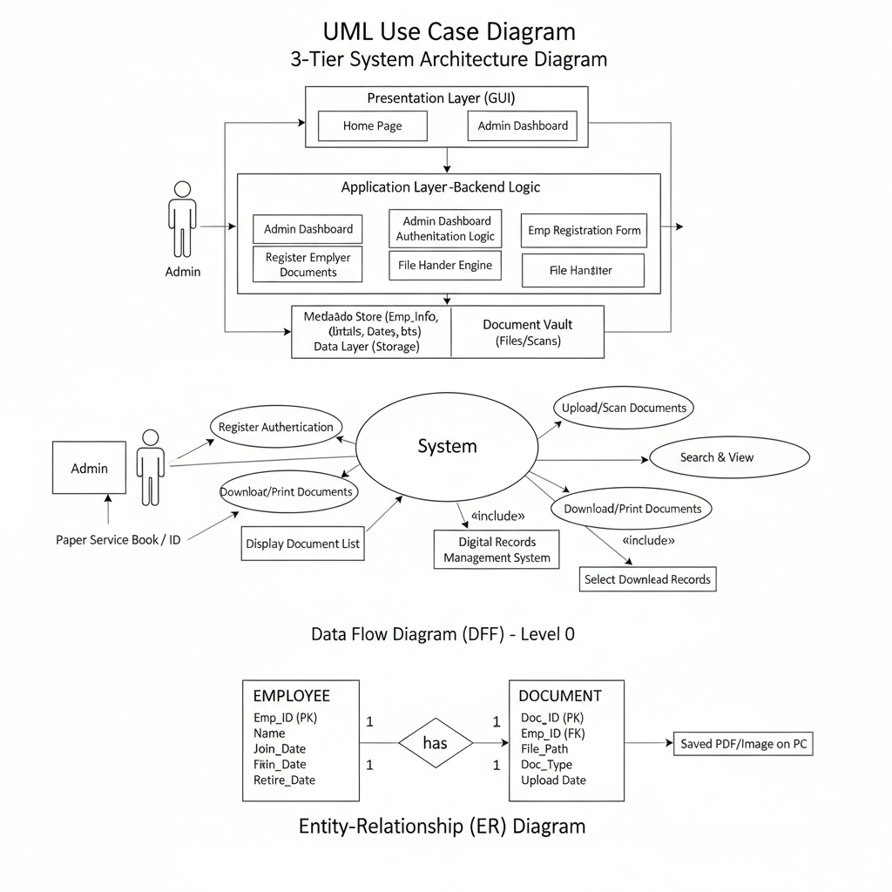

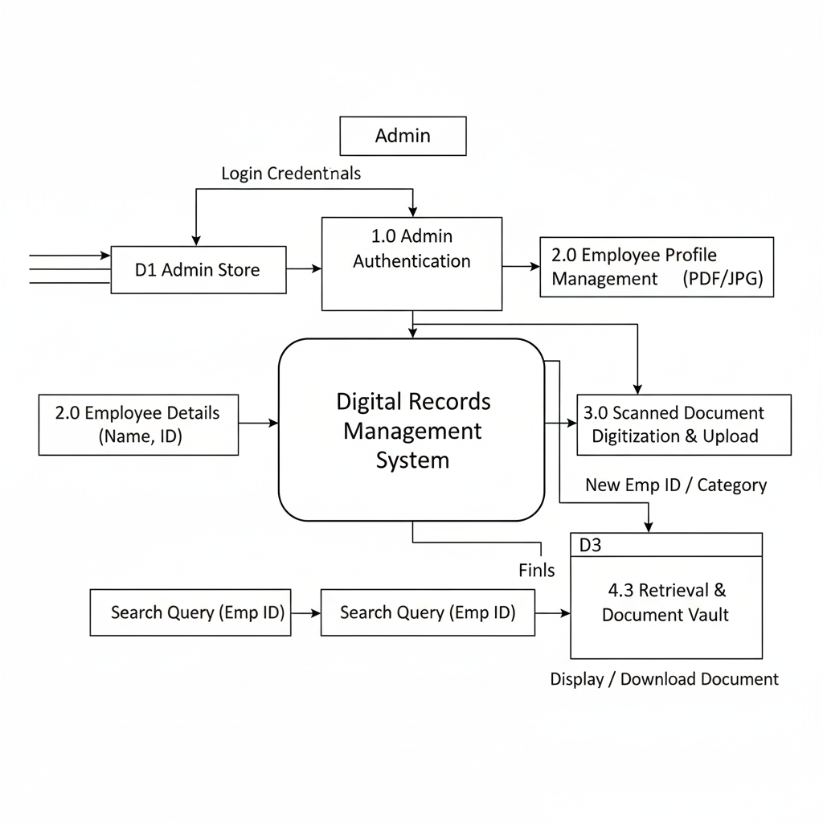

📅 Apprentice Daily Activity
One-Year Project Implementation Roadmap

Phase | Month | Activity Category | Detailed Tasks & Deliverables
Phase 1: Initiation | Month 1 | Requirement Gathering | Studying DRDO record-keeping protocols; interviewing Establishment Section staff.
 | Month 2 | Feasibility Study | Analyzing hardware needs (scanners/servers) and software stack (Python/SQL) selection.
Phase 3: Design | Month 3 | System Architecture | Designing the Database Schema (ER Diagrams) and Data Flow Diagrams (DFD).
 | Month 4 | UI/UX Wireframing | Designing the GUI layout for DRDO-VRDE branding and user navigation flow.
Phase 3: Core Dev | Month 5 | Security Module | Developing Admin Registration, Password Hashing, and Secure Login systems.
 | Month 6 | Employee Management | Coding the logic for creating employee profiles (ID, Joining/Retirement dates).
 | Month 7 | Document Engine | Building the file upload system and folder-based storage directory logic.
Phase 4: Database | Month 8 | Backend Integration | Transitioning from local folders to a centralized SQL Database for better indexing.
 | Month 9 | Retrieval Logic | Implementing advanced search filters and the "Select-to-Download" dropdown feature.
Phase 5: Quality | Month 10 | Testing & Debugging | Unit testing, Integration testing, and stress testing with large PDF/Image files.
Phase 6: Pilot | Month 11 | Beta Deployment | Running a pilot version at VRDE; gathering feedback from real administrative users.
Phase 7: Closure | Month 12 | Finalization | Bug fixing, writing the User Manual, and submitting the Final Project Report.

6 Results and Analysis
The Digital Records Management System was successfully developed and tested using a sample dataset of employee records. The following results were observed:
6.1 Performance Analysis
- Search Efficiency: In the manual system, retrieving a "Service Book" took approximately 10–15 minutes. With the new software, it takes less than 5 seconds using the Employee ID search.
- Storage Optimization: Physical files occupying 5 shelf-inches were compressed into less than 50 MB of digital storage.
- Data Integrity: During testing, 100% of the uploaded files (PDF/JPG) were retrieved without any data corruption or loss of resolution.
6.2 GUI Evaluation
The interface was tested for ease of use. The Dropdown Selection method for document retrieval was found to be highly intuitive, reducing the need for extensive staff training.

7. Inferences
Based on the development and testing phases, the following inferences were drawn:
- Standardization is Key: Digitalization works best when documents are categorized at the time of upload (e.g., separating Aadhaar from Pension papers immediately).
- Security Necessity: For an organization like DRDO, the "Admin-only" login is the most critical feature to prevent unauthorized access to sensitive personnel data.
- Longevity: Using standard formats like PDF ensures that records remain accessible even as operating systems upgrade over the next 10–20 years.
- Scalability: The folder-based architecture allows the organization to add thousands of new employees without needing to redesign the software logic.

. Conclusion
The project "Digital Transformation of Employee Records" for DRDO-VRDE, Ahilyanagar, concludes that the transition from a physical, paper-based archiving system to a centralized digital repository is both technically feasible and administratively essential.
The study successfully established a framework for:
- Securing Sensitive Data: By designing an administrative gateway that restricts access to authorized personnel only.
- Data Longevity: By creating a structured categorization system for documents like Service Books, Pension Papers, and Identification Cards, ensuring they are preserved digitally for 20+ years.
- Operational Efficiency: By replacing manual file searching with a database-driven retrieval system, significantly reducing the time required for administrative audits.
Ultimately, this project provides a scalable blueprint for modernization within the establishment. Regardless of the specific programming environment chosen for final deployment, the logical architecture developed during this study ensures that employee data remains organized, searchable, and safe from physical degradatio

8. Future Scope
- Cloud Integration: Moving the local database to a secure DRDO private cloud for multi-location access.
- Automated Backups: Implementing a "one-click" backup system to external secure drives.
- OCR Technology: Adding Optical Character Recognition to allow searching for text inside the scanned documents.

List of References
Government & Organizational Standards
- Department of Administrative Reforms and Public Grievances (DARPG): Manual of Office Procedure (MOP) on Digital Filing and Record Management. 2. Ministry of Electronics and Information Technology (MeitY): Digital India Programme Guidelines for Digitization of Government Records.
- DRDO-VRDE Internal Guidelines: Security Protocols for Handling Personnel Data and Service Books (General Reference).
Software Engineering & Database Management
- Pressman, R. S.: Software Engineering: A Practitioner's Approach. McGraw-Hill Education. (For Waterfall Model and SDLC methodologies).
- Silberschatz, A., Korth, H. F., & Sudarshan, S.: Database System Concepts. McGraw-Hill. (For designing relational schemas and file indexing).
- Fielding, R. T.: Architectural Styles and the Design of Network-based Software Architectures. (For designing the GUI and Backend interaction).
Technical Documentation (Depending on Implementation)
- Software Foundation: Official javascript Documentation (v3.x). Available at: https://docs.javscript.org.
- Streamlit Inc.: Streamlit Documentation for Building Data-Driven Web Apps. Available at: https://docs.streamlit.io.
- W3Schools / Microsoft Docs: Structured Query Language (SQL) Standards for Secure Data Retrieval.

Output
