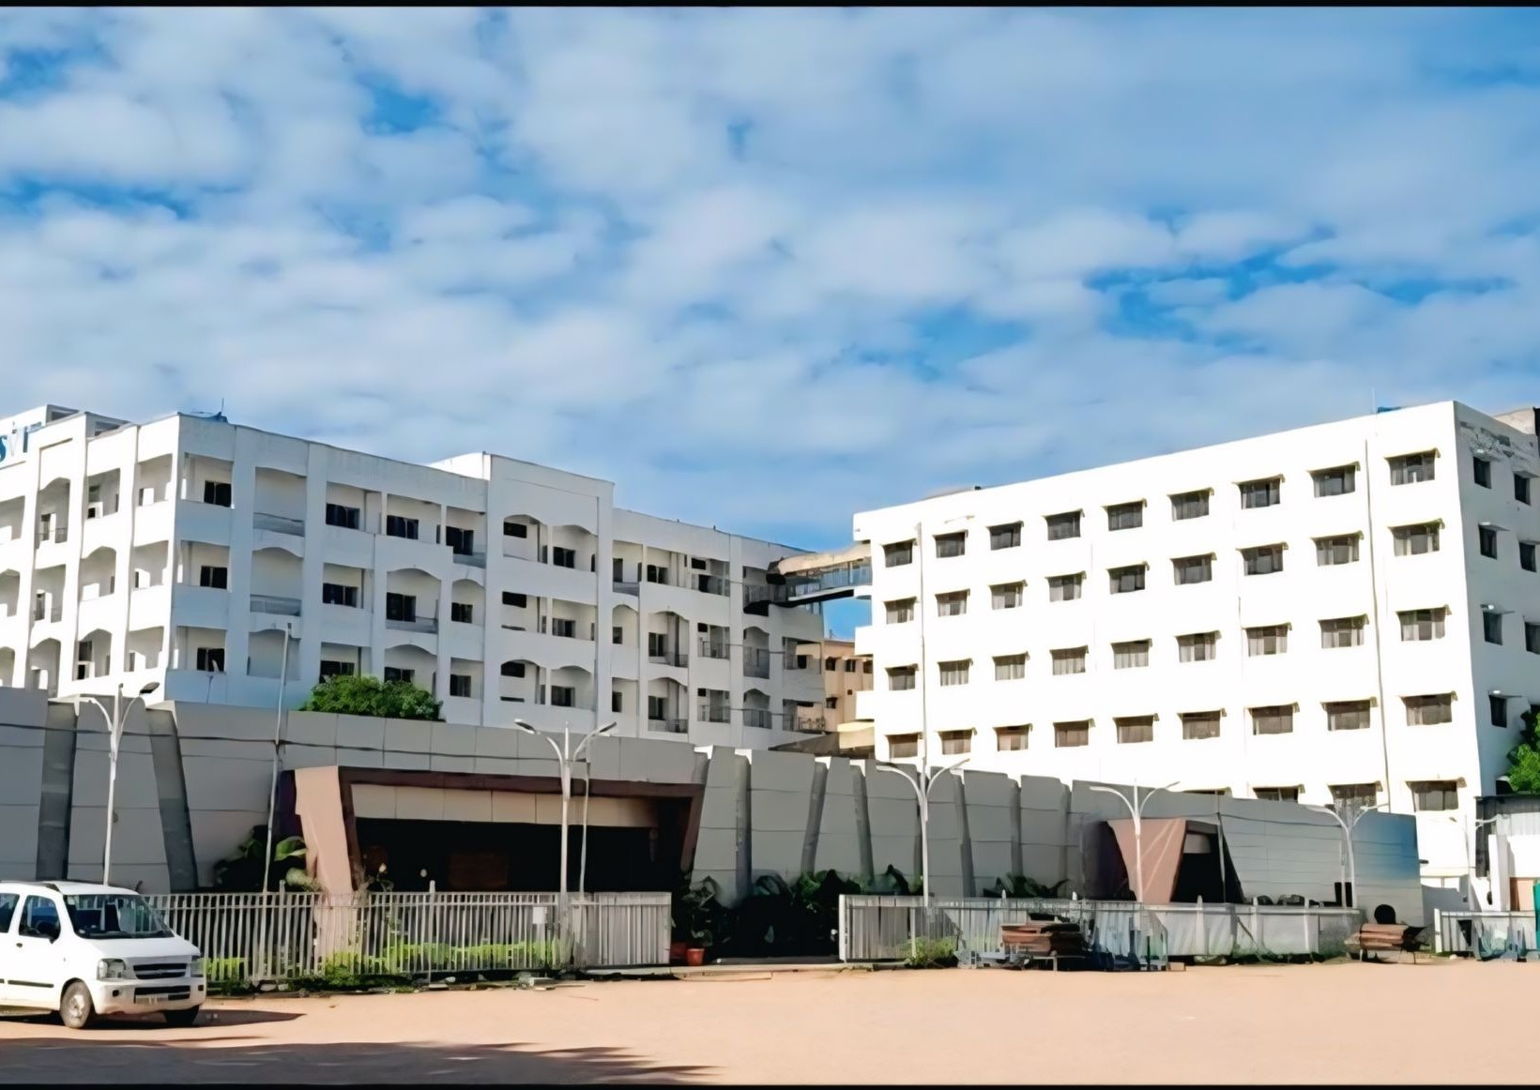
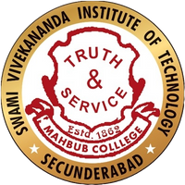
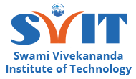


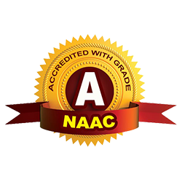
Mahbub College Campus, Patny Centre, S.D. Road, Secunderabad -500003, Telangana
72078 24778, 72078 24779 I
Swami Vivekananda Institute of Technology I
www.svit.ac.in I
newsletter@svit.ac.in
svit_official

TECHVANI

Voice of Youth
Power of Innovation

Newsletter
October 2025

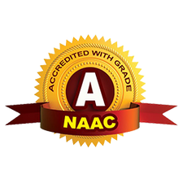

Swami Vivekananda Institute of Technology Under the Management of Mahbub College (MHSS)
AN UGC AUTONOMOUS INSTITUTION
Mahbub College Campus, S.D Road, Secunderabad-500003, T.G.
info@svit.ac.in October,2025 Vol.No. : 01 Issue No. 2510

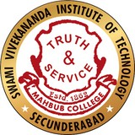
MANAGING COMMITEE of MHSS
Sri P.L. Srinivas, President
Sri N. Naresh Kumar Yadav, Vice President
bout

SVIT


Dr. K. Anil Kumar, Hony. Secretary
A
Sri C.S. Narsimha Rao, Hony. Jt. Secretary
Sri Syed. Nayeemuddin, Hony. Asst. Secretary
Sri Varanasi Bhagvath, Hony. Treasurer
Sri C.B. Namdev, Member
Sri M.P. Rabindranath, Member DR. N. Prem Narayan, Member Sri S. Padma Rao Member

GOVERNING BODY of SVIT
Dr. N. Prem Narayan, Chairman
Sri P.L. Srinivas, Hony. Secretary cum Correspondent
Sri M. P. Rabindranath, Member
Sri N. Naresh Kumar Yadav, Member
Dr. K. Anil Kumar, Member Dr. K. Suneel Kumar, Member Dr. K. Kasi Ratnam, Member Smt. Nishat Sultana, Member
Dr. B. Shankar Nayak, Member
Dr. J. Ujwala Rekha, University Nominee
Dr. D. Eshwar, Principal

Editors:
Pappu Ananya, AIML III yr Likith Talla, AIML III yr Kanak Sharma, AIML II yr Sai Deekshith, DS II yr

Linguistic Advisor : Mrs. Meenakshi Dhondi Aesthetic Advisor : Dr. Jyothi Shinde Advisor : B.Srinivas Rao, TPO

Highlights
Orientation Day
Induction Program Teachers' Day
GATE Examination Awareness Program Visit to Ramakrishna Math
SIH Internal Hackathon
Swami Vivekananda Institute of Technology is more than just a college—it’s a place where learning meets inspiration. With a wide range of undergraduate and postgraduate programs in engineering, SVIT focuses on blending strong academics with real-world exposure. Guided by experienced faculty and supported by modern infrastructure, students are encouraged to explore, innovate, and think beyond textbooks. The institute maintains close ties with industries, ensuring that students gain practical skills to face today’s challenges with confidence. Life at SVIT goes beyond classrooms, with opportunities in research, cultural events, and community service. Here, education isn’t just about building a career, but also about shaping responsible, well-rounded individuals ready to make a difference.

ditorial
E
TechVani
Dear Readers,
Welcome to the first edition of TechVani, the official newsletter of SVIT. This platform reflects the spirit of our campus—our ideas, achievements, and aspirations.
In today’s world, Artificial Intelligence is reshaping everything around us. Skills like prompt engineering and building smart chatbots are opening new opportunities for engineers. Beyond coding, the ability to design human-AI interactions and innovative workflows is becoming just as important.
For our engineering graduates, this is a chance to step into a future where adaptability, creativity, and strong fundamentals will define success. Let TechVani be both a reflection of who we are today and a guide toward the exciting possibilities ahead.
Happy Reading!
The Editorial Team

Message From The Management

It gives me immense pleasure to witness the launch of our institution's monthly newsletter—an initiative that reflects the vibrant spirit, innovation, and collaborative ethos of our engineering community. This platform is not just a window into our academic and extracurricular achievements, but a celebration of our students’ creativity, our faculty's dedication, and the unrelenting pursuit of excellence that defines our college. I extend my heartfelt congratulations to the editorial team and contributors for taking this significant step toward documenting and sharing our journey.
As Chairman, I firmly believe that such initiatives foster a sense of belonging and intellectual curiosity among all stakeholders. You have my full support and encouragement as you continue to make this publication a dynamic voice of the college.
TechVani

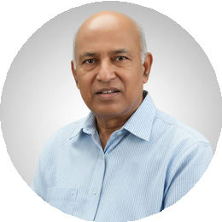

Dr. Prem Narayan
Chairman, Governing Body of SVIT

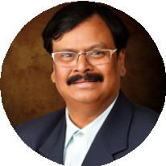
Sri. P.L.Srinivas President, Managing Committee of MHSS Hony. Secretary cum
Correspondent, Governing Body of SVIT

Congratulations to everyone involved in launching the college newsletter—an exciting initiative that promises to bridge communication, share inspiration, and chronicle the progress of our academic family. A newsletter serves as a mirror of the institution, and I am confident that this endeavor will shine a light on the incredible talent, innovation, and dedication thriving within our campus. From breakthrough projects to cultural highlights and student achievements, this publication will play a key role in nurturing a sense of unity and purpose. I deeply appreciate the dedication shown by the editorial team, and I assure you of my unwavering support as you carry forward this valuable and visionary mission.

The launch of our monthly newsletter is a commendable initiative and a true reflection of the proactive and progressive mindset of our institution. I applaud the team for bringing this vision to life and providing a platform that not only informs but also inspires. This publication will surely become a vital medium through which knowledge, achievements, ideas, and innovations are exchanged and celebrated within the college community. It is through such creative ventures that we cultivate a culture of communication, collaboration, and continuous learning. I remain firmly committed to supporting this initiative and look forward to witnessing the newsletter grow into a defining element of our institutional identity.

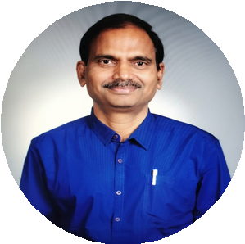
Dr. K.Anil Kumar
Hony. Secretary, Managing Committee of MHSS

Message From The Faculty



Dr. Eshwar Dara
Principal, SVIT
Dear Students,
It gives me immense joy to see the launch of TechVani, our very own newsletter at Swami Vivekananda Institute of Technology. This platform is not just about news and updates—it is about capturing the heartbeat of our campus, where ideas, innovations, and achievements converge.
We live in an age where technology changes faster than we can imagine. Artificial Intelligence, Robotics, and digital transformation are not just buzzwords, they are realities shaping the world you will lead tomorrow. As engineers, your role is not limited to acquiring skills but also to applying them with creativity, responsibility, and courage. I urge every student to participate actively, contribute articles, and share experiences. Let TechVani be your voice, your mirror, and your inspiration.

Dear Students, Faculty, and Friends,
It gives me great pleasure to welcome you to the first edition of TechVani, the official newsletter of SVIT. This initiative is a step towards creating a lively platform where ideas, achievements, and creativity converge.
TechVani
Engineering today is not confined to textbooks or examinations. It is about curiosity, innovation, and the courage to explore uncharted territories. Technology continues to evolve—from Artificial Intelligence, Cloud computing and Cyber Security to renewable energy and smart devices—and each advancement brings new challenges and greater opportunities. As future engineers, you must not only keep pace with these changes but also develop the ability to lead them.
Through TechVani, we will showcase the vibrancy of our campus life— academic milestones, departmental initiatives, student success, and the spirit of innovation that defines our institution. I encourage you all to see this newsletter as more than a bulletin; let it be a source of inspiration, a platform for your voice, and a record of your journey.
Let us embrace Swami Vivekananda's vision: to channel knowledge into character and technology into service for society.

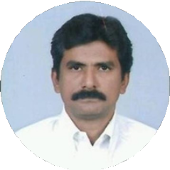

Prof. Raghuraj Singh
Dean Academics, SVIT

Note from Editorial Board : “TechVani is more than just a newsletter—it is a celebration of our campus life, achievements, and aspirations. We invite every student to contribute their voice and creativity to make this platform a vibrant reflection of SVIT.”

Overcoming Exam Stress
“Exams are not a test of life , but a step in learning . Stay calm , stay focused , and let your effort speak louder than your stress.”


Exams are not just a test of knowledge—they often feel like a test of nerves. Sleepless nights, racing thoughts, and endless cups of coffee are familiar companions for many students. Yet, stress does not have to be the villain in your academic story. With the right mindset and strategies, exam time can be transformed into a period of focus, growth, and even confidence.
The first step in overcoming exam stress is planning. Most of the anxiety stems from last-minute preparation and unclear study routines. Creating a simple timetable, breaking the syllabus into small, manageable parts, and setting realistic daily goals can make the mountain of preparation look like a series of small, climbable hills.
Second, remember the power of balance. Marathon study sessions with no breaks may seem heroic, but they exhaust the mind. Short breaks, light exercise, or even a five-minute breathing routine can refresh your focus. Sleep, often sacrificed during exams, is actually the brain's best tool for memory retention.
i
Third, positive self-talk is crucial. Replace thoughts like "I can't do this" with "I am prepared and improving." Our mind often believes the story we repeatedly tell it—so tell it a story of resilience and capability.
Finally, put things in perspective. Exams are important, but they do not define your entire worth or future. Think of them as stepping stones, not stumbling blocks. Even if one result does not go your way, the skills of discipline, focus, and problem- solving you build during preparation will serve you for life.
TechVan
Stress is natural, but it doesn't have to overpower you. With preparation, balance, and perspective, you can turn exam season into a showcase of your strengths rather than your fears.

Quiz : Did You Know ?
- By Editorial Team

- The first computer mouse, invented in 1964, was made of .
- More than % of the world's currency exists only in digital form—not as physical cash.
- Your today has more computing power than NASA had when it sent astronauts to the moon in 1969.
- Bluetooth technology was named after a 10th- century Scandinavian king, Harald “ ” Gormsson.
- The keyboard layout was designed in 1873 to slow down typists so typewriter keys wouldn’t jam.
- By the end of 2025, experts predict the world will generate exabytes of data per day.
- The first 1GB hard drive, introduced in 1980, was the size of a refrigerator and weighed over kilos.
- The very first email ever sent was simply the text “ .”
- The word “ ” is still one of the most common passwords worldwide!
- By 2030, it’s expected that there will be
billion IoT devices connected worldwide.
- The first “smart appliance” was a Coca-Cola vending machine at University in 1982.
- IoT sensors are being embedded in streetlights, reducing power consumption by up to % in smart cities.
- technology can support 1 million IoT devices per square kilometer.
- Over % of global manufacturing firms now use IoT for predictive maintenance.
- The term “Information Technology” first appeared in a Harvard Business Review article.

Harnessing Renewable Energy with the Power of
IT
Renewable energy—such as solar, wind, hydro, and bioenergy—has become one of the most crucial solutions to meet the world’s rising energy needs while addressing environmental
concerns. However, generating this energy is not just about installing more solar panels or building additional wind turbines.
The real challenge lies in using this energy efficiently. This is where Information Technology (IT) comes in. ITl has the power to make renewable energy systems smarter, more reliable, and more sustainable by optimizing how energy is produced, stored, and consumed.
With the right use of technology, renewable energy can transform from being an alternative to becoming the primary, dependable source of power for the future

The Role of IT in Renewable Energy

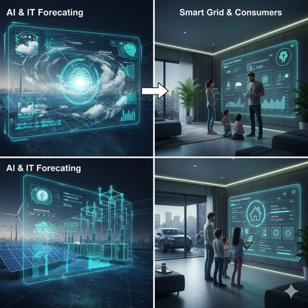
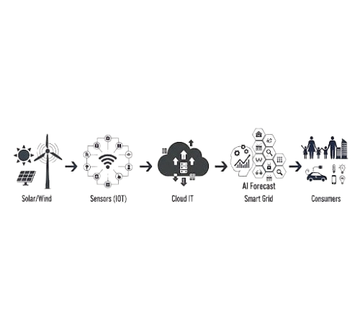
Modern renewable energy systems generate vast amounts of data. Every solar panel, wind turbine, and smart meter produces streams of information on performance, weather impact, and energy usage. Here, IT plays a transformative role. With advanced data analytics, operators can predict when a wind turbine needs maintenance, or when a solar grid will generate peak power, reducing downtime and maximizing efficiency.

Another major contribution comes from the Internet of Things (IoT). IoT-enabled sensors track everything from sunlight intensity to grid demand in real-time. These devices, when connected to cloud platforms, allow energy companies to balance loads, store surplus power, and even redirect energy to where it is needed most.
TechVani

Artificial Intelligence (AI), integrated with IT systems, takes this further by forecasting energy supply and demand patterns with remarkable accuracy. For example, AI can predict cloudy weather and adjust energy distribution from other renewable sources, ensuring uninterrupted supply.
On the consumer side, IT enables the creation of smart grids and smart homes, where users monitor and optimize their own energy consumption through mobile apps and dashboards. This not only saves costs but also creates awareness of sustainable living.
In short, IT is the silent force that makes renewable energy more than just an alternative—it makes it a dependable, scalable solution for the future.

“Together , technology and clean energy can power the world more responsibly.”

5 TECHVANI

Events this Month

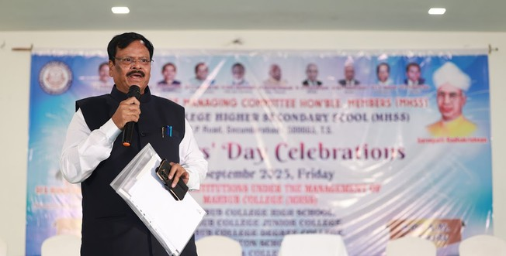
Teachers' Day Celebrations
Teachers’ Day was celebrated on 5th September in the SVIT Auditorium, where faculty members from all six institutions of the Mahbub College Group of Institutions came together for a day of appreciation and joy.
Sports competitions added a lively touch to the occasion, with prizes awarded to the winners, while the spirit of the event reflected gratitude, camaraderie, and the strong bond shared among teachers.

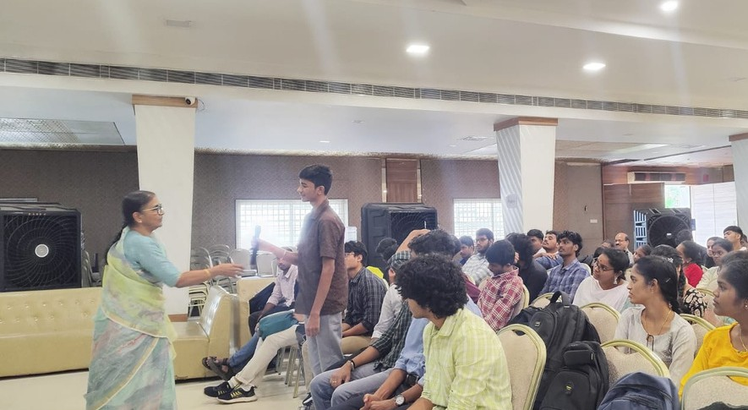

Visit to Ramakrishna Math
TechVani

On 11th September, first-year students visited Ramakrishna Math for the Silver Jubilee Celebrations – Sampriti Divas, gaining inspiration and a sense of reflection in the serene environment.

Orientation & Induction Program

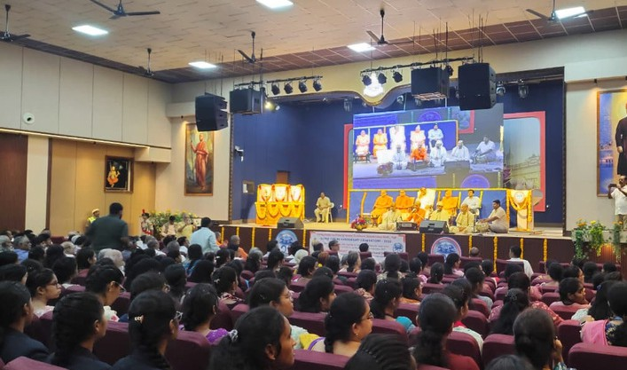
First-year students were warmly welcomed through an engaging induction program that introduced them to college life, its values, and opportunities, helping them begin their journey with confidence.

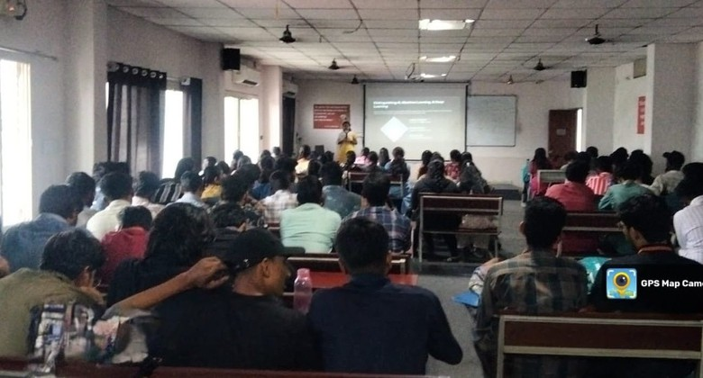
GATE Examination Awareness Program
Held on 9th September, the session guided students on the GATE exam, its benefits, and preparation strategies, inspiring them to aim higher in their academic journey.

IBM Workshop on AI Fundamentals
Conducted on 20th August, the IBM workshop introduced students to the world of Artificial Intelligence with hands- on learning, sparking curiosity and innovation.

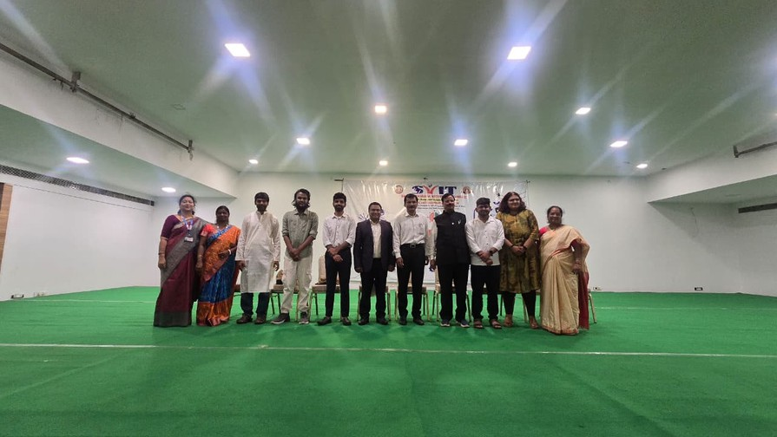
Smart India Hackathon 2025
A three-day SIH Internal Hackathon was held from 15th to 17th September 2025, bringing together students with innovative ideas and problem-solving spirit.
The event was made even more special with SVIT alumni serving as judges, offering guidance and encouragement to the participants.
The hackathon concluded with a vibrant prize distribution ceremony, where the management and judges recognized the creativity, hard work, and teamwork of the winners, leaving all participants motivated and inspired.

Our Proud Alumnus

We take immense pride in celebrating the achievements of our distinguished alumna, Narapureddy Mourya, an IAS officer from the 2018 batch of the Andhra Pradesh cadre. A graduate in Electronics and Communication Engineering (B.Tech) from SVIT College, Secunderabad, she has consistently demonstrated excellence and dedication in her service career. Over the years, she has held prestigious roles, including Municipal Commissioner, and is now serving as the Commissioner of Tirupati, taking charge of one of the most important administrative positions in the state. Her remarkable journey from the classrooms of SVIT to the corridors of public service continues to inspire our students to dream big and serve society with commitment and integrity.


Narapureddy Mourya IAS, Joint Collector Tirupathi

Our alumnus, Poornima Ramachandran, serving as a judge, is giving away the prizes."

Second Year
Syed Yonus
Smart India Hackathon Winners
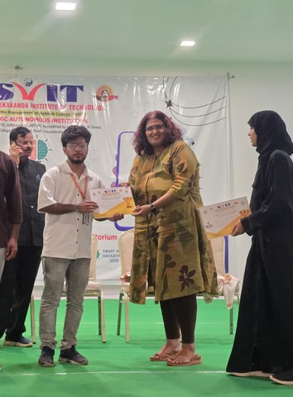
The Smart India Hackathon witnessed remarkable talent and innovation from our students. After an intense round of problem-solving, creative pitching, and teamwork, the results were announced with much excitement.
🏆 1st Prize – Impacteers
A.J. Abhishek(AIML IIIyr), Aman Kumar Sharma(AIML IIIyr), Kanaka Sree(AIML IIIyr), Rishika Dasari(DS IIIyr), Rishi Sharma(AIDS IIIyr), Likith Talla(AIML IIIyr)
🥈 2nd Prize – Byte Blenders (DS IVyr)
TechVani
Jeevangi Srineketh, Samiullah Syed Hussain, Sree Harsha Vadlamudi, Sifat Singh Rajpal, Vedika Nagodi, Nomula Keerthi
🥉 3rd Prize – Safe Safar (DS IVyr)
Mohammed Mustafa, Sita Ganesh, Sagar Rajarapu, Chepuri Karthik, Reem Mohammed Arif, Azeeza Begam
👏 Heartfelt congratulations to all the winners and participants for making the event a grand success. Your hard work, dedication, and innovative spirit continue to make our college proud!

Internship Spotlights

Fourth Year
Mohammed Mustafa

Inspiring Work Digitech (2nd Year)

Third Year
Advait Joshi
Tech Peek / DRDO,RCI / IIT Kanpur / IIT Patna / Inspiring Wave DigiTech Pvt Ltd
Manchikanti Prachalth
Inspiring Wave DigiTech Pvt Ltd
J. Shiva Shankar
Inspiring Wave DigiTech Pvt Ltd/Voila Code
Manas Kandapally
Inspiring Wave DigiTech Pvt Ltd
Varun Bejjugum
Inspiring Wave DigiTech Pvt Ltd
68M Hospitality Services Pvt Ltd

Syed Samiullah Hussain
Inspiring Wave DigiTech Pvt Ltd

Rishab Jain
Inspiring Wave DigiTech Pvt Ltd

Jeevangi Sriniketh
Inspiring Wave DigiTech Pvt Ltd

Sree Harsha
Inspiring Wave DigiTech Pvt Ltd

“The success of our students is the pride of our institution”

SUDOKU
2

4

5

3
5
1

6

5
8

3

4
2

5

1

3
4

2

7

1

Tips :
Start with the easiest rows/boxes Use Pencil Marks
Look for lone Candidates Cross-check lines & boxes
3

1

9
4

2

9

5

Quiz : Answers
1) wood 2) 90 3) smartphone 4) Bluetooth 5) QWERTY 6) 463 7) 200 8) QWERTYUIOP 9) password 10) 29 11) Carnegie
Mellon 12) 40 13) 5G 14) 35 15) 1958
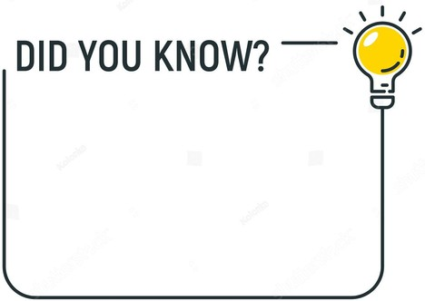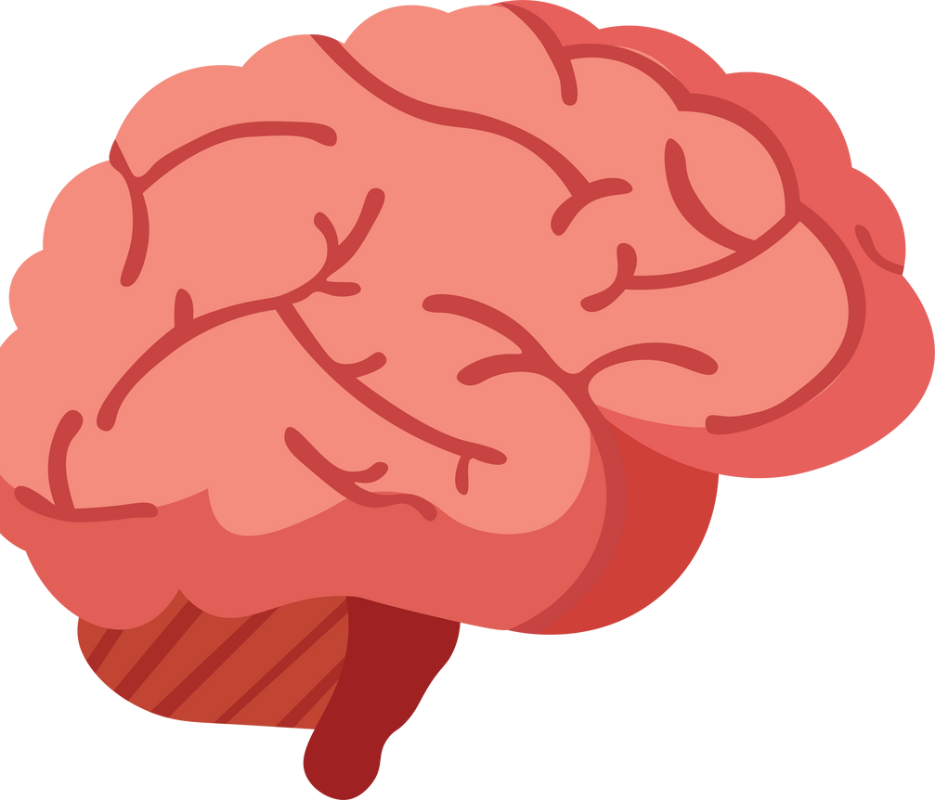

“Virtual reality has a rich history. The first VR headset was invented in 1968!”
“Coding is the new literacy.
Knowing how to code can open doors to new opportunities!”
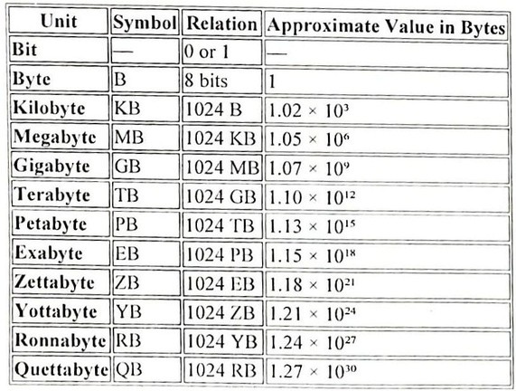
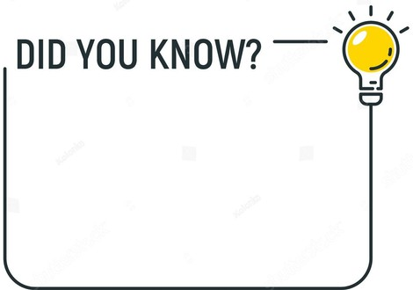

Answer : In Next Month
7

5

1

9

4
ni
ch
Digital Memory Scale :Understanding Data Units
“The world's fastest supercomputer. It can perform over 200 petaflops (1 petaflop = 1 million billion calculations per second)!”
Va
Te

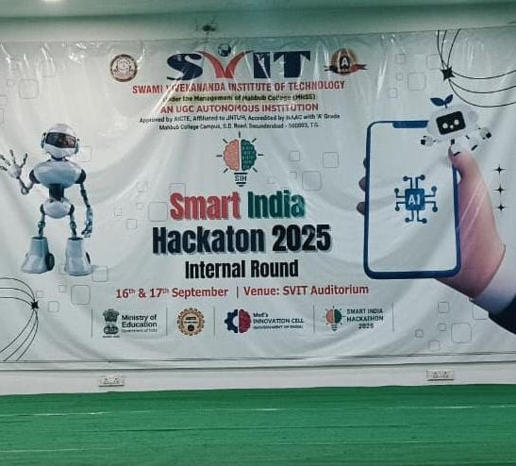
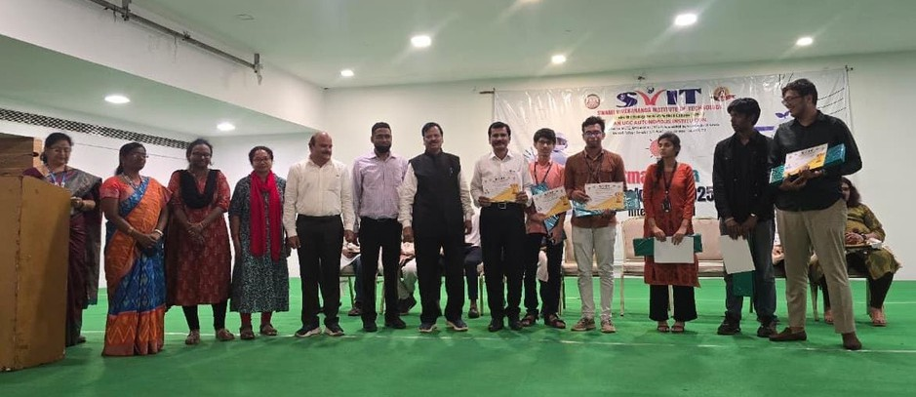
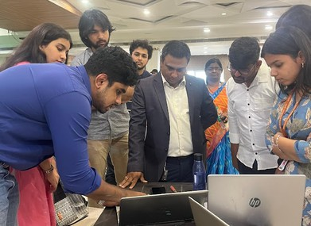
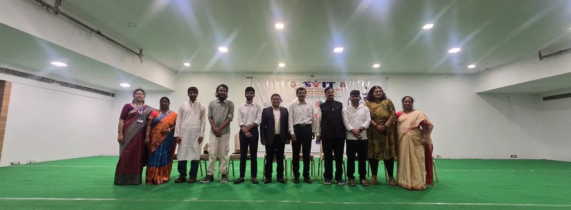
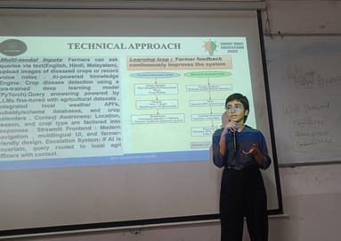

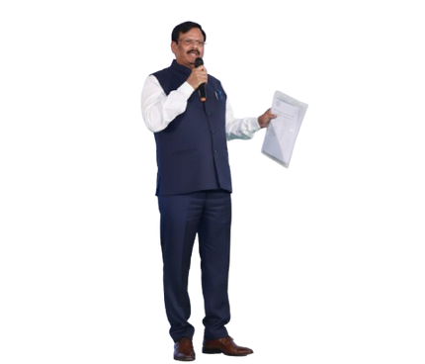
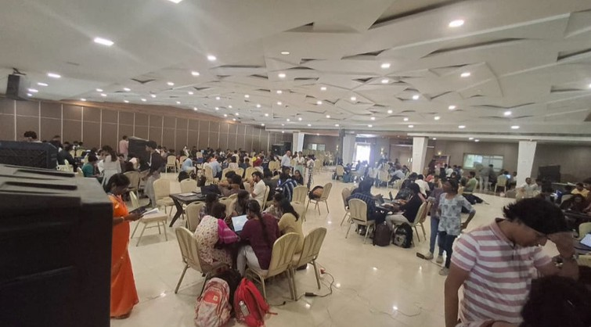
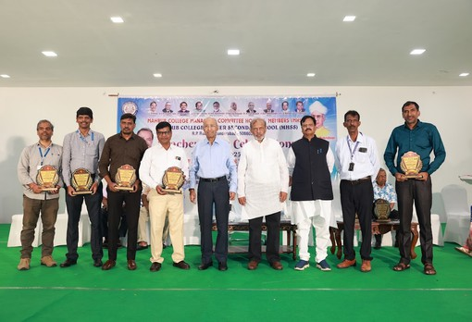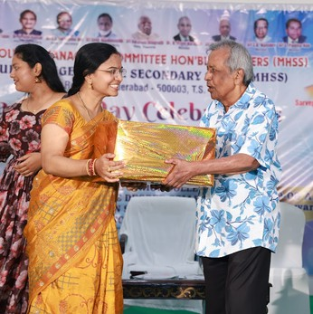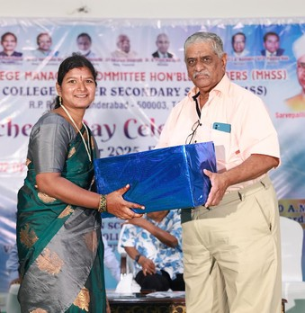
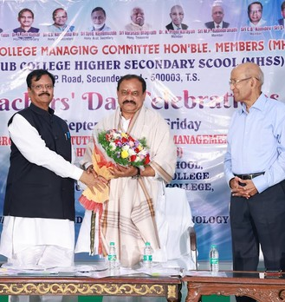
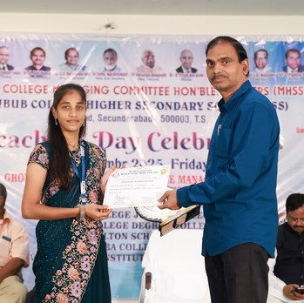
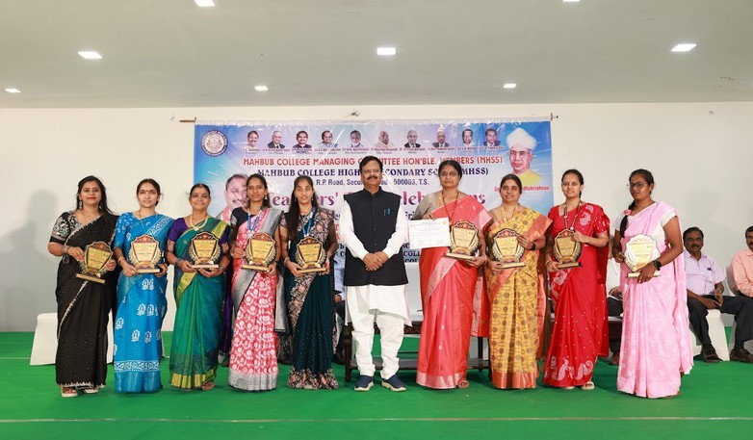

Teachers' Day Celebrations

Smart India Hackhaton
ni
Tech
Va

9 TECHVANI

