**SYNOPSIS**

# EDU-CARE SYSTEM

**AIM :**

Helping students to connect with people who could support them with all electronic gadgets for their education.

**Overview :**

Edu-care system is a web app developed to help students who are

financially weak during this hard times of pandemic by helping students to connect

with people who could support them with all electronic gadgets for their education.

The whole world is adjusting to the reality of the covid-19 pandemic

by finding alternating to the disruption caused thus far. Corporates are allowing their

work forces to work from home while schools and colleges are conducting online

classes. As the country takes to online education the current pandemic is impacting

students who are financially weak. Such students has no electronic gadgets for their

education.

This project is developed to help the students by eradicating the

scarcity of electronic devices such as TVs, mobile phones ,computer systems hence

ensuring education to all irrespective of financial conditions of families.

All the details of the eligible students are collected through school and

the students will upload their income certificates so that the information collected will

be more trust worthy and accurate and would make it more easy to for the students

to access to the website.

## MODULES

It consist of 4 modules.

1. Administration
2. Organisation
3. School
4. Student

## 1• Administration.

* **View/approve/delete Organisations**
* **View/approve/delete Schools.**
* **View products in particular organisation and distribute products in school**
* **View students in particular schools.**
* **Add events and view/edit/delete.**
* **Add notifications**
* **View sponsor organisation**

## 2• Organisation

* + - **View profile edit/delete**
    - **Add product and view/edit/delete the product**
    - **View events**
    - **View notifications**
    - **View school and particular students**
    - **Add feedback**
    - **Add cash as payment and edit/delete the cash details**

## 3• School

* + - **View profile edit/delete**
    - **Add student and view/edit/delete the student**
    - **View events**
    - **View notification**
    - **Add feedback**
    - **Add useful product details**

## 4• Student

* **View profile and edit/delete**
* **View distributed product/cash**
* **Add feedback**

**FRONT END :** HTML, JavaScript, PHP, CSS

**BACK END :** mysql

**ADVANTAGES :**

* Time saving
* Easy to consult doctor
* Security
* Easy to recover patient details

# CONTENTS

## 1. INTRODUCTION 2. SYSTEM STUDY & ANALYSIS

2.1. Existing System

2.2. Proposed System

2.3. Feasibility Study

2.4. Software Requirement Specification

## 3. SYSTEM CONFIGURATION 4. HARDWARE CONFIGURATION

4.1. About Windows

4.2. About Back End

4.3. About Front End

## 5. SYSTEM DESIGN

5.1. System Flow

5.2. DFD

5.3. DB Design

5.4. ER Diagram

5.5. Table Design

5.6. Normalization

5.7. Input Design

5.8. Output Design

**6. SYSTEM TESTING & IMPLEMENTATION 7. SYSTEM SECURITY 8. SCREEN LAYOUTS 9. CONCLUSION 10. BIBLIOGRAPHY**

# SYSTEM STUDY AND ANALYSIS

System analysis is a detailed study of the various operations performed by the system und their relationship within and module of the system. The phase involves the study of parent system and identification of the system objectives. Information is collected by all people who are affected by or who use the system. During analysis data are collected on variable file decision point and transaction handle by the parent system. It involves gathering the necessary information and using the structured tool for analysis.

This includes the information of existing system and their drawback, designing a new system and conducting cost and benefits analysis, In brief, analysis specifies what the system does.

## EXISTING SYSTEM

The medical field has made remarkable progress in end of twentieth and the initial twenty first centuries. This emerges high specialized hospitals for serving patients. Nowadays most of the hospitals are overcrowded with patients. It may affect patients symptoms, clinical outcome. and satisfaction. It can also affect physician's effectiveness, causing frustration among medical staff. This overcrowding is due to lack of effective queue management system in hospitals, which is due time required for each patient would be uneven based on how much time doctor takes and other tasks such as scanning. pharmacy, testing, etc. This is a challenging and complicated job because every patient in queue may came just for consultation of doctor or check- up or test etc. Each treatment task can have varying time requirements for each patient of different age groups.

## DRAWBACKS

* Lack of effective queue management system in hospitals
* how much time doctor takes and other tasks such as scanning, pharmacy. testing,

etc

* effectiveness, causing frustration among medical staff

## PROPOSEDSYSTEM

The proposed system focuses on helping patients complete their treatment tasks in a predictable time and helping hospitals schedule each treatment task queue and avoid overcrowded and ineffective queues. In this system. algorithm model is trained based on hospitals historical data. The waiting time of each treatment task is predicted by this algorithm, which is the sum of all patients waiting times in the current queue. Then. according to each patients requested treatment tasks. this hospital system recommends an efficient and convenient treatment plan with the least waiting time for the patient. To compute all of the required treatment tasks in the shortest waiting time, the waiting time of each task is predicted in real-time. Because the waiting queue for each task updates, the queuing recommendation is recomputed in real-time. Therefore, each patient can be advised to complete his treatment activities in the most convenient way and with the accurate waiting time. [4] The proposed system starts with patient registering with the system, once registered he will login to the system where he can book an appointment of a particular date. The patient will get notified on his scheduled date through message alert. Once he consults with doctor and gets medicine prescription, he will receive medicine alerts on periodic basis until his medicine course gets completed.

## FEASIBILITY STUDY

Feasibility study is a test of a system proposal according to its workability, impact on the organization, ability to meet user needs and effective use of the available resources. The objective of feasibility study is not to solve the problem but to acquire a sense of its scope.

Four key combinations are involved in the feasibility analysis. They are:-

* **ECONOMICAL FEASIBILITY:**

Economic analysis is the most frequently used method for evaluating the effectiveness of a client system. More commonly known as cost/benefit analysis, the procedure is to determine the benefits and savings that are expecting from a client system and compare them with cost.

* **TECHNICAL FEASIBILITY:**

Technical feasibility centers on the existing computer system (hardware, software etc) and to what extent it can support the proposed addition. The benefits such as high accuracy, minimum response time and user friendliness of the proposed system over weights cost for designing and implementing the new system.

* **BEHAVIOURAL FEASIBILITY:**

People are inherently resistant to change, and computers have been known to facilitate change. An estimate should be made of how strong a reaction the user staff is likely to have towards the development of a computerized system. It is common knowledge that computer installations have something to do with turnover transfers, retaining and changes in employee job status. Therefore, it is understandable that the introduction of a client system requires special effects to educate, sell and train the staff on new ways of conducting business.

* **OPERATIONAL FEASIBILITY:**

The system is operationally feasible; it is made so easy that operator will not encounter any problem during working, as it is very user-friendly. Operational feasibility checks the scope of the system. The system under consideration should have enough operational research.

It is observed that the proposed system would provide a very interactive means to share information and have a far and wide range. The proposed system would make the information more interactive. Thus operation feasibility of the proposed system id found to be high.

### 2.4 SOFTWARE REQUIREMENT SPECIFICATION

Software Requirements

|  |  |
| --- | --- |
| OS | : Windows 10, Android. |
| Software | : Wamp server |
| Language | : PHP |

## 3. HARDWARE CONFIGURATION

In the software development process, the requirement phase is the first software engineering activity. It translates ideas or views into a requirements document. The phase is a user dominated phase. Defining and documenting the user's requirements in a concise and unambiguous manner is the first major step to achieve a high quality product. The requirement phase encompasses a set of task that helps to specify the impact of the software on the organization, customer's need and how users will interact with the developed software. The requirements are the basis of system design. If the requirements are not correct the end product will also contain errors.

### HARDWARE REQUIREMENTS

|  |  |
| --- | --- |
| o Processor | : Intel(R) Core T"i7 |
| o Hard Disk | : 1 TB |
| o Monitor | : 15 VGA Color |
| o RAM | : 8Gb |

# 4. SOFTWARE CONFIGURATION

## 4.1. ABOUT WINDOWS

### Windows

Microsoft Windows is an operating system for computers made by the United States based company Microsoft. Windows is used by almost 90% of desktop and laptop computers.

The first version of Windows, Windows 1.0, came out on November 20, 1985. Since then, new versions of Windows go on sale every three years. The newest version, Windows 10, came out July 29, 2015. Most new personal computers come with Windows 10. However, some older or cheaper personal computers may come with Windows 8.1 or Windows 7.

#### Windows 10

Microsoft announced Windows 10 in September 2014, skipping Windows 9. Version 10 includes the Start menu, which was absent from Windows 8. A responsive design feature called Continuum adapts the interface depending on whether the user works with a touch screen or a keyboard and mouse for input. New features like an onscreen back button simplified touch input. Microsoft designed the OS to have a consistent interface across devices including PCs. laptops and tablets.

## 4.2 ABOUT FRONT-END

### PHP

What is PHP?

PHP is an acronym for "PHP: Hypertext Preprocessor"PHP is a widely- used, open source scripting language. PHP scripts are executed on the server PHPIS free to download and use

What is a PHP File?

PHP files can contain text, HTML, CSS, JavaScript, and PHP code PHP code is executed on the server, and the result is returned to the browser as plain HTML

PHP files have extension ".php" What Can PHIP Do?

PHP can generate dynamic page content

PHP can create, open, read, write, delete, and close files on the server

PHP can collect form data

PHP can send and receive cookies

PHP can add, delete, modify data in your database

PHP can be used to control user-access

PHP can encrypt data With PHP you are not limited to output HTML. You can output images, PDF files, and even Flash movies. You can also output any text, such as XHTML and XML.

Why PHP?

PHP runs on various platforms (Windows, Linux, Unix, Mac OS X, etc.) PHP is compatible with almost all servers used today (Apache, IIS, etc.) PHP supports a wide range of databases PHP is free. Download it from the official PHP resource: [www.php.net.](http://www.php.net/) PHP is easy to learn and runs efficiently on the server side

What's new in PHP 7

PHP 7 is much faster than the previous popular stable release (PHP 5.6)

PHP 7 has improved Error Handling

PHP 7 supports stricter Type Declarations for function arguments

PHP 7 supports new operators (like the spaceship operator: <=>)

## 4.3 ABOUT BACK-END

PHP MYSQL Database With PHP, you can connect to and manipulate databases. MYSQL is the most popular database system used with PHP.

What is MYSQL?

MYSQL is a database system used on the web

MYSQL is a database system that runs on a server

MYSQL is ideal for both small and large applications

MYSQL is very fast, reliable, and easy to use

MYSQL uses standard SQL

MYSQL compiles on a number of platforms

MYSQL is free to download and use

MYSQL is developed, distributed, and supported by Oracle Corporation

MYSQL is named after co-founder Monty Widenius's daughter: My

The data in a MYSQL database are stored in tables. A table is a collection of related data, and it consists of columns and rows.

MySQL is a freely available open source Relational Database Management System (RDBMS) that uses Structured Query Language (SQL).

SQL is the most popular language for adding, accessing and managing content in a database. It is most noted for its quick processing, proven reliability, ease and flexibility of use. MYSQL is an essential part of almost every open source PHP application. Good examples for PHP & MYSQL-based scripts are WordPress, Joomla, Magento and Drupal.

One of the most important things about using MySQL is to have a MYSQL specialized host. Here are some of the things SiteGround can offer:

We have long experience in providing technical support for MYSQL-based web sites. Thanks to it our servers are perfectly optimized to off

# 5. SYSYEM DESIGN

## 5.1 SYSTEM FLOW

There are five modules in this project:

1. ADMIN MODULE
2. PATIENT MODULE
3. DOCTOR MODULE

1.ADMIN MODULE

Administrators shall usually do anything on the library, in all pages administrator is responsible for updating and maintenance of the website content such as adding/removing information. Admin can manage services, check bookings and reports.

1. PATIENT MODULE
2. DOCTOR MODULE
3. LAB MODULE
4. PHARMACY MODULE

## 5.2 DATA FLOW DIAGRAM (DFD)

Data flow diagram is used to define the flow of system and its resources such as information. Data flow diagrams represent one of the most ingenious tools used for structured analysis. A data flow diagram (DFD) as it is shortly called is also known as bubble chart. It has the purpose of clarifying system requirements and identifying major transformation that will becomes programs in decomposes the requirement specifications down to the lowest level of details. A DFD consist of a series of bubble joined by lines. The bubbles represent data transformations and lines represent flow in the systems.

In normal conventional DFD have four major symbols:

**Rectangle**, this defines source or destinations of data

**Arrow**, which shows data flow

**Circle**, which represents a process

**Open rectangle**, which shows a data store

## 5.3 DATABASE DESIGN

As large amount of data is stored, the database is designed in such a way that the searching process takes less me and the data stored are not repeated. Mostly all tables are designed and indexed with a key. Most of the tables contain identification number such that, the space used to store is reduced to maximum. The database is password protected. The database for the system is designed in such a manner that it can store data with minimum redundancy to serve many users quickly and efficiently. Also the following objectives are considered while designing the database. Controlled redundancy is achieved using well designable tables. While designing the database we also consider about the independence, each of use, accuracy and integrity and storing information at low costs. By selecting Google Cloud Fire store and using Database designing practices we achieved data independence, privacy and security easy recovery from failure and increased performance. 5.5 TABLE DESIGN Collection- Gallery Document

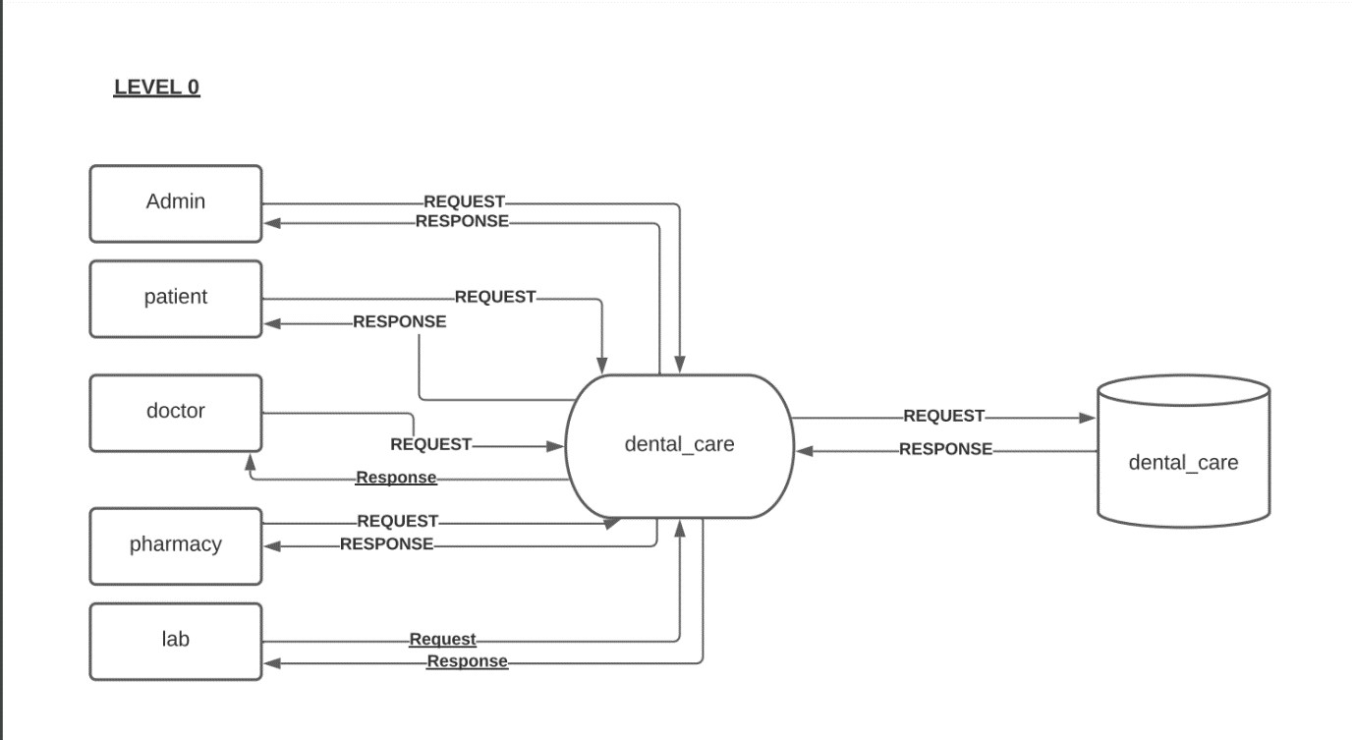

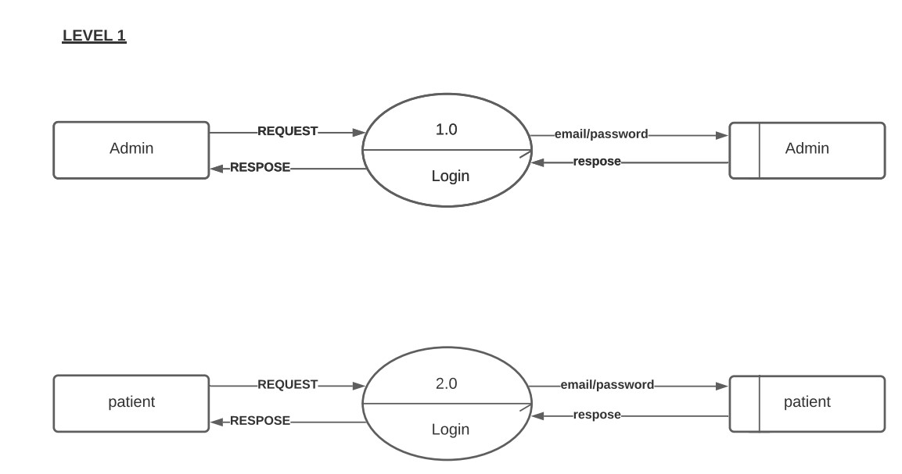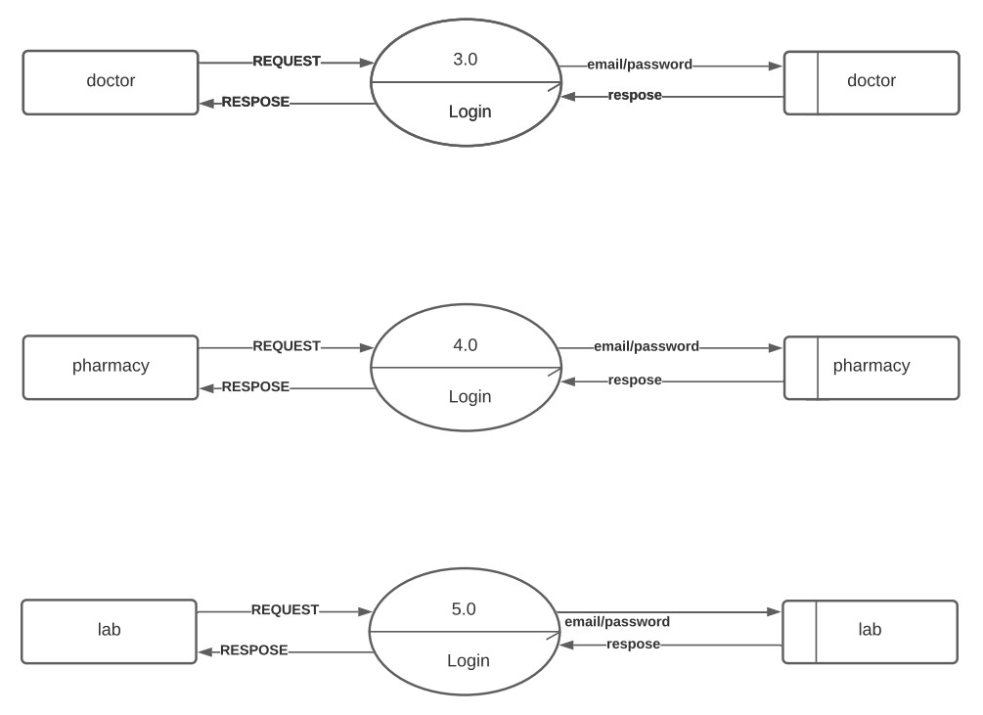

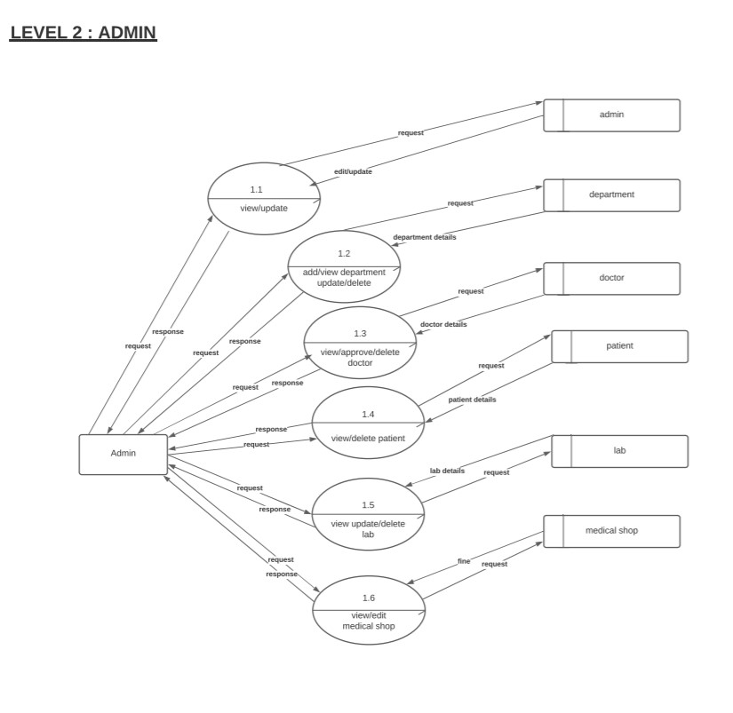

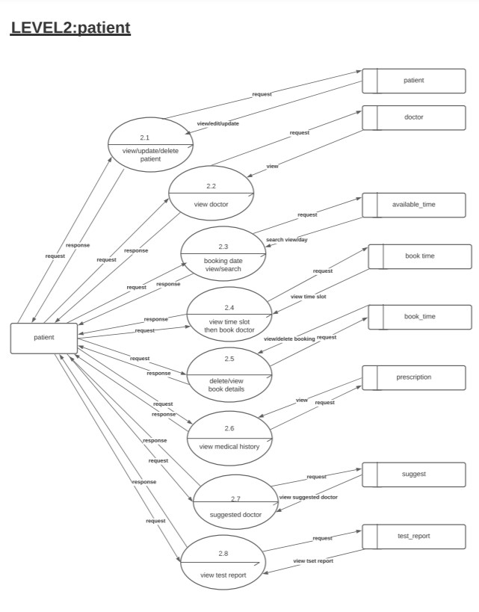

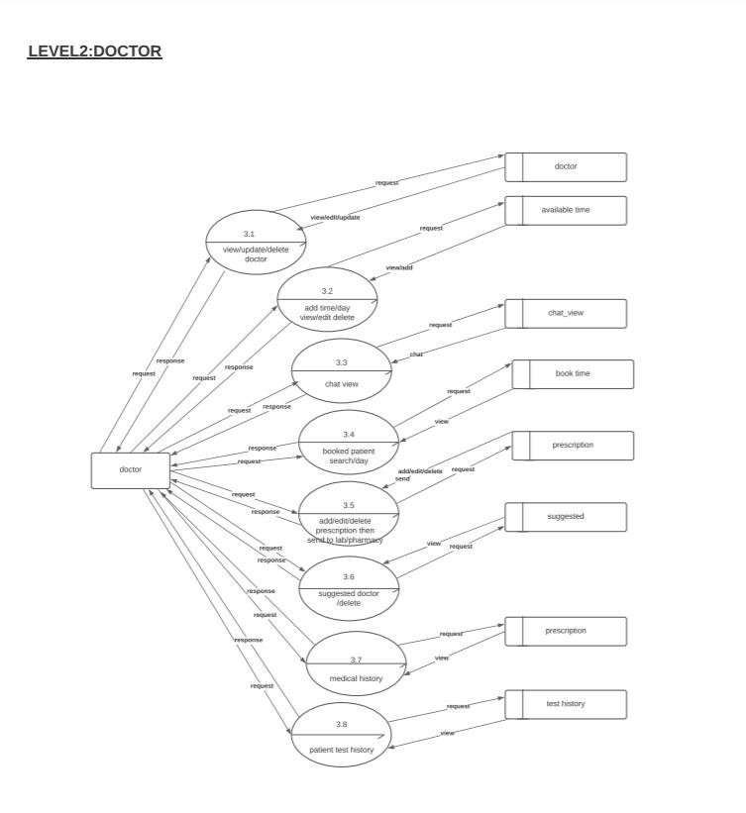

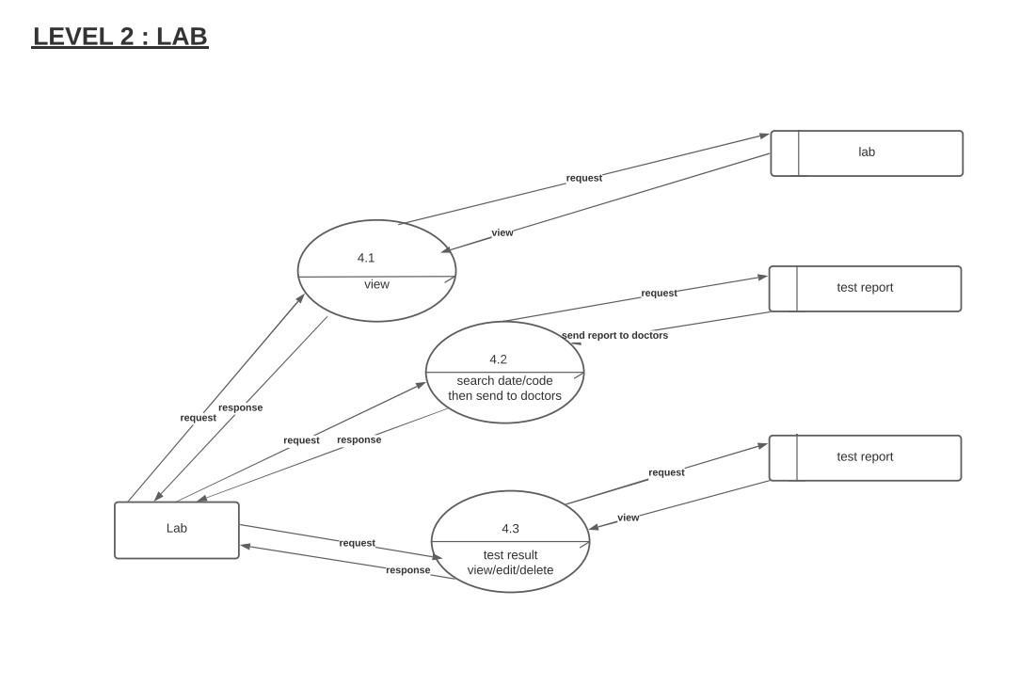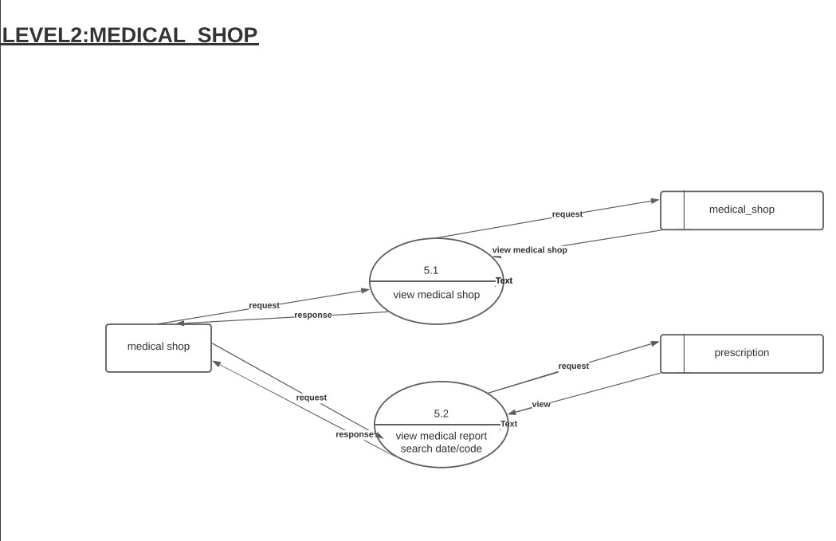

## 5.4 ER Diagram



• • • •



•

•

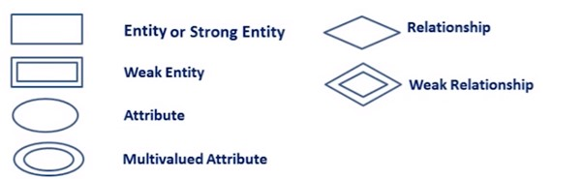

ER Diagram Symbols

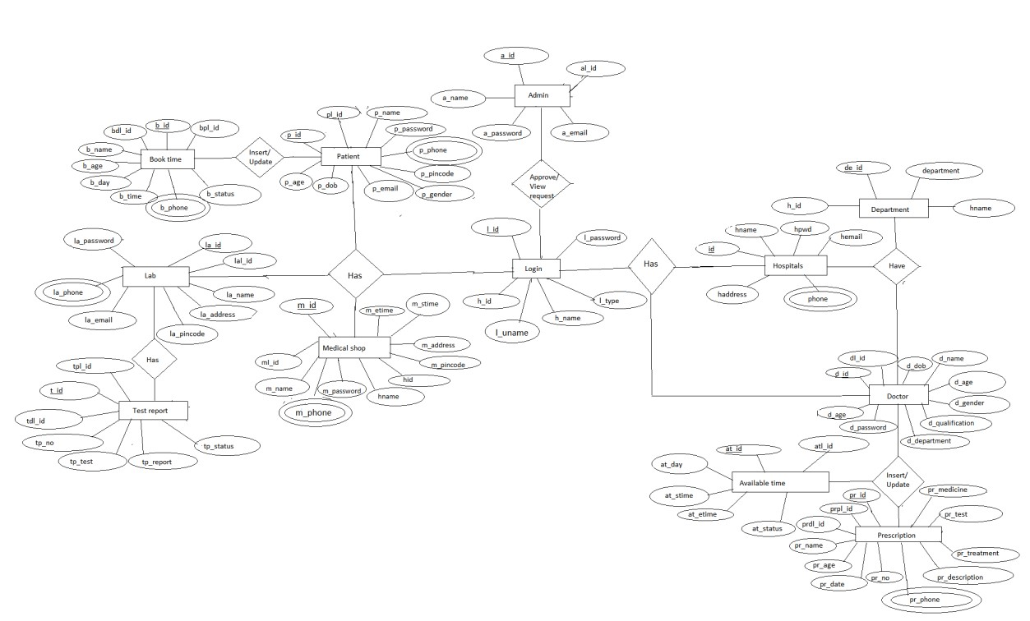

## 5.5 Table Design

### Login

|  |  |  |  |
| --- | --- | --- | --- |
| Sl_No | Name | Type | Constraints |
| 1 | **l**_id | int(100) | PRIMARY KEY NOT NULL |
| 2 | l_name | varchar(100) | NOT NULL |
| 3 | l_password | varchar(100) | NOT NULL |
| 4 | l_approve | varchar(100) | NOT NULL |
| 5 | l_type | varchar(100) | NOT NULL |

### Doctor registration

|  |  |  |  |
| --- | --- | --- | --- |
| Sl_No | Name | Type | Constraints |
| 1 | d_id | int(100) | PRIMARY KEY NOT NULL |
| 2 | dl_id | Int(100) | NOT NULL |
| 3 | d_name | varchar(100) | NOT NULL |
| 4 | d_dob | varchar(100) | NOT NULL |
| 5 | d_age | int(100) | NOT NULL |
| 6 | d_gender | varchar(100) | NOT NULL |
| 7 | d_phone | varchar(100) | NOT NULL |
| 8 | d_email | varchar(100) | NOT NULL |
| 9 | d_password | varchar(100) | NOT NULL |
| 10 | d_designation | varchar(100) | NOT NULL |
| 11 | d_department | varchar(100) | NOT NULL |
| 12 | d_qualification | varchar(100) | NOT NULL |
| 13 | d_address | varchar(100) | NOT NULL |
| 14 | image | varchar(100) | NOT NULL |

### LAB

|  |  |  |  |
| --- | --- | --- | --- |
| Sl_No | Name  la_id  lal_id | Int(100) | NOT NULL  NOT NULL |
| 1 |
| 2 |
| 3 | la_name | varchar(100) | NOT NULL |
| 4 | la_phone | varchar(100) | NOT NULL |
| 5 | la_email | varchar(100) | NOT NULL |
| 6 | la_password | varchar(100) | NOT NULL |
| 7 | la_stime | varchar(100) | NOT NULL |
| 8 | la_etime | varchar(100) | NOT NULL |
| 9 | la_citty | varchar(100) | NOT NULL |
| 10 | la_state | varchar(100) | NOT NULL |
| 11 | la_address | varchar(100) | NOT NULL |
| 12 | la_pincde | varchar(100) | NOT NULL |
| 13 | image | varchar(100) | NOT NULL |

#### Medical shop

|  |  |  |  |
| --- | --- | --- | --- |
| Sl_No | Name  m_id  ml_id | Int(100) | NOT NULL  NOT NULL |
| 1 |
| 2 |
| 3 | m_name | varchar(100) | NOT NULL |
| 4 | m_phone | varchar(100) | NOT NULL |
| 5 | m_email | varchar(100) | NOT NULL |
| 6 | m_password | varchar(100) | NOT NULL |
| 7 | m_stime | varchar(100) | NOT NULL |
| 8 | m_etime | varchar(100) | NOT NULL |
| 9 | m_citty | varchar(100) | NOT NULL |
| 10 | m_state | varchar(100) | NOT NULL |
| 11 | m_address | varchar(100) | NOT NULL |
| 12 | m_pincde | varchar(100) | NOT NULL |
| 13 | image | varchar(100) | NOT NULL |

#### Patient registration

|  |  |  |  |
| --- | --- | --- | --- |
| Sl_No | Name  p_id  pl_id | Int(100) | NOT NULL  NOT NULL |
| 1 |
| 2 |
| 3 | p_name | varchar(100) | NOT NULL |
| 4 | p_dob | varchar(100) | NOT NULL |
| 5 | p_age | int(100) | NOT NULL |
| 6 | p_gender | varchar(100) | NOT NULL |
| 7 | p_phone | varchar(100) | NOT NULL |
| 8 | p_email | varchar(100) | NOT NULL |
| 9 | p_password | varchar(100) | NOT NULL |
| 10 | p_city | varchar(100) | NOT NULL |
| 11 | p_state | varchar(100) | NOT NULL |
| 12 | p_address | varchar(100) | NOT NULL |
| 13 | p_pincode | varchar(100) | NOT NULL |
| 14 | image | varchar(100) | NOT NULL |

#### Admin registration

|  |  |  |  |
| --- | --- | --- | --- |
| Sl_No | Name | Type | Constraints |
| 1 | a_id | int(100) | PRIMARY KEY NOT NULL |
| 2 | al_id | Int(100) | NOT NULL |
| 3 | a_name | varchar(100) | NOT NULL |
| 4 | a_dob | varchar(100) | NOT NULL |
| 5 | a_age | int(100) | NOT NULL |
| 6 | a_gender | varchar(100) | NOT NULL |
| 7 | a_phone | varchar(100) | NOT NULL |
| 8 | a_email | varchar(100) | NOT NULL |
| 9 | a_password | varchar(100) | NOT NULL |
| 10 | a_designation | varchar(100) | NOT NULL |
| 11 | a_qualification | varchar(100) | NOT NULL |
| 12 | a_address | varchar(100) | NOT NULL |
| 13 | a_pincode | varchar(100) | NOT NULL |
| 14 | image | varchar(100) | NOT NULL |

##### Available time

|  |  |  |  |
| --- | --- | --- | --- |
| Sl_No | Name | Type | Constraints |
| 1 | at_id | int(100) | PRIMARY KEY NOT NULL |
| 2 | atl_id | int(100) | NOT NULL |
| 3 | at_day | day | NOT NULL |
| 4 | at_stime | time | NOT NULL |
| 5 | at_etime | time | NOT NULL |
| 6 | at_status | int(100) | NOT NULL |

##### Book time

|  |  |  |  |
| --- | --- | --- | --- |
| Sl_No | Name | Type | Constraints |
| 1 | b_id | int(100) | PRIMARY KEY NOT NULL |
| 2 | bpl_id | int(100) | NOT NULL |
| 3 | bdl_id | int(100) | NOT NULL |
| 4 | b_day | day | NOT NULL |
| 5 | b_time | time | NOT NULL |
| 6 | b_name | varchar(100) | NOT NULL |
| 7 | b_age | int(100) | NOT NULL |
| 8 | b_phone | varchar(100) | NOT NULL |
| 9 | b_status | varchar(100) | NOT NULL |
| 10 | timestamp | varchar(100) | NOT NULL |

##### Chat message

|  |  |  |  |
| --- | --- | --- | --- |
| Sl_No | Name | Type | Constraints |
| 1 | ch_id | int(100) | PRIMARY KEY NOT NULL |
| 2 | message | varchar(100) | NOT NULL |
| 3 | from_user | varchar(100) | NOT NULL |
| 4 | from_id | int(100) | NOT NULL |
| 5 | to_user | varchar(100) | NOT NULL |
| 6 | to_id | int(100) | NOT NULL |
| 7 | attach | varchar(100) | NOT NULL |
| 8 | status | varchar(100) | NOT NULL |
| 9 | timestamp | varchar(100) | NOT NULL |

##### Department

|  |  |  |  |
| --- | --- | --- | --- |
| Sl_No | Name | Type | Constraints |
| 1 | de_id | int(100) | PRIMARY KEY NOT NULL |
| 2 | department | varchar(100) | NOT NULL |

#### Prescription

|  |  |  |  |
| --- | --- | --- | --- |
| Sl_No | Name | Type | Constraints |
| 1 | pr_id | int(100) | PRIMARY KEY NOT NULL |
| 2 | prpl_id | Int(100) | NOT NULL |
| 3 | prdl_id | Int(100) | NOT NULL |
| 4 | pr_name | varchar(100) | NOT NULL |
| 5 | pr_age | int(100) | NOT NULL |
| 6 | pr_phone | varchar(100) | NOT NULL |
| 7 | pr_date | varchar(100) | NOT NULL |
| 8 | pr_no | varchar(100) | NOT NULL |
| 9 | pr_medicine | text | NOT NULL |
| 10 | pr_text | text | NOT NULL |
| 11 | pr_treatment | text | NOT NULL |
| 12 | pr_description | text | NOT NULL |
| 13 | pr_mstatus | varchar(100) | NOT NULL |
| 14 | pr_lstatus | varchar(100) | NOT NULL |
| 15 | timestamp | varchar(100) | NOT NULL |

##### Suggest

|  |  |  |  |
| --- | --- | --- | --- |
| Sl_No | Name | Type | Constraints |
| 1 | s_id | int(100) | PRIMARY KEY NOT NULL |
| 2 | spl_id | int(100) | NOT NULL |
| 3 | sdl_id | int(100) | NOT NULL |
| 4 | s_name | varchar(100) | NOT NULL |
| 5 | s_gender | varchar(100) | NOT NULL |
| 6 | s_email | varchar(100) | NOT NULL |
| 7 | s_phone | varchar(100) | NOT NULL |
| 8 | s_department | varchar(100) | NOT NULL |

##### Test report

|  |  |  |  |
| --- | --- | --- | --- |
| Sl_No | Name | Type | Constraints |
| 1 | t_id | int(100) | PRIMARY KEY NOT NULL |
| 2 | tpl_id | int(100) | NOT NULL |
| 3 | tdl_id | int(100) | NOT NULL |
| 4 | tp_no | varchar(100) | NOT NULL |
| 5 | tp_test | text | NOT NULL |
| 6 | tp_report | text | NOT NULL |
| 7 | tp_status | varchar(100) | NOT NULL |

## 5.6 NORMALIZATION

Normalization is the process. of efficiently organizing data in a database. s normalization, or data normalization, is a technique to organize the contents of tables for transactional databases and data warehouses Normalization is part of successful database design; without normalization, inaccurate, slow, and inefficient, and they might not produce the data you except the process; eliminating redundant data and ensuring data dependencies make sense. Both of these are worthy goals as zivey reduce the amount of space a database consumes and ensure that data is logically stored. Efficiently organizing data in a database. D database systems can be after the conceptual level, the next level of process of database design to organize the database structure into a good shape called normalization. Normalization simplifies the entries, removing redundancies from the system data and finally builds a data structure, which is both flexible and adaptable to the system. in this project the different normal forms obtained during the database design. That is given below,

### First Normal Form

A relation is said to be first normal form if & only if it satisfies the constraints that contains the primary key only. A row of data cannot contain repeating group of data. Ie. each column must have a unique value. Each row of data must have a unique identifier primary key A database is in first normal form if it satisfies the following conditions o Contains only atomic values o There are no repeating groups Second Normal Form A relation is said to be in second normal form if & only if it satisfies all the first normal form condition for the primary key and every non primary key attributes of the relation is fully dependent on its primary key alone.. A table to be normalized to Second Normal Form should meet all the needs of First Normal Form and there must not be any partial dependency of any column on primary key.

It means that for a table has concatenated primary key, each column in the table any column depends only on one part of the concatenated key, then exist the table fails Second normal form. A database is in second normal form if it satisfies the following conditions: o It is in first normal form o All non-key attributes are fully functional dependent on the primary key.

### Second Normal Form

Second normal form is based on the concept of full functional dependency. It states that a relation R is in second normal form. If it is in First Normal Form and every non key attribute is fully dependent on the primary that is a relation is said to be NE in each attribute meets one of the following criteria.

* It appears in the primary key
* it is functionally depend on the primary key.

In our E-library most of the tables have primary keys and it depends on primary key As primary key is unique we can use this key for referring. Primary key only implies a single row. Most of our table has primary key and it fully depend on that key.

### Third Normal Form

Second normal form is based on concept of full functional dependency. It states that a relation are is in second normal form if it is in first normal form and every non key attribute is fully dependent on that primary that is a relation is said to be in 2NF in each attribute meets one of the following criteria.

* It appears in the primary key.
* It is functionally depend on the primary key.

### Boyce-Codd Normal Form [BCNF or 3.5NF]

BCNF is normal form used in data base normalization. It is a slightly stronger version of the third normal form. BCNF was developed in 1974 by Raymond F. Boyce and Edgar F. Codd to address certain types of anomaly not dealt with by 3NF as originally defined.

If a relational schema are is in Boyce Codd normal form if and only if for every ie of the dependency has been removed, although other types of redundancy may still exist. A relational schema is in Boyce-Codd normal form if and only if for every one of is dependencies X to Y at least one of the following conditions holds

* X to Y is a trivial functional dependency (Y C X).
* X is a super key for schema R.

### Fourth Normal form

A 4NF is a normal form used in database normalization Introduced by Ronald Fagin in 1977, 4NF is the next level of normalization after Boyce-Codd normal form E Where as the second third and Boyce-Codd normal forms are concerned functional dependencies 4NF is concerned with a more general type of dependency known as multi valued dependencies X to Y, X is a super key -that is X is either a candidate key or a super set thereof.

### Fifth Normal Form

5NF also known as project-join normal form (PJ/NF) is a level of database normalization designed to reduce redundancy in relational databases. A table is said w be in the 5NF if and only if every non-trivial join dependency in it is implied by the candidate keys. A join dependency "(A. B. Z ) on R is implied by the candidate key(s) of R if and only if each of A.B. Z is a super key for R

### 5.7. INPUT DESIGN

In input design stage, which is the part of the system design stage the system analyst has to decide what inputs are required for the system and prepare input format Considering the input to the friendly visual basic software so that the user to give input to the system according to the requirement front end from the user we use the user- can easily enter the data.

### 5.8. OUTPUT DESIGN

Intelligent output design will improve systems relationships with the user and nelp in decision making. Outputs are also used to provide permanent results for latter Consultations. The most important reason, which tempts the user to go often, regarded system, Here the output and hard copy of the for a new system is the output. The output generated by the system is as the criterion for evaluating the usefulness tor the requirements use to be predetermined before going to the actual system design. The put design is based on the following: Determining the various outputs to be presented to the user. . Differentiating between inputs to be displayed and those to be printed, The format for the presentation of the outputs.

## 6. SYSTEM TESTING AND IMPLEMENTATION

### 6.1. TYPES OF TESTING

System testing is the process in which the system undergoes experimental testing so as to check that the system does not fail i.e.to check whether the required stem is running according to specification and user expectation. System testing also tests to find discrepancies between the system and its original objectives, current specification and the system documentation. Hence most useful and practical approach is with the understanding that testing is the process of executing a program with the explicit intention of finding errors that is making the program fail.

#### 6.1.1. Testing

It considers to be the least creative phase of the whole cycle of system design in the real sense it is the phase which helps to bring out the creativity of the other phases make it shine. Types of testing forms a core part of any project. There are various types of testing. In this system we did the following testing.

White box Testing e Black box Testing entity Testing e- Integration Testing e User Interface Testing White Box Testing White box testing. sometimes called glass box, is test case method uses the control structure of the procedural design to derive test Dang white box testing method, we can derive test case that e Guarantee that all independent parts with a minute have exercised at least once, o Exercise all logical decisions on their true and fits sides to Execute all loops at their boundaries and within their operations bounds e Exercise internal data structures to ensure their validity hack Box Testing Black box testing focuses on the functional requirements of the software. That is, black box testing enables the software engineer to derive sets of input conditions that will fully exercise full functional requirements for a program. Black box testing is not a alternative to white box testing. Rather it is a complementary approach that is likely to uncover a different class of errors than white box methods.

Black box testing attempts to find errors in the following categories e Incorrect or missing functions o Interface errors o Errors in data structures on external database access o Performance error o Initialization and termination errors Unlike white box testing which is performed early on the testing process black box testing tends to be applied during later stages of testing because black box testing which is purposely disregards control structures attention is focused on the information domain. Unit testing Unit testing focuses verification error on the smallest unit of software design the module. Using the procedural design description as a guide, important, control are tested to uncover errors with the boundary of the module. The relative wunuplexity of the test and uncovered errors is limited by the constraint scope established for unit testing. The unit test is normally white box oriented and the step conducted in parallel for multiple modules. The module interface is tested to can ensure that information properly flows into and out of the program unit under test. The local data structure is examined to ensure that data stored temporarily maintains its integrity during all steps in an algorithm's execution. Boundary conditions are tested to ensure that the module operates properly at boundaries established to limit or restrict processing. All independent paths through the control structure are exercised to ensure that all statements in a module have been executed at least once: And finally. all handling paths are tested Test Procedures Unit testing normally considered as an adjunct to the coding step. After source level code has been developed, reviewed and verified for correct syntax, unit test case design review of design information provides guidance for establishment test cases that are likely to uncover all errors. Because a module is not a standalone program, driver and/or sub software must be developed for Catch unit test. In most applications a driver is nothing more than a "main program" accepts test case date. passes such data to the modules to be tested) and brings relevant results. Stubs serve to replace modules that are subordinate to (called by) the module to be tested. A stub or "dummy subprogram" ses the subordinate modules interface, may do minimal data manipulation, prints verification of entry and returns Drivers and stubs represents overhead. That is both the software must be developed but that is not delivered with the final software products drivers and stubs are kept simple. actual overhead is relatively low. Unit testing is simplified when a module with high cohesion is designed. when only one function is addressed by a module, the number of test cases id reduced and errors can predicated and uncovered. User Interface Testing An interactive interface is a system that is dominated by interaction between Subsystems and external agents, such as humans, device or other program. The external agents are independent of the system, so their inputs cannot be controlled solicit response from them. An interactive interface y includes only part of an entire application, one that can often be handled although the system may independently from the computational part of the application. The major concern of an interactive interface are the communication protocols between the system and external agents, the Syntax of possible interactions the presentation of outputs, the flow of control within system, the case of understanding and user interface performance and error handling.

#### 6.2 IMPLEMENTATION

Implementation is the most crucial stage in achieving a successful system and giving the user's confidence that the new system is effective and workable Implementation of project refers to the installation of the package in its real environment to the full satisfaction of the users and operations of the system. Testing is done individually at the time of the development using the data and verification is done the way specified in the program specification In short implementation constitutes all activities that are required to put an already tested and completed package into operation. The success of any information system lies in its successful implementation. System implementation is the stage in the project where the theoretical design is turned into a working system. The most critical stage is achieving successful system and in giving confidence on the new system for the user that it Wil Work efficiently and effectively. The existing system was long time process.

The project execution was checked with live environment and the user requirement is satisfied. Proper implementation is essential to provide a reliable system to meet the organization requirements. Implementation is the stage of project where the theoretical design is turned into a working system Implementation is the process of converting a new or revised system design in to operational one. The objective is to put the tested system into operation while holding cost, risk and personal irritation to a minimum. It involves careful planning. investigations of the current system and its constraints on implementation, design of methods the achieve the change over. an evolution of change over methods. An implementation co- ordination committee based on policies of individual organization has been appointed. Thus

implementation preparing a plan for the implementation of the system. According this plan. the activities are to be carried out, discussion made regarding the equipment and resource and the additional equipment has to be acquired to implement the new system process begins with Implementation is the final and important phase. The system can be implemented only after through testing is done and if it found to be working according to the specification. The method also offers the greatest security since the old system can take over if the errors are found or inability to handle certain types of transactions while using the new system.

#### 6.2.1. Planning and Control

The implementation of the system involves people from different department, in effective control of implementation results in the failure of the system. The use of the committee for carrying out the implementation function may prove useful.

#### 6.2.2. Education and Training

To achieve the benefits and objectives expected from computer base system (online system), it is essential for the users to be involved with the system. If the system becomes more complex the need for education and training is more and more Important adequate training was given to the staff at the main office, regarding the use of the system, And a one day technical meet was held at the main office for all technical heads of franchisees The method to be followed was taught to them for he client side. The students who are the end users of the software need not be rained because the software is very user friendly and anyone can easily handle it. By reading Mie instructions given, and follow it correctly.

#### 6.2.3 User

Training after the system is implemented successfully; training of the user is one of most important sub tasks of the developer. For this purpose user manuals and prepared and handled over to this user to operate the developed system. Thus the users are trained to operate the developed system. Both the hardware and software securities un made to run the developed system successfully in future in order to put new application system into user, the following activities were taken care of: . Preparation of user and system documentation e conducting user training with demo and hands on Test run for some period to ensure smooth switching over the system the users are trained to use the newly developed function. User manuals describing the procedures for using the functions are circulated to all the users. It i confirmed that the system is implemented up to users need and expectation.

## 7. SYSTEM SECURITY

All software that is used in a multi-user environment should have some level o security, Proper security facilities will surely increases the quality of the software we au implement two type's application security of security facilities such as database and **7.1 DATABASE SECURITY** because the data we keep in our database be confidential, Microsoft has created powerful security features to ensure that unauthorized users cannot access our data. Users passwords, roles and privileges enables us to decide who has access to what part our database **7.2 APPLICATION SECURITY** Application security deals with the security of the processes in the system. We can implement the application security in two ways through password and through limitation in the access rights. Password facility does not allow the unauthorized users to access the database unless they know the correct password. & CHECKS AND CONTROLS & Data type we have used string type for character. int for numeric, and date for data type. No numeric field insert in date. Character never inputted in numeric field as phone no never accept character if any person input wrongly give message. When this problem is removed then user performs further operation. Length when we define a max length. it never accepts more data. For example if define numeric length is 5 than it store either equal to length or less than length. If user give more character than required than display message processing Constraints and stop in this we are defining range of data if data is less than display error with message. For example code of password is 4 characters. The field of data must be 8 characters. Format the predefined format is used not change daily to daily, for example format of data is YY/MM/DD used in all data type field. If user inserts another format than display message. Web design constraints the following design constraints were kept in mind while designing the page for the whole application:

The page should be consistent and easy to operate It should be designed in such a way that an average user who does not have much idea about JSP and related technology can still be able to access the information needed.

**7.4 DATA SECURITY** Back up and security provides off site data storage for your Computer files protecting yourself from data loss is one of the most important aspects of your business. Unfortunately. this is usually released only after having been affected by data loss in one form or other. Data loss can occur in several ways like human error, mechanical failure computer theft, virus corruption or force of nature. Information is one of our most important asset, so whatever the form, data loss without a method of recovery will be detrimental. Many business have been forced to shut down due to the data lo The cost or recreating lost data, if the source of information has not been destroyed. can run into thousands of dollars. With the back up security your data is available for you to restore it immediately **7.5 USER SECURITY** User security lets your application use security rules to determine what it shows. It has two elements: Authentication ensures that a valid user is logged-in, based on a ID and password provided by the user.

Authorization: ensure that the logged-in user is allowed to use page or perform an operation. Authorization is typically based on one more roles (sometimes called groups) to which the user belongs. For example a member who logged-in may be an administrator or user.

## 8. SCREEN LAYOUTS

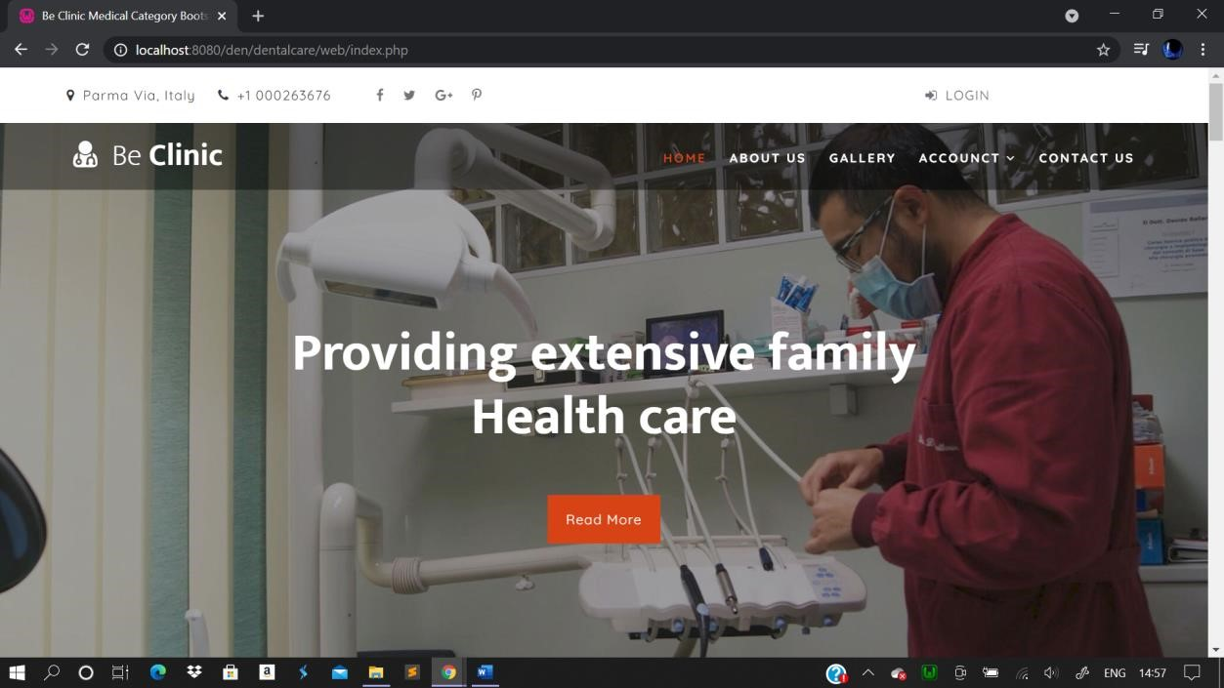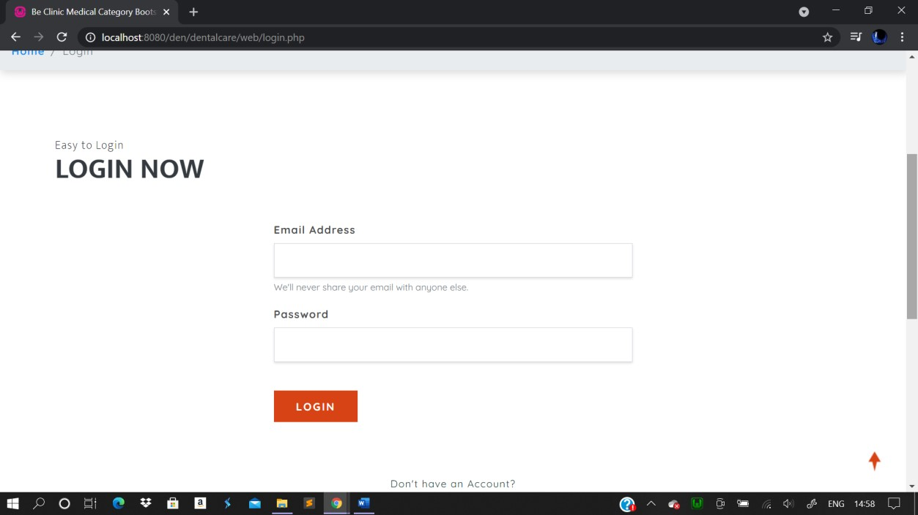

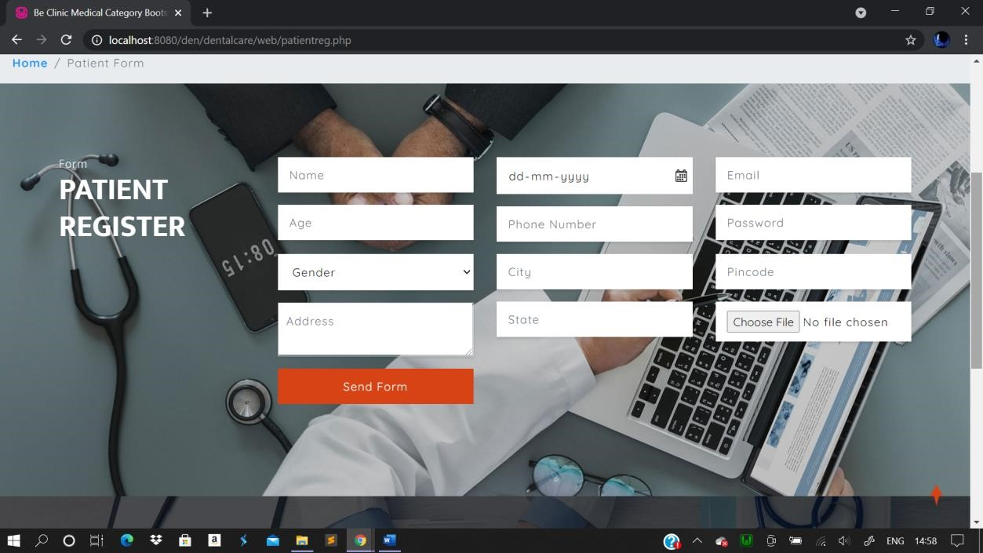

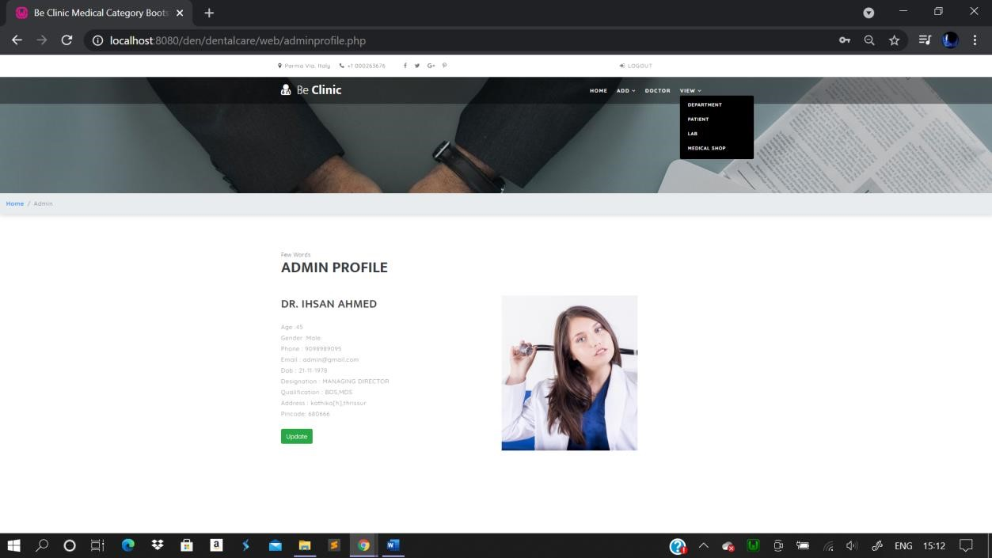

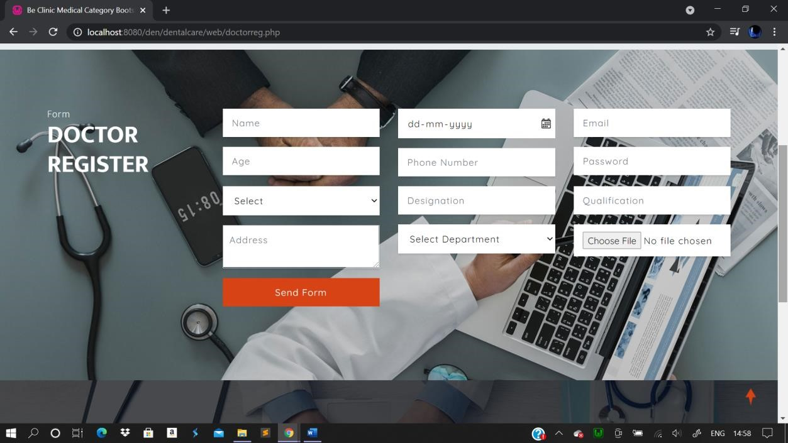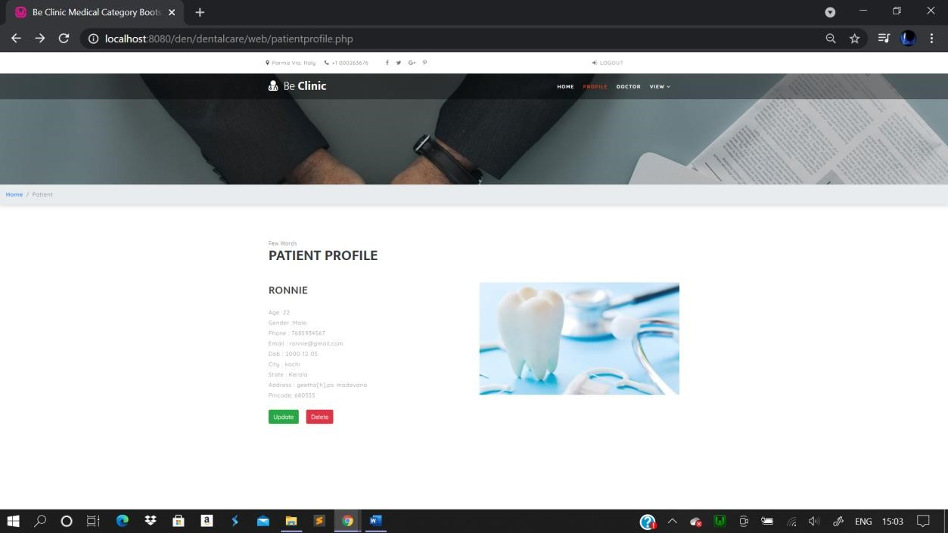

**-**

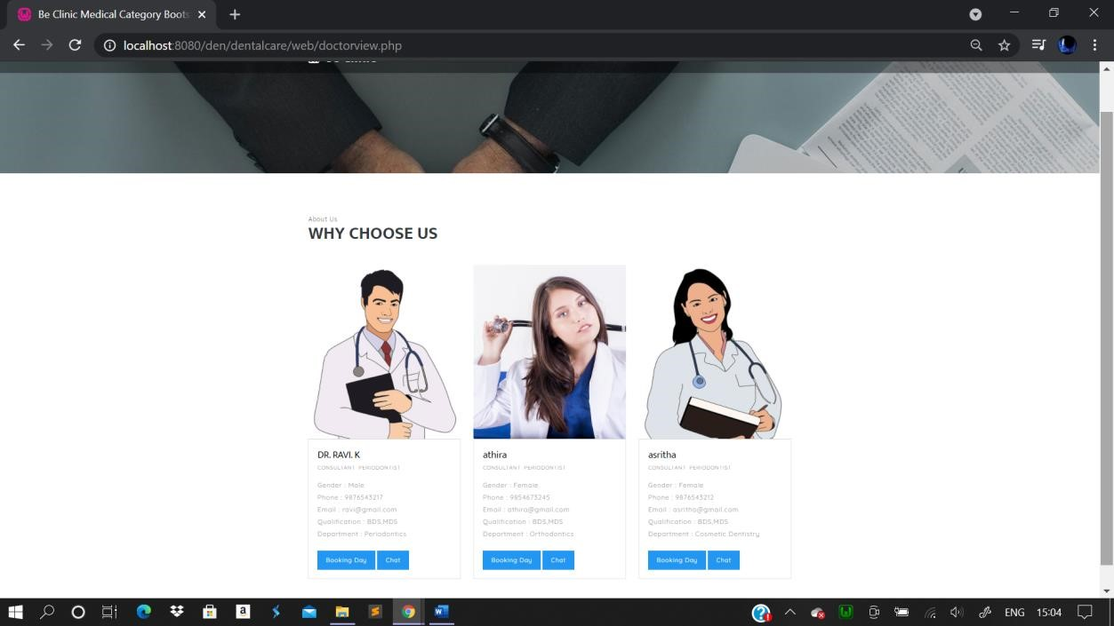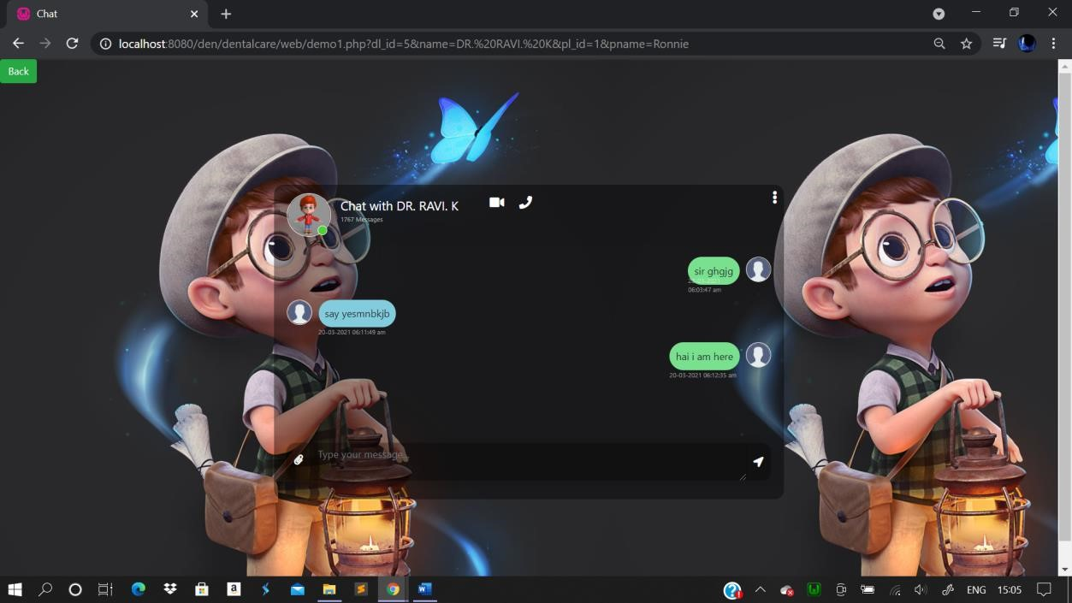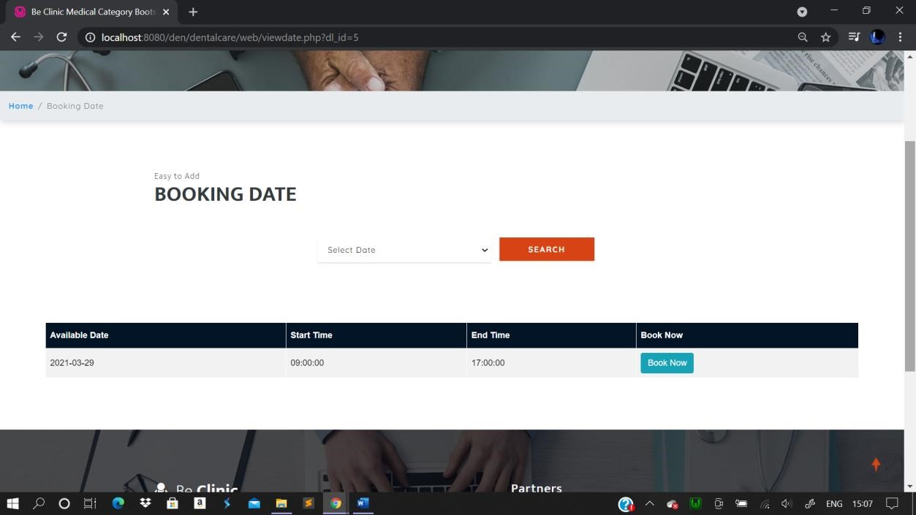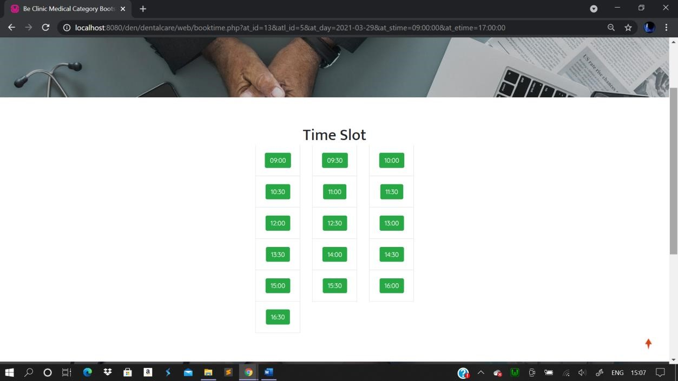

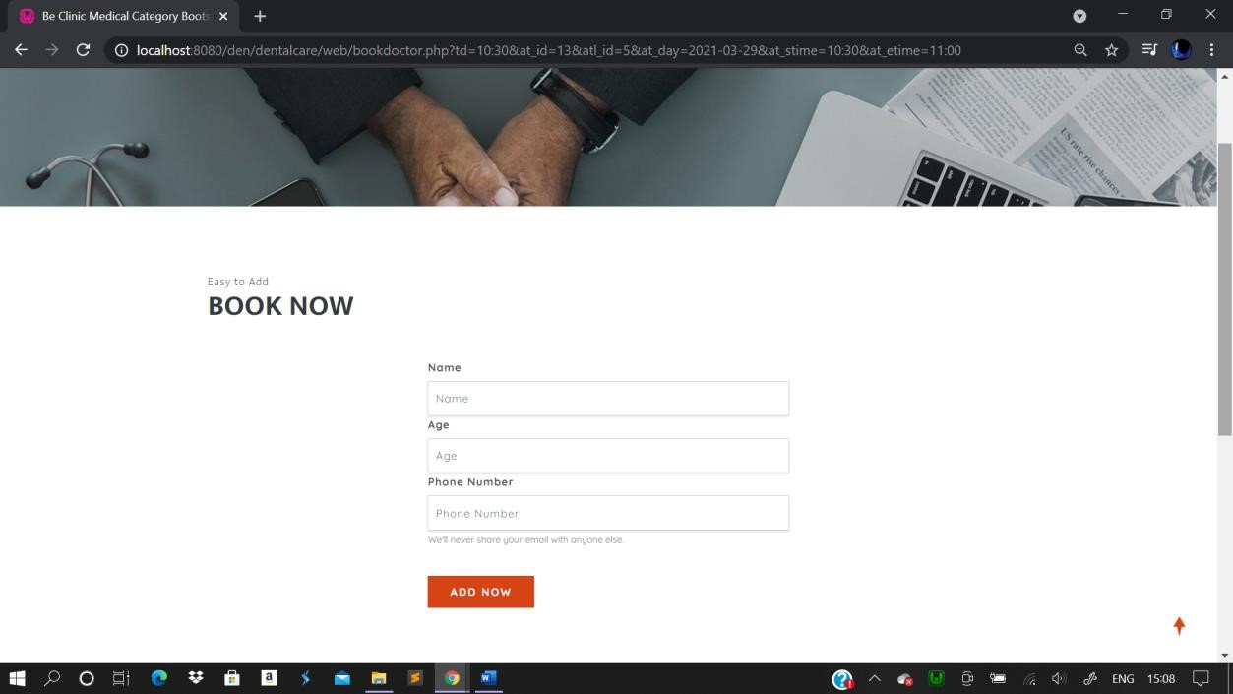

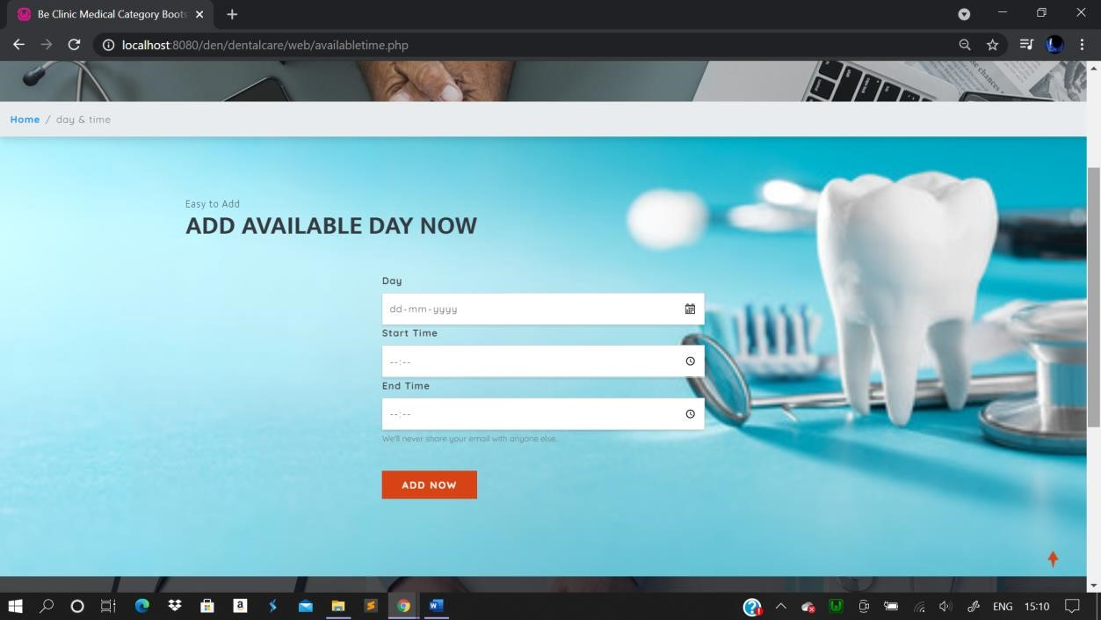

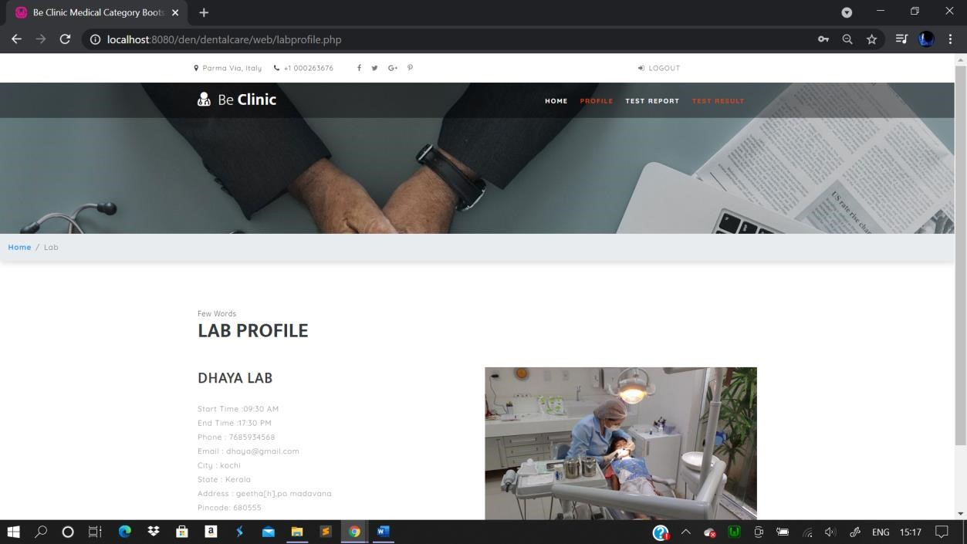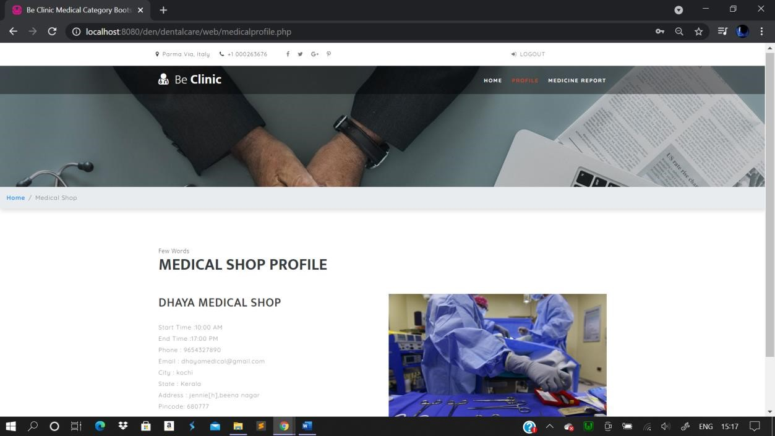

## 9. CONCLUSION

The project was completed within the time span allotted. Every effort has been made to present the system in more user-friendly manner. All the activities provide a feeling like an easy walk over to the user who is inter facing with the system. Most of the disadvantages of the existing system have been overcome using the present system of "dental care appointment management system". A trial run of the system has been made and is giving good result.

## 10. BIBLIOGRAPHY

* www.w3school.com
* [www.layout.com](http://www.layout.com/)
* [www.firebasecontrol.com](http://www.firebasecontrol.com/)
* [www.tutorialpoint.com](http://www.tutorialpoint.com/)
* [www.udacity.com](http://www.udacity.com/)