Solution:

**Task1:**

hadoop fs -p -mkdir /user/acadgild/hadoop

hadoop fs -ls /user/acadgild



**Task2:**

hadoop fs -touchz /user/acadgild/hadoop/word-count.txt

hadoop fs -appendToFile - /user/acadgild/hadoop/word-count.txt

hadoop fs -cat /user/acadgild/hadoop/word-count.txt

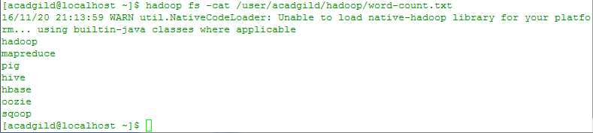

**Task3:**

hadoop fs -put /home/acadgild/hadoop/word-count.txt /user/acadgild/hadoop

hadoop fs -cat /user/acadgild/hadoop/max-temp.txt

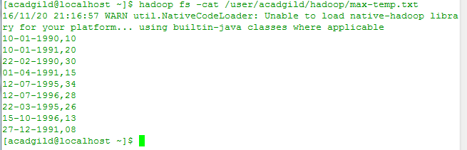

**Task4:**

hadoop fs -chmod 770 /user/acadgild/hadoop/max-temp.txt

hadoop fs -ls /user/acadgild/hadoop/max-temp.txt

