Data Ingestion:

Data Ingestion: flume job

agent1.sources = mysrc

agent1.sinks = hdfsdest

agent1.channels = mychannel

agent1.sources.mysrc.type = exec

agent1.sources.mysrc.command = hadoop dfs -put /home/acadgild/Project/StatewiseDistrictwisePhysicalProgress.xml /flume_import

agent1.sinks.hdfsdest.type = hdfs

agent1.sinks.hdfsdest.hdfs.path = hdfs://localhost:9000/flume_import

agent1.channels.mychannel.type = memory

agent1.sources.mysrc.channels = mychannel

agent1.sinks.hdfsdest.channel = mychannel

flume-ng agent -n agent1 --conf-file filecopy.conf

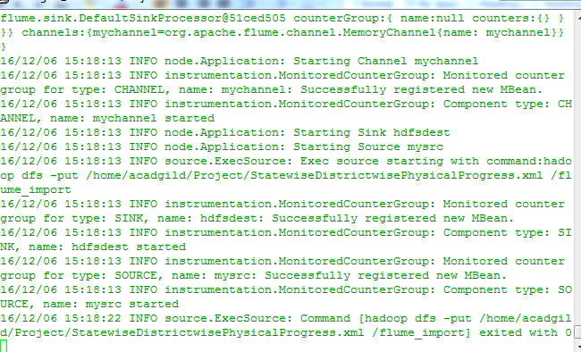

The command is executed. The file is now present in HDFS.

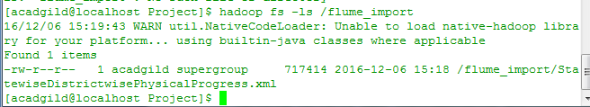  
Pig/Mapreduce job for parsing the XML data:

1. Find out the districts who achieved 100 percent objective in BPL cards

Export the results to mysql using sqoop

hadoop fs -mkdir -p /project/lib

hadoop fs -put /home/acadgild/project/lib/piggybank.jar /project/lib/piggybank.jar

pig -x mapreduce

REGISTER 'hdfs:///project/lib/piggybank.jar';

DEFINE XPath org.apache.pig.piggybank.evaluation.xml.XPath();

A = LOAD '/flume_import/StatewiseDistrictwisePhysicalProgress.xml' using org.apache.pig.piggybank.storage.XMLLoader('row') as (x:chararray);

B = FOREACH A GENERATE XPath(x, 'row/District_Name') AS district_Name, XPath(x, 'row/Project_Objectives_IHHL_BPL') AS bpl_objective, XPath(x, 'row/Project_Performance-IHHL_BPL') AS bpl_performance;

result = FOREACH B GENERATE district_Name, (((double)bpl_performance/(double)bpl_objective) * 100) AS objective_percent;

filtered_result = FILTER result by objective_percent == 100;

dump filtered_result;

*****************************************************

2. Write a Pig UDF to filter the districts who have reached 80% of objectives of BPL cards.

Export the results to mysql using sqoop.

*******************************************************************

package pigudf;

import java.io.IOException;

import org.apache.pig.FilterFunc;

import org.apache.pig.data.Tuple;

public class FilterUDF extends FilterFunc {

public Boolean exec(Tuple input) throws IOException {

try {

double value1 = (double) input.get(0);

double value2= (double)input.get(1);

if ((value1/value2) * 100 = 80) {

return true;

}

else {

return false;

}

}

catch (Exception e) {

throw new IOException(e);

}

}

}

***************************************************************************************

pig -x mapreduce

REGISTER 'hdfs:///project/lib/pig-udf.jar';

DEFINE filterRecords pigudf.FilterUDF;

A = LOAD '/project/lib/result2' USING PigStorage(';') AS (district:chararray, bpl_performance:double, bpl_objective:double);

result_eighty_percent = FOREACH A GENERATE filterRecords(bpl_performance, bpl_objective, district);

dump result_eighty_percent;

STORE result_eighty_percent into '/project/lib/result_eighty_percent' using PigStorage(';');