**Disaster Recovery and Business Continuity Plan for On-Premises Virtual Machine on IBM Cloud Virtual Servers**

**Phase3: Development Part 1**

In this phase, we will begin building the disaster recovery plan using IBM Cloud Virtual Servers, incorporating the innovative solutions outlined in Phase 2. This document provides a detailed plan for implementation.

**Disaster Recovery Strategy**

Recovery Time Objective (RTO) and Recovery Point Objective (RPO)

- RTO: Our goal is to achieve an RTO of 4 hours, ensuring that critical systems are recovered within this time frame.

- RPO: We aim for an RPO of 1 hour, minimizing data loss to a maximum of one hour.

**Priority of Virtual Machines**

We have categorized virtual machines into three priority levels:

1. High Priority: These are mission-critical systems with the highest priority for recovery.

2. Medium Priority: These systems are essential but can tolerate a slightly longer recovery time.

3. Low Priority: Non-essential systems that can wait for recovery.

**Implementation Plan**

1. **Automated Backup and Recovery**

- We will implement an AI-driven backup solution that intelligently schedules backups, optimizes storage, and automates recovery processes.

- This ensures minimal manual intervention and faster recovery.

**2. Blockchain for Data Integrity**

- We will integrate blockchain technology to maintain the integrity and security of critical data backups.

- Blockchain ensures an immutable ledger for tracking changes, enhancing trust and reliability during recovery.

**3. Machine Learning for Predictive Analysis**

- Machine learning algorithms will be employed to analyze historical data, predict potential failure points, and take proactive measures to prevent disasters.

**4. Multi-Cloud Redundancy**

- We will replicate critical data and workloads across multiple cloud providers, ensuring redundancy.

- This strategy enhances business continuity, even in case of significant cloud provider outages.

**5. Microservices Architecture**

- We will adopt a microservices architecture for the on-premises virtual machine, enabling easier scalability and rapid recovery of specific components.

**6. Zero Trust Security Model**

- A Zero Trust security model will be implemented to continuously authenticate and authorize access, enhancing security during recovery.

**7. Disaster Recovery as a Service (DRaaS)**

- We will explore DRaaS solutions to provide a scalable and cost-effective disaster recovery platform with automated failover and minimal RTO.

After we create a Lite account (Trail Free account) as students, we can log in to IBM Cloud by visiting htps://cloud.ibm.com/login.

Our registered email IDs should then be entered to access the account. Once logged in, we can explore the various services and features offered by IBM Cloud for our projects and studies.

Then we entered the password

Following the instructions, we successfully logged in to our account, and we were redirected to the account Dashboard page.

Once on the Dashboard, we had access to a range of tools and information that allowed us to manage our account, monitor usage, and make the most of the available features and resources.

This made it easy for us to effectively utilize IBM Cloud for our projects and studies.

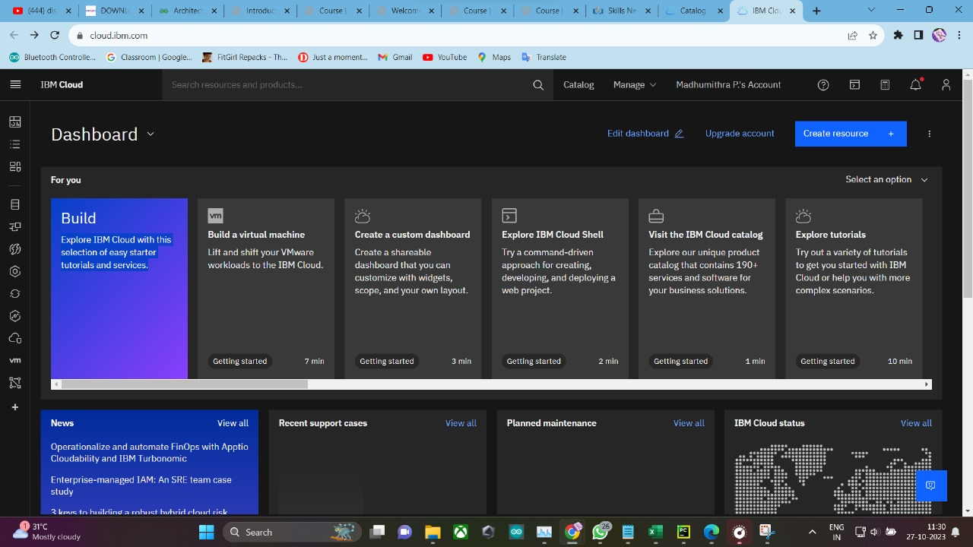

we then added IBM Cognos Dashboard Embedded and we went to the Catalog menu and search for 'Cognos'. This streamlined search helped us quickly find and integrate the service, enhancing our data analysis capabilities effortlessly.

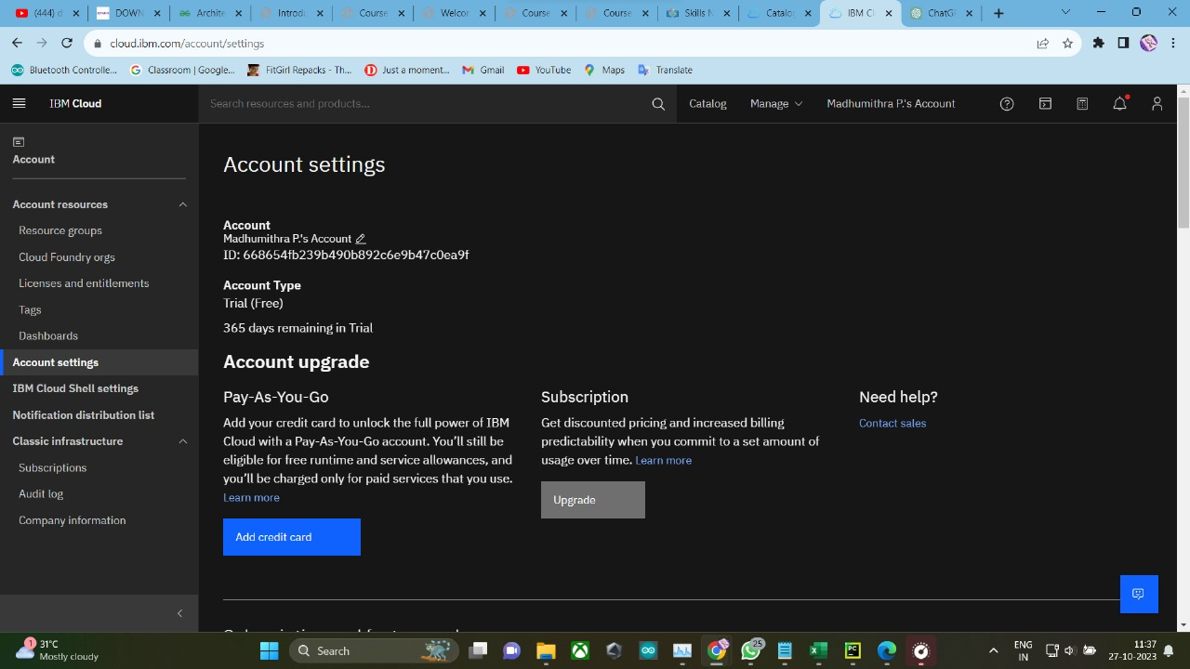

"Having clicked 'IBM Cognos Dashboard Embedded,' we were seamlessly redirected to the dedicated Cognos page. There, we explored a wealth of data visualization tools and analytical features tailored to our specific business needs. This smooth transition ensured a hassle-free experience, allowing us to dive right into the world of powerful insights and streamlined analytics.

I selected 'London' as the location, chose the 'Lite' pricing plan, and agreed to the terms and conditions (license agreements). Then, I clicked on the 'Create' button. After clicking 'Create,' I patiently waited for some time as the service was being created. Then, I clicked on the 'Create' button. After a few minutes, I checked the resource list to confirm the service creation.

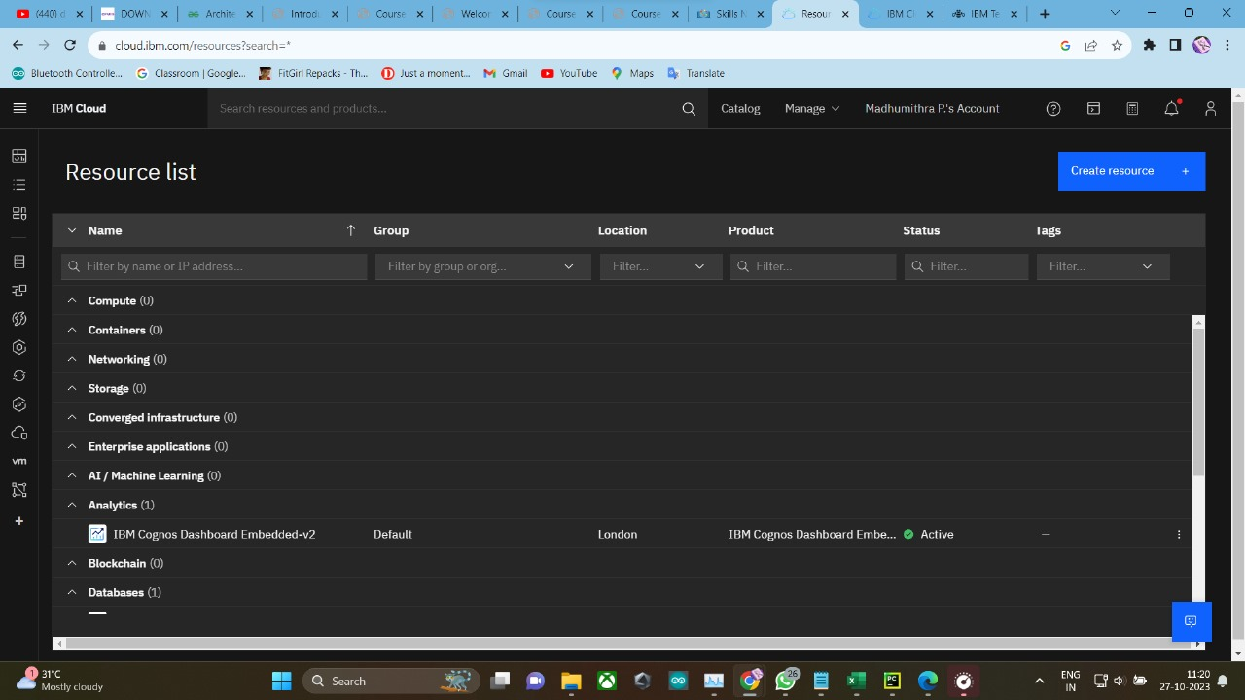

I added the DB2 service to my account and then searched for it again in the catalog by entering 'DB2' in the search bar.

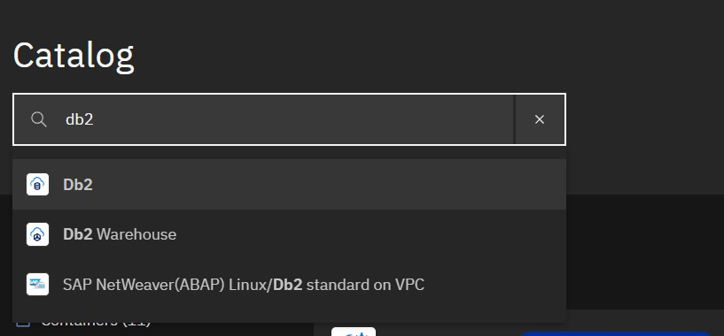

I clicked on Db2 and was redirected to the DB2 service page. From there, I selected 'London' as the location, opted for the 'Lite' pricing plan, and agreed to the terms and conditions (license agreements). Then, I clicked on the 'Create' button. After clicking 'Create,' we patiently waited for some time as the service was being created.

