COL216
MINOR ASSIGNMENT
ABHINAV SINGHAL (2019CS50768)

Problem Statement: MIPS simulator with DRAM timing model

This MIPS Simulator has been built upon the MIPS Interpreter which was implemented in Assignment-3 by both me and my partner Abhishek Kumar (2019CS10458).

Major Design Considerations:

- All the steps upto lexing and parsing the given input file, and storing the instructions in a struct format in the memory remain same as in Assignment-3. Only the execution steps of how to handle the instructions changes. Error handling is also almost the same as in the previous assignment.

- Input/Output: The various parameters such as input file name, output file name (optional – by default is named as “output.txt”), ROW_ACCESS_DELAY, COL_ACCESS_DELAY and most importantly, which part (part-1 or part-2) of the Assignment is to be executed, all are taken from the command line. A sample is shown below -

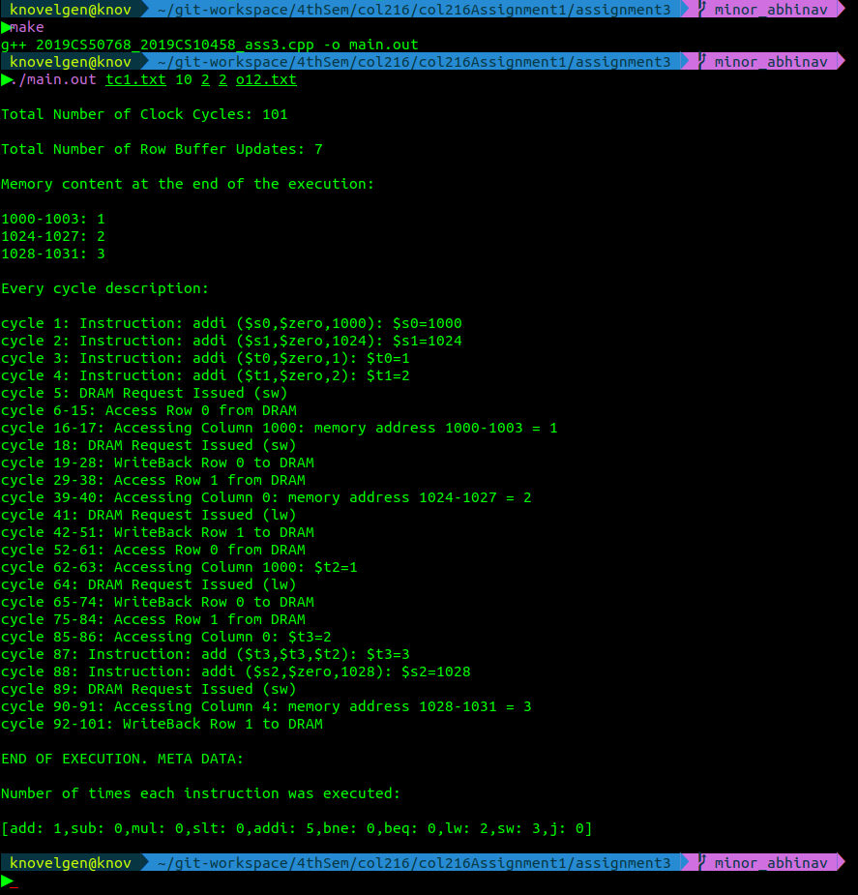
- Execution: As usual, the instructions are read one by one according to where the PC (Program Counter) points. For different kinds of instructions, we execute the instruction accordingly. Note that the implementation doesn’t actually maintain ROW_BUFFER or the DRAM, their movement, copying etc. We simply simulate (Black Box Implementation) all copying /writing to DRAM and other such operations just with the help of some variables and vectors. The execution output is stored in an array and is printed at the end of execution if there are no errors.
All the relevant statistics are printed as well after the execution both to the terminal and the output file.

- Note that I have considered all instructions that were present in Assignment-3 for this Simulator. Hence apart from the basic add, addi, lw and sw instructions, other instructions such as sub, mul, bne, beq, slt and j will also work incase they are present in the input file.

The following important points have been kept in mind while implementing the Simulator:
1. Instructions execute **SEQUENTIALLY**
2. ONLY ONE instruction can be processed at a time in a processor
3. ONLY ONE instruction request can be processed at a time in a DRAM
4. Final value to be stored in the memory does not change with my DRAM implementation

I have followed Design Choice – 1 (as on Piazza) :
Lets say I have a processor connected directly to DRAM:
a. If DRAM is idle, lw/sw can execute and request can be sent to DRAM
b. If DRAM is busy, no new lw/sw is safe to be processed
c. If b is the case then processor waits for the response from DRAM for the prev lw/sw

Part-A: Implementing DRAM without Non-Blocking Memory Access feature.

- In this case the execution doesn’t jump over to the next instruction while the lw / sw instruction takes time for accessing rows and columns of DRAM if the next instructions are independent of the current instruction (lw / sw).

- All instructions are implemented sequentially and we wait for as many clock cycles as neccessary for lw / sw instruction to finish before proceeding to the next instruction. Even if the next instruction (s) are independent of previous instructions, we do not execute them.

- This has been implemented by keeping information about whether a DRAM request is ongoing currently or not. If yes, then what register or memory address cannot be used and upto how many clock cycles. Then we wait till clock cycles which are needed for the DRAM opertaion are over and execute the current instruction.

Part-B: Non-Blocking Memory Access:

- In this case the execution jumps over to the next instruction while the lw / sw instruction takes time for accessing rows and columns of DRAM if the next instructions are independent of the current instruction (lw / sw).

- When the first instruction which depends on the current lw / sw instruction is encountered ( maybe because that register in lw instruction is needed for the current instruction, or the memory address in sw instruction is needed for the next lw instruction etc), we don’t go forward because then instructions present ahead of current instruction might need registers which will be updated in the current instruction, which would not happen before the previous instruction is executed fully, and hence going forward may result in errors.

- This has been implemented by keeping information about whether a DRAM request is ongoing currently or not. If yes, then what register or memory address cannot be used and upto how many clock cycles. Then we check whether current instruction has a register or memory address which overlaps with those register or memory address which are busy. If there is an overlap, we do not go forward and wait for the previous lw / sw instruction to finish and only then do we go ahead. If there is no overlap, then that means we can safely execute the current instruction without any problem.

- This helps to reduce some of the clock cycles which would have been idle in the Part-A of the Assignment, whereas here they are effectively used to execute some of the instructions. Apart from some constant memory variables, no other extra space is required by the Simulator.

- Though this implementation was little bit easier to implement, this also has a weakness – if after that instruction (which depends on the previous lw / sw instruction) there were some instructions which were independent of all the previous instructions, then those could be executed even while the lw / sw instruction was taking time, but will not be executed in this implementation because we would have stopped at that instruction first and wait for the previous lw / sw instruction to finish.

Test – Cases: The implementation has been throughly tested with multiple test cases and ten of the test cases and their respective outputs for both the parts of the assignment have been attached with this document and the supporting C++ file.

~THANK YOU~

