COL216
ASSIGNMENT – 4

ABHISHEK KUMAR (2019CS10458) ABHINAV SINGHAL (2019CS50768)

Problem Statement: Memory Request Ordering

Major Design Considerations:

- All the steps upto lexing and parsing the given input file, and storing the instructions in a struct format in the memory remain same as in Assignment-3. Only the execution steps of how to handle the instructions changes. Error handling is also almost the same as in the previous assignment.

- Input/Output: The various parameters such as input file name, output file name (optional – by default is named as “output.txt”), ROW_ACCESS_DELAY, COL_ACCESS_DELAY and most importantly, which part (part-1 or part-2) of the Assignment is to be executed, all are taken from the command line. A sample is shown below -

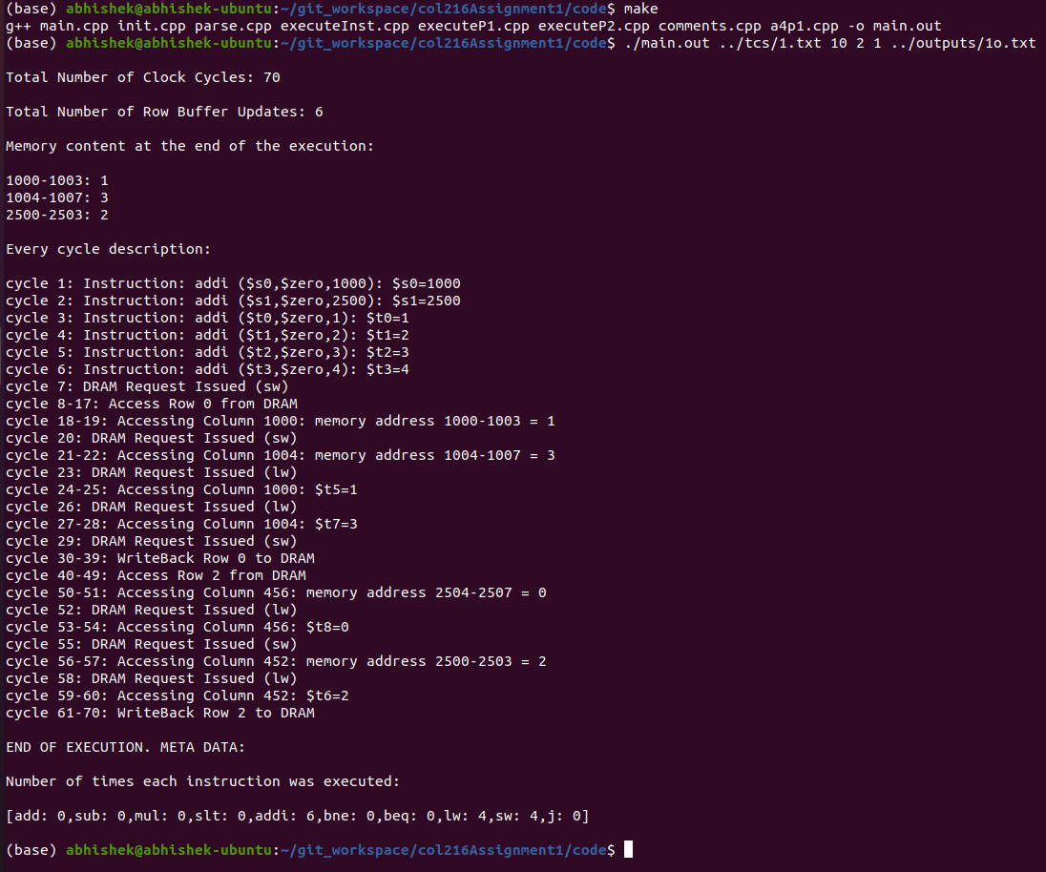

- Maintaining Data Structures: many data structures were used in addition to those used in assignment – 3:
  - We maintain 4 global multi-sets to identify which registers and memory have been blocked (each has two kinds: cannot use and cannot change since, it depends instruction to instruction) and hence if any upcoming instruction contradicts these sets, then all the instruction which blocked that register/memory will be executed first.
  - To do so, we also maintain queues for each register and memory which remember which lw/sw instructions blocked in the order in which they blocked it. We maintain two different kinds of queues for each register / memory – the “cannot change” and the “cannot use” queue.
  - For each lw/sw instruction which is postponed, we block the respective registers and memory locations as required and we also maintain this information - which instruction at what instruction address blocked what all registers and memory locations.

- Execution: As usual, the instructions are read one by one according to where the PC (Program Counter) points. For different kinds of instructions, we execute the instruction according to the following criteria:

- If it is lw or sw instruction, and the current row in row buffer is the same as the row which the instructiion wishes to access, then, if all registers and memory locations are free, we execute it right away,where as if some are blocked then we postpone the instruction by blocking appropriate locations.
- If it is not an lw / sw instruction, then we first execute all the instructions which are blocking the registers for that instruction in the order in which they blocked it. In case the instuctions called in the queue are themselves dependent on previous instructions then through recurrsion we keep on going up until we meet the first independent lw/sw instruction which needs a change in the row buffer and execute it. Then after all the instructions are executed in the queue and all queues for all registers are empty then we are safe and can execute the current instruction.
- Once we reach the end of file, it is possible that some of the instructions which were postponed earlier were not executed, and hence we begin from the bottom and begin executing those instructions which were not executed during the routine execution.

Strength: Linear Time complexity and improvement in number of clock cycles due to reduction in number of changes of row buffer.

Weakness: At the end of the execution of input file, if some of the instructions are remaining, then we do not execute all instructions demanding same rows from the DRAM together which could have optimized the performance and reduced the number of clock cycles because they would be scattered at unknown locations in the input file and hence have different dependencies with respect to different instructions and hence their order of execution cannot be determined so easily. Another weakness is heavy requirement of auxiliary space to maintain various data structures.

As usual, all the relevant statistics are printed as well after the execution both to the terminal and the output file.

Test – Cases: The implementation has been throughly tested with multiple test cases and ten of the test cases and their respective outputs for both the parts of the assignment have been attached with this document and the supporting C++ file.

~THANK YOU~

