Setup instructions for robot framework automation -   
Please follow all the steps sequentially.

* Install Python - <https://www.python.org/ftp/python/2.7.13/python-2.7.13.amd64.msi>  
  Make sure to check for pip, it usually installs with python itself, but if it doesn’t then install pip – refer following doc https://pip.pypa.io/en/stable/installing/  
  Configure the python’s path to Environment Variables - C:\Python27\Scripts  
  In the Scripts folder we will be installing Chrome driver depending on your browser -   
  <http://chromedriver.chromium.org/downloads?tmpl=%2Fsystem%2Fapp%2Ftemplates%2Fprint%2F&showPrintDialog=1>
* Install Pycharm IDE(Community Edition) - <https://www.jetbrains.com/pycharm/download/download-thanks.html?platform=windows&code=PCC>
* Install Selenium package  
  Make sure python is available in your machine, type the following command in CMD – **python --version**  
  Then install selenium using the command – **pip install selenium**
* Install robot framework package  
  Type the following command in CMD – **pip install robotframework**
* Install Robotframework Selenium Library package  
  Type the following command in CMD – **pip install robotframework-seleniumlibrary**
* *Make sure to check all the libraries are installed by using the following command –* ***pip list***
* Open the pycharm IDE  
   🡪 File 🡪Settings 🡪 Project 🡪Python Interpreter 🡪 For python interpreter select the python.exe installed in local machine
* Install packages in the pycharm IDE using the plus icon as show in the package  
  File 🡪Settings 🡪 Project 🡪Python Interpreter 🡪  
  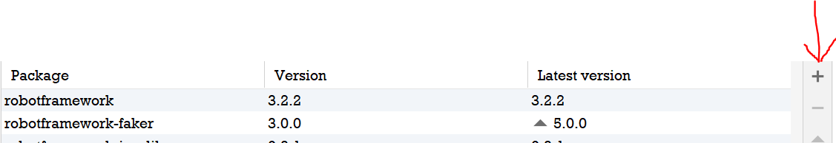
* Install the following packages -   
   robotframework  
   selenium  
   robotframework-seleniumlibrary
* Now you are ready to run the script -   
   🡪 From pycharm IDE go to files and open the following project.  
   🡪 then go to terminal in pycharm and enter the following command -  
   ***robot -d results tests/AddDealToCart.robot***