Test Cases:

1. User enters correct credentials and is able to login

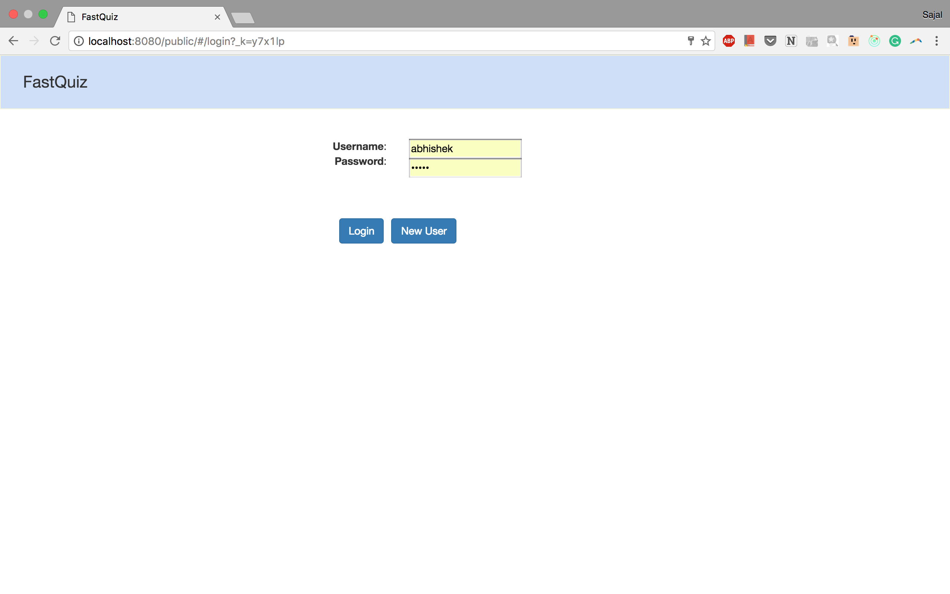

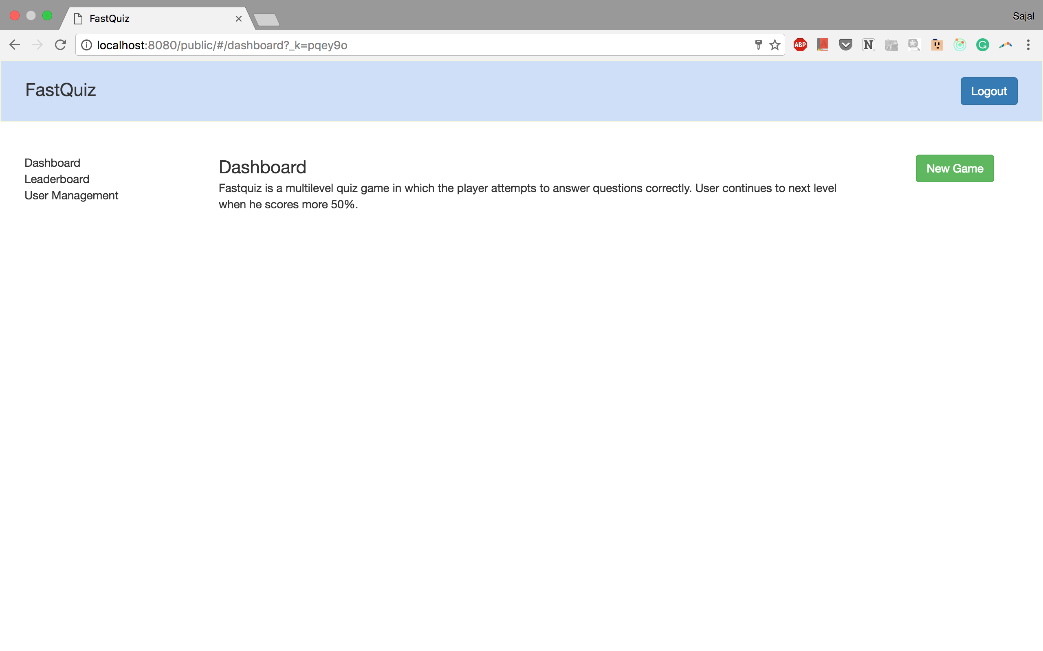

1. User enters incorrect credentials and is unable to login

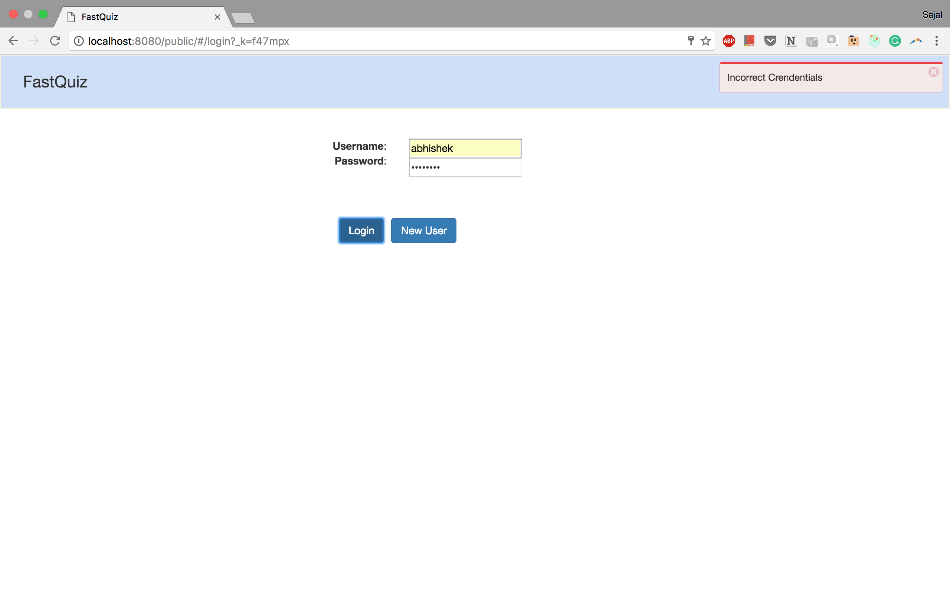

1. User enters valid form data for signup and is able to sign up

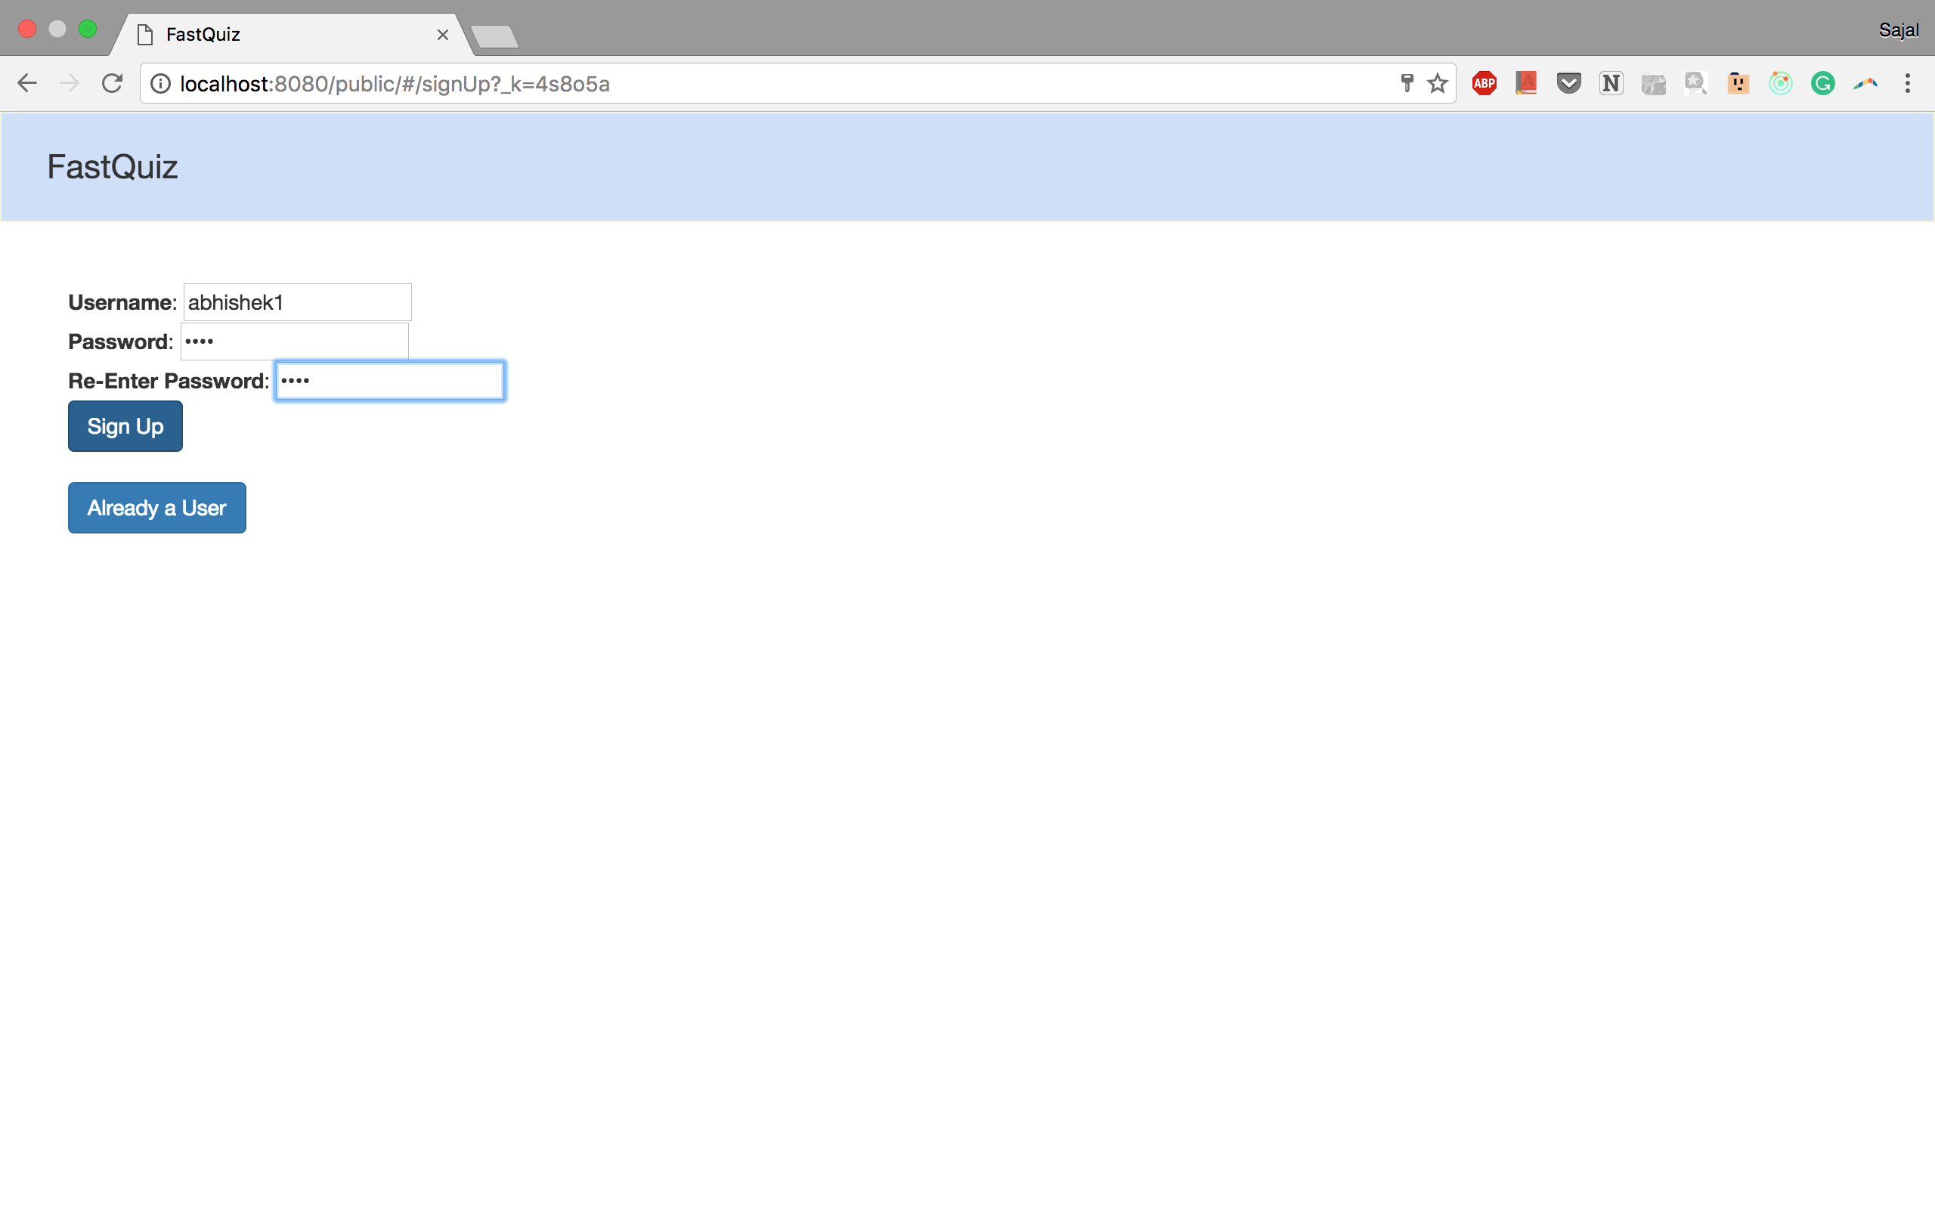

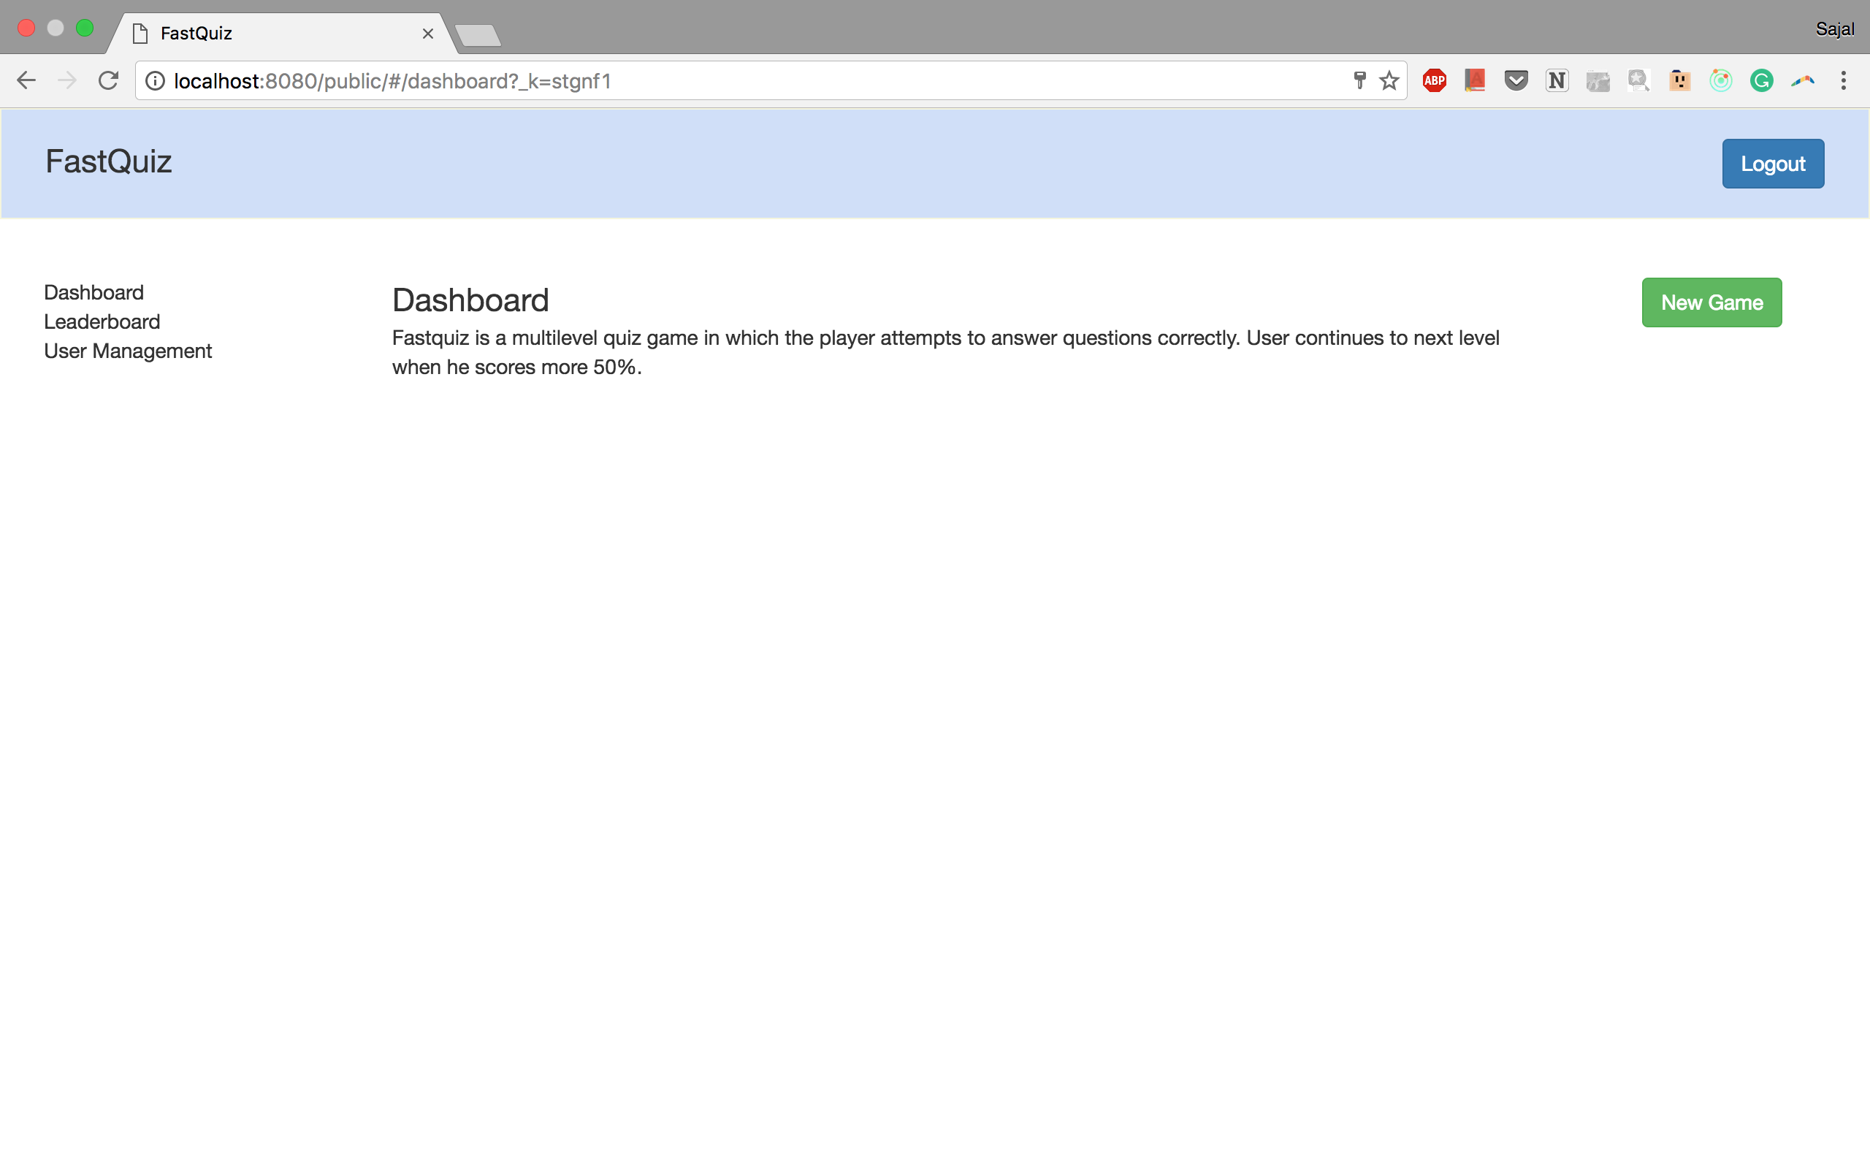

1. User enters invalid form data for signup and is unable to sign up

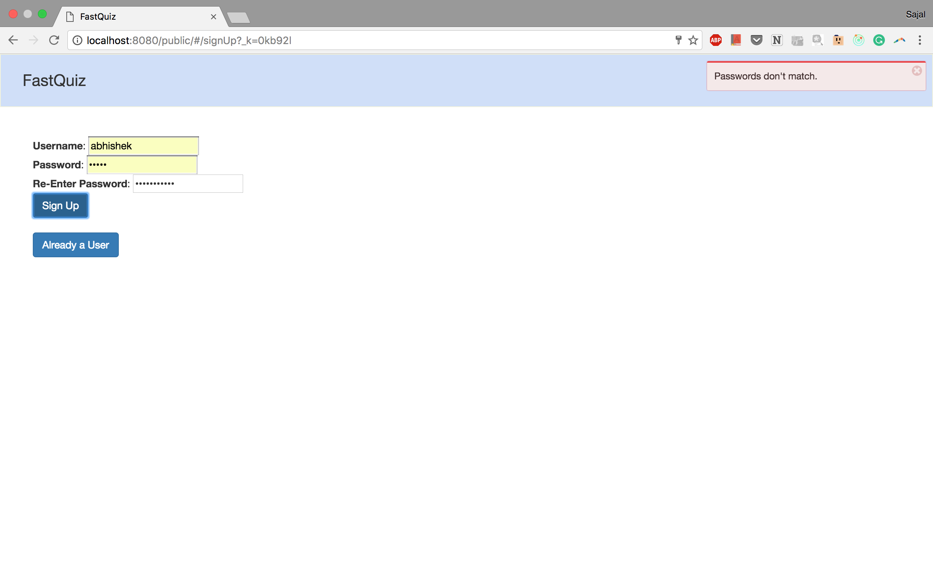

1. User is able to logout on click of logout button

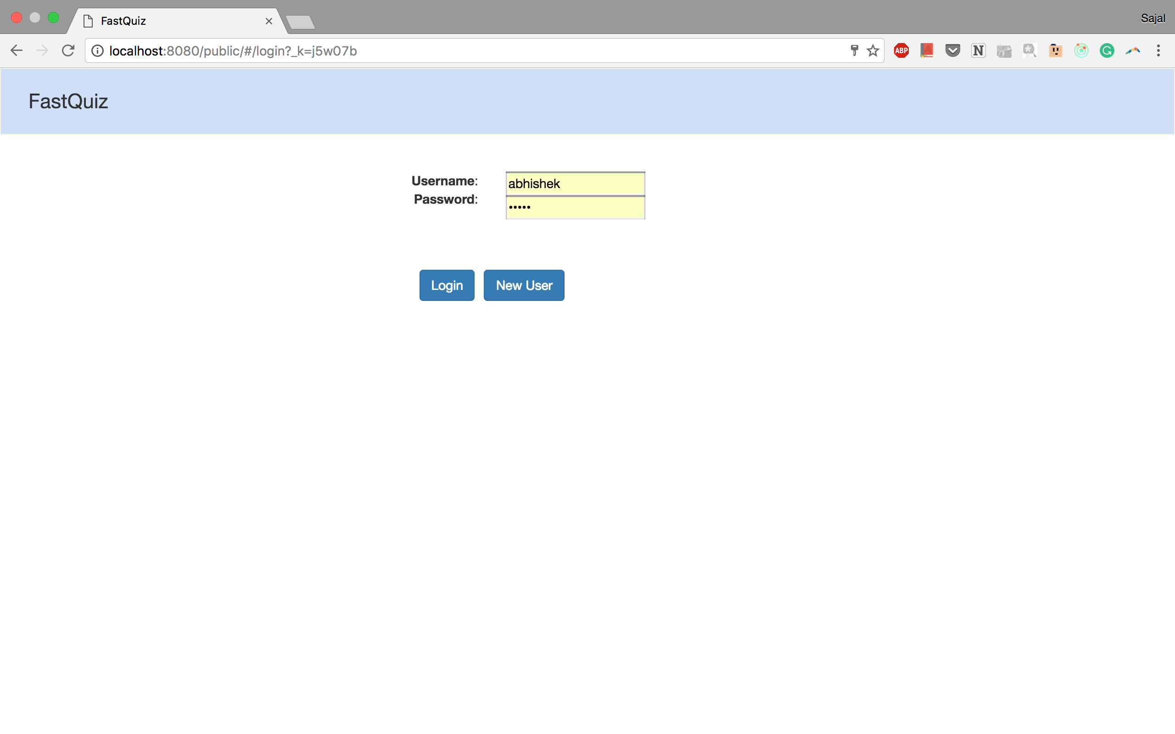

1. User is able to see the leaderboard on click of leaderboard tab

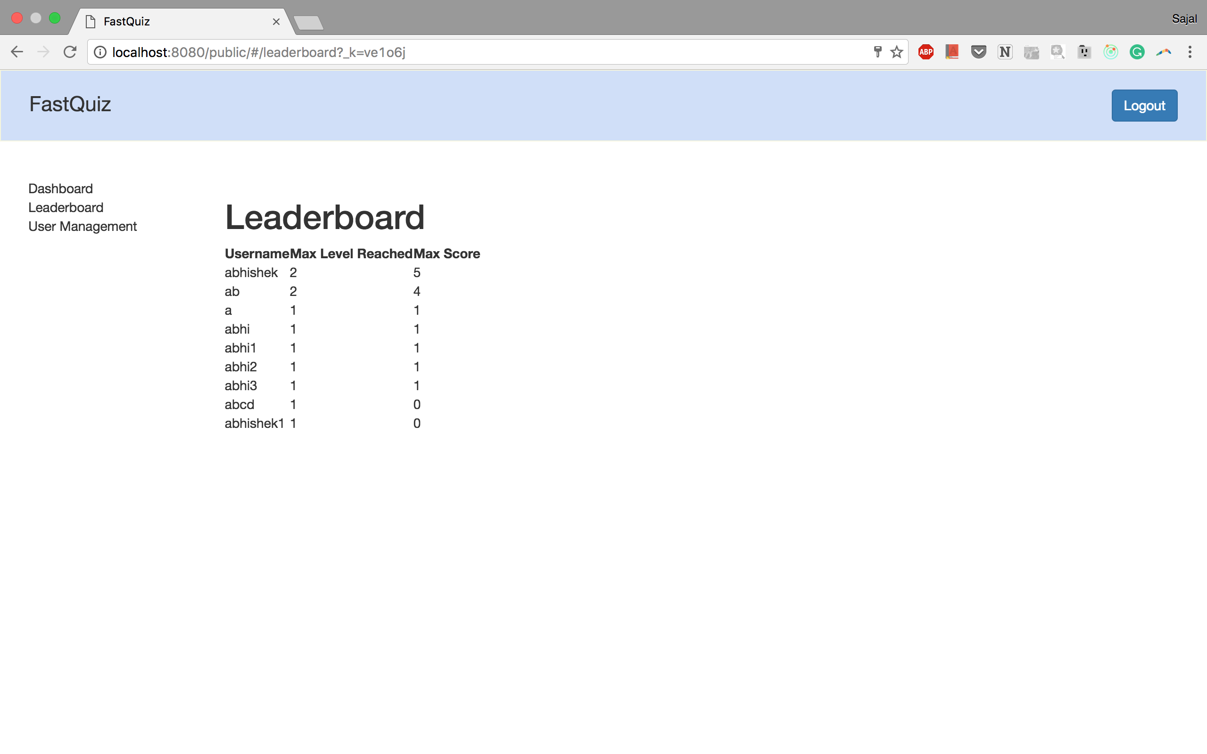

1. User is able to update password when he enters correct old password

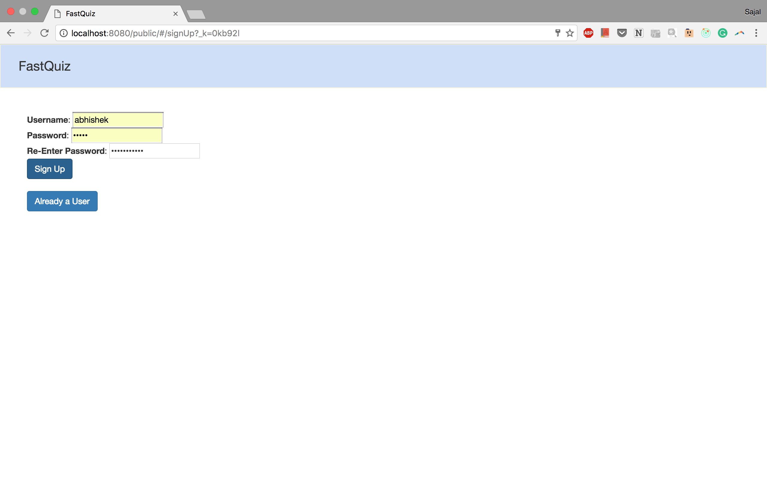

1. User is unable to update password when he enters incorrect old password

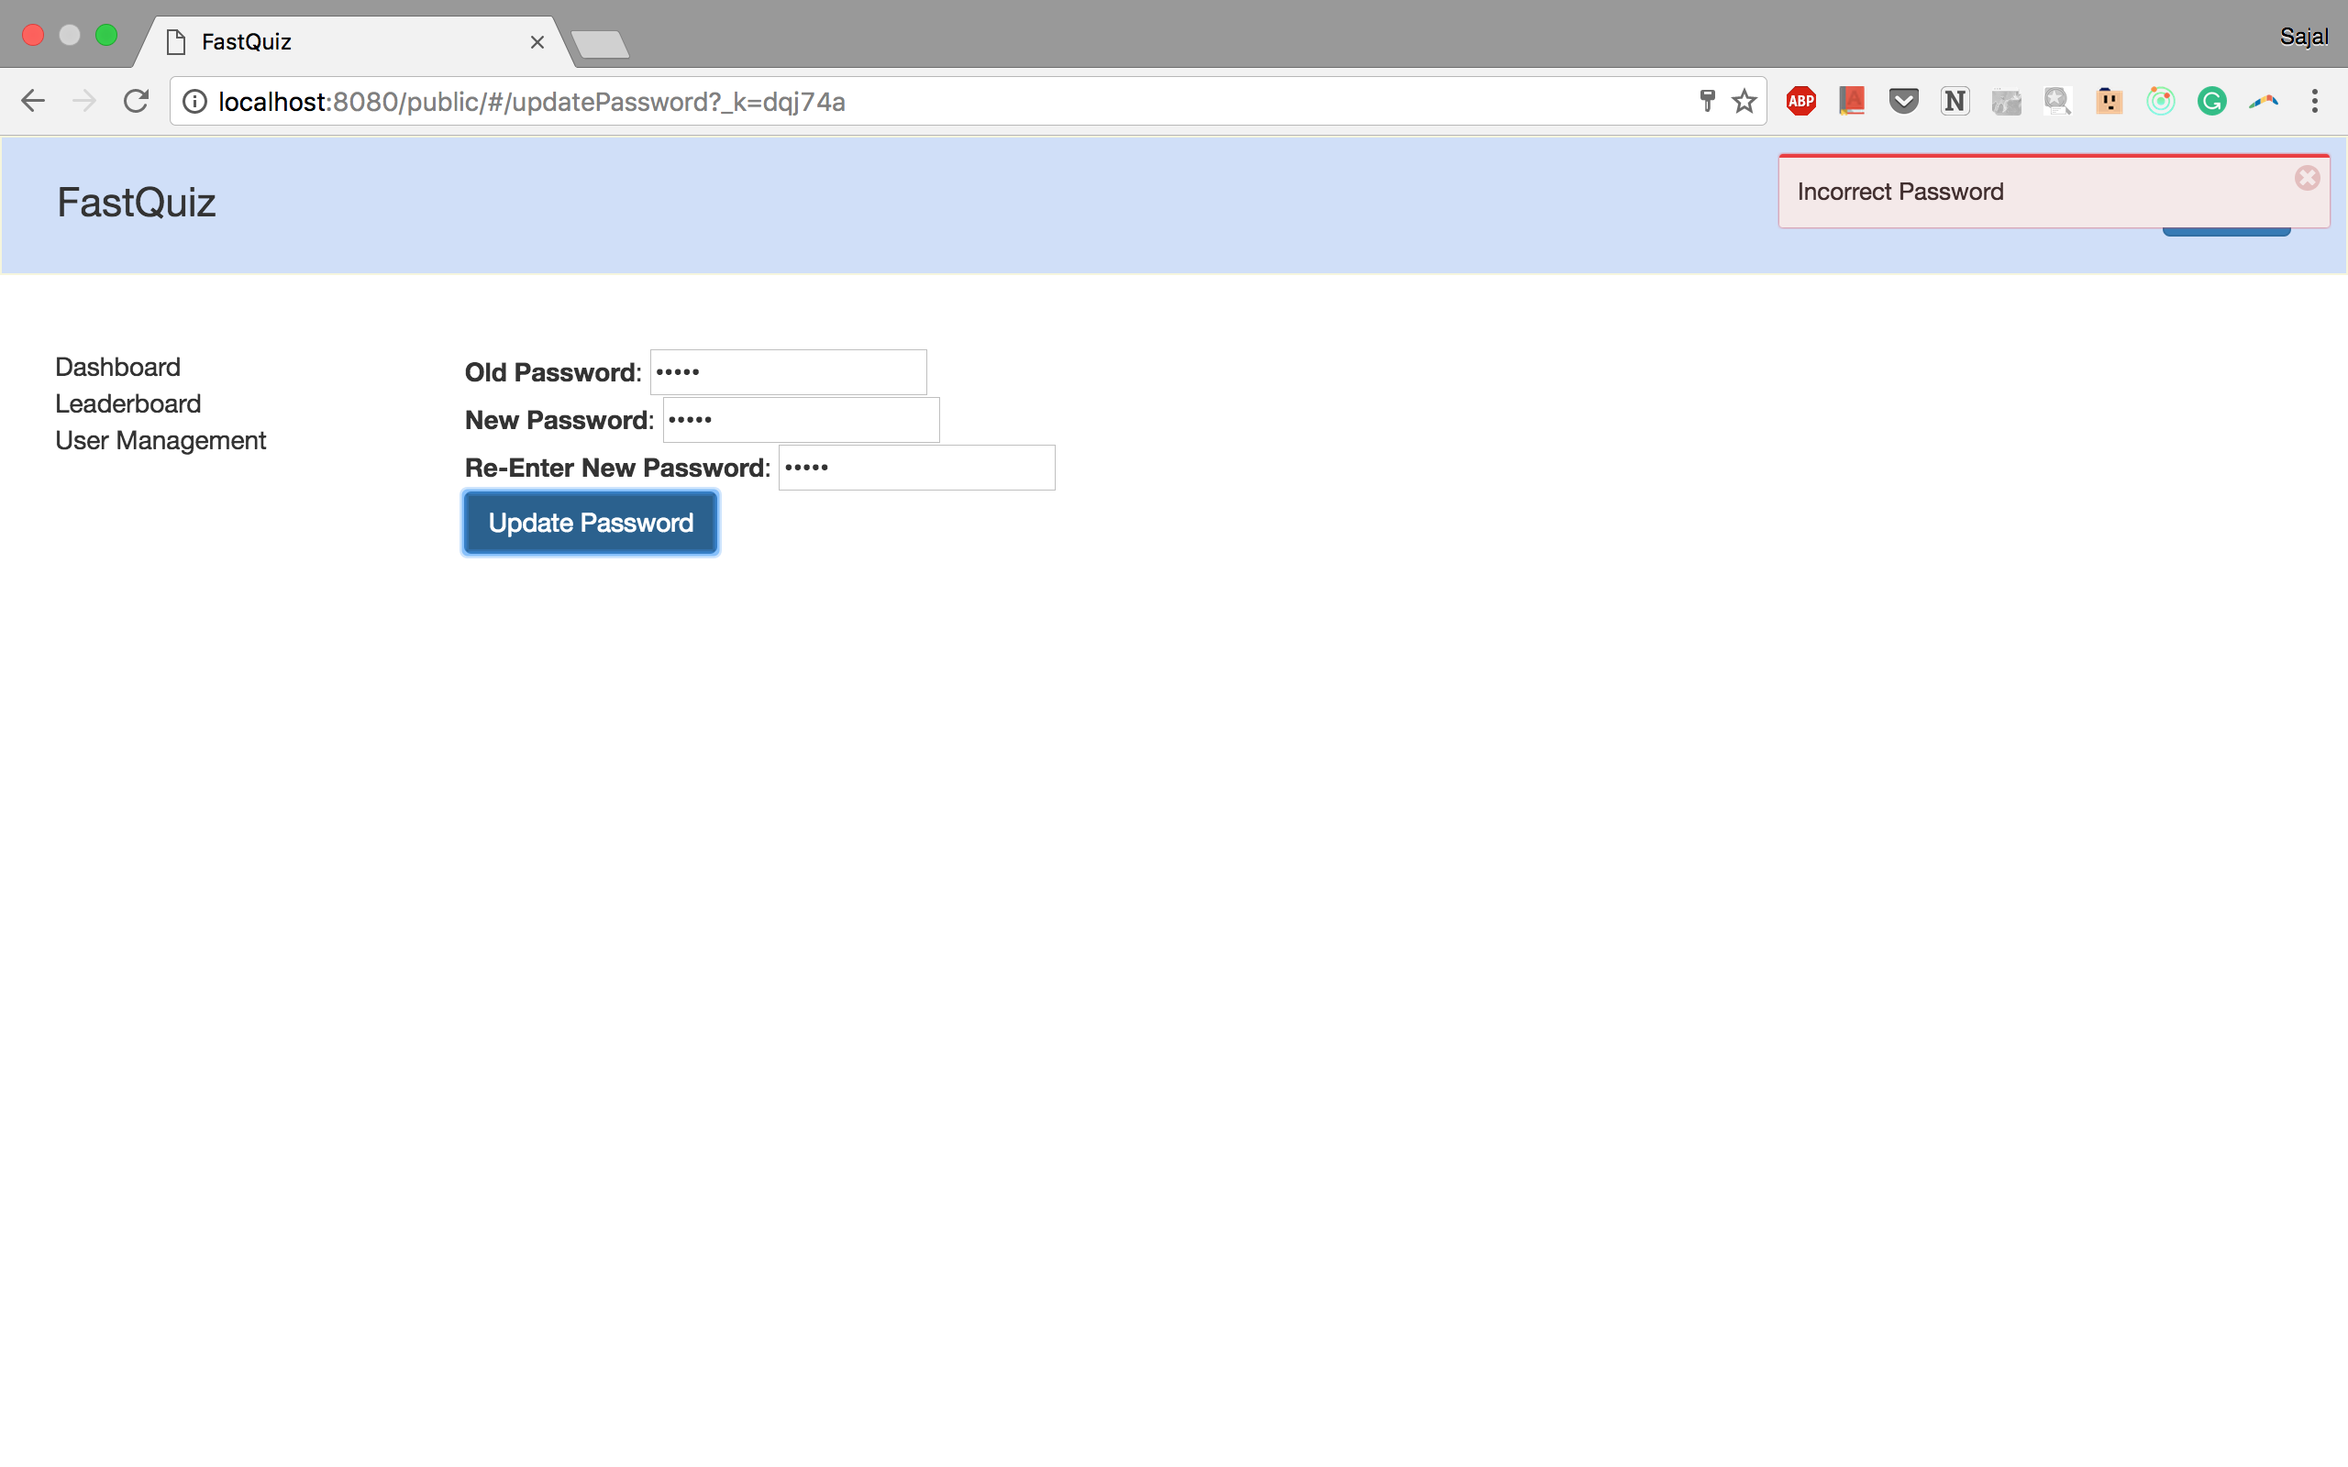

1. New instance of a game starts on click of new game button

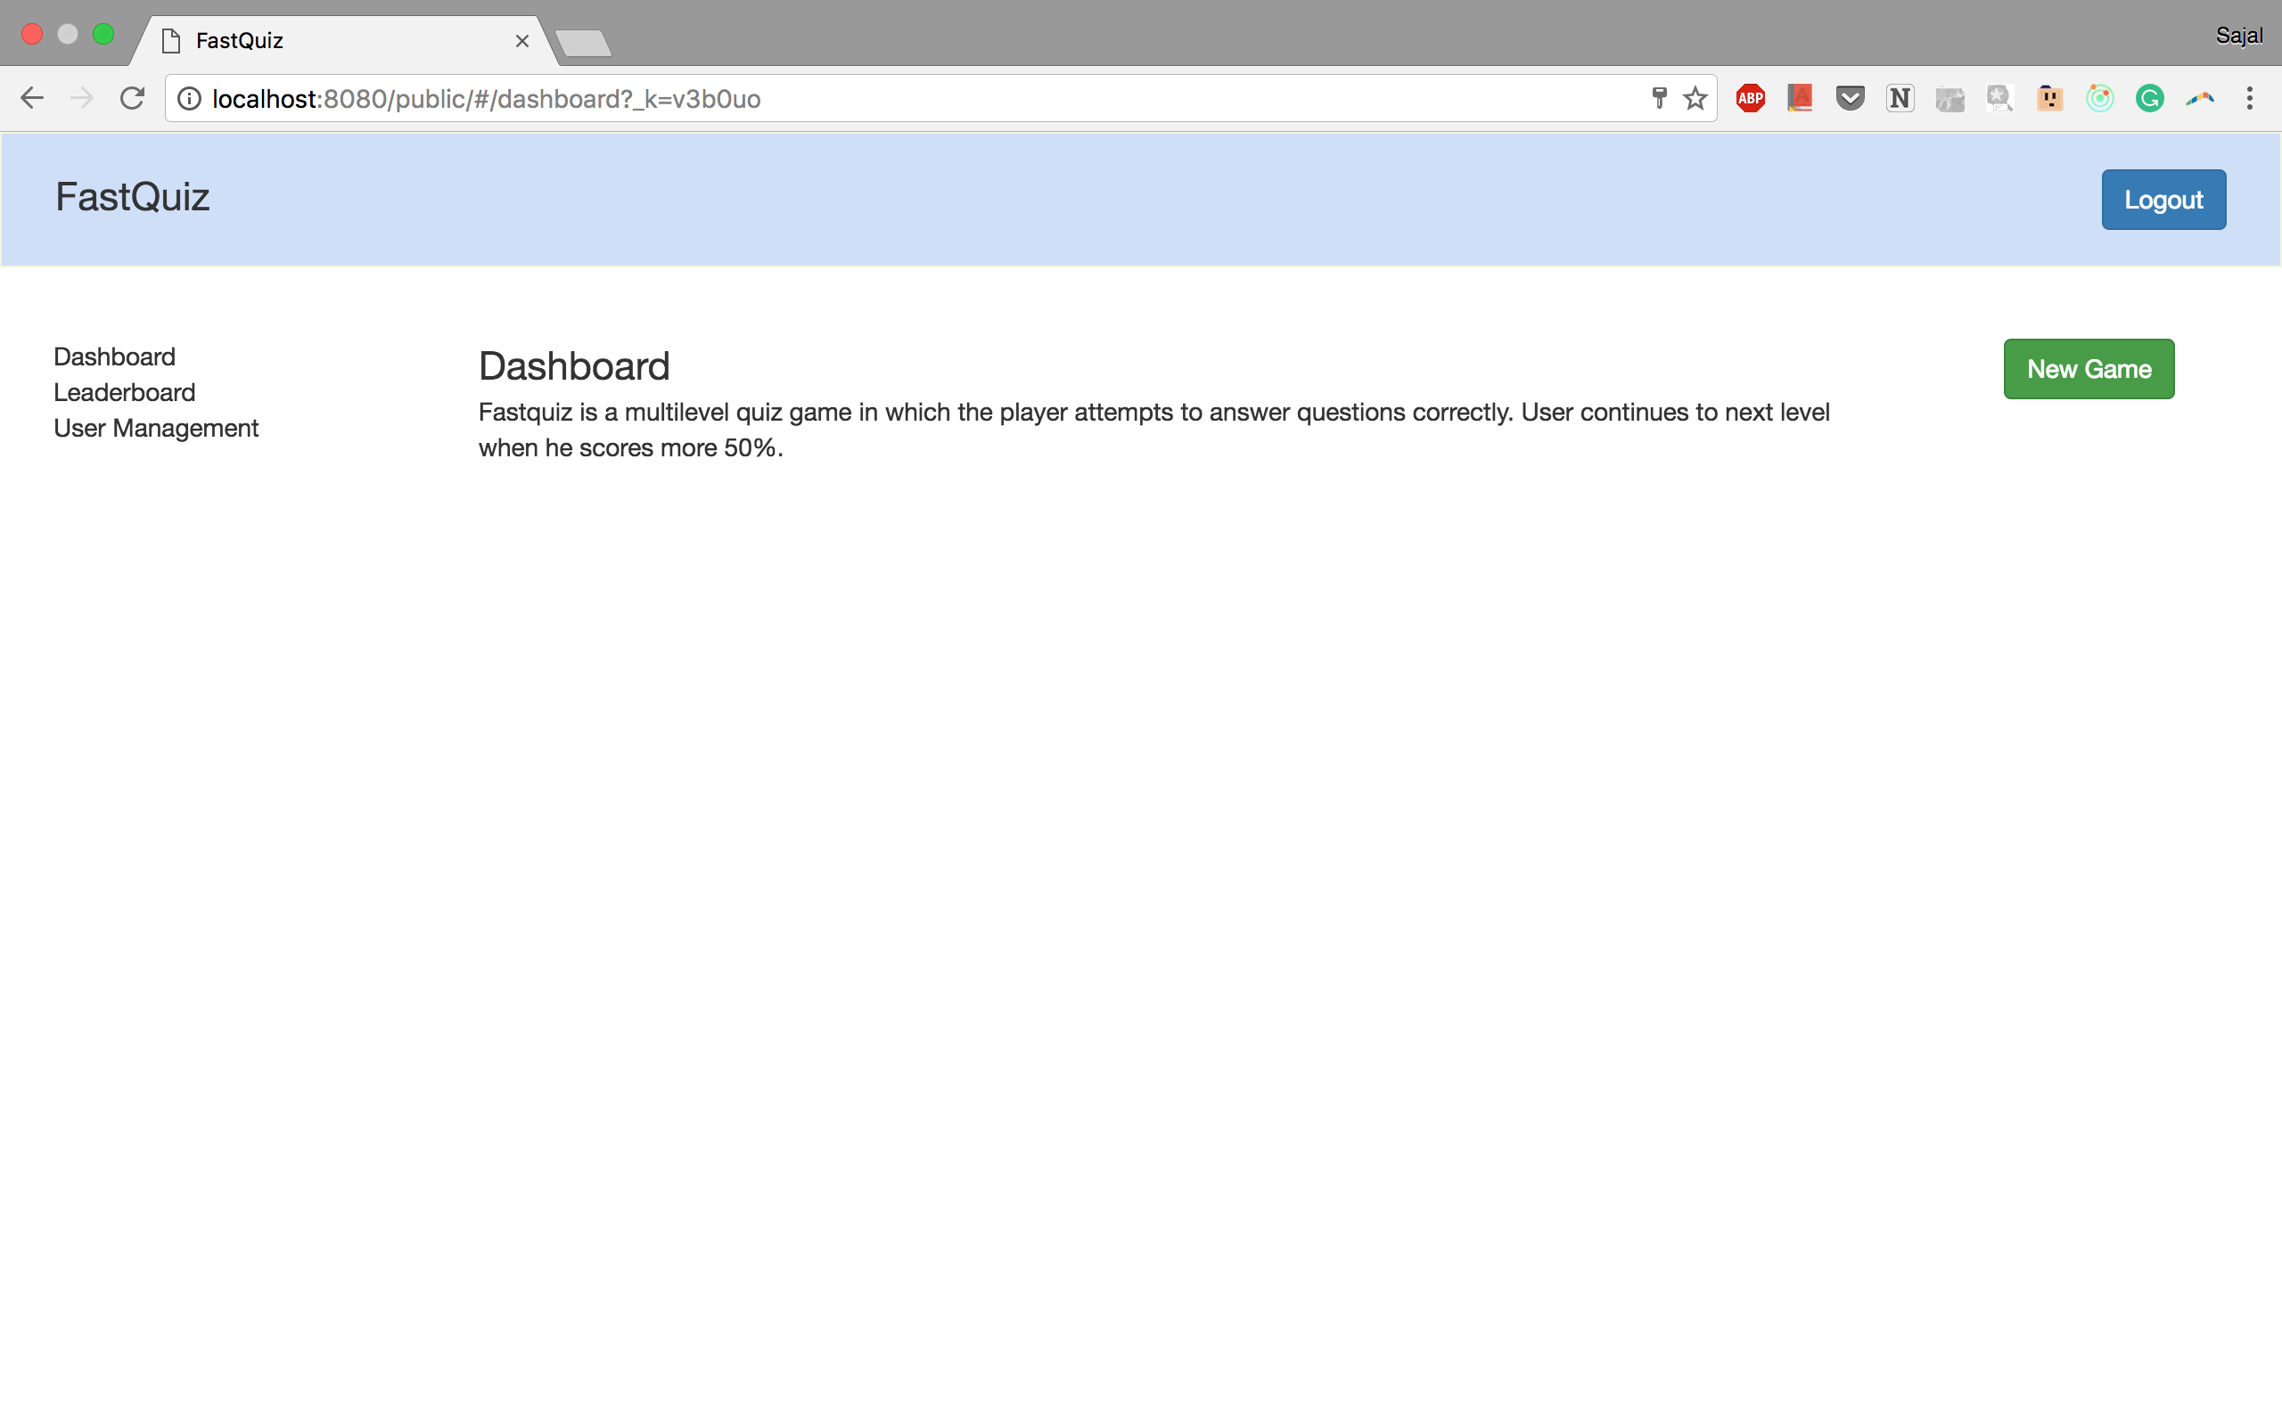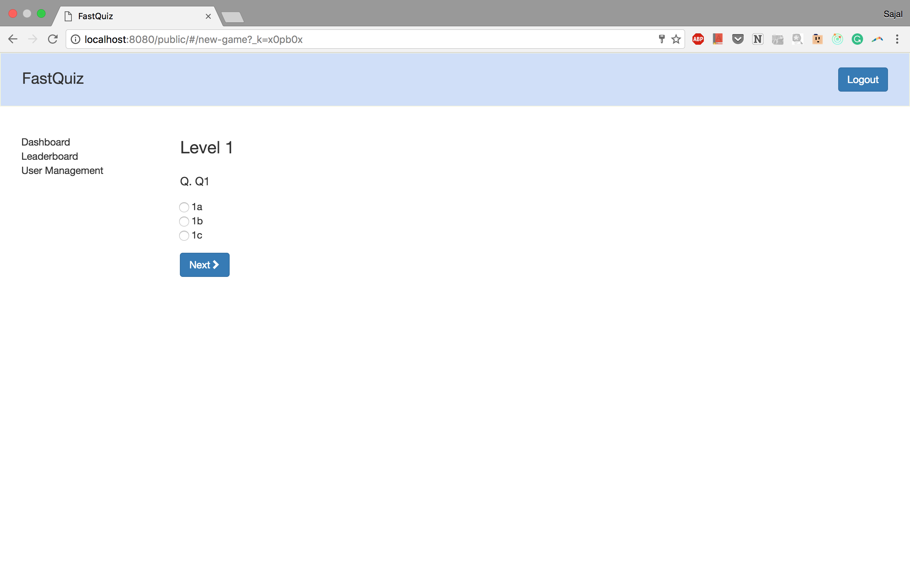

1. After selecting an option user is able to move to the next question on clicking next button

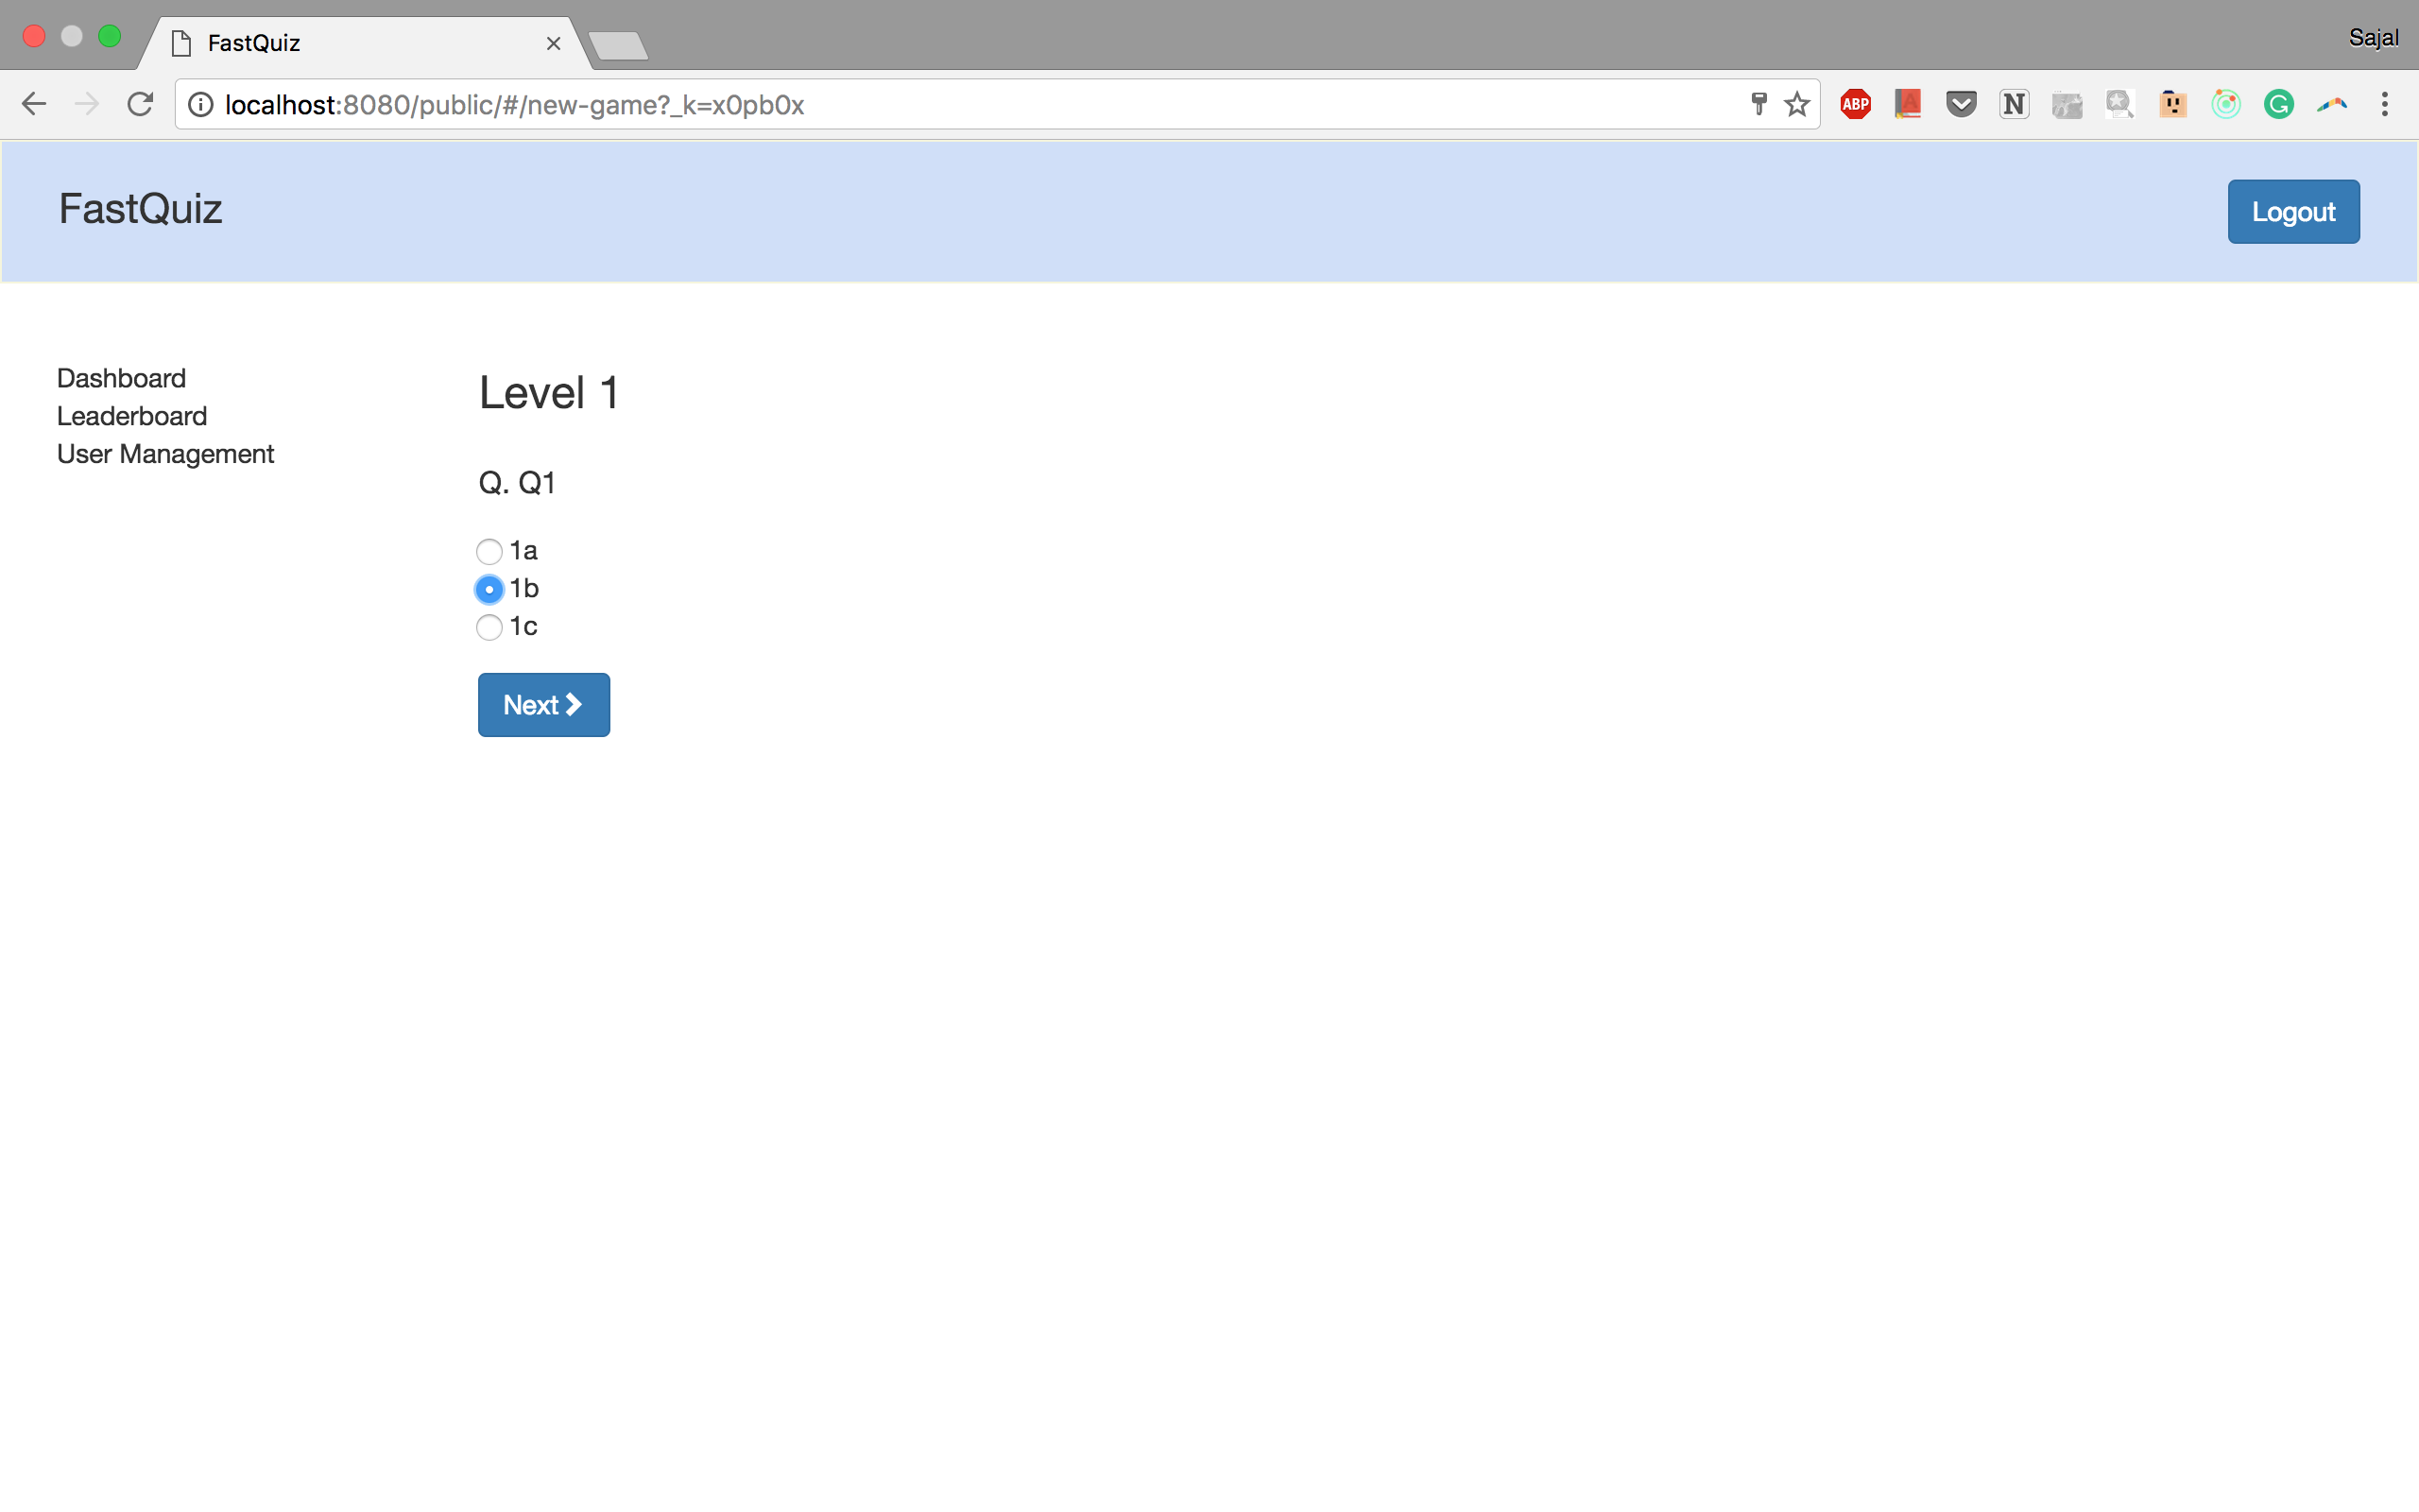

1. Without selecting an option user is unable to move to the next question on clicking next button

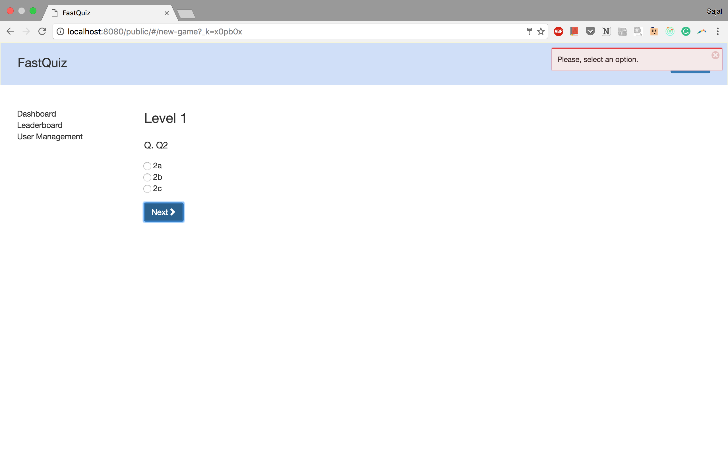

1. On completion of a level user is able to see the review of his answers

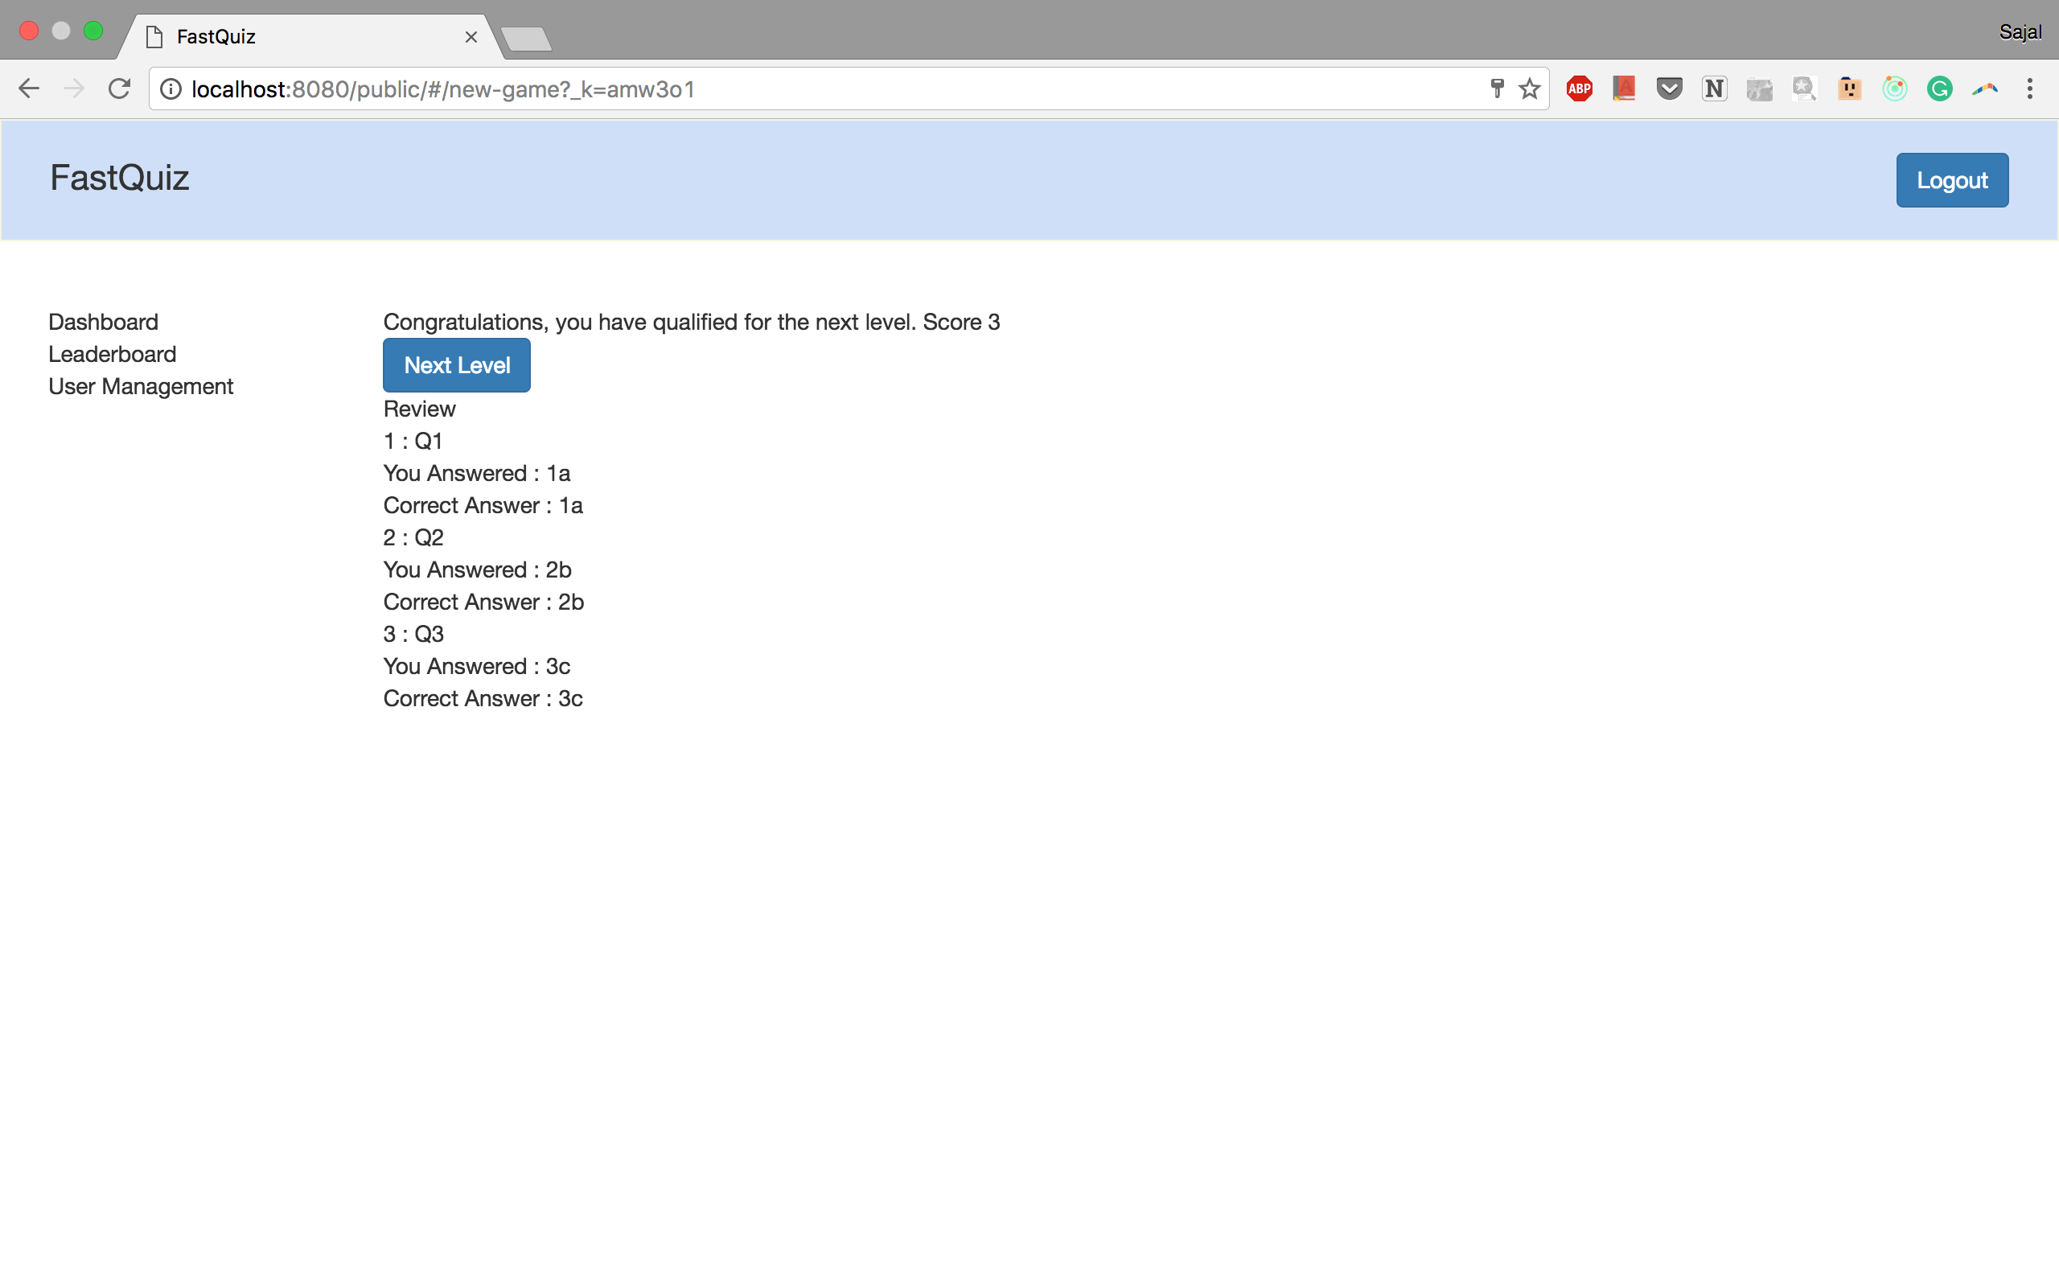

1. On completion of a level if user does not qualify he will not be allowed to move to the next level

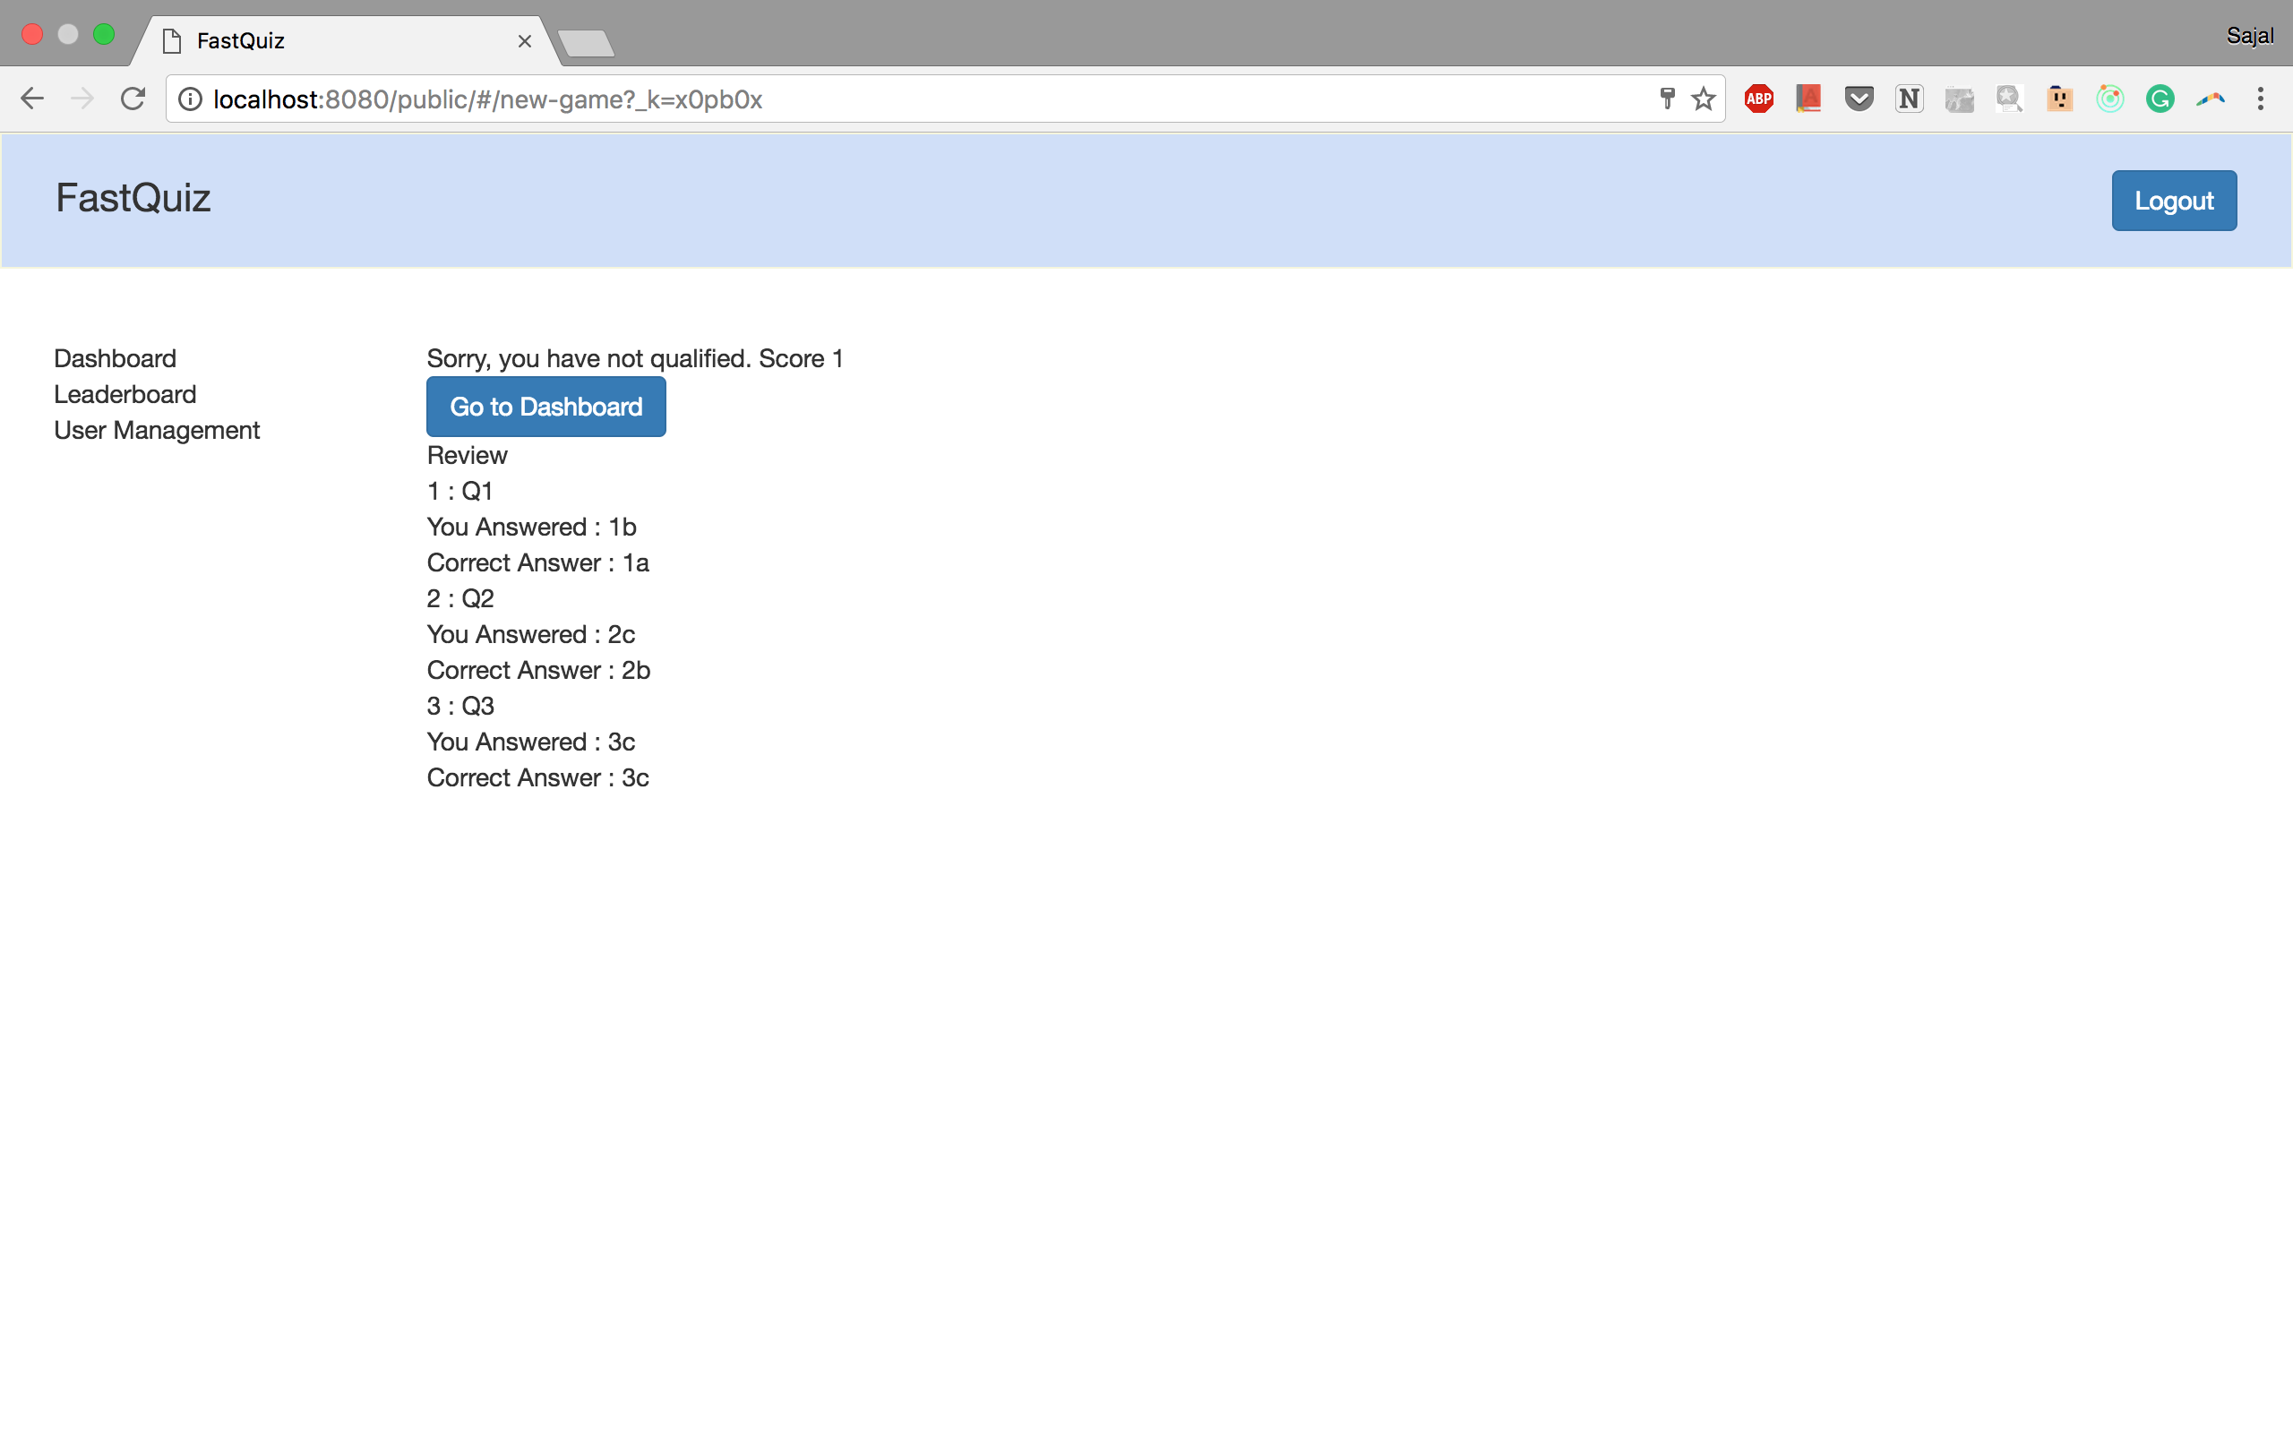

1. On completion of a level if user qualifies he will be allowed to move to the next level



1. The game ends on completion of all the levels

