MATRIX

- Given an m x n matrix and an integer x. In the matrix every row and column of the matrix is sorted in increasing order, find the position of x in the matrix if it is present. Otherwise, print Element not found.

Example: Input: mat[4][4] = { {10, 20, 30, 40}, x = 29
{15, 25, 35, 45},
{27, 29, 37, 48},
{32, 33, 39, 50}}
Output: Found at (2, 1)

Solution
TC: O(max(m,n))
public void search(int[][] mat, int m, int n, int x) {
// set indexes for top right
int i = 0, j = n - 1;
while (i < m && j >= 0) {
if (mat[i][j] == x) {
System.out.print("Element found at " + i
+ " " + j);
return;
}
if (mat[i][j] > x)
j--;
else // if mat[i][j] < x
i++;
}

System.out.println(“Element ” + x + “not found.”);
return;
}

- Given an m x n matrix, return all elements of the matrix in spiral order.

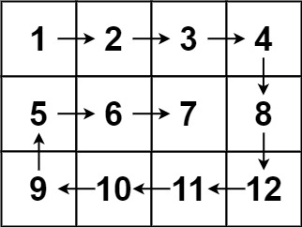

Solution:

TC: O(mn)

public List<Integer> spiralOrder(int[][] matrix) {
List<Integer> res = new ArrayList<Integer>();
if(matrix.length == 0 || matrix[0].length == 0) return res;

int top = 0;
int bottom = matrix.length-1;
int left = 0;
int right = matrix[0].length-1;

while(true){
for(int i = left; i <= right; i++) res.add(matrix[top][i]);
top++;
if(left > right || top > bottom) break;

for(int i = top; i <= bottom; i++) res.add(matrix[i][right]);
right--;
if(left > right || top > bottom) break;

for(int i = right; i >= left; i--) res.add(matrix[bottom][i]);
bottom--;
if(left > right || top > bottom) break;

for(int i = bottom; i >= top; i--) res.add(matrix[i][left]);
left++;
if(left > right || top > bottom) break;
}

return res;
}

- Given an m x n binary matrix filled with 0's and 1's, find the largest square containing only 1's and return its area.

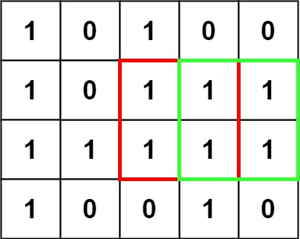

Solution:
public int maximalSquare(char[][] a) {
if(a.length == 0) return 0;
int m = a.length, n = a[0].length, result = 0;
int[][] b = new int[m+1][n+1];
for (int i = 1 ; i <= m; i++) {
for (int j = 1; j <= n; j++) {
if(a[i-1][j-1] == '1') {
b[i][j] = Math.min(Math.min(b[i][j-1] , b[i-1][j-1]), b[i-1][j]) + 1;
result = Math.max(b[i][j], result); // update result
}
}
}
return result*result;
}

TC: O(mn)
SC: O(mn)

- Given a 2D integer array n*n matrix, return the transpose of matrix. The transpose of a matrix is the matrix flipped over its main diagonal, switching the matrix's row and column indices.
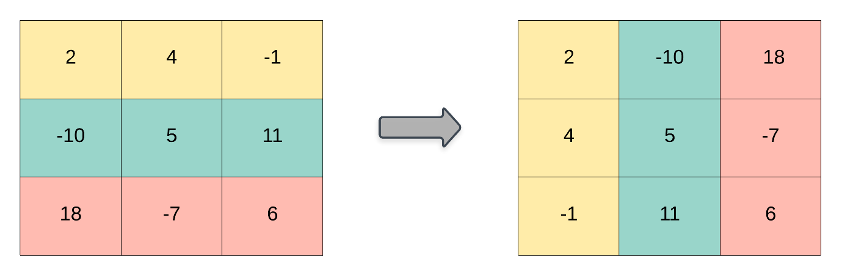

Solution:
TC: O(n*n)
SC: O(1)
public void transpose(int[][] matrix) {
int n =matrix.length;
//transpose the matrix
for(int i = 0; i<n; i++){
for(int j = i; j<matrix[0].length; j++){
//swap 2 variables
int temp = matrix[i][j];
matrix[i][j] = matrix[j][i];
matrix[j][i] = temp;
}
}

- Given an m x n integer matrix, if an element is 0, set its entire row and column to 0's. You must do it in place.

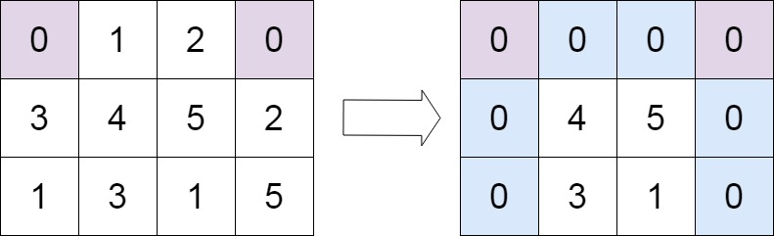

Solution:

TC: O(mn)
SC: O(1)

public void setZeroes(int[][] matrix) {
int col_no_0=0;
int row_no_0=0;
for(int i=0;i<matrix.length;i++)
{
if(matrix[i][0]==0)
col_no_0=1;
for(int j=1;j<matrix[0].length;j++)
{
if(matrix[i][j]==0)
{
matrix[0][j]=0;
matrix[i][0]=0;
}
}
}

for(int i=1;i<matrix.size();i++)
{
for(int j=1;j<matrix[0].size();j++)
{

if(matrix[i][0]==0 || matrix[0][j]==0)
{
matrix[i][j]=0;
}
}
}

if(matrix[0][0]==0)

for(int j=0;j<matrix[0].size();j++)
matrix[0][j]=0;

if(col_no_0==1)
{
for(int j=0;j<matrix.size();j++)
matrix[j][0]=0;
}

}

