Breadth First Traversal In Matrix

1.Given an n x n binary matrix grid, return the length of the shortest clear path in the matrix. If there is no clear path, return -1. A clear path in a binary matrix is a path from the top-left cell (i.e., (0, 0)) to the bottom-right cell (i.e., (n - 1, n - 1)) such that:
All the visited cells of the path are 0.
All the adjacent cells of the path are 8-directionally connected. The length of a clear path is the number of visited cells of this path.

Solution:

public int shortestPathBinaryMatrix(int[][] g) {

int dx[] = {-1,0,1,1,1,0,-1,-1};
int dy[] = {1,1,1,0,-1,-1,-1,0};
int r=g.length;
int c=g[0].length;

Queue<int[]> queue = new LinkedList<>();
queue.offer(new int[]{0, 0});

int ans = 0;

if(g[0][0]==1)
return -1;
while (!queue.isEmpty()) {

int levelSize = queue.size();
ans++;

while(levelSize-->0) {

int[] point = queue.poll();
int xx = point[0];
int yy = point[1];

if (xx == r - 1 && yy == c - 1) {
return ans;
}

for(int k=0;k<8;k++){

int nx = xx + dx[k];
int ny = yy + dy[k];

if(nx<0 || nx>=r || ny<0 || ny>=c)
continue;

if(g[nx][ny]==1)
continue;

queue.offer(new int[]{nx, ny});
g[nx][ny]=1;

}

}

}

return -1;
}

TC: O(n*n)
SC: O(n*n)

2. In an infinite chess board with coordinates from -infinity to +infinity, you have a knight at square [0, 0].
A knight has 8 possible moves it can make, as illustrated below. Each move is two squares in a cardinal direction, then one square in an orthogonal direction.
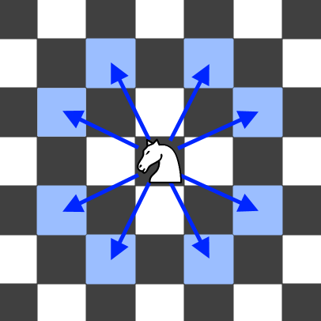

Return the minimum number of steps needed to move the knight to the square [x, y].
Where 0 <= |x| + |y| <= 300

Solution:

public int minKnightMoves(int x, int y) {
if (x == 0 && y == 0) {
return 0;
}
int dx[]={-2,-1,1,2,2,1,-1,-2};
int dy[]={1,2,2,1,-1,-2,-2,-1};
x=Math.abs(x);
y=Math.abs(y);
Queue<int[]> q = new LinkedList<>();
boolean[][] vis = new boolean[301][301];

vis[0][0]=true;
q.add(new int[]{0,0});
int l=0;
while(!q.isEmpty())
{
int n=q.size();
l++;
while(n--!=0)
{
int[] temp=q.poll();
//q.pop();
int xx=temp[0];
int yy=temp[1];
if(xx==x && yy==y)
return l-1;

for(int k=0;k<8;k++)
{
int nx=Math.abs(xx+dx[k]);
int ny=Math.abs(yy+dy[k]);

if(nx>=0 && ny>=0 && nx<301 && ny<301)
{
if(vis[nx][ny]==false){
vis[nx][ny]=true;
q.add(new int[]{nx,ny});
}
}
}
}
}
return -1;

}

T.C= O(m*n) where m is the no of row and n is the no of column.

DEPTH FIRST TRAVERSAL IN A MATRIX

3. Given an m x n 2D binary grid which represents a map of '1's (land) and '0's (water), return the number of islands.

An island is surrounded by water and is formed by connecting adjacent lands horizontally or vertically. You may assume all four edges of the grid are all surrounded by water.

Input: grid = [
["1","1","0","0","0"],
["1","1","0","0","0"],
["0","0","1","0","0"],
["0","0","0","1","1"]
]
Output: 3

Solution:
T.C= O(m*n) where m is the no of row and n is the no of column.

int dx[] = {-1,0,1,0};
int dy[] = {0,1,0,-1};

public void dfs(int x, int y, int r, int c, char [][] grid, boolean [][] vis)
{
if(x<0 || x>=r || y<0 || y>=c || vis[x][y]==true || grid[x][y] == '0') return;

vis[x][y]=true;

for(int i=0;i<4;i++)
{
int nx = x+dx[i];
int ny = y+dy[i];

if(nx>=0 && nx<r && ny>=0 && ny<c && vis[nx][ny]==false && grid[x][y] == '1')
dfs(nx,ny,r,c,grid,vis);
}

}
public int numIslands(char[][] g) {

int r=g.length;
int c=g[0].length;
boolean[][] vis = new boolean[r+1][c+1];

// vector<vector<bool>>vis(r,vector<bool>(c,false));
int ans=0;
for(int i=0;i<r;i++)
{
for(int j=0;j<c;j++)
{
if(g[i][j]=='1' && !vis[i][j])
{
dfs(i,j,r,c,g,vis);
ans++;
}
}
}
return ans;
}
4. You are given an m x n binary matrix grid. An island is a group of 1's (representing land) connected 4-directionally (horizontal or vertical.) You may assume all four edges of the grid are surrounded by water.
The area of an island is the number of cells with a value 1 in the island.
Return the maximum area of an island in grid. If there is no island, return 0.

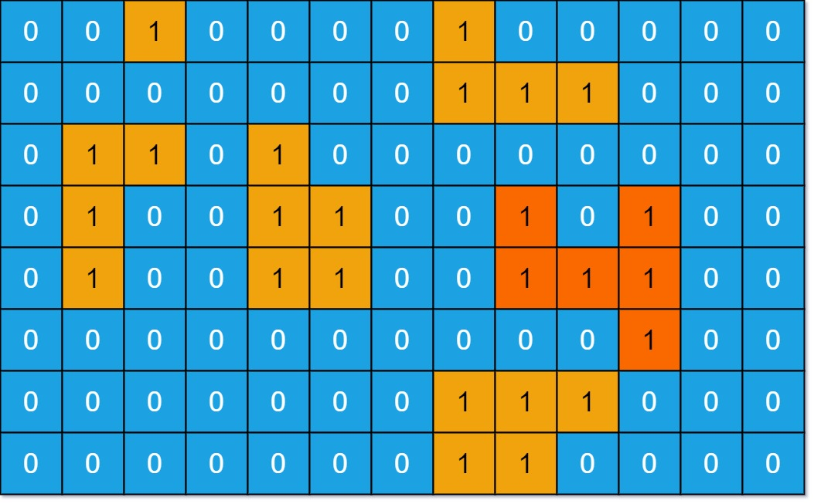
Output: 6

Solution:
public int dfs(int x,int y, int r, int c, int[][] g, boolean[][] vis)
{
if(x<0 || y<0 || x>=r || y>=c || g[x][y]==0 || vis[x][y]==true)
return 0;

vis[x][y]=true;

return 1 + dfs(x+1,y,r,c,g,vis) + dfs(x,y+1,r,c,g,vis) + dfs(x-1,y,r,c,g,vis) + dfs(x,y-1,r,c,g,vis);

}

public int maxAreaOfIsland(int[][] g) {

int r = g.length;
int c = g[0].length;
int ans=0;
boolean[][] vis = new boolean[r+1][c+1];
int cnt=0;
for(int i=0;i<r;i++)
{
for(int j=0;j<c;j++)
{
if(g[i][j]==1 && vis[i][j]==false)
{
int cnt = dfs(i,j,r,c,g,vis);
if(cnt>ans)
ans=cnt;
}
}
}
return ans;
}
TC: O(m*n)

