T-REX / ERC-3643 Contract Suite
Architecture, Transaction Flow & Function Reference
This document covers the core T-REX permissioned token suite: the Token contract, the Identity Registry stack (KYC/claims layer), Modular Compliance and its active rule modules, the Factory/Gateway deployment system, and the Proxy/Implementation Authority upgrade layer. Legacy compliance contracts and test-only contracts are out of scope.

1. How the Contract Works — Plain-Language Overview
T-REX is a regulated ERC-20 token. A normal ERC-20 lets any wallet hold and trade the token freely. T-REX adds a checkpoint before every transfer, mint, or burn: is the wallet a verified, KYC'd identity, and does the transfer obey the compliance rules configured for this token (country limits, holder caps, volume limits, etc.)? If either check fails, the transaction reverts — no exceptions, not even for the token owner's own wallet.
The suite is built from five cooperating pieces:
- Token — the ERC-20 logic itself, extended so every transfer/mint/burn consults the other pieces before moving balances.
- Identity Registry stack (Identity Registry + Storage + Claim Topics Registry + Trusted Issuers Registry) — determines whether a wallet counts as “verified” by checking that its linked on-chain identity holds valid claims (e.g. “KYC passed”) signed by an approved issuer.
- Modular Compliance — a pluggable rule engine. Rules (country restriction, max balance, max holders, supply cap, volume limits, fees, blackout windows, sender whitelist) are separate module contracts bound to the compliance contract, so rules can be added or removed without redeploying the token.
- Proxy / Implementation Authority — every contract in a deployed suite is a thin proxy that delegates its logic to a shared implementation contract referenced by a central beacon (the Implementation Authority). Upgrading the beacon upgrades every deployed suite's logic at once.
- Factory / Gateway — deploys a complete, wired-together suite (Token + the four registry/compliance contracts) in a single transaction, with optional deployer permissioning and deployment fees.

Architecture Diagram
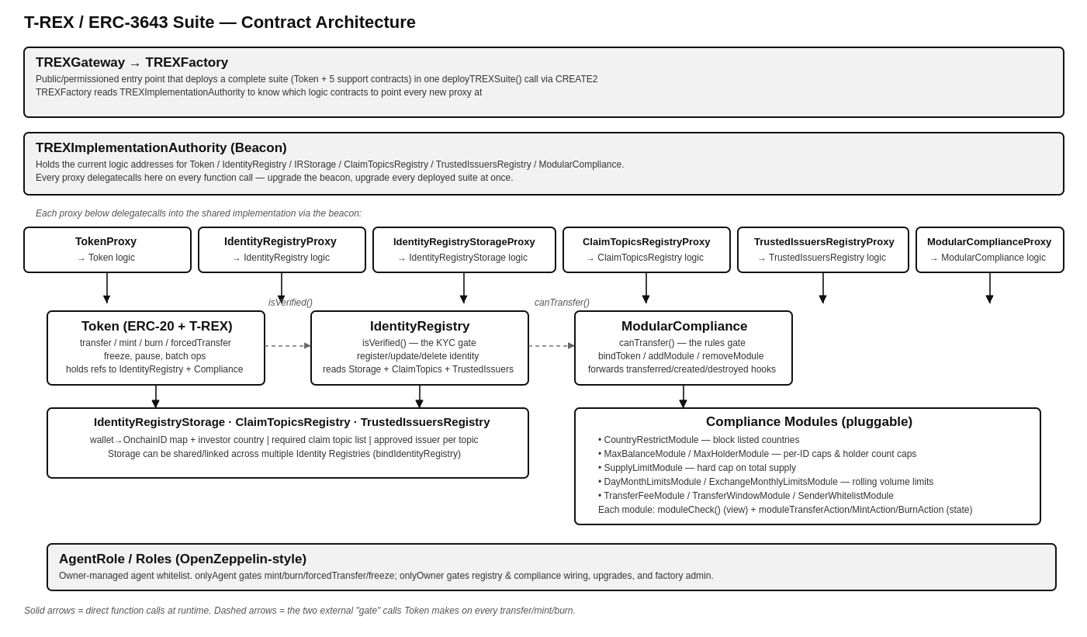

2. Transaction Flow — Token.transfer()
Every state-changing token action funnels through the same verify → comply → execute → notify pattern. The diagram below traces a standard transfer() call end to end; the box beneath it notes where mint(), burn(), and forcedTransfer() diverge from this path.
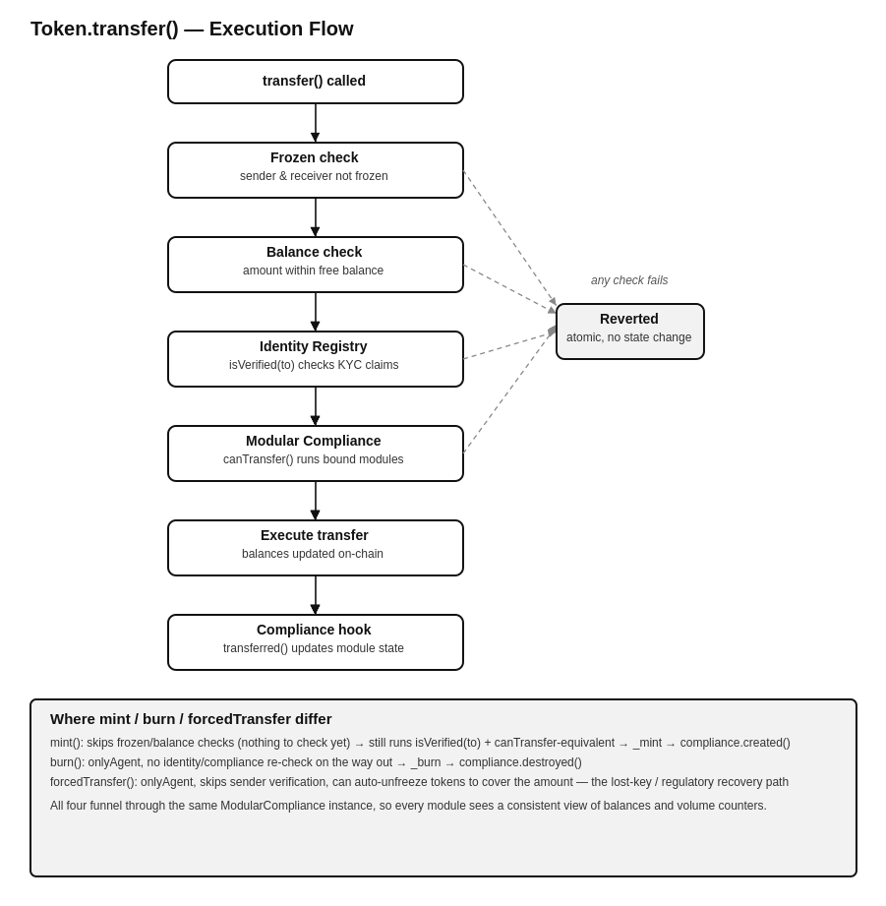

3. Function-by-Function Reference
Access column: Public = any caller, Owner = onlyOwner (token/registry/compliance owner or contract deployer), Agent = onlyAgent (agent role granted by the owner), Internal = not externally callable, Compliance-only = callable only by the bound ModularCompliance contract, Module-owner = the entity that configured that module instance.

3.1 Token.sol
contracts/token/Token.sol
The ERC-20 implementation with T-REX's compliance gate built into every balance-changing function. Holds references to one IdentityRegistry and one ModularCompliance contract, set at initialization and changeable later by the owner.
Function | Access | What it does
init(...) | Internal (proxy init) | One-time initializer called by TokenProxy's constructor via delegatecall. Sets name, symbol, decimals, onchainID, and wires the IdentityRegistry and ModularCompliance addresses.
transfer(to, amount) | Public (whenNotPaused) | Standard ERC-20 transfer, overridden to require: neither wallet frozen, amount within sender's unfrozen balance, isVerified(to) on the Identity Registry, and canTransfer() on Modular Compliance. Reverts atomically if any check fails; calls compliance.transferred() after a successful move.
transferFrom(from, to, amount) | Public | Allowance-based transfer; consumes the ERC-20 allowance then routes through the same _transfer path, so it is subject to the identical frozen/verify/compliance checks as transfer().
batchTransfer(toList, amounts) | Public | Loops transfer() over parallel arrays — convenience for paying out to many recipients in one transaction. No gas savings on the per-transfer checks; each iteration re-runs the full verify+compliance path.
forcedTransfer(from, to, amount) | Agent | Agent-only override that moves tokens without checking the sender's verification status, and can pull from frozen balances if needed to cover the amount (auto-unfreezing just enough). Used for lost-key recovery or regulator-ordered clawbacks.
batchForcedTransfer(...) | Agent | Batched version of forcedTransfer() over parallel arrays.
mint(to, amount) | Agent | Issues new tokens to a verified, compliant recipient. Runs isVerified + compliance checks on the recipient, then _mint, then compliance.created() to update module counters (e.g. supply, holder count).
batchMint(...) | Agent | Batched mint() over parallel arrays.
burn(userAddress, amount) | Agent | Destroys tokens from a wallet, pulling from frozen balance first if the free balance is insufficient. Calls compliance.destroyed() afterward to keep module counters in sync.
batchBurn(...) | Agent | Batched burn() over parallel arrays.
setAddressFrozen(user, freeze) | Agent | Freezes or unfrozen an entire wallet; frozen wallets can neither send nor receive tokens.
batchSetAddressFrozen(...) | Agent | Batched setAddressFrozen() over parallel arrays.
freezePartialTokens(user, amount) | Agent | Locks a specific amount of a wallet's balance while leaving the rest transferable — used for vesting, escrow, or partial holds without freezing the whole wallet.
unfreezePartialTokens(user, amount) | Agent | Releases a previously frozen partial amount back to transferable balance.
batchFreezePartialTokens / batchUnfreezePartialTokens(...) | Agent | Batched versions of the above over parallel arrays.
recoveryAddress(lostWallet, newWallet, investorOnchainID) | Agent | Moves a lost wallet's full balance (including frozen portion) to a new wallet controlled by the same verified identity, then updates the Identity Registry to point at the new wallet. The standard wallet-loss recovery flow.
pause() / unpause() | Agent | Global circuit breaker; transfer() reverts entirely while paused. mint/burn/forcedTransfer are not gated by pause in this implementation.
setName / setSymbol / setOnchainID | Owner | Updates the token's ERC-20 metadata or its own OnchainID reference.
setIdentityRegistry(address) | Owner | Repoints the token at a different Identity Registry contract — effectively swapping the KYC provider for the token.
setCompliance(address) | Owner | Repoints the token at a different ModularCompliance contract, swapping the entire rule set.
approve / increaseAllowance / decreaseAllowance | Public | Standard ERC-20 allowance management, unmodified.
balanceOf / totalSupply / allowance / decimals / name / symbol / onchainID / version | Public view | Standard read accessors.
identityRegistry() / compliance() | Public view | Returns the currently bound IdentityRegistry / ModularCompliance addresses.
paused() / isFrozen(user) / getFrozenTokens(user) | Public view | Status reads for pause state, wallet freeze state, and a wallet's frozen token amount.
_transfer / _mint / _burn / _approve (internal) | Internal | Low-level balance/allowance bookkeeping, called only after all external checks in the public functions above have passed.

3.2 IdentityRegistry.sol
contracts/registry/implementation/IdentityRegistry.sol
The KYC gate. Determines whether a wallet is “verified” by checking its linked OnchainID identity contract for valid claims against the required topics and trusted issuers. Delegates actual data storage to a separate IdentityRegistryStorage contract so storage can be shared across multiple registries.
Function | Access | What it does
init(trustedIssuersRegistry, claimTopicsRegistry, identityStorage) | Internal (proxy init) | Wires the three supporting registries this Identity Registry reads from.
isVerified(userAddress) | Public view | The core check. Returns false if no identity is linked; if required claim topics exist, for each topic it checks whether any trusted issuer's claim on the user's identity validates (live external call to the issuer's isClaimValid). All required topics must pass (AND across topics, OR across issuers per topic). Returns true immediately if zero topics are required (KYC gating not yet configured).
registerIdentity(userAddress, identity, country) | Agent (via storage) | Links a wallet to an OnchainID identity contract and records its investor country, via the underlying IdentityRegistryStorage.
batchRegisterIdentity(...) | Public (loops registerIdentity) | Registers multiple wallet/identity/country triples in one call.
updateIdentity(userAddress, identity) | Agent | Repoints a wallet at a different identity contract, e.g. after an identity migration.
updateCountry(userAddress, country) | Agent | Updates the recorded investor country for a wallet — read by country-based compliance modules.
deleteIdentity(userAddress) | Agent | Removes a wallet's identity link entirely; isVerified() will return false for it afterward.
identity(userAddress) | Public view | Returns the OnchainID identity contract address linked to a wallet (address(0) if none).
investorCountry(userAddress) | Public view | Returns the recorded country code for a wallet.
contains(userAddress) | Public view | Returns whether a wallet has any identity registered, regardless of claim validity.
identityStorage() / issuersRegistry() / topicsRegistry() | Public view | Returns the addresses of the linked storage / trusted issuers / claim topics contracts.
setIdentityRegistryStorage / setClaimTopicsRegistry / setTrustedIssuersRegistry | Owner | Repoints this registry at different supporting contracts.

3.3 IdentityRegistryStorage.sol
contracts/registry/implementation/IdentityRegistryStorage.sol
Pure data layer for the identity mapping: wallet address → OnchainID identity contract, plus wallet → investor country. Separated from IdentityRegistry so a single storage instance can be shared/linked across several Identity Registries (e.g. one KYC database serving multiple tokens).
Function | Access | What it does
init() | Internal (proxy init) | One-time initializer, sets deployer as owner/agent root.
addIdentityToStorage(userAddress, identity, country) | Agent | Writes a new wallet→identity→country record.
modifyStoredIdentity(userAddress, identity) | Agent | Overwrites the identity contract linked to a wallet.
modifyStoredInvestorCountry(userAddress, country) | Agent | Overwrites the recorded country for a wallet.
removeIdentityFromStorage(userAddress) | Agent | Deletes a wallet's stored record entirely.
bindIdentityRegistry(address) | Public (self-registers) | Registers an Identity Registry contract as a consumer of this storage, allowing it to call the agent-gated write functions above.
unbindIdentityRegistry(address) | Public | Removes a previously bound Identity Registry's access to this storage.
linkedIdentityRegistries() | Public view | Lists all Identity Registry contracts currently bound to this storage.
storedIdentity(userAddress) / storedInvestorCountry(userAddress) | Public view | Raw reads of the identity contract / country recorded for a wallet.

3.4 ClaimTopicsRegistry.sol
contracts/registry/implementation/ClaimTopicsRegistry.sol
Holds the list of claim topic IDs (e.g. “KYC”, “AML”, “accredited investor” — plain uint256 IDs by convention) that a wallet's identity must hold valid claims for in order to pass isVerified(). If this list is empty, isVerified() treats everyone as verified.
Function | Access | What it does
init() | Internal (proxy init) | One-time initializer.
addClaimTopic(claimTopic) | Owner | Adds a required claim topic ID to the list checked by isVerified().
removeClaimTopic(claimTopic) | Owner | Removes a claim topic from the required list.
getClaimTopics() | Public view | Returns the full list of currently required claim topic IDs.

3.5 TrustedIssuersRegistry.sol
contracts/registry/implementation/TrustedIssuersRegistry.sol
Whitelist of ClaimIssuer contracts approved to sign claims for specific topics. isVerified() only accepts a claim if it was signed by an issuer listed here for that exact topic.
Function | Access | What it does
init() | Internal (proxy init) | One-time initializer.
addTrustedIssuer(issuer, claimTopics[]) | Owner | Approves a ClaimIssuer contract to sign claims for the given list of topic IDs.
removeTrustedIssuer(issuer) | Owner | Revokes an issuer's trusted status entirely, for all topics.
updateIssuerClaimTopics(issuer, claimTopics[]) | Owner | Replaces the set of topics a given issuer is trusted for.
getTrustedIssuers() | Public view | Lists all currently trusted issuer contracts.
getTrustedIssuersForClaimTopic(topic) | Public view | Lists the issuers trusted specifically for one topic — what IdentityRegistry.isVerified() queries per topic.
isTrustedIssuer(issuer) | Public view | Returns whether an address is trusted for at least one topic.
getTrustedIssuerClaimTopics(issuer) | Public view | Lists the topics a specific issuer is trusted for.
hasClaimTopic(issuer, claimTopic) | Public view | Returns whether a specific issuer is trusted for a specific topic.

3.6 ModularCompliance.sol
contracts/compliance/modular/ModularCompliance.sol
The rules gate. Bound to exactly one Token contract at a time. Holds a list of module contracts and, for every transfer/mint/burn, requires ALL bound modules to approve before Token proceeds, then forwards a post-action notification to every module so they can update their own counters.
Function | Access | What it does
init() | Internal (proxy init) | One-time initializer, sets deployer as owner.
bindToken(token) | Owner or token itself | Attaches this compliance contract to a Token — one compliance instance serves exactly one token at a time.
unbindToken(token) | Owner or token itself | Detaches the currently bound token.
addModule(module) | Owner | Binds a new compliance module contract, calling the module's bindCompliance() so it starts tracking state for this compliance instance.
removeModule(module) | Owner | Unbinds a module; it stops being consulted in canTransfer() checks going forward.
canTransfer(from, to, value) | Public view | Loops every bound module's moduleCheck() and returns true only if every module returns true. This is what Token.transfer()/mint() call before moving balances.
transferred(from, to, value) | Compliance-only caller: bound Token | Post-transfer hook; forwards moduleTransferAction() to every bound module so counters (holder counts, volume totals, etc.) stay in sync with actual token movement.
created(to, value) | Token-only | Post-mint hook; forwards moduleMintAction() to every bound module.
destroyed(from, value) | Token-only | Post-burn hook; forwards moduleBurnAction() to every bound module.
callModuleFunction(callData, module) | Owner | Generic passthrough letting the owner call arbitrary configuration functions on a bound module (e.g. setMaxBalance) as msg.sender = the compliance contract, since modules gate their setters to onlyComplianceCall.
isModuleBound(module) | Public view | Returns whether a given module is currently bound.
getModules() | Public view | Lists all currently bound modules.
getTokenBound() | Public view | Returns the Token address this compliance instance is attached to.

3.7 Compliance Modules
Each module shares the same IModule interface: moduleCheck() (a pure/view pre-transfer gate) plus moduleTransferAction / moduleMintAction / moduleBurnAction (post-action state updates), all callable only by a bound ModularCompliance contract (onlyComplianceCall). One deployed module instance can serve many compliance contracts — all per-token state is keyed by the calling compliance contract's address.

CountryRestrictModule.sol
Blocks transfers to investors from specific country codes.
Function | Access | What it does
addCountryRestriction(country) | Module-owner (compliance) | Adds a country code to this compliance instance's restricted list.
removeCountryRestriction(country) | Module-owner | Removes a country from the restricted list.
batchRestrictCountries(countries[]) | Module-owner | Restricts multiple countries in one call.
isCountryRestricted(compliance, country) | Public view | Checks whether a country is currently restricted for a given compliance instance.
moduleCheck(from, to, value, compliance) | Public view | Returns false if the receiver's registered investor country is on the restricted list.
moduleTransferAction / moduleMintAction / moduleBurnAction | Compliance-only | No-ops — this module needs no post-action bookkeeping.

MaxBalanceModule.sol
Caps how many tokens a single identity (tracked by OnchainID, not wallet address — so an investor can't bypass the cap by splitting tokens across multiple wallets under the same identity) can hold.
Function | Access | What it does
setMaxBalance(max) | Module-owner | Sets the maximum per-identity balance for this compliance instance.
getMaxBalance(compliance) | Public view | Returns the configured cap.
getIDBalance(compliance, identity) | Public view | Returns the tracked running balance for an identity.
moduleCheck(from, to, value, compliance) | Public view | Returns false if the receiver identity's post-transfer balance would exceed the cap.
moduleTransferAction / moduleMintAction / moduleBurnAction | Compliance-only | Increments/decrements the tracked per-identity balance to match the real token movement.

MaxHolderModule.sol
Caps the total number of distinct token holders — common for regulatory holder-count limits (e.g. Reg D 506(b)).
Function | Access | What it does
setMaxHolders(max) | Module-owner | Sets the maximum holder count for this compliance instance.
getMaxHolders / getHolderCount(compliance) | Public view | Returns the configured cap / current tracked holder count.
isHolder(compliance, wallet) | Public view | Returns whether a wallet is currently tracked as a holder.
moduleCheck(from, to, value, compliance) | Public view | Allows the transfer if the receiver is already a holder, the cap is unset, or the current holder count is below the cap — otherwise blocks it, since it would need a new holder slot.
moduleTransferAction(from, to, value) | Compliance-only | Marks the receiver a holder if their balance just became positive; unmarks the sender if their balance just hit zero.
moduleMintAction(to, value) | Compliance-only | Marks the recipient a holder on first mint.
moduleBurnAction(from, value) | Compliance-only | Unmarks the holder if the burn brought their balance to zero.

SupplyLimitModule.sol
Enforces a hard cap on total token supply.
Function | Access | What it does
setSupplyLimit(limit) | Module-owner | Sets the max total supply for this compliance instance.
getSupplyLimit(compliance) | Public view | Returns the configured cap.
moduleCheck(from, to, value, compliance) | Public view | On a mint (from == address(0)), returns false if totalSupply + value would exceed the cap; always true for regular transfers.
moduleTransferAction / moduleMintAction / moduleBurnAction | Compliance-only | No-ops — the check reads Token.totalSupply() directly, so no separate counter is needed.

DayMonthLimitsModule.sol
Rolling daily and monthly transfer volume limits per identity — prevents rapid large-scale movement even from a verified, compliant holder.
Function | Access | What it does
setDailyLimit(limit) / setMonthlyLimit(limit) | Module-owner | Configures the rolling volume caps for this compliance instance.
getDailyLimit / getMonthlyLimit(compliance) | Public view | Returns the configured limits.
getCounters(compliance, identity) | Public view | Returns the identity's current tracked daily/monthly transferred volume and the window timestamps.
moduleCheck(from, to, value, compliance) | Public view | Returns false if adding this transfer's value to the sender identity's current-day or current-month running total would exceed the configured limit.
moduleTransferAction(from, to, value) | Compliance-only | Rolls the day/month counters over if the window has elapsed, then adds this transfer's value to the sender identity's running totals.
moduleMintAction / moduleBurnAction | Compliance-only | No-ops — only peer-to-peer transfer volume is limited, not issuance/redemption.

ExchangeMonthlyLimitsModule.sol
A variant of the monthly-limit idea aimed specifically at exchange wallets: each registered exchange ID gets its own monthly inbound-volume limit per counterparty investor, letting compliant investors trade on approved exchanges up to a controlled monthly amount.
Function | Access | What it does
addExchangeID(exchangeID) / removeExchangeID(exchangeID) | Module-owner | Registers or removes a wallet/identity as a recognized exchange for this compliance instance.
setExchangeMonthlyLimit(exchangeID, limit) | Module-owner | Sets the monthly volume limit for transfers into that exchange, per counterparty investor.
isExchangeID(compliance, exchangeID) | Public view | Checks whether an address is registered as an exchange.
getExchangeMonthlyLimit(compliance, exchangeID) | Public view | Returns the configured limit for an exchange.
getCounter(compliance, exchangeID, investorID) | Public view | Returns an investor's current tracked monthly volume sent to a given exchange.
moduleCheck(from, to, value, compliance) | Public view | If the receiver is a registered exchange, returns false if this transfer would push the sending investor's monthly volume to that exchange over its limit.
moduleTransferAction(from, to, value) | Compliance-only | Rolls the monthly counter over if elapsed, then updates the investor→exchange running total when the receiver is a registered exchange.
moduleMintAction / moduleBurnAction | Compliance-only | No-ops.

TransferFeeModule.sol
Calculates a basis-point fee on transfers and emits an event for off-chain settlement. Important: it never blocks a transfer and never moves tokens itself — the fee is not deducted on-chain; a listener is expected to settle FeeCharged events separately.
Function | Access | What it does
setFeeConfig(feeBps, collector) | Module-owner | Sets the fee rate (basis points) and collector address for this compliance instance.
removeFeeConfig() | Module-owner | Deactivates fee charging for this compliance instance.
getFeeConfig(compliance) | Public view | Returns the configured feeBps, collector, and active flag.
calculateFee(compliance, amount) | Public view | Returns the fee that would apply to a given transfer amount.
moduleCheck(...) | Public view (pure) | Always returns true — fees never block a transfer.
moduleTransferAction(from, to, value) | Compliance-only | Computes the fee and emits FeeCharged(compliance, from, to, value, feeAmount, collector) if a fee is configured and non-zero; performs no token movement.
moduleMintAction / moduleBurnAction | Compliance-only | No-ops — fees apply to transfers only.

TransferWindowModule.sol
Implements a blackout window during which all transfers are blocked — useful around corporate actions, audits, or token migrations.
Function | Access | What it does
activateBlackout(start, end) | Module-owner | Sets an active blackout window [start, end] (unix timestamps) for this compliance instance.
deactivateBlackout() | Module-owner | Clears the blackout window early.
getBlackout(compliance) | Public view | Returns the configured start, end, and active flag.
moduleCheck(from, to, value, compliance) | Public view | Returns false if a blackout is active and the current block timestamp falls inside [start, end].
moduleTransferAction / moduleMintAction / moduleBurnAction | Compliance-only | No-ops — purely a time-based gate, no counters to maintain.

SenderWhitelistModule.sol
Restricts which sender addresses are allowed to initiate transfers at all — e.g. limiting transfers to only originate from a known custodian or exchange hot wallet.
Function | Access | What it does
addSender(sender) / removeSender(sender) | Module-owner | Adds or removes an address from the allowed-sender list for this compliance instance.
batchAddSenders(senders[]) | Module-owner | Whitelists multiple senders in one call.
isSenderWhitelisted(compliance, sender) | Public view | Checks whether an address is on the allowed-sender list.
moduleCheck(from, to, value, compliance) | Public view | Returns false if the sender is not on the whitelist.
moduleTransferAction / moduleMintAction / moduleBurnAction | Compliance-only | No-ops.

AbstractModuleUpgradeable.sol
Base contract every module above inherits. Handles the compliance-binding lifecycle and the onlyComplianceCall access modifier that all module setters rely on.
Function | Access | What it does
bindCompliance(compliance) | Public, self-registers | Called by a ModularCompliance contract (msg.sender must equal the compliance address passed in) to register itself as bound to this module instance.
unbindCompliance(compliance) | Compliance-only | Removes the binding between this module and a compliance contract.
isComplianceBound(compliance) | Public view | Returns whether a given compliance contract is currently bound to this module.
_authorizeUpgrade(newImplementation) | Owner (internal, UUPS hook) | Authorizes upgrading this module's own logic contract — standard UUPS upgrade gate.

4. Roles

4.1 AgentRole.sol
contracts/roles/AgentRole.sol
Simple owner-managed agent whitelist, inherited by Token/IdentityRegistry/IdentityRegistryStorage. The onlyAgent modifier used throughout the suite (mint, burn, forcedTransfer, freeze, identity registration) checks this list.
Function | Access | What it does
addAgent(agent) | Owner | Grants agent status to an address.
removeAgent(agent) | Owner | Revokes agent status.
isAgent(agent) | Public view | Checks whether an address currently holds agent status.

Roles.sol
Internal library providing the add/remove/has primitives (a role → membership mapping) that AgentRole builds on. Not deployed on its own; used via library calls.

5. Proxy & Upgrade Layer
Every core contract in a deployed suite (Token, IdentityRegistry, IdentityRegistryStorage, ClaimTopicsRegistry, TrustedIssuersRegistry, ModularCompliance) is deployed as a thin proxy that stores no business logic of its own. Each proxy's fallback function delegatecalls into whichever logic address the shared TREXImplementationAuthority currently reports for that contract type — a beacon-proxy pattern. This means upgrading the Implementation Authority's registered logic addresses upgrades every deployed suite's behavior simultaneously, without touching any individual proxy.

5.1 AbstractProxy.sol
contracts/proxy/AbstractProxy.sol
Base contract shared by every proxy type. Stores the Implementation Authority address in a fixed, collision-resistant storage slot (keccak256("ERC-3643.proxy.beacon")) using raw assembly, so it never clashes with the delegated logic contract's own storage layout.
Function | Access | What it does
setImplementationAuthority(newAuthority) | Current Implementation Authority only | Repoints this proxy at a different Implementation Authority, after verifying the new authority reports non-zero addresses for all six required logic contracts.
getImplementationAuthority() | Public view | Reads the beacon address from the fixed storage slot via inline assembly.
_storeImplementationAuthority(address) | Internal | Writes the beacon address into the fixed storage slot.

Concrete proxies: TokenProxy, IdentityRegistryProxy, IdentityRegistryStorageProxy, ClaimTopicsRegistryProxy, TrustedIssuersRegistryProxy, ModularComplianceProxy
Each concrete proxy's constructor takes the Implementation Authority address plus that contract type's own init arguments (e.g. TokenProxy takes identityRegistry, compliance, name, symbol, decimals, onchainID). The constructor stores the authority address, looks up the correct logic contract from it (e.g. getTokenImplementation()), and immediately delegatecalls that logic's init(...) function to set initial state. After deployment, every call to the proxy falls through to its fallback function, which delegatecalls the current logic contract for every invocation — so the proxy's own storage is what actually holds all the contract's state, while the code that operates on it lives in the shared implementation.

5.2 TREXImplementationAuthority.sol
contracts/proxy/authority/TREXImplementationAuthority.sol
The beacon. Tracks versioned bundles of logic-contract addresses (one bundle per T-REX suite version) and which version is “current” for a given deployment. A single “reference contract” instance manages version history; per-token Implementation Authorities can be deployed to let individual tokens pin to a specific version or opt into upgrades independently.
Function | Access | What it does
addTREXVersion(version, contracts) | Owner, reference contract only | Registers a new named bundle of logic addresses (Token, IR, IRS, CTR, TIR, MC implementations) as an available version.
addAndUseTREXVersion(version, contracts) | Owner | Registers a new version and immediately switches this authority to use it.
useTREXVersion(version) | Owner, reference contract only | Switches which previously-registered version this authority currently points proxies at.
fetchVersion(version) | Public | Pulls a version's contract bundle from the reference contract into this authority's own records.
changeImplementationAuthority(token, newAuthority) | Reference contract only | Migrates an entire deployed suite (token + its four registries + compliance) to a new Implementation Authority in one call — requires the caller to own every contract in that suite.
setTREXFactory(address) / setIAFactory(address) | Owner, reference contract only | Wires this authority to the factory that deploys new suites and the factory that deploys new per-suite Implementation Authorities.
getCurrentVersion() | Public view | Returns the version struct currently in use.
getContracts(version) | Public view | Returns the logic-contract bundle for a given registered version.
getTokenImplementation / getCTRImplementation / getIRImplementation / getIRSImplementation / getTIRImplementation / getMCImplementation | Public view | Returns the current logic address for each contract type — these are what every proxy's fallback function calls to find out where to delegatecall.
isReferenceContract() | Public view | Returns whether this authority instance is the canonical reference contract (as opposed to a per-token authority).
getReferenceContract() / getTREXFactory() | Public view | Returns the reference contract address / the wired factory address.

6. Deployment: Factory & Gateway

6.1 TREXFactory.sol
contracts/factory/TREXFactory.sol
Deploys a complete, wired T-REX suite (Token + IdentityRegistry + IdentityRegistryStorage + ClaimTopicsRegistry + TrustedIssuersRegistry + ModularCompliance) in a single transaction, using CREATE2 so suite addresses are deterministic and predictable ahead of deployment.
Function | Access | What it does
deployTREXSuite(salt, tokenDetails, claimDetails) | Owner | The main entry point: deploys all six contracts via CREATE2 using the given salt, wires them together (sets the token's registry/compliance references, registers initial claim topics and trusted issuers), and transfers ownership of the suite to the intended owner from tokenDetails.
recoverContractOwnership(contract, newOwner) | Owner | Transfers ownership of a factory-deployed contract to a new address — an escape hatch if suite ownership needs correcting post-deployment.
setImplementationAuthority(address) | Owner | Sets which Implementation Authority newly deployed suites will reference.
setIdFactory(address) | Owner | Sets the OnchainID factory used to deploy identity contracts for new investors during suite setup, if configured to do so.
getImplementationAuthority() / getIdFactory() / getToken(salt) | Public view | Returns the wired Implementation Authority / ID factory address, or looks up a previously deployed token by the salt used to create it.
_deployTIR / _deployCTR / _deployMC / _deployIRS / _deployIR / _deployToken (internal) | Internal | Per-contract-type CREATE2 deployment helpers called by deployTREXSuite(), each computing a distinct salt derivation so all six addresses are deterministic but unique.
_deploy(salt, bytecode) (internal) | Internal | Low-level CREATE2 opcode wrapper shared by all the _deployX helpers.

6.2 TREXGateway.sol
contracts/factory/TREXGateway.sol
An access-controlled front door to TREXFactory. Lets the factory owner open deployment to the public or restrict it to an approved deployer list, optionally charge a deployment fee (with per-deployer discounts), and batch-deploy multiple suites in one transaction.
Function | Access | What it does
setFactory(address) | Owner | Wires the TREXFactory this gateway forwards deployments to.
setPublicDeploymentStatus(enabled) | Owner | Toggles whether any address can call deployTREXSuite() through the gateway, or only whitelisted deployers.
transferFactoryOwnership(newOwner) | Owner | Transfers ownership of the underlying TREXFactory contract.
enableDeploymentFee(enabled) | Owner | Toggles whether a fee is charged per suite deployment.
setDeploymentFee(fee, feeToken, feeCollector) | Owner | Configures the fee amount, the ERC-20 token it's paid in, and the collector address.
addDeployer(deployer) / batchAddDeployer(deployers[]) | Owner or Agent | Grants an address (or several) permission to deploy suites when public deployment is disabled.
removeDeployer(deployer) / batchRemoveDeployer(deployers[]) | Owner or Agent | Revokes deployer permission.
applyFeeDiscount(deployer, discount) / batchApplyFeeDiscount(...) | Owner or Agent | Sets a percentage discount off the standard deployment fee for a specific deployer.
deployTREXSuite(tokenDetails, claimDetails) | Public or approved deployer, depending on setting | Charges the configured fee (if enabled, net of any discount) and forwards the call to TREXFactory.deployTREXSuite().
batchDeployTREXSuite(...) | Public or approved deployer | Deploys multiple suites in one transaction.
getPublicDeploymentStatus() / getFactory() / getDeploymentFee() / isDeploymentFeeEnabled() | Public view | Returns the current gateway configuration.
isDeployer(address) | Public view | Checks whether an address is currently permitted to deploy.
calculateFee(deployer) | Public view | Returns the net fee a given deployer would pay, after any applied discount.

7. Notes for Integrators
- isVerified() and canTransfer() are both external view calls made on every transfer/mint/burn — they are the main gas cost beyond a plain ERC-20 transfer. Cost scales with the number of required claim topics, issuers per topic, and bound compliance modules.
- TransferFeeModule never moves tokens on-chain — it only emits an event. If on-chain fee deduction is required, this module needs to be extended or replaced.
- Only the receiver is isVerified()-checked in transfer(); sender verification is assumed to have happened when they first received tokens. Post-issuance identity revocation is therefore enforced by compliance modules and agent action (freeze/forcedTransfer), not automatically by the identity check on outgoing transfers.
- forcedTransfer() and recoveryAddress() are powerful agent-only recovery tools — the agent list managed by AgentRole is a key trust boundary to review in any audit.
- Upgrading logic via TREXImplementationAuthority affects every proxy pointed at that authority simultaneously — test version bundles thoroughly before calling useTREXVersion() on a production authority.

