Homework 0

Robot Autonomy

CMU 16-662, Spring 2016

Abhishek Bhatia ([abhatia1@andrew.cmu.edu](mailto:abhatia1@andrew.cmu.edu))

3). OpenRAVE

a) 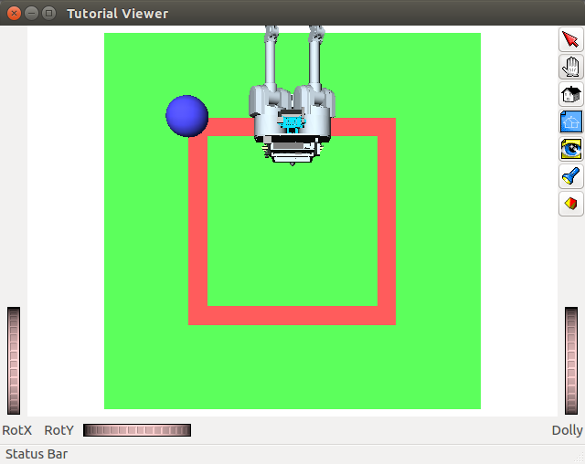move_straight

Figure 1: Robot moving straight

b) rotate_by

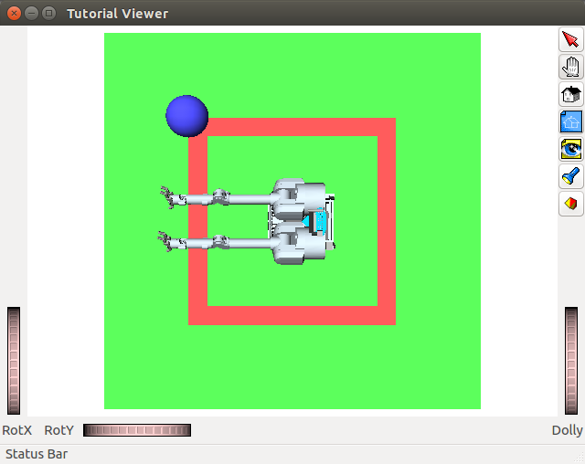

Figure 2: Robot after rotation 90 degrees

c) go_around_square

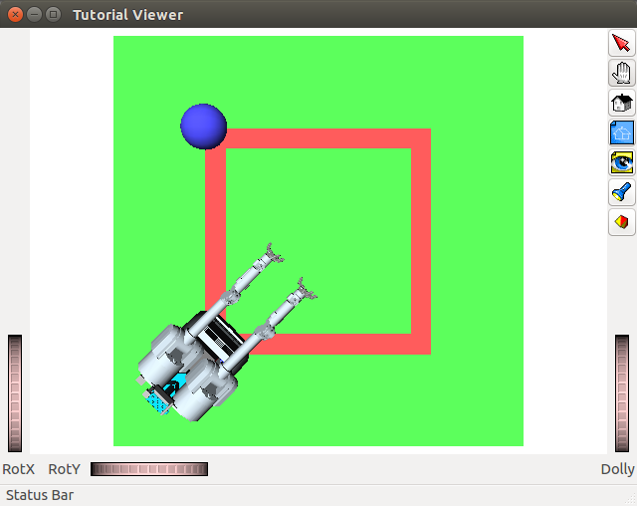

Figure 3: Robot looking towards center, while moving around the square

Figure 4: Robot looking towards center, while moving around the square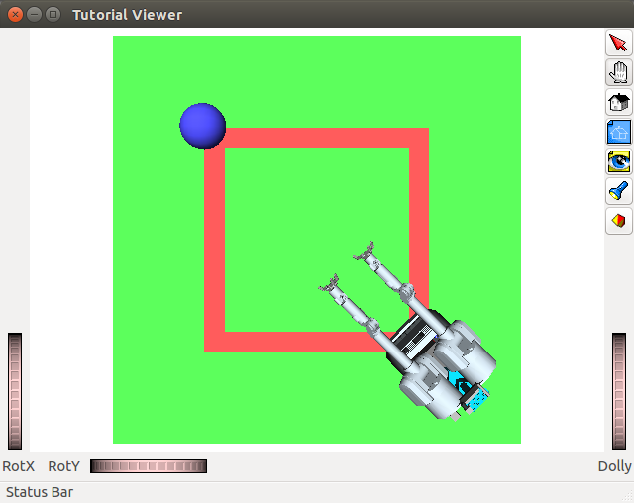

Figure 5: Robot moving around the square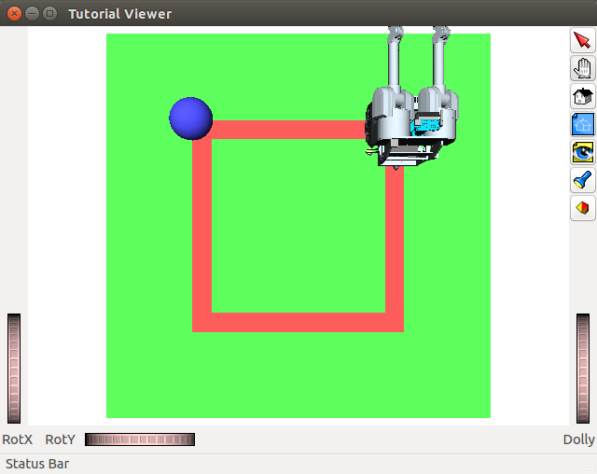

Figure 6: Robot back to initial position after completing its run around the square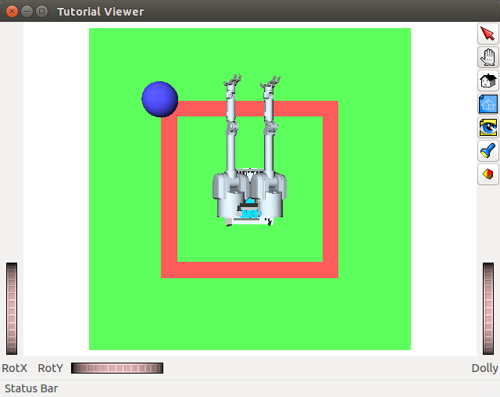

d) DOF's for the complete robot

<joint:R_Shoulder_Pitch (1), dof=1, parent=Herb2>

<joint:R_Shoulder_Roll (2), dof=2, parent=Herb2>

<joint:R_Elbow (3), dof=3, parent=Herb2>

<joint:R_Wrist_Yaw (4), dof=4, parent=Herb2>

<joint:R_Wrist_Pitch (5), dof=5, parent=Herb2>

<joint:R_Wrist_Roll (6), dof=6, parent=Herb2>

<joint:RJF1 (7), dof=7, parent=Herb2>

<joint:RJF2 (8), dof=8, parent=Herb2>

<joint:RJF3 (9), dof=9, parent=Herb2>

<joint:RJF4 (10), dof=10, parent=Herb2>

<joint:L_Shoulder_Yaw (11), dof=11, parent=Herb2>

<joint:L_Shoulder_Pitch (12), dof=12, parent=Herb2>

<joint:L_Shoulder_Roll (13), dof=13, parent=Herb2>

<joint:L_Elbow (14), dof=14, parent=Herb2>

<joint:L_Wrist_Yaw (15), dof=15, parent=Herb2>

<joint:L_Wrist_Pitch (16), dof=16, parent=Herb2>

<joint:L_Wrist_Roll (17), dof=17, parent=Herb2>

<joint:LJF1 (18), dof=18, parent=Herb2>

<joint:LJF2 (19), dof=19, parent=Herb2>

<joint:LJF3 (20), dof=20, parent=Herb2>

<joint:LJF4 (21), dof=21, parent=Herb2>

<joint:Joint_Pan (22), dof=22, parent=Herb2>

<joint:Joint_Tilt (23), dof=23, parent=Herb2>

DOF for the right arm:

DOF for the right hand:

DOF for the left arm:

DOF for the left hand:

DOF for the head:

e) Self Collision

Figure 7: Robot in self collision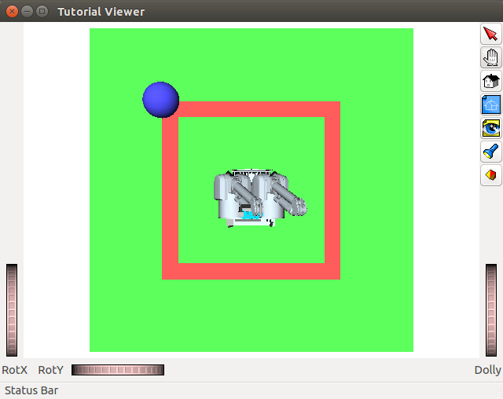

f) Sphere in the environment

Figure 8: Sphere introduced in the environment

4) About HW

It took me slightly more than an hour to complete the python part and another couple of hours to figure out different openRAVE functions and complete the openRAVE part. Finally another hour to cleanup the code, generate the images and complete the writeup.