**Homework 3**

*16-662 Robot Autonomy*, Carnegie Mellon University

Team 10

**Abhishek Bhatia** **William Seto**  **Tae-Hyung Kim**

[abhatia1@andrew.cmu.edu](mailto:abhatia1@andrew.cmu.edu) [wseto@andrew.cmu.edu](mailto:wseto@andrew.cmu.edu) [tk1@andrew.cmu.edu](mailto:tk1@andrew.cmu.edu)

**Note:**

* RRT and HRRT utilize same functions in run.py (main) and RRTTree.py (GetNearestVertex). Please comment/un-comment the appropriate lines in the 2 functions, the directions are explained in the respective functions in the code.
* The command line option to run rrt/hrrt is same: --planner hrrt. Currently, the code is left in a condition to run HRRT.

**1. Breadth-First search, Depth-First search and A-Star planner for the 2D configuration space.**

Table 1. BFS, DFS, A-Star planner for 2D configuration

|  |  |  |  |  |
| --- | --- | --- | --- | --- |
|  | resolution | Path length | Plan time | # Nodes expanded |
| Breadth-First search | 0.05 | 111 | 13.528 | 20796 |
| 0.1 | 55 | 3.109 | 4968 |
| 0.25 | 23 | 0.514 | 778 |
| Depth-First  search | 0.05 | 7663 | 5.02 | 7664 |
| 0.1 | 1835 | 1.182 | 1834 |
| 0.25 | 253 | 0.185 | 252 |
| A-Star planner | 0.05 | 111 | 1.23 | 1733 |
| 0.1 | 55 | 0.318 | 427 |
| 0.25 | 23 | 0.057 | 77 |

* Path length considered as number of grid cells (nodes)

BFS

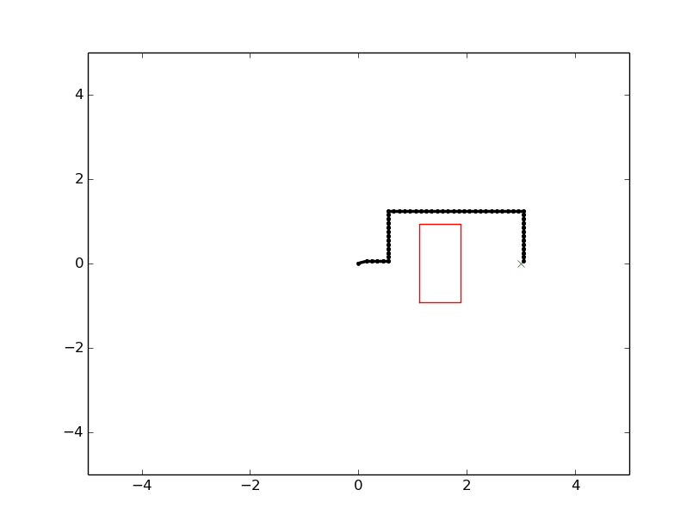

DFS

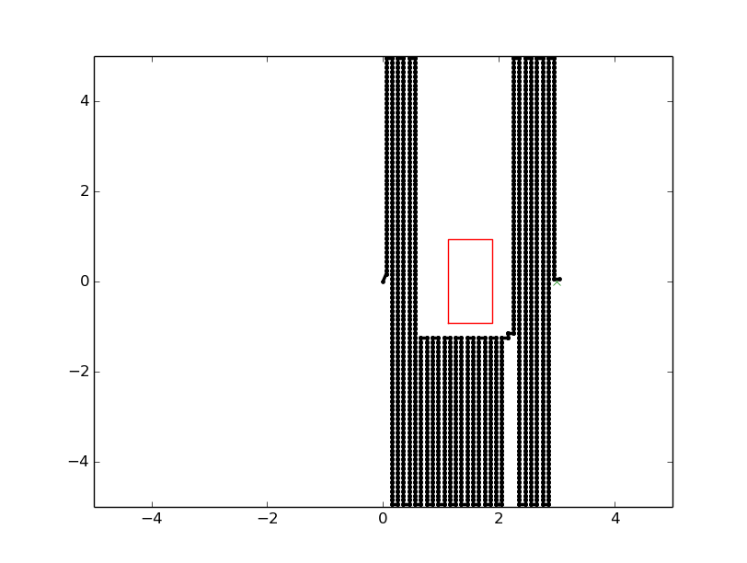

AStar

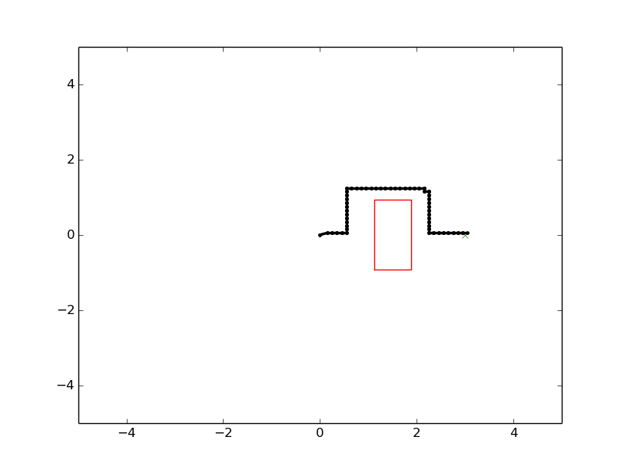

**2. AStar planner for the WAM arm**

Table 2. AStar planner for the WAM arm

|  |  |  |  |  |
| --- | --- | --- | --- | --- |
|  | resolution | Path length | Plan time | Number of nodes |
| AStar planner | 0.1 | 27 | 3.432 | 82 |

* Path length given in number of grid cells (nodes)

**3. RRT planner with path shortening and AStar for the 2D space and the WAM arm**

* Path lengths given in Euclidean distance

Table 3. RRT planner and AStar for the 2D space

|  |  |  |  |
| --- | --- | --- | --- |
|  | resolution | Path length | Plan Time |
| RRT (Average) | - | 7.216 | 0.139 |
| AStar | 0.05 | 5.55 | 1.23 |
| 0.1 | 5.5 | 0.318 |
| 0.25 | 5.75 | 0.057 |

Table 4. RRT planner and AStar for the WAM arm

|  |  |  |  |
| --- | --- | --- | --- |
|  | resolution | Path length | Plan Time |
| RRT (Average) | - | 7.957 | 9.024 |
| AStar | 0.05 | 3.25 | 24.769 |
| 0.1 | 2.7 | 3.025 |

**AStar**

Strength: Generate optimal path.

Weakness: Planning time increases exponentially considering the resolution and configuration space dimension.

**RRT**

Strength: RRT may quickly find a path.

Weakness: RRT has greater variance of plan time and may generate suboptimal paths.

**4. EXTRA CREDIT: hRRT algorithm**

Table 5. hRRT planner and AStar for the 2D space (resolution: 0.1)

|  |  |  |
| --- | --- | --- |
|  | Path length | Plan time |
| hRRT (Average) | 10.806 | 0.193 |
| AStar (Average) | 5.5 | 0.318 |

Table 6. hRRT planner and AStar for the WAM arm (resolution: 0.1)

|  |  |  |
| --- | --- | --- |
|  | Path length | Plan time |
| hRRT (Average) | 11.995 | 4.548 |
| AStar (Average) | 2.7 | 3.432 |