1.HTML Basics - center tag

Alaska Card Makers are the best in making unique and innovative invitations for special occasions like weddings, house warming, birthdays etc,. Marlin has newly joined the company and he has been assigned the task of creating a party invitation card for the company's new client Mr.Peter on account of his Holiday Party. Its the right time for Marlin to show his artistic talent in making a card that conveys emotions and hopes. He surfed many websites for the prototypes and came out with a design that is more aesthetic. The design should display the card's main contents embolded at the center. Let us help Marlin by creating an invitation model web page using center tag.

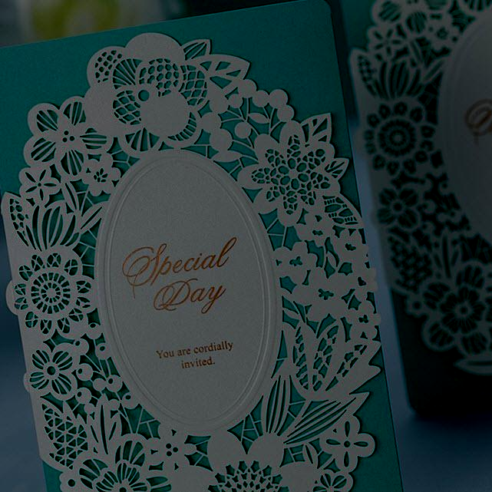

Hints :

Tag <center>

The <center> tag is used to center-align text.

Syntax :

<center> </center>

Content :  
center -  
h3 - Invitation for de'Party  
Peters, Wells & Bingham invites you and your family to their annual Holiday Party for cocktails and hors d'oeuvres. Would be a Great eve !!! Lots of fun and entertainment for the gatherings..Funny activities been planned for kids...Awaiting for the moment of happiness   
<hr>  
Saturday, December 8th  8 o’clock in the evening Sun Valley Resort & Spa 12 Sun Road Sun Valley, California  
  
Constraints :  
The contents of the html page should be present inside the 'center' tag.

Note :  
Content of the page should be present as shown in the screenshot.  
Kindly refer the content which is given as a part of description.  
  
Sample Screenshot 1 :  
  
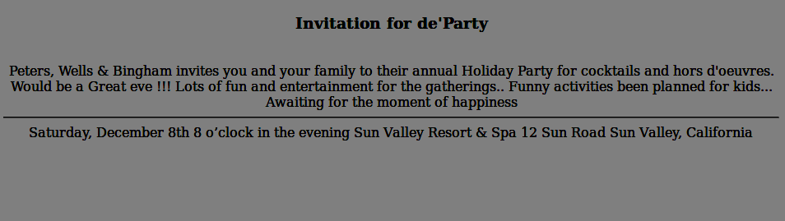  
  
Sample Screenshot 2 :  
  
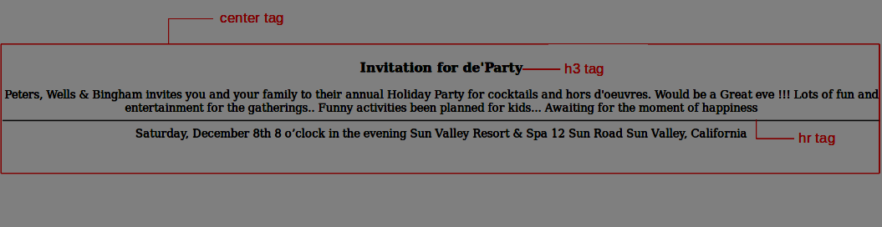

2.HTML Basics - br & hr tags

The Pink Frag Event Organization is offering trustworthy Wedding Event Management, Promotional Event Management, Birthday Party Management and many more. To expand their business, they thought of creating a website for the company to  improve customer interaction. Presentation of the website was taken to the highest priority. The contents in web pages usually should be separated from other contents and there must be appropriate breaks in the page. To ensure this capability, there are two tags namely <hr> and <br> tags. The organization needed to implement these tags in his web page.  
  
Let us help them to use the <hr> and <br> tags in his web page.

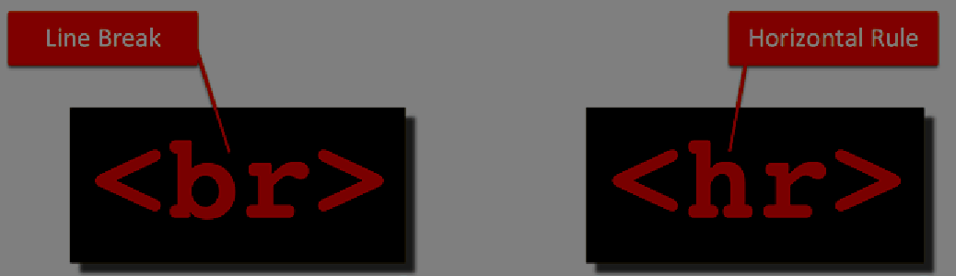

Hints :

Tag <hr>

The <hr> tag defines a thematic break in an HTML page.

In HTML, the <hr> tag has no end tag.

The <hr> element is used to separate content (or define a change) in an HTML page.

Tag <br>

The <br> tag inserts a single line break.

The <br> tag is an empty tag which means that it has no end tag.

Content :  
H1 - Pink Frag Event Organizer  
HR  
H2 - Service Description  
P - We are indulged in offering a Promotional Event Management. These services are provided by our team of professionals as per the requirement of the client. These services are highly praised for their features like sophisticated technology, effective results and reliability. We offer these services in a definite time frame and at affordable rates.  
HR  
H2 - Features  
H5 - Customized services  
H5 - On-time completion  
H5 - Execution in tandem with clients demand  
HR  
H2 - About Us  
p- Pink Frag Event  is a reputed organization, which has come into being in 2009, as a Sole Proprietorship Firm, with a sole aim of achieving the trust and support of large customers. We have indulged our all endeavors towards offering trustworthy Wedding Event Management, Promotional Event Management, Birthday Party Management and many more. All our services are reliable and offered keeping the exact customers’ preferences and choice in mind. To offer these services, we have hired specialized professionals, who are capable of understanding as well as accomplishing the specific customers’ desires.  
 <br>  
We have adopted modern technology, to cope up with the challenges of industry. We keep all quality parameters in mind, so that we cannot make any compromise in terms of the excellence of products.  
HR  
<br>  
<br>  
<br>  
<br>  
 H2 - Contact Us  
 H3 - Address  
 p - 14/509A,Sterlin Street,Nungambakkam Chennai - 600034.  
 H3 - Mobile  
 p - Manager-9596645125  
 H3 - Landline  
 p - 0422-2727272  
 H3 - EMail  
 p - pinkfragevent123@gmail.com pinkfragOfficial@gmail.com  
  
Constraints :  
Tag 'hr' must be present minimum 3 times in the html page.  
Tag 'br' must be present minimum 5 times in the html page.  
  
Note :  
Content of the page should be present as shown in the screenshot.  
Kindly refer the content which is given as a part of description  
  
Sample Screenshot 1 :  
  
