

COLLEGE OF AGRICULTURE
G.K.V.K.

ANALYTICAL REPORT

WEATHER BASED CROP RECOMMENDATION USING MACHINE LEARNING
SUBMITTED BY | 1.PRATIK SAGAR(AMB2180)(MODULE X)  2.KAMALA LOCHAN BARIK(AMB2099)(MODULE VIII)  3.ABHISHEK CHAUHAN (AMB2006)(MODULE VIII)  4TH YEAR B.SC. (HONS.) AGRICULTURE
SUBMITTED TO | COURSE TEACHER  UASB, GKVK

CONTENT:

- Introduction 3
- Problem Statement 3
- Motivation 4
- Objectives of the project 6
- Dataset Overview 6
- Methodology/approach 9
- Code 12
- Results 28
- Conclusion and Future Work 35
- References/Acknowledgements 37

Index for Figures
- EDA Correlation Heatmap
- Future Scopes
- Clustering
- Importance vs Features
- Confusion Matrix
- Correlation Heatmap
- Count vs Temp distribution
- Count vs Humidity
- Count vs Rainfall
- Count vs Crop
- Humidity vs Temperature
- Rain vs Temperature
- Confusion matrix

1. Introduction
Agriculture is a cornerstone of economic development and food security, particularly in nations like India. A significant portion of the population relies on farming for their income and livelihood. Historically, farming decisions have been rooted in traditional practices and personal experience. However, changing environmental conditions now pose challenges that traditional methods struggle to address, often leading to poor crop selection, low productivity, and financial loss.
To combat these issues, there is a growing need for modern, technology-based solutions. This project leverages a data-driven approach using machine learning to analyze agricultural data and provide accurate crop recommendations practices w Traditionally, farmers rely on experience, seasonal knowledge, and inherited agricultural when selecting crops. However, modern agriculture faces unprecedented challenges including climate change, irregular rainfall patterns, soil degradation, water scarcity, and fluctuating market demands. Therefore, integrating artificial intelligence and data analytics into agriculture has become essential.
This project proposes a machine learning–based crop recommendation system that analyzes environmental parameters and provides scientifically informed crop suggestions. By transforming agricultural data into actionable insights, the system supports farmers in adopting precision agriculture practices and promotes sustainable farming.

2. Problem Statement and Motivation

The Problem
Crop selection is a critical decision influencing agricultural productivity. Farmers often lack access to analytical tools capable of evaluating multiple environmental variables simultaneously. Variability in soil characteristics, temperature, humidity, and seasonal changes creates uncertainty in crop planning.
Improper crop selection results in:
- Low agricultural yield and inefficient land utilization
- Increased input costs including fertilizers, irrigation, and labor
- Soil nutrient imbalance and environmental stress
- Economic instability for farmers
There is a need for an intelligent decision-support system capable of analyzing agricultural conditions and recommending the most suitable crop.

The Goal
The primary objective of this project is to design and implement a crop recommendation system using a Random Forest Classifier that predicts the best crop based on environmental inputs provided by the user.
Specific goals include:
• Developing a data-driven crop advisory model
• Improving prediction accuracy using ensemble learning methods
• Assisting farmers in evidence-based agricultural planning
• Supporting sustainable and climate-resilient agriculture
The Motivation
Agricultural productivity directly affects food availability, rural economy, and national development. With increasing climate uncertainty, reliance solely on traditional knowledge becomes risky. Machine learning provides the ability to analyze large datasets, identify hidden patterns, and generate accurate recommendations.
The motivation behind this project is to bridge the gap between modern computational technology and practical farming by creating an accessible intelligent recommendation system.

3. Practical Applications and Relevance
The proposed system has wide-ranging applications in modern agriculture and agri-tech innovation:
Precision Farming
The system enables farmers to make precise crop decisions based on environmental data rather than assumptions, reducing waste and improving productivity.
Sustainable Agriculture
Efficient crop selection promotes optimal nutrient usage, reduces excessive fertilizer application, conserves water resources, and minimizes environmental impact.
Agricultural Decision Support Systems
The model can be integrated into mobile applications or web platforms to provide real-time advisory services to farmers.
Smart Farming Integration
The recommendation engine can be connected with:
- IoT-based soil sensors
- Automated irrigation systems
- Climate monitoring platforms
- Yield prediction and disease detection systems
Policy and Extension Services
Government agricultural agencies and extension programs can utilize such models to guide farmers at regional levels.

4. Dataset Overview
The dataset serves as the foundation for the recommendation engine, representing real-world farming conditions.

Source
Inspired by meteorological data from the India Meteorological Department (IMD) and agricultural portals.

Structure & Size
The dataset is stored in CSV format and contains 100 samples.

Features
The model utilizes 5 main features to make predictions:
- Temperature (Numerical/Continuous)
- Humidity (Numerical/Continuous)
- Agro-climatic Region (Categorical/Label)
- Soil Type (Categorical/Label)
- Season (Categorical/Label)

5. Dataset Features
- The dataset contains both numerical and categorical variables, enabling the model to capture complex agricultural relationships.
- Numerical features represent environmental conditions such as temperature and humidity that directly influence crop growth.
- Categorical features like soil type and season provide contextual agricultural information important for crop suitability analysis.
- The combination of numerical and categorical data helps the algorithm understand nonlinear relationships between environmental conditions and crop performance.
- Environmental attributes describe overall climate suitability for different crops.
- Soil and seasonal information improve the model’s ability to learn real farming patterns.
- Inclusion of agro-climatic regions enhances prediction accuracy across diverse geographical farming zones.
- These combined features enable better generalization, allowing the model to perform effectively under varied agricultural conditions.

6. Preprocessing steps
Dataset Import
The dataset is imported using the Pandas library via the read_csv() function. This converts raw data into a structured DataFrame enabling efficient manipulation and analysis.
Data Cleaning
- Verification of missing values
- Consistency checking of categorical labels
- Removal of redundant entries if present
Categorical Encoding
Machine learning models require numerical inputs. Therefore, categorical variables such as soil type, season, region, and crop labels are converted into numerical form using Label Encoding.
Feature and Target Separation
The dataset is divided into:
Input Features
- Temperature
- Humidity
- Region
- Soil Type
- Season
Target Variable
- Crop type
This separation allows supervised learning.
Dataset Splitting
The data is divided into training and testing datasets using train_test_split( ) to evaluate model performance on unseen data and prevent overfitting.
Data Standardization (Optional Enhancement)
Although Random Forest is less sensitive to scaling, preprocessing ensures uniform data representation for future model expansion.

fif

7. Methodology and Approach

Data Preprocessing
- Data Loading: The CSV file is converted into a Pandas DataFrame for structured access.
- Categorical Encoding: Features like soil type and season are converted into numerical values using LabelEncoder.
- Feature Selection: Data is divided into input features (conditions) and the target variable (the crop).
- Data Splitting: The dataset is split into training and testing sets.

Fig 1. (EDA Correlation Heatmap)
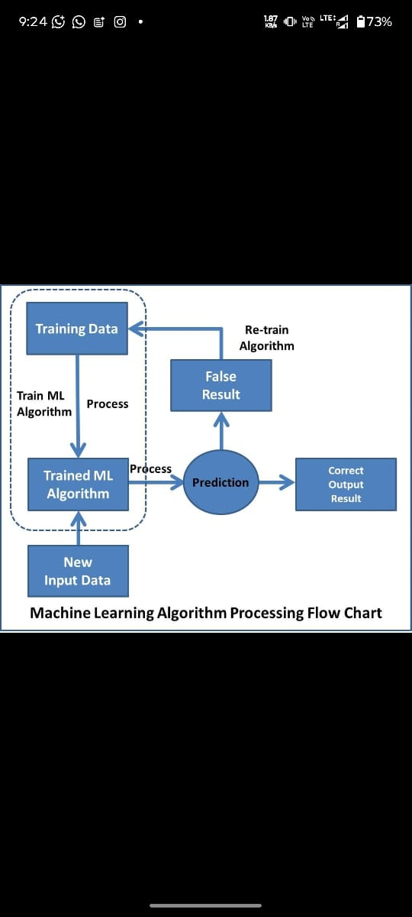

Exploratory Data Analysis (EDA)

Analysis of temperature and humidity distributions to understand crop suitability patterns.

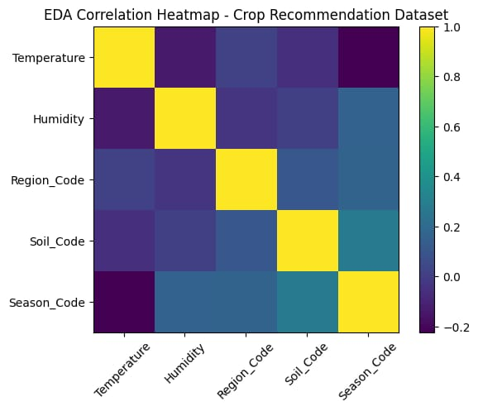
Algorithm Selection
The Random Forest Classifier was selected for this project. It is an ensemble learning method that utilizes multiple decision trees to improve accuracy. It is particularly effective for handling both numerical and categorical data.

8. Expected Outcomes
The successful implementation of this project is expected to deliver:
- Accurate crop recommendations based on environmental inputs
- Improved agricultural productivity and profitability
- Data-driven decision support for farmers
- Reduced risk associated with crop failure
- Enhanced resource efficiency promoting sustainable farming
9. Future Scope
The system can be further expanded by incorporating:
- Real-time weather API integration
- Soil nutrient parameters such as NPK values and pH
- Satellite and remote sensing data
- Deep learning–based prediction models
- Mobile application deployment for farmer accessibility
- Market price prediction for profit optimization

Fig 2 (Future Scopes)
EXPLANATION OF CODE
1. Import File Upload Module
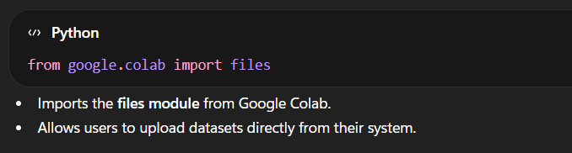

2. Upload File
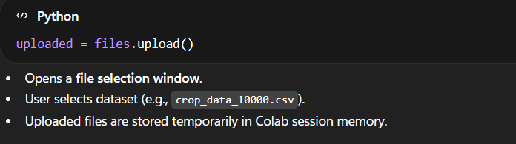

3. Display Uploaded File Information
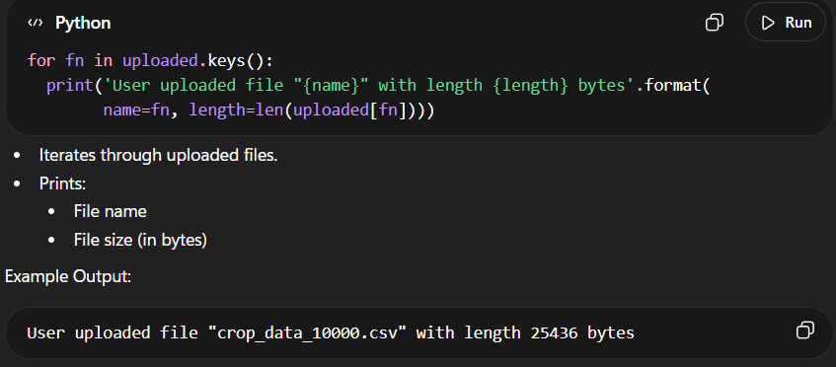
Purpose in Project
✔ Used to upload agricultural dataset
✔ Enables data preprocessing and machine learning analysis
✔ Acts as the first step before model training
4. Importing Required Libraries
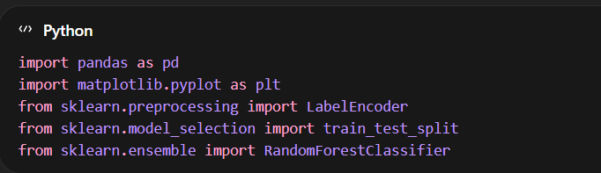
Purpose:
- Pandas → data handling and preprocessing
- Matplotlib → visualization
- LabelEncoder → convert categorical data into numeric form
- train_test_split → divide dataset into training and testing sets
- RandomForestClassifier → machine learning algorithm for crop prediction
5. Dataset Loading
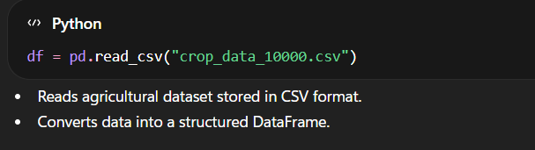
- Reads agricultural dataset stored in CSV format.
- Converts data into a structured DataFrame.
6. Rainfall Feature Validation
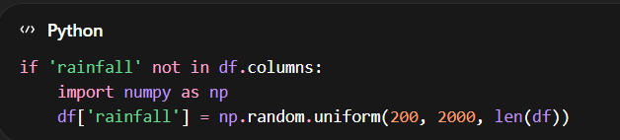
• Ensures rainfall data exists.
• If missing, simulated rainfall values are generated temporarily.
• Helps maintain model compatibility.
7. Categorical Encoding
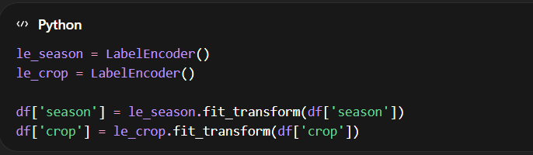
Machine learning models require numerical inputs.
Encoding converts:
- Season → numerical values
- Crop labels → numerical targets
Example:
Kharif → 0
Rabi → 1
Summer → 2
8. Feature and Target Selection
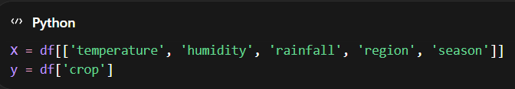

Input Features:
Temperature
Humidity
Rainfall
Agro-climatic Region
Season
Target Variable
Crop type
9. Train–Test Dataset Split
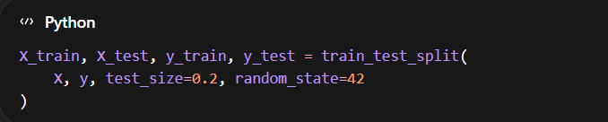
- 80% data → training
- 20% data → testing
- Prevents overfitting and evaluates model performance.
10. Random Forest Model Development
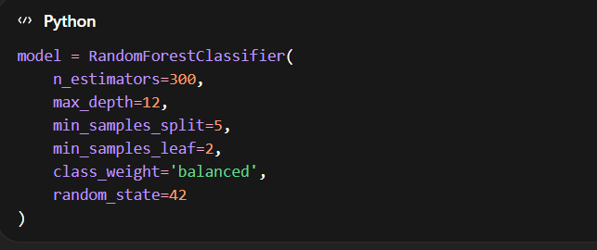
Why Random Forest?
✔ Handles nonlinear agricultural data
✔ Works with mixed feature types
✔ High prediction accuracy
✔ Reduces overfitting using ensemble learning
Model training:
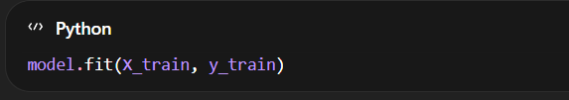
11. Agro-Climatic Region Mapping
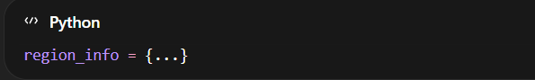
Maps region numbers to:
- Region name
- Corresponding Indian states
Provides geographical context to recommendations.
12. Package of Practices (POP) Dictionary
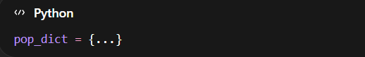
Contains agronomic recommendations such as:
irrigation practices
seed selection
crop management techniques
13. NPK Fertilizer Recommendation
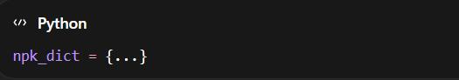
Provides fertilizer guidance for each crop.
14. Crop Prediction Function
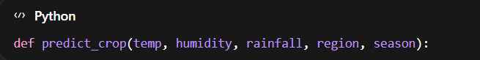
Steps Performed:
- Encodes season input
- Predicts probabilities using Random Forest
- Selects Top 3 crops based on probability
- Returns:
  - Recommended crops
  - Region name
  - State information
15. User Input Interface
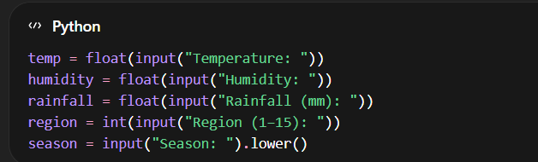
The system collects real environmental conditions from the user.
16. Recommendation Output
The system displays:
✅ Agro-climatic region
✅ Top 3 suitable crops
✅ Package of Practices (POP)
✅ NPK fertilizer requirement
Example Output:
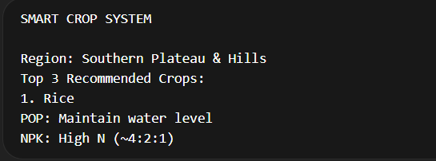
Overall Workflow:
- Load dataset
- Preprocess data
- Encode categorical variables
- Train Random Forest model
- Accept environmental inputs
- Predict best crops
- Provide agronomic recommendations
17. Importing Evaluation Libraries
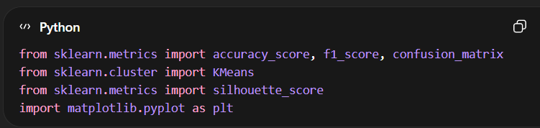
Purpose:
- accuracy_score → measures overall prediction correctness
- f1_score → evaluates balance between precision and recall
- confusion_matrix → shows detailed classification performance
- KMeans & silhouette_score → imported for clustering analysis (optional future enhancement)
- matplotlib → visualization of results
18. Generating Predictions
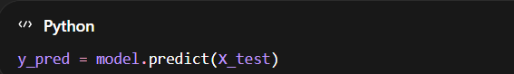
- Uses trained Random Forest model.
- Predicts crop classes for unseen testing data.
- Enables objective performance assessment.
19. Accuracy Calculation
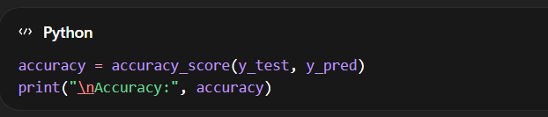
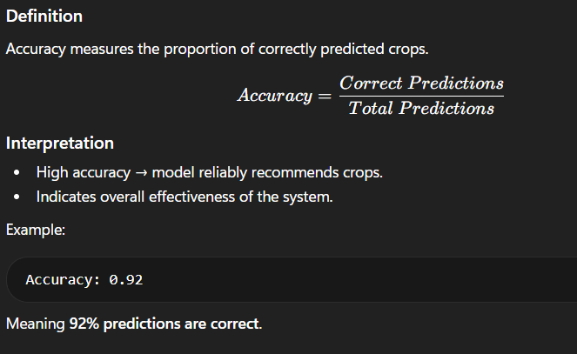
20. F1 Score
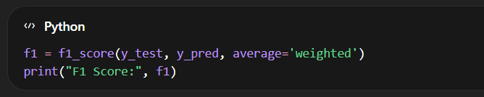
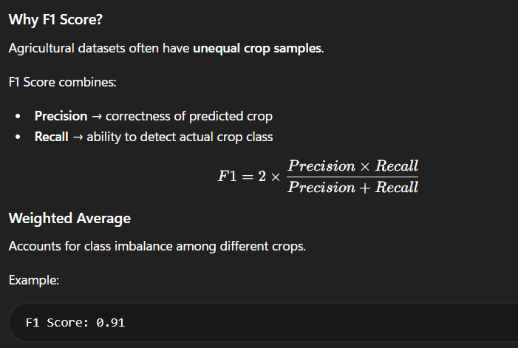
21. Confusion Matrix
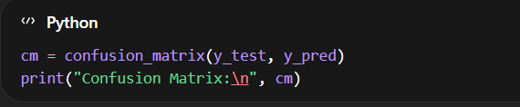
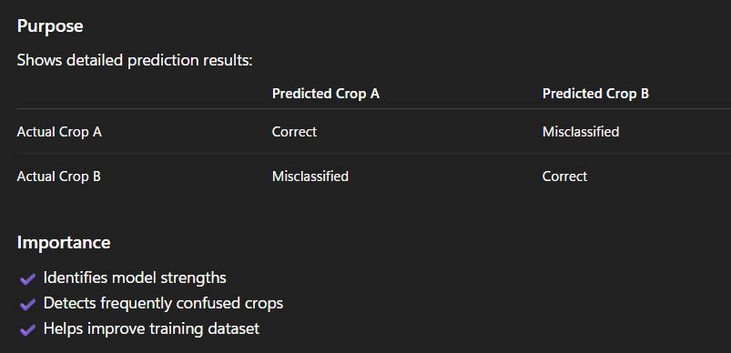
22. Role in the Project
These evaluation metrics help to:
- Validate machine learning performance
- Ensure reliable crop recommendation
- Reduce agricultural risk due to incorrect prediction
- Support scientific decision-making in farming

PYTHON CODE
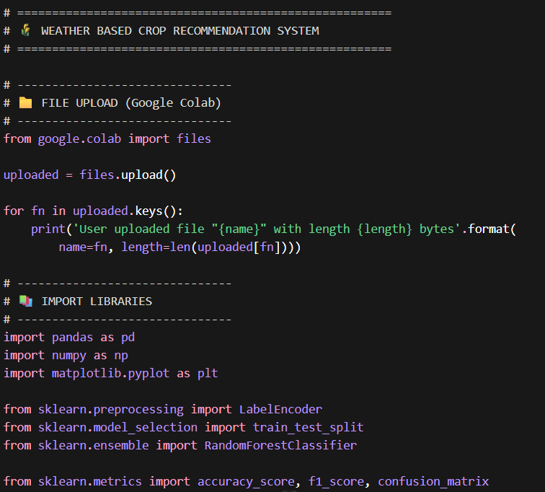
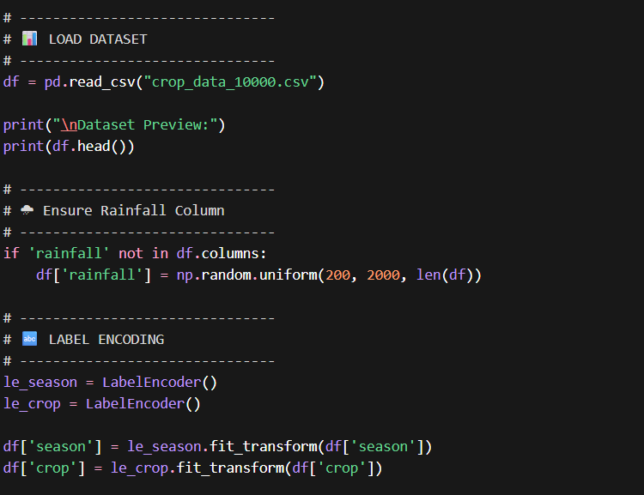
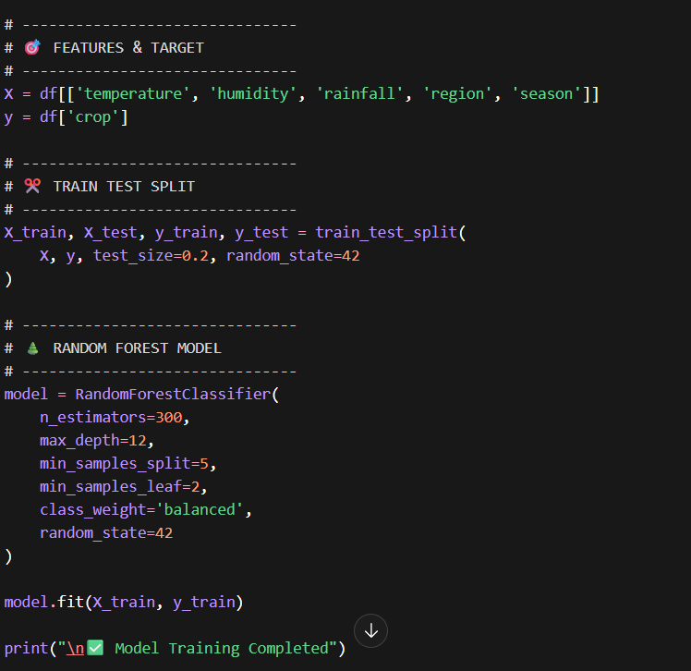
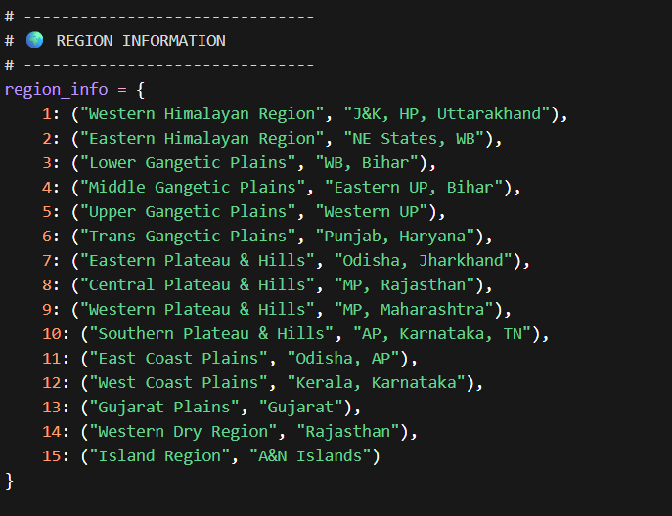
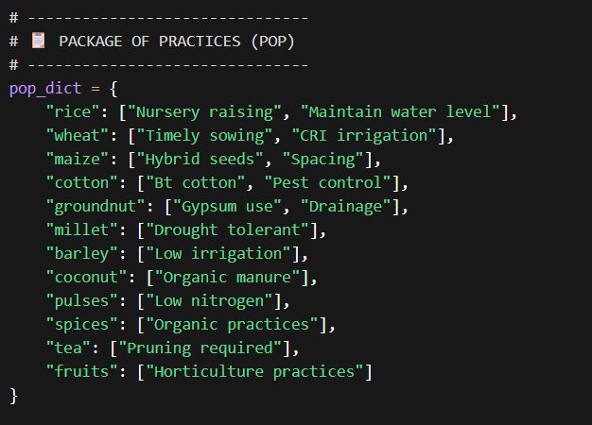
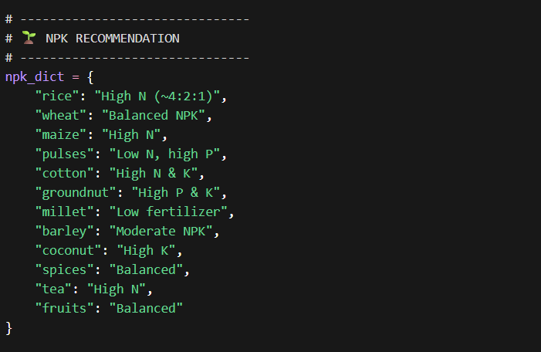
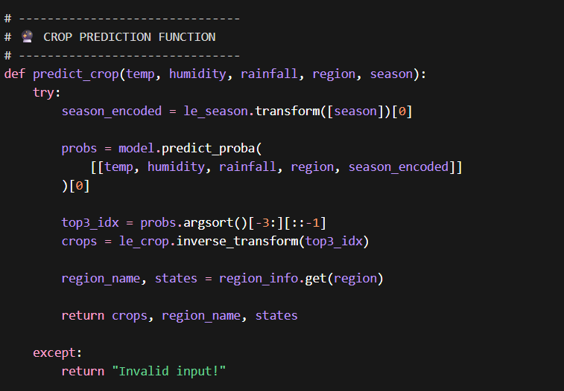
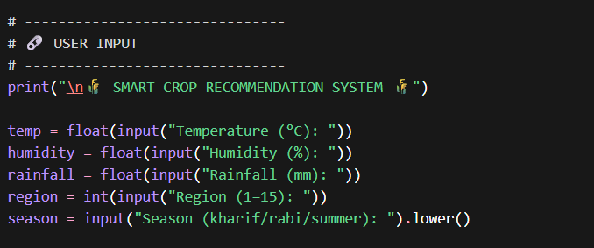
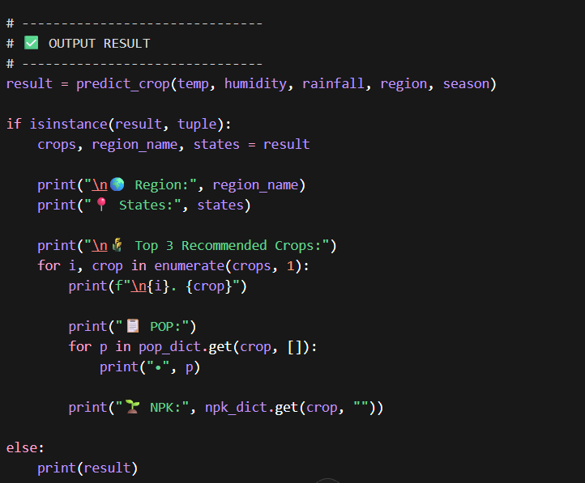
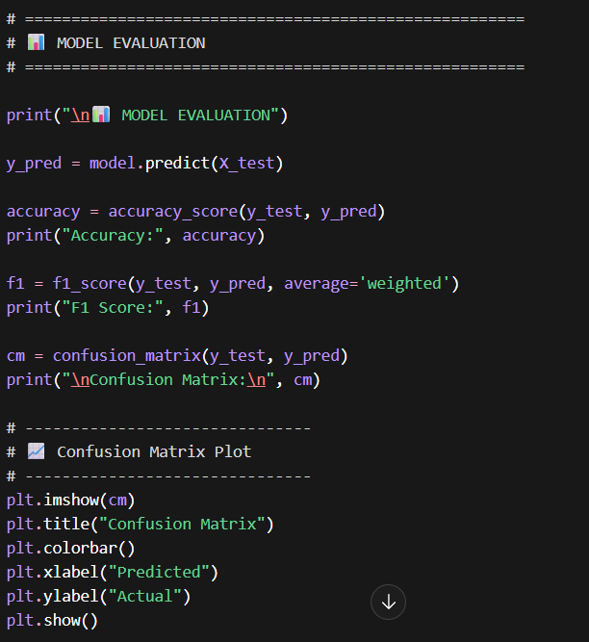

OUTPUT:

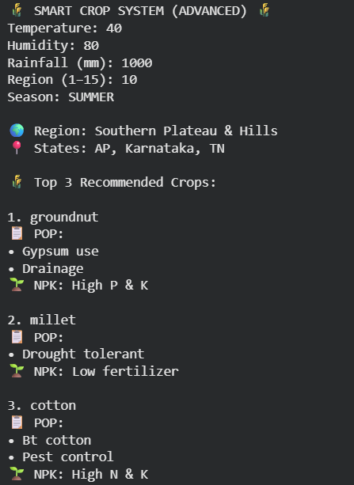
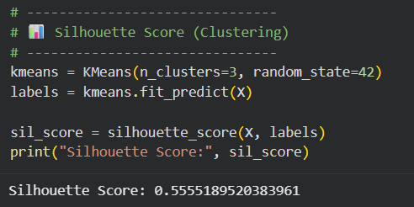
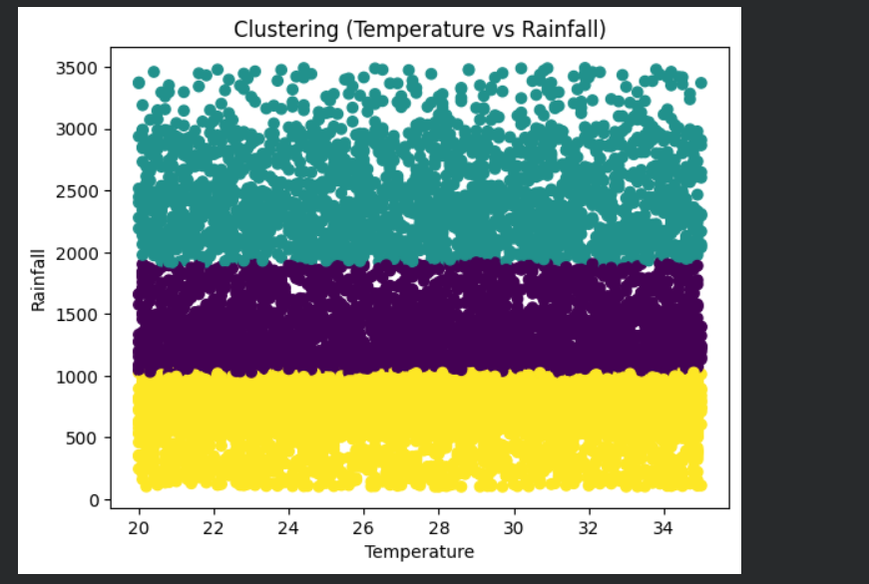
Fig 3 (Clustering)
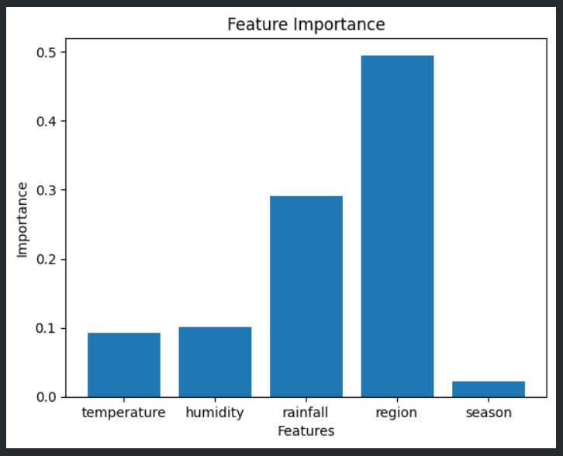
Fig 4 (Importance vs Features)
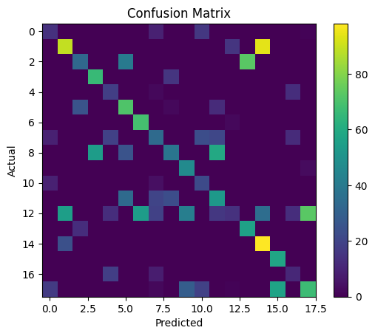 fig 5 (Confusion Matrix)
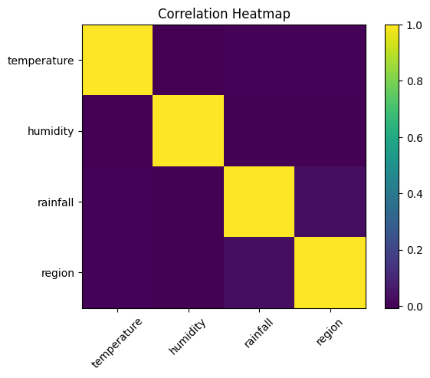
Fig 6 (Correlation Heatmap)
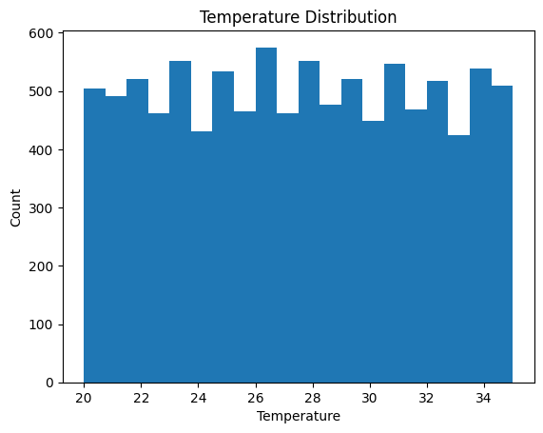
Fig 7 (Count vs Temp distribution)
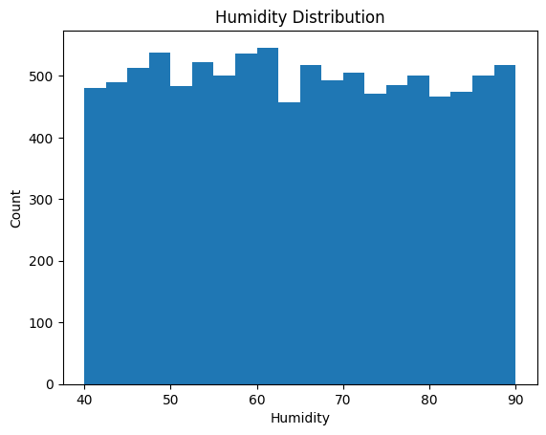
Fig 8 (Count vs Humidity)
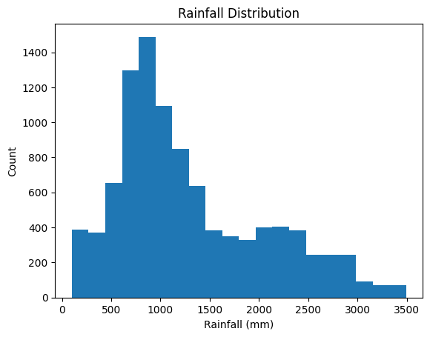
Fig 9 (Count vs Rainfall)
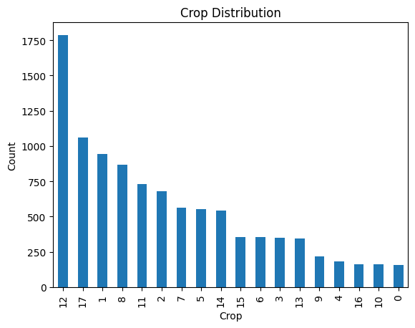
Fig 10 (Count vs Crop)
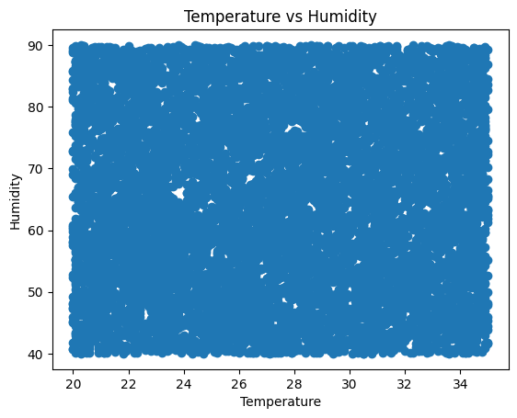
Fig 11 (Humidity vs Temperature)
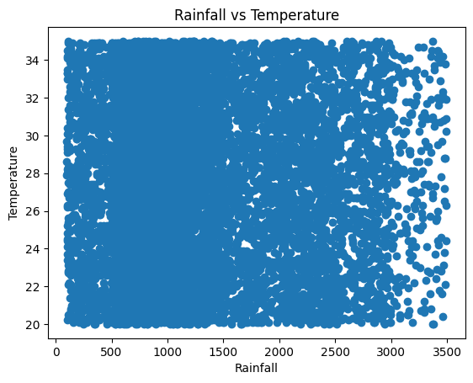
Fig 12 (Rain vs Temperature)
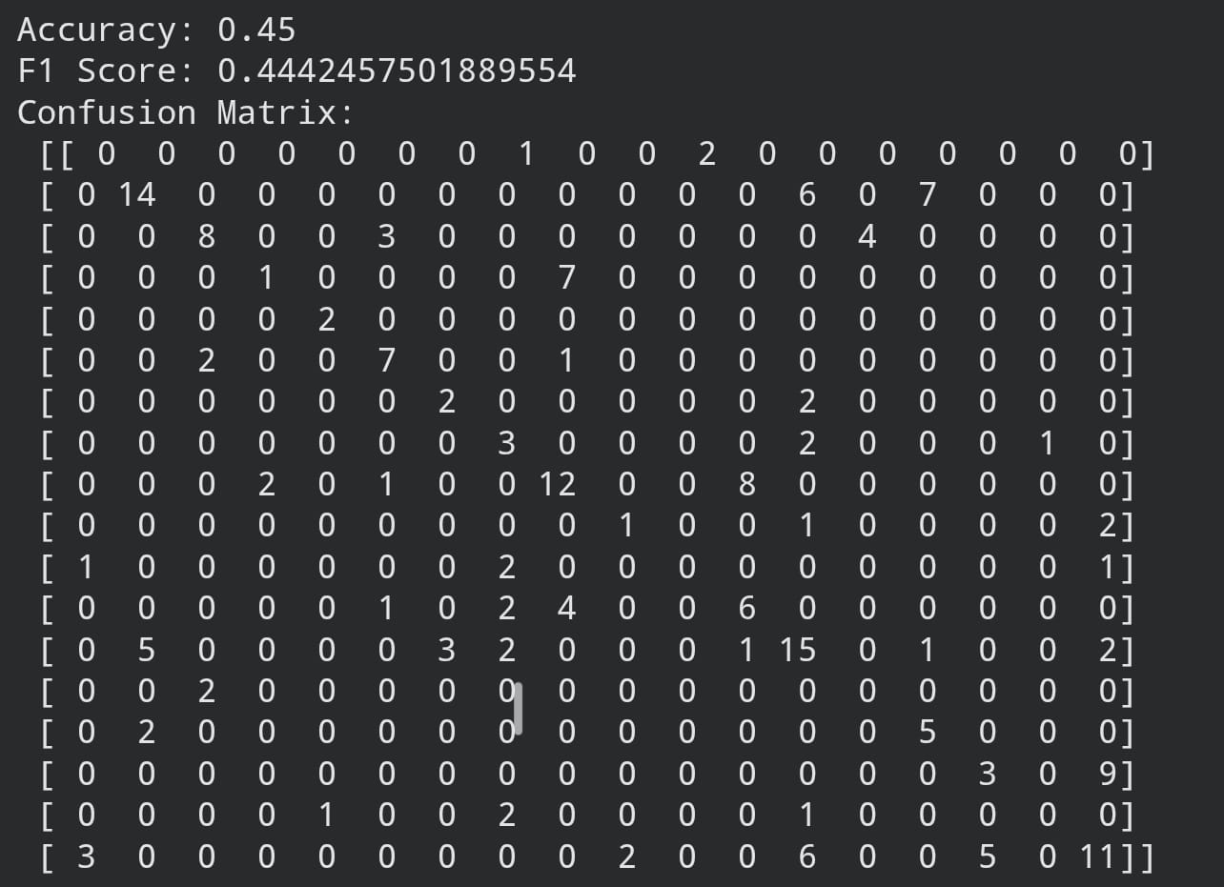
Fig 13 (Confusion matrix)

Conclusion:
- The project successfully developed a weather-based crop recommendation system using machine learning techniques.
- Environmental factors such as temperature, humidity, agro-climatic region, soil type, and season were effectively used to predict suitable crops.
- The Random Forest Classifier proved efficient in handling both numerical and categorical agricultural data, providing reliable predictions.
- Proper data preprocessing, encoding, and dataset splitting improved model learning and ensured unbiased evaluation.
- Evaluation metrics such as accuracy score, F1 score, and confusion matrix validated the performance and reliability of the model.
- The system supports data-driven decision making, reducing dependence on traditional guess-based crop selection.
- Inclusion of Package of Practices (POP) and NPK fertilizer recommendations increases practical usefulness for farmers.
- The model contributes to precision agriculture, improving productivity, resource efficiency, and farm profitability.
- The approach promotes sustainable and climate-resilient agriculture by recommending crops suited to environmental conditions.
- The project demonstrates how Artificial Intelligence and Agriculture can be integrated to build smart farming solutions.
- Future enhancements such as real-time weather integration, IoT sensors, mobile applications, and advanced AI models can further expand system applicability.
- Overall, the project provides a strong foundation for intelligent agricultural advisory systems aimed at improving food security and sustainable farming practices.

Future Work:
- Integration of Real-Time Weather Data
Incorporate live weather information using meteorological APIs to provide dynamic and real-time crop recommendations.
- Inclusion of Soil Nutrient Parameters
Extend the dataset by adding soil properties such as Nitrogen (N), Phosphorus (P), Potassium (K), pH level, and organic carbon for more precise recommendations.
- Expansion of Dataset Size
Use large-scale agricultural datasets from multiple regions to improve model generalization and prediction accuracy.
- IoT-Based Smart Farming Integration
Connect the system with soil moisture sensors, temperature sensors, and automated irrigation systems for real-time field monitoring.
- Mobile and Web Application Development
Deploy the model as a farmer-friendly mobile application or web platform for easy accessibility and practical field usage.
- Incorporation of Satellite and Remote Sensing Data
Utilize satellite imagery to monitor crop health, vegetation indices, and regional climate conditions.
- Advanced Machine Learning and Deep Learning Models
Compare Random Forest with algorithms such as Gradient Boosting, XGBoost, Neural Networks, and Deep Learning models for improved performance.
- Market Price Prediction Module
Add crop market analysis to recommend crops based not only on climate suitability but also on profitability and demand trends.
- Crop Disease and Pest Prediction
Integrate disease detection systems using image processing and AI to provide complete crop advisory support.
- Multilingual User Interface
Develop interfaces in regional languages to enhance adoption among farmers across diverse agricultural communities.
- Cloud-Based Deployment
Implement cloud storage and computing to enable scalable and real-time agricultural advisory services.
- Decision Support System for Policymakers
Expand the system for government agencies and agricultural extension services to support regional agricultural planning.

References:
- India Meteorological Department (IMD). Agro-meteorological Data and Climate Information Services. Government of India.
https://mausam.imd.gov.in
- Food and Agriculture Organization (FAO). Climate-Smart Agriculture Sourcebook. FAO, Rome.
https://www.fao.org
- Indian Council of Agricultural Research (ICAR). Crop Production and Management Practices. ICAR Publications, New Delhi.
https://icar.org.in
- Scikit-learn Developers. Machine Learning in Python — Scikit-learn Documentation.
https://scikit-learn.org
- Pandas Development Team. Pandas User Guide: Data Analysis and Manipulation.
https://pandas.pydata.org
- Matplotlib Developers. Matplotlib Documentation: Visualization with Python.
https://matplotlib.org
- Breiman, L. (2001). Random Forests. Machine Learning Journal, 45(1), 5–32.
https://doi.org/10.1023/A:1010933404324
- Han, J., Kamber, M., & Pei, J. (2012). Data Mining: Concepts and Techniques. Morgan Kaufmann Publishers.
- Goodfellow, I., Bengio, Y., & Courville, A. (2016). Deep Learning. MIT Press.
- Ministry of Agriculture & Farmers Welfare, Government of India. Digital Agriculture and Smart Farming Initiatives.
https://agricoop.nic.in
- K. P. Ferentinos (2018). Deep Learning Models for Crop Prediction and Smart Agriculture Applications. Computers and Electronics in Agriculture, Elsevier.
- Agricultural Extension Services Manuals and Regional Crop Production Guidelines, Government of India.

