The Irrigator

Proof of Concept

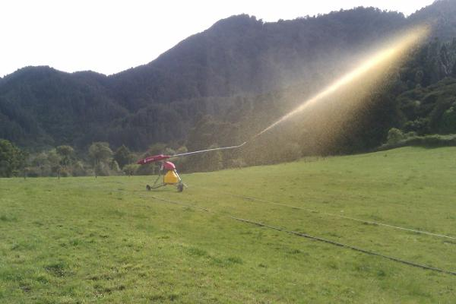

--Author’s Name

-----------------------

Contents

1. Motivation: 3

1.1. Study: 3

2. Objective: 4

3. Components used: 4

4. Building Steps: 5

6. Steps to Test or use: 6

6.1. Getting Ready 6

6.2. Using the box 6

6.3. Giving Commands to the Controller board. 6

7. Cost Considerations: 7

8. Applications: 7

9. Current limitations: 7

10. Other possible improvements: 7

11. References: 7

# Motivation:

India is and for the near foreseeable future will remain an agriculture dependent economy. And despite its rapid development in many technological areas like space science, IT, medicine etc. the sector of agriculture unfortunately remains rather deprived. Although there has been elaborate government programs to change the situation, but such measures either largely miscalculates the ground problem or are inadequately implemented at the grass root level. This keeps the situation impervious at the farmer’s end. Amongst other problems the available on-shelf farming solutions are either too costly or are so non-customizable that adoption of these products become possible by only rich farmers.

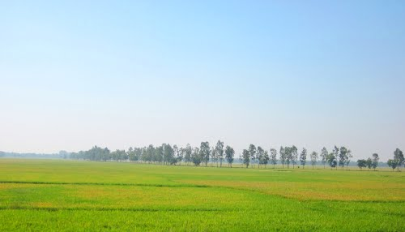

## Study:

**Country**: India

**State**: West-Bengal **District**: Midnapore

West-Bengal is the second most densely populated state of India and the major revenue of the state is from agriculture. One of the most fertile agricultural lands of the country has vast fields and ample natural and climatic resources. But the state has not done well in the energy sector and electricity is not available as a regular facility. Not to mention the agricultural is most affected industry.

Apart from the above factor, constant migration of farm workers from villages to cities to find a better livelihood is also creating a huge labor crisis, leaving the farms unmanned and most of the times unmanageable by the handful few with old technology at their disposal.

Unlike most developed countries the fields are dependent on shared resources. For example around 45-50 fields would be dependent on just one water-pumping unit, which usually is located at the center of the field cluster. By understanding the effort needed to operate this installation would help create a plausible perspective of the dire situation, and how technology can help.

To operate the pumping installation, one has to walk anywhere between 3.5-6 Km (approximately 2 - 3 Miles) in one direction on non-motor able bypaths. So each access to the pumping station is a 7-12 km walk. Naturally the whole setup is very unproductive.

# Objective:

The objective of this proof of concept product has been

* Creating a cheap, remotely operable irrigator enabler module.
* Create the solution Cost effective
* Make the solution user-friendly
* Make the solution energy efficient.
* Make the solution easily adaptable and customizable.
* Make the solution maintainable.

p.s: Not each of the target is fully realized in the POC, however a reasonable explanation is provided further in the text.

# Components used:

1 x Arduino UNO (Atmega 328p-pu)

1 x icomsat SIMCOM sim900 Quad band module

1 x 12Vdc Power source wall-wart.

1 x Relay

1 x Enclosure Box

1 x 5 Pin universal Power Socket

1 x Activated SIM card

1 x USB programming cable

Connection wires

Soldering equipments

# http://www.robotaki.com/resources/image/18/7f/9.jpgBuilding Steps:

1. Upload the Irrigator Sketch on the Arduino Uno board using the USB cable.

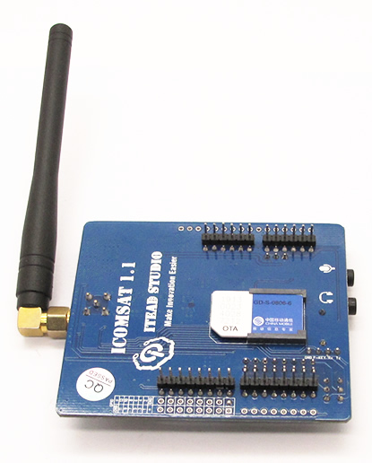

1. Insert an activated SIM-card in the sim card slot of the ITEAD ICOM SAT GSM shield.

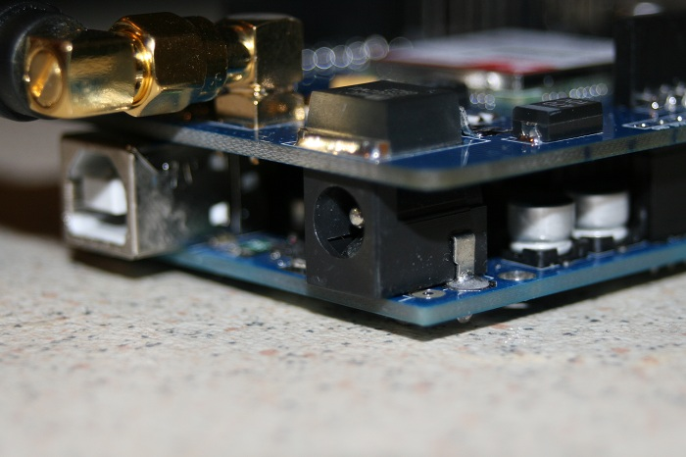

1. Push the GSM shield over the Arduino uno, Connections enabled via header pins.

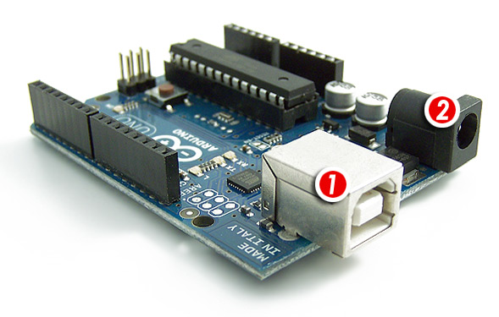

1. Provide power to the Arduino Uno using the 12VDC power supply. (using the connection marked (2))
2. Connect the Relay to Digital PIN 13 of the Arduino UNO. 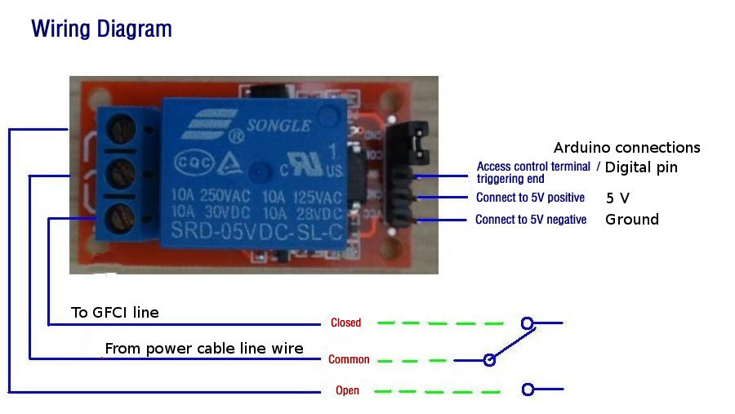

# Steps to Test or use:

## Getting Ready

* + 1. Remove the collar from the box.
    2. Use a screwdriver to unscrew the screws from the board.
    3. Gently remove the faceplate and turn it upside down.
    4. Remove the shield from the arduino.
    5. Insert sim card.
    6. Reattach the gsm shield over the arduino.
    7. Replace the face-plate.
    8. Secure the faceplate as before using the four available nuts,
    9. Push the collar over the box

## Using the box

1. Provide power to the controller box.
2. Connect any equipment which needs to be controlled remotely using the universal power outlet.

## Giving Commands to the Controller board.

1. The First step is to register a mobile phone with the controller box.
2. Send an SMS to the SIM number(in the controller box) format🡪 “register”
3. To switch the appliance ON: Send text sms “ON” to the controller box
4. To switch the appliance OFF: Send text sms “OFF” to the controller box.

# Cost Considerations:

ITEAD ICOMSAT SIM900 module was used keeping in mind the geography where the equipment would be used. If the application is confined to pan-Asia a cheaper alternative (sim900A) can be used.

Arduino UNO can be convenient replaced with an Arduino nano pro or mini which can be further cost effective.

Bulk ordering too can attribute to cost effectiveness.

# Applications:

Farm Automation

Home Automation

# Current limitations:

The controller can only control one power plug at present.

# Other possible improvements:

The Controller board can be made flexible so that more power plugs can be attached to the same board.

Can add Radio Frequency or Infra Red based remote triggering facilities.

# References:

[www.arduino.cc](http://www.arduino.cc)

[www.instructables.com](http://www.instructables.com)