# Profile

Im a criminology student, with a minor in Human Rights. I’m a good timekeeper, always willing to learn new skills. I’m a punctual and motivated individual who is able to work in a busy environment and produce high standards of work. Im able to take instructions from all levels and build a good working relationship.

# Volunteer Experience

SACY program - January 2013

It was a program with my school Templeton, were we would go do capacity cafes to educate parents of youth that were in high school or just entering high school about preventing drug use. We would talk about how important it was to communicate with their children. In this program we would also do food banks for youth that maybe didn’t have enough, and I was in charged of making sure that all the food arrived on time and that it was packed for the delivery the next day.

Cell phone 778-903-1423

valentina_valencia5@hotmail.com

2320 Franklin street Vancouver Apt #302

V5l1s1

Laura valencia

Hastings spring fair — spring 2011

Helping out setting up games and making sure that everything was going smoothly, I would also sell tickets.

Kiwassa neighbourhood house — 2010

Working with the kids program making sure that everything was ready for when the kids came after school.

Grazzia marketing salud & Belleza - 2019

I worked at the reception doing the following duties

1.answering phone calls

2. Customer support

3. Booking appointments

4. Billing customers

5. Payments to suppliers

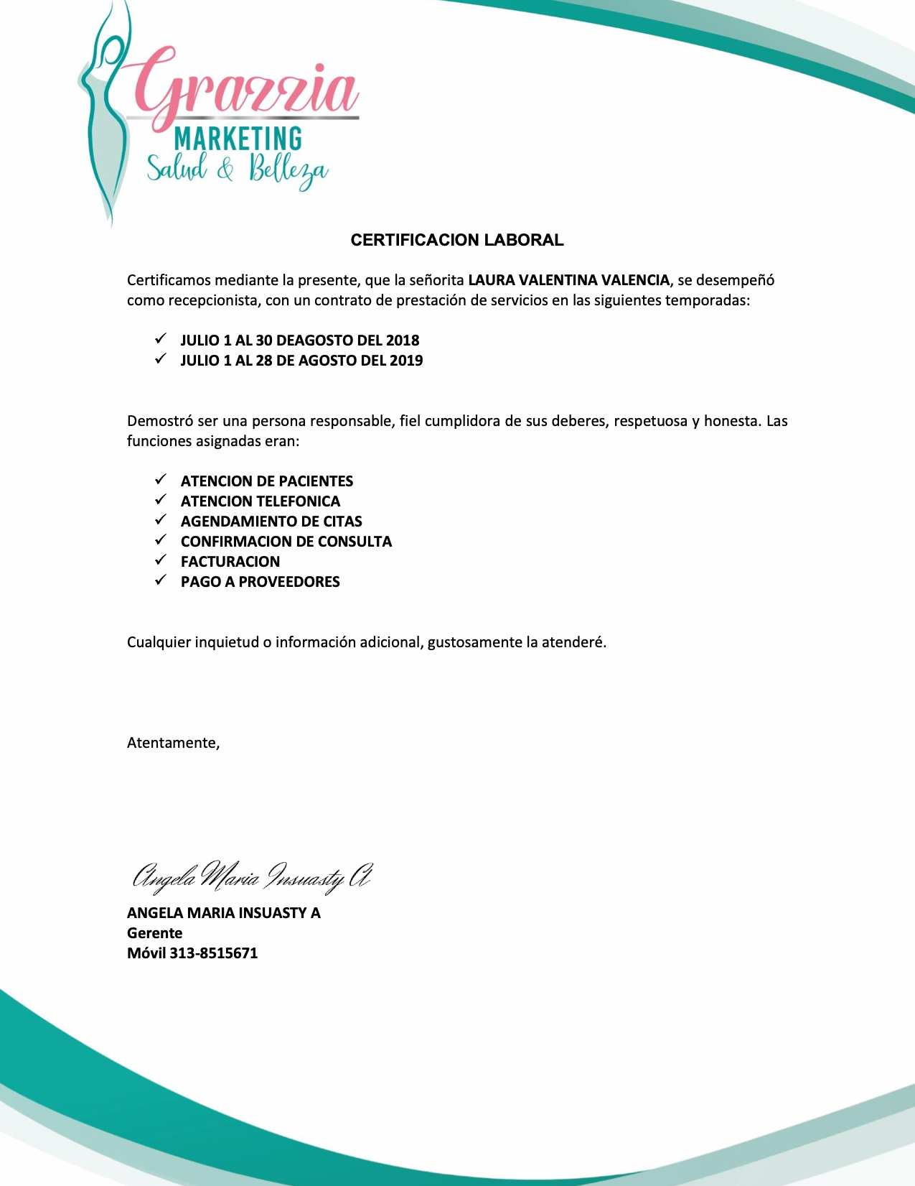

This is the translation for the letter my old boss sent

We hereby certify that Miss LAURA VALENTINA VALENCIA, worked as a receptionist, with a service provision contract in the following seasons:

✓ JULY 1 TO AUGUST 30, 2018

✓ JULY AUGUST 28-28, 2019

She proved to be a responsible person, faithful to her duties, respectful and honest. The assigned functions were:

✓ PATIENT CARE

✓ TELEPHONE ATTENTION

✓ SCHEDULE OF APPOINTMENTS

✓ CONFIRMATION OF CONSULTATION

✓ BILLING

✓ PAYMENT TO SUPPLIERS

Any concerns or additional information, I will gladly attend you.

Sincerely,

ANGELA MARIA INSUASTY A

Manager

Mobile 313-8515671

# Education

High school Templeton secondary - 2016

Wilfrid Laurier university - **Bachelors in criminology**

Wilfrid Laurier university **- Minor in Human Rights**

# Skills and qualification

1. Excellent organizational skills, and detail oriented
2. Fluent in English and Spanish
3. Excellent listening skills, empathic and professional
4. Great in working as a team
5. Helpful and positive

# References

# Marylin - 604-617-5530/604-254-5401

Kiwassa neighborhood house

Prevention violence domestic worker

Luis Aguirre- 778-836-0647

Peak janitorial company- owner

Rigoberto celis - 778-836-8936

Just perfect cleaning