To Whom It May Concern:

Regarding the job posting from your website, I am writing this letter to apply my candidacy for the Maintenance Program Specialist. I am eager to join VIA Rail because it seems like a challenging yet rewarding opportunity.

I have been working in purchasing, compliance, and documentation for the airline industry for over two (2) decades. I believe my experiences and extensive knowledge in the business would enable me to hit all the main deliverables of my day-to-day tasks and significant projects. I have an excellent track record for being **an organized person**, strategic thinker, and solid problem-solving skills due to my managerial experience.

I have personally always maintained a strict adherence to project KPIs and processes. My key skills include strong computer knowledge, process optimization, and project planning.

I am confident that my experience and skills will make me a valuable member of the technical documentation team at VIA Rail. I am sharing my resume here for you and hope to hear from you soon. Please feel free to contact me at 514-889-2976.

Sincerely,

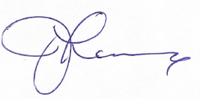

Johanne Lanciaux