November 5, 2021

Dear Hiring Manager,

***RE: Application for Strategic Procurement Manager - 27170***

I wish to apply for the above position with your company as I firmly believe I have the necessary skills, qualities, and experience to carry out the duties to a very high standard.

Having already worked within this industry for several years, I will learn the role quickly and, therefore, start contributing to the team in the fastest time possible.

The skills, qualities, and attributes I possess that will be of benefit to this role are as follows:

* An ability to work as part of a team to achieve the company goals and projects;
* A desire to continually develop within the position, so I continue to contribute positively;
* A reliable, trustworthy, and professional approach to my work;
* Able to follow the rules and procedures;
* A willingness to take on all tasks, regardless of their complexity;
* Able to communicate professionally with all customers and clients, internally and externally of the organization;
* An ability to work under pressure and multi-task, and accommodate changing priorities
* Proficient in all types of Microsoft applications;

I am available for an interview at short notice and would very much appreciate the opportunity to demonstrate to you my skill, attributes, and experience. Please feel free to contact me at 514-889-2976.

Warm Regards,

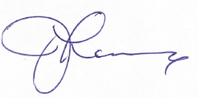

Johanne Lanciaux