|  |  |
| --- | --- |
| < ONLINE TICKET RESERVATION > | Version < X.0> |
| Software Requirements Specification | <date> |
| <team name> | |

< team Name >

**<ONLINE TICKET RESERVATION>**

**Software Requirements Specification**

Version < X.0>

**Team Guide:**( Faculty Guide’s Name )

**Members:**(Team members name)

College Name:

Department: State:

**­A Software Requirement Specification**

**On**

**Online Ticket Reservation**

**Swami Keshvanand Institute of Technology, Management &Gramothan, Jaipur**



In the partial fulfillment of Bachelor of technology in computer science and Engineering under Rajasthan Technical University.

**Submitted to: Submitted By :**

Prof. Dr. C M Choudhary Priyanka Gupta 12ESKCS739

(HOD CS) Urvashi Rawat 12ESKCS758

Mr. Deepak Garg Vini Saxena 12ESKCS761

(Lecturer CS)

TABLE OF CONTENTS

**1. Introduction**

1.1Methodology………………………………………………………………

1.2Purpose…………………………………………………

1.3Scope…………………………………

1.4 Definitions, Acronyms and Abbreviations

1.5 Tools Used ……………………………………

1.6 References ……………………………

1.7 Technologies to be used ………………… ……………………

1.8 Overview ………………………………………………...

**2. Overall Description**

2.1 performance requirement ………………………………………..

2.2 Software Interface………………………..

2.3Hardware Interface ……………

2.4 Communication Interface……………………………………………….. 10

2.5 Constraints ……………………………………………………………… 10

2.6 Data flow Diagram………………………………………………………………

2.7 E-R Diagram ……………………………………………………

2.8 Database Design…………………………………………….. 14

2.9Class Diagram ……………………

2.10Use-Case Model ……………………………………………….. 18

**3. Specific Requirement**

3.1 Activity Diagrams……………………………………….. 21

3.2Sequence Diagrams……………………………………

**4. Supporting Information**……………………………………………………….. 28

INTRODUCTION

This project aims at development of an Online Railway Reservation Utility which facilitates the Railway customers to manage their reservations online, and the Railway administrators to modify the backend databases in a User-Friendly manner.

The Customers are required to register on the server for getting access to the database and query result retrieval. Upon registration, each user has an account which is essentially the ‘view level’ for the customer. The account contains comprehensive information of the user entered during registration and permits the customer to get access to his past reservations, enquire about travel fare and availability of seats, make afresh reservations, update his account details, etc.

The Railway Administrator is the second party in the transactions. The administrator is required to login using a master password, once authenticated as an administrator, one has access and right of modification to all the information stored in the database at the server. This includes the account information of the customers, attributes and statistics of stations, description of the train stoppages and physical description of coaches, all the reservations that have been made, etc. The railway administrator has the right to modify any information stored at the server database.

1.1 Methodology

**Rational Unified Process**

The Rational Unified Process brings together elements from all of the generic process models, supports iteration and illustrates good practice in specification and design. The RUP is normally described from three perspectives:

* A ***dynamic perspective*** that shows the phases of the model over time.
* A ***static perspective*** that shows the process activities that are enacted.
* A ***practice perspective*** that suggests good practices to be used during the process.

**Inception**

The goal of the inception phase is to establish a business case for the system. Identifying all external entities that will interact with the system and defining these interaction. This information is used to assess the contribution of system to business.

**Elaboration**

The goals of the elaboration phase are to develop an understanding of the problem domain, establish an architectural framework, develop project plan and identify key project risks.

**Construction**

This phase is concerned with system design, programming and testing. Parts of the system are developed in parallel and integrated during this phase.

**Transition**

This is the final phase of RUP and is concerned with moving the system from the development community to the user community and making it work in real environment.

1.2 Purpose:

The purpose of this source is to describe the railway reservation system which provides the train timing details, reservation, billing and cancellation on various types of reservation namely,

• Confirm Reservation for confirm Seat.

• Reservation against Cancellation.

• Waiting list Reservation.

• Online Reservation.

• Tatkal Reservation.

1.3 **Scope And Feasibility:**

Implementations of this project idea are in industrial use in the form of ‘www.irctc.co.in’, etc. Hence, this can be used for suggesting improvements in design, performance and greater usability.

Apart from the industrial applications mentioned above, it is a research oriented project as well, the task of performance evaluation of different database designs, for efficiency, is in this spirit.

• Freight Revenue enhancement.

• Passenger Revenue enhancement.

• Improved & optimized service

1.4 Definations, Acronyms And Abbreviations

• NTES – National Train Enquiry System

• IVRS – Interactive Voice Response system

• PRS – passenger reservation system

1.5 Tools Used

**Application architecture – JAVA, J2EE**

**JAVA**

Java is an object-oriented programming language developed by Sun Microsystems a company best known for its high end UNIX workstations. Java language was designed to be small, simple, and portable across platforms, operating systems, both at the source and at the binary level, which means that Java programs (applet and application) can run on any machine that has the Java virtual machine (JVM) installed.

**J2EE**

**Java Platform, Enterprise Edition** or**Java**

**EE**is a widely used platform for server programming in the Java programming language. The Java platform (Enterprise Edition) differs from the Java Standard Edition Platform (Java SE) in that it adds libraries which provide functionality to deploy fault-tolerant, distributed, multi-tier Java software, based largely on modular components running on an application server.

**Web server – WASCE**

**Web Sphere Application Server Community Edition**(from now on WASCE) is a free, certified Java EE 5 server for building and managing Java applications. It is IBM's supported distribution of Apache Geronimo that uses Tomcat for servlet container and Axis 2 for web services. Over 15WASCE developers are committers in the Apache Geronimo project.

**Development tool –RAD**

IBM Rational Application Developer for Web Sphere Software (RAD) is an integrated development environment (IDE), made by IBM's Rational Software division, for visually designing, constructing, testing, and deploying Web services, portals, and Java (J2EE) applications.

**Database platform – DB2**

DB2 Database is the database management system that delivers a flexible and cost effective database platform to build robust on demand business applications and supports the J2EE and web services standards.

**Design tool – Rational Software Modeler**

**IBM Rational Software Modeler**, (RSM) made by IBM's Rational Software division, is a Unified Modeling Language UML 2.0-based visual modeling and design tool. Rational Software Modeler is built on the Eclipse open-source software framework and includes capabilities focused on visual modeling and model-driven development (MDD) with the UML for creating resilient, thought-out applications and web services.

1.6 REFRENCES

* Object Oriented Modeling and Design with UML-Michael Blaha, James Rambaugh.
* IBM – www.ibm.in/developerworks .
* Wikipedia - [*www.wikipedia.com*](http://www.wikipedia.com)
* [*www.yatra.com*](http://www.yatra.com)
* [*www.scribd.com*](http://www.scribd.com)

1.7 Technologies to be used

* DB2: Relational Database Management system
* IBM Rational Software architect
* Microsoft Visual studio 2010
* Microsoft office tools

1.8 Overview

* Existing System:

**TRAIN DETAILS:**

Customers may view the train timing at a date their name and number of tickets.

. **RESERVATION:**

After checking the number of seats available the customers reserve the tickets.

**BILLING:**

After reserving the required amount of tickets, the customer paid the amount.

**CANCELLATION:** If the customers want to cancel the ticket, then half of the amount paid by the customer will be refunded to him.

* Drawbacks:
* In the old system there is no room to generate reservation chart ,train report,

Reservation ticket which will have train number and name ,date of journey ,boarding station, destination station ,person name ,age ,sex, total fare and a unique PNR number.

* Remote area users and people who does not have knowledge of internet cannot use the system.
* Users cannot view the train details simultaneously.
* They have not provide multi-train service for connecting 2 stations, i.e. if there is no direct train between 2 stations, then we may use more than 1 train to book our reservations
* Proposed System:
* We have provided the ability where at max 3 people can be booked reservations for, this may not be desirable.
* We can extend it to provide multi-train service for connecting 2 stations, i.e. if there is no direct train between 2 stations, then we may use more than 1 train to book our reservations.
* The analysis assumes conservative and uniform spread of values, this may not hold and more sophisticated tools for estimation should be used.
* Greater information about the user can be stored and the user may be updated about changes in reservation status upon cancellations, via email
* Our Plan:
* Online ticket reservation for users.
* Online maintenance of customer records.
* Online cancellation facility.
* Users feedback for the system.

Overall Description

2.1 Performance Requirements:

It is available during all 24 hours.

• Offered through Mail express, super fast , Rajdhani & Shatabdi Trains. About 1520 Trains runs daily. Variety of compartments based on comfort :

• AC first class.

• AC sleeper.

• First class.

• AC three tier.

• AC chair car.

• Sleeper class

• Ordinary chair car.

Types of concerns & complexities:

• 44 types of quotas.

• 8 types of trains.

• 9 types of classes.

• 162 types of concessions.

2.2 Software Interface :

* Client on Internet

Web Browser, windows8

* Client on Intranet

Web Browser, windows8

* Web Server

Apache

* Data Base Server

IBM DB2,windows8

* Development End

RAD (J2EE, Java, Java , HTML, XML, AJAX), DB2, OS (Windows8),WebSphere(Web Server)

 Front end -> Visual Basic

 Back end -> MS-Access

2.3 Hardware Interface :

* Normal pc-

|  |  |  |  |
| --- | --- | --- | --- |
| **Client Side** | | | |
|  | **Processor** | **RAM** | **Disk Space** |
| Google chrome | Intel Pentium III | 2048mb | 1024 MB |

|  |  |  |  |
| --- | --- | --- | --- |
| **Server Side** | | | |
| RAD | All Intel or AMD - 2 GHZ | 2 GB | 3.5 GB |
| DB2 - 9.5 | 512 MB | 500 MB  (Excluding Data  Size) |

* Printer
* Keyboard
* Mouse
* Flash drives

2.4. Communication Interfaces :

• Indian Railway’s web-site,www.indianrail.gov.in offers PRS enquiries on the internet

Berth/Seat availability, Passenger Status, Fare, Train Schedule etc,.

• National Train Enquiry System (NTES) website,www.trainenquiry.com gives dynamic

information about the running status of any train and its expected arrival/departure at any

given station.

• Mobile telephone based SMS enquiry service.

**2.5. Constraints :**

• Less than 1 sec for local transactions.

• 3 sec for network transaction.

• Capable for providing transaction for 22 hrs per day.

• Uptime of PRS is 99.5 + %.

SOFTWARE CONSTRAINTS:

• Designing -> Rational Rose

• Developing -> Visual Basic

2.6 Data Flow Diagram:

A **data flow diagram** (**DFD**) is a graphical representation of the "flow" of data through

an information system. DFDs can also be used for the visualization of data processing (structured

design).On a DFD, data items flow from an external data source or an internal data store to an

internal data store or an external data sink, via an internal process. A DFD provides no information

about the timing of processes, or about whether processes will operate in sequence or in parallel. It

is therefore quite different from a flowchart, which shows the flow of control through an algorithm,

allowing a reader to determine what operations will be performed, in what order, and under what

circumstances, but not what kinds of data will be input to and output from the system, nor where

the data will come from and go to, nor where the data will be stored (all of which are shown on a DFD.)



0 Level DFD



Level 1 DFD

**2.8 E-R diagram :**

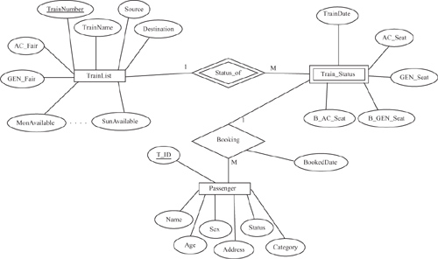

2.8 Database Design :

**2.22grgrrgghrg TABLES**

**Customer Table**

|  |  |  |  |
| --- | --- | --- | --- |
| Serial No | Customer ID | Int identity | Constraint |
| 1 | custTitle | Varchar | Primary key |
| 2 | custFirstName | varchar |  |
| 3 | custLastName | Varchar |  |
| 4 | custStreetAddress | Varchar |  |
| 5 | CustCity | Varchar |  |
| 6 | CustState | Varchar |  |
| 7 | CustomerPhone | Numeric |  |
| 8 | CustEmail | Varchar |  |
| 9 | CustGender | Varchar |  |
| 10 | CustomerDOB | Date |  |

**Reservation Table**

|  |  |  |  |
| --- | --- | --- | --- |
| Serial No | Reservation id | Int identity | Constraint |
| 1 | Reservationdate | Datetime | Primary key |
| 2 | Reservation time | Datetime |  |
| 3 | Reserventrydate | Datetime |  |
| 4 | Reservebywhom | Varchar |  |
| 5 | Customerid | Int |  |
| 6 | Tableid | Varchar |  |
| 7 | Seatingclass | Varchar |  |
| 8 | Seatingtype | Varchar |  |

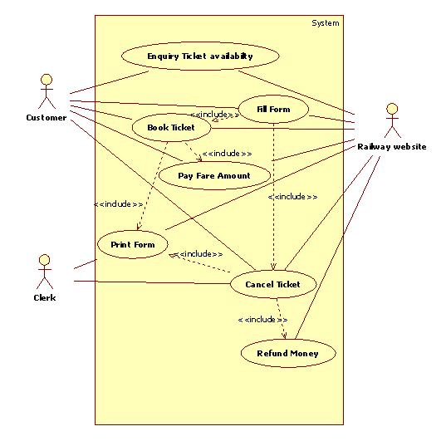

USE CASE DIAGRAM

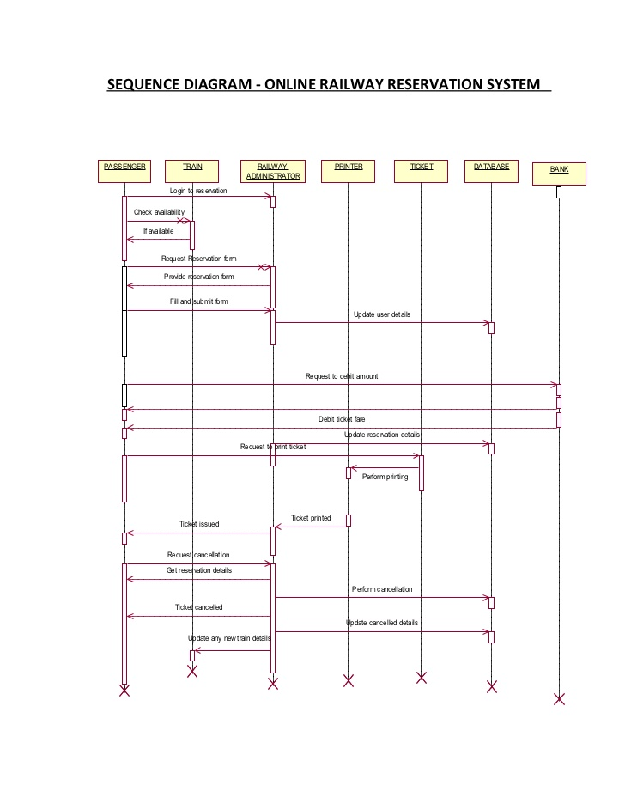

# ClASS DIAGRAM



ACTIVITY DIAGRAM

ACKNOWLEDGEMENT

The present work is an effort to throw some light on our SRS presentation “Online Railway Reservation System”. The work would not have been possible to come to the present shape without the able guidance, supervision and help by our teacher Nidhi Jain. With deep sense of gratitude We acknowledge the encouragement and guidance received . We convey our heartful affection to all those people who helped and supported us during our course ,for the completion of our project.