# Lists Rendering

Sometimes we are required to render list of items to our page and we use lists rendering for that.

There are 3 ways to render the list of items on page.

1. Direct rendering

import React from "react";

function NameList() {

  const names = ["rohit", "virat", "dhoni"];

  return (

    <div>

      <h2>{names[0]}</h2>

      <h2>{names[1]}</h2>

      <h2>{names[2]}</h2>

    </div>

  );

}

export default NameList;

2) Rendering using map Method

import React from "react";

function NameList() {

  const names = ["rohit", "virat", "dhoni"]

const nameList = names.map((name)=><h2>{name}</h2>)

  return (

    <div>

      <h2>{nameList}</h2>

    </div>

  );

}

export default NameList;

3) Rendering using map Method where definition and using in separate JS files (Recommended way).

Defining here:

import React from "react";

import PersonDisplay from "./PersonDisplay";

function PersonData() {

  const persons = [

    { id: 1, name: "rohit", age: 30, skill: "hitting" },

    { id: 2, name: "virat", age: 32, skill: "batting" },

    { id: 3, name: "dhoni", age: 40, skill: "wicket keeper" }

  ];

  const personList = persons.map(person => (

    <PersonDisplay key={person.id} person={person}></PersonDisplay>

  ));

  return <div> {personList}</div>;

}

export default PersonData;

Using here:

import React from "react";

function PersonDisplay({ person }) {

  return (

    <div>

      <h2>

        My name is {person.name}. I am {person.age}. i'm know for {person.skill}

      </h2>

    </div>

  );

}

export default PersonDisplay;

Output on screen:

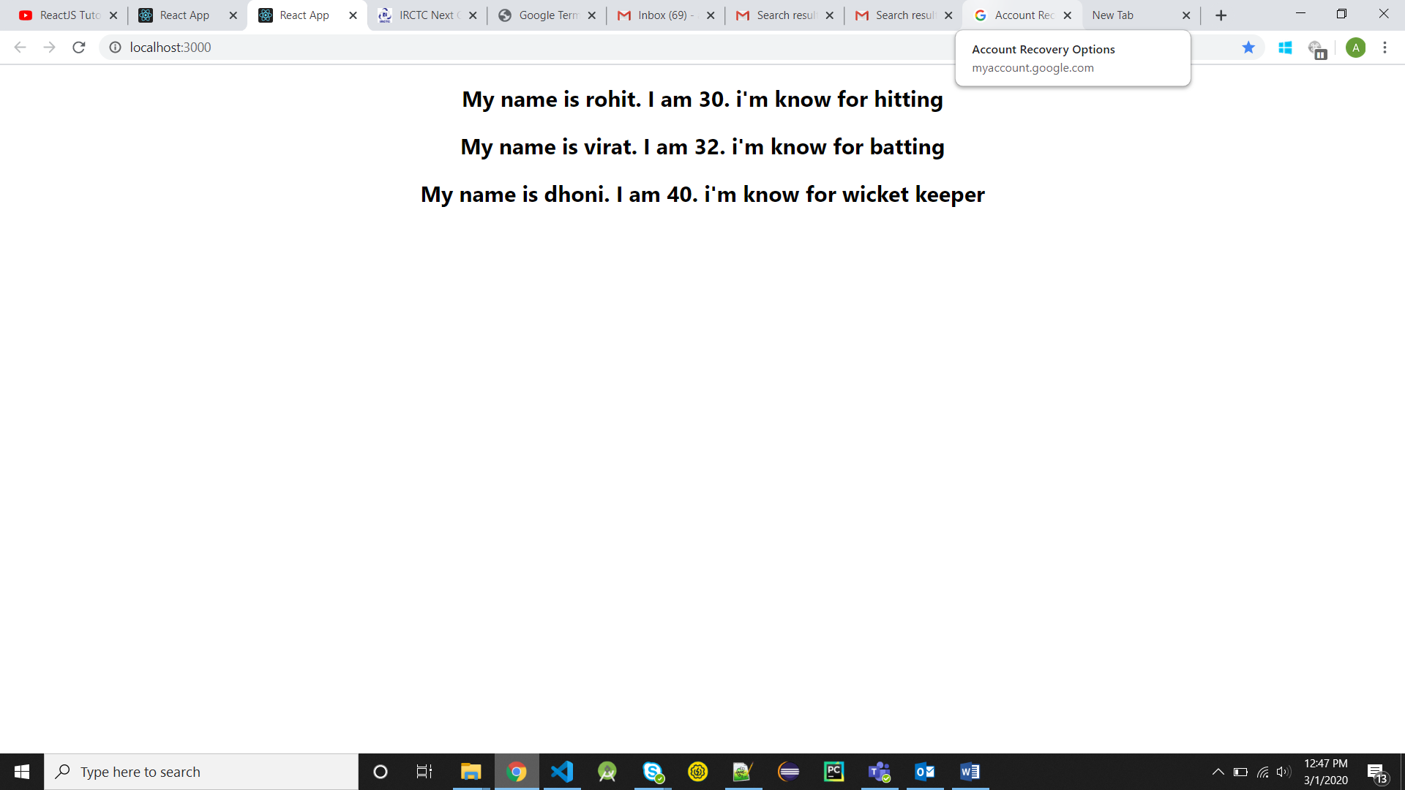

Notes:

* We cannot access key as prop to display. If we want to display key then we have to use another prop (key prop is reserved).

# Indexes as Key

import React from "react";

function IndexAsKey() {

  const names = ["rohit", "virat", "dhoni", "pandya"];

  const nameList = names.map((name, index) => (

    <h2 key={index}>

      {index}

      {name}

    </h2>

  ));

  return (

    <div>

      <h2>{nameList}</h2>

    </div>

  );

}

export default IndexAsKey;