A PROJECT REPORT ON

**JARVIS: The Personal AI Assistant**

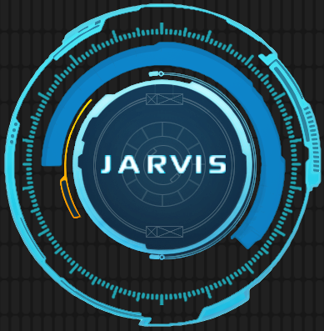

## Submitted in the partial fulfilment of award of

# **National Innovation Contest 2020**

# **Institution’s Innovation Council**

**Submitted By:**

1. Aritro Chakraborty
2. Sudipta Roy Chowdhury
3. Dabjeet Laha

# ABSTRACT

The project aims to develop a personal-assistant for Windows-based systems. Jarvis draws its inspiration from virtual assistants like Cortana for Windows, and Siri for iOS. It has been designed to provide a **user-friendly interface** for carrying out a variety of tasks by employing certain **well-defined commands**. Users can interact with the assistant either through **voice commands** or using keyboard input.

As a personal assistant, Jarvis assists the end-user with *day-to-day activities like general human conversation, searching queries in google, bing or yahoo, searching for videos, retrieving images, live weather conditions, word meanings, searching for medicine details, health recommendations based on symptoms and reminding the user about the scheduled events and tasks.* The user statements/commands are analysed with the help of **machine learning** to give an optimal solution.

#### Keywords:- Personal Assistant, Windows Systems, Automation, Machine Learning