Store Sales Prediction

Wireframe Documentation

Store Sales Prediction

Store Sales Prediction is of Three Pages :

1) Home Page

2) Input Page

3) Result Page

After accessing the [URL](https://storesalesprediction.herokuapp.com/), user will get directed to the Home Page.

After pressing the PREDICT button, User will get directed to the Input Page, where user have to fill the input fields

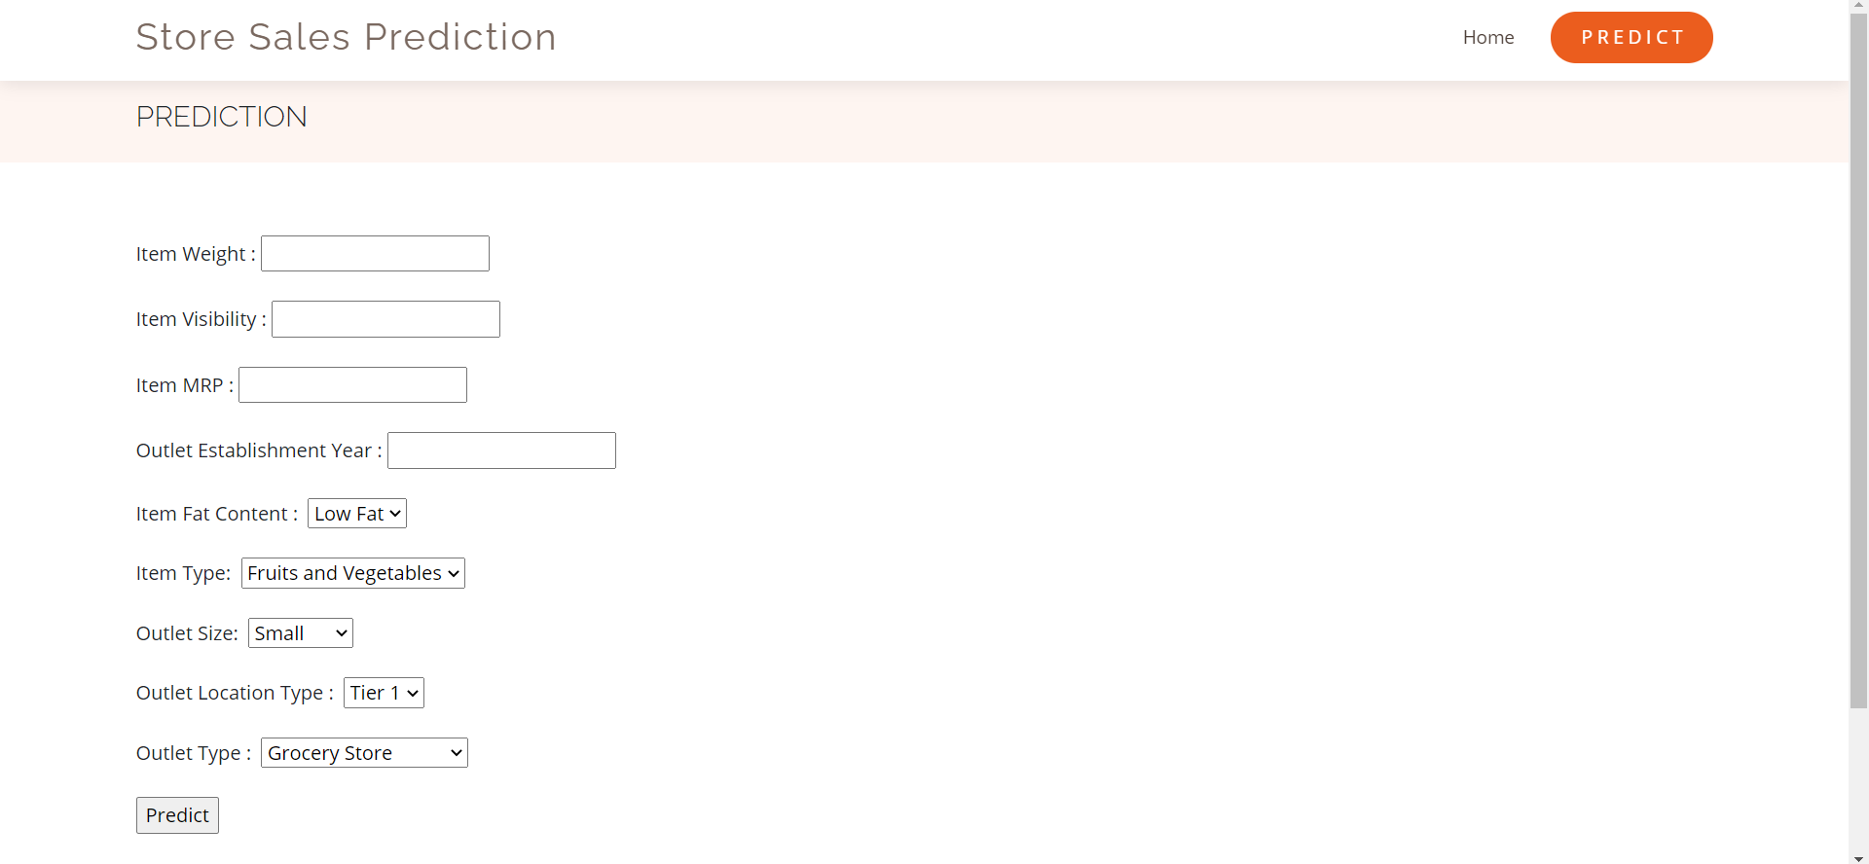Based on User Inputs, Store Sales Prediction will predict the Item Outlet Sales and user will get predicted results 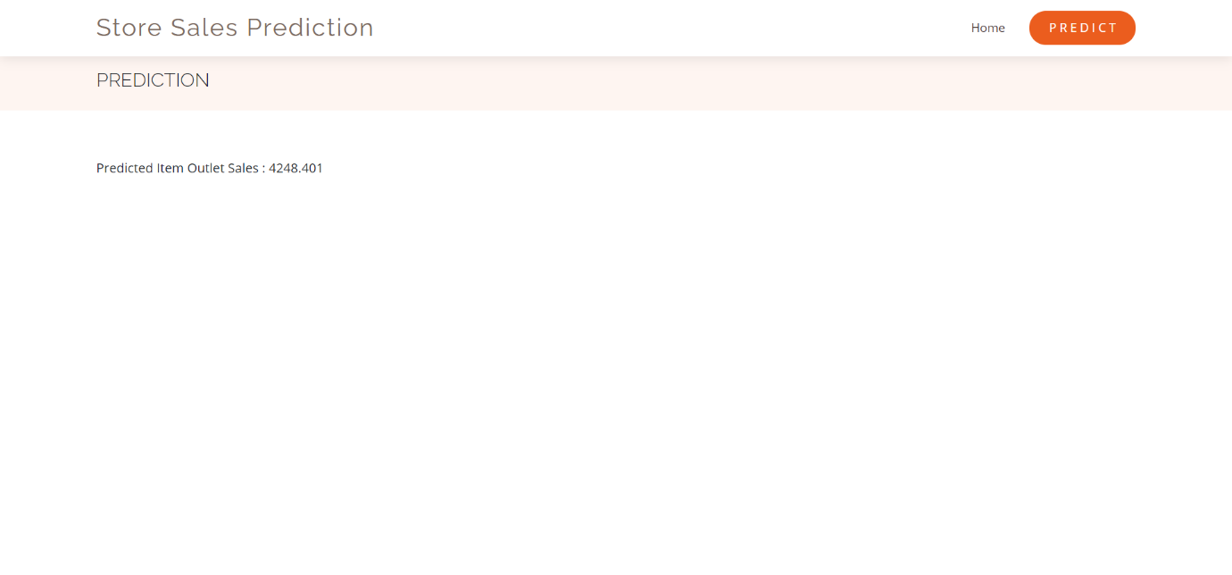on Result Page.