QRFL Complete Technical Report
Threat-Timeline-Driven Quantum-Resistant Federated Learning
for Blockchain-Enabled Healthcare Systems
Compact DOCX · All measured tables · All generated diagrams · Values · Analysis · Performance
Item | Value
Corpus date | 2026-09-03
FL scale | 10 seeds × 50 rounds × 270 configs
PQC backend | quantcrypt-cffi
Determinism | passed
Planning trigger (bootstrap 95% lower) | 2042.10
Artifacts | qrfl-artifacts/results/* · figures/output/* · docs/

1. Executive Summary
QRFL integrates quantum-threat forecasting, NIST PQC benchmarking, healthcare FL (Classical / Hybrid / Native PQ), Hyperledger Fabric validation, and Mosca/MOSCoW migration planning. Tables and diagrams below are generated from measured CSVs.
Metric | Measured result
IID-25 accuracy (classical / hybrid / native) | 65.3% / 65.3% / 65.3%
IID-25 AUROC | 0.566
Native PQ FL latency overhead % | -0.53
HLF total latency classical → native | 80.8 → 84.2 ms (~4%)
Forecast growth rate / doubling | 0.3731 / 1.86 yr
Hold-out MAE / RMSE / MAPE | 563.39 / 602.62 / 424.63%
FL determinism check | passed

2. Five-Layer Architecture
Lower layers constrain upper layers (crossing years → algorithm choice → FL/Fabric cost → roadmap).
Layer | Name | Role | Primary measured outputs
L1 | Forecasting | When to migrate | scenarios.csv, forecast_validation
L2 | PQC / Crypto-Agility | What algorithms | pqc/summary.csv, ablation.tex
L3 | Healthcare FL | Utility & FL cost | fl/all_results.csv, fl_*.tex
L4 | Blockchain | Ledger cost | ledger_latency.tex, docker_stats
L5 | Migration Support | Roadmap | Mosca + MOSCoW (manuscript)

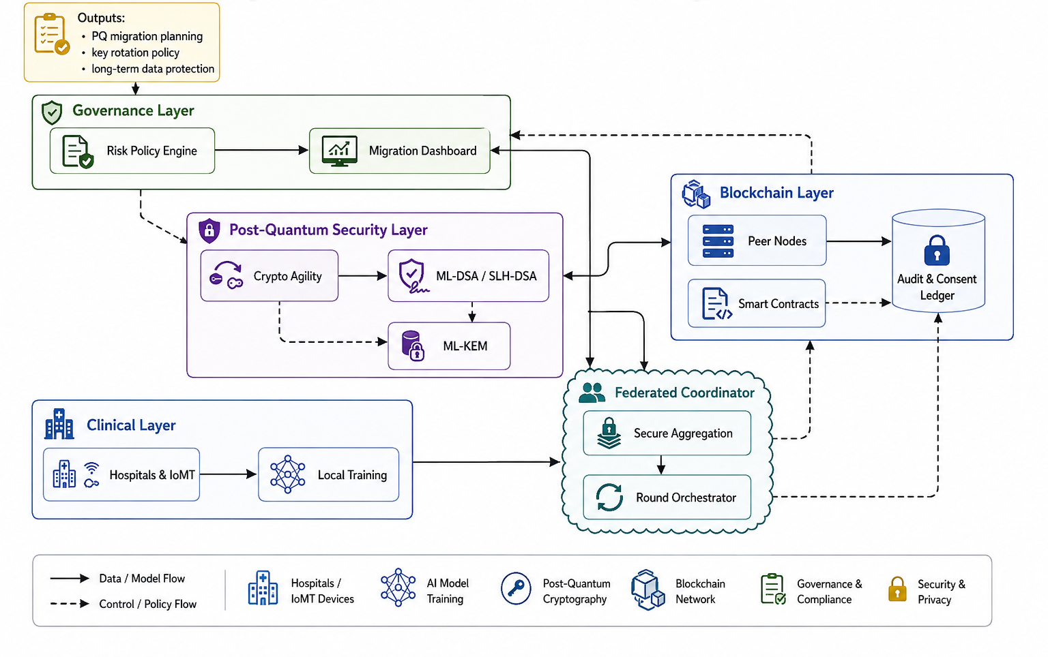
Figure 2.1 — Layered QRFL system architecture (manuscript Fig. 2).
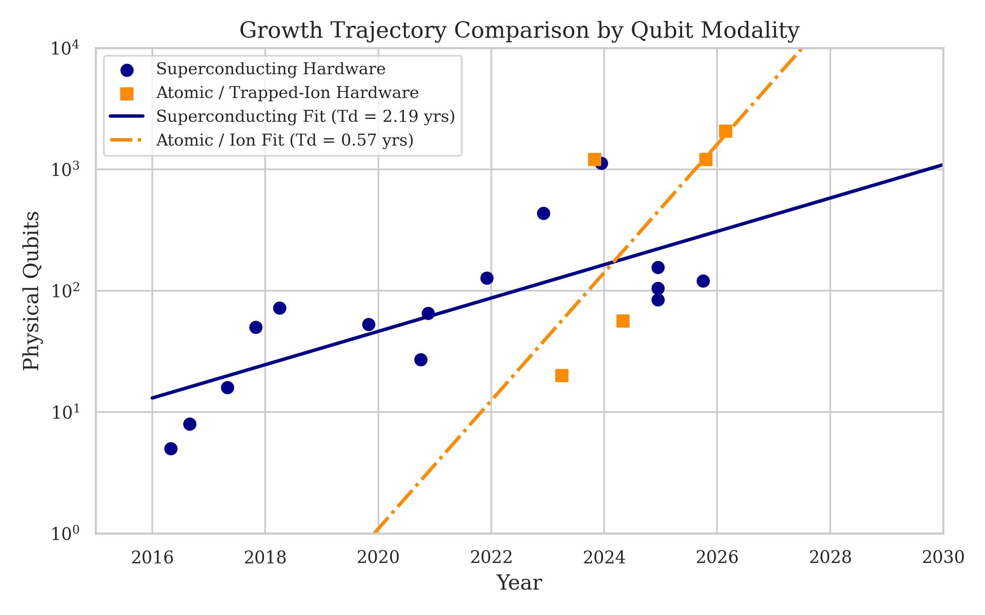
Figure 2.2 — Modality / security-mode comparison diagram.

2.1 Reproducibility pipeline
Step | Module | Produces
1 | forecasting.run_all | fit/scenarios/validation CSVs + .tex
2 | pqc_benchmarks.run_benchmarks | trials.csv, summary.csv, crypto + ablation .tex
3 | federated_learning.run_experiment | all_results.csv (270), fl_*.tex
4 | resource_profiling.run_profile | resource summary/trials + .tex
5 | statistical_tests.run_all | fl_statistical_tests.csv + .tex
6 | figures.generate_all | figures/output/*.png|pdf + layer_*.tex
7 | capture_hardware.py | hardware_specs.json
Opt | blockchain stack | ledger_latency.tex, summary.csv, docker_stats.json

2.2 Protocol flows
Flow | Mechanism | Measured / design note
F1 Hybrid certs | ECDSA + ML-DSA X.509 | ~6.2× cert size vs classical
F2 Hybrid KEM | ML-KEM-768 ∥ ECDHE → HKDF | HNDL-safe if ML-KEM holds
F3 Masking | Pairwise modular masks Σ=0 | Utility identical across modes
F4 Sign+endorse | ML-DSA-65 + Fabric 2-of-3 | HLF sim +~4% total latency
F5 Revocation | DCRL + policy algo swap | Architectural (not timed)

3. Experiment A — PQC Micro-benchmarks (full table)
Backend: quantcrypt-cffi / PQClean; values from results/pqc/summary.csv (measured).
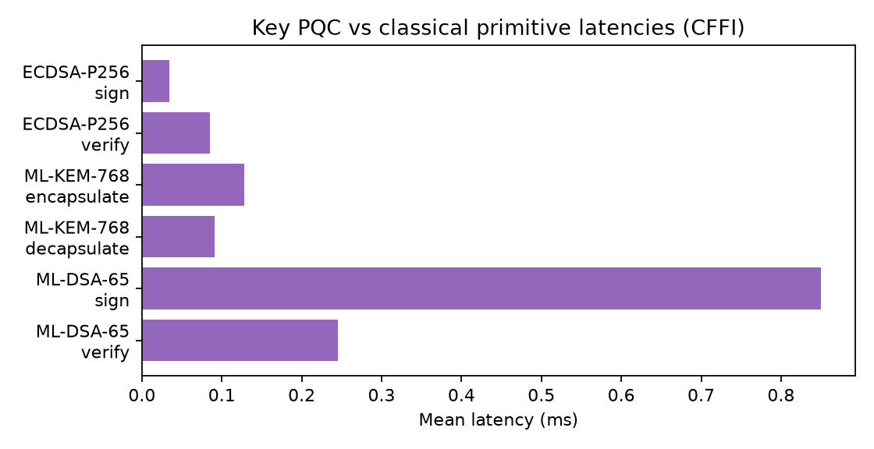
Figure 3.1 — Key classical vs PQC latencies.
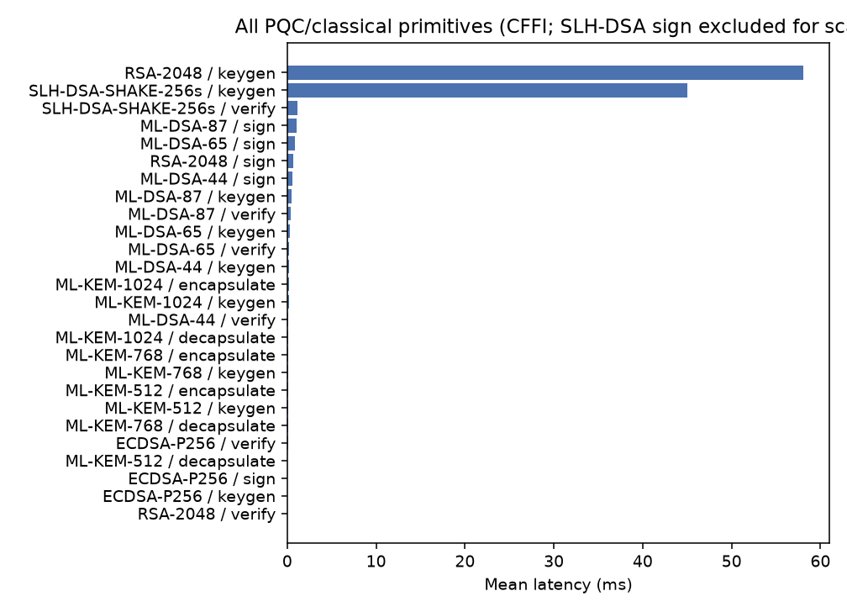
Figure 3.2 — Full primitive set (SLH-DSA sign omitted for scale; see table).
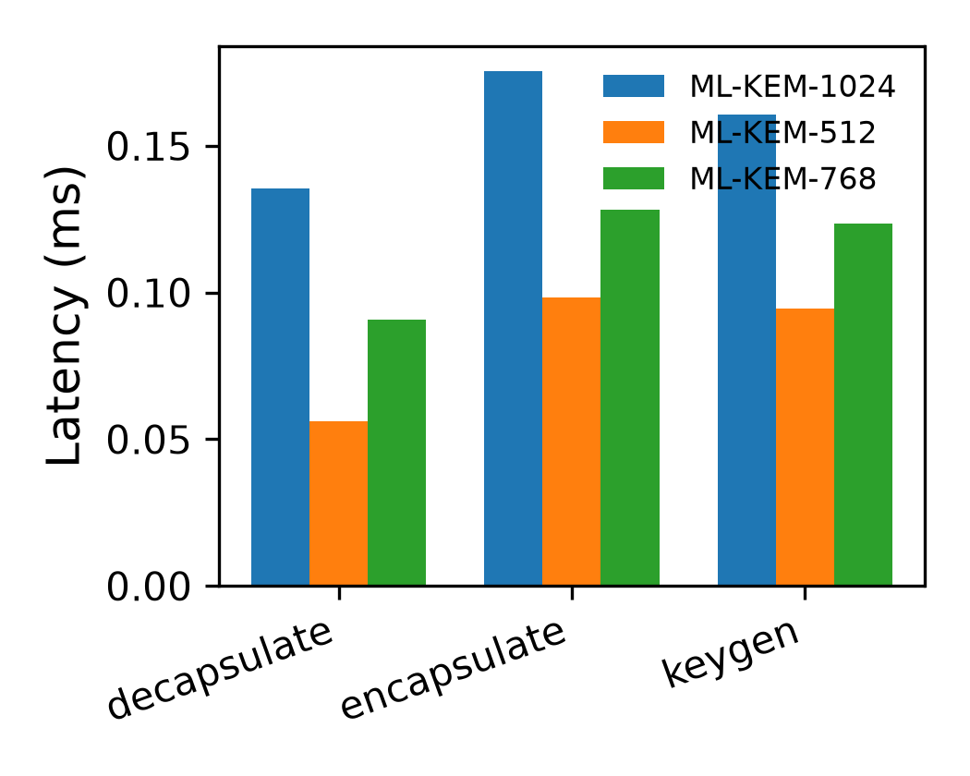
Figure 3.3 — Pipeline figure: pqc_overhead_results.png
Scheme | Op | Mean (ms) | SD | Median | P95 | N | PK (B) | CT/Sig (B)
ECDSA-P256 | keygen | 0.031 | 0.002 | 0.032 | 0.032 | 10000 | 64 | 71.00
ECDSA-P256 | sign | 0.035 | 0.002 | 0.035 | 0.035 | 10000 | 64 | 71.00
ECDSA-P256 | verify | 0.085 | 0.003 | 0.086 | 0.087 | 10000 | 64 | 71.00
ML-DSA-44 | keygen | 0.204 | 0.027 | 0.199 | 0.215 | 10000 | 1312 | 2420.0
ML-DSA-44 | sign | 0.580 | 0.333 | 0.466 | 1.232 | 10000 | 1312 | 2420.0
ML-DSA-44 | verify | 0.151 | 0.016 | 0.149 | 0.160 | 10000 | 1312 | 2420.0
ML-DSA-65 | keygen | 0.313 | 0.009 | 0.311 | 0.334 | 10000 | 1952 | 3309.0
ML-DSA-65 | sign | 0.850 | 0.502 | 0.715 | 1.820 | 10000 | 1952 | 3309.0
ML-DSA-65 | verify | 0.245 | 0.019 | 0.241 | 0.260 | 10000 | 1952 | 3309.0
ML-DSA-87 | keygen | 0.464 | 0.013 | 0.461 | 0.496 | 10000 | 2592 | 4627.0
ML-DSA-87 | sign | 1.068 | 0.527 | 0.919 | 2.126 | 10000 | 2592 | 4627.0
ML-DSA-87 | verify | 0.411 | 0.023 | 0.411 | 0.426 | 10000 | 2592 | 4627.0
ML-KEM-1024 | decapsulate | 0.135 | 0.008 | 0.131 | 0.144 | 10000 | 1568 | 1568.0
ML-KEM-1024 | encapsulate | 0.175 | 0.015 | 0.177 | 0.186 | 10000 | 1568 | 1568.0
ML-KEM-1024 | keygen | 0.161 | 0.015 | 0.160 | 0.172 | 10000 | 1568 | 1568.0
ML-KEM-512 | decapsulate | 0.056 | 0.002 | 0.056 | 0.057 | 10000 | 800 | 768.0
ML-KEM-512 | encapsulate | 0.098 | 0.003 | 0.099 | 0.101 | 10000 | 800 | 768.0
ML-KEM-512 | keygen | 0.094 | 0.003 | 0.094 | 0.098 | 10000 | 800 | 768.0
ML-KEM-768 | decapsulate | 0.091 | 0.013 | 0.089 | 0.096 | 10000 | 1184 | 1088.0
ML-KEM-768 | encapsulate | 0.128 | 0.004 | 0.128 | 0.137 | 10000 | 1184 | 1088.0
ML-KEM-768 | keygen | 0.123 | 0.003 | 0.124 | 0.127 | 10000 | 1184 | 1088.0
RSA-2048 | keygen | 58.09 | 36.56 | 50.36 | 116.7 | 25 | 256 | 256.0
RSA-2048 | sign | 0.718 | 0.113 | 0.699 | 0.754 | 10000 | 256 | 256.0
RSA-2048 | verify | 0.030 | 0.002 | 0.029 | 0.032 | 10000 | 256 | 256.0
SLH-DSA-SHAKE-256s | keygen | 44.99 | 0.823 | 44.93 | 45.63 | 1334 | 64 | 29792.0
SLH-DSA-SHAKE-256s | sign | 536.8 | 5.838 | 535.5 | 547.6 | 112 | 64 | 29792.0
SLH-DSA-SHAKE-256s | verify | 1.108 | 0.074 | 1.107 | 1.189 | 10000 | 64 | 29792.0

3.1 Experiment E — Parameter ablation
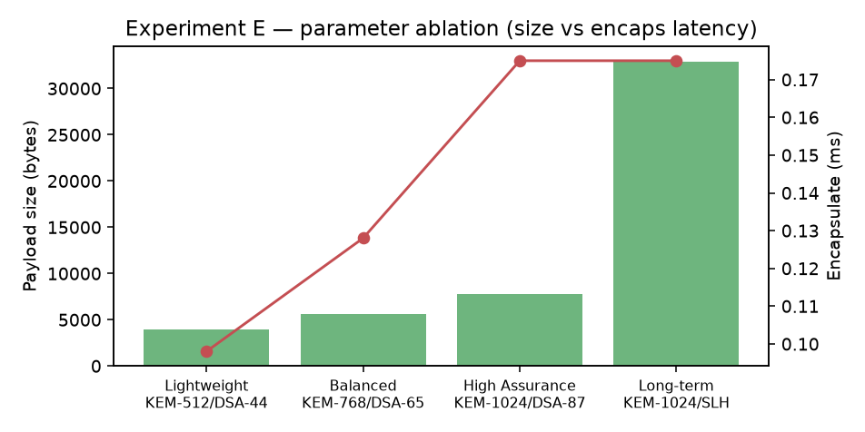
Figure 3.4 — Ablation: payload size vs encapsulate latency.
Profile | KEM | Signature | NIST | Encaps (ms) | Decaps (ms) | Payload (B) | Use case
Lightweight | ML-KEM-512 | ML-DSA-44 | 1/2 | 0.098 | 0.056 | 3,988 | IoMT sensors
Balanced (default) | ML-KEM-768 | ML-DSA-65 | 3/3 | 0.128 | 0.091 | 5,581 | Healthcare FL
High Assurance | ML-KEM-1024 | ML-DSA-87 | 5/5 | 0.175 | 0.135 | 7,763 | Archival/audit
Long-term | ML-KEM-1024 | SLH-DSA-256s | 5/1 | 0.175 | 0.135 | 32,928 | 30-yr retention

4. Experiments B / B-2 / D — Federated Learning
Dataset PneumoniaMNIST · 270 configs · seeds=10 · rounds=50. Tables computed from results/fl/all_results.csv (IID FedAvg, attack=none for scaling).

4.1 FL round process
Step | Function | Effect
1 | load_pneumoniamnist | Train/val/test
2 | dirichlet_partition | Shards by α
3 | train_local × N | 5 epochs Adam / round
4 | apply_attack | Optional Byzantine
5 | apply_mask | Pairwise masks Σ=0
6 | fedavg|median|krum | Aggregate CNN
7 | crypto_round_overhead | KEM+sig × N from Exp A
8 | evaluate | Acc, AUROC, F1, latency

4.2 IID client scaling — values + diagrams
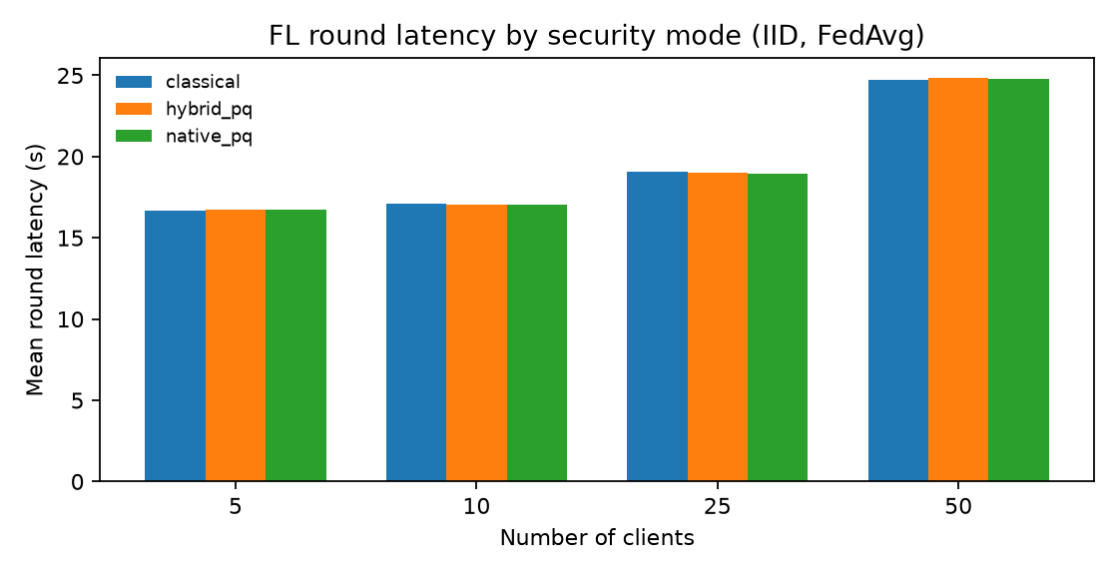
Figure 4.1 — FL round latency by security mode (IID FedAvg).
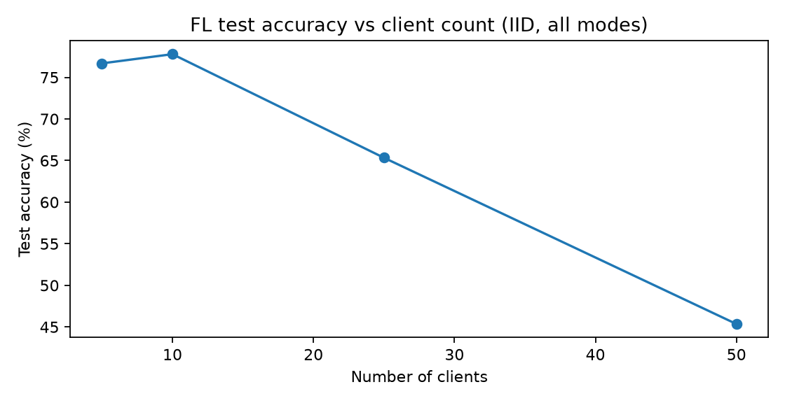
Figure 4.2 — Test accuracy vs client count.
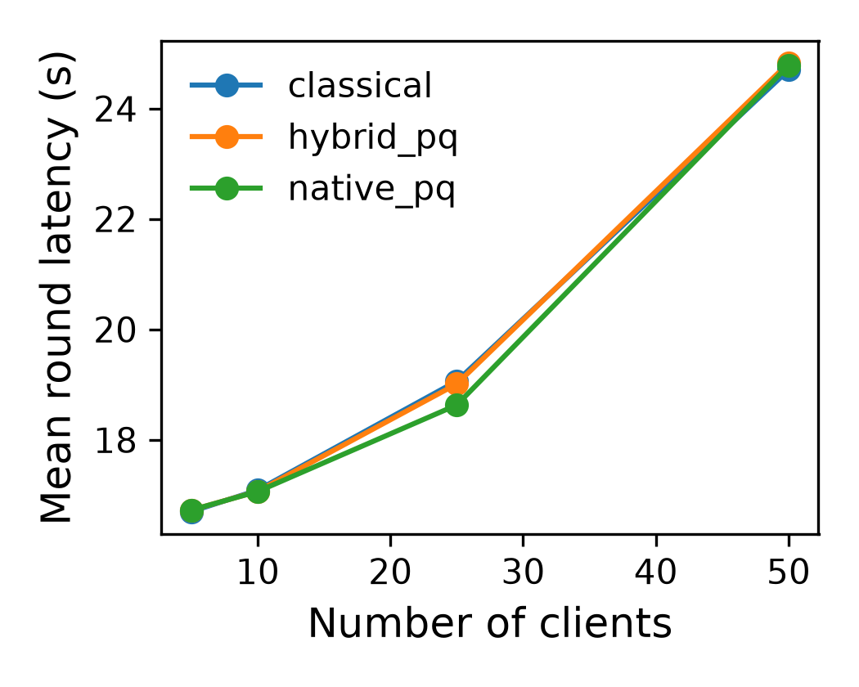
Figure 4.3 — Pipeline figure: fl_overhead_results.png
Clients | Accuracy | AUROC | F1 | Classical (s) | Hybrid (s) | Native (s) | Native Δ%
5 | 76.7% | 0.712 | 0.834 | 16.70±0.18 | 16.73±0.18 | 16.73±0.18 | +0.17%
10 | 77.8% | 0.720 | 0.843 | 17.09±0.17 | 17.07±0.20 | 17.06±0.15 | -0.15%
25 | 65.3% | 0.566 | 0.767 | 19.06±0.28 | 19.01±0.29 | 18.96±0.27 | -0.53%
50 | 45.4% | 0.524 | 0.355 | 24.70±0.37 | 24.82±0.24 | 24.78±0.37 | +0.34%

4.3 IID-25 medical / utility metrics (all modes)
Mode | Accuracy | AUROC | Sens. | Spec. | Precision | Recall | F1
Classical | 65.34% ± 0.15% | 0.5664 ± 0.0009 | 91.44% | 21.84% | 66.10% | 91.44% | 0.7673
Hybrid PQ | 65.34% ± 0.15% | 0.5664 ± 0.0009 | 91.44% | 21.84% | 66.10% | 91.44% | 0.7673
Native PQ | 65.34% ± 0.15% | 0.5664 ± 0.0009 | 91.44% | 21.84% | 66.10% | 91.44% | 0.7673

Analysis: predictive metrics identical across modes (masking preserves utility). Latency differences are sub-percent and not significant after Holm (Section 5).

4.4 Non-IID Dirichlet (25 clients, FedAvg, all modes pooled means)
α | Accuracy | F1 | AUROC | Latency (s)
0.1 | 65.30% | 0.767 | 0.566 | 19.18
0.5 | 65.42% | 0.768 | 0.567 | 19.12
1.0 | 65.34% | 0.767 | 0.566 | 19.01

4.4.1 Non-IID by security mode (values)
α | Mode | Accuracy | Latency mean (s) | Latency SD
0.1 | classical | 65.30% | 19.160 | 0.271
0.1 | hybrid_pq | 65.30% | 19.181 | 0.237
0.1 | native_pq | 65.30% | 19.193 | 0.261
0.5 | classical | 65.42% | 19.117 | 0.272
0.5 | hybrid_pq | 65.42% | 19.121 | 0.247
0.5 | native_pq | 65.42% | 19.125 | 0.223
1.0 | classical | 65.34% | 19.063 | 0.276
1.0 | hybrid_pq | 65.34% | 19.012 | 0.287
1.0 | native_pq | 65.34% | 18.961 | 0.271

4.5 Experiment D — Byzantine robustness (full table)
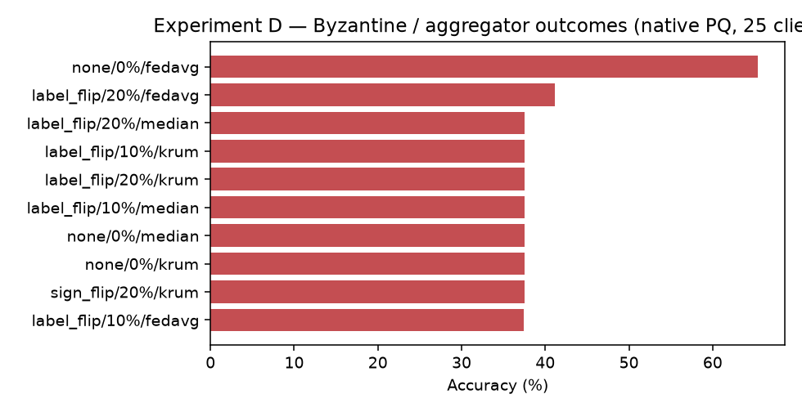
Figure 4.4 — Byzantine / aggregator accuracy (native PQ).
Attack | Mal % | Agg | N | Accuracy | AUROC | F1 | Latency (s)
label_flip | 10% | fedavg | 10 | 37.45% | 0.4512 | 0.1867 | 19.01
label_flip | 10% | krum | 10 | 37.50% | — | 0.0000 | 18.53
label_flip | 10% | median | 10 | 37.50% | — | 0.0000 | 18.43
label_flip | 20% | fedavg | 10 | 41.15% | 0.5079 | 0.1590 | 19.01
label_flip | 20% | krum | 10 | 37.50% | 0.5000 | 0.0000 | 18.56
label_flip | 20% | median | 10 | 37.50% | — | 0.0000 | 18.39
none | 0% | fedavg | 30 | 65.35% | 0.5666 | 0.7674 | 19.09
none | 0% | krum | 10 | 37.50% | — | 0.0000 | 18.52
none | 0% | median | 10 | 37.50% | — | 0.0000 | 18.39
sign_flip | 20% | krum | 10 | 37.50% | 0.5000 | 0.0000 | 18.52

Analysis: label-flip collapses FedAvg utility; Median/Krum stay near ~37.5% on this imbalanced task and need further tuning. PQ crypto tax remains secondary to training/aggregation.

5. Statistical Outcomes (full measured rows)
Metric | Mode A | Mode B | Test | p / equiv | Holm sig? | Interpretation
accuracy | classical | hybrid_pq | tost equivalence | equiv=True | True | equivalent
accuracy | classical | native_pq | tost equivalence | equiv=True | True | equivalent
accuracy | hybrid_pq | native_pq | tost equivalence | equiv=True | True | equivalent
f1 | classical | hybrid_pq | tost equivalence | equiv=True | True | equivalent
f1 | classical | native_pq | tost equivalence | equiv=True | True | equivalent
f1 | hybrid_pq | native_pq | tost equivalence | equiv=True | True | equivalent
mean_round_latency_s | classical | hybrid_pq | paired t test | p=0.5966 | False | not_significant
mean_round_latency_s | classical | native_pq | paired t test | p=0.2861 | False | not_significant
mean_round_latency_s | hybrid_pq | native_pq | wilcoxon signed rank | p=0.9219 | False | not_significant

Setting: IID α=1.0, 25 clients, FedAvg, attack=none; Holm-corrected α=0.05.

6. Experiment C — Blockchain (HLF)
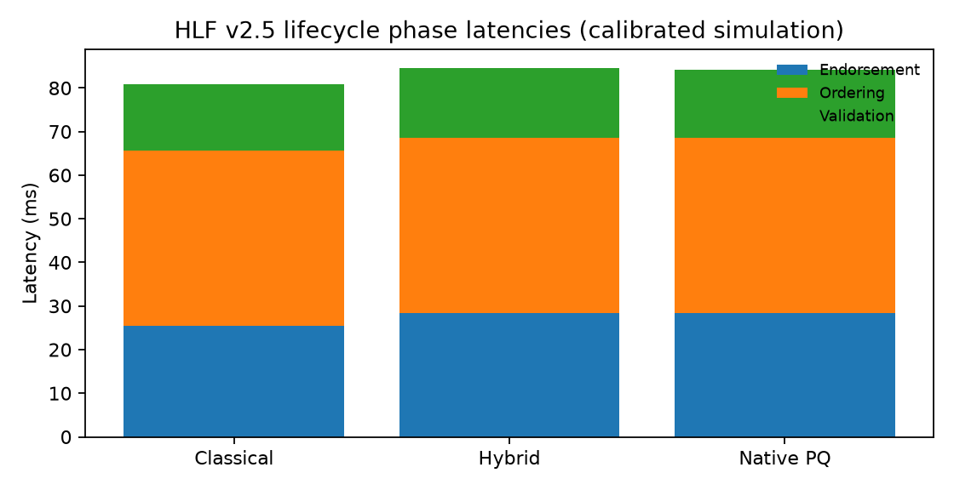
Figure 6.1 — Calibrated HLF phase stack.
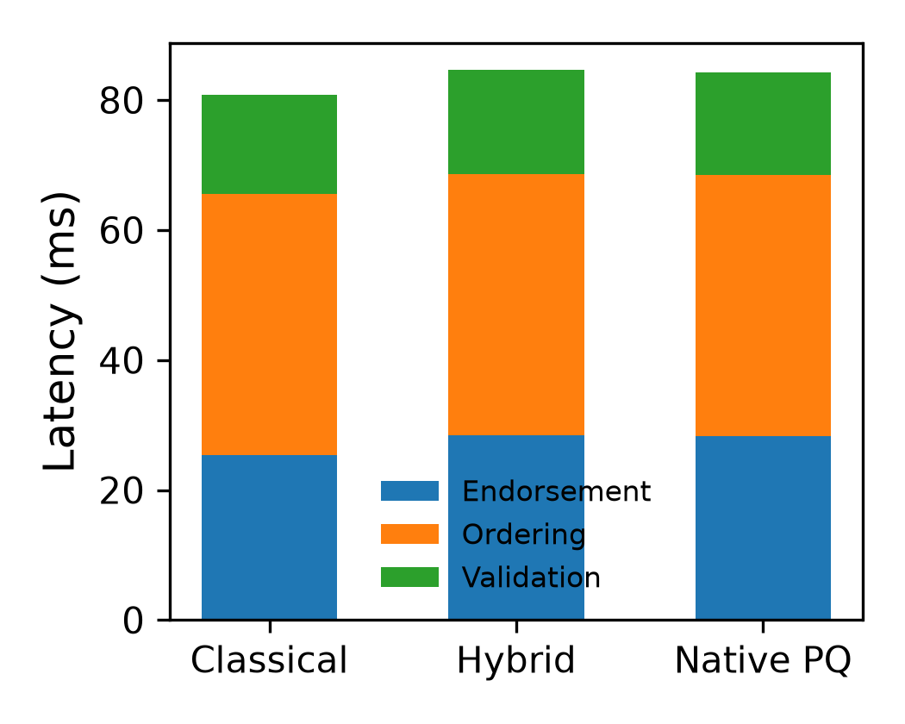
Figure 6.2 — Pipeline figure: hlf_phase_latencies.png
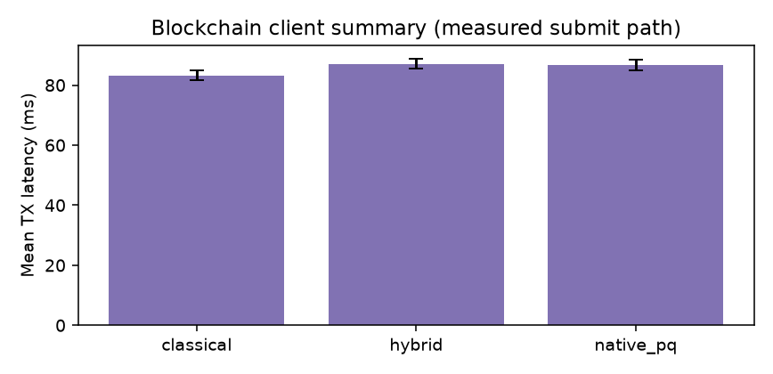
Figure 6.3 — Client submit-path mean latency (±SD).
Phase | Classical (ms) | Hybrid (ms) | Native PQ (ms)
Endorsement | 25.4 | 28.4 | 28.3
Ordering | 40.2 | 40.2 | 40.2
Validation / commit | 15.3 | 16.0 | 15.7
Total | 80.8 | 84.6 | 84.2

6.1 Blockchain summary.csv (measured)
Config | Mean latency (ms) | SD | Throughput TPS | Mean payload (B)
classical | 83.22 | 1.634 | 100 | 576.0
hybrid | 87.10 | 1.711 | 100 | 10245.0
native_pq | 86.73 | 1.703 | 100 | 9927.0

6.2 Live Docker stats
Name | CPU % | Mem usage | Mem % | Net I/O | Block I/O | PIDs
peer0.hospitala.example.com | 2.42% | 18.57MiB / 23.3GiB | 0.08% | 7.23kB / 4.62kB | 45MB / 152kB | 14
peer0.hospitalb.example.com | 2.51% | 22.6MiB / 23.3GiB | 0.09% | 1.44kB / 126B | 4.21MB / 156kB | 15
peer0.research.example.com | 2.44% | 17.6MiB / 23.3GiB | 0.07% | 1.4kB / 126B | 139kB / 156kB | 14
orderer.example.com | 0.03% | 13.34MiB / 23.3GiB | 0.06% | 1.68kB / 126B | 7.61MB / 20.5kB | 14
couchdb-hospitala | 0.26% | 77.7MiB / 23.3GiB | 0.33% | 6.17kB / 5.87kB | 18.4MB / 205kB | 66

MSP remains ECDSA; ML-DSA applies at application/chaincode payload layer (Go chaincode deploy deferred).

7. Forecasting & Validation (values + diagrams)
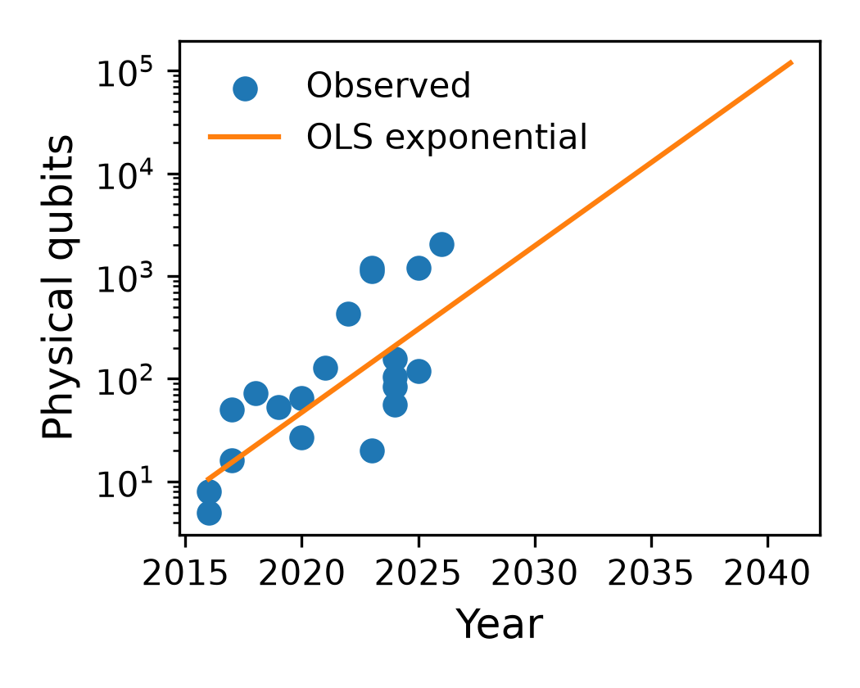
Figure — Pipeline: forecasting_model_comparison.png
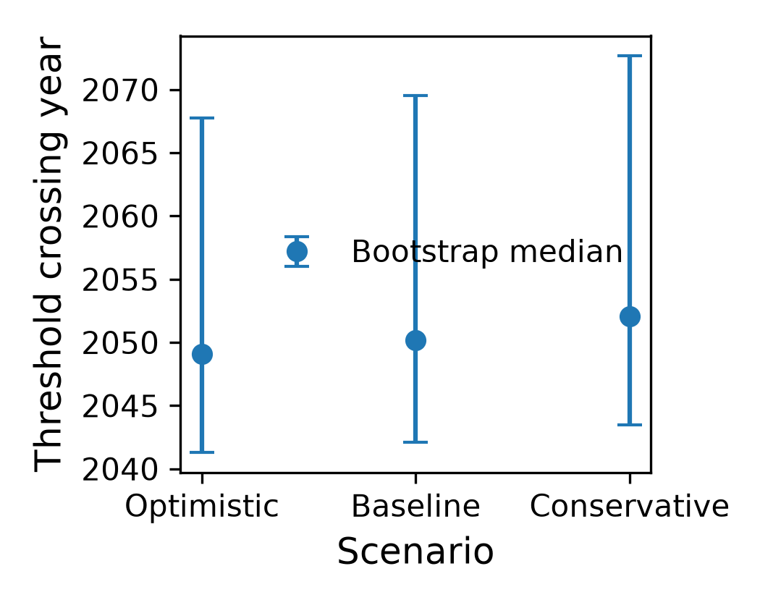
Figure — Pipeline: threshold_crossing_uncertainty.png
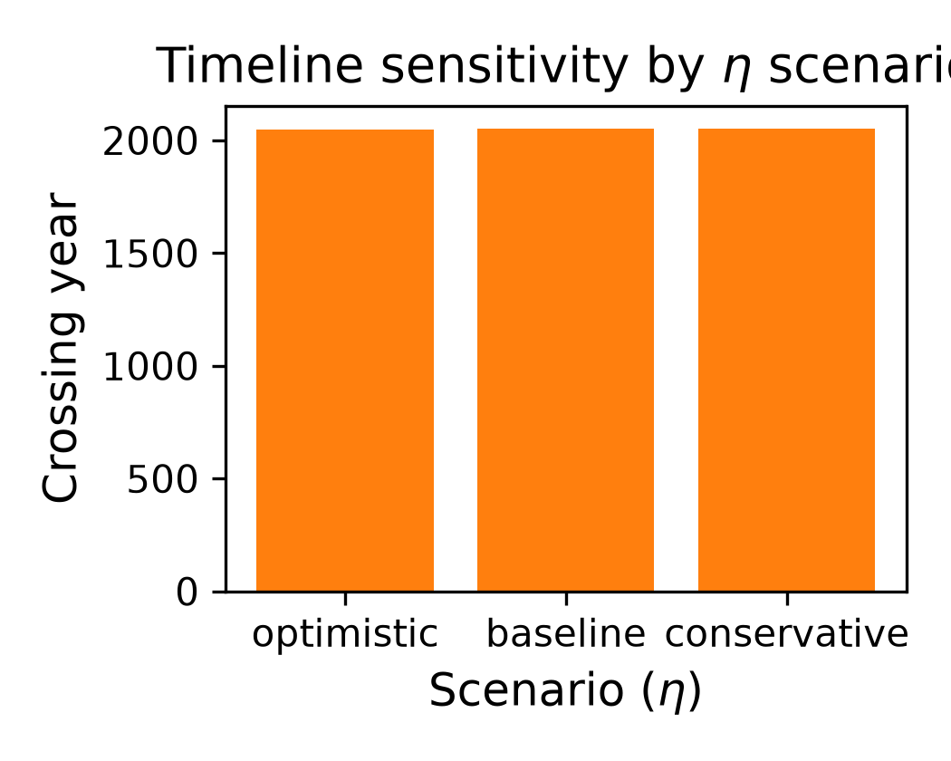
Figure — Pipeline: sensitivity_analysis.png
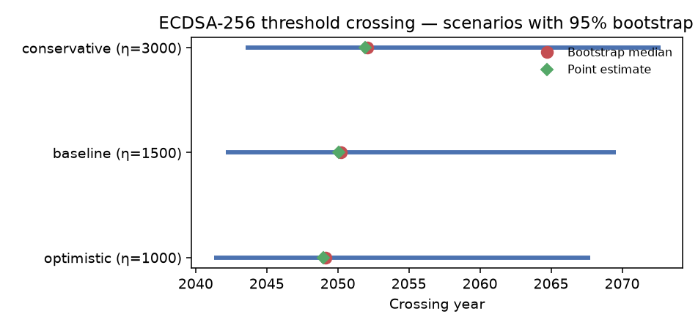
Figure 7.4 — Scenario crossing years with 95% bootstrap CI (from scenarios.csv).

7.1 Fit summary
Parameter | Value
intercept_ln | 2.359532
intercept_a | 10.59
growth_rate_b | 0.373095
doubling_time | 1.857828
r_squared | 0.530790
adj_r_squared | 0.504723
n | 20.00
ci_intercept_ln_lower | 2.277610
ci_intercept_ln_upper | 2.441455
ci_growth_lower | 0.199389
ci_growth_upper | 0.546802
logistic_L | 1.38825e+07
logistic_k | 2.808957
logistic_t0 | 13.22
logistic_rmse | 408.1
logistic_aic | 246.5
bootstrap_median | 2050.2
bootstrap_ci_lower | 2042.1
bootstrap_ci_upper | 2069.6

7.2 Scenarios (full)
Scenario | η | Point year | Boot. median | CI lower 95 | CI upper 95
optimistic | 1000 | 2049.0 | 2049.1 | 2041.3 | 2067.8
baseline | 1500 | 2050.1 | 2050.2 | 2042.1 | 2069.6
conservative | 3000 | 2051.9 | 2052.1 | 2043.5 | 2072.7

7.3 Backtest validation
Strategy | MAE | RMSE | MAPE (%)
Hold-out 2024–2026 | 563.4 | 602.6 | 424.6
Rolling-origin | 600.5 | 768.9 | 311.4
Leave-one-out | 316.2 | 544.7 | 151.4

Residual diagnostic | Value
residual_mean | -0.000
residual_std | 1.1580
Shapiro–Wilk p | 0.3948
Durbin–Watson | 1.796
Ljung–Box p | 0.8377

Analysis: high MAPE reflects sparse hardware jumps. Risk-management trigger uses bootstrap 95% lower bound ≈ 2042.10 (baseline η).

8. Experiment F — Resource Profiling
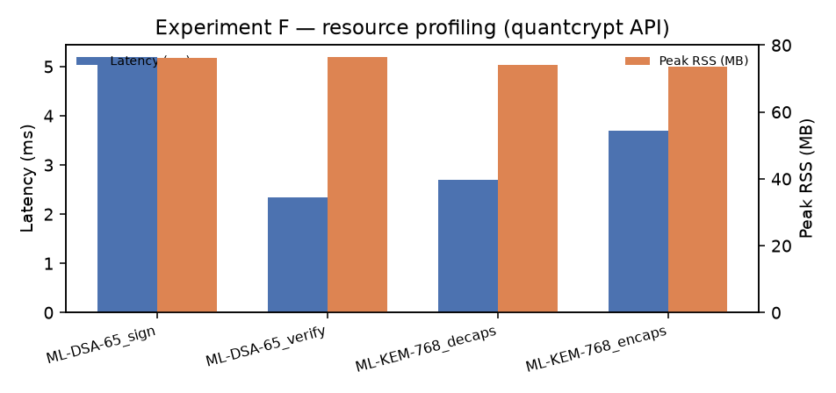
Figure 8.1 — API-level latency and peak RSS.
Operation | Mean latency (ms) | SD (ms) | Peak RSS (MB) | Energy (J)
ML-DSA-65_sign | 5.187 | 1.258 | 76.20 | —
ML-DSA-65_verify | 2.338 | 0.467 | 76.34 | —
ML-KEM-768_decaps | 2.701 | 0.456 | 74.13 | —
ML-KEM-768_encaps | 3.688 | 0.661 | 73.45 | —

Note: Exp F uses quantcrypt high-level API (wrapper overhead). Energy unavailable without RAPL on this host.

9. Cross-Layer Performance Synthesis
Question | Evidence | Outcome
When migrate? | L1 CI lower ≈ 2042.10 | Begin hybrid now (long EHR retention)
Which params? | Exp E ablation | ML-KEM-768 / ML-DSA-65 default
FL utility hit? | TOST equivalent (Sec 5) | No predictive degradation
FL latency hit? | Holm NS latency | Training dominates crypto tax
Ledger hit? | 80.8→84.2 ms | Ordering dominates; +~4%
Poisoning? | Exp D full table | FedAvg fragile; robust aggs need tuning

10. Emitted Macros (key values)
Macro | Value
FLNumSeeds | 10
FLNumRounds | 50
FLIIDAccuracyClassical | 65.3
FLIIDAccuracyHybrid | 65.3
FLIIDAccuracyNative | 65.3
FLIIDAUROC | 0.566
FLClientTenAccuracy | 77.8
FLNativeLatencyOverheadPct | -0.53
FLDeterminismCheck | passed
ForecastBootstrapCILower | 2042.10
ForecastGrowthRate | 0.3731
ForecastDoublingTime | 1.86
ForecastRSquared | 0.5308
ForecastHoldoutMAE | 563.39
ForecastHoldoutRMSE | 602.62
ForecastHoldoutMAPE | 424.63
ForecastLOOCVMAE | 316.24
PQCBackend | quantcrypt-cffi
PqcMlKemSevenSixEightEncapsulateMean | 0.128
PqcMlKemSevenSixEightDecapsulateMean | 0.091
PqcMlDsaSixFiveSignMean | 0.850
PqcMlDsaSixFiveVerifyMean | 0.245

11. Generated Diagram Inventory
Source | File | Embedded?
figures/output | fl_overhead_results.png | Yes
figures/output | forecasting_model_comparison.png | Yes
figures/output | hlf_phase_latencies.png | Yes
figures/output | pqc_overhead_results.png | Yes
figures/output | sensitivity_analysis.png | Yes
figures/output | threshold_crossing_uncertainty.png | Yes
docs/_pdf_assets | chart_ablation.png | Yes
docs/_pdf_assets | chart_bc_summary.png | Yes
docs/_pdf_assets | chart_byzantine.png | Yes
docs/_pdf_assets | chart_fl_accuracy.png | Yes
docs/_pdf_assets | chart_fl_latency_modes.png | Yes
docs/_pdf_assets | chart_hlf_phases.png | Yes
docs/_pdf_assets | chart_pqc_all_ops.png | Yes
docs/_pdf_assets | chart_pqc_ops.png | Yes
docs/_pdf_assets | chart_resource.png | Yes
docs/_pdf_assets | chart_scenarios.png | Yes
figs/ | fig2-Layered Architecture of Quantum-Resistant Federated Lea… | Yes
figs/ | modality_comparison.png | Yes
figures/output | layer_blockchainlayer.tex (TikZ source) | Listed (LaTeX)
figures/output | layer_cryptolayer.tex (TikZ source) | Listed (LaTeX)
figures/output | layer_fllayer.tex (TikZ source) | Listed (LaTeX)
figures/output | layer_forecastinglayer.tex (TikZ source) | Listed (LaTeX)
figures/output | layer_migrationlayer.tex (TikZ source) | Listed (LaTeX)

12. Outputs Checklist
Artifact | Path | State
Macros | results/macros.json + results_macros.tex | Present
PQC full | results/pqc/summary.csv + trials.csv | 27 ops
FL full | results/fl/all_results.csv | 270 rows
Stats | results/statistics/fl_statistical_tests.csv | 9 rows
Forecast | results/forecasting/** | Present
Resource | results/resource/summary.csv | 4 ops
Blockchain | results/blockchain/* | Present
Figures PNG/PDF | figures/output/* | Present
This DOCX | docs/QRFL_Complete_Report.docx | Generated

13. Limitations
- FL PQ cost modeled from Exp A means (not live PQ-TLS every round).
- Fabric MSP remains ECDSA; PQ authenticity is application/chaincode-level.
- Forecast MAPE is high — prefer bootstrap lower-bound planning.
- RAPL energy and Go chaincode deploy deferred on this host.
- Byzantine Median/Krum need further tuning for PneumoniaMNIST imbalance.
- fl/summary.csv / fl_metrics.tex may mix Byzantine rows for native@25 — this DOCX uses filtered all_results.csv.
Auto-built from measured results/* and figures/output/* by scripts/build_complete_report_docx.py.

